CONTENTS PAGE
Page 2-3 - My PDP (professional personal development plan)
Page 5- poster
Page 6- poster references
Page 7- 12- Written essay
Page 13-15 – references for write up

I confirm that I have not used any AI tools in the research and creation of this assignment. I can confirm that I have not presented any AI generated materials as my own work. I can confirm I have copies of my drafts, Notes and other resources I used, which I may be asked to provide in evidence.

Part One- My PDP (personal development) plan
Specific, Measurable, Achievable, Relevant, Time-bound.

 | Specific goals | Success Criteria  (Specific) | The actions I will take to achieve the goal (achievable) | Timelines  (Time-Bound) | What will this help me to achieve?  (Relevant) | Achievements  (Measurable)
1 | Going for education in nursery setting | Adapting and changing the nursery setting, suiting to the criteria given by educational key worker, communication back and forth to know when change is made, having constant feedback. | Planned visit and meetings with educational key worker, providing guidelines and next steps to successfully carrying out education in the early year setting I am working at. Continuing to grow and work together to push and earn the educational funding. | 5 months- to change and re arrange setting layout, with new routine, set up areas and activities. Visit in November to see progress as a setting, if we are on the right path to be credited education, start in January, still supporting part-time schoolers and fully implement education in January 2027 | This will help me achieve further educational knowledge and experience, allowing more understanding and able to reflect this information onto other staff and help them gain a much stronger understanding on the educational system. | In three months- hoping to start changing and implementing educational structure with staff feedback and education feedback for correct guidance and a plan.
2 | Autism awareness | To be awarded certificates on Autism awareness to support children in the early years setting with the same equal opportunity as others. To also further my own research and courses through the support of work. | To go and research my own courses as well as ones that are supplied by work, to further training and to constantly learn on the job. I also want to expand my knowledge and support in the working roll to offer my support to others, as well as being able to teach others and share my knowledge. | Over my whole employment time, I would like to constantly learn and grow, learning on the job. I would like to at least gain more of an understanding in the children play of autism awareness before the new year (3 months). | This will help me achieve more experience and knowledge in my position, as a room lead, I believe this will benefit me long term, expanding my opportunities for the future. | To have been able to achieve at least two certificates training and experience over 1 year.
3 | Social carer/play therapy worker. | To complete university, explore my options and explore outside early years, furthering my knowledge to challenge myself more and provide help to those in need. | Completing university, exploring in my own time new information needed for the position and continue to grow and develop in my own personal professional practice. | To complete university in two years, having that as a mind map and then going off to continue my employment, with no exact timeline. | This will help me achieve the knowledge needed to gain experience and meet the key criteria roles to be able to achieve this position. | To at least have gained a better understanding and have had a meeting with someone in the sector of either job role, to have a clearer expectation of what is required for the position after 2/3 years of education.

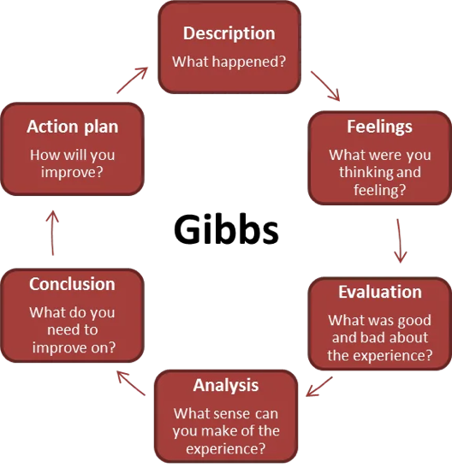
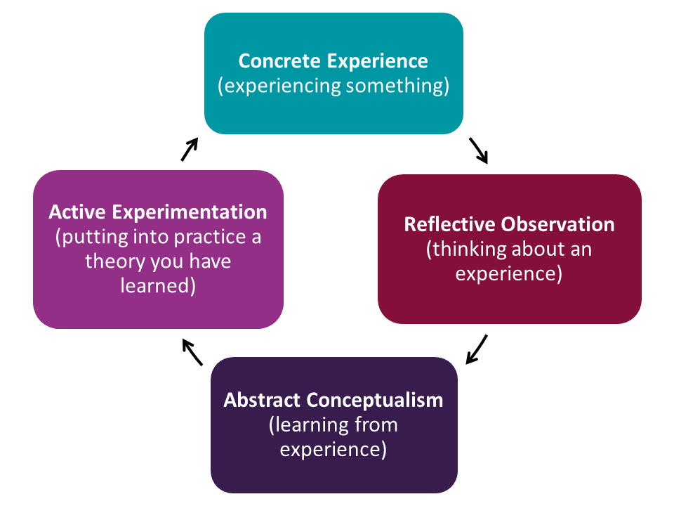
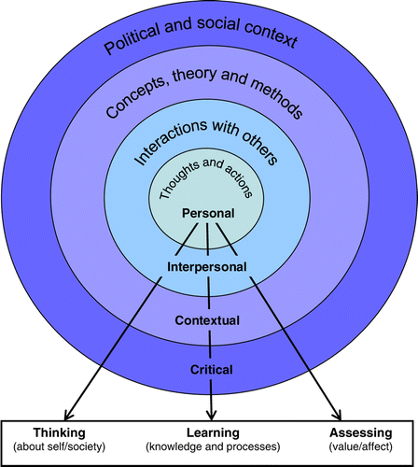
Part 2
Reflection practice
‘Reflection involves reviewing your experiences to help make positive changes for your future practice. It turns your experiences into learning and helps you improve your practice in a way that is right for you’. (Social Work England, n.d.)

Theory of reflection
Kolb’s (1984) ‘Cycle of reflective practice is a model designed to help people learn from their experiences’ (University of Hull, 2026). Kolb’s (1984) Theory of reflection is broken down into four areas, Concrete experience, reflective observation, abstract conceptualism and active experimentation. Kolb’s (1984) ‘Cycle of reflective practice is a model designed to help people learn from their experiences’ ‘The learning cycle emphasises reflective observation as a way to analyse and draw conclusions from an experience’ (University of Hull, 2026). The focus is completing the cycle. Gibbs (1988) is another theorist who has explored reflection and the importance of it. Gibbs (1988) broke down reflection into six stages, Feeling, evaluation, analysis, conclusion, action plan and description. This model allows you to ‘learn and plan from things that either went well or didn’t go well’ (University of Edinburgh, 2024).

Critical reflection
Critical Reflection is a ‘powerful process of making meaning out of a purposeful combination of experiences and academic content’ (Jacoby, 2010). It explores conclusions, compares perspectives, promoting challenges, exploring the ‘simplistic’ in more ‘depth’ (Jacoby, 2010).

Why is reflective practice important in Early years?
Reflective practice is important to help planning, through flexibility, being responsive, and bridging interests. ‘Practitioners reflect on what worked really well and identify any changes that may be needed’ (Early Years Wales, n.d.). Reflective practice is important to early years as it is ‘integral to making informed decisions that continue to support children’s development’ (Early years Wales, n.d). making sure the care and education in early years is provided to the best possible standard.

What is reflective practice?
‘Reflective practice is the ability to reflect on one’s actions so as to engage in a process of continuous learning’ (Schon 2025) every individual has their own perspective on how they reflect on their own personal development. It’s your own experiences and what you did right or wrong, reflect look back and see how you can improve or change. Reflective practice is ‘thinking about our experiences, to learn from them for the future’(Schon 2025) mistakes can be made, we are only human and we cannot ‘time travel’, but we are able to work towards being a reflective practitioner. This can be done by undertaking ‘activities to think about own experiences, learn from them, develop an action plan for what you will do next’(Schon2025). One of the most important parts about reflective practice is working on focus points, bettering yourself for a more experienced future practitioner. There is a process of reviewing reflective practice and usually is ‘viewed as a cycle, which is repeated’(finaly2008) Reflective practice is also another way of ‘learning through and from the experience towards gaining new insights of self and practice’ (finaly2008) Gibbs(1988) theory looked at a ‘6 stage step approach leading from a description of the experience through conclusions and considerations for future events’(Cambridge international education,2017). Gibbs(1988) cycle is broken down to allow individuals to reflect more on ‘thoughts and feelings’ as practitioners and to also ‘encourage’ them to do so, highlighting the importance of self-evaluation (Cambridge international education, 2017)

Poster References
Early Years Wales (n.d.) Reflective Practice and Responsive Planning. Available at:
⁠https://www.earlyyears.wales/sites/default/files/reflective_practice_responsive_planning_-_final_eng.pdf (Accessed: 24 October 2026).
Jacoby, B. (2010) What is Critical Reflection? University of Maryland. Available at: https://www.dso.ufl.edu/documents/nsfp/What_is_Critical_Reflection.pdf ⁠ (Accessed: 24 October 2026).

Finally, (2008). What is reflective practice? – Cambridge University Cambridge International Education (2017) Getting Started with Reflective Practice. Available at: https://www.cambridge-community.org.uk/professional-development/gswrp/index.html ⁠(Accessed: 24 October 2026).

Schon, D. (2025). reflective Practice Toolkit: What is reflective practice?
Available at: https://libguides.cam.ac.uk/reflectivepracticetoolkit/whatisreflectivepractice accessed on- 19.10.26

University of Edinburgh (2024) Gibbs’ Reflective Cycle. Reflection Toolkit. Available at: https://reflection.ed.ac.uk/reflectors-toolkit/reflecting-on-experience/gibbs-reflective-cycle ⁠ (Accessed: 24 October 2026).

University of Hull (2026) Reflective writing: Kolb. Available at: https://libguides.hull.ac.uk/reflectivewriting/kolb ⁠ (Accessed: 24 October 2026).

Picture References
Smith, E. (2011) ‘Teaching critical reflection’, Teaching in Higher Education, 16(2), pp. 211–223. doi: 10.1080/13562517.2010.515022.Available at: https://www.tandfonline.com/doi/full/10.1080/13562517.2010.515022
University of Edinburgh (2024) Gibbs’ Reflective Cycle. Reflection Toolkit. Available at: https://reflection.ed.ac.uk/reflectors-toolkit/reflecting-on-experience/gibbs-reflective-cycle ⁠(Accessed: 24 October 2026).

Part 3 – written essay 1500
Professional practice, especially for the care of children involves the ‘high-quality care, learning supports and ethical conduct’ (Department for education, 2026) required for the basic standard of care. The practice offers various guided support including the ‘official structure, statutory standards and continuous development’ to better yourself (Department for education, 2026). There is also a professional practice framework plan, to help you develop yourself into a professional practitioner, continuing to better yourself, not only for your own personal development but for the care of the children at heart. Professionalism is viewed as the step to becoming the professional practitioner you want to be. The General Chiropractic Council (n.d.) explains how professionalism can go ‘beyond the ability to do your job well’. Being a professional in any workplace, especially childcare, includes ‘demonstrating the right behaviours, attitudes and competencies (The General Chiropractic Council, n.d.) Setting a strong and positive role model, being approachable and interacting with others, displays ‘personal qualities such as honesty, empathy and compassion’ (The General Chiropractic Council, n.d.), Striving to be the best.
In any workplace, especially with children, communication and building relationships is an extremely important aspect of professional practice, when meeting the needs of the children because it shows and proves that their care is your main priority and you put all your effort into being a safe person/carer, remaining professional, remembering boundaries. In childcare, communication plays a ‘crucial role in a child’s development’ (ChildcareEd, n.d.). Communication between caregivers, families, health visitors, siblings, etc can ‘foster effective communication’ (ChildcareEd, n.d.) providing essential information, highlighting the needs of the children. According to the ChildcareEd (n.d) they believe that children ‘rely heavily’ on basic communication, they also believe that communication, even through adults, it’s a way of developing a way to ‘express needs, learn, build relationships and develop socially and emotionally’ (ChildcareEd, n.d.). During research, ChildcareEd(n.d.) has discovered that children who early on develop ‘strong communication skills’ are ‘more likely to succeed academically and socially later in life’(ChildcareEd, n.d.). Not only providing strong quality of care but a massive positive impact for future needs. Healthy and positive relationships are important in childcare as “A child might forget what you said and what you did, but they will never forget how you made them feel” (adapted from Buehner, 1971). With children, building and developing that strong, trusting relationship can help them learn through ‘connection and relationships’ (Parenta, 2026). Healthy relationships in childcare, can promote them to confidently ‘explore, take risks, communicate or manage feelings, they need to feel safe and secure’(Parenta, 2026). But it’s extremely important not to break that trust and that you remain professional, to keep that sense of ‘safety and security’ as the trust is built through ‘warm, consistent relationships with trusted adults’ (Parenta, 2026). The safety of the children also is an incredibly important factor of forming the relationship as children ‘can be physically safe but still feel anxious if relationships are inconsistent’ (Parenta, 2026). That’s why in childcare, having key workers can really provide the reassurance and sense of familiarity to the child, supporting them tom regulate healthy emotions, in a consistent environment. Having a key worker system in place, is an effective way of building trust and relationships with children to meet their needs ‘plays an central role in supporting child development by providing consistent care’ (N Family Club, 2026). The communication is also extremely important for the families as children are in the setting for full days, which can bring ‘big feelings and in some cases, separation anxiety’ (N Family Club, 2026) not only for the families but the children too. ‘A key person helps make that experience feel safe, predictable and reassuring’ (N Family Club, 2026).

Safeguarding is an extremely important aspect of being a professional practitioner, as it highlights the needs to protect the children when in your care. Gaining more of an in-depth knowledge on safeguarding and professional care ‘is essential to professional practice because it enables practitioners to make accurate assessments, act lawfully and protect vulnerable individuals from harm’ (Safeguarding Support, 2024). Practitioners need to remember the importance of safeguarding, even before becoming professional, taking the correct courses, as you are uncharged of a life and their safety is more of a priority than your own. Phoenix-Kaw Care Consultancy (2025) emphasises that safeguarding responsibility is on every individual who works or supports children. It is also essential that settings that provide care for children follow policies as ‘Safeguarding practice in the Uk is guided by a robust framework of legislation, policies and statutory duties’ (Phoenix-Kaw Care Consultancy, 2025). As a professional practitioner, it is your duty of care to ensure you put the safety of the children first, ensuring they are in no way of harm or danger, it is important that as a professional you know the correct steps to report or discuss any potential harm or threat to the children in your care. ‘Every child has a right to protection from harm’ (NSPCC, n.d).
All settings should influence the importance of communication between multi-agencies. ‘Multi-agencies working and information sharing are key to effective safeguarding and child protection’ (NSPCC, 2024). Mult agencies communicating together should be for the best interest of the child, as ‘Good practice involves professionals from different agencies taking joint responsibility for finding effective ways of working together’ (NSPCC, 2024). In early years, multi-agencies can support each other, especially when it comes to the holistic needs and development of children. There is an importance of communication between multi-agencies, like midwifes, GP, health visitors, as well as any therapists they may use in their life, for example speech and language as ‘children and their families will access a range of services throughout a child’s life’ (NSPCC, 2023). The NSPCC (2023) highlights the importance of the communication between agencies as it allows professionals and practitioners to gain a full understanding of a child’s situation, their life experiences, allowing them to have a co-ordinated approach to support. Knowing this information and having professional communication between agencies, allows the child to be always safeguarded, as well as having their needs met.

Observations, as well as a planning cycle is extremely important within the childcare sector as it allows a professional practitioner to have accurate recordings of holistic development, allowing them to see and meet the needs of the children. ‘Quality observation, assessment and planning should be embedded in everyday practice to build up an accurate picture of the unique child’ (Waltham ForestCouncil, n.d.). Observations, especially when kept up to do date by a key worker, can allow an accurate account of development stages, allowing practitioners to see what stage that child is at, making it unique and not being compared to any other child. When observing children, it’s important to take a ‘central approach’ (Waltham ForestCouncil, n.d.). This allows ‘good high-quality provision’ as well as the observations taking places ‘naturally during everyday activities and interactions’ (Waltham ForestCouncil, n.d.), you are not forcing a child to do something, you are observing their capabilities, logging them before implementing changes suited to their individual needs. The planning cycle is broken down into seven areas, ‘Observation, documentation, reflection and analysis, goal setting, planning and implementation, evaluation and Documentation and Reporting’(Butler Diaries, 2026). In childcare, the planning cycle framework is a way to observe ‘children and supporting them as they meet the national quality standards’ (Twinkl, n.d.). The benefit to using the planning cycle is that it ‘ensures that educators have reviewed and examined different developmental areas’ (Twinkl, n.d.), allowing an overall focus point. Another approach of a planning cycle is the ‘Pedagogy method’, ‘Practitioners should take into account what children already know and can do, building on their strengths and meeting their development needs’. (Department for Education, 2024).

‘The UN convention on the rights of the child (UNCRC) is an important, legally binding agreement signed by 196 countries which outline the fundamental rights of every child, regardless of their race, religion or abilities’ (UNICEFUK, 2026). The principles of UNCRC inform professional practice the importance of every child ‘experiences their rights equally’ and ‘identifying barriers, offering targeted support to vulnerable groups’(Early ChildhoodIreland, 2026). It is important, especially in professional practice as all children should be given the same equal opportunity to have their needs met, no matter what boundary. The principles of children’s rights include ‘embedding, equality and non-discrimination, empowerment, participation and accountability’ (Early ChildhoodIreland, 2026). The UNCRC is so important as it ‘emphasises that children and young people require protection’ as well as it ‘gives children and young people additional human rights’ (Welsh Government, 2015, p. 2)
This conclusion will recognise and analyse the importance of professional practitioners and their roles, including the importance of meeting the children’s needs. As professional practitioners, especially key workers, you personally understand the importance of that child’s needs and development stages, knowing background and family life. Vygotsky (1924) theory of cognitive development ‘emphasizes the role of social interaction and cultural in learning’ (McLeod, 2026). Providing support of the benefits of relationships with children in the setting. Vygotsky believed ‘that children learn through guided participation with more knowledgeable other, like teachers or peers’ (McLeod, 2026) Proving the difference healthy professional relationships and communication in the care can help. Another theorist is Bronfenbrenner ecological systems theory. This theory ‘posits that an individual’s development emergences from interconnected environmental systems, spanning intimate to societal levels’ (Guy-Evans, 2026). For example, family and culture. Bronfenbrenner’s theory includes areas of ‘microsystem, mesosystem, exosystem, macrosystem and chronosystem, each influencing growth and behaviour’ (Guy-Evans, 2026). Meaning professional practitioners falling under the microsystem, knowing the individuals needs and wants to support development. To conclude, all the different aspects that a professional practitioner carries out, makes a massive impact on the child’s development and needs, proving that a well-trained, knowledgeable professional can safeguard, support and care for a child, understanding their rights.

References
Buehner (1971). Quote Investigator (2014) ‘Quote origin: They may forget what you said, but they will never forget how you made them feel’. Available at: https://quoteinvestigator.com/2014/04/06/they-feel/ (Accessed:25 October 2026)
Butler Diaries (2026) A practical example of a cycle of planning. Available at:https://butlerdiaries.com/blogs/blog/a-practical-example-of-a-cycle-of-planning (Accessed:25 October 2026).
ChildCareEd (n.d.) The importance of communication in early childhood development: Key insights forchildcare professionals. Available at:https://www.cdacertification.com/a/the-importance-of-communication-in-early-childhood-development.html (Accessed: 25 October 2026).
Department for Education (2024) Curriculum planning. Help for early years providers. Available at:https://help-for-early-years-providers.education.gov.uk/support-for-practitioners/curriculum-planning (Accessed: 25 October 2026).
Department for Education (2026) Early years continuing professional development and support. GOV.UK. Updated 22 October 2026. Available at: https://www.gov.uk/government/publications/early-years-continuing-professional-development-and-support/early-years-continuing-professional-development-and-support (Accessed: 25 October 2026)

Early Childhood Ireland (2026) Policy in Focus: How to embed UNCRC principles into everyday practice –Part 1. Available at:https://www.earlychildhoodireland.ie/how-to-embed-uncrc-principles-into-everyday-practice-part-1/ (Accessed: 25 October 2026).

General Chiropractic Council (GCC) (n.d.) Resource packs. Available at:https://www.gcc-uk.org/i-am-a-chiropractor/resource-packs (Accessed: 25 October 2026).
Guy-Evans, O. (2026) ‘Bronfenbrenner’s Ecological Systems Theory’. Simply Psychology. Availableat: https://www.simplypsychology.org/bronfenbrenner.html (Accessed: 25 October 2026).
McLeod, S. (2026) ‘Vygotsky’s Theory of Cognitive Development’. Simply Psychology. Availableat: https://www.simplypsychology.org/vygotsky.html (Accessed: 25 October 2026).
N Family Club (2026) The role and importance of a key person in nursery. 19 January. Availableat: https://nfamilycareers.com/careershub/news/key-person-in-nursery-role/ (Accessed: 25October 2026)
NSPCC (2024) Multi-agency working and information sharing: learning from case reviews. Available at:https://learning.nspcc.org.uk/research-resources/learning-from-case-reviews/multi-agency-working-information-sharing (Accessed: 25 October 2026)
NSPCC (2023) Multi-agency and interdisciplinary working. NSPCC Learning. Available at:https://learning.nspcc.org.uk/child-protection-system/multi-agency-working-child-protection (Accessed: 25 October 2026).
NSPCC (n.d.) Safeguarding children and child protection. Available at:https://learning.nspcc.org.uk/safeguarding-child-protection (Accessed: 25 October2026).
Parenta (2026) Positive relationships in early years – Why the key person approach is so powerful!Available at:https://www.parenta.com/2026/01/28/positive-relationships-in-early-years-why-the-key-person-approach-is-so-powerful/ (Accessed: 25 October 2026).

Phoenix-Kaw Care Consultancy (2025) The importance of safeguarding children and young people. TheCPD Certification Service, 17 September. Available at:https://www.cpduk.co.uk/news/importance-safeguarding-children-and-young-people (Accessed:25 October 2026).

Safeguarding Support (2024) The benefits of continuous professional development (CPD) insafeguarding. 15 February. Available at:https://safeguardingsupport.com/the-benefits-of-continuous-professional-development-in-safeguarding/ (Accessed: 25 October 2026).
Twinkl (n.d.) EYLF Planning Cycle. Teaching Wiki. Available at:https://www.twinkl.co.uk/teaching-wiki/eylf-planning-cycle (Accessed: 25 October2026).
UNICEF UK (n.d.) UN Convention on the Rights of the Child. Available at:https://www.unicef.org.uk/what-we-do/un-convention-child-rights/ (Accessed: 25 October2026).
Waltham Forest Council (n.d.) Observation, Assessment and Planning Cycle. The Hub – Waltham ForestEducation Hub. Available at:https://thehub-beta.walthamforest.gov.uk/observation-assessment-planning (Accessed: 25October 2026).
Welsh Government (2015) UNCRC: An introduction to the United Nations Convention on the Rights of theChild. Available at:https://www.gov.wales/sites/default/files/inline-documents/2019-03/1_UNCRC%20Rights_En%20(1).pdf (Accessed: 25 October 2026).

