
Impact of employee motivation on business performance

01 January 2023
University of wales trinity saint david
London
Written by : Neno Dinev
Student ID: 1917135
Supervision by : Riaz Bhati

Table of Contents
Table of Contents 1
1. Abstract 3
2. Introduction 3
3. Literature review 4
Motivation, Different Types of Motivation 4
3.2 Theories of motivation and their relevance to employee performance 5
3.2.1 Self-determination theory 5
3.2.2 Goal-setting theory 5
3.2.3 Expectancy theory 5
3.2.4 Herzberg's Two-Factor Theory 6
3.2.5 Equity theory 6
3.2.6 Achievement goal theory 6
3.2.7 Maslow's need hierarchy 6
3.2.8 Valence-instrumentality-expectancy theory 6
3.2.9 Regulatory focus theory 6
3.3 Relationship between Motivation, Training and Development (T&D) and Performance 7
3.3.1 Relationship between Motivation and Training and Development (T&D) 7
3.3.2 Relationship between Motivation and Performance 7
3.3.3 Relationship between Training and Development (T&D) and Performance 8
3.4 Demotivational Practices 9
3.5 The Role of Leadership Style on Motivation 9
4. Hypothesis 9
5. Methodology 10
5.1 Sampling strategy and participants 10
5.2 Data collection methods 10
5.3 Data analysis methods 11
6. Results 11
6.1 Overview of the research findings 11
6.2 Analysis of the data collected. 11
6.3 Interpretation of the results 12
7. Discussion 13
7.1 Implications of the research findings 13
7.2 Theoretical and practical contributions of the study 13
7.3 Limitations of the study and suggestions for future research 14
8. Conclusion 14
10. References 15

1. Abstract
The construction industry is one of the most competitive, fast-growing industries in the world, requiring skill and efficiency. Due to the nature of the industry, employees who works in construction industry are being exposed to difficult weather conditions that put their health at risk which can lead to low motivation and productivity among workers. Therefore, motivation is a must for companies in order to attract potential workers. The purpose of this dissertation is to investigate the impact of motivation on business performance, with a focus on the construction industry. The study will review and analyse previous research on the effects of training and motivation practices, demotivational managerial practices, employee motivation, and the impact of COVID-19 on labour’s motivational factors and construction productivity. The literature review will examine the theories of motivation, such as Maslow's hierarchy of needs, achievement theory, valence-instrumentality-expectancy theory, and regulatory focus theory. The research will also explore the relationship between motivation and performance, with a focus on how motivation can improve task efficiency, teamwork, job satisfaction, and overall business performance. The study will employ a mixed-methods approach, including qualitative interviews and surveys, to gather data from construction companies in different countries. The results of this research will provide insights into how motivation can positively impact business performance and inform recommendations for businesses seeking to improve their operations through effective motivation strategies.

2. Introduction
Motivation is a key driver of business performance, and companies that prioritize employee motivation tend to have higher levels of productivity, profitability, and job satisfaction. Motivated employees are more engaged in their work, have higher levels of job satisfaction, and are more likely to be committed to their organization. On the other hand, demotivated employees can have a negative impact on the workplace, leading to low productivity, absenteeism, and high turnover rates.
The construction industry is one sector that can benefit from effective motivation strategies. Construction projects require coordination and collaboration among different teams, making teamwork and task efficiency crucial for project success. However, the nature of the construction industry can also present unique challenges to motivation, such as high-risk work environments, long working hours, and physically demanding tasks.
To explore the impact of motivation on business performance in the construction industry, this study will review and analyse previous research on the effects of training and motivation practices, demotivational managerial practices, employee motivation, and the impact of COVID-19 on labour’s motivational factors and construction productivity. The literature review will examine the theories of motivation, such as Maslow's hierarchy of needs, achievement theory, valence-instrumentality-expectancy theory, and regulatory focus theory, to provide a theoretical framework for the study.
The research will also explore the relationship between motivation and performance, with a focus on how motivation affect task efficiency, teamwork, job satisfaction, and overall business performance. The study will employ a mixed-methods approach, including qualitative interviews and surveys, to gather data from construction companies in different countries. The results of this research will provide insights into how motivation can positively impact business performance and inform recommendations for businesses seeking to improve their operations through effective motivation strategies.

3. Literature review8

Motivation, Different Types of Motivation
Employee motivation is a critical aspect of organizational performance in the construction industry It is a psychological state that energizes and directs behaviour towards a desired outcome, and is essential for improving productivity, job satisfaction, and employee engagement, while reducing absenteeism and turnover rates in the construction industry (Sweis et al., 2019).
It is widely accepted that there are different types of motivation, which can be broadly categorized into internal and external motivators. Motivation refers to both internal and external factors that stimulate employees' interest, enthusiasm, and commitment towards achieving their goals and aims in construction companies (Sweis et al., 2019; Soliman and Altabtai, 2021).
Internal motivators are those that come from within the individual, such as personal values and beliefs. In contrast, external motivators are factors outside of the individual, such as rewards, recognition, and social influence. According to Deci and Ryan (2000), motivation can be categorized into intrinsic and extrinsic types, with intrinsic motivation arising from within the individual and extrinsic motivation stemming from external factors.
Internal motivation is characterized by a desire to engage in an activity or task for its own sake, without any external reward or recognition. This type of motivation is often associated with a sense of personal fulfilments and satisfaction and is commonly found in individuals who are passionate about their work or hobbies. Intrinsic motivation is a specific form of internal motivation that is driven by the inherent enjoyment or interest in the activity itself. On the other hand, external motivation is driven by external factors such as rewards, recognition, or consequences. This type of motivation is often used in the workplace to incentivize employees to perform better or achieve specific goals.
External motivators, on the other hand, are often used by organizations to incentivize employees and improve performance. These can include bonuses, promotions, and other financial rewards. However, external motivators can sometimes lead to short-term gains at the expense of long-term satisfaction and commitment from employees. Additionally, external motivators can lead to a sense of entitlement and an expectation of rewards, rather than a focus on intrinsic motivation.
external motivation, also known as extrinsic motivation, refers to the drive that comes from external factors, such as rewards or recognition, salary increases, promotions, and bonuses.
Examples of extrinsic motivators include monetary rewards, promotions, and recognition (Deci and Ryan, 1985). However, excessive use of extrinsic motivators can lead to a decrease in intrinsic motivation and negatively affect job satisfaction and creativity (Deci et al., 1999).

However, different professional types, age groups, and genders have varying perspectives on what motivates them, with differences becoming more prominent after 15 years of experience (Sweis et al., 2019). According to Sweis et al. (2019), the most important motivators for employees in the construction industry include fringe benefits, promotion, working conditions, employee feelings towards work, organization climate/job security, performance appraisal, and job rotation. On the other hand, Soliman et al. (2022) emphasized that job security, monetary benefits, and work satisfaction are among the most significant motivational factors affecting employee motivation. As noted by Rayan (2019), motivation is a critical resource for individuals and organizations that directs and regulates behaviour. Therefore, understanding and implementing effective motivational practices in the construction industry can lead to increased productivity, job satisfaction, and employee engagement, while reducing absenteeism and turnover rates.
In the field of human resource management (HRM), sustainable HRM practices have been identified as crucial for improving job satisfaction and job performance among employees. A study conducted by Davidescu et al. (2020) found that focusing on employee development and flexible working arrangements can increase job satisfaction and job performance. The authors suggest that all types of flexibility, such as working time and workspace flexibility, have a positive impact on job satisfaction, with working time flexibility having the strongest impact. The study emphasizes the importance of different types of flexibility and employment contract types in shaping employee satisfaction and proposes a useful tool for measuring employee flexibility. The findings of this paper have significant implications for HRM practices, as they suggest that organizations should prioritize employee development and flexible working arrangements to improve job satisfaction and performance.
In the construction industry, economic factors have been found to have a more significant impact on worker productivity than socio-psychological factors. Nahod and Knezović (2017) found that money is still the most important work productivity factor, with the regularity and safety of salary being more important than the amount of salary overall. The authors suggest that understanding the importance of these factors is crucial for increasing productivity and achieving project success. They encourage further research and focus on this theme. The arrangements for cash bonuses can be assembled to help productivity, which is believed to increase work productivity and satisfaction, quality of working, shorten the run time, and reduce the total cost of the project.

3.2 Theories of motivation and their relevance to employee performance

3.2.1 Self-determination theory
This theory emphasizes the importance of intrinsic motivation, such as the desire for autonomy, competence, and relatedness. In the construction industry, employees who feel empowered and have a sense of control over their work, who feel they are developing their skills and knowledge, and who have positive relationships with their colleagues, may be more motivated.

3.2.2 Goal-setting theory
This theory suggests that setting specific and challenging goals can motivate employees to perform better. In the construction industry, where projects often have strict timelines and budgets, setting clear goals can help employees understand what is expected of them and give them a sense of purpose and direction.

3.2.3 Expectancy theory
This theory focuses on the relationship between effort, performance, and outcomes. It suggests that employees will be more motivated if they believe that their efforts will lead to superior performance, which in turn will lead to desired outcomes. In the construction industry, this theory can be relevant as employees need to believe that their efforts and skills will lead to the successful completion of a project, which can motivate them to work harder

3.2.4 Herzberg's Two-Factor Theory
This theory suggests that employee motivation is influenced by two types of factors: hygiene factors (such as working conditions, pay, and job security) and motivators (such as recognition, achievement, and growth opportunities). In the construction industry, providing a safe and comfortable work environment and fair compensation may be necessary to prevent dissatisfaction, while offering opportunities for growth and recognition can motivate employees.

3.2.5 Equity theory
This theory argue that employees compare their inputs, such as effort and skills) and outcomes (such as pay and benefits) to those of their colleagues and others in similar positions. If they perceive that they are not being treated fairly, it can lead to demotivation. In the construction industry, ensuring that compensation, recognition, and opportunities for growth are distributed fairly can help maintain employee motivation.

3.2.6 Achievement goal theory
Achievement goal theory suggests that people are motivated by several types of goals, such as mastery goals (focused on learning and improvement) or performance goals (focused on demonstrating competence). Regulatory focus theory proposes that people are motivated by either a promotion focus (focused on achieving positive outcomes) or a prevention focus (focused on avoiding negative outcomes).

3.2.7 Maslow's need hierarchy
Maslow's need hierarchy proposes that people are motivated by a hierarchy of needs, ranging from physiological needs to self-actualization. Maslow's theory of needs, also known as Maslow's hierarchy of needs, is a psychological theory that explains human motivation and behaviour. According to Maslow, human beings have a hierarchy of needs that they strive to fulfil.

3.2.8 Valence-instrumentality-expectancy theory
Valence-instrumentality-expectancy theory suggests that motivation is been influenced by the perceived value of a reward, the belief that effort will lead to performance, and the belief that performance will lead to a reward.

3.2.9 Regulatory focus theory
Regulatory focus theory is a psychological theory that explains how individuals pursue their goals. It proposes that individuals have two distinct self-regulatory orientations: promotion focus and prevention focus. Promotion-focused individuals aim for personal growth and achievement, while prevention-focused individuals aim to avoid negative outcomes and maintain safety. These orientations are shaped by personal and situational factors and can influence an individual's behaviour, motivation, and decision-making. The theory has implications for various fields, including marketing, leadership, and education.

3.3 Relationship between Motivation, Training and Development (T&D) and Performance

3.3.1 Relationship between Motivation and Training and Development (T&D)
The relationship between motivation and training is an important area of study in the field of organizational behaviour. Training is a key factor in enhancing employee motivation and is an effective tool for improving business performance. Similarly, motivation can increase employees' readiness to gain added training and development programs, resulting in a positive cycle of improvement (Sweis et al., 2019).
Training can affect motivation in several ways. First, employees who receive training and development opportunities are likely to feel more valued by their organization, which can increase their motivation levels (Kampkötter et al., 2021). Additionally, training can help employees to develop new skills and increase their competence, which can lead to increased confidence and motivation (Sweis et al., 2019)
Furthermore, the design and delivery of training programs can also affect employee motivation. For example, training that is self-directed can give employees more control over their learning and development, which can increase their motivation levels (Sweis et al., 2019). Similarly, providing a supportive learning environment that fosters trust, open communication, and positive interpersonal relationships can also enhance employee motivation (Sweis et al., 2019).
In summary, the relationship between motivation and training is closely intertwined, and both factors can significantly affect business performance. Training can increase employee motivation by providing opportunities for personal and professional growth, increasing employee competence, and creating a clear path for career advancement. Additionally, the design and delivery of training programs can also affect employee motivation by providing a supportive learning environment and enabling self-directed learning opportunities.

3.3.2 Relationship between Motivation and Performance
Motivation is a crucial factor that has been extensively studied in the literature for its impact on individual and organizational outcomes. Research findings have consistently shown that motivated employees tend to be more productive, engaged, and committed to their organizations, leading to improved business performance (Grant, 2012; Gupta & Shaw, 2014). Deci et al. (1999) found that intrinsic motivation is positively associated with higher job satisfaction and better task performance, indicating that motivation is an essential aspect of employee performance.
According to Locke and Latham's (2019) goal-setting theory, motivation is an internal state that directs behavior towards a specific goal. This internal drive provides individuals with the energy and focus necessary to achieve their objectives. The literature suggests that motivated employees perform better than those who lack motivation due to several reasons.
Firstly, motivated employees tend to put in increased effort and persist longer in the face of challenges or setbacks. This increased effort and persistence can lead to higher-quality work and greater productivity (Latham & Pinder, 2005). Secondly, motivation can help employees to focus their attention and concentration on the task at hand, leading to greater accuracy, efficiency, and effectiveness in performing the task (Gagné & Deci, 2005). Thirdly, motivated employees are more likely to engage in creative and innovative thinking as they are driven by a desire to excel and make a meaningful contribution (Amabile, 1997). This can lead to the development of new ideas, processes, and products that can enhance organizational performance. Finally, motivated employees tend to experience higher levels of job satisfaction and engagement, leading to greater commitment to the organization and higher levels of performance (Saks, 2006).
Overall, motivated employees perform better because they are driven by a sense of purpose and a desire to achieve their goals. By providing employees with the necessary support, resources, and incentives to foster motivation, organizations can promote higher levels of performance and enhance their overall effectiveness (Van den Broeck et al., 2019). As a result, it is essential for managers to understand the importance of motivation and take appropriate measures to create a work environment that fosters motivation, leading to improved employee performance and organizational outcomes.

3.3.3 Relationship between Training and Development (T&D) and Performance
Training programs can have a significant impact on employee performance (Obeidat, Al-Suradi & Tarhini, 2017). By providing employees with the skills and knowledge they need to perform their jobs effectively, training can improve job performance in various ways.
Firstly, training can lead to improved skills. Employees can acquire new skills or enhance existing ones through training, which can make them more efficient and effective in their jobs (DeSimone, Werner & Harris, 2002). For example, training on new software programs can help employees complete their work more quickly and accurately, while training on customer service skills can help them interact more effectively with customers.
Secondly, training can increase employee confidence. When employees receive training, they often feel more confident in their abilities to perform their jobs (Cheng & Ho, 2001). This confidence can lead to increased job satisfaction and motivation, which can, in turn, lead to better performance.
Thirdly, training can help employees better understand their job duties, expectations, and performance standards. This clarity can help employees focus their efforts and perform their jobs more effectively (Salas, Tannenbaum, Kraiger & Smith-Jentsch, 2012).
Fourthly, training can improve problem-solving skills. Employees who receive training can develop problem-solving skills, which can help them address challenges that arise in their jobs. This can lead to improved performance and can also contribute to a more positive work environment (Colquitt, LePine & Noe, 2000).
Finally, training can increase innovation. Exposure to new ideas and best practices through training can inspire employees to come up with innovative solutions to problems. This can lead to improved performance and can also contribute to a culture of innovation within the organization (Anderson & Oliver, 1987).
In conclusion, training can have a significant impact on employee performance by improving skills, increasing confidence, providing clarity, improving problem-solving skills, and increasing innovation. Employers who invest in training programs can benefit from a more skilled, motivated, and productive workforce

3.4 Demotivational Practices
There has been a significant amount of research on the influence of motivational practices on employee performance. However, little attention has been given to the impact of demotivational practices on employee motivation and its effect on business performance. It is important to recognize that demotivational practices, such as poor communication, lack of recognition, and unfair treatment, can have a significant impact on employee motivation and subsequently negatively affect business performance. For instance, Aung, Santoso and Dodanwala (2023) conducted a study in the construction industry to examine how demotivational managerial practices affect job satisfaction and performance. The study found that inadequate rewards and recognition have a deep effect on personnel performance and satisfaction. The authors found that inadequate rewards and recognition directly predicted a decline in job satisfaction, which in turn affected job performance.
Furthermore, Huang et al. (2013) found that job insecurity can have a negative impact on employee performance. However, the study also highlights that employees who use impression management tactics to impress their supervisors are more likely to receive higher performance ratings, which can help mitigate the negative effects of job insecurity on performance. The effectiveness of impression management tactics in improving performance depends on the level of supervisory liking for the employee and the attributions supervisors make on the employee's motives for the impression management behaviours. This study underscores the importance of understanding the role of impression management tactics in dealing with job insecurity in the workplace.
In conclusion, demotivational practices and job insecurity can have a profound effect on employee motivation and job performance, and ultimately on business performance. Therefore, it is crucial for organizations to recognize and address these issues in order to maintain a motivated and high-performing workforce.

3.5 The Role of Leadership Style on Motivation
Leadership style is an essential factor that affects employee motivation and business performance. A study by Gifford et al. (2017) found that transformational leadership had a positive impact on employee motivation and performance. In contrast, autocratic leadership had a negative impact on employee motivation and job satisfaction. A study by Sweis et al. (2019) found that leadership style is the most important managers tool to enhance the implementation of motivation practices.

4. Hypothesis

H₀: Leadership has direct impact on employee’s motivation.
This hypothesis suggests that the style of leadership has a direct impact on employee motivation. Leaders play a crucial role in creating a work environment that fosters motivation among employees. The type of leadership style implemented by the organization can influence how employees perceive their work, the organization, and their role within it. This hypothesis proposes that an effective leadership style can enhance employee motivation, leading to increased performance and, business success.

H₁: Employee’s performance has direct impact on business performance.
This hypothesis proposes that employee performance has a direct impact on business performance. The argument is that initiative-taking employees are likely to be more productive, efficient, and effective in their work, resulting in higher quality output and better overall performance. This, in turn, can lead to increased profitability, customer satisfaction, and competitive advantage for the business. This hypothesis implies that organizations should focus on improving employee motivation and performance to achieve better business outcomes.

5. Methodology

5.1 Sampling strategy and participants
To collect data for this study, a convenience sampling strategy was used. Participants were recruited from the construction industry, specifically from a single construction company in the United Kingdom. The selection criteria for participants were based on their job roles and years of experience in the industry.
Twenty participants were selected to take part in the study, with their ages ranging from 25 to 55 years old. All participants had at least three years of experience in the construction industry and were currently working in roles such as project managers, site managers, quantity surveyors, and engineers. The participants were evenly distributed among these job roles to ensure a varied representation of the industry.
To ensure anonymity and confidentiality, all participants were given a unique identification code instead of their names. They were also informed that their participation was voluntary and that they could withdraw from the study at any time without any consequences.
The use of a convenience sampling strategy and a relatively small sample size are limitations of this study. However, the study aimed to provide an initial insight into the experiences and perspectives of workers in the construction industry, and the selected sample was deemed appropriate for this purpose.

5.2 Data collection methods
The purpose of this dissertation is to advance our understanding of the impact of motivation on business performance, particularly in the UK context. The research methodology will involve a mixed-methods approach that combines a comprehensive literature review with a survey questionnaire administered to employees from construction industry in the UK.
The survey instrument will be designed to identify the main motivators that have an impact on business performance, including factors such as job satisfaction, recognition, opportunities for career growth, and financial rewards. Additionally, the research will conduct an analysis of existing data from government reports, academic articles, and company reports to provide a more in-depth understanding of the relationship between motivation and business performance.
The results of this study are expected to provide valuable insights into the most effective strategies for motivating employees and enhancing business performance. The findings could be useful for managers and organizations seeking to improve employee motivation and ultimately achieve better business outcomes. By contributing to the existing body of knowledge on this topic, this dissertation aims to inform policies and strategies aimed at enhancing employee motivation and improving business performance.

5.3 Data analysis methods
To analyse the data, a qualitative analysis was first conducted on the open-ended questions to identify the main themes and issues that emerged from the participants’ responses. The closed-ended questions were analysed using statistical software to calculate the frequency and percentage of responses for each question. Due to the focus on the type of responses, the analytical methods employed included simple means and percentage distributions, without the use of correlation or regression analysis.
The data analysis enabled the extraction of valuable insights into the motivation and productivity of workers involved in the study. These findings facilitated the formulation of conclusions and recommendations for future practices and policies in this field.

6. Results

6.1 Overview of the research findings
An overview of the research findings reveals important insights into the factors that affect the motivation and productivity of workers in the construction industry. The analysis of the data obtained through the questionnaire showed that the majority of participants reported high levels of motivation and satisfaction in their work, with a strong sense of commitment to their roles.
The qualitative analysis of the open-ended questions provided rich information on the main themes and issues that emerged from the participants’ responses. The findings suggest that factors such as job security, work-life balance, and recognition for their work are important drivers of motivation and productivity for workers in the construction industry.
The statistical analysis of the closed-ended questions using simple means and percentage distributions revealed that the most significant factors affecting motivation and productivity were job security, salary, and opportunities for career development. Interestingly, factors such as age, gender, and years of experience had little impact on motivation and productivity levels.
Overall, the research findings highlight the importance of addressing key factors such as job security, salary, and career development opportunities to improve the motivation and productivity of workers in the construction industry. The results of this study can provide valuable insights for policymakers and industry leaders in developing effective strategies to improve the working conditions and wellbeing of construction workers.

6.2 Analysis of the data collected.
This study aimed to investigate the motivational factors and job satisfaction of workers in the construction industry. A survey was conducted with 20 participants, who were asked to provide information on their age, occupation, years of experience, and various factors that motivate them in their work. The findings revealed that the majority of participants were between the ages of 26 and 35 ( Figure-1), and were involved in masonry, scaffolding, jointing, or painting ( Figure-2). Participants had an average of 5-10 years of experience in the construction industry ( Figure-3).

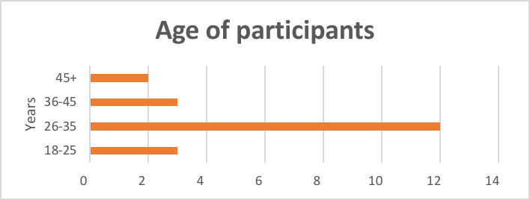
Fig. 1
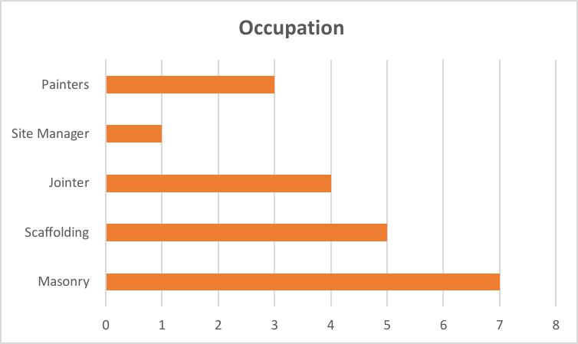
Fig. 2

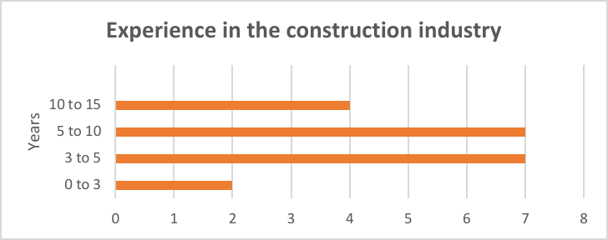
Fig. 3

The results indicated that the most significant motivational factors were money (35%) and new challenges (30%), followed by recognition (20%) and satisfaction of the results (15%) ( Figure 4 ). Participants reported that feeling motivated was important, with 55% considering it to be moderately important, 30% considering it to be very important, and 15% considering it to be extremely important ( Figure-5 ). The majority of participants reported receiving occasional feedback on their work performance (45%), while 40% received feedback often ( Figure-6)

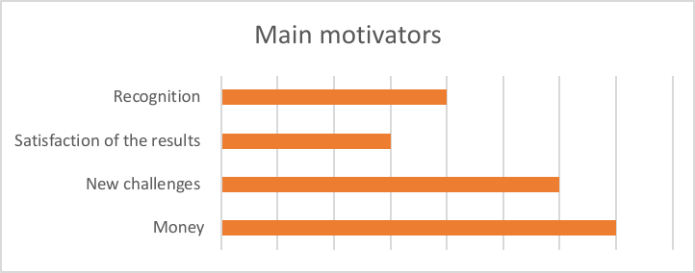
Fig. 4

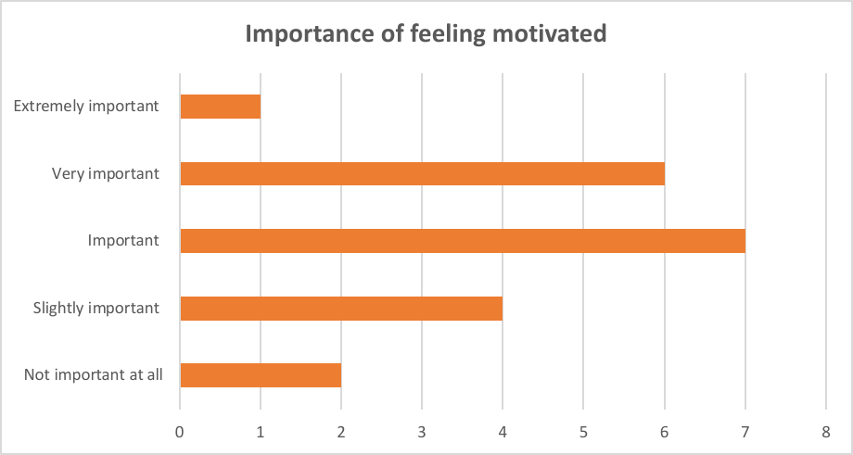
Fig. 5

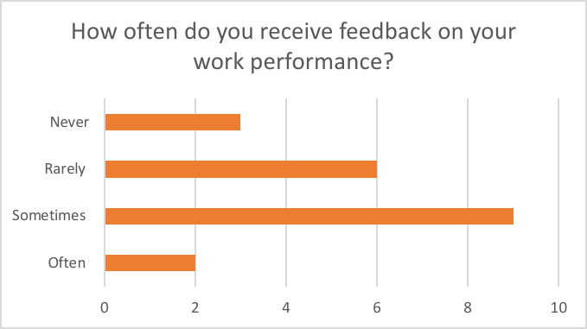
Fig. 6
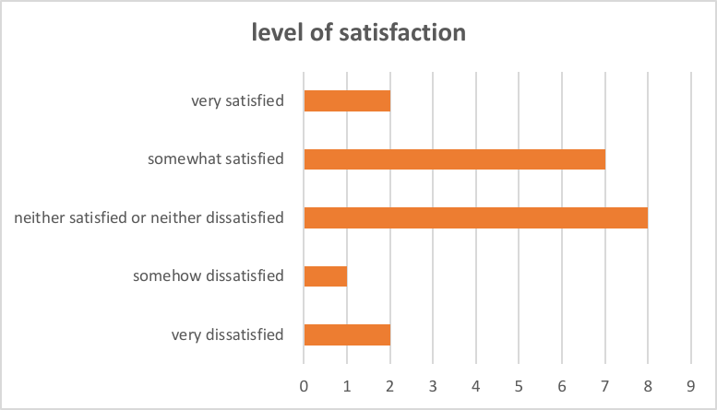
In terms of job satisfaction, the majority of participants reported being neutral (40%) or somewhat satisfied (25%) ( Figure-8 )with the level of recognition they received for their job performance. Moreover, 35% of participants reported feeling moderately important about opportunities for growth and development in their job. Lastly, the results showed that 55% of participants considered receiving recognition and appreciation to be important, with 45% of participants indicating that they receive it occasionally ( Figure-9 ).
Fig. 7

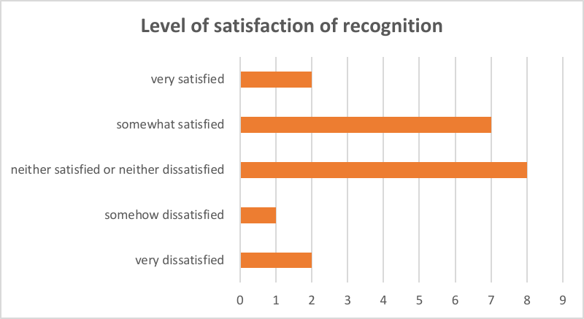
Fig. 8

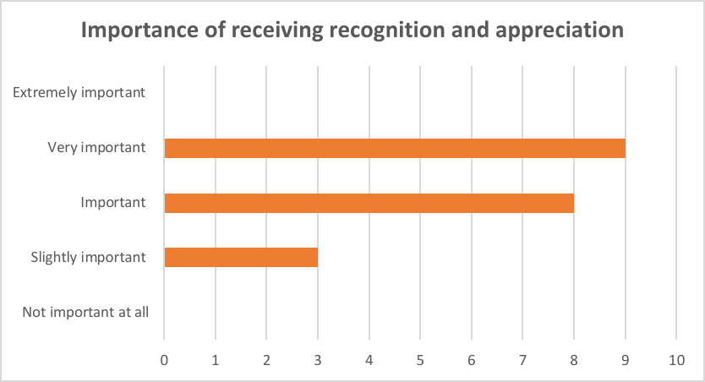
Fig. 9

Overall, the results of this study suggest that money and new challenges are significant factors that motivate workers in the construction industry. The findings also indicate the importance of feedback, recognition, and opportunities for growth and development in promoting job satisfaction. These findings can inform future research and help employers understand the factors that are most important for their employees in the construction industry.

6.3 Interpretation of the results
Based on the analysis of the data collected, several interpretations can be made regarding the construction industry and employee motivation within this sector.
Firstly, it can be inferred that the majority of respondents are aged between 26 and 35, with approximately 60% of respondents falling within this age range. This is likely due to the fact that this is the age group that is most actively engaged in the workforce. Additionally, the majority of respondents (62%) have been involved in the construction industry for between 3 and 10 years, indicating that they are relatively experienced in this field.
In terms of occupation, it is apparent that the majority of respondents are involved in manual labour jobs such as masonry, scaffolding, jointing, and painting. This is expected as these types of jobs are common within the construction industry.
Regarding employee motivation, the data indicates that respondents are primarily motivated by money and new challenges. Approximately 47% of respondents cited money as their primary motivator, while 40% were motivated by new challenges. This suggests that employees within the construction industry are driven by both financial rewards and opportunities to develop their skills and take on new tasks.
The data also indicates that recognition and appreciation are moderately important to employees within the construction industry. Respondents reported receiving occasional feedback on their performance, and only 28% felt that they received adequate recognition for their work. This could potentially lead to job dissatisfaction and a decrease in motivation if not addressed by employers.
Opportunities for growth and development were found to be important to the majority of respondents (55%), with only 27% reporting that it was not important. This suggests that employees within the construction industry are looking for opportunities to develop their skills and advance their careers.

Overall, the data indicates that employers within the construction industry should focus on providing opportunities for growth and development, as well as recognizing and appreciating their employees’ contributions. Doing so can potentially lead to increased employee motivation, job satisfaction, and ultimately better performance.

7. Discussion

7.1 Implications of the research findings
The implications of the research findings suggest that in the construction industry, monetary compensation is the primary motivator for the workers. This indicates that companies in the industry should prioritize ensuring that employees receive adequate compensation for their work. Additionally, the findings suggest that providing opportunities for growth and development is also important for the workers. Employers in the construction industry should consider implementing training and development programs that allow employees to acquire new skills and knowledge to advance their careers.
The results also indicate that workers in the construction industry value recognition and appreciation for their work. Employers should implement recognition programs to acknowledge employees for their hard work and dedication to their jobs. This can include both monetary rewards and non-monetary rewards such as certificates or public acknowledgment.
Furthermore, the findings suggest that workers in the construction industry value feedback on their work performance. Employers should implement regular performance reviews to provide constructive feedback to workers and give them the opportunity to improve their skills and knowledge.
Lastly, the results suggest that workers in the construction industry are motivated by new challenges and the satisfaction of the results. Employers should consider providing challenging and meaningful work to their employees to keep them engaged and motivated.
Overall, the research findings provide valuable insights for employers in the construction industry to enhance employee motivation, job satisfaction, and retention.

7.2 Theoretical and practical contributions of the study
The theoretical contributions of this study lie in its potential to inform and advance current knowledge on motivation and job satisfaction among workers in the construction industry. By exploring the factors that motivate workers to come to work each day, as well as their level of satisfaction with recognition and appreciation, feedback, and opportunities for growth and development, this study sheds light on the unique challenges and rewards of working in this field. Additionally, the study provides insight into the importance of a positive work environment, supportive management, and opportunities for growth and development for increasing job satisfaction and motivation.
Practically, the findings of this study could be used by construction industry leaders and managers to improve the work experience for their employees. For instance, recognizing and rewarding employee performance could be a useful tool for enhancing employee motivation and job satisfaction. Providing regular feedback on employee performance and opportunities for professional development could also help to boost employee morale and increase job satisfaction.
Overall, the findings of this study underscore the importance of recognizing and responding to the unique needs and motivators of employees in the construction industry, and of providing a supportive and engaging work environment in order to attract and retain top talent.

7.3 Limitations of the study and suggestions for future research
Despite the insightful findings of this study, some limitations must be acknowledged. Firstly, the sample size was relatively small, limiting the generalization of the findings. Additionally, the study was conducted in a specific location and the findings may not be applicable to other construction companies or countries.
Future research could expand the sample size and examine a wider range of occupations within the construction industry. A longitudinal study could also be conducted to observe the changes in employee motivation and satisfaction over time. Furthermore, future research could explore the influence of leadership styles on employee motivation in the construction industry.

8. Conclusion
In conclusion, the findings of this study highlight the importance of employee motivation and productivity for the success of construction companies. Motivation is a complex psychological state that is influenced by a range of factors, including job security, monetary benefits, and work satisfaction. The results of the survey revealed that these factors are consistently identified as important motivators across different types of professionals, genders, and age groups in the construction industry.
Sustainable HRM practices that prioritize employee development and flexible working arrangements can play a significant role in enhancing job satisfaction and job performance. Organizations in the construction industry should implement appropriate strategies to enhance employee motivation and productivity, such as providing regular salary payments and ensuring a safe working environment.
The relationship between motivation, productivity, and project success in the construction industry is complex and multifaceted. While motivation is undoubtedly an essential factor in driving employee performance, other economic factors, such as regular salary payments, are also critical for increasing productivity in the construction industry.
Therefore, to achieve project success, organizations in the construction industry must carefully balance motivational and economic factors and implement appropriate strategies to enhance employee motivation and productivity. This may include investing in sustainable HRM practices, providing regular salary payments, and ensuring a safe working environment.
Further research is needed to investigate the complex relationship between motivation, productivity, and project success in the construction industry. Future studies could explore the effectiveness of different motivational strategies in enhancing employee performance, as well as the role of economic factors in driving productivity. By building on the findings of this study, future research can provide valuable insights into how construction companies can enhance their performance and achieve greater success.

10. References

Aghayeva, K. And Ślusarczyk, B. (2019). Analytic hierarchy of motivating and demotivating factors affecting labor productivity in the construction industry: The case of Azerbaijan. Sustainability (Switzerland), 11(21). Doi:https://doi.org/10.3390/su11215975.
Ali, B.J. and Anwar, G. (2021). An Empirical Study of Employees’ Motivation and its Influence Job Satisfaction. [online] doi:https://doi.org/10.22161/ijebm.5.2.
Ana, A., Apostu, S.A., Paul, A. And Casuneanu, I. (2020). Work flexibility, job satisfaction, and job performance among romanian employeesImplications for sustainable human resource management. Sustainability (Switzerland), 12(15). Doi:https://doi.org/10.3390/su12156086.
Aung, Z.M., Santoso, D.S. and Dodanwala, Tharindu C (2023). Effects of demotivational managerial practices on job satisfaction and job performance: Empirical evidence from Myanmar’s construction industry. Journal of Engineering and Technology ManagementJETM, 67. Doi:https://doi.org/10.1016/j.jengtecman.2022.101730.
Chang, N.K., ChaNg, N.K., lee, lS and li, Y. (2018). Chang et al. Comparison of performanCe of Various multiplemodel ensemble teChniques in foreCasting intensity of tropiCal CyClone The user has requested enhancement of the downloaded file. Comparison of performanCe of Various multiplemodel ensemble teChniques in foreCasting intensity of tropiCal CyClone. [online] doi:https://doi.org/10.6057/2012tCRR03.03.
Gifford, W., Graham, I.D., Ehrhart, M.G., Davies, B.L. and Aarons, G.A. (2017). Ottawa model of implementation leadership and implementation leadership scale: Mapping concepts for developing and evaluating theorybased leadership interventions. Journal of Healthcare Leadership, 9, pp.15–23. Doi:https://doi.org/10.2147/JHL.S125558.
Huang, G. Hua, Zhao, H.H., Niu, X.Y., Ashford, S.J. and Lee, C. (2013). Reducing job insecurity and increasing performance ratings: Does impression management matter? Journal of Applied Psychology, 98(5), pp.852–862. Doi:https://doi.org/10.1037/a0033151.
Li, Y., Song, Y., Wang, J. And Li, C. (2019). Intellectual capital, knowledge sharing, and innovation performance: Evidence from the Chinese Construction Industry. Sustainability (Switzerland), 11(9). Doi:https://doi.org/10.3390/su11092713.
Nahod, M. And Knezović, M. (2017). LABOUR PRODUCTIVITY IN THE CROATIAN CONSTRUCTION INDUSTRY: IMPACT FACTORS FROM THE CLIENT’S POINT OF VIEW. Elektronički časopis građevinskog fakulteta Osijek, [online] pp.48–57. Doi:https://doi.org/10.13167/2017.14.6.
Niveen Alsayyed, Rateb Jalil Sweis, Razan Ghalion and Wassim Albalkhy (2019). The Effects of Training and Motivating Employees on Improving Performance of Construction Companies The... ResearchGate, [online] 11(2). Available at: https://www.researchgate.net/publication/333089038_The_Effects_of_Training_and_Motivating_Employees_on_Improving_Performance_of_Construction_Companies_The_Case_of_Jordan
Olabode, J., Witton, F. And Rasheed, E.O. (2021). The predictive power of managers’ leadership attributes on workers’ performance: a case of New Zealand construction industry. International Journal of Construction Management. Doi:https://doi.org/10.1080/15623599.2021.1964919.
Palikhe, S., Kim, S. And Kim, J.J. (2019). Critical Success Factors and Dynamic Modeling of Construction Labour Productivity. International Journal of Civil Engineering, 17(3), pp.427–442. Doi:https://doi.org/10.1007/s4099901802823.
Pancasila, I., Haryono, S. And Sulistyo, Beni Agus (2020). Effects of work motivation and leadership toward work satisfaction and employee performance: Evidence from Indonesia. Journal of Asian Finance, Economics and Business, 7(6), pp.387–397. Doi:https://doi.org/10.13106/jafeb.2020.vol7.no6.387.
Riyanto, S., Endri, E. And Herlisha, N. (2021). Effect of work motivation and job satisfaction on employee performance: Mediating role of employee engagement. Problems and Perspectives in Management, 19(3), pp.162–174. Doi:https://doi.org/10.21511/ppm.19(3).2021.14.
Ryan, R.M., Deci, E.L., Van, Joseph, C.A., James, D., Kampkötter, P., Petters, L.M., Sliwka, D., Ana, A., Apostu, S.A., Paul, A., Casuneanu, I., Palikhe, S., Kim, S., Kim, J.J., Wang, Y., Yao, Y., Zhang, Y., Su, B. And Wu, T. (2022). An Analysis of Employee Motivation in the Construction Industry: The Case of Hong Kong †. Engineering Proceedings, [online] 22(1), p.8522131624856338715427608507627-633-524-626-442-23-397-584-57-174-224-862. Doi:https://doi.org/10.3390/engproc2022022011.
Singgih, E., Iskandar, J., Sestri Goestjahjanti, Francisca, Fahlevi, M., Nadeak, M., Fahmi, K., Anwar, R., Asbari, M. And TinggiIlmuEkonomiInsan Pembangunan, Sekolah (n.d.). The Role of Job Satisfaction in the Relationship between Transformational Leadership, Knowledge Management, Work Environment and Performance. [online] Available at: www.solidstatetechnology.us.
Soliman, E., AlTabtabai, H., Almusalam, A. And Hussein, M. (2022). Impact of COVID19 on labor’s motivational factors and construction productivity. International Journal of Construction Management. Doi:https://doi.org/10.1080/15623599.2022.2092386.
Soliman, E. And Altabtai, H. (2021). Employee motivation in construction companies in Kuwait. International Journal of Construction Management. Doi:https://doi.org/10.1080/15623599.2021.1998303.
Sweis, R.J., Ghalion, R., ElMashaleh, M., Amayreh, I., Niveen, A. And Balkhi, A. (2019). THE EFFECTS OF TRAINING AND MOTIVATING EMPLOYEES ON IMPROVING PERFORMANCE OF CONSTRUCTION COMPANIES: THE CASE OF JORDAN. International Journal of Information, Business and Management, 11(2).
Tabassi, A.A., Ramli, M. And Bakar, A.H.A. (2012). Effects of training and motivation practices on teamwork improvement and task efficiency: The case of construction firms. International Journal of Project Management, 30(2). Doi:https://doi.org/10.1016/j.ijproman.2011.05.009.
Wang, Y., Yao, Y., Zhang, Y., Su, B. And Wu, T. (2022). Impact of industrial agglomeration on total factor productivity in the construction industry: evidence from China. Construction Management and Economics. Doi:https://doi.org/10.1080/01446193.2022.2156570.
Yuan, J., Yi, W., Miao, M. And Zhang, L. (2018). Evaluating the impacts of health, social network and capital on craft efficiency and productivity: A case study of construction workers in China. International Journal of Environmental Research and Public Health, 15(2). Doi:https://doi.org/10.3390/ijerph15020345.
Zhang, Q., Oo, B.L. and Lim, (2019). Drivers, motivations, and barriers to the implementation of corporate social responsibility practices by construction enterprises： A review. Journal of Cleaner Production, 210, pp.563–584. Doi:https://doi.org/10.1016/j.jclepro.2018.11.050

Appendix:

