

HTML & CSS Web
Development

Suzanne Davies – 1809913
Internet Technology and Security

School of Applied Computing
3rd May 2019

Contents

1. Introduction 3
2. Background Research 4
2.1 What is HTML? 4
2.2 What is CSS? 5
3. Requirements 6
4. Implementation 7
4.1 Website Design 8
5. Validation 13
5.1 HTML 13
5.2 CSS 15
6. Evaluation 16
7. Recommendations 17
Bibliography 18

1. Introduction
The World Wide Web was first introduced over 20 years ago and is ever evolving, driven by economy and innovation which is heavily relied upon from a commercial perspective [1].
The purpose of this report is to demonstrate the development and implementation of a website that has been specifically designed to attract the end user and how user experience and interaction is integral throughout the whole process, taking careful consideration of the fundamental requirements which includes HyperText Markup Language (HTML) and Cascading Style Sheets (CSS) as well as the importance of applying these standards to the overall project.
The key to making a good website should ideally include the following set of web design principles:
- Content
- Visual
- Layout
Applying these basic steps will enable the developer to engage with the target audience and more importantly keep them interested in the subject matter.

2. Background Research
HTML and CSS are the two most fundamental factors required to form a fully established web page. HTML is used to build its structure, whilst CSS is used for styling and layout purposes.
W3C is the definition of an Open Web Platform, which gives developers/ designers the ability to create a thorough product [2].
To ensure its integrity and to enable users to interact with the application with ease and on any device, W3C works in close partnership with:
- HTML and CSS
- Audio and Video
- Mobile Web
- JavaScript Web API’s
- Accessibility
- Privacy
- Graphics
- Internationalisation
- Math on the Web
According to Taylor Savage [3] a typical web application must be engineered to comply with specific standards, concepts, principles and practice advanced enough to work to its full potential across various types of equipment.
Additionally, it must always be fully operational including when offline and therefore should be sophisticated enough to send push notifications.
At the proceedings of the 19th Annual SIG Conference on Information Technology, Ryan MacMichael [4] suggested that when HTML was first introduced, standards or correct standards wasn’t factored in by designers or developers as they were more concerned about the websites layout and the way it looked.
He [4] also advised that by the late 1990’s, the number of online web pages were well into the millions due to the lack of basic housekeeping or conforming to set standards, resulting in several versions of every webpage available on a particular site and so work was undertaken to improve HTML as a whole. Although this wasn’t welcomed initially, over time developers learned to embrace this change.

2.1 What is HTML?
The language used to structure a webpage is known as HTML [5] and provides developers with the ability to:
- Share documents online with content such as headings, text, tables, lists and photos etc
- Select hypertext links to request information online
- Customise features such as forms and questionnaires to complete online transactions via remote services
- Comprise workbooks, audio, video applications and any other features directly into their documents
Mark-up tags are applied within HTML to construct the framework within a web page, which are inscribed in the form of labels within angled brackets comprising of 3 different types [6]:
- Start “<” Tag label “>”
- End “</” Tag label “>”
- Empty “<” Tag label “/>”
The above mark-up tags are followed by HTML elements which is defined as the content within a webpage. Examples of which include <h1> Header, <p> Paragraph, <img> Image.
Attributes are also applied to record supplementary material that describes the element and coded as <a>.

2.2 What is CSS?
CSS is the language used to present a webpage in a specific layout, padding, margins or theme, incorporating the use of colours and different style fonts [5].
Its versatility means that it’s adaptable to change and can be accommodated on any device despite its shape and size.
CSS is a stand-alone feature and completely separate from HTML, which makes it easier for sites to be maintained as well as duplicate styles sheets across several pages which can be tailored to suit the needs of the environment.
There are 2 significant HTML attributes designed for CSS [7]:
- Id attribute – classifies an individual component within the webpage, and convenient for the programming of CSS and JavaScript
- Class attribute – Applies class name to gather and categorise several elements to style
CSS selectors enables the designer to style and format specific elements in the HTML based on their type, id, class and attribute.

3. Requirements
The website created and incorporated within this report, is entitled ‘Paradise in Mexico – Riviera Maya.’ Its simplistic design and key features have been incorporated to entice anyone with a keen interest in experiencing the beauty that lies within Riviera Maya or Mexico in general.
There’s a wealth of information contained behind each tab of the websites home page, to help anyone planning to visit Mexico including the do’s and don’ts of what is or isn’t acceptable whilst visiting the country.
This includes:
- Safety and Security – Swimming and water sports, crocodiles
- Local Laws and Customs
- Entry Requirements – Passport validity, visa’s, travelling with children, UK emergency travel documents, departure tax
- Health
- Travel Advice
- Money
- Help and Support
- Gallery – Video’s and pictures
- History of Mexico
- Interesting facts
- Things to do
- Annual Weather
- News Updates
The website isn’t solely for the purpose of anyone planning to visit Mexico, but also for anyone that has an avid interest in the history behind it.
Designing a website in such a way that it includes as much information as possible, will keep the audience engaged and more importantly have all the relevant information that they require at the click of a button without having to search the web for it.

4. Implementation
According to Sue Jenkins [8] a logical flow of website development is required to ensure the process is fully streamlined by applying the following stages:
- Planning Phase – The developer and client need to work together to determine the overall aim or purpose of the site and decide on a theme that will attract users of the site once it’s been published for use.
- Design Phase – Specify the audience the site is intended to target, deciding on the overall layout, colour and content.
- Building Phase – Utilise HTML, CSS and JavaScript to convert the test site in the software of choice to understand its capabilities and visualise the way it will look.
- Testing Phase – Test the design both on a remote host and local server, ideally on platforms with the most popular operating systems. It’s essential to test on devices such as smartphones or tablets as well as PC’s or laptops making certain that the validation process of all codes takes place along the way, ensuring that any errors are rectified immediately. The navigation process also needs to be closely scrutinised to ensure that the user is able to access each part of the site without incurring any technical difficulties.
- Site Launch – Registration of a domain and secure hosting plan will need to take place so that the sites files can be uploaded and maintained once downloaded. The URL of the site will need to be sent to the search engines in order for a search to be completed by the user at any given time.
- Post Launch Site Maintenance – Continuous maintenance checks will need to be incorporated to ensure that the information available on the site is current and up-to-date as well as putting into practice ways in which the site can be improved.

4.1 Website Design

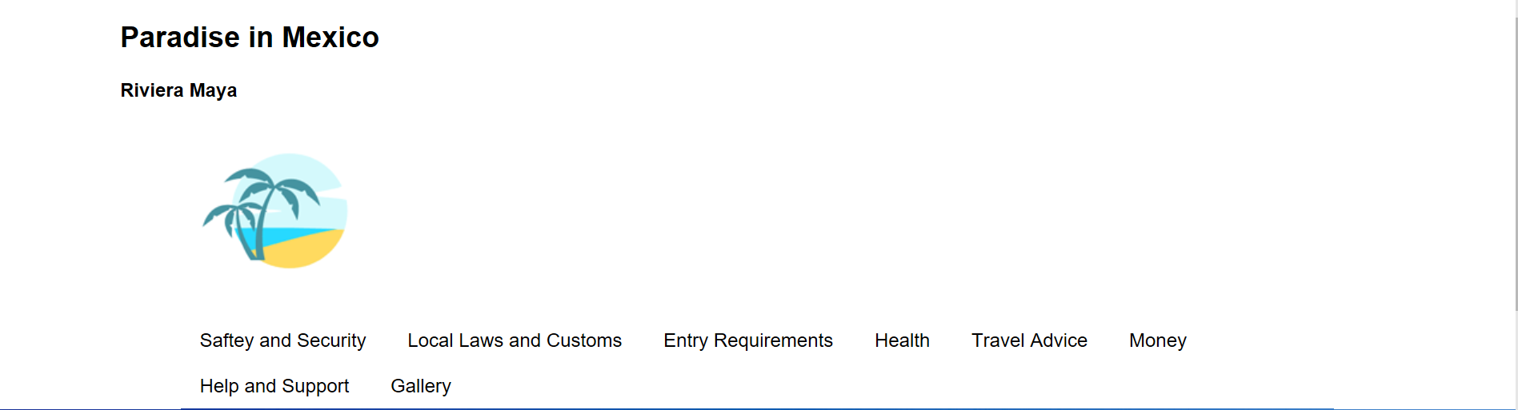
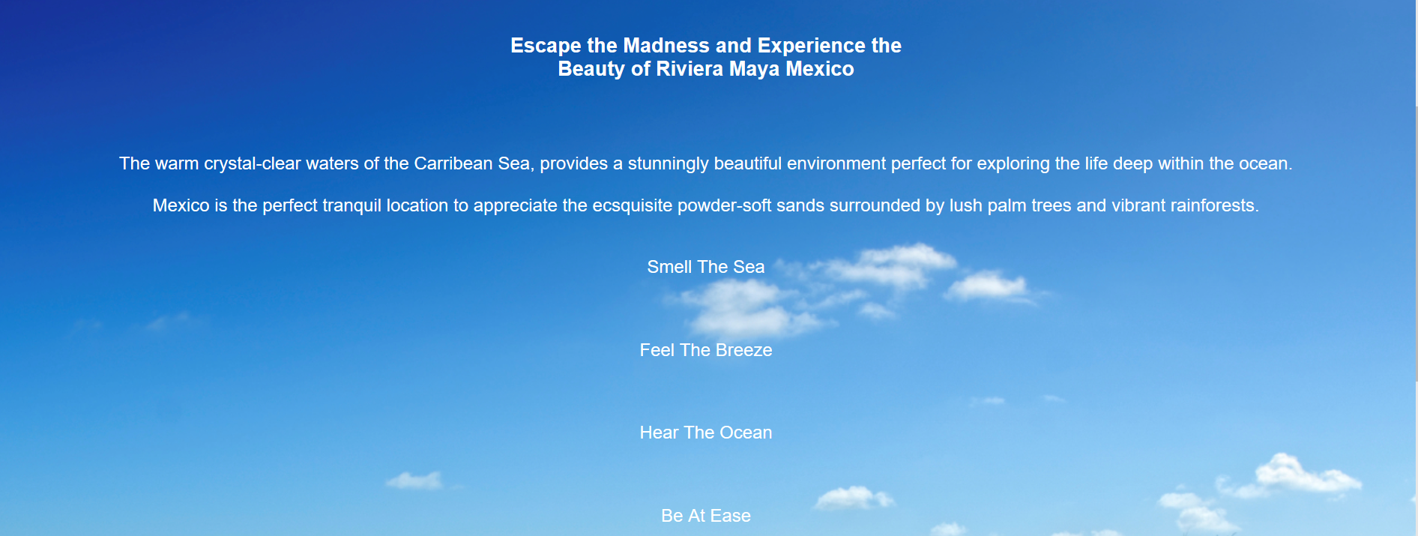

Figure 1- Website Home Page
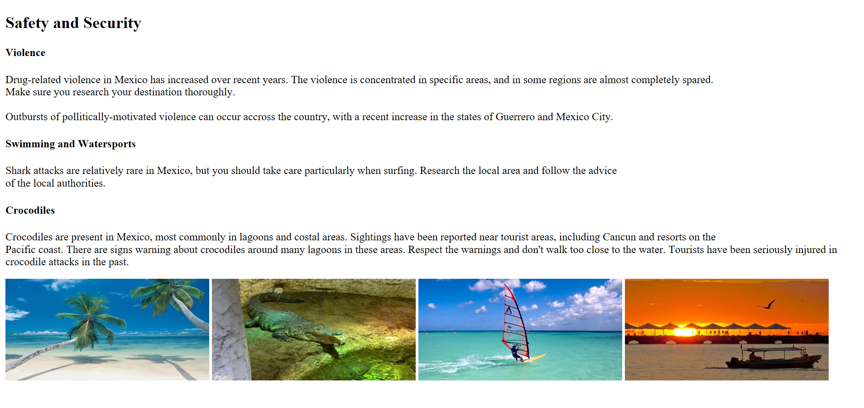
Figure 2 - [9]
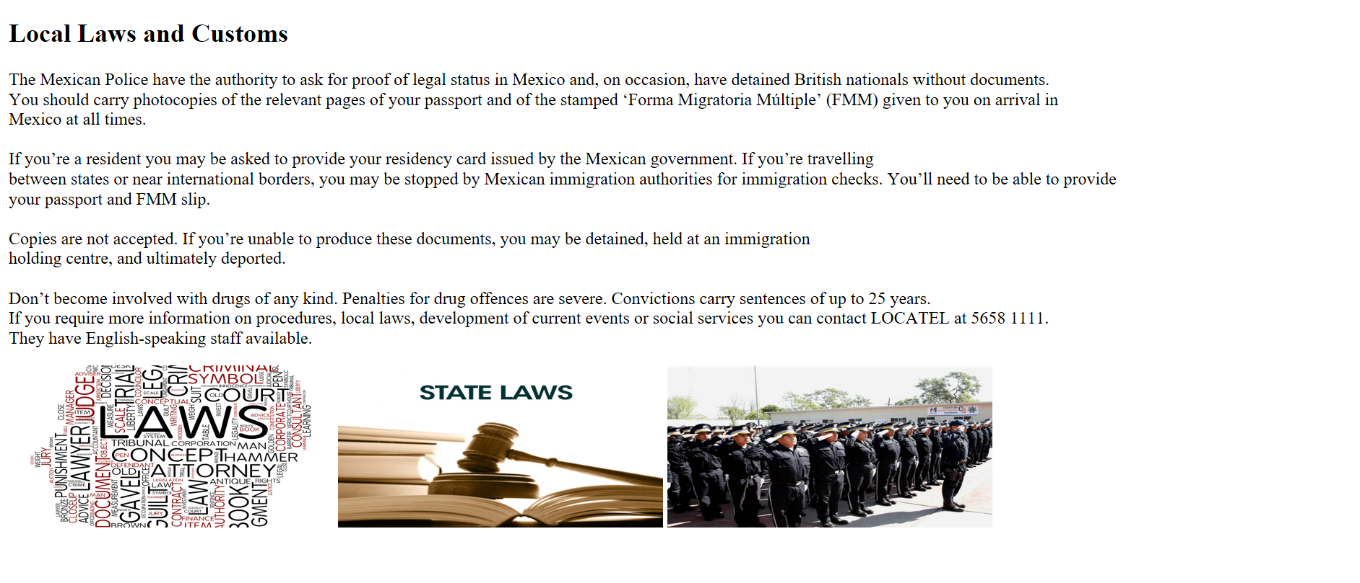
Figure 3 - [9]
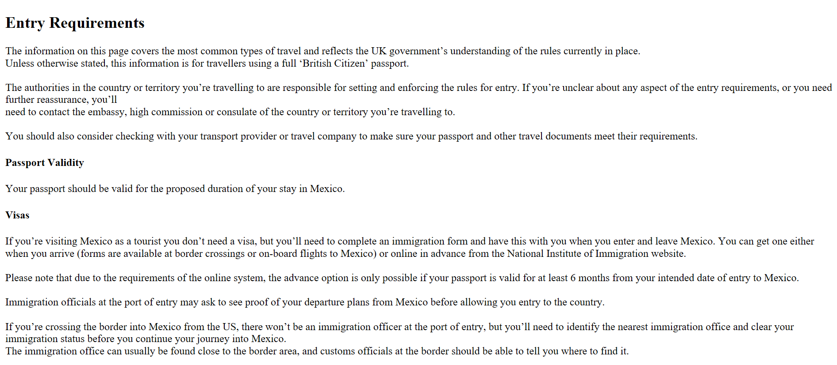

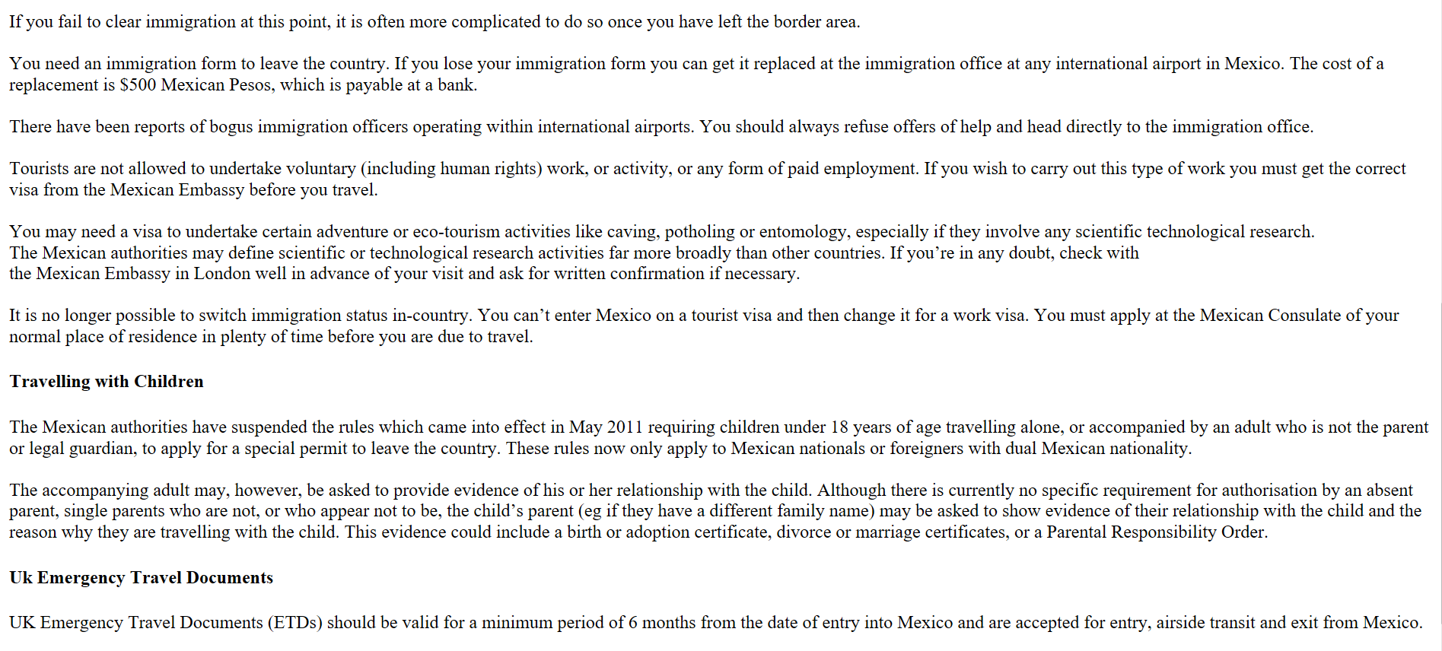
Figure 4 - [9]
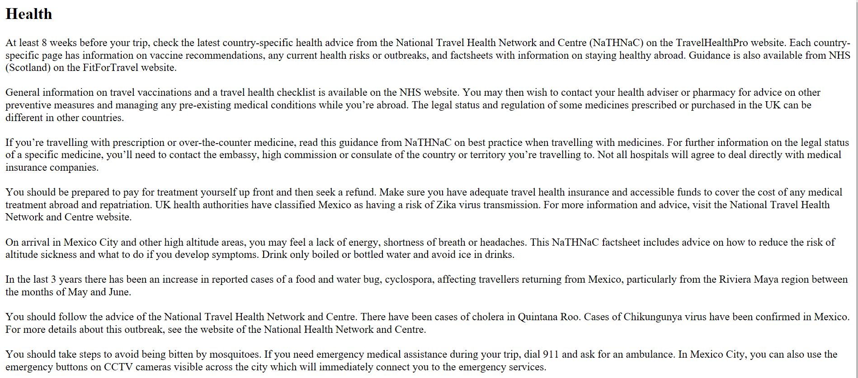
Figure 5 - [9]

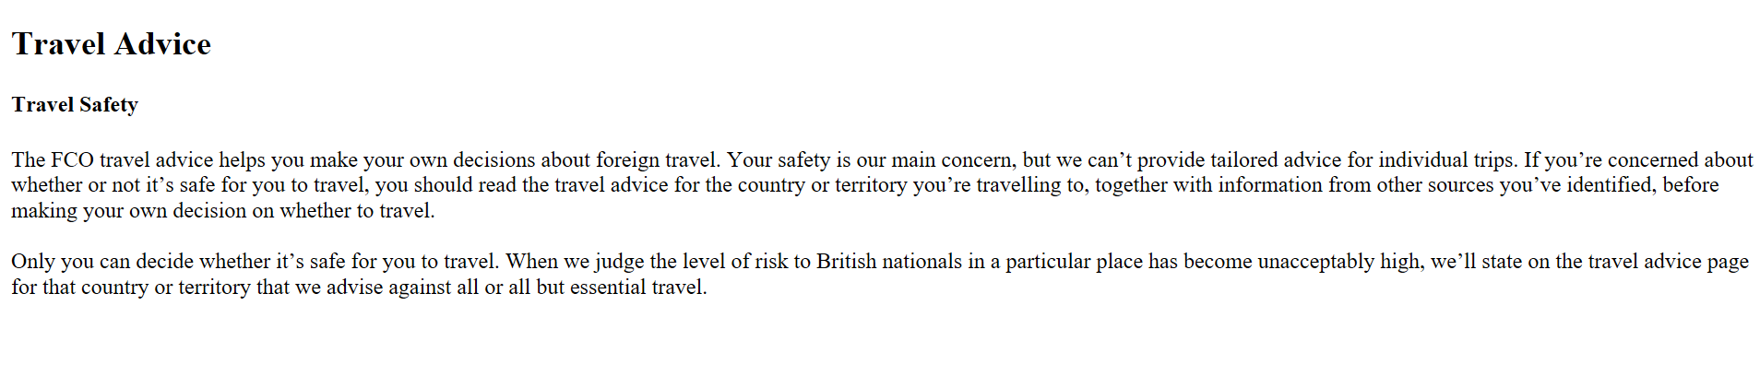

Figure 6 - [9]

Figure 7 - [9]
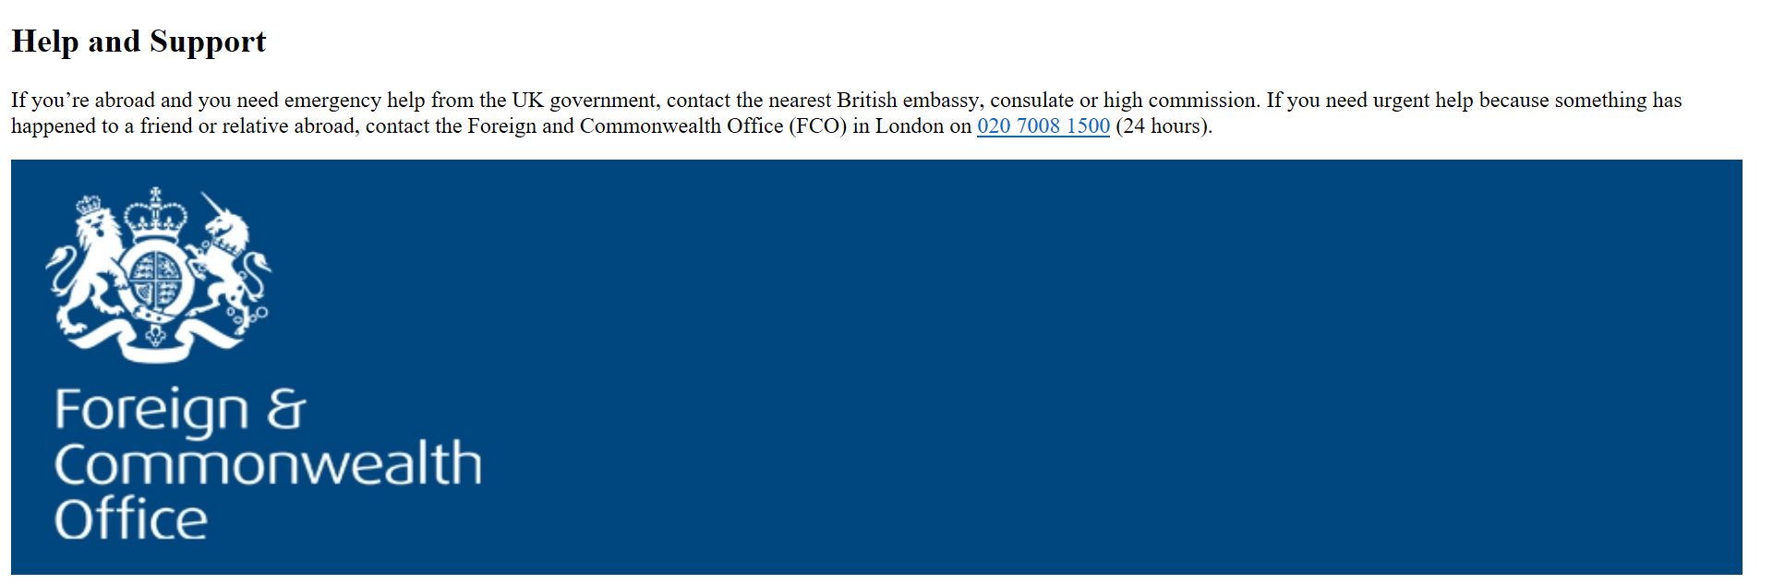
Figure 8 - [9]
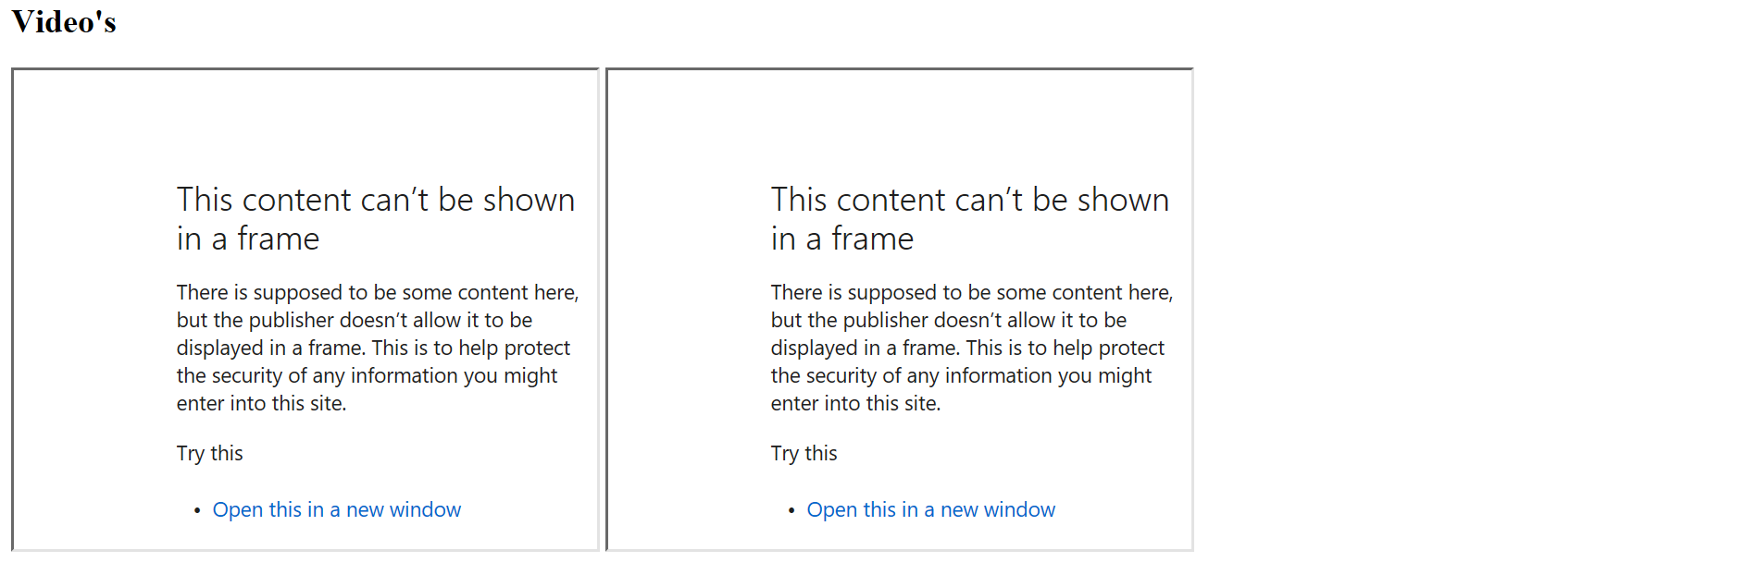
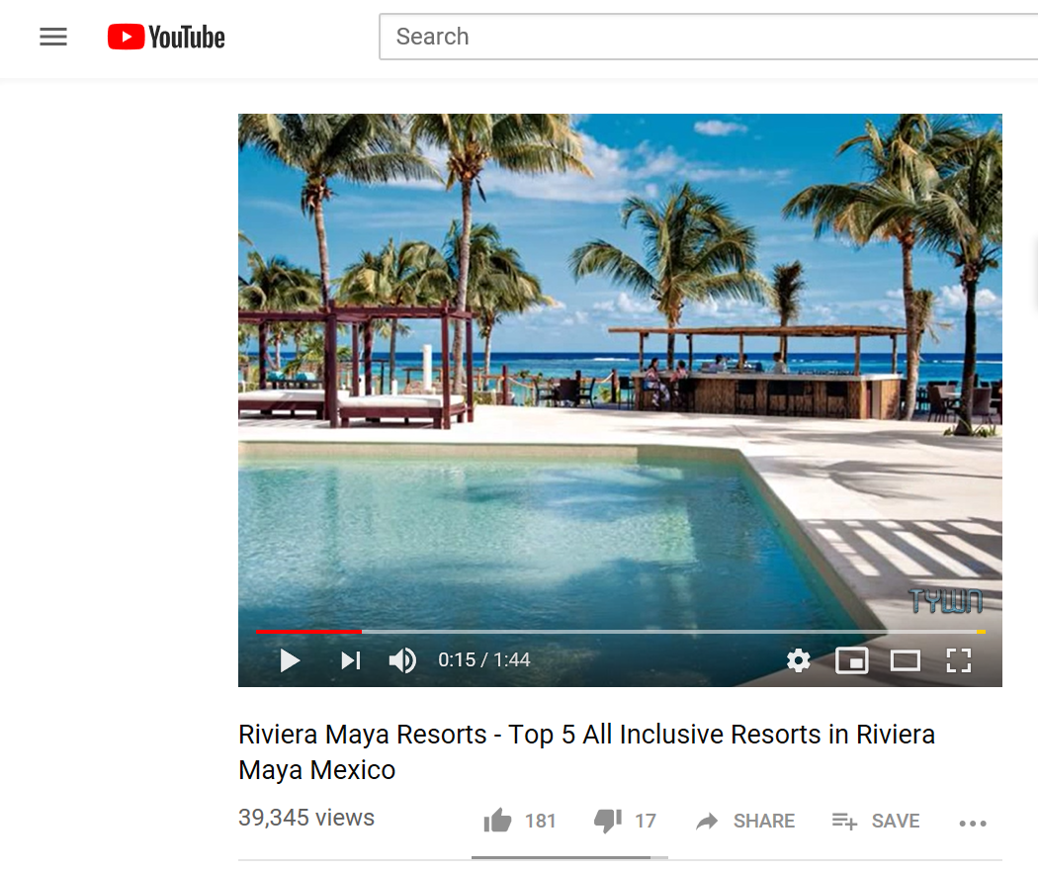
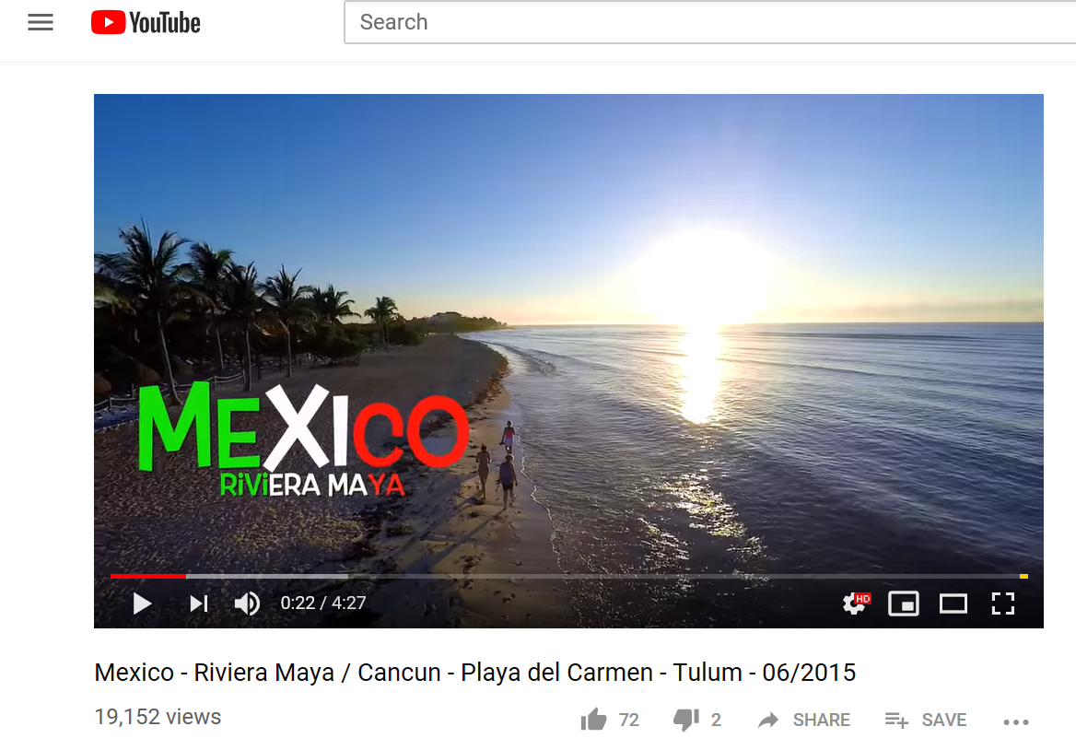

Figure 9 - [10] [11]

5. Validation

5.1 HTML
Figure 10 demonstrates the outcome of the validation process of the websites home page HTML.
Its identified common errors around breaks between the context. Its obvious that the author of the website hasn’t closed the mark-up tag/ label <br> correctly and has instead utilised the empty tag.
Whilst this hasn’t had a negative impact and has done what the author expected; this error can easily be rectified by applying </br> to end the tag.

Error: Bad value eng for attribute lang on element html: The language subtag eng is not a valid ISO language part of a language tag.
From line 1, column 16; to line 2, column 17
TYPE html>↩<html lang="eng">↩<head
- Error: An img element must have an alt attribute, except under certain conditions. For details, consult guidance on providing text alternatives for images.
From line 14, column 40; to line 14, column 68
d="logo"> <img src="Images/Logo.png" /> </a>↩
- Error: End tag br.
From line 30, column 13; to line 30, column 17
</br>↩↩
- Error: End tag br.
From line 32, column 55; to line 32, column 59
ience the </br> Beaut
- Error: End tag br.
From line 32, column 95; to line 32, column 99
exico</h1></br> </br>
- Error: End tag br.
From line 32, column 101; to line 32, column 105
/h1></br> </br>↩↩
- Error: End tag br.
From line 34, column 167; to line 34, column 171
he ocean. </br> </br>
- Error: End tag br.
From line 34, column 173; to line 34, column 177
an. </br> </br> Mexic
- Error: End tag br.
From line 34, column 320; to line 34, column 324
inforests.</br> </br>
- Error: End tag br.
From line 34, column 326; to line 34, column 330
sts.</br> </br> </br>
- Error: End tag br.
From line 34, column 332; to line 34, column 336
br> </br> </br> Smell
- Error: End tag br.
From line 34, column 352; to line 34, column 356
l The Sea </br> </br>
- Error: End tag br.
From line 34, column 358; to line 34, column 362
Sea </br> </br> </br>
- Error: End tag br.
From line 34, column 364; to line 34, column 368
br> </br> </br> </br>
- Error: End tag br.
From line 34, column 370; to line 34, column 374
br> </br> </br> Feel
- Error: End tag br.
From line 34, column 392; to line 34, column 396
he Breeze </br> </br>
- Error: End tag br.
From line 34, column 398; to line 34, column 402
eze </br> </br> </br>
- Error: End tag br.
From line 34, column 404; to line 34, column 408
br> </br> </br> </br>
- Error: End tag br.
From line 34, column 410; to line 34, column 414
br> </br> </br> Hear
- Error: End tag br.
From line 34, column 431; to line 34, column 435
The Ocean </br> </br>
- Error: End tag br.
From line 34, column 437; to line 34, column 441
ean </br> </br> </br>
- Error: End tag br.
From line 34, column 443; to line 34, column 447
br> </br> </br> </br>
- Error: End tag br.
From line 34, column 449; to line 34, column 453
br> </br> </br> Be At
- Error: Duplicate ID main-menu.
From line 47, column 21; to line 47, column 52
<ul class="menu" id="main-menu">↩
- Warning: The first occurrence of ID main-menu was here.
From line 16, column 17; to line 16, column 48
<ul class="menu" id="main-menu">↩
Figure 10 - [12]

5.2 CSS
The validation process of the websites main CSS hasn’t identified any errors.

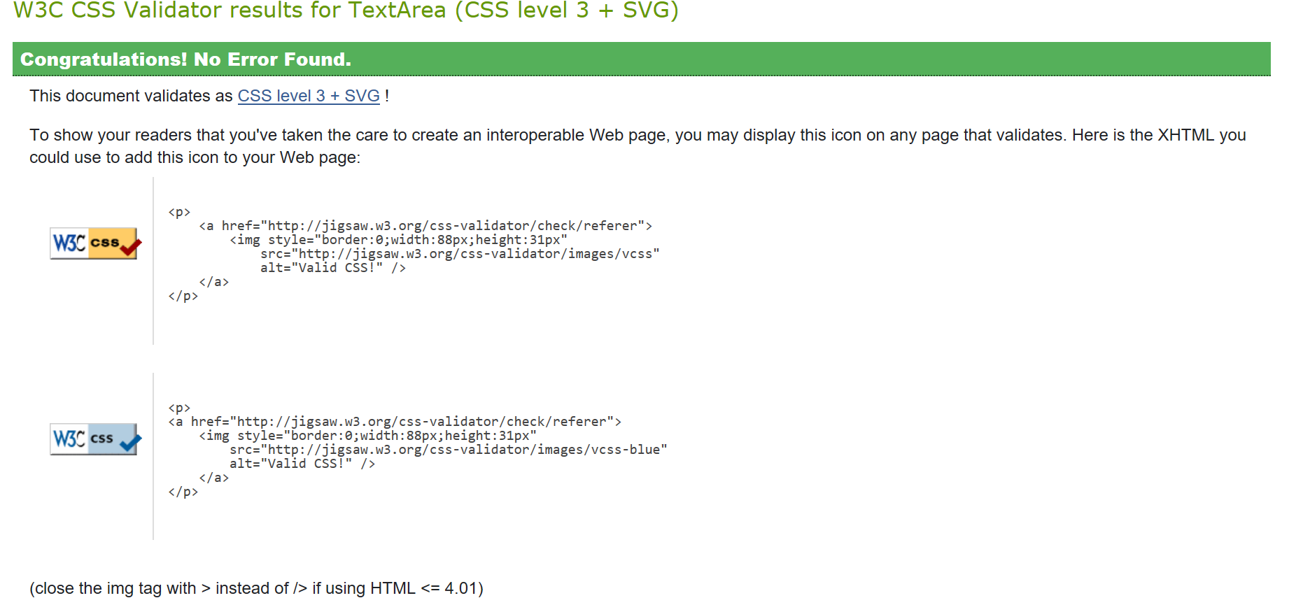
Figure 11 - [13]

6. Evaluation
According to the Web Content Accessibility Guidelines (WCAG) 2.1 [14], there are 4 main design principles that are required to meet the government accessibility specifications:
- Perceivable – operators can identify and practice the service through senses that are available to them
- Operable – users can discover and exercise the subject matter irrespective of how they elected to retrieve it e.g. keyboard of voice command
- Understandable – appreciate the content and in what way the facility works
- Robust – content can be understood consistently by extensive user handlers including dated, up-to-date and awaited browsers and assistive technologies
Whilst the author of this website has carefully designed it to attract users with the various content, videos, text and links to social media sites, users with visual impairment, hearing, mobility or cognitive impairments may experience difficulties in accessing it.

7. Recommendations
Testing is essential for any website to ensure that it meets the responsibilities of the Web Content Accessibility Guidelines 2.0 (WCAG) [15] under the Equality Act 2010 [16] and EU web Accessibility Directive [17].
As such, user testing of blind or partially sighted individuals testing a range of technology/ operating systems will help enhance its future development.

Bibliography

[1] | J. N. Robins, Learning Web Design: A Beginners Guide to HTML, CSS, JavaScript, and Web Graphics, 4th ed., S. S. Laurent, Ed., O'Reilly Media, 2012.
[2] | “Web Design and Applications - W3C,” [Online]. Available: http://www.w3.org/standards/webdesign/. [Accessed 20 February 2019].
[3] | T. Savage, “Componentizing the Web,” ACM Queue, vol. 58, no. 11, p. 55, November 2015.
[4] | R. A. MacMichael, “IT Professional Magazine,” Washington.
[5] | “HLML & CSS - W3C,” [Online]. Available: http://www.w3.org/standards/webdesign/htmlcss. [Accessed 20 February 2019].
[6] | D. K. Ademoye, Introduction to HTML.
[7] | D. K. Ademoye, Cascading Style Sheets (CSS), 2017.
[8] | S. Jenkins, Web Desigin: All-In-One for Dummies, 2nd ed., R. Senninger, Ed., John Wiley & Sons, In, 2013.
[9] | “Mexico Travel Advice - GOV.UK,” Government Digital Service, [Online]. Available: https://www.gov.uk/foreign-travel-advice/mexico. [Accessed 1st March 2019].
[10] | “YouTube,” [Online]. Available: https://youtu.be/hRfM6nCn824. [Accessed 3rd April 2019].
[11] | imAGination, “YouTube,” [Online]. Available: https://www.youtube.com/watch?v=X4N_Wx7kXSI&feature=youtu.be. [Accessed 3rd April 2019].
[12] | “NU - HTML Checker,” [Online]. Available: https://validator.w3.org/nu/#l2c17. [Accessed 28 April 2019].
[13] | “The W3C CSS Validation Service,” [Online]. Available: http://jigsaw.w3.org/css-validator/#validate_by_input. [Accessed 28 April 2019].
[14] | “WCAG 2.1 - Service Manual - GOV.UK,” 10 October 2018. [Online]. Available: https://www.gov.uk/service-manual/helping-people-to-use-your-service/understanding-wcag. [Accessed 28 April 2019].
[15] | “Web Accessibility Statement - RNIB - See Differently,” [Online]. Available: https://www.rnib.org.uk/about-rnib/web-accessibility-statement. [Accessed 21 April 2019].
[16] | “Equality Act 2010,” [Online]. Available: https://www.rnib.org.uk/about-rnib/web-accessibility-statement. [Accessed 21 April 2019].
[17] | “EU Web Accessibility Directive,” [Online]. Available: https://www.rnib.org.uk/about-rnib/web-accessibility-statement. [Accessed 21 April 2019].

