STARTERS |  |  | MAIN COURSE
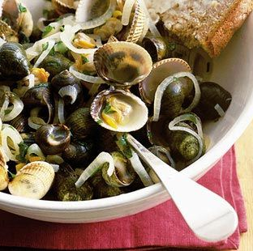  POTATO SKINS | 4.50 |  | WELSH LAMB CAWL | 8.50
PRAWN COCKTAIL | 5.50 |  | VEG/ CHICKEN STROGANOFF | 8.50/9.95
LEEK SOUP | 4.50 |  | WELSH CHICKEN LEEK PIE  WELSH BLACK BEEF STEAK | 9.95  9.95
WELSH RAREBIT  (Cheese sauce on toast) | 5.50 |  | Served with hand-cut CHIPS or RICE
COCKLES AND LAVERBREAD  GLAMORGAN SAUSAGE  Welsh vegetarian sausage with apple chutney | 4.95  4.95 |  | WELSH TRADITIONAL FAGGOT  Meatballs with mushy peas, mashed potatoes, and onion gravy. | 9.50
SIDES & SAUCES |  |  | SCAMPI | 8.75
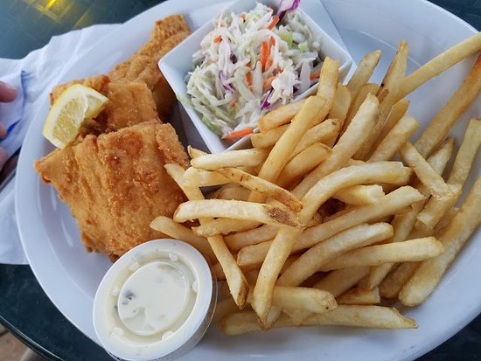  HAND-CUT CHIPS | 2.50 |  | LASAGNE AL FORNO  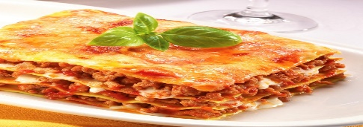  With hand-cut CHIPS or Garlic Bread | 8.95
SPICY HAND-CUT CHIPS | 2.50 |  |  | 8.95
SKINNY FRIES | 2.25 |  |  | 8.95
COLESLAW | 2.00 |  |  | 8.95
NEW POTATOES | 2.50 |  |  | 8.95
PEPPER SAUCE | 2.75 |  |  | 8.95
 |  |  | BREADED OR BATTERED HADDOCK | 9.95
SPECIAL DEAL
STICKY BBQ CHICKEN  With fresh SALAD and FRIES  Pair With  Gewürztraminer 'Les Princes Abbés' Domaines Schlumberger  (75cl, 2019) | 31.50 |  | 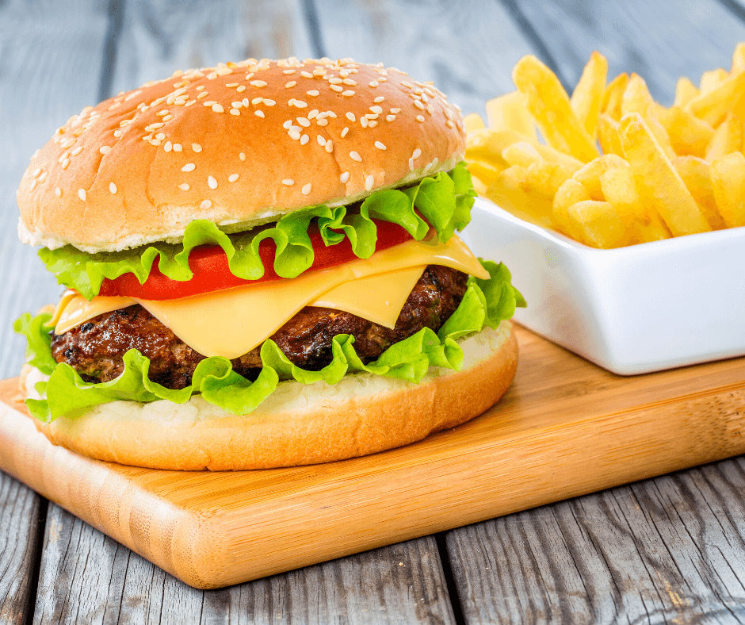  6OZ CHEESEBURGER | 7.95
HOME MADE ABERDEEN ANGUS STEAK PIE  Pair With  Bodegas Bardos Ribera del Duero Reserva (75cl, 2016) | 33.50 |  | BANG BANG CHICKEN | 9.95
 | 33.50 |  | WELSH CHICKEN LEEK PIE | 9.50
SPAGHETTI CARBONARA  Pair With  Cavazza Pinot Grigio, Delle Venezie DOC  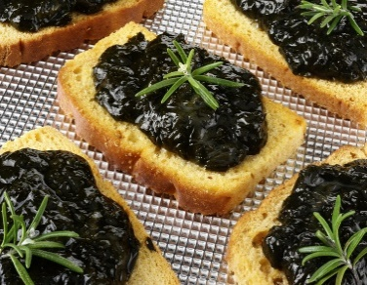  (75CL, 2020) | 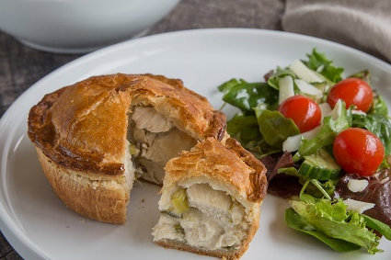  28.50 |  | MACARONI CHEESE  With Garlic Bread or FRIES | 8.50
 |  |  | PENNE ARABIATTA  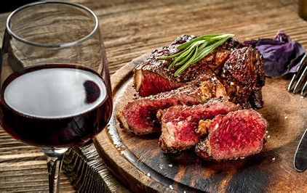  With Laverbread | 8.50
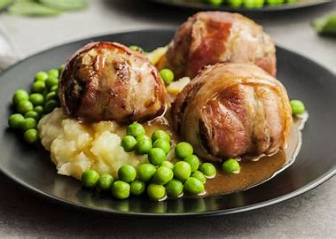

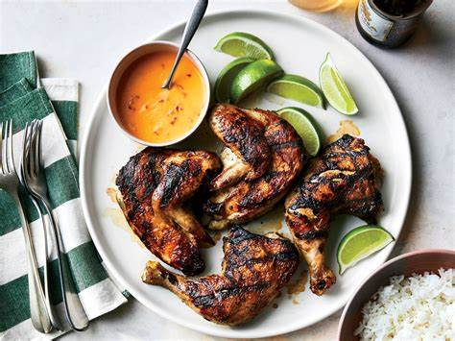
Call us to order or you can also order online
102-106 Marlin Street, Swansea, SA24 1DT Tel: 02920294920, Home Delivery Service Available, Opening Hours: Monday -Friday, 12 am-11 pm, Open on Bank Holidays.




EXCLUSIVE LUNCH AND TAKE AWAY MENU
IF YOU HAVE A FOOD ALLERGY OR A SPECIAL DIETARY REQUIREMENT, PLEASE INFORM US BEFORE YOU PLACE AN ORDER

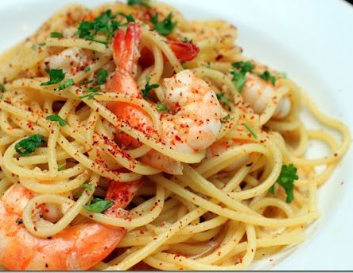
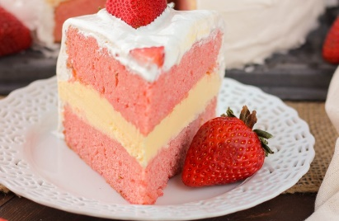
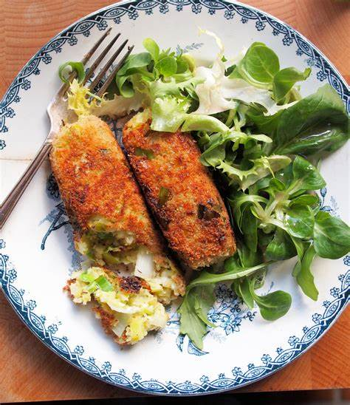
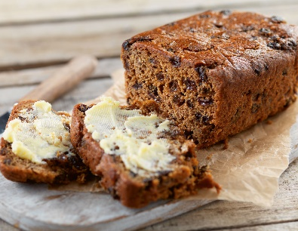
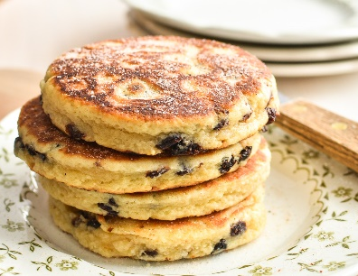

DESSERTS |  |  | KIDS TAKEAWAY
CHEESECAKE OF THE DAY | 4.25 |  | MOZZARELLA STICKS | 3.50
WELSH CAKE | 3.25 |  | KIDS MACARONI  With CHIPS and Garlic Bread | 4.25
BARA BRITH (Welsh Traditional Fruit Cake) | 4.25 |  | KIDS MACARONI  With CHIPS and Garlic Bread | 4.25
TOFFEE CRUNCH PIE | 4.25 |  | MINI CHEESE/CHICKEN BURGER | 3.95
STRAWBERRY CREAM CAKE | 3.95 |  | CHICKEN NUGGETS and CHIPS | 3.95
DRINKS
BEER/ WINE |  |  | SOFT DRINKS
CYT WINE (All 75cl Bottle)  Merlot, Cabernet, Sauvignon, Chardonnay, or Sauvignon Blanc | 13.99 |  | SPARKLING WATER (500ml) | 2.50
 | 13.99 |  | STILL WATER (500ml) | 1.50
 | 13.99 |  | COKE Original (330ml) | 1.50
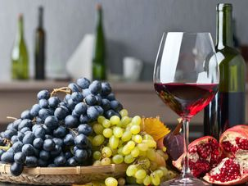  GREEN LIP SAUVIGNON BLANC | 20.50 |  | COKE Diet (330ml) | 1.50
CHOCOLATE BOX GSM | 20.50 |  | RIO Original | 1.50
GUINNESS/ HEVERLEE  2X Pints Guinness or Heverlee | 8.95 |  | FANTA Orange/Lemon/Peach  (330ml) | 1.50
TENNENTS LAGER  2X Pints | 8.30 |  | SPRITE (330ml) | 1.50
DRYGATE PILSNER  2X Pints | 8.50 |  | RED BULL ENERGY DRINK (250ml) | 2.40
HOT DRINKS
ESPRESSO/ MACCHIATO/ AMERICANO (Regular) | 2.50 |  | ENGLISH TEA (Regular) | 2.00
ESPRESSO/ MACCHIATO/ AMERICANO (Regular) | 2.50 |  | HONEY LEMON TEA (Regular) | 2.00
LATTE/ CAPPUCCINO/ FLAT WHITE (Regular) | 2.95 |  | MATCHA TEA (Regular) | 2.00
HOT CHOCOLATE/ MOCHA (Regular) | 3.20 |  | PEPPERMINT TEA (Regular) | 2.00


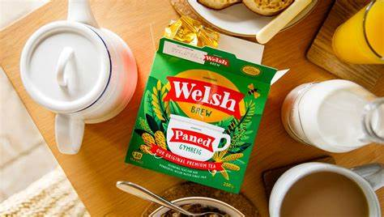


CONNECT WITH us on…..

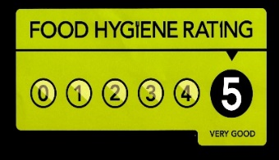
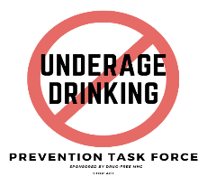

@TrinityCityHotelSwansea@ @TrinityCityHotelSwansea@ @TrinityCityHotelSwansea@

Ferdous Rahman, ( Id No-2120267),
REFERENCE LIST

Abbotsford Hotel (2020) abbotsfordhotel.com.Takeaway-Menu.pdf. Available at: https://www.abbotsfordhotel.com/wp-content/uploads/2020/10/Takeaway-Menu.pdf (Accessed: 8 June 2022)
Cavazza Pinot Grigio (2022) Cavazza Pinot Grigio 2020, Delle Venezie DOC. Majestic.co.uk. Available at: https://www.majestic.co.uk/wines/cavazza-pinot-grigio-doc-97152 (Accessed: 9 June 2022)
CHILL: Communities Helping Improve Local Lives (2021) Underage Drinking Prevention Task Force Newsletter - April 2021 | CHILL: Communities Helping Improve Local Lives. Available at: https://chillmhc.com/blog/underage-drinking-prevention-task-force-newsletter-april-2021/ (Accessed: 12 June 2022).
Food Standards Agency (2022) Food allergy and intolerance. Available at: https://www.food.gov.uk/safety-hygiene/food-allergy-and-intolerance (Accessed: 9 June 2022).
Food Standards Agency (2022) Food Hygiene Rating Scheme. Available at: https://www.food.gov.uk/safety-hygiene/food-hygiene-rating-scheme (Accessed: 8 June 2022).
GOV.UK (2022) Alcohol and young people. Available at: https://www.gov.uk/alcohol-young-people-law (Accessed: 9 June 2022).
Mercer, C. (2021) Wine with beef: A food pairing guide with expert advice - Decanter. Decanter. Available at: https://www.decanter.com/learn/food/christmas-beef-wine-pairing-tips-351001/ (Accessed: 10 June 2022).
Welsh Food & Drink (2022) Traditional Welsh Food and Drink. Welsh Food and Drink. Available at: https://www.welshfoodanddrink.wales/ (Accessed: 10 June 2022)

