Speaker notes
- Problem Solving and Decision Making (Term 3)
- BMSW4004
- Lecturer: Yajesh Kumar
- Speaker notes & Power Point
- Mohammed Arif Khan (1818579)


Slide 1: Cover Slide
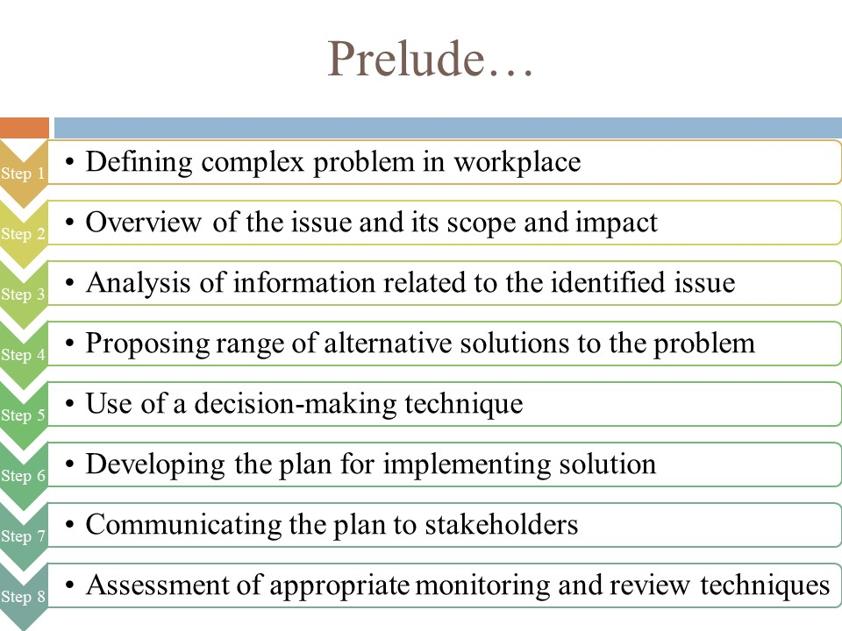
Slide 2: Prelude

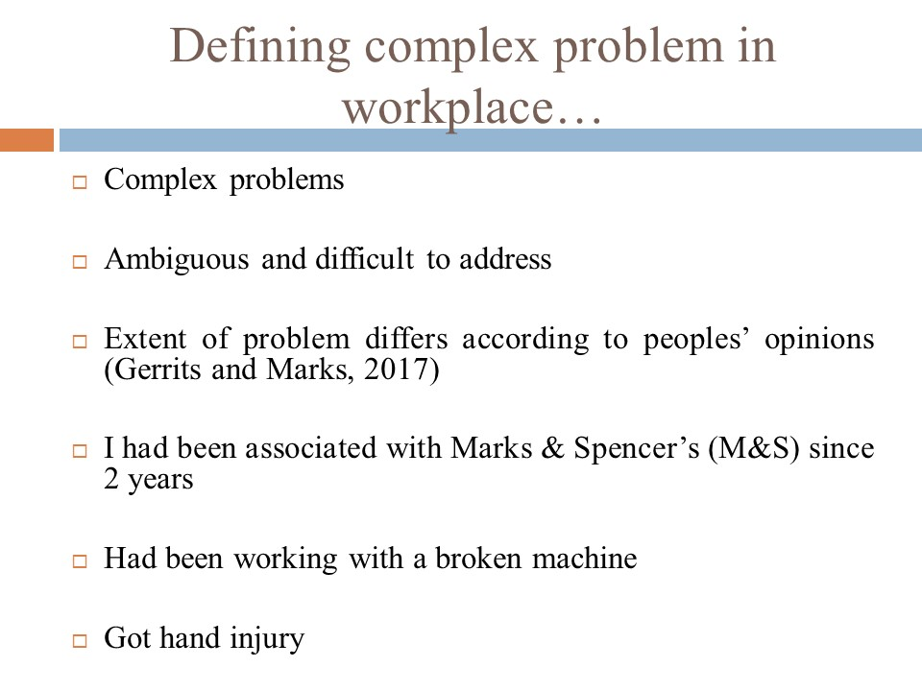
Slide 3: Defining complex problem in workplace

There are several types of problems and issues that impacts the families and the communities with whom we are directly or indirectly associated, and these issues are often multifaceted in nature. These issues have also been characterized to be ambiguous and difficult to administer and hence they are treated as complex problems. Such issues may prevail in the workplace as well wherein employees or the employers face these instances. Complex problems are often difficult to address since the opinions regarding the extent of difficulty associated with the said issues vary across people. Such differences of opinions are usually associated regarding the cause, nature and extent of the problem. The complex workplace problem that has been chosen for the effective amelioration has been discussed herewith with abrupt decision-making skills and problem-solving scenarios. I had been associated with Marks & Spencer’s (M&S) since the last two years. The workplace issue that I had been facing since quite some time is that my office authorities wanted me to work on a broken machine and having done that, I accidentally injured my hands. This is indeed a workplace problem that I have been facing since its inception and requires immediate resolution.

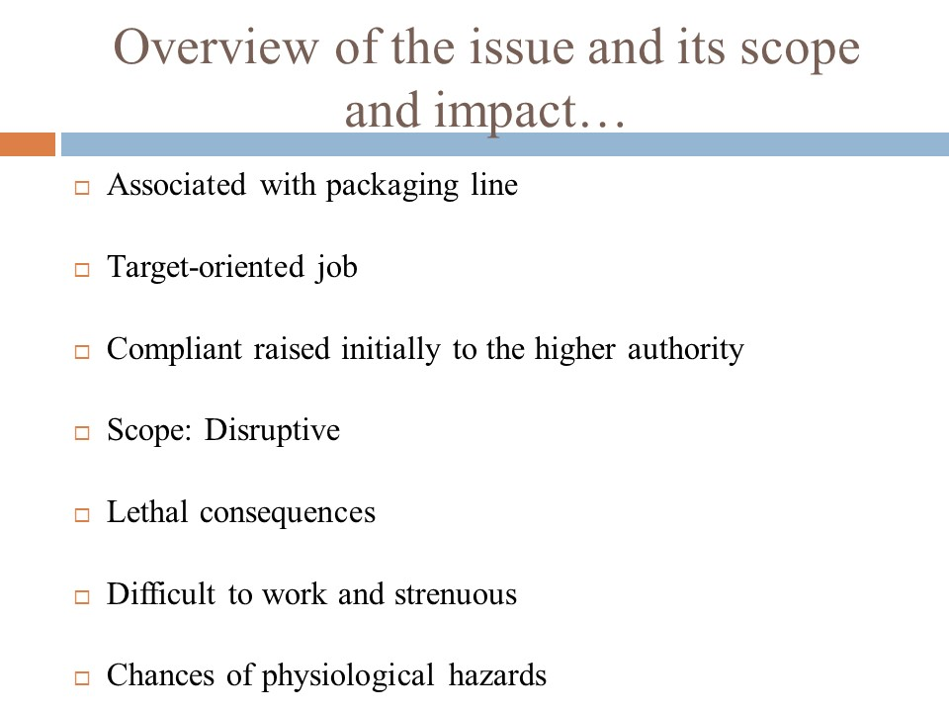
Slide 4: Overview of the issue and its scope and impact

The scope and impact of this problem which I had been facing in the M&S work floor can be ascertained with intricacy. Since M&S is a fashion brand and I need to assist other employees with the packaging facilities of the readymade products, having done that, it is very much important to have access to machines so that more number of products can be packaged in the shortest time period. The machine with which I had been associated was a faulty one and had broken down after significant time period of usage. I had to complain to the higher authorities regarding the replacement or repairing of the machine but was in vain. Since we the workers need to fulfill a target every day, hence I was pretty much preoccupied in accomplishing as much packaging as possible and while doing so ended up injuring my hand on the broken machine. The scope of using such machines is way too disruptive and the impact can be lethal at times. I had to constantly lift the machine every time it stopped working and it was difficult for me to do so and strenuous at the same time. Hence, working with such broken machine can be considered as a workplace difficult scenario which may result in physical hazards.

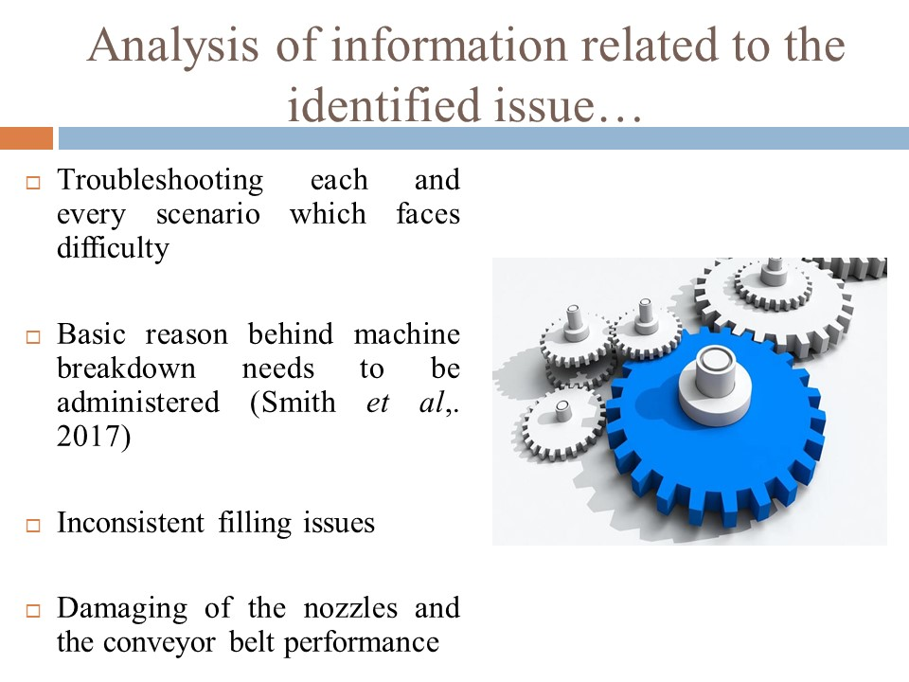
Slide 5: Analysis of information related to the identified issue

It is pretty much impossible to troubleshoot every possible scenario associated with a broken packaging machine in the production line. But on the contrary, there are indeed some of the recurring issues that have risen in the past few years and although some of these problems do not have any obvious resolution, identifying the basic reason behind the breakdown of the machines can make the resolution far easier. There can be inconsistent filling issue in the packaging machine since different filling machines use different protocols and principles. Hence inconsistent filling can be an issue and a suitable cause behind the breakdown of the machine being handles in the packaging line. Since the machine that I had been handling in the M&S production line platform had associated nozzles and with overflow fillers, the equipment might have become disrupted in this technique.

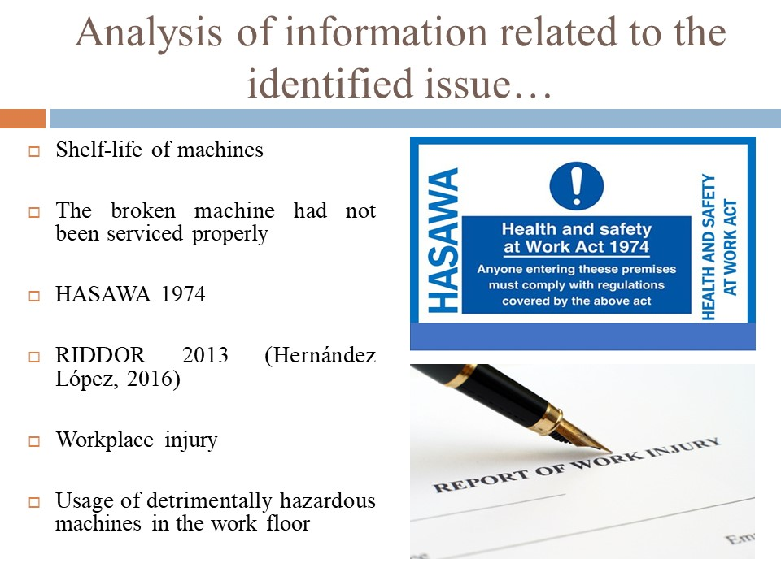
Slide 6: Further Analysis

Every machine has got its own shelf life and having said that, the machines need periodic servicing to monitor its effectiveness. I do not suppose the machine that I had been associated with was serviced properly and even if done so, it had not been monitored properly for surveillance measurements. Following the protocols of the Health and Safety at Work Act (HASAWA) 1974, each and every instrument in the work floor needs to be periodically kept under strict monitoring so that the health and safety concerns and issues of the workers can be eventually addressed without delay. Since I had been injured while working with the broken machine and I had previously risen compliant regarding this issue, I fall within the compliance of the Reporting of Injuries, Diseases and Dangerous Occurrences Regulations (RIDDOR) of 2013 wherein the company is liable to acknowledge their act of denial of my complaints in the very initial basis.

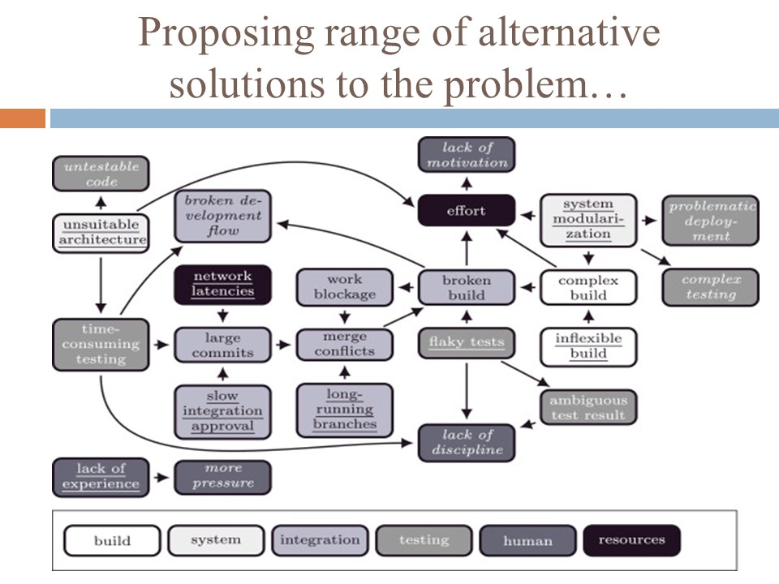
Slide 7: Proposing range of alternative solutions to the problem

There can be a range of alternative solutions which can be implemented in response to the risen concern of the broken equipment. The first and foremost troubleshooting approach that can be implemented is to call the service center from where the machine had been initially bought and request for an immediate service check. This is may deem to be suitable if the machine is repairable. On the other hand, if there is no way the machine can be repaired or even if partially repaired may become unserviceable every now and then resulting in detrimental effect, another alternative is to completely replace the broken machine with a new one. The replacement alternative can be considered as a long-term measure for solving this issue under context as it will allow professionals like us to handle instruments more intricately and without having to fall prey to any machine-based hazard in the workplace. The decision needs to be undertaken at once and until and unless any solution is being implemented, the machine needs to be kept away from the working floor in order to prevent any further accidents. It is the responsibility of the company authorities to collaborate with the service center from where the machine had been bought and consider the conduction of a risk assessment of the machine on an overall basis. This would allow both the company from where the machine hails as well as M&S to understand the probable issue with the machine and to what extent is it repairable. The entire risk assessment should be carried out in a preplanned manner followed by reporting the findings to the higher authorities and the stakeholders of M&S regarding the further decision to be taken.
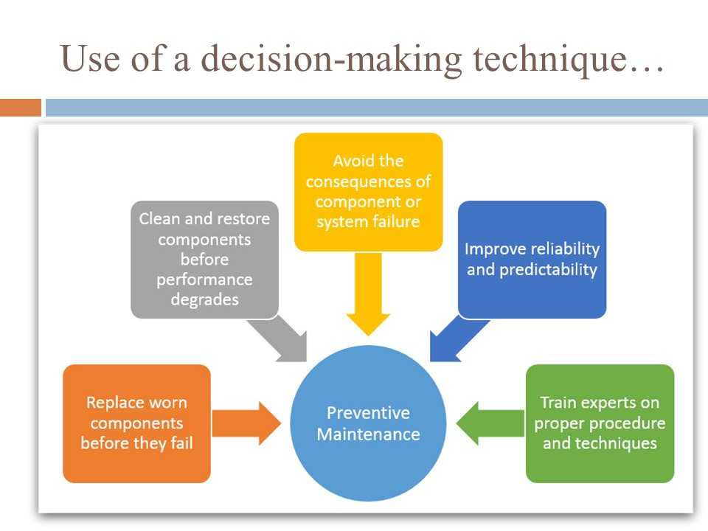
Slide 8: Use of a decision-making technique

M&S has the option of undertaking the Preventive Maintenance (PM) program which helps in addressing, anticipating and acknowledging the changes or the wear and tear issue of the machine. This can be performed on a continuous basis so that the corrective actions can be undertaken with immediate effect. This also ensures that the machine either repaired or replaced remains reliable and also performs effectively. All the PM’s need to be comprised of activities controlling and planning for maintenance of the items such as inspections, adjustments, lubricating parts as well as replacement of any non-functional components. The PM for the broken machine might also include regular testing and analysis on the performance of the machine such as the maintenance of the diesel fuel system followed by testing. The prime principle of PM in this case is to ensure the fact that machines are eventually screened before any sort of breakdown or resultant accident occurs. The successful PM practices can be undertaken in this case as well to extenuate the lifespan of the machine, provided the machine is repairable. This needs to be done for minimizing the unscheduled downtime that might emerge with unnecessary CAT breakdown of machines.

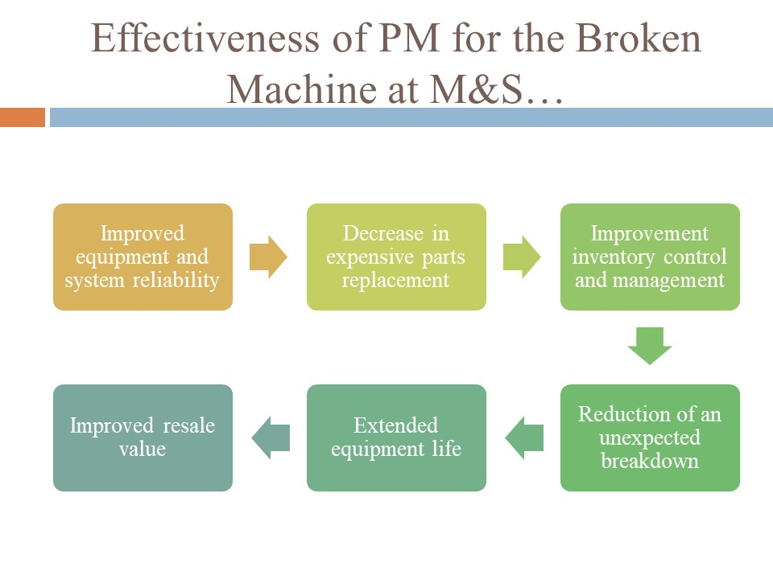
Slide 9: Effectiveness of PM for the Broken Machine at M&S
If the PM protocols are properly implemented, there shall be inclusion of certain benefits such as improvement of the machine and reliability of the system; reduction of the replacing the expensive parts of the machine; improving the inventory control and management; minimizing any unexpected breakdown, extension of the longevity of the machine; and, improving the resale value of the machine. An effective PM program has been considered as an all-inclusive approach towards machine management from the moment the machine gets purchased till the end of its useful life.

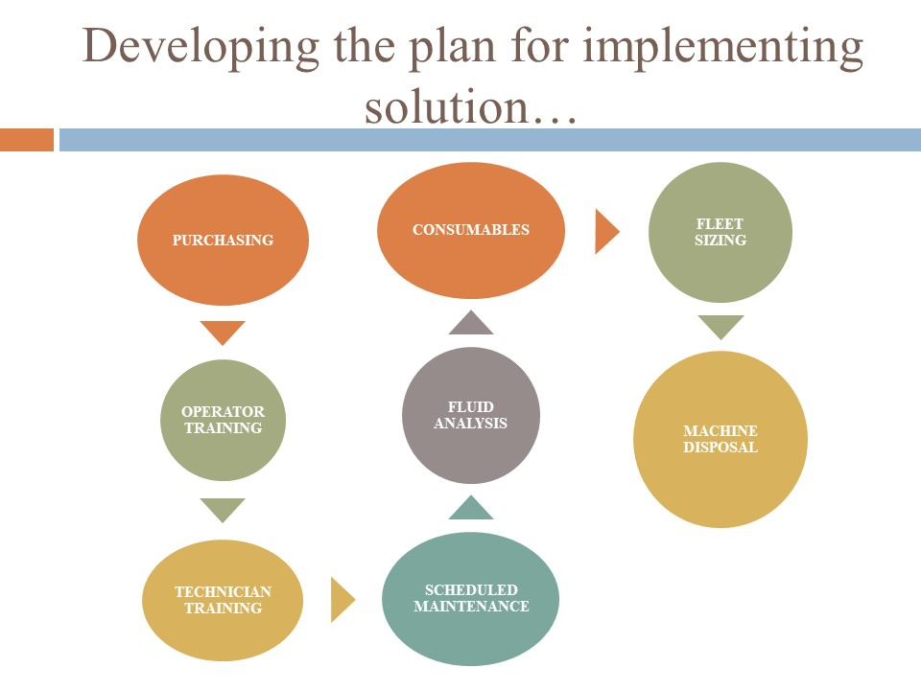
Slide 10: Developing the plan for implementing solution
The total PM package which would eventually increase the lifecycle of the machine besides minimizing the chances of further breakdown consists of certain parameters and stages. First and foremost, purchasing the right machine if replacement is the only solution is critical and crucial at the same time. This is of paramount importance and the most appropriate machine needs to be bought in the right condition whether it is new or a used one. Training the operators is another crucial stage that needs to be undertaken to implement the solutions in case the machine gets repaired or replaced. Being a worker of M&S, I had been trained to handle the machine quite effectively although it becomes way more difficult to handle these equipment’s when they are worn out. The time spent in training the staffs in handling the equipment’s provides highest return on investment in equipment purchasing. Being an operator, I know the basic eligibility required to know the machine, its abilities and its limitations and the requirement of attention which would greatly minimize the probability of future breakdown. The technicians also need to be trained and this is also considered as another stage of the implementation plan for solving the issue. It is the duty of the company to hire mechanics and train them to maintain the equipment’s thoroughly so that such incidents never happen. Troubleshooting is usually the responsibility of the technicians and the time spent to train and develop their operational expertise would eventually pay back whenever the breakdown occurs. Scheduled maintenance is another important stage which needs to be undertaken every now and then and as per my opinion; the broken machine was not maintained and serviced properly for a long time. The maintenance should be conducted on straight time and should not be on overtime. Since all these machines are electronically driven and has conveyor belts associated with them, application of fluid is necessary and having said that, fluid analysis of the machines is also necessary. The fluids of the machine provide numerous information about its condition. If the broken machine is repaired, then a chemical fluid analysis needs to be contracted towards third-party expert analyzers. Finally, if the machine needs to be replaced altogether, disposing off the broken machine should be carried out which is also considered as s apart of the PM program. The disposal should be done in such a way that the environment does not get affected or the disposed parts do not hamper the biotic life of the surrounding.

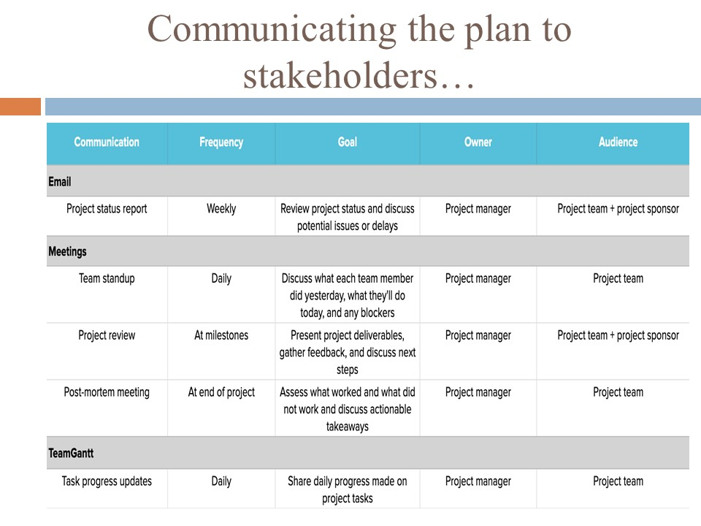
Slide 11: Communicating the plan to stakeholders

The plan needs to be communicated to the stakeholders of the M&S and depending on their decision, the plan or the resolution will be implemented. On this perspective, a risk assessment matrix needs to be undertaken which would eventually reflect the hazardous nature of the broken machine and further accidents that might arise if it does not get repaired or replaced at once. The risk assessment matrix shows that the likelihood of risk is very much probable which can be showcased from my incident and impact is unacceptable.

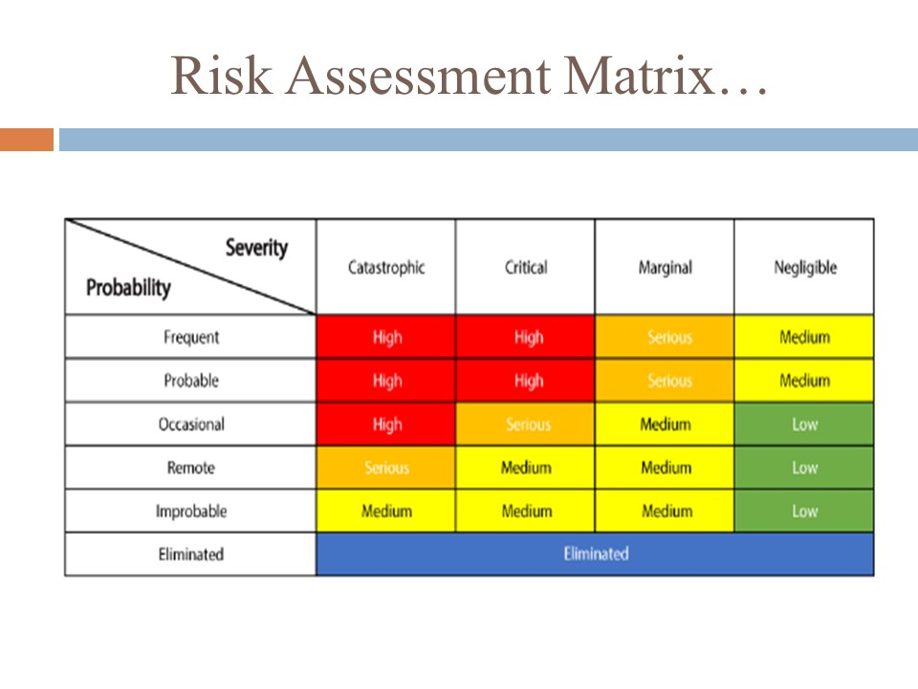
Slide 12: Risk Assessment Matrix
For generally excellent explanation, risk matrices have been broadly advanced in every workplace environment and academic settings, and even though they have been met with various forms of criticism, they've been broadly received by numerous associations. In the correct hands, they are a useful and simple to utilise device, which can help most associations manage their potential risks. However, they are not without defects be that as it may and are unquestionably not a response for all ills. In the hands of the unpractised, the one-sided or people with a motivation, they can obviously create misdirecting evaluations. Risk matrices usually contain limitations, for example they can effectively and unambiguously look at just a little division of arbitrarily chose sets of dangers and can dole out indistinguishable evaluations to quantitatively various dangers.

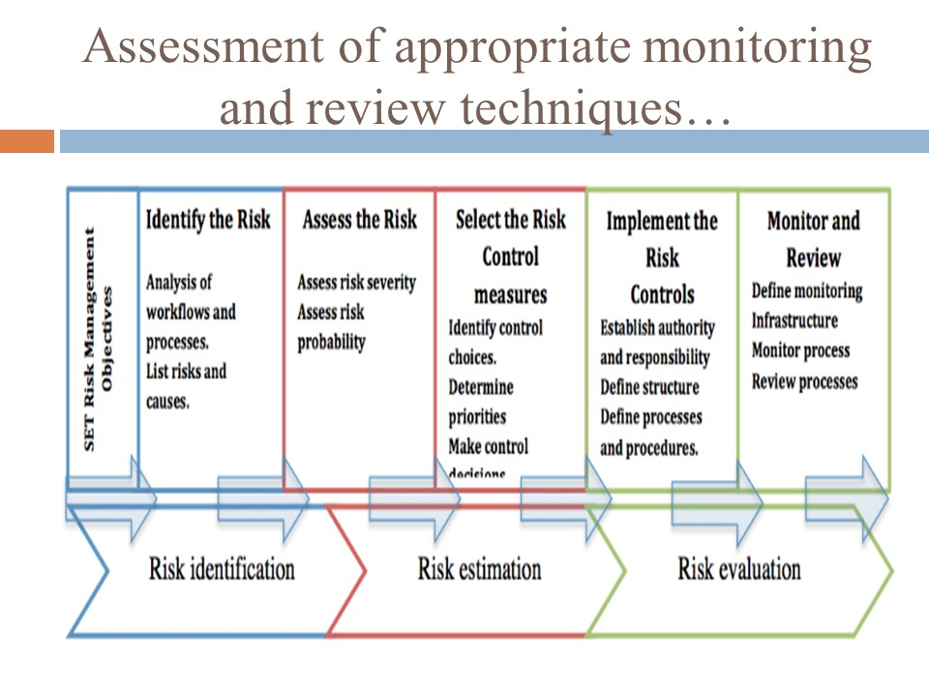
Slide 13: Assessment of appropriate monitoring and review techniques

Repairing or replacing the broken machine does not guarantee the termination of events. The repaired or the replaced machine needs to be monitored, reviewed and scrutinized every now and then followed by servicing every 2-3 months at least for the initial time period so that the effectiveness and the operational capability of the repaired or replaced machine can be guaranteed. The report needs to be sent to the higher authorities and since this is a time-consuming process and is also associated with heavy expenditure, the report should be attached with prominent monitoring and servicing evidences. The conveyor belt of the machine needs to be kept under quality check besides the fluid analysis so that further hazardous incidents can be restricted.

Conclusion
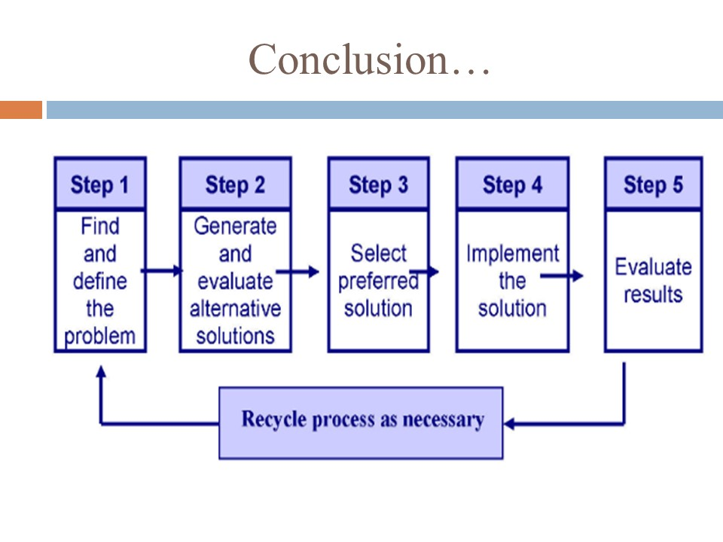

References
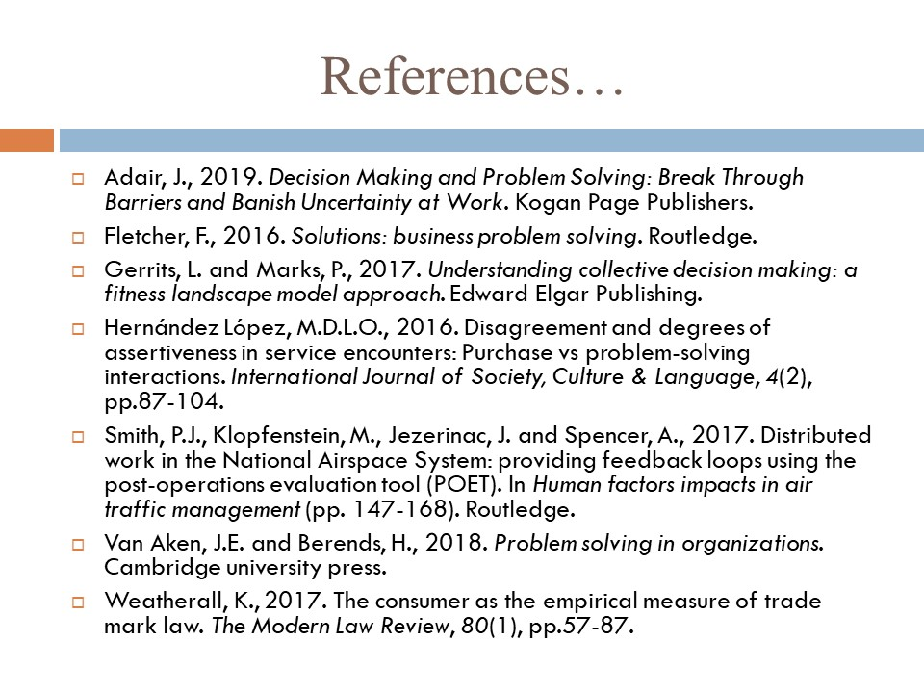
Reference List
Adair, J., 2019. Decision Making and Problem Solving: Break Through Barriers and Banish Uncertainty at Work. Kogan Page Publishers.
Fletcher, F., 2016. Solutions: business problem solving. Routledge.
Gerrits, L. and Marks, P., 2017. Understanding collective decision making: a fitness landscape model approach. Edward Elgar Publishing.
Hernández López, M.D.L.O., 2016. Disagreement and degrees of assertiveness in service encounters: Purchase vs problem-solving interactions. International Journal of Society, Culture & Language, 4(2), pp.87-104.
Smith, P.J., Klopfenstein, M., Jezerinac, J. and Spencer, A., 2017. Distributed work in the National Airspace System: providing feedback loops using the post-operations evaluation tool (POET). In Human factors impacts in air traffic management (pp. 147-168). Routledge.
Van Aken, J.E. and Berends, H., 2018. Problem solving in organizations. Cambridge university press.
Weatherall, K., 2017. The consumer as the empirical measure of trade mark law. The Modern Law Review, 80(1), pp.57-87.

