


RUBBER PROPERTIES
MATERIALS AND INTRODUCTION TO PROCESSING (2022)
Revision 1
Dylan Payne
Renishaw QUALITY CONTROL TECHNICIAN

Chris Wyatt
LECTURER
Contents

Introduction 2
Theory of Elastomer Behaviour 2
Experimental Method 3
Process 3
Results 4
Length of Band Under Tension for Rubber 4
Method 5
Analysis of Results 6
Engineering Stress Strain Curve for Rubber 6
True Stress Strain Curve for Rubber 7
Analysis of experimental inaccuracy and cost/quality trade-off 8
Discussion 9
Conclusion 9
Acknowledgement 10
Bibliography 10
Table of Tables 10
Table of Figures 10
Table of Equations 10

Introduction

I have been tasked to design an experiment to find the stress strain curve for a rubber material which is used in the manufacturing of rubber bands.
This experiment should be conducted using materials at hand, with minimal expenditure.

Theory of Elastomer Behaviour

High elasticity is one of elastomers distinctive characteristics. This generally refers to an elastomers ability to return to its initial state after being stretched, compressed, or deformed in any other way, with no discernible time delay once the deforming force has been removed.
When elastomers are compared with metals such as steel, the primary properties of elastomers become apparent. In fact, elastomers have a very high resilience that is 400 times greater than that of steel.
Steel is made up of metallic atoms latched together in a lattice structure, whereas rubber is made up of long threadlike molecules which, when in a state of rest, consist of a coil-type shape and are not orientated in a straight line. These disorganized coils detangle when an external force is applied, and the chains then orient and align into a more ordered configuration. The molecules instantly revert to the coil-type configuration after the force is removed.
The molecules' end-to-end distance may then rise by several hundred percent. This explains why elastomers have such remarkable resilience. (Ringfeder, 2016)
The high elasticity of rubber and its high resilience will be crucial to consider when concluding the results of this experiment. From this, we can theorise that as the strain is increased through the increasing load, the stress will also increase, as well as that the rubber band will reach its yield point and start to fracture as it can no longer stretch.

Experimental Method

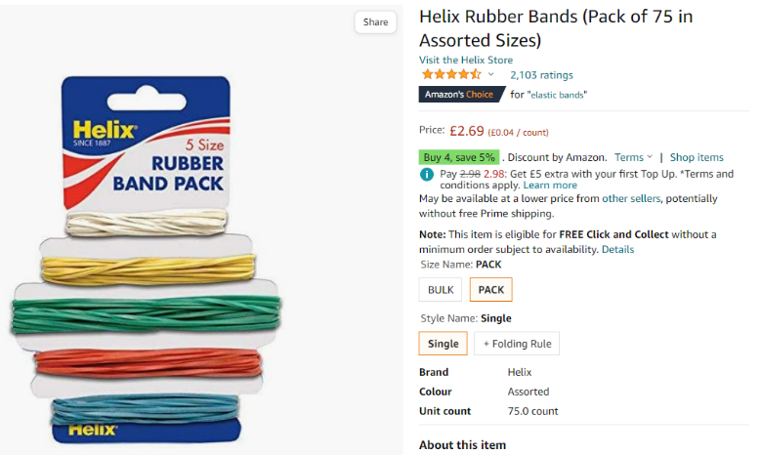
I started my experiment by ordering rubber bands. For this I ordered a pack of Helix Rubber Bands on Amazon. The total price for these bands was £2.69.
Figure 1 – Helix Rubber Bands
Next was to determine how to stretch the rubber bands using a known force. I decided to use a mix of pasta and rice as I live in a fairly large household where these are used frequently.
For this I used zip-lock bags that I aquired from the stockroom in work and I measured 250g into each bag using a standard kitchen scale.

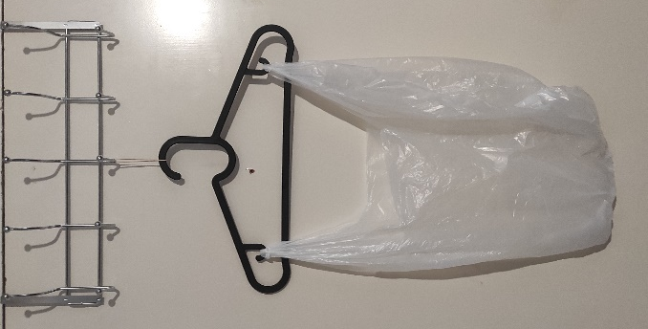
The final decision was to locate the best location to carry out the experiment. I decided to use the coat hooks on the back of my bedroom door, a coat hanger and a carrier bag to hold the individual bags of pasta/rice.
This can be demonstrated in Figure 2.

Process
Figure 2 – Initial Experiment Setup

I began the experiment using a coat hanger and a carrier bag, then added 250g bags into the carrier bag.
Figure 3 – Rubber Band Under Load
I then measured the length of the rubber band using a tape measure and recorded this in a table of data.
I repeated this until the rubber band snapped under the force of the bearing load.
Due to the weight that the rubber band was subjected to, the initial carrier bag used was damaged, so a tougher carrier bag was used in its place.
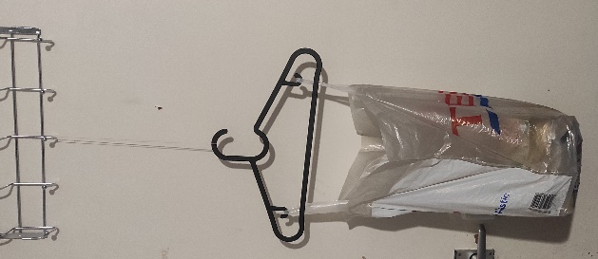
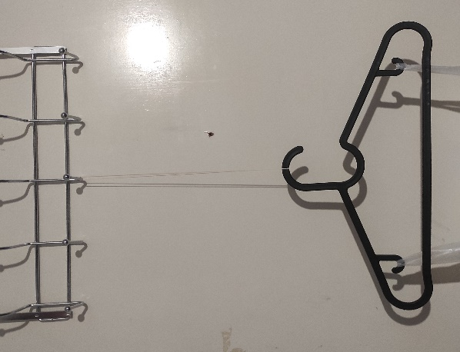
Figures 3 and 4 show the rubber band under load.
Figure 4 – Close-up of Figure 3

Results

Force (gf) | Force (N) | Length (mm) | Engineering Strain | True Strain | Cross Sectional Area | Engineering Stress N/mm² | True Stress  N/mm²
0 | 0 | 52 | 0 | 0 | 3.6 | 0 | 0
250 | 2.4525 | 165 | 2.173076923 | 1.1547018 | 1.134545455 | 0.68125 | 2.16165865
500 | 4.905 | 211 | 3.057692308 | 1.4006144 | 0.887203791 | 1.3625 | 5.52860577
750 | 7.3575 | 232 | 3.461538462 | 1.4954937 | 0.806896552 | 2.04375 | 9.11826923
1000 | 9.81 | 253 | 3.865384615 | 1.5821458 | 0.739920949 | 2.725 | 13.2581731
1250 | 12.2625 | 261 | 4.019230769 | 1.6132767 | 0.717241379 | 3.40625 | 17.0967548
1500 | 14.715 | 279 | 4.365384615 | 1.6799681 | 0.670967742 | 4.0875 | 21.9310096
1750 | 17.1675 | 290 | 4.576923077 | 1.7186372 | 0.645517241 | 4.76875 | 26.5949519
2000 | 19.62 | 299 | 4.75 | 1.7491999 | 0.626086957 | 5.45 | 31.3375
2250 | 22.0725 | 308 | 4.923076923 | 1.7788561 | 0.607792208 | 6.13125 | 36.3158654
2500 | 24.525 | 315 | 5.057692308 | 1.8013289 | 0.594285714 | 6.8125 | 41.2680288
2750 | 26.9775 | 322 | 5.192307692 | 1.8233078 | 0.58136646 | 7.49375 | 46.4036058
3000 | 29.43 | 329 | 5.326923077 | 1.844814 | 0.56899696 | 8.175 | 51.7225962
3250 | 31.8825 | 335 | 5.442307692 | 1.8628868 | 0.55880597 | 8.85625 | 57.0546875
3500 | 34.335 | 341 | 5.557692308 | 1.8806388 | 0.548973607 | 9.5375 | 62.5439904
3750 | 36.7875 | 347 | 5.673076923 | 1.8980811 | 0.539481268 | 10.21875 | 68.1905048
4000 | 39.24 | 349 | 5.711538462 | 1.9038282 | 0.536389685 | 10.9 | 73.1557692
4250 | 41.6925 | 352 | 5.769230769 | 1.9123875 | 0.531818182 | 11.58125 | 78.3961538
4500 | 44.145 | Snap |  |  |  | 12.2625
4750 | 46.5975 |  |  |  |  | 12.94375
Table 1 – Experiment Data

Length of Band Under Tension for Rubber

Figure 5 – Length of Band Under Tension for Rubber

Figure 5 shows the correlation between the length of the rubber band and the amount of force that is being applied. As Depicted, there is a clear trendline that shows as the tension on the rubber band increases, so does the length of the rubber band.

Method

Table 2 shows the data taken when carrying out the experiment. I began by recording the length of the rubber band (column 3) against the force added (column 1) throughout my experiment.
I then used the formula in equation 1 to convert the force to Newtons by multiplying the mass by the acceleration due to gravity, 9.81 m/s², and then dividing by 1000.

$$Force \left(N\right)=\frac{Mass \left(Kg\right) x acceleration due to gravity (9.81m/s²)}{1000}$$
Equation 1 – Force
To calculate the Engineering Strain, I used the formula in equation 2 where I divided the change in length by the original length.

$$Engineering Strain= \frac{∆Length (mm)}{Original Length (mm)}$$
Equation 2 – Engineering Strain
To calculate the True Strain, I used the formula in equation 3 where I calculated the natural log of the stretched length over the original length.

$$True Strain=Log\frac{Stretched Length (mm)}{Original Length (mm)}$$
Equation 3 – True Strain
Next, I used a digital caliper to carefully measure the width and thickness of the rubber band to calculate the cross-sectional area. I then used the formula in equation 4 to calculate the cross-sectional area at each recorded stretched interval.

$$Cross-Sectional Area= \frac{Original Cross-Sectional Area (mm^{2}) x Original Length (mm)}{Stretched Length (mm)}$$
Equation 4 – Cross-Sectional Area
To calculate the Engineering Stress, I used the formula in equation 5 where I divided the force by the original cross-sectional area.

$$Engineering Stress=\frac{Force (N)}{Original Cross-Sectional Area (mm^{2})}$$
Equation 5 – Engineering Stress
To calculate the True Stress, I used the formula in equation 6 where I divided the force by the actual cross-sectional area.

$$True Stress= \frac{Force (N)}{Actual Cross-Sectional Area \left(mm^{2}\right)}$$
Equation 6 – True Stress
(Wyatt, 2020)

Analysis of Results

Engineering Stress Strain Curve for Rubber

Figure 6 – Engineering Stress Strain Curve for Rubber

The Engineering Stress Strain Curve shown in Figure 6 was created using the data from table 2.
According to this graph, the rubber band was under Stress for approximately 11.5N/mm² before it broke. Knowing this can help when designing a product as it can be used to determine that the nominal Stress must remain below 11.5N/mm². The rubber band's ability to extend about 5.8 times its original length before breaking is also visible in Figure 6, serving as the best representation of how ductile rubber is. This graph also demonstrates the toughness of the material through how the rubber band deformed while under load to prevent fracturing. Toughness is a measure of impact resistance and can best be visually represented by the area under the line on the Engineering Stress Strain Curve.

Figure 7 demonstrates the Young’s Modulus by using the elastic region of the rubber band for the Engineering Stress Strain Curve, plotting the linear region onto a graph, and finding the gradient. Youngs modulus is the measure of elasticity, which is the stress strain ratio.
Presented in figure 7, the Youngs Modulus for this rubber band is equal to 0.4207x10⁶ in correlation to Engineering Stress and Engineering Strain.
Figure 7 – Engineering Stress Strain Elastic Region for a Rubber Band

The R number measures how good the regression line is, and as our value is close to 1 this shows that our data is fairly reliable.

True Stress Strain Curve for Rubber

Figure 8 – True Stress Strain Curve for Rubber

Figure 8 illustrates a very typical Elastomer Stress Strain curve, which can be demonstrated by the very large elastic region and that there is no well-defined plastic range. Also demonstrated in Figure 8 is how the rubber band's Ultimate Tensile Strength (UTS) is significantly higher in terms of True Stress than it is in terms of Engineering Stress. The UTS for the rubber band is roughly 78N/mm², which is the maximum stress this rubber band could withstand whilst being stretched.
The Stress on the rubber band dramatically rises when additional Strain is applied. This depicts how rubber may harden as it is subjected to increasing amounts of stress until it reaches its yield point.

Figure 9 demonstrates the Young’s Modulus by using the elastic region of the rubber band for the True Stress Strain Curve.
Presented in figure 9, the Youngs Modulus for this rubber band is equal to 0.8531x10⁶ in correlation to True Stress and True Strain.
Figure 9 – True Stress Strain Elastic Region for a Rubber Band

Analysis of experimental inaccuracy and cost/quality trade-off

There are a number of adjustments I would make if I were to repeat this experiment in order to get more precise and trustworthy results.

First, I would change the method used to calculate the rubber band's cross-sectional area. The rubber band was measured with a digital calliper, which was challenging due to the rubber's soft structure. I would take numerous measurements around the band with a micrometre and average them.

To improve the reliability of results I would improve the sample used to carry out the experiment. The way the experiment is designed is to load the rubber band at the top and bottom, over a door hook and loaded using a coat hanger. These in fact result in increased stress zones that eventually fracture. An alternative would be to create a sample with a more tapered shape that would focus the stress into a specific location.

Thirdly, standard kitchen scales were used to weigh the individual bags of pasta/rice. These may not be very accurate and could lead to compounding errors when adding the pasta to the bag loaded on the rubber band. A more accurate method would be the ability to measure the weight WHILST it is loaded on the rubber band.

I would also be more considerate with the time intervals at which I added the loads onto the rubber band. There was moments where I needed to take notes in-between loading the rubber band, which lead to the band being loaded at different loads for different amounts of time.

Finally, I would record the specific temperature at which I carried out the experiment. Rubber actually has a structure that causes it to contract as it gets warmer and expand as it gets cooler (Finio, 2015). As rubber becomes cooler, it actually becomes more brittle and more susceptible to fractures. I would ensure that the rubber is at optimal conditions before carrying out the experiment.

Discussion

As a first cut experiment the results were very successful. The graphs visually represent the typical curve that you would expect to see when incrementally increasing the load on a rubber band. Overall, there were no results that appeared to be out of place and the graphs successfully support the hypothesis theorised in the introduction of this report that stated, “As the strain is increased through the increasing load, the stress will also increase, as well as that the rubber band will reach its yield point and start to fracture as it can no longer stretch”.
Each graph visually represented the relationship between stress and strain and the point at which the rubber band attained its ultimate tensile strength (UTS) and failed. This was also hypothesised in the beginning since the rubber band could only be stretched to a certain length before fracturing occurred.
These graphs have helped designers better comprehend the materials' toughness, hardness, and yield point by graphically illustrating the essential properties needed when using rubber as a design material.

If I had more time and resources, I would improve upon the aforementioned experimental inaccuracies stated above. I would invest in a more accurate method to measure the sample to yield a more accurate cross-sectional area, or have a specific sample created in order to carry out the experiment. In order to fully understand the unique features rubber has at different temperatures, I would also do the experiment in a temperature-controlled setting. Finally, I would find a way to load the rubber band at a constant rate to ensure that the strain rate on the rubber band remains consistent throughout the experiment.
This would make the experiment more reliable and yield more accurate results which would demonstrate a better understanding for the rubbers properties such as strength, deformation, and failure criteria.

Conclusion

In conclusion, I have been able to determine the Engineering and True Stress Strain curves for a rubber band using the experiment I created. The experiment as a whole was successful, producing accurate data that compare favourably with the normal graphical curve for rubber materials that can be found online. Throughout the loading phase depicted on these graphs, I determined the yield strength, UTS, and other important parameters for the rubber material used within the experiment.
Even though the experiment was successful, there are still certain areas where it might have been improved upon, including temperature, consistency, and measurement errors.

Acknowledgement

I would like to thank my family for allowing me to use the communal pasta/rice during this experiment.

I would also like to thank Chris Wyatt for the information that he provided throughout the lectures relating to this subject, as well as the information he provided online.

Bibliography
Finio, B. (2015, April 15). Stretch It! How Does Temperature Affect a Rubber Band? Retrieved from Scientific American: https://www.scientificamerican.com/article/stretch-it-how-does-temperature-affect-a-rubber-band/
Ringfeder. (2016, November 30). Mechanical Properties of Elastomers. Retrieved from Ringfeder Power Transmission: https://blog.ringfeder.com/mechanical-properties-elastomers
Wyatt, C. (2020, October 19). Heath Robinson Material properties experiment.

Table of Tables
Table 1 – Experiment Data 4

Table of Figures
Figure 1 – Helix Rubber Bands 3
Figure 2 – Initial Experiment Setup 3
Figure 3 – Rubber Band Under Load 3
Figure 4 – Close-up of Figure 3 3
Figure 5 – Length of Band Under Tension for Rubber 4
Figure 6 – Engineering Stress Strain Curve for Rubber 6
Figure 7 – Engineering Stress Strain Elastic Region for a Rubber Band 6
Figure 8 – True Stress Strain Curve for Rubber 7
Figure 9 – True Stress Strain Elastic Region for a Rubber Band 7

Table of Equations
Equation 1 – Force 5
Equation 2 – Engineering Strain 5
Equation 3 – True Strain 5
Equation 4 – Cross-Sectional Area 5
Equation 5 – Engineering Stress 5
Equation 6 – True Stress 5

