Level 4 assessment specification
Level 4 Assessment Specification

Student name: Sabine Pindou-Bouanga
Student ID: 2335155
Programme: Cert HE Business Skills for workplace
Module: Digital Skills
Module Cod: LCL M4002
Assignment Title: Digital Skills Portfolio
How to create a chart in Excel
A SIMPLE GUIDE FOR BEGINNERS TO VISUALISE DATA EFFECTIVELY
Step1 Open a blank workbook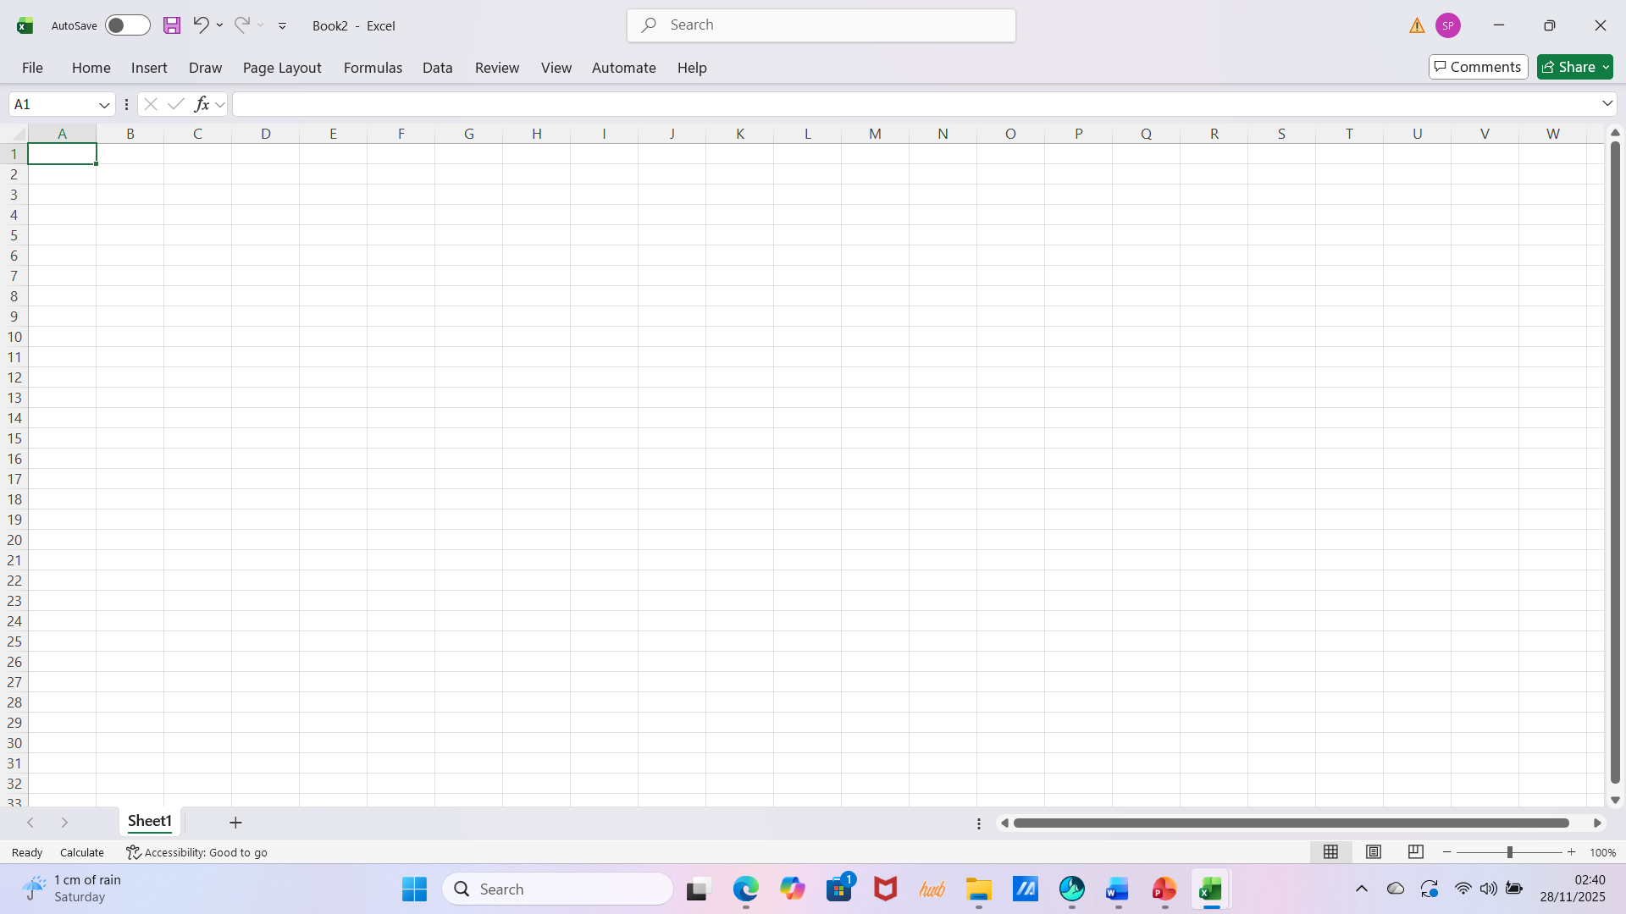 Step 3 Select data ; click insert and then chart 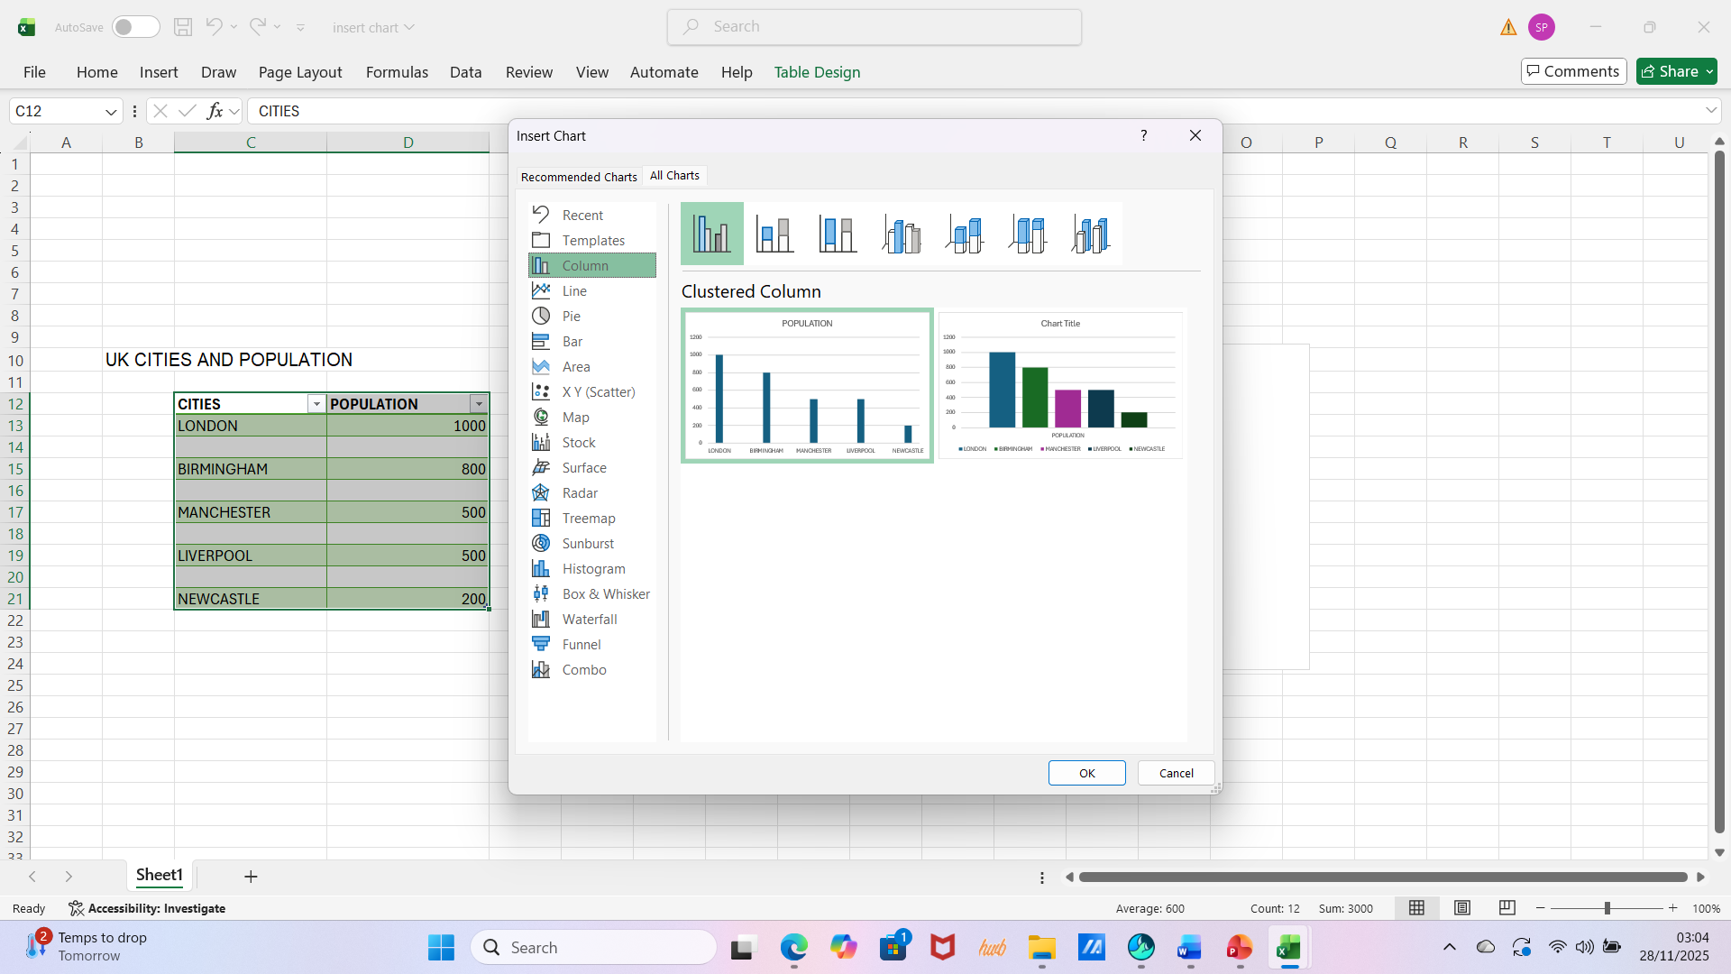
Highlight the data who want to include in the chart, including the headers. Click Insert then Charts.

Step 2 creation of data table 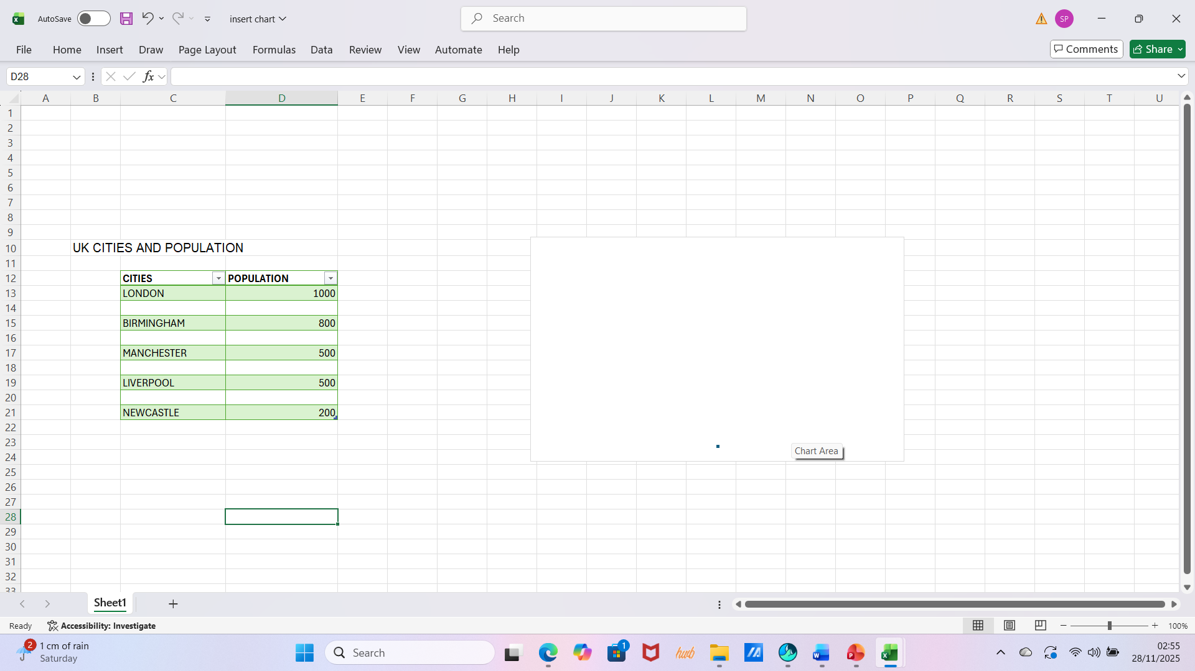 Step 4 select type of chart, e.g. Pie chart 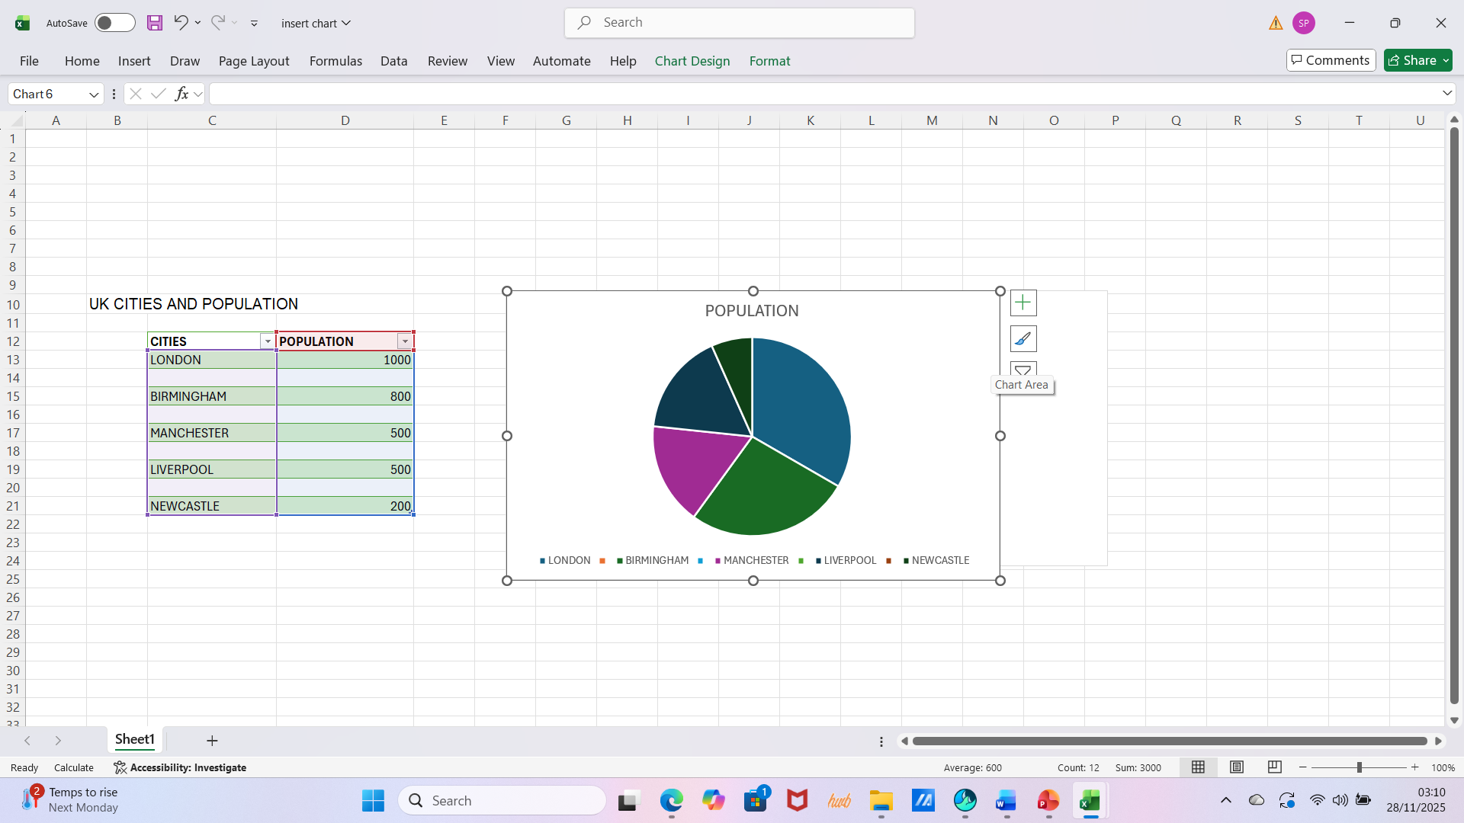
Input data into a spreadsheet; organised in columns and rows with clear headers
Choose a chart type that best describe the information you want to present.

Step 5 Customise your Chart: use chart design and format to add labels, colors and styles
Step 6 Save your Work click File then Save As, Name your file and Save

