Ansible-Driven Automation: Verifyi Ansible-Driven Automation: Verifying, Updating and Validating Network Configurations ng, Updating and Validating Network Configurations



University of Wales Trinity Saint David : BSc Degree Apprenticeship Computing (Computer Networks & Cybersecurity)
Module: ACCB5029 - Network Programmability
Student Name: Thomas Martin Walters
Student Number: 0652274
Student Name: Zoe Selina Clark
Student Number: 97011450
Student Name: Terra Strickland
Student Number: 2316328
Date: 19th January 2026

Ansible-Driven Automation:
Repeatable and Scalable Network Configuration
Contents
AI Acknowledgement 3
1. Introduction 3
2. Teamwork and Design 3
2.1 Teamworking 3
2.2 Design Approach 5
Conclusions 16
References 17
Appendix 21
Appendix A – Planning 21
Appendix A.1 – Planning Documentation 21
Appendix B – GitHub Repository 23
Appendix B.1 – Repo Structure 23
Appendix C – Run Commands 29
Appendix D – Code 29
Code 35
ACCB5029_GroupAssignment 35
README.md 35
Playbooks_Report.yml 35
Playbooks_Run.yml 35
Test_connection.yaml 36
ansible.cfg 37
hosts.ini 37
inventory.yml 38
inventory_post_security.yml 38
.github/workflows 38
main.yml 39
.idea 39
gitignore 39
ACCB5029_GroupAssignment.iml 40
misc.xml 40
modules.xml 40
vcs.xml 41
inspectionProfiles 41
profiles_settings.xml 41
Config_Baseline 41
banner_motd.yml 41
baseline.yml 42
config_ntp.yml 43
hostname.yml 43
inventory.ini 44
no_domain_lookup.yml 44
Config_IP 45
IP_DefaultRoute.yml 45
IP_EnableIPv6.yml 45
IP_EnableRIPv2.yml 46
IP_Loopback1_Create.yml 46
Config_OutputReport 47
CheckReportPlaybook.yml 47
Report_OutputPlaybook.yml 49
TEST_FalsePositive.txt 51
output 52
check_report.txt 52
Config_Security 53
LowPriv_User_Password.yml 53
Security_EnableSecret.yml 53
Security_SetPassword.yml 54
net-automation 54
CheckReportPlaybook.yml 54
Dockerfile 54
ExampleScaledInventory.yml 55
ansible.cfg 56
inventory.yml 56
Appendix E: PowerPoint Presentation 56

AI Acknowledgement
AI has been used to assist building code, syntax, structuring. Other design decisions, logical, configuration choices, run order were produced collaboratively by the project team. AI has been used to check formatting of the reference section on this document.

Tools used by team: Microsoft Copilot, ChatGPT, CursorAI

Introduction

This document collates the project teams supporting material and outlines the solution development through the stages from team formation to demonstrating working automation.
The project was developed using a controlled environment using tools available and accessible to all members of the group.
The project team brought diverse experiences, and varied areas of interest. This diversity directly informed design decisions and problem-solving.
Roles were agreed based on strengths and availability, with collaboration used to avoid silos.
Code for the demo is hosted in GitHub at the following link
https://github.com/Tom-wales/ACCB5029_GroupAssignment.git

Teamwork and Design
The project was delivered by a three-person team with a range of skills and experiences. Roles were agreed pragmatically based on strengths and interest. While each member had a primary focus, work was collaborative and reviewed collectively to avoid siloed development.

2.1 Teamworking
Following discussion of an initial proposal the team set out design decisions and framework. Discussions were held in addition to formal meetings to debate, clarify and resolve issues.

Checkpoint meetings were used to review progress, validate integration between individual contributions, and agree next steps. GitHub pull requests supported controlled merging of changes and reduced the risk of conflicts or regressions.
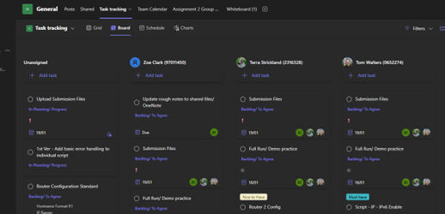
Figure 5: Team Task board. Used to assist team in breaking down activity into deliverable, steps and responsibilities for overall direction and momentum.


Figure 4: Regular Checkpoints. Meetings shown agreed as a team in the previous session.

Table 1: Key Focus areas
Team Member | Primary Focus
Terra | Core automation of configuration  Initial testing  Documenting
Tom | GitHub, IP & Security configuration  PowerPoint slides and notes
Zoe | Playbook run testing,  Data handling and outputs to file.  Physical Demo

Design Approach

Design decisions prioritised reliability, clarity, and demonstrability. The solution was deliberately scoped to a single virtual router to reduce risk during the live demonstration, while providing for future scaling.

Figure 1: Key Design Principles

Table 2: Constraints
Constraint | Impact | Mitigation
Time | Limited joint working hours | Independent tasks + checkpoints
Equipment | Single virtual device | Design for scalability
Availability | Team members work full time | Modular tasks, async comms
Validation | Pre/post checks | Confirm state change – demo data handling
Scaling | Inventory-driven | Enable future extension

Table 3: Tools
Type | Name | Purpose | Justification
Administrative | Microsoft Teams | Primary communication channel for meetings, troubleshooting discussions, shared notes, and reference material storage | Central, transparent point, available and some familiarity enabling quick adoption and use.
Version Control | GitHub |  | Distributed – Allowed independent yet aligned development.
  Central repository for source code, version control, branching, pull requests, and integration
Code Development | VS Code  PyCharm | Manually write, check and adjust code | User friendly, familiar and available
Generative AI | ChatGPT  CoPilot  CursorAI | Structure and Syntax | help develop code in tight timeframe based on teams agreed design logic

Team channel designed as a support tool, team discussed use of tool to ensure it supported not took over from core solution development.

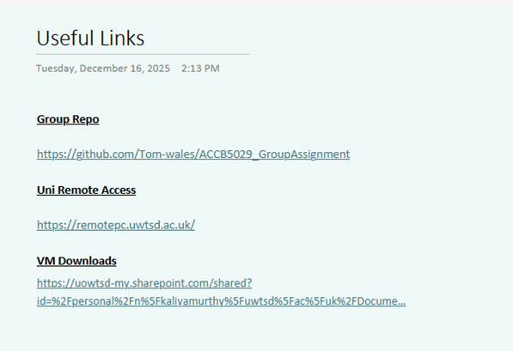
Figure 2: OneNote Page. Centralised, visible and transparent point for notes. Image shows team page for links.

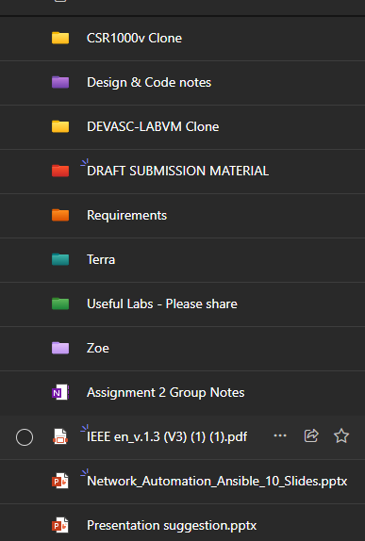
Figure 3: Teamwork via the sharing of reference documentation and design notes.

See Appendix A for Planning materials, Gantt Chart (Appendix A)

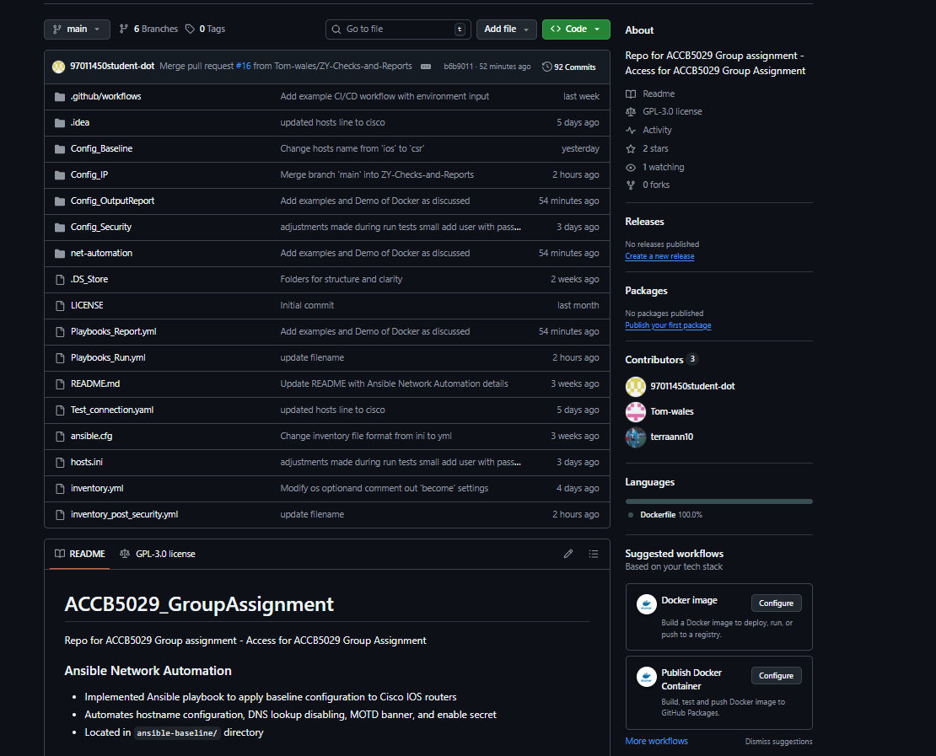
Figure 6: Distributed GitHub Repository. Design by T. Walters

Results, Testing & Evidence

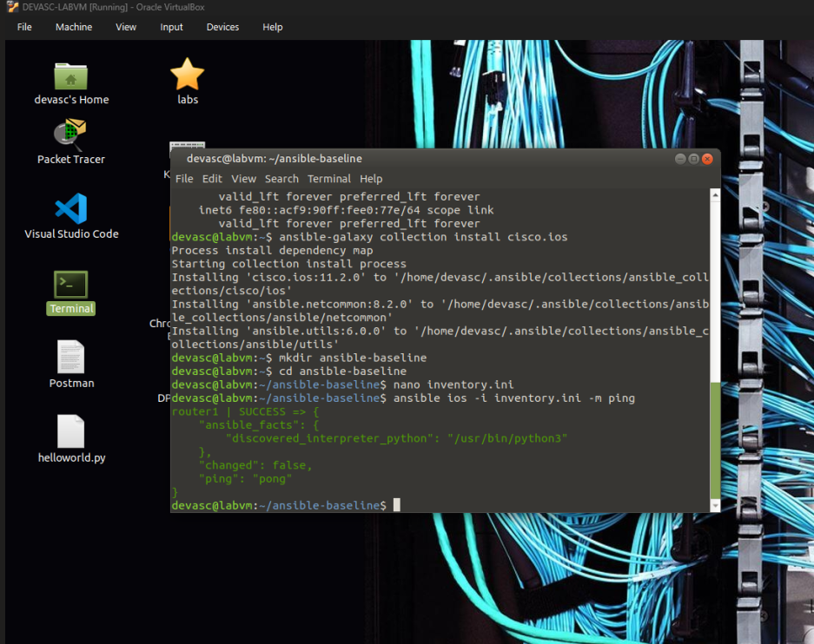
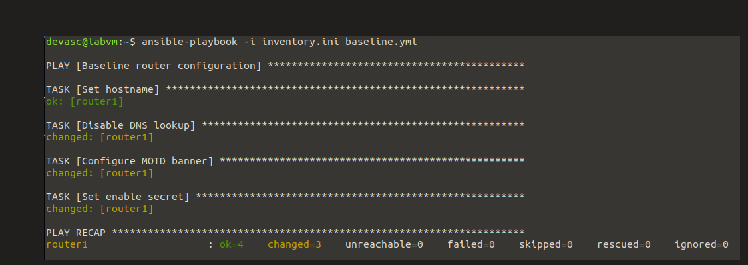
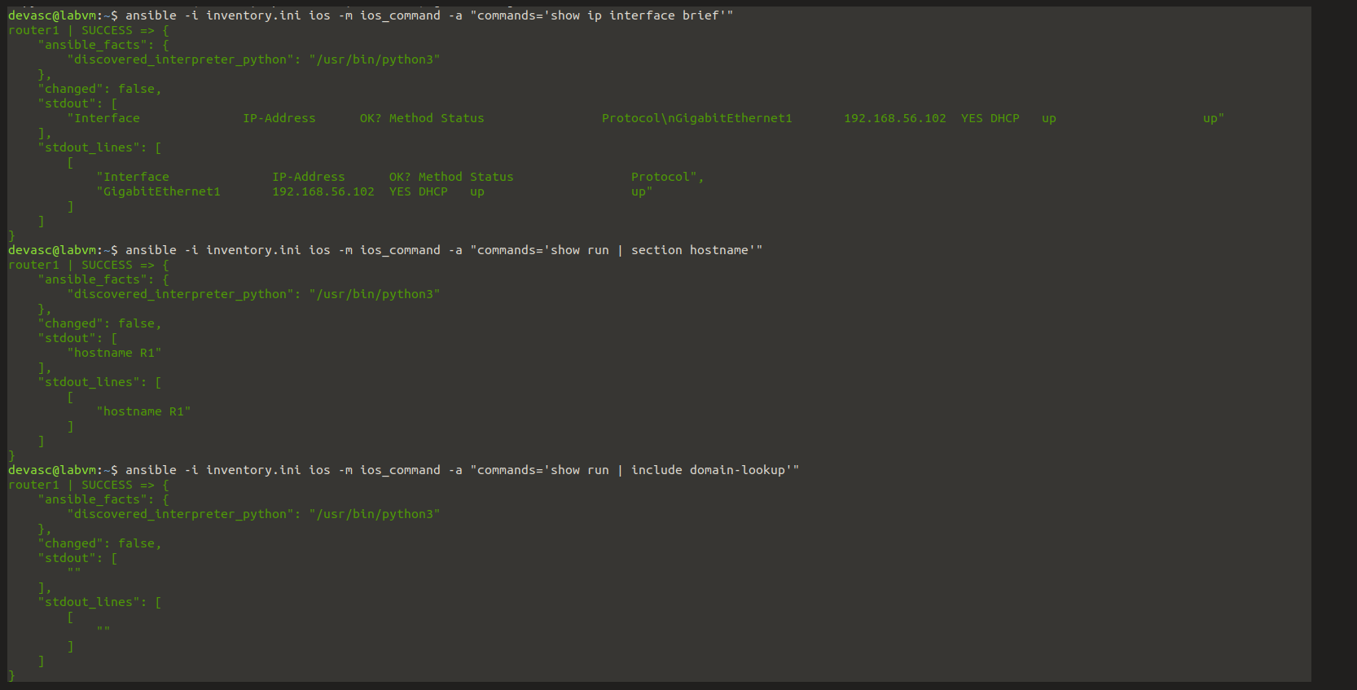

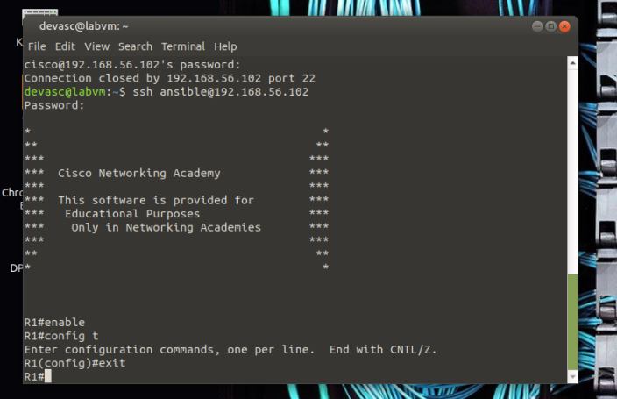
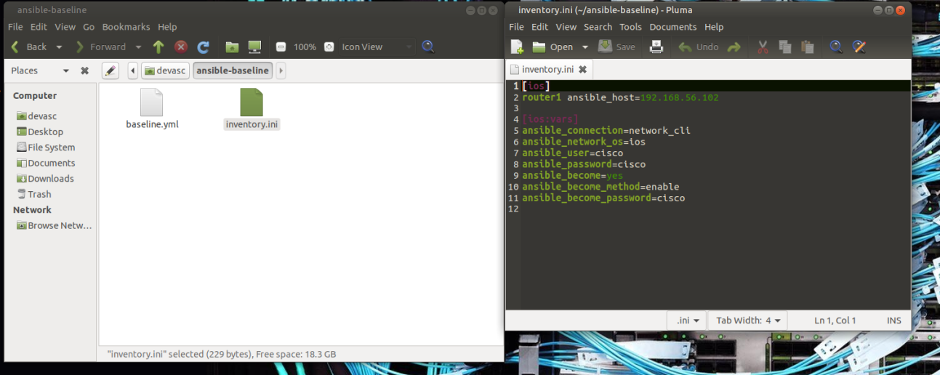

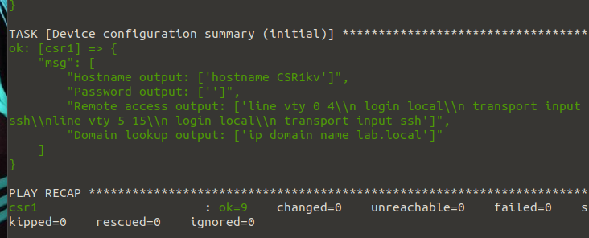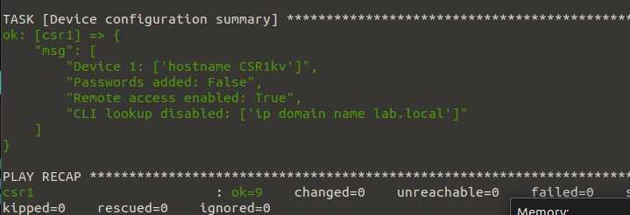
Figure 7: Image improvements made despite no errors to consider design intent and practical use.
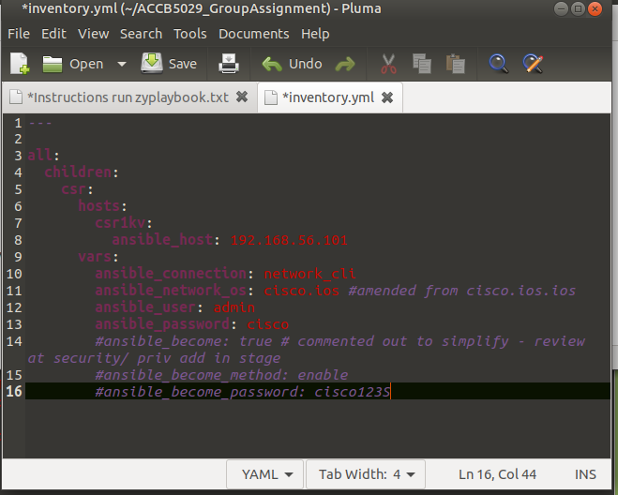
Figure 8: Minimised inventory file contents for basic troubleshooting steps. Code commented out to return to in future stages.

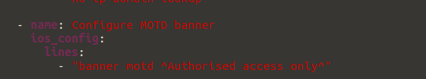
Figure 9: Adjust format/ syntax to suit ansible from # (read as comments) to ^

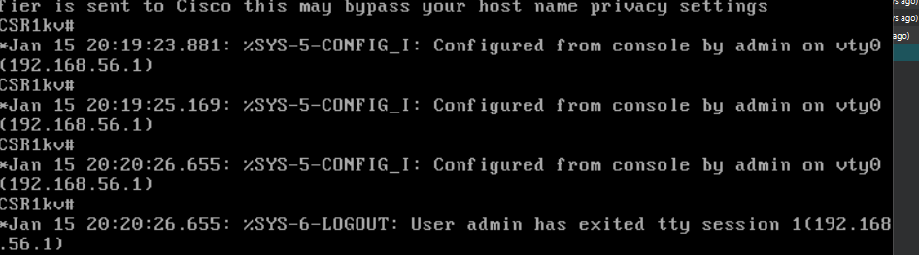
Figure 10: Playbooks in action. Image shows interactions on the CSR1000v Router

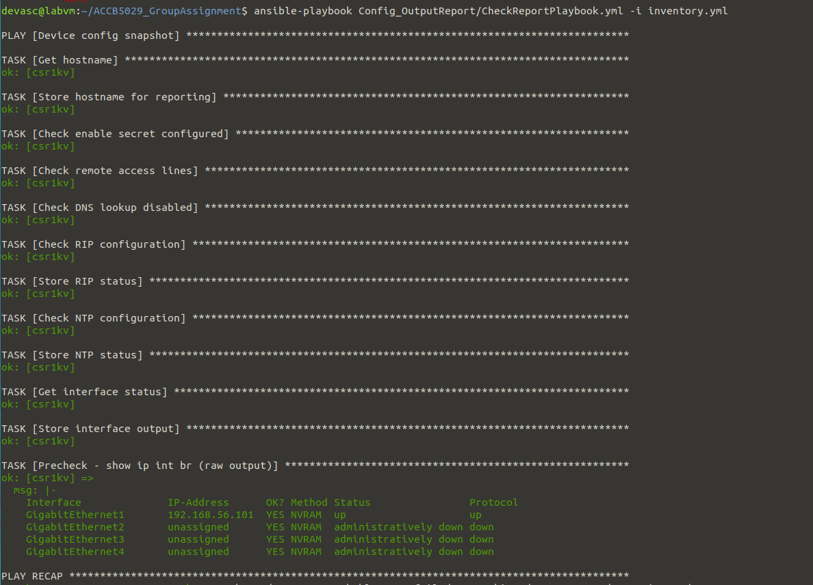
Figure 11: Show Playbooks running and tagged task running as the final step.

Terra:
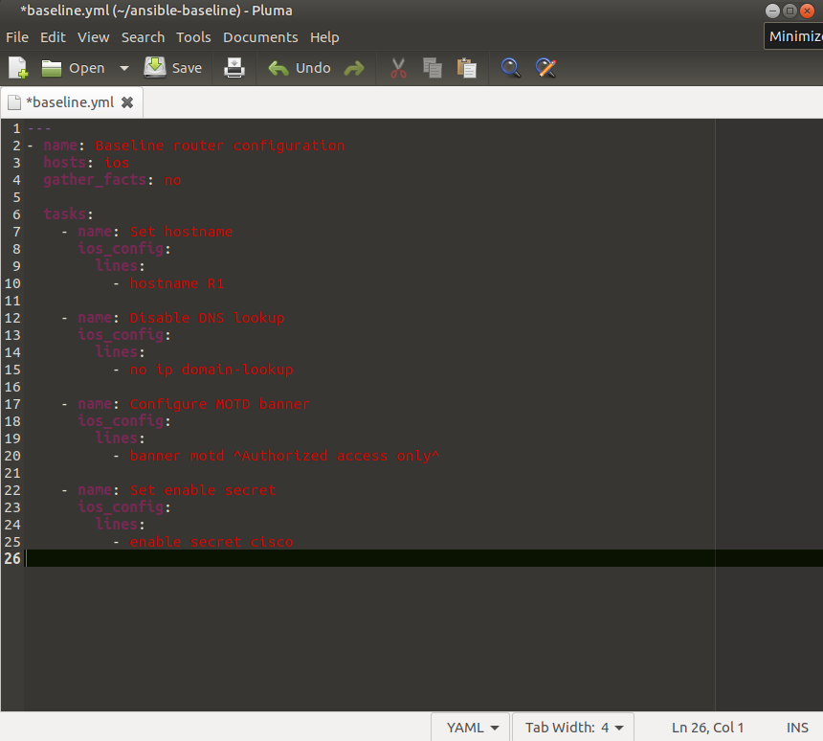
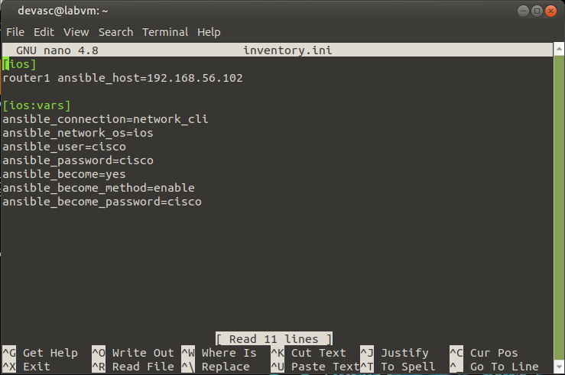
*Codes have since been updated to work in the testing environment

Terra:
Errors:
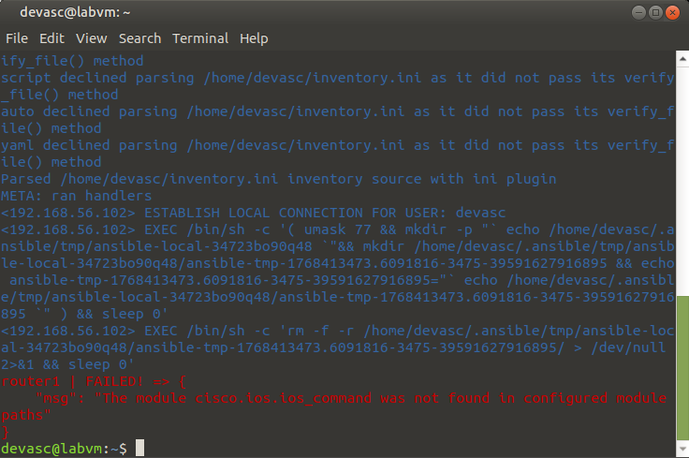
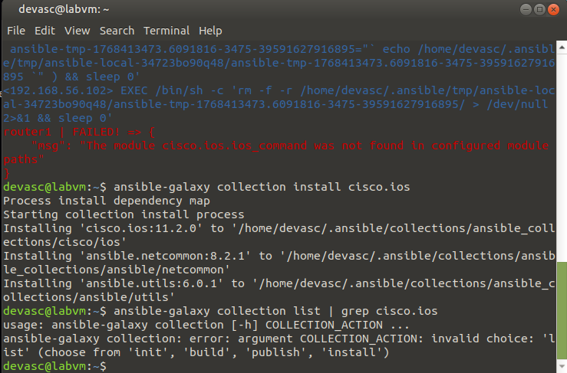

Successful Commands:
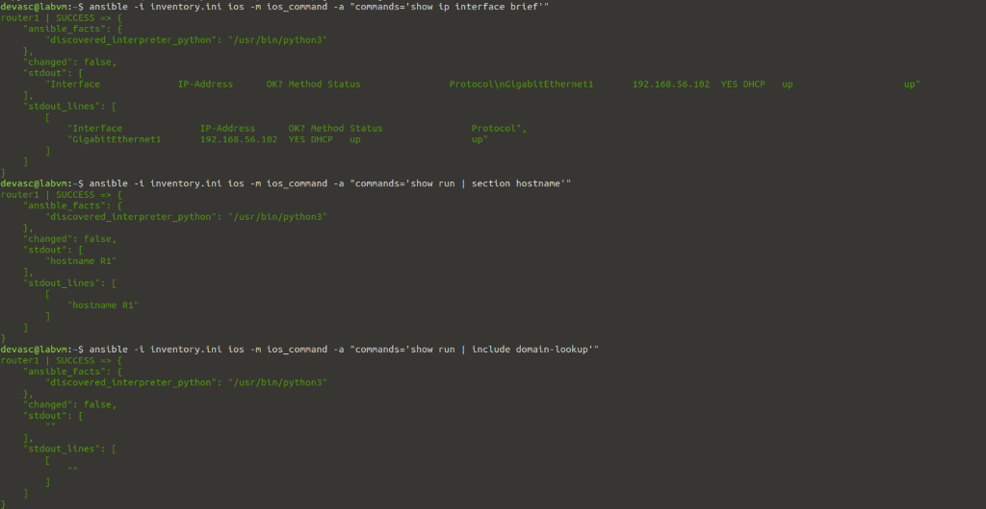

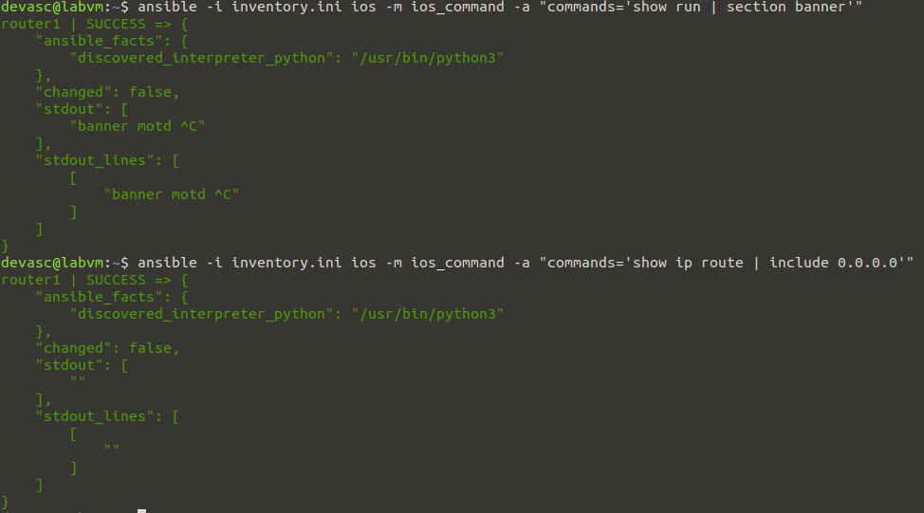

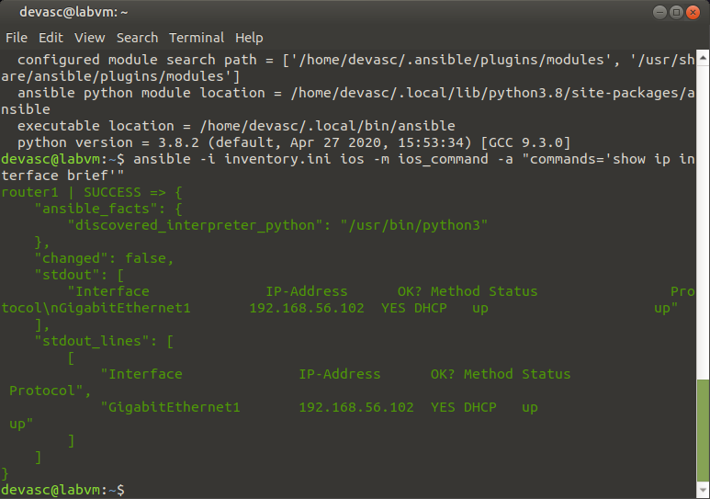

Successful Commands:

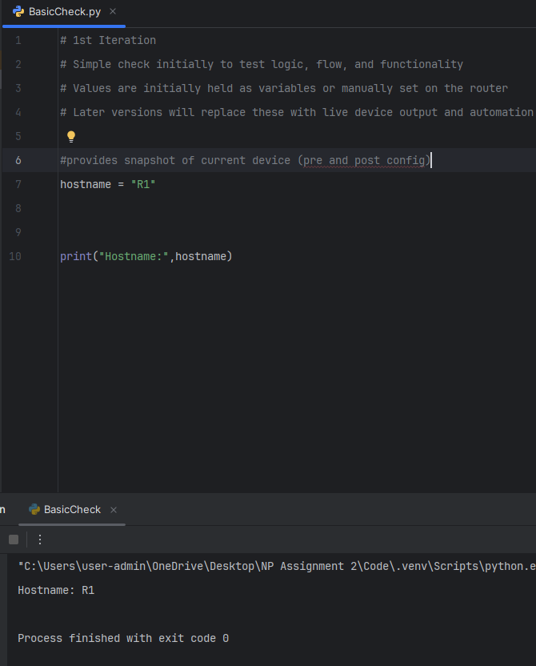

Conclusions

Did we deliver against the aims – anything not? Why & was it justified, next steps/ elements to further deliver. Lessons learned,
- Automation executed successfully against the target device
- Intended configuration changes confirmed via Ansible output and validation checks
- Testing performed incrementally at both element and integrated levels
- Recorded execution available as supporting evidence

Scope prioritised reliability and demonstrability over scale Validation focused on execution success and configuration state

- More formal tests would strengthen separation between:
- functional success (does the playbook run and apply config?)
- operational correctness (does it behave correctly within the full automation process?)
- Built to allow build on as a foundation. Next steps discussed include more structured testing, adding a test branch and further separation of sections of code working on. Also GitHub CI/CD integration, and multi-device deployment e.g. multiple routers in same environment and deployment across different environments.

References
Additional Reading and Research
Terra:
[1] Ansible, “Network Automation with Ansible,” Ansible Documentation, 2024. [Online]. Available: https://docs.ansible.com/ansible/latest/network/index.html. [Accessed: Dec 23rd. 2026].
[2] Ansible, “ios_config — Manage configuration sections on Cisco IOS devices,” Ansible Collections Documentation, 2024. [Online]. Available: https://docs.ansible.com/ansible/latest/collections/cisco/ios/ios_config_module.html. [Accessed: Dec 23rd. 2026].
[3] Ansible, “Inventory basics,” Ansible Documentation, 2024. [Online]. Available: https://docs.ansible.com/ansible/latest/inventory_guide/intro_inventory.html. [Accessed: Dec 23rd. 2026].
[4] Cisco Systems, Inc., “Cisco IOS XE Configuration Guides,” Cisco Documentation, 2024. [Online]. Available: https://www.cisco.com/c/en/us/support/ios-nx-os-software/ios-xe/products-installation-and-configuration-guides-list.html. [Accessed: Dec 30th. 2026].
[5] Cisco Systems, Inc., “Configuring Static Routes,” Cisco Technical Documentation, 2024. [Online]. Available: https://www.cisco.com/c/en/us/support/docs/ip/routing-information-protocol-rip/13730-static.html. [Accessed: Dec 30th. 2026].

Zoe Clark
[6] Internet Engineering Task Force (IETF), “Network management technologies,” IETF. [Online]. Available: https://www.ietf.org/technologies/netmgmt/ [Accessed: Dec. 6, 2025].

[7] Ansible Community Documentation, “Getting started with Ansible,” Ansible Community Docs, 2025. [Online]. Available: https://docs.ansible.com/projects/ansible/latest/getting_started/get_started_ansible.html
[Accessed: Dec. 17, 2025].

[8] Ansible Community Documentation, “cisco.ios.ios_command module,” Ansible Community Docs, 2025. [Online]. Available: https://docs.ansible.com/projects/ansible/latest/collections/cisco/ios/ios_command_module.html [Accessed: Dec. 17, 2025].

[9] Ansible Community Documentation, “Ansible command guide cheatsheet,” Ansible Community Docs, 2025. [Online]. Available: https://docs.ansible.com/projects/ansible/latest/command_guide/cheatsheet.html[Accessed: Dec. 17, 2025].

[10] Ansible Community Documentation, “Common return values,” Ansible Community Docs, 2025. [Online]. Available: https://docs.ansible.com/projects/ansible/latest/reference_appendices/common_return_values.html [Accessed: Dec. 17, 2025].

[11] Ansible Community Documentation, “Testing strategies,” Ansible Community Docs, 2025. [Online]. Available: https://docs.ansible.com/projects/ansible/latest/reference_appendices/test_strategies.html
[Accessed: Dec. 6, 2025].
[12] Ansible Community Documentation, “Command-line tools,” Ansible Community Docs, 2025. [Online]. Available: https://docs.ansible.com/projects/ansible/latest/command_guide/command_line_tools.html
[Accessed: Dec. 18, 2025].

[12] Ansible Community Documentation, “Inventory guide,” Ansible Community Docs, 2025. [Online]. Available: https://docs.ansible.com/projects/ansible/latest/inventory_guide/index.html
[Accessed: Dec. 18, 2025].

[14] Ansible Community Documentation, “Debugging Ansible,” Ansible Community Docs, 2025. [Online]. Available: https://docs.ansible.com/projects/ansible/latest/dev_guide/debugging.html
[Accessed: Dec. 17, 2025].
[15] Red Hat, “Pipes on the Linux command line,” Red Hat Blog, 2023. [Online]. Available: https://www.redhat.com/en/blog/pipes-command-line-linux [Accessed: Jan. 19, 2026].

[16] Unity Technologies, “Unity Version Control CLI pipe,” Unity Documentation, 2024. [Online]. Available: https://docs.unity.com/en-us/unity-version-control/cli/pipe [Accessed: Dec. 18, 2025].

[17] Cisco Systems, “Cisco IOS command reference,” Cisco IOS Fundamentals Configuration Guide, 2024. [Online]. Available: https://www.cisco.com/c/en/us/td/docs/ios/fundamentals/command/reference/cf_book/cf_s1.html[Accessed: Dec. 18, 2025].

[18] Ansible Community Documentation, “Network differences,” Ansible Community Docs, 2025. [Online]. Available: https://docs.ansible.com/projects/ansible/latest/network/getting_started/network_differences.html [Accessed: Jan. 19, 2026].

[19] Ansible Community Documentation, “Understanding network roles,” Ansible Community Docs, 2025. [Online]. Available: https://docs.ansible.com/projects/ansible/latest/network/getting_started/network_roles.html#understanding-roles[Accessed: Dec. 6, 2025].

[20] Ansible Community Documentation, “IOCage inventory tags,” Ansible Community Docs, 2025. [Online]. Available: https://docs.ansible.com/projects/ansible/latest/collections/community/general/docsite/guide_iocage_inventory_tags.html#tags[Accessed: Dec. 24, 2025].

[21] IONOS, “How to install Docker on Ubuntu 22.04,” IONOS Digital Guide, 2024. [Online]. Available: https://www.ionos.co.uk/digitalguide/server/configuration/install-docker-on-ubuntu-2204/
[Accessed: Jan. 10, 2026].

[22] Docker Inc., “Install Docker Desktop on Ubuntu,” Docker Documentation, 2025. [Online]. Available: https://docs.docker.com/desktop/setup/install/linux/ubuntu/ [Accessed: Jan. 17, 2026].

[23] Docker Inc., “Docker CLI reference,” Docker Documentation, 2025. [Online]. Available: https://docs.docker.com/reference/cli/docker/ [Accessed: Jan. 19, 2026].
Further Reading
[24] S. V. Georgiev and K. S. Nikolova, “An innovative comparison of NetDevOps configuration management solutions for automation of data center networks,” in Proc. 2025 60th Int. Sci. Conf. Inf., Commun. Energy Syst. Technol. (ICEST), Ohrid, North Macedonia, Jun. 2025, pp. 1–4, doi: 10.1109/ICEST66328.2025.11098348.
[25] M. M. Hassan and A. Rahman, “As code testing: Characterizing test quality in open source Ansible development,” in Proc. 2022 IEEE Conf. Softw. Testing, Verification and Validation (ICST), Apr. 2022, pp. 208–219, doi: 10.1109/ICST53961.2022.00031.
[26] N. Singh, A. Singh, and V. Rawat, “Deploying Jenkins, Ansible and Kubernetes to automate continuous integration and continuous deployment pipeline,” in Proc. 2022 IEEE Int. Conf. Service Operations and Logistics, and Informatics (SOLI), Dec. 2022, pp. 1–5, doi: 10.1109/SOLI57430.2022.10294378.
[27] Y. Wang, T. Zhang, and Y. Guo, “Design and implementation of continuous integration scheme based on Jenkins and Ansible,” in Proc. 2018 Int. Conf. Artificial Intelligence and Big Data, Chengdu, China, 2018, pp. 245–249, doi: 10.1109/ICAIBD.2018.8396191.
[28] E. Horton and C. Parnin, “Dozer: Migrating shell commands to Ansible modules via execution profiling and synthesis,” in Proc. 44th Int. Conf. Software Engineering: Software Engineering in Practice (ICSE-SEIP), Pittsburgh, PA, USA, May 2022, pp. 1–2, doi: 10.1145/3510457.3513060.
[29] G. Salazar-Chacón and D. M. Parra, “Infrastructure-as-code in open-networking: Git, Ansible, and Cumulus-Linux case study,” in Proc. 2023 IEEE 13th Annu. Comput. Commun. Workshop Conf. (CCWC), Jan. 2023, pp. 1126–1131, doi: 10.1109/CCWC57344.2023.10099084.
[30] R. Mohammed, “Modernizing legacy systems with DevSecOps: A case study of refactoring Minitwit for secure and scalable deployment,” in Proc. 2025 Int. Conf. Computing Technologies (ICOCT), Bangalore, India, Jun. 2025, pp. 1–7, doi: 10.1109/ICOCT64433.2025.11118372.
[31] N. Dsilva, J.-P. Elbers, V. Karunakaran, T. Bauschert, and A. Autenrieth, “Network automation using NetDevOps in optical networks,” in Proc. 2025 Int. Conf. Optical Network Design and Modeling (ONDM), Pisa, Italy, 2025, pp. 1–3.
[32] Cisco DevNet, “CSR1000v VMware deployment,” Cisco Code Exchange, 2024. [Online]. Available: https://developer.cisco.com/codeexchange/github/repo/aawarner/CSR1000v_Vmware_Deployment/ [Accessed: Dec. 17, 2025].
[33] O. Abaffy, “12 bash scripts to automate configuration management with Ansible,” Medium, 2020. [Online]. Available: https://medium.com/@obaff/12-bash-scripts-to-automate-configuration-management-with-ansible-75bdd86cf484 [Accessed: Dec. 6, 2025].
[34] Network to Code, “Ansible network infrastructure testing,” Network to Code Blog, 2021. [Online]. Available: https://networktocode.com/blog/ansible-network-infrastructure-testing/
[Accessed: Dec. 6, 2025].
[35] Cisco Networking Academy, “DevNet Associate – Network Programmability Module,” Cisco NetAcad, 2024. [Online]. Available: https://www.netacad.com/launch?id=4a04bf0f-321f-4ac8-8226-3cea34fd28c1 [Accessed: Jan. 19, 2026].
[36] Ansible Community Documentation, “Rolling upgrade playbook guide,” Ansible Community Docs, 2025. [Online]. Available: https://docs.ansible.com/projects/ansible/latest/playbook_guide/guide_rolling_upgrade.html
[Accessed: Jan. 11, 2026].

Tom
[37] Ansible Documentation Project, Ansible Documentation – Latest, Ansible Community. [Online]. Available: https://docs.ansible.com/projects/ansible/latest/index.html. [Accessed: 15-Dec-2025].
[38] Ansible Documentation Project, Getting Started with Ansible, Ansible Community. [Online]. Available: https://docs.ansible.com/projects/ansible/latest/getting_started/index.html. [Accessed: 15-Dec-2025].
[39] Ansible Documentation Project, Ansible Playbooks – Introduction, Ansible Community. [Online]. Available: https://docs.ansible.com/ansible/latest/playbook_guide/playbooks_intro.html. [Accessed: 16-Dec-2025].
[40] Learn X in Y Minutes, Ansible in Y Minutes. [Online]. Available: https://learnxinyminutes.com/ansible/. [Accessed: 18-Dec-2025].
[41] Red Hat, Learning Ansible Automation Tutorial. [Online]. Available: https://www.redhat.com/en/topics/automation/learning-ansible-tutorial. [Accessed: 20-Dec-2025].
[42] Ansible Community, Awesome Ansible – Curated Ansible Resources, GitHub Repository. [Online]. Available: https://github.com/ansible-community/awesome-ansible. [Accessed: 21-Dec-2025].
[43] Ansible Documentation Project, Ansible Playbooks Best Practices (v2.9), Ansible Community. [Online]. Available: https://docs.ansible.com/ansible/2.9/user_guide/playbooks_best_practices.html. [Accessed: 03-Jan-2026].
[44] Red Hat Communities of Practice, Automation Good Practices. [Online]. Available: https://redhat-cop.github.io/automation-good-practices/. [Accessed: 05-Jan-2026].
[45] Spacelift, Ansible Best Practices – A Practical Guide. [Online]. Available: https://spacelift.io/blog/ansible-best-practices. [Accessed: 08-Jan-2026].
[46] Ansible Documentation Project, Ansible Documentation, Ansible Community. [Online]. Available: https://docs.ansible.com. [Accessed: 10-Jan-2026].
[47] PyNet Labs, Ansible Roles Explained. [Online]. Available: https://www.pynetlabs.com/ansible-roles/. [Accessed: 12-Jan-2026].

Appendix

Appendix A – Planning

Appendix A.1 – Planning Documentation

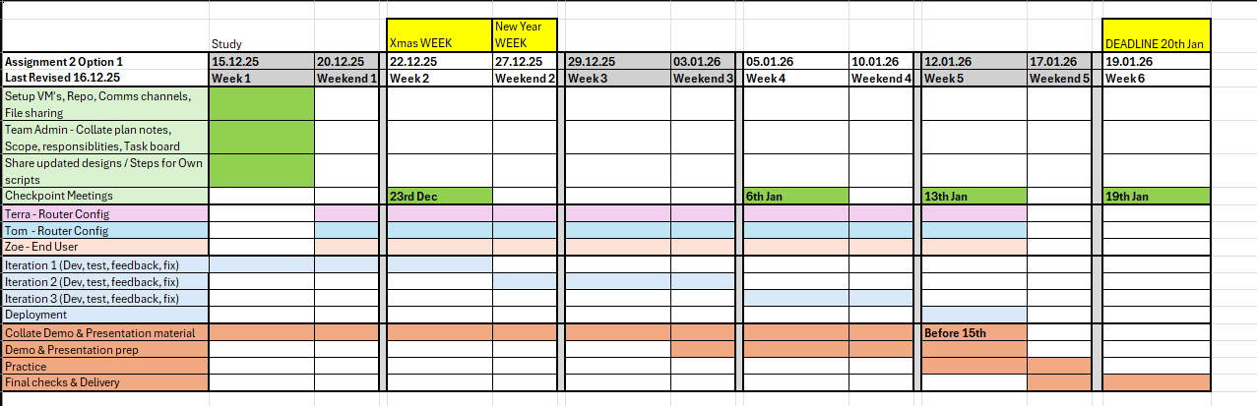
Figure 12: Gantt Chart Author Z. Clark

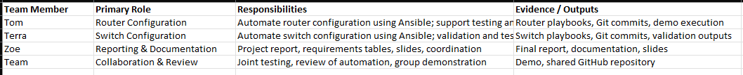
Figure 13: Roles & Responsibilities Table: Author T. Strickland

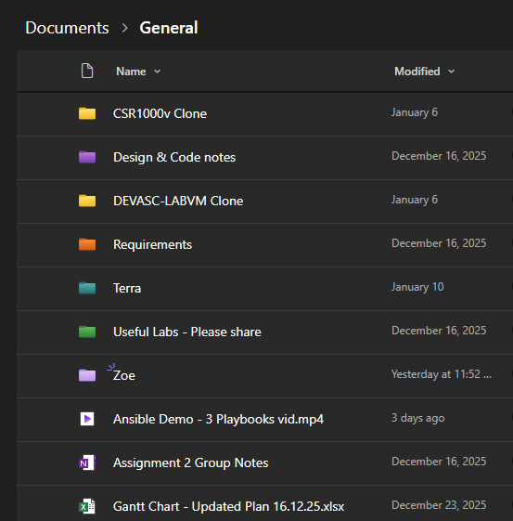
Figure 14: Shared Files in Teams Channel

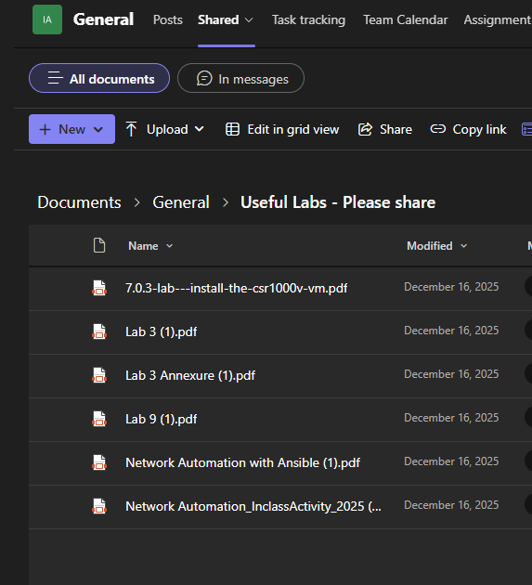
Central Reference point for relevant class materials

Technical Delivery Plan – role allocation
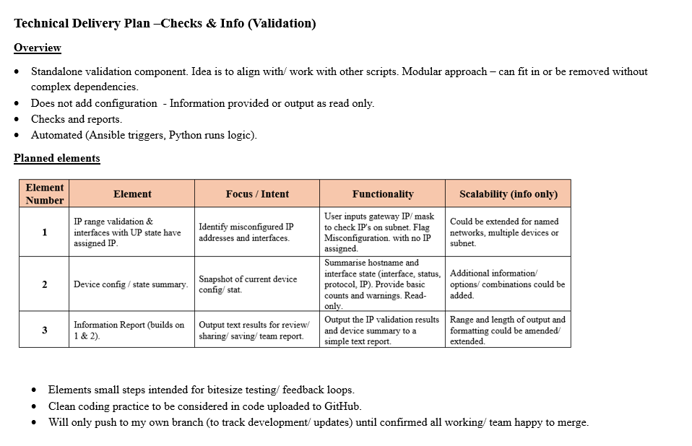

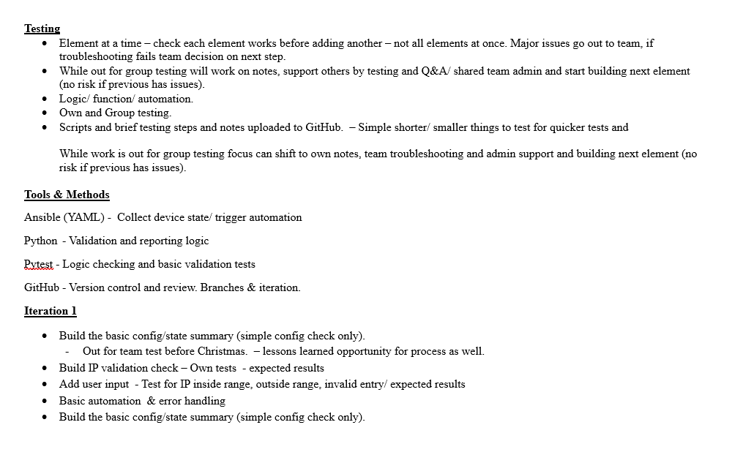
Example Technical Delivery created to set out methodology and aims to team members. Author Z. Clark

Appendix B – GitHub Repository

Appendix B.1 – Repo Structure

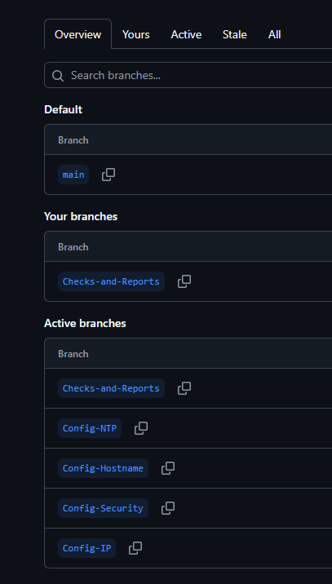

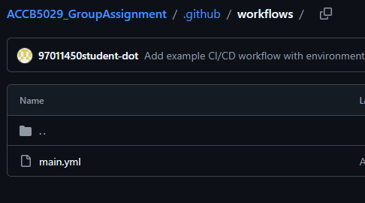
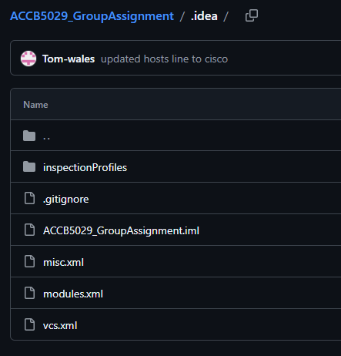
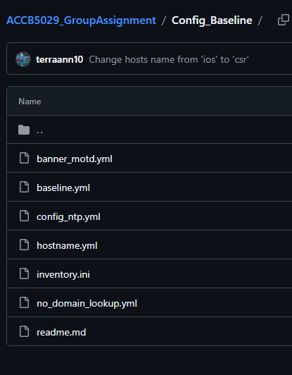
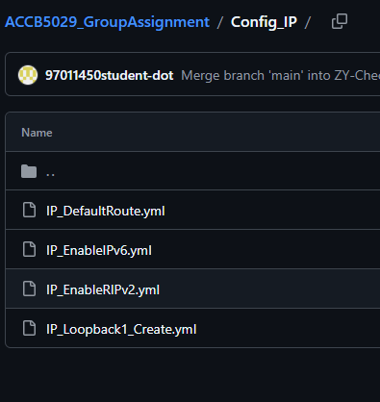
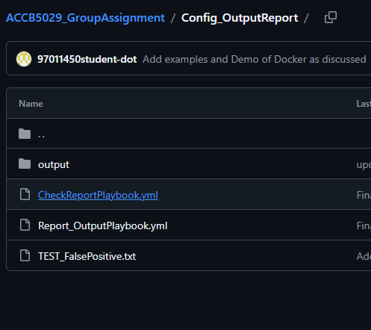
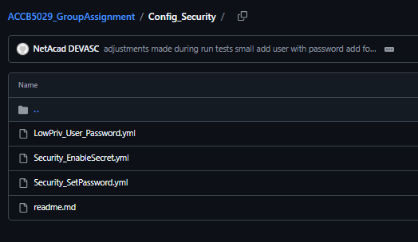

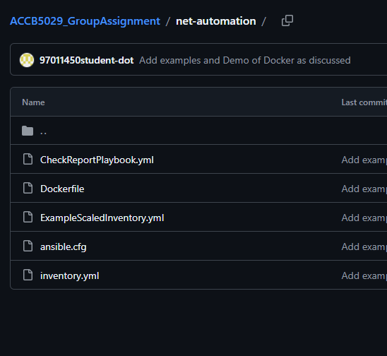

Appendix C – Run Commands

ansible-playbook -i inventory.yml Playbooks_Run.yml
ansible-playbook -i inventory_post_security.yml Playbooks_Report.yml
docker run -it --rm -v $(pwd):/automation net-automation

Appendix D – Code

*baseline.yml (~/ansible-baseline) - Pluma
X
File Edit View Search Tools Documents Help
Minimiz
Open
Save
Undo
*baseline.yml x
1
- - -
- name: Baseline router configuration
3
hosts: ios
4
gather_facts: no
5
6
tasks:
7
- name: Set hostname
ios_config:
00
lines:
10
hostname R1
11
12
- name: Disable DNS lookup
13
ios_config:
14
Lines:
15
- no ip domain-lookup
16
17
- name: Configure MOTD banner
18
ios_config:
19
lines:
20
banner motd ^Authorized access only^
21
22
- name: Set enable secret
23
ios_config:
24
Lines:
25
enable secret cisco
26
YAML v
Tab Width: 4
Ln 26, Col 1
INS
devasc@labvm: ~
X
File Edit View Search Terminal Help
GNU nano 4.8
[ios]
inventory.ini
router1 ansible_host=192.168.56.102
[ios : vars]
ansible_connection=network_cli
ansible_network_os=ios
ansible_user=cisco
ansible_password=cisco
ansible_become=yes
ansible_become_method=enable
ansible_become_password=cisco
[ Read 11 lines ]
^G
Get Help
Write Out
Where Is
AK Cut Text
Justify
Cur Pos
^X Exit
AR Read File
Mv
AJ
0v
Replace
^U Paste Text^T To Spell
Go To Line
*Codes have since been updated to work in the testing environment
Testing & Troubleshooting
Terra:
Errors:

Successful Commands:

Code

ACCB5029_GroupAssignment

README.md
Repo for ACCB5029 Group assignment - Access for ACCB5029 Group Assignment
Ansible Network Automation
- Implemented Ansible playbook to apply baseline configuration to Cisco IOS routers
- Automates hostname configuration, DNS lookup disabling, MOTD banner, and enable secret
- Located in ansible-baseline/ directory

Playbooks_Report.yml
---
# Playbook to control the run order for post configuration, checks, and reporting
# Configuration playbooks run first (currently seperate run until security config reworked), followed by checks and then output to file

# Execution order only, does not contain tasks
# Error handling needed - will be added later to allow overall execution to continue if a step fails. *Would not have resolved the SSH issue in this instance.

# CHECKS / SNAPSHOT (DATA GATHERING)
- import_playbook: Config_OutputReport/CheckReportPlaybook.yml

# REPORT OUTPUT (FORMATTING / .txt OUTPUT)
- import_playbook: Config_OutputReport/Report_OutputPlaybook.yml

Playbooks_Run.yml
---
# Playbook to control the run order for configuration, checks, and reporting
# Configuration playbooks run first, followed by checks and then output to file

# Execution order only, does not contain tasks
# Error handling needed - will be added later to allow overall execution to continue if a step fails.

# BASELINE CONFIG
- import_playbook: Config_Baseline/baseline.yml
- import_playbook: Config_Baseline/config_ntp.yml

# IP / ROUTING CONFIG
#- import_playbook: Config_IP/IP_DefaultRoute.yml
- import_playbook: Config_IP/IP_EnableIPv6.yml
- import_playbook: Config_IP/IP_Loopback1_Create.yml
- import_playbook: Config_IP/IP_EnableRIPv2.yml
- import_playbook: Config_IP/IP_DefaultRoute.yml

# SECURITY CONFIG - NOTE TROUBLESHOOTING ONGOING AS THESE STEPS BREAK THE SSH CONNECTION - SO REWORKING TO RE-INTRO REPEATABILITY ASPECT OF AUTOMATION.

- import_playbook: Config_Security/LowPriv_User_Password.yml
- import_playbook: Config_Security/Security_EnableSecret.yml
- import_playbook: Config_Security/Security_SetPassword.yml

# CHECKS / SNAPSHOT (DATA GATHERING) - moved to seperate stage due to SSH issue
#- import_playbook: Config_OutputReport/CheckReportPlaybook.yml

# REPORT OUTPUT (FORMATTING / .txt OUTPUT)
#- import_playbook: Config_OutputReport/Report_OutputPlaybook.yml

Test_connection.yaml
---
- name: Test CSR1kv access
hosts: cisco
gather_facts: no
connection: network_cli

vars:
ansible_network_os: ios
ansible_command_timeout: 60
# Uncomment if the device requires enable mode
# ansible_become: yes
# ansible_become_method: enable
# ansible_become_password: "{{ vault_enable_password }}"

tasks:
- name: Show version
cisco.ios.ios_command:
commands:
- show version
register: out

- name: Print output
debug:
var: out.stdout_lines

ansible.cfg
[defaults]
inventory = inventory.yml
host_key_checking = False
stdout_callback = yaml
timeout = 30

[persistent_connection]
command_timeout = 60
connect_timeout = 60

hosts.ini
No longer in use
[cisco]
CSR1KV ansible_host=192.168.56.101

[cisco:vars]
ansible_connection=network_cli
ansible_network_os=ios
ansible_user=admin
ansible_password=cisco
ansible_port=22
ansible_command_timeout=60S

inventory.yml
---

all:
children:
csr:
hosts:
csr1kv:
ansible_host: 192.168.56.101
vars:
ansible_connection: network_cli
ansible_network_os: ios # amended to ios to work on demo setup
ansible_user: admin
ansible_password: cisco
# ansible_become: true
# ansible_become_method: enable
# ansible_become_password: cisco123 Use later if initial login priv changes.

inventory_post_security.yml
---
all:
children:
csr:
hosts:
csr1kv:
ansible_host: 192.168.56.101
vars:
ansible_connection: network_cli
ansible_network_os: ios
ansible_user: admin
ansible_password: cisco

.github/workflows
main.yml
Example – not in use

# Example GitHub Actions workflow
# This is an illustration only, not a finished deployment
# It does not run playbooks or interact with any other files unless the group chooses to extend it.
# Ansible Vault would be used here to handle any sensitive values if playbooks are added.
name: Example CI/CD Trigger

on:
workflow_dispatch:
inputs:
target_environment:
description: "Choose which environment to run against"
required: true
type: choice
options:
- dev
- test
- prod

jobs:
example:
runs-on: ubuntu-latest

steps:
- name: Show selected environment
run: |
echo "automation would run here for the selected enviroment"
echo "Selected environment:"
echo "${{ inputs.target_environment }}"

.idea

gitignore
Example – not in use
# Default ignored files
/shelf/
/workspace.xml
# Editor-based HTTP Client requests
/httpRequests/
# Ignored default folder with query files
/queries/
# Datasource local storage ignored files
/dataSources/
/dataSources.local.xml

ACCB5029_GroupAssignment.iml
Example – not in use
<?xml version="1.0" encoding="UTF-8"?>
<module type="PYTHON_MODULE" version="4">
<component name="NewModuleRootManager">
<content url="file://$MODULE_DIR$" />
<orderEntry type="jdk" jdkName="Python 3.14" jdkType="Python SDK" />
<orderEntry type="sourceFolder" forTests="false" />
</component>
</module>

misc.xml
Example – not in use

<?xml version="1.0" encoding="UTF-8"?>
<project version="4">
<component name="Black">
<option name="sdkName" value="Python 3.14" />
</component>
<component name="ProjectRootManager" version="2" project-jdk-name="Python 3.14" project-jdk-type="Python SDK" />
</project>

modules.xml
Example – not in use

<?xml version="1.0" encoding="UTF-8"?>
<project version="4">
<component name="ProjectModuleManager">
<modules>
<module fileurl="file://$PROJECT_DIR$/.idea/ACCB5029_GroupAssignment.iml" filepath="$PROJECT_DIR$/.idea/ACCB5029_GroupAssignment.iml" />
</modules>
</component>
</project>

vcs.xml
Example – not in use
<?xml version="1.0" encoding="UTF-8"?>
<project version="4">
<component name="VcsDirectoryMappings">
<mapping directory="" vcs="Git" />
</component>
</project>

inspectionProfiles

profiles_settings.xml
Example – not in use
<component name="InspectionProjectProfileManager">
<settings>
<option name="USE_PROJECT_PROFILE" value="false" />
<version value="1.0" />
</settings>
</component>

Config_Baseline

banner_motd.yml
No longer in use - Code moved into “baseline” file
---
# This playbook configures a Message of the Day (MOTD) banner.
# Security banners are a baseline requirement to warn users
# about authorised access before login.

- name: Configure MOTD banner
hosts: csr # changed host name
gather_facts: no

tasks:
- name: Set MOTD banner message
ios_config:
lines:
# The banner text is enclosed with # delimiters
- banner motd ^Authorized access only^

baseline.yml
---
- name: Baseline router configuration
hosts: csr
gather_facts: no

tasks:
- name: Set hostname
ios_config:
lines:
- hostname R1

- name: Disable DNS lookup
ios_config:
lines:
- no ip domain-lookup

- name: Configure MOTD banner
ios_config:
lines:
- "banner motd ^Authorised access only^"

#- name: Set enable secret
#ios_config:
#lines:
# - enable secret cisco - SSH password in place for ansible connect now security playbook seperates out this function.

- name: Configure default routeS
ios_config:
lines:
- ip route 0.0.0.0 0.0.0.0 GigabitEthernet1

config_ntp.yml
---
- name: Enable NTP on Cisco IOS router
hosts: csr
gather_facts: no

tasks:
- name: Enable NTP service
ios_config:
lines:
- ntp server 0.pool.ntp.org
- ntp server 1.pool.ntp.org
- ntp server 2.pool.ntp.org
save_when: modified

- name: Set timezone (optional - adjust as needed)
ios_config:
lines:
- clock timezone UTC 0 0
save_when: modified

hostname.yml
No longer in use – code moved to “baseline” file
---
# This playbook sets the hostname of the router.
# Hostname configuration is part of the baseline
# because it uniquely identifies the device.

- name: Configure router hostname
hosts: csr # Target the IOS devices defined in inventory
gather_facts: no # Disable fact gathering (not needed for network devices)

tasks:
- name: Set hostname to R1
ios_config:
lines:
- hostname R1 # IOS command to set the router hostname

inventory.ini
No longer in use
[ios]
router1 ansible_host=192.168.56.102

[ios:vars]
ansible_connection=network_cli
ansible_network_os=ios
ansible_user=cisco
ansible_password=cisco
ansible_become=yes
ansible_become_method=enable
ansible_become_password=cisco

#Used this as my test. We have since edited and reconfigured it

no_domain_lookup.yml
---
# This playbook disables DNS lookup on the router.
# This prevents IOS from attempting name resolution
# when a command is mistyped, which improves usability.

- name: Disable DNS lookup
hosts: csr # changed hosts name
gather_facts: no

tasks:
- name: Disable IP domain lookup
ios_config:
lines:
- no ip domain-lookup # Prevents unwanted DNS lookups

Config_IP

IP_DefaultRoute.yml
---
# This playbook configures the default IPv4 route.
# The default route allows the router to forward
# traffic to external networks via the gateway.

- name: Configure default IPv4 route
hosts: csr
gather_facts: no

tasks:
- name: Set default route via gateway
ios_config:
lines:
# 0.0.0.0/0 represents the default route
# 10.0.3.2 is the NAT gateway for the DEVASC VM environment
- ip route 0.0.0.0 0.0.0.0 10.0.3.2

IP_EnableIPv6.yml
---
- name: Enable IPv6 on Cisco IOS router
hosts: csr
gather_facts: no

tasks:
- name: Enable IPv6 unicast routing
ios_config:
lines:
- ipv6 unicast-routing
save_when: modified

IP_EnableRIPv2.yml
---
- name: Enable RIP v2 on Cisco IOS router
hosts: csr
gather_facts: no

tasks:
- name: Enable RIP v2 routing protocol
ios_config:
parents:
- router rip # Added to handle more than one network command
lines:
- version 2
- no auto-summary
- network 192.168.56.0
- network 192.168.1.0
save_when: modified

IP_Loopback1_Create.yml
---
- name: Create loopback interface on Cisco IOS router
hosts: csr
gather_facts: no

tasks:
- name: Create loopback interface Loopback1
ios_config:
parents: interface Loopback1 # added parents (direct would just be conf t then ip address under int Loopback 1)
lines:
- ip address 192.168.1.1 255.255.255.255
save_when: modified

Config_OutputReport

CheckReportPlaybook.yml
---
# Basic device snapshot
# Purpose:
# - collect core device information
# - prepare data for reporting
# - no formatting
# - no deployment logic
#
# Notes:
# - safe to run pre or post config
# - interface data stored once and reused

- name: Device config snapshot
hosts: all
gather_facts: no
connection: network_cli

vars:
interfaces: []

tasks:

# Identity / basic checks
- block:
- name: Get hostname
ios_command:
commands:
- show running-config | include hostname
register: hostname

- name: Store hostname for reporting
set_fact:
device_hostname: "{{ hostname.stdout[0] }}"

- name: Check enable secret configured
ios_command:
commands:
- show running-config | include enable secret
register: enable_secret_check

- name: Check remote access lines
ios_command:
commands:
- show running-config | section line vty
register: remote_access

- name: Check DNS lookup disabled
ios_command:
commands:
- show running-config | include no ip domain lookup
register: domain_lookup

- name: Check RIP configuration
ios_command:
commands:
- show running-config | section router rip
register: rip_check

- name: Store RIP status
set_fact:
rip_enabled: "{{ rip_check.stdout[0] != '' }}"
rip_version: "{{ '2' if 'version 2' in rip_check.stdout[0] else 'N/A' }}"

- name: Check NTP configuration
ios_command:
commands:
- show running-config | include ntp server
register: ntp_check

- name: Store NTP status
set_fact:
ntp_enabled: "{{ ntp_check.stdout[0] != '' }}"

tags:
- snapshot

# Interface snapshot
- block:
- name: Get interface status
ios_command:
commands:
- show ip interface brief
register: interface_summary

- name: Store interface output
set_fact:
interfaces: "{{ interface_summary.stdout[0].split('\n') }}"

- name: Precheck - show ip int br (raw output)
debug:
msg: "{{ interface_summary.stdout[0] }}"

tags:
- snapshot
- precheck

Report_OutputPlaybook.yml
---
# Output / report playbook
# Purpose:
# - format snapshot data
# - write readable report
# - reporting only
#
# Notes:
# - uses data already collected
# - no device access
# - no validation or decisions

- name: Output check report data to text file
hosts: all
gather_facts: no

tasks:

- name: Create output directory
file:
path: "./output"
state: directory
delegate_to: localhost

- name: Write formatted configuration report
copy:
dest: "./output/check_report.txt"
content: |
================================
CONFIGURATION CHECK REPORT
================================

Hostname:
{{ device_hostname }}

--------------------------------
Interfaces (show ip interface brief)
--------------------------------
{% for iface in interfaces %}
{{ iface }}
{% endfor %}

--------------------------------
Routing
--------------------------------
RIP enabled: {{ 'YES' if rip_enabled else 'NO' }}
RIP version: {{ rip_version }}

--------------------------------
Time / Sync
--------------------------------
NTP enabled: {{ 'YES' if ntp_enabled else 'NO' }}

--------------------------------
Security
--------------------------------
Enable secret configured: {{ 'YES' if enable_secret_check.stdout[0] != '' else 'NO' }}
Remote access configured: {{ 'YES' if remote_access.stdout[0] != '' else 'NO' }}
DNS lookup disabled: {{ 'YES' if 'no ip domain lookup' in domain_lookup.stdout | join(' ') else 'NO' }}
delegate_to: localhost

TEST_FalsePositive.txt
Not in use – Used in discussion of testing improvements
#Draft test code

- name: Check privilege level
ios_command:
commands:
- show privilege
register: priv_check

- name: Report enable secret status
debug:
msg: >
Enable secret configured:
{{
'NOT TESTED (insufficient privilege)'
if 'Current privilege level is 1' in priv_check.stdout[0]
else 'YES'
}}

#This is testing step missed that would highlight the false positive.

output

check_report.txt
Resulting Text report from running Report_OutputPlaybook.yml
================================
CONFIGURATION CHECK REPORT
================================

Hostname:
hostname R1

--------------------------------
Interfaces (show ip interface brief)
--------------------------------
Interface IP-Address OK? Method Status Protocol
GigabitEthernet1 192.168.56.101 YES NVRAM up up
GigabitEthernet2 192.168.57.101 YES NVRAM administratively down down
GigabitEthernet3 unassigned YES NVRAM administratively down down
GigabitEthernet4 unassigned YES NVRAM administratively down down
Loopback1 192.168.1.1 YES manual up up

--------------------------------
Routing
--------------------------------
RIP enabled: YES
RIP version: 2

--------------------------------
Time / Sync
--------------------------------
NTP enabled: YES

--------------------------------
Security
--------------------------------
Enable secret configured: YES
Remote access configured: YES
DNS lookup disabled: YES

Config_Security

LowPriv_User_Password.yml
---
- name: Security – local users
hosts: csr
gather_facts: no

tasks:
- name: Add low-privilege local user
ios_config:
lines:
- username audit privilege 1 secret cisco26
save_when: modified

Security_EnableSecret.yml
---
- name: Enable secret password on Cisco IOS router
hosts: csr
gather_facts: no

tasks:
- name: Set enable secret password
ios_config:
lines:
- enable secret cisco
save_when: modified

Security_SetPassword.yml
---
- name: Set password on Cisco IOS router
hosts: csr
gather_facts: no

tasks:
- name: Set password for console # and vty lines
ios_config:
lines:
- no login local
- password cisco
- login
parents:
- line console 0
# - line vty 0 4 # Removed for Ansible functionality - issues with auth
save_when: modified

net-automation

CheckReportPlaybook.yml
See CheckReportPlaybook.yml

Dockerfile
FROM python:3.9-slim

RUN pip install ansible paramiko netmiko

WORKDIR /automation
COPY . .

ENV ANSIBLE_CONFIG=/automation/ansible.cfg

CMD ["ansible-playbook", "CheckReportPlaybook.yml", "-i", "inventory.yml","--tags", "precheck"]

ExampleScaledInventory.yml
Not in use – example used for next steps discussion
# Example inventory structure – future state
# Illustrative only
# Purpose:
# - demo how would scale up
# - example of different environments and router functions
# - demo how avoids building containes per environment. eg Design need only (trust level/ tools/ in one is overcomplex)

# all:
# children:
# dev:
# children:
# edge:
# hosts:
# csr-edge-dev-1:
# finance:
# hosts:
# csr-finance-dev-1
#
# test:
# children:
# edge:
# hosts:
# csr-edge-test-1
# dmz:
# hosts:
# csr-dmz-test-1
#
# prod:
# children:
# edge:
# hosts:
# csr-edge-prod-1
# customer_services:
# hosts:
# csr-cs-prod-1

ansible.cfg
See ansible.cfg

inventory.yml
See inventory.yml

Appendix E: PowerPoint Presentation

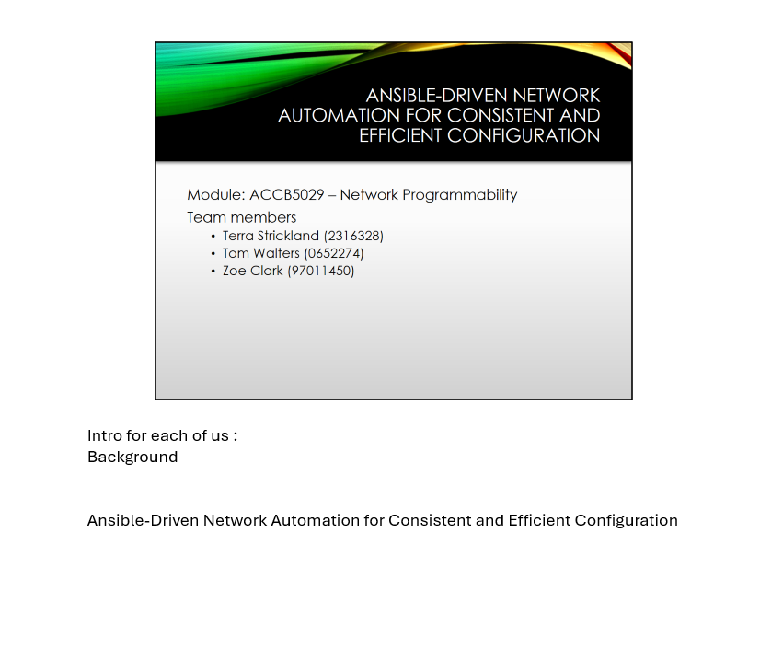
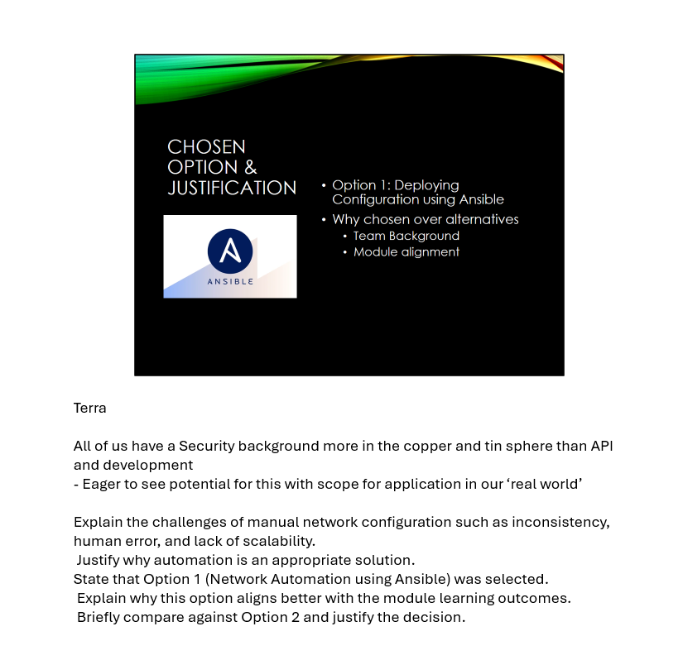
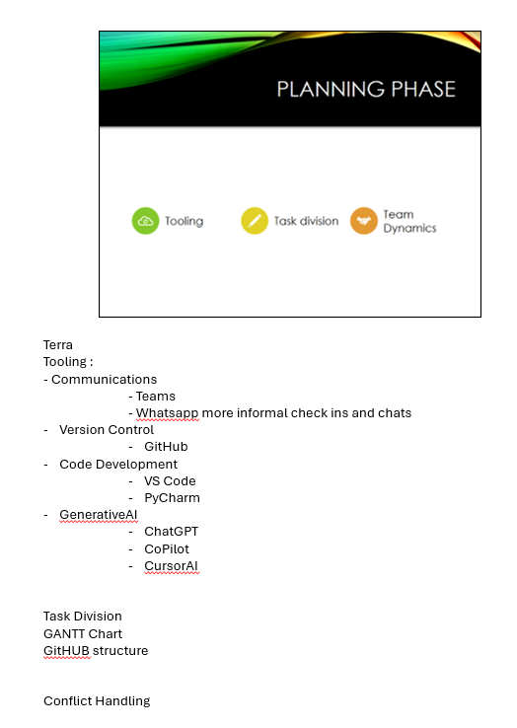
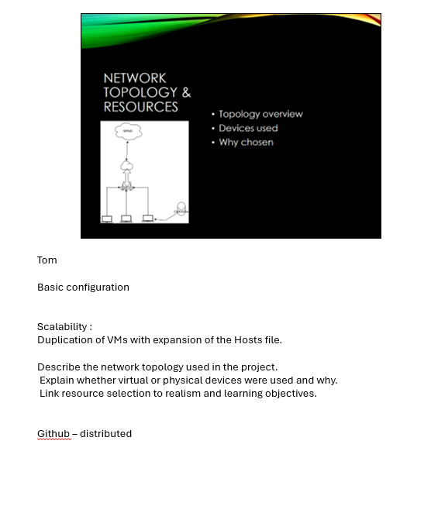
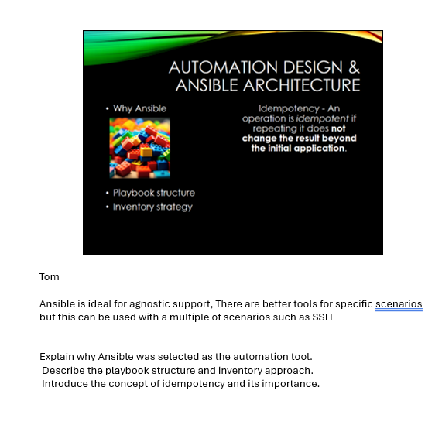
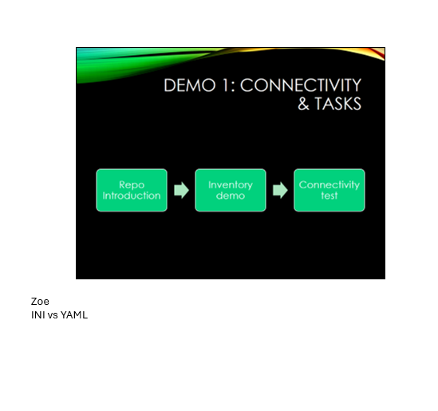
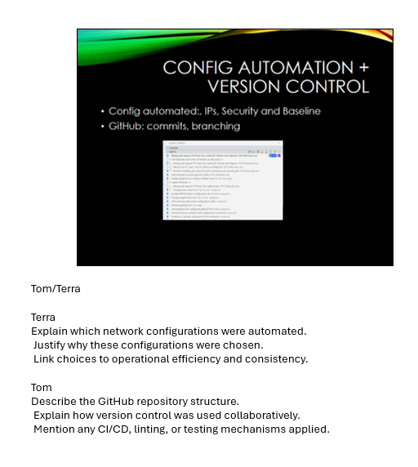
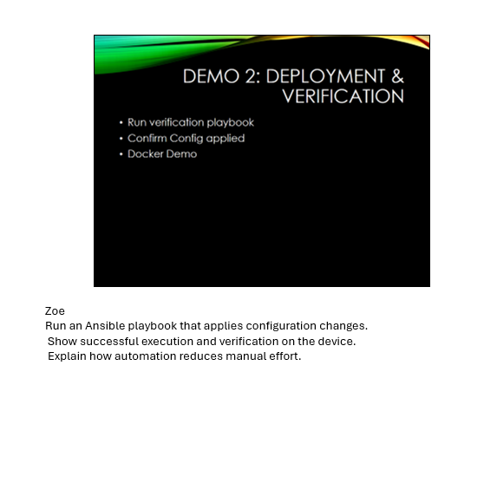
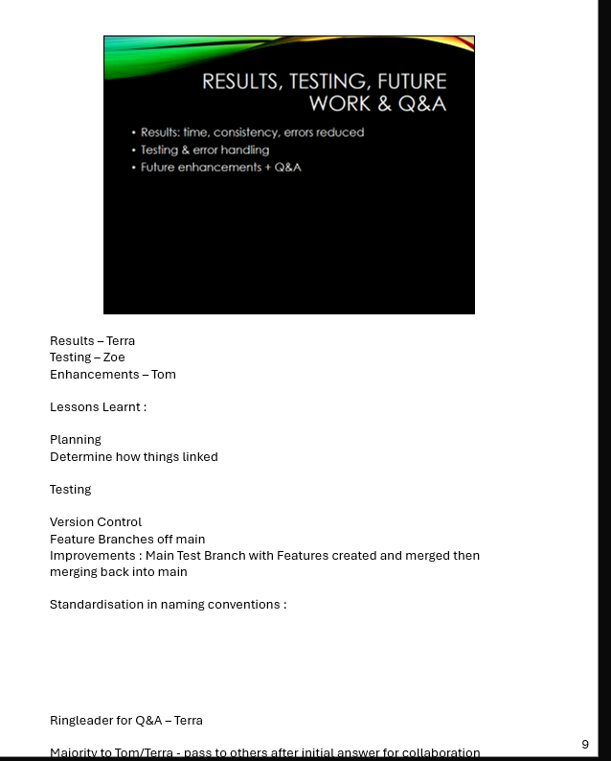

This is a compilation of group material. Submitters can only confirm other participants material as seen as declared.

END OF DOCUMENT

