
Sports Industry Research
Project Proposal M6X02100
Assignment 1

Student Name

Martene Morgan

Project Title

- Evaluating the challenges and barriers from a Sports Development Officer perspective, that ks3 and ks4 girls are facing when participating in Physical activity.

Insert Rationale – Why are you researching this area (Screenshot from PowerPoint)

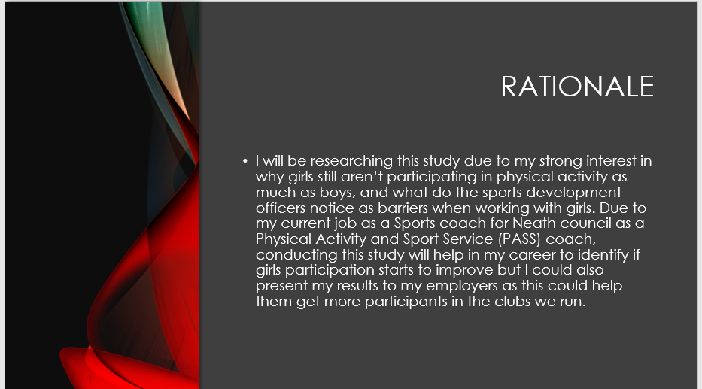

Insert Project Aim and Objectives into the table below (Screenshot from PowerPoint)

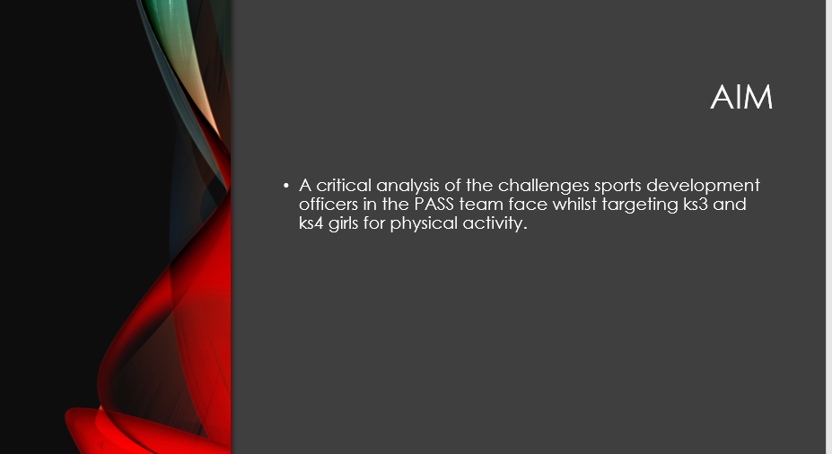

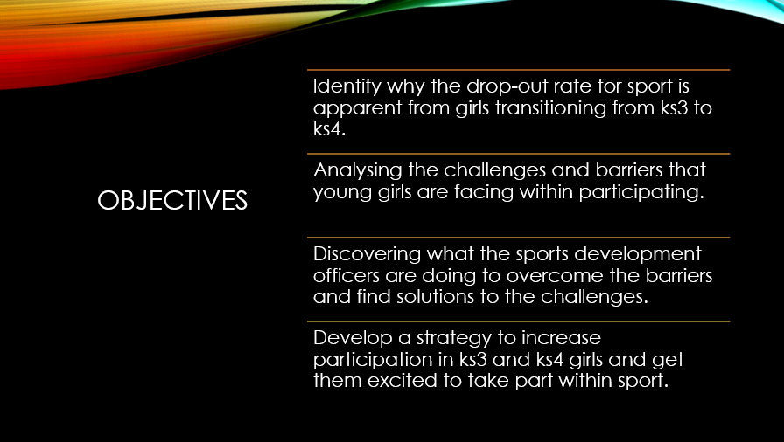

Insert Background to the Organisation, Facility, Group or Athlete into the table below (Screenshot from PowerPoint)

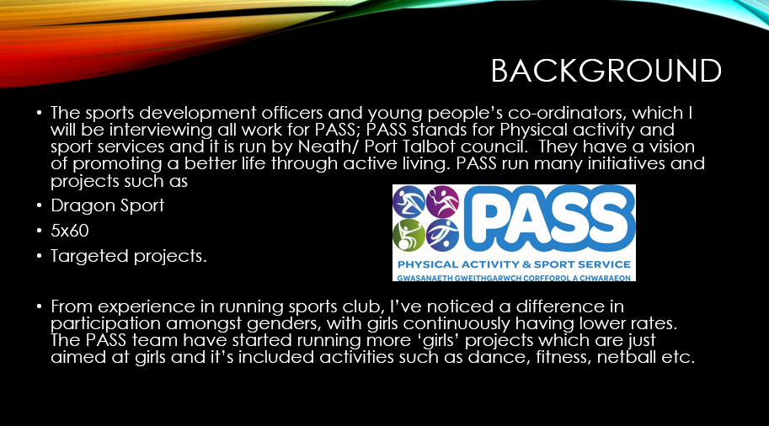

Insert Miniature Literature Review into the table below (Screenshot from PowerPoint)

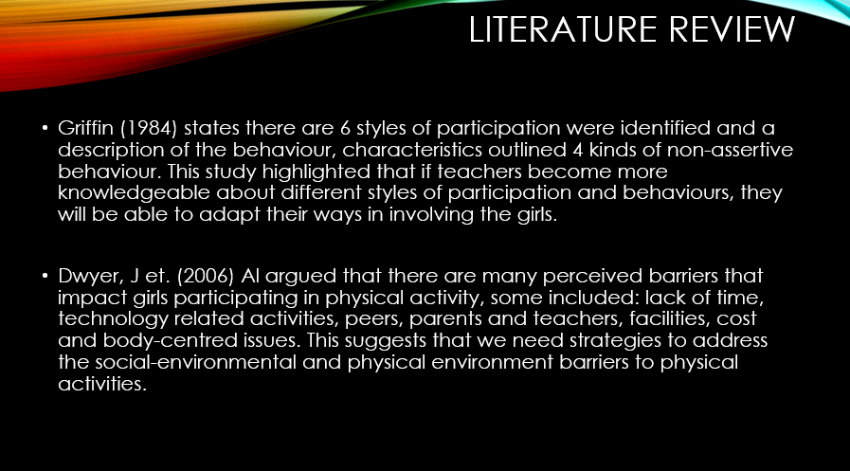
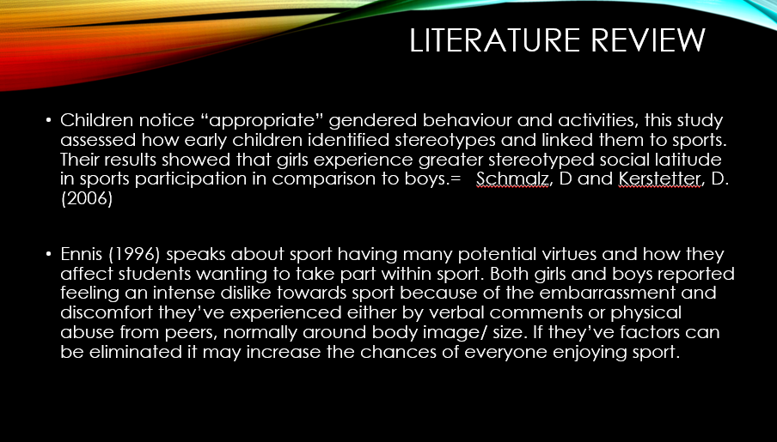

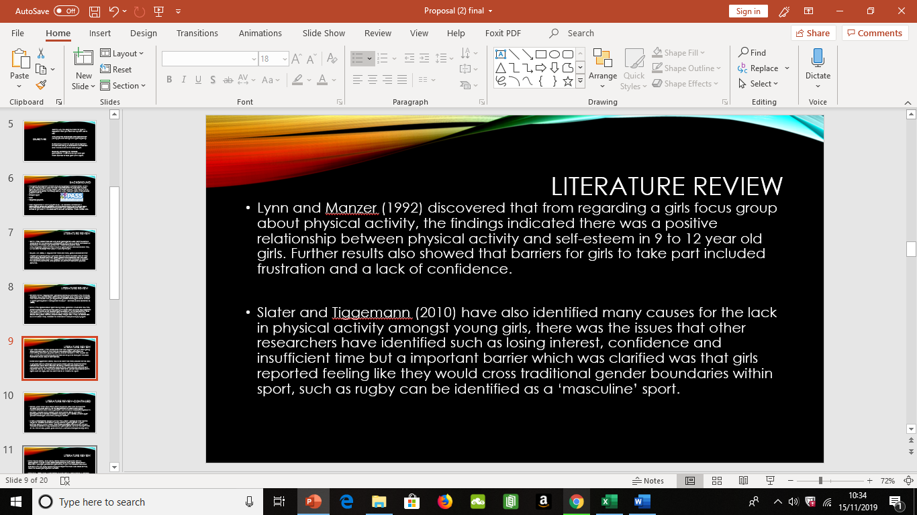
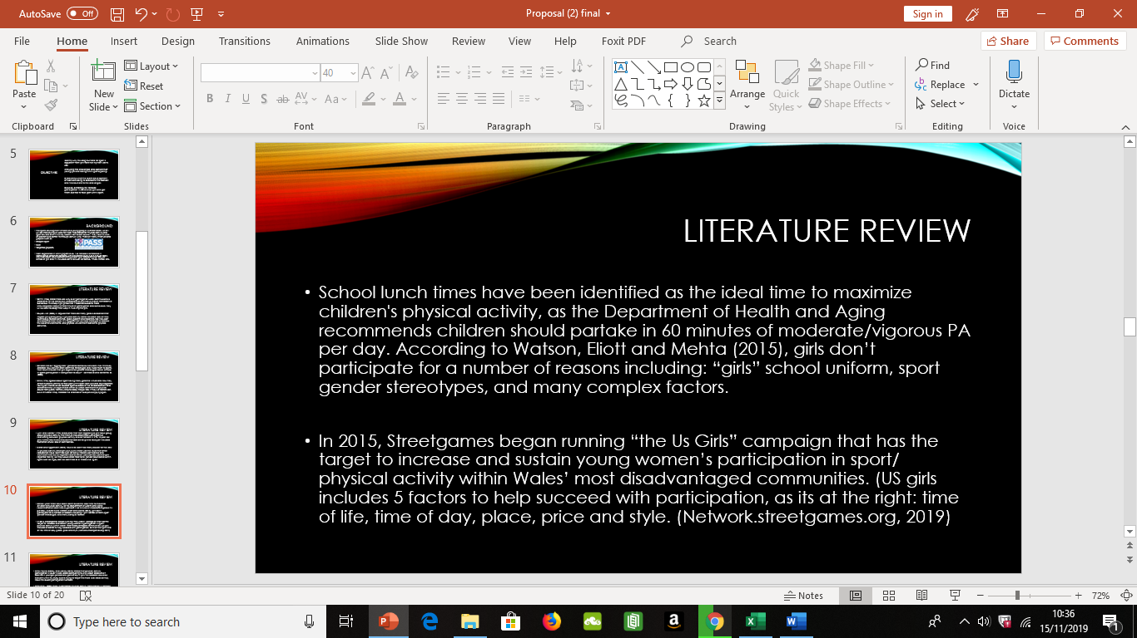

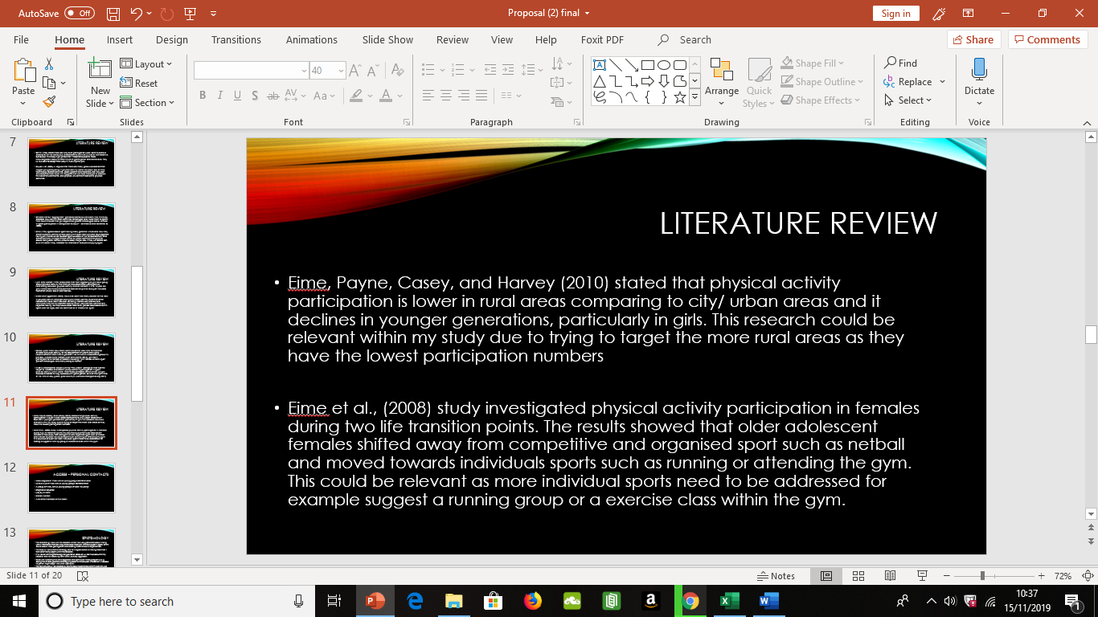

Insert Access to Resources and Methodology into the table below (Screenshot from PowerPoint)
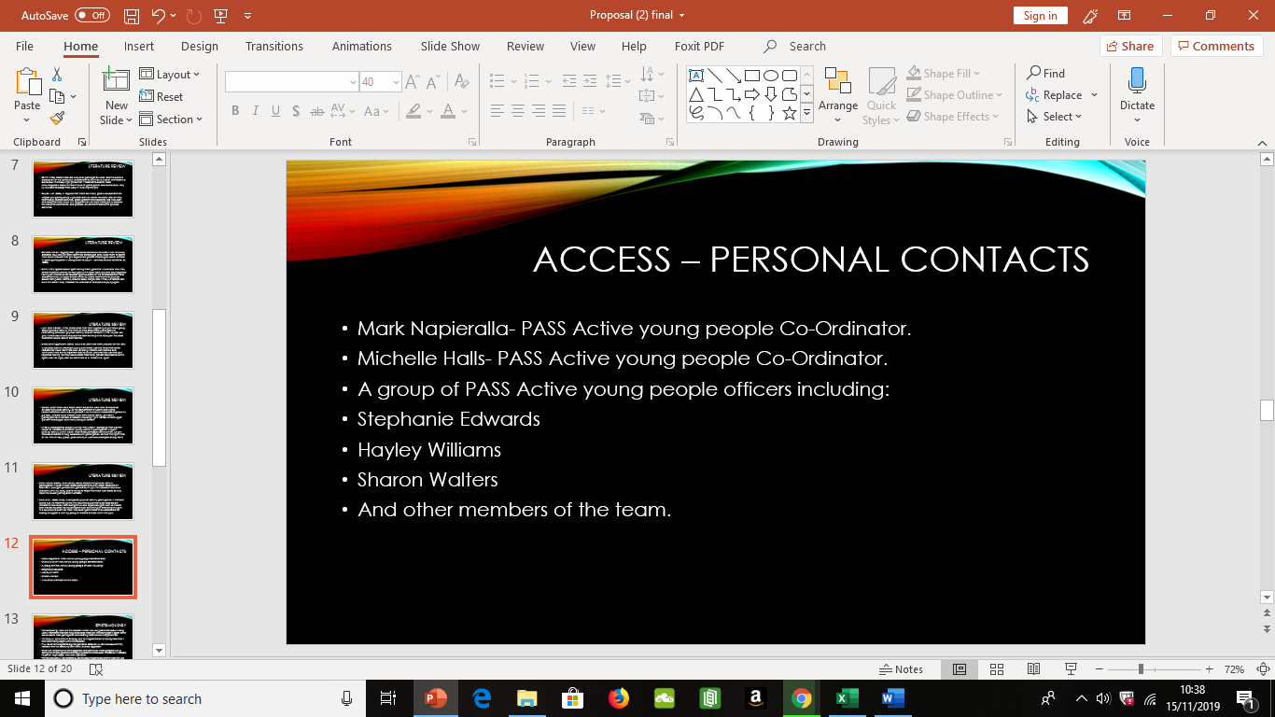
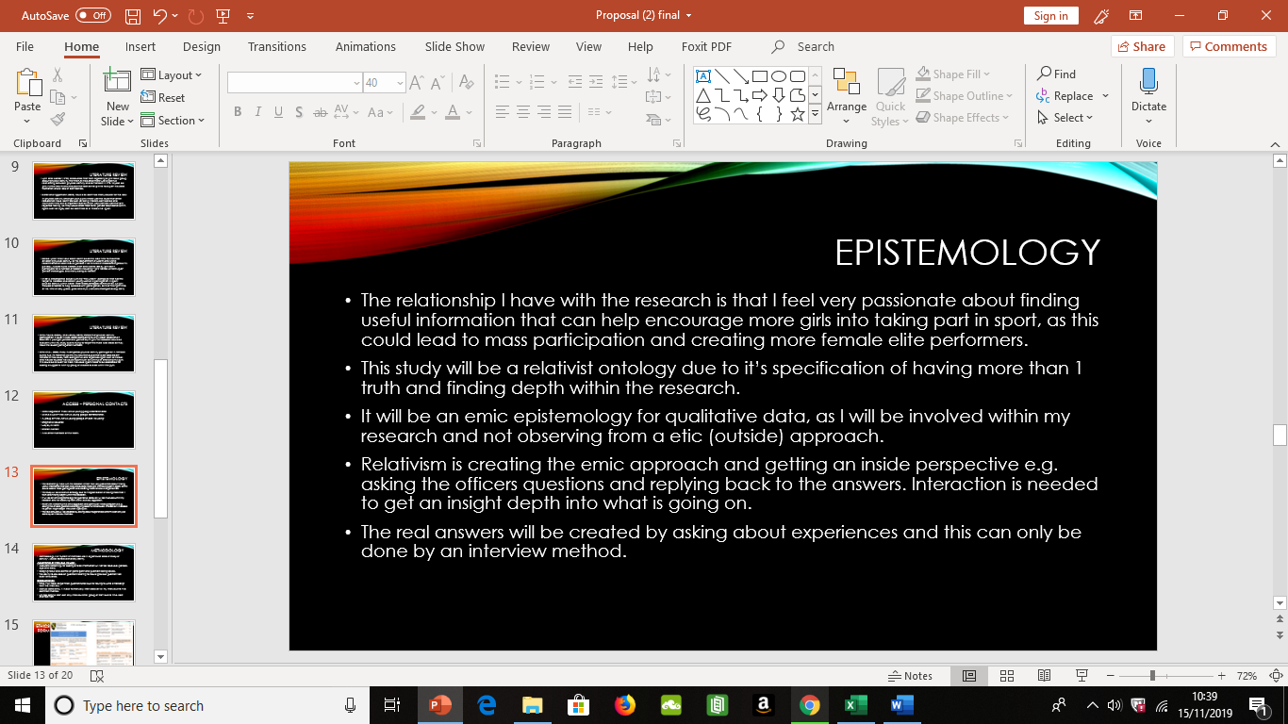

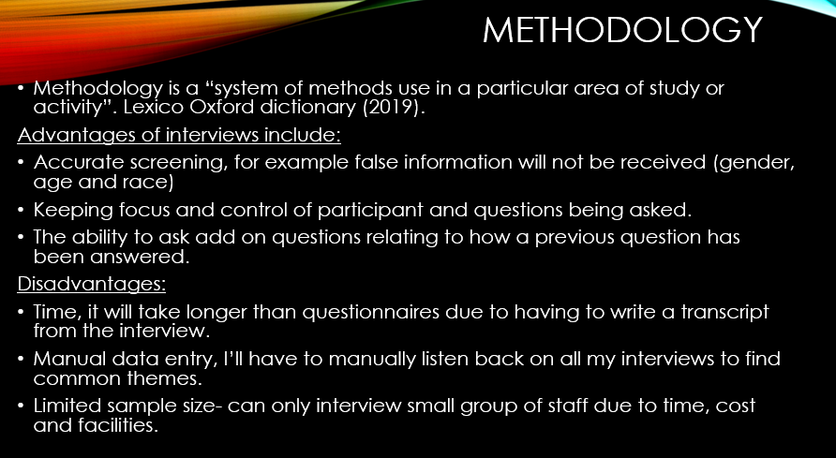

Insert Timeline into the table below (Screenshot from PowerPoint)

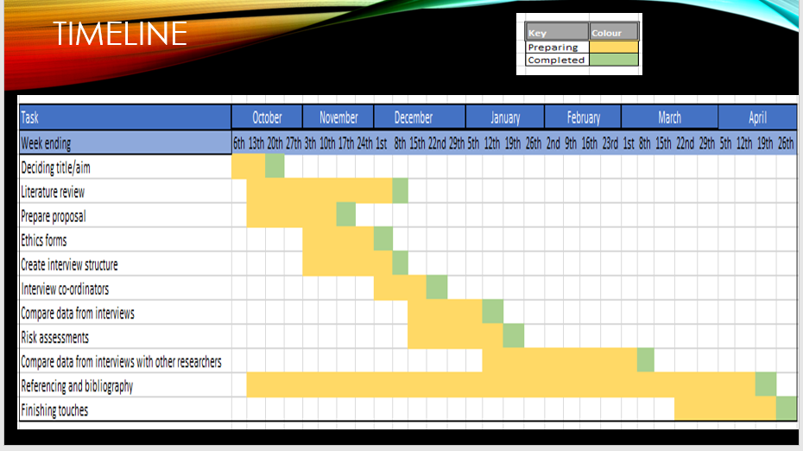

Insert Bibliography, Books, Online Sources and Professional Bodies into the table below (Screenshot from PowerPoint)

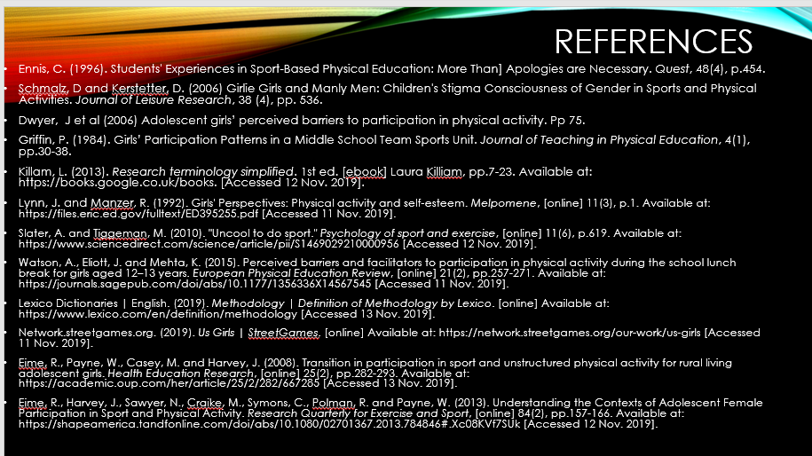

Insert Ethics Form P1 into the table below

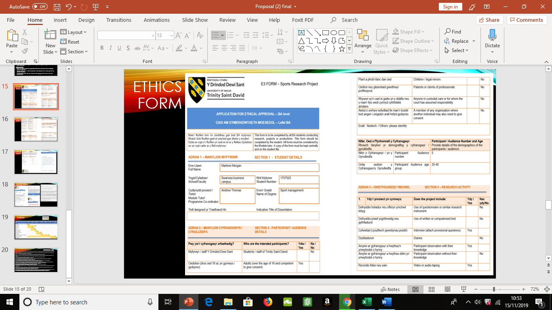

Insert Ethics Form P2 into the table below

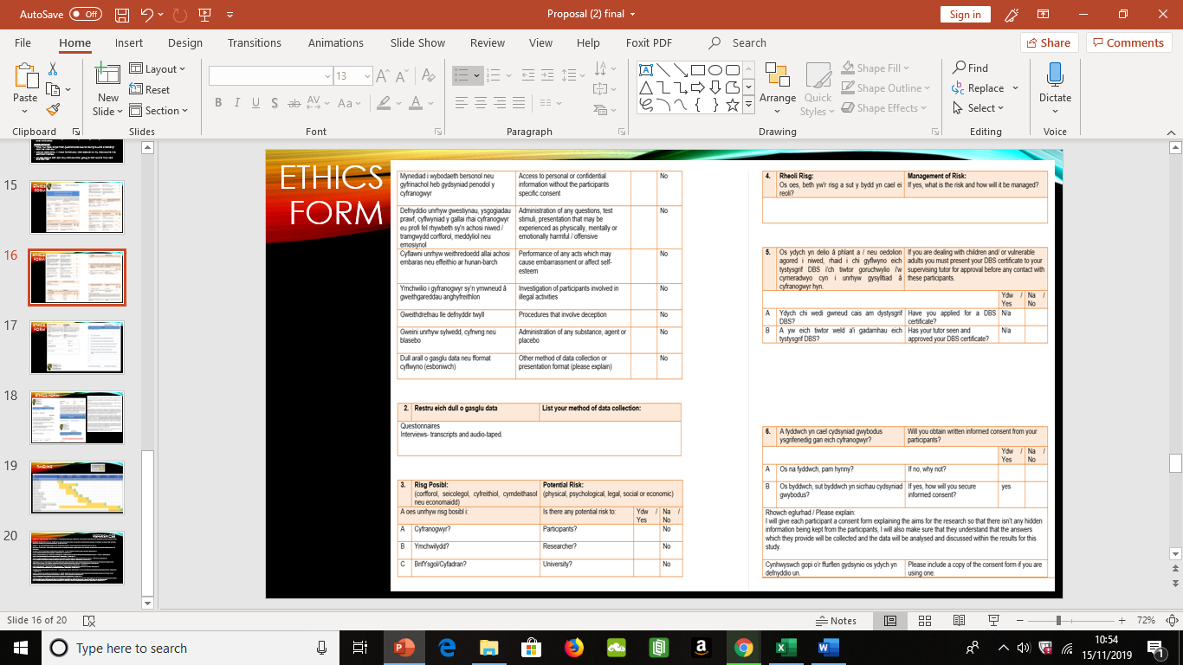

Insert Ethics Form P3 into the table below

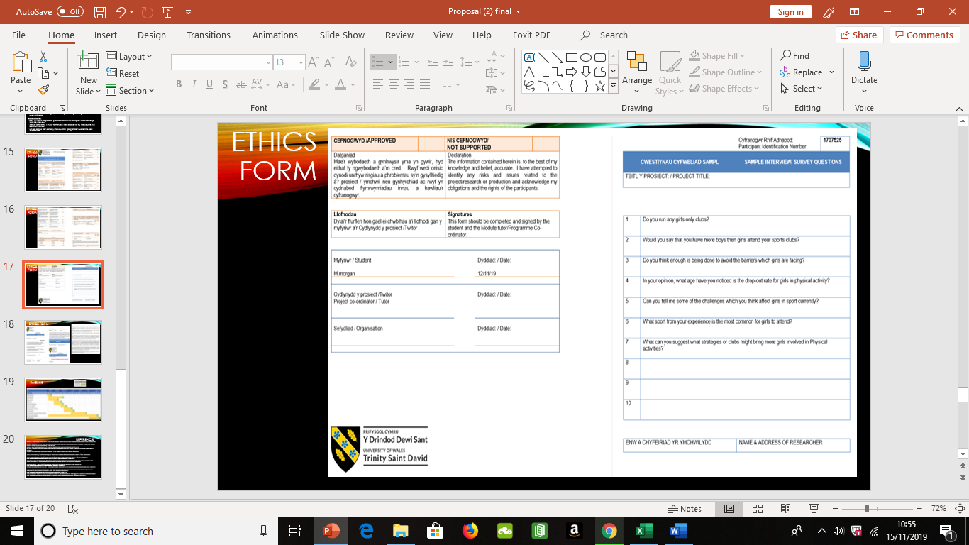

Insert Ethics Form P4 into the table below

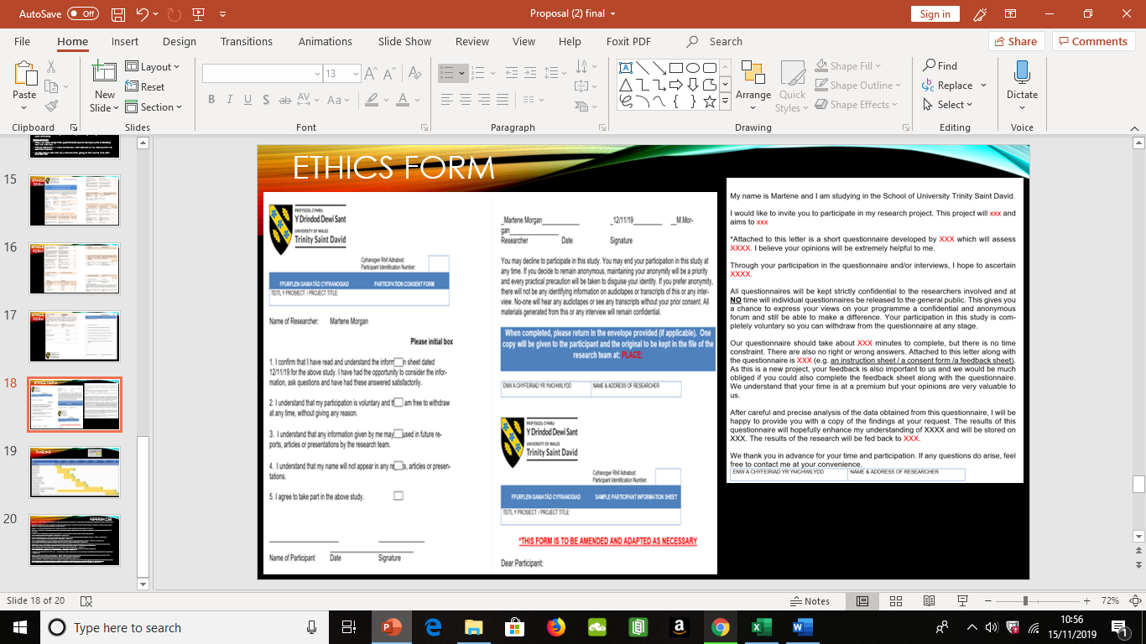

Insert Ethics Form P5 into the table below

Insert Ethics Form P6 into the table below

Insert Ethics Form P7 into the table below



Questions for Viva?

