CertHE Skills for the Workplace

Digital Skills & Reaserch Method
BMSW 4003

Task 2
Report about the impact of Virtual Learning Environment

Student: Sasha Galster n. 202986
Lecturer: Sadeque Shaikh

Page of context:

Introduction…………………………………………………………………………………………...3
Virtual Learning Environment………………………………………………………………………4
Analysis and Data Collection……………………………………………………………………….5
Conclusion…………………………………………………………………………………………...10
List of references……………………………………………………………………………………11

Introduction:
“Digital Skills and Research Method” is a module which as a class has been treated in online sessions. Due to Corona virus, we are obliged to work through online lessons and not more in presence, I am telling that, because this is the reason why I am writing this report, how the virtual learning environment has suddenly become an important way for the studies in the latest times. Digital skills in modern times are very relevant and indispensably in the workplace, most of the companies have an IT service department, which helps the company itself regarding any issue in the field of I.T. technology. Every single person should have IT competencies, at least the basic ones, such as how to use a computer, how to use some software such as the packet “Microsoft Office” (which is an important tool for writing, doing presentation or calculation etc.) and how to do online research, data collection and analysing. For students it is required to be confident on that for achieving higher education. In the past we were used to think about our learnings in front of a desk in the class, where close to us there is a lecturer who teaches us and improves our minds with what they themselves have learnt before in their classes. But time passes and what was ordinary before, in the present it is not any longer. Digital technology is not just influencing myself but every single person in the whole world. Lately also the pandemic has sustained the introduction of this modern and innovative way to learn. As I have said in the group presentation about how technology has had a big impact and has had an enormous influence in a company in comparison digital technology is a big component in our life nowadays in equally way. It seems that we can’t proceed without it, and now we rely more often on digital technology than ever. Such as smart phones, smart watches, smart televisions, computers and lately also robot for cleaning our own home or items for the kitchen are just examples of ordinary tech-tools we use every day. We rely also on high-tech because for example there is huge reduction of paperwork, in fact thanks to Cloud (a big networked digital storage), there is a service which helps to save our files metaphorically in the clouds, but it is online actually. Moreover, it is very useful for the Environment and for time managing too because everything is faster and helpful for cost reduction as well. Faster, saver, better for the world and with a low cost, it seems a good deal but sometimes it might be dangerous: for example, Data can be lost or stolen, but the “hosters” (cloud deployments) which can be private, public or multi ones are working on this issue and despite those inconvenient the advantages are bigger and most of the people take the risk of it. Furthermore, it is thanks to technical knowledge that the universities in Corona virus times could help the students in the entire world without closing. For uncertain and undefined time all the colleges could establish portals called Virtual Learning Environment (VLE), extending the lessons even if online courses with those Environments were already existing, consequently in this way the universities could still give the lessons to the students in the comfort of their own home without the necessity of going encountering the risk of the contagion of the virus.
Virtual Learning Environment:
According with Benjamin Franklin “Tell me and I forget, teach me and I may remember, involve me and I learn” I can say the same for this environment. VLEs are commonly utilized in education and other fields to distribute educational materials and improve communication (Barker, Jenny and Gossman, Peter 2013). Students can use VLEs to assist them moving from being passive to active learners. Active learning helps students to develop the critical thinking skills they need to transfer and apply classroom knowledge in the working environment. A VLE is becoming an increasingly significant component of skill development in a certain range of professions (Eimear Ryan, Claire Poole 2019). In my university, University of Wales Trinity Saint David, we have a portal called Moodle which is very popular and used by most of the universities because free of cost. Moodle is the acronym of Modular Object-Oriented Dynamic Learning Environment. It may seem difficult on the first glance, but after a while you are navigating inside the portal you will understand how you have to use it, being an active participant. This portal helps the students with everything they need for themselves and their learnings: from looking for the scheduled lessons you might have, checking the results of your tasks, to a proper researching in the University library, very useful tools, indeed, for your assignment. And those are just few parts of this modern environment. Moodle is a free learning management system that enables you to construct engaging, powerful, and adaptive online learning environments. There may be some email or bulletin board communication between the teacher and the students. On the other side, online learning can have a lot more fun (William H. Rice IV, 2006). After all being an active student in the university, I think it is a beautiful and positive and moreover having the awareness in what is happening I guess is better than of being unconsciousness, and the portal provides all those approaches which in a common way may not have. Let’s see what the students think about the virtual learning especially about this one, Moodle. With the help of a survey conducted between different students and proposed through Microsoft Teams, a virtual platform for communication and live-virtual lessons which is a useful tool, not just for communication, but also for sharing and exchanging files which connects all the students and the lectures in that case too. In effect we can analyse how the students have found this new environment very useful. In the following pages I am going to show all the questions I have proposed and how the students have answered. I came up with eight questions: Do you think Moodle is good for virtual learning? How often do you use it? Does it work for your necessities? How useful was the course material? It was clear how to use it? Are the lectures prepared for answering any questions? Will you suggest it as virtual learning? Are you comfortable using it? And with the benefit of SurveyMonkey an online page which helps you creating surveys, I have design one and propose it in the different online sessions.
Let us see, how the students have returned the answers back.
Analysis and data collection:

- Do you think Moodle is good for virtual learning?
RESPONSE ANSWER CHOICES
Excellent 54.55%

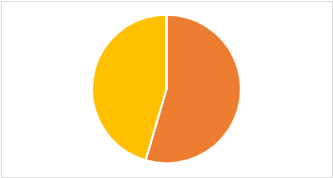
Very good 45.45%

Good 0.00%

Poor 0.00%

- How often do you use it?
RESPONSE ANSWER CHOICES
Always 36.36%
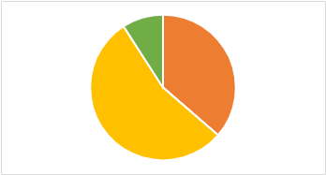
Usually 54.55%

Sometimes 9.09%

Rarely 0.00%

Never 0.00%
- Does it work for your necessities?
ANSWER CHOICES RESPONSES
A great deal 30.00%
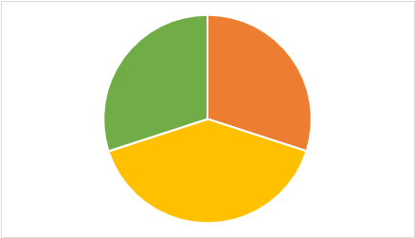
A lot 40.00%

A moderate amount 30.00%
A little 0.00%

None at all 0.00%

- How useful was the course material?

ANSWER CHOICES RESPONSES
Extremely useful 45.45%
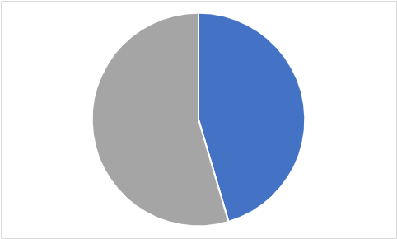
Very useful 54.55%

Somewhat useful 0.00%

Not so useful 0.00%

Not at all useful 0.00%

- It was clear how to use it?

ANSWER CHOICES RESPONSES
Extremely clear 45.45%
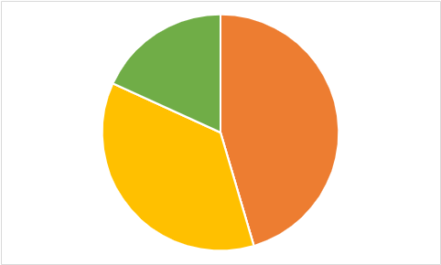
Very clearly 36.47%

Somewhat clearly 18.18%

Not so clearly 0.00%

Not at all clearly 0.00%

- Are the lectures prepared for answering any questions?

ANSWER CHOICES RESPONSES
Always 90.00%

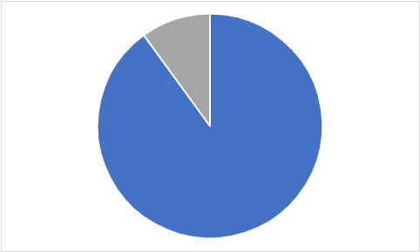
Usually 10.00%

Sometimes 0.00%

Rarely 0.00%

Never 0.00%

- Will you suggest it as virtual learning?

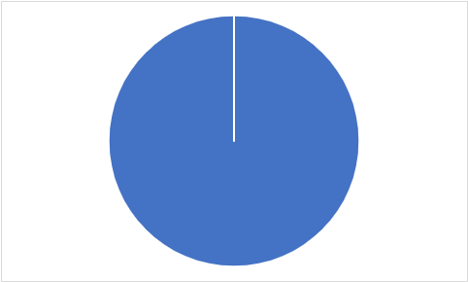
ANSWER CHOICES RESPONSES
Yes 100.00%

No 0.00%

- Are you comfortable using it?
ANSWER CHOICES RESPONSES
Extremely comfortable 45.45%
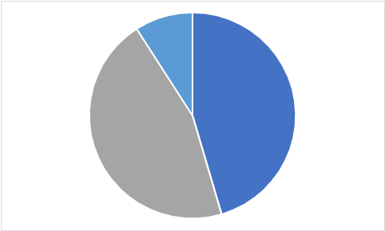
Very comfortable 45.45%

Somewhat comfortable 9.09%

Not so comfortable 0.00%

Not at all comfortable 0.00%

As you can see from the previous questions and the pie charts (which I have created in Excel and then copied and pasted in this document) there are not significant differences in the percentual between the various percentual. It has been denoted that Moodle most of the cases is liked by the students. We don’t have big differences, but for sure we can agree that all the students at least in that small survey will suggest Moodle as virtual environment for learning. I can also say, most of the student are happy with this new way of learning and it is possible to deduct too that no one of the students in the survey is unhappy, or not comfortable using this environment. For sure this is just a small example of primary data analysing (primary data analyse is a conduction and collecting of data done by my own, in that case of the survey, where I have conducted the research and collected the information). In view of what I have written, data analysing, and method research is another task we should have for to proceed of our higher education. The ability to do research with proper adequate method is fundamental. That is called Data collection and Analysis, in the terms I have described above. There are many tools in data collection such as questionnaire, checklist, distribution, interview, observation, records, experimental and survey. The last one is the one I have used in this small data collection. Besides there is another data analysing and it is called secondary data (secondary data analyse and it means data collection conducted and collected from someone else), in the following words I am going to show and report what other have researched and workshopped. For example, Data studies shown by several research and highlight shortcomings such as a lack of technological knowledge, traditional training, and the financial commitment required to employ these technologies (Torres Martín, César, Christian Acal, Mohammed El Homrani, and Ángel C. Mingorance Estrada 2021) According to other report, students are enthusiastic about using VLEs and recommend that all teachers utilize them in their classes. Students also acknowledged that, although living in a digital age where personal digital devices are ubiquitous, coping with certain types of instructional technology can be challenging (Eimear Ryan, Claire Poole 2019).

Conclusion:
After the understanding how to do research with appropriate tools we analyse them, and we put all the informations togheter. As I’ve done above. Usually for an appropriate survey we should have a bigger number of students but because this was just an example, they were eleven, the number who participated. That is for understanding the divergences and differences about primary and secondary data. Because in one case people can agree with argoment and the other case they can’t and have different point of view. For example, for my research I’ve conduct the survey which I showed previosly and most of the agreed with the good efficiency of the virtual learning environment, Moodle, and then after few other research I can see that other student they don’t agree with what I have collected. For sure the data research I did it has not finished yet and still have to do a lot. I can’t rely in what I have collected because as I said then number are less then should be. But I am very proud for what I have done and before I have never imagined talking about data analysing and what it will comport but this is also another aspect of digital technology which is influencing every day more our lifes. I don’t know what this subject will bring us for sure we are just in the beginning of this path which every day is changing and evolving in something smarter, clever, and bigger. I do not know if I will be part of this changing perhaps yes or maybe not but for sure now, I have some more tools for analysing them which it is really important for understanding better the concerns around us as a student, as a human being and also as worker

List of references:
Barker, Jenny and Gossman, Peter 2013, The learning impact of a virtual learning environment: students’ views. Teacher Education Advancement Network Journal (TEAN), 5 (2). pp. 19-38.
Eimear Ryan, Claire Poole 2019, Impact of Virtual Learning Environment on Students’ Satisfaction, Engagement, Recall, and Retention, Journal of Medical Imaging and Radiation Sciences, Volume 50, Issue 3,
Torres Martín, César, Christian Acal, Mohammed El Homrani, and Ángel C. Mingorance Estrada 2021. "Impact on the Virtual Learning Environment Due to COVID-19" Sustainability 13, no. 2: 582. https://doi.org/10.3390/su13020582
William H. Rice IV Moodle 2006, E-Learning Course Development A complete guide to successful learning using Moodle

