Student Name : Valentin Dan Simion
University Name : University of Wales Trinity Saint David’s
Student number : 2222011@student.uwtsd.ac.uk

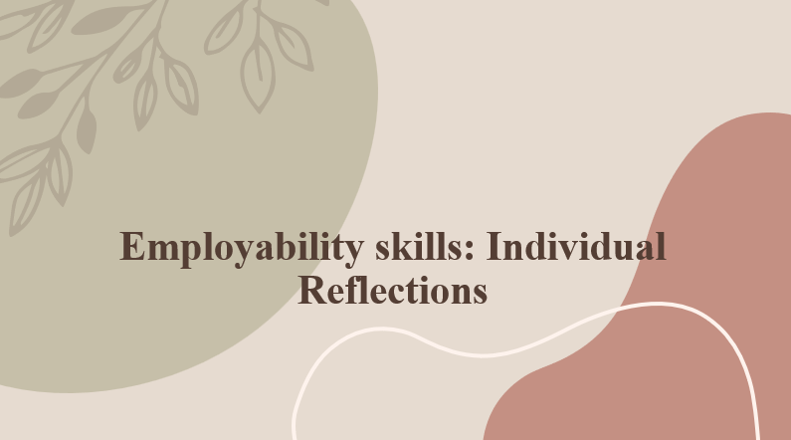
Table of Contents
Part 1 3
Introduction 3
Skills required for betterment in the future 4
Engagement and literature skills 4
Challenges faced with engagement and literature skills 5
Benefits, I can have with the aforementioned skills 6
Knowledge and understanding skills 6
Some challenges which I faced while generating understanding and knowledge skills 7
Benefits of understanding and knowledge skills 8
Transferable skills for professional career and life 9
Challenges that I faced while improving the above-mentioned skills 10
Benefits that I have with the help of the transferrable skills 11
Conclusion 13
Part 2 14
Introduction 14
Understanding the learning experience of new skills by using a reflective model 15
Conclusion 19
References 20

Part 1

Introduction
Slide
Notes
The following reflection will show different types of skills which is essential for an individual in their academic and also in their professional career as well. Along with those skills, the challenges that I have faced have also been elaborated on in the below reflection. Other than this, some of the benefits have also been discussed below.

Skills required for betterment in the future
Slide
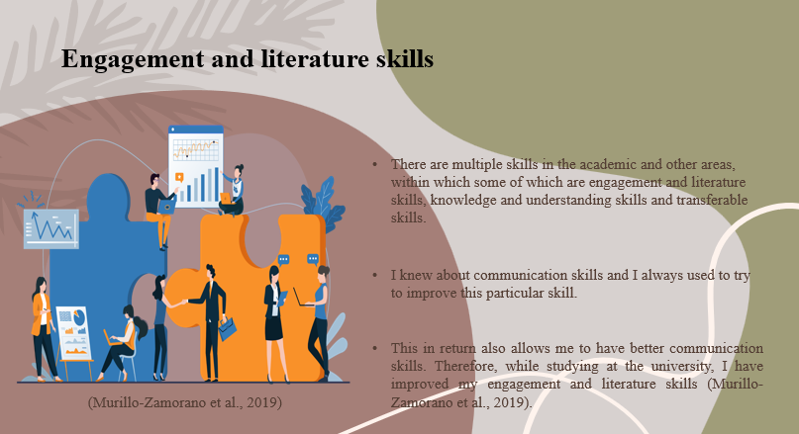
Notes

Engagement and literature skills
There are multiple skills in the academic and other areas, within which some of which are engagement and literature skills, knowledge and understanding skills and transferable skills. These types of skills are essential for the students and also the individual in multiple ways. They help the students in their academic careers and also in their professional careers as well in the future. Engagement skills usually mean and include different types of skills such as communicational skills, active listening skills and also influencing skills. These types of skills are quite essential in multiple areas such as in the universities and also in the professional field as well. While gathering knowledge and generating these specific skills I have come to know about multiple other aspects such as influencing and active listening skills (Murillo-Zamorano et al., 2019). I knew about communication skills and I always used to try to improve this particular skill. On the other hand, I was unaware of my influencing skills. I and multiple other people are normally used to this term about influencing other people with words and only talking to them. Later I came to know that there is a particular skill named the influencing skills. Therefore, talking casually, I can say that my influencing skills are quite better. This in return also allows me to have better communication skills. Therefore, while studying at the university, I have improved my engagement and literature skills (Murillo-Zamorano et al., 2019).

Challenges faced with engagement and literature skills
Slide
Notes
While generating this specific skill, I have faced multiple challenges as well while interacting with the other students in the classes. These issues were ultimately reduced and the other students in the class became my friends. Moreover, during university, I have tried a lot and interacted with others, which could be the reason I have achieved this skill (Murillo-Zamorano et al., 2019).

Benefits, I can have with the aforementioned skills
Slide
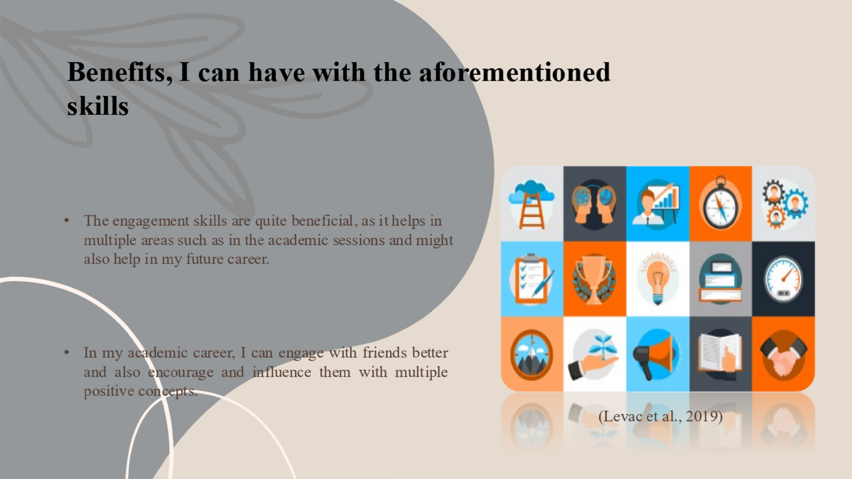
Notes
The engagement skills are quite beneficial, as it helps in multiple areas such as in the academic sessions and might also help in my future career. In my academic career, I can engage with friends better and also encourage and influence them with multiple positive concepts.

Knowledge and understanding skills
Slide
Notes
Knowledge skills are nothing but having great knowledge of certain aspects like technology, software and Big Data. My primary institutions actually had these topics and lessons in my syllabus. This is because I usually have quite some knowledge and skills in these elements. Other than this, the understanding skill is also quite easy to understand as it includes understanding others' perspectives and behaviours (Levac et al., 2019). While in my university classes, I started improving my knowledge and understanding skills. This helped me to understand my friends better, during any intense conversation. Understanding other people and their behaviour also helps in making the relationship with friends and family better.

Some challenges which I faced while generating understanding and knowledge skills
Slide
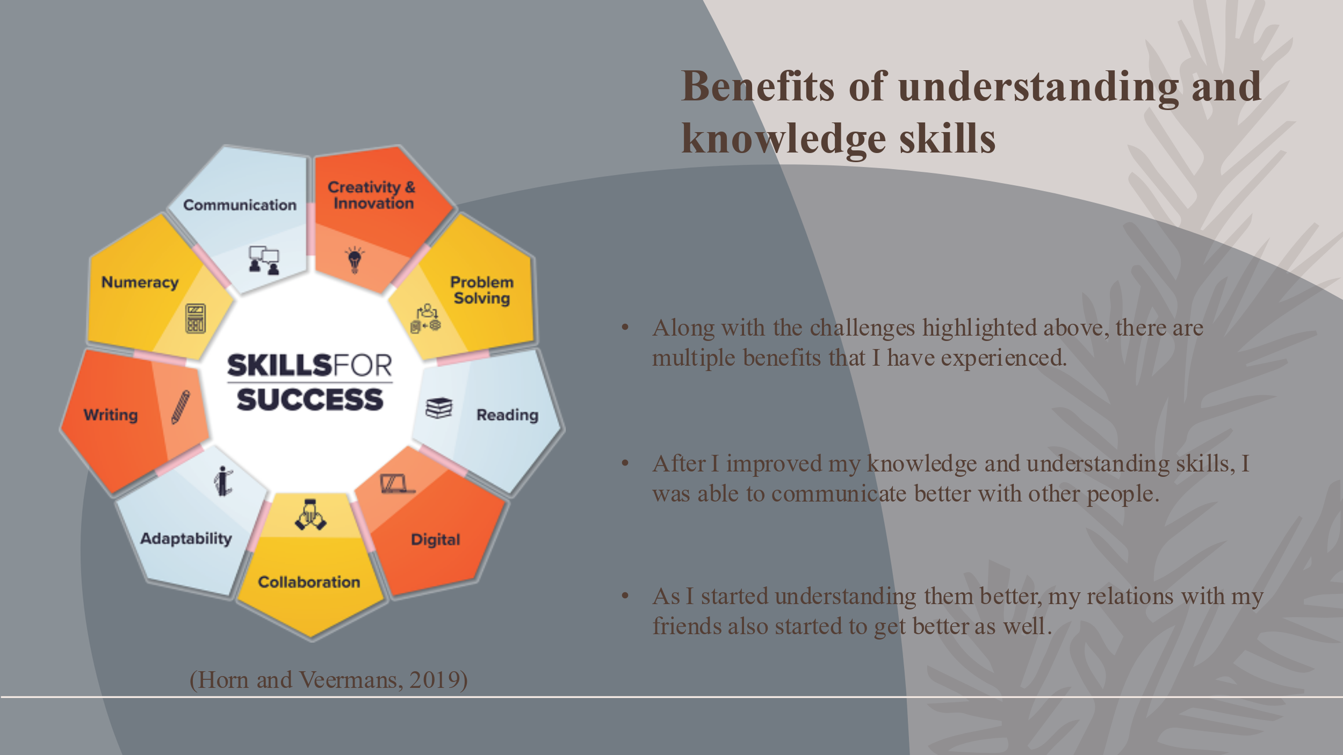
Notes
During my university classes, after I came to know about understanding skills, I thought it was quite practical. It made me gather interest in improving my communication with other students and also teachers at my university. I have multiple misunderstandings as well with my friends due to a lack of understanding skills (Levac et al., 2019).

Benefits of understanding and knowledge skills
Slide
Notes
Along with the challenges highlighted above, there are multiple benefits that I have experienced. After I improved my knowledge and understanding skills, I was able to communicate better with other people. As I started understanding them better, my relations with my friends also started to get better as well.

Transferable skills for professional career and life
Slide
Notes
Transferable skills include a lot of things and a lot of different categories of skills. Some of them are problem-solving skills, critical thinking skills, leadership and also teamworking skills. Among these previously mentioned skills, I have already generated and am quite good at the team-working and leadership skills. These skills are mainly good for me because, during the academic sessions, I got the chance of leading multiple teams during assignments and other aspects (Horn and Veermans, 2019). Moreover, during the academic sports at my university, sometimes I use to lead the team for the college in my senior years. This has increased my teamwork and leadership skills. While working in a group with other members helps me to understand the criteria of the assignments, understand other perspectives and other aspects as well. Working together also helps me and the other students or individuals to learn various other skills and gather knowledge regarding different aspects (Hill et al., 2019).

Challenges that I faced while improving the above-mentioned skills
Slide
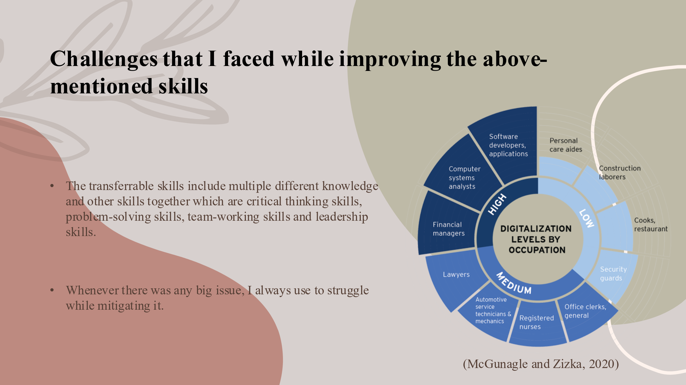
Notes
The transferrable skills include multiple different knowledge and other skills together which are critical thinking skills, problem-solving skills, team-working skills and leadership skills. Whenever there was any big issue, I always use to struggle while mitigating it. This is one of the flaws that I need to improve. I tried to improve these particular skills, but I am lacking somewhere in between. This is the reason why I am still unable to generate these specific skills on my own (McGunagle and Zizka, 2020).

Benefits that I have with the help of the transferrable skills
Slide
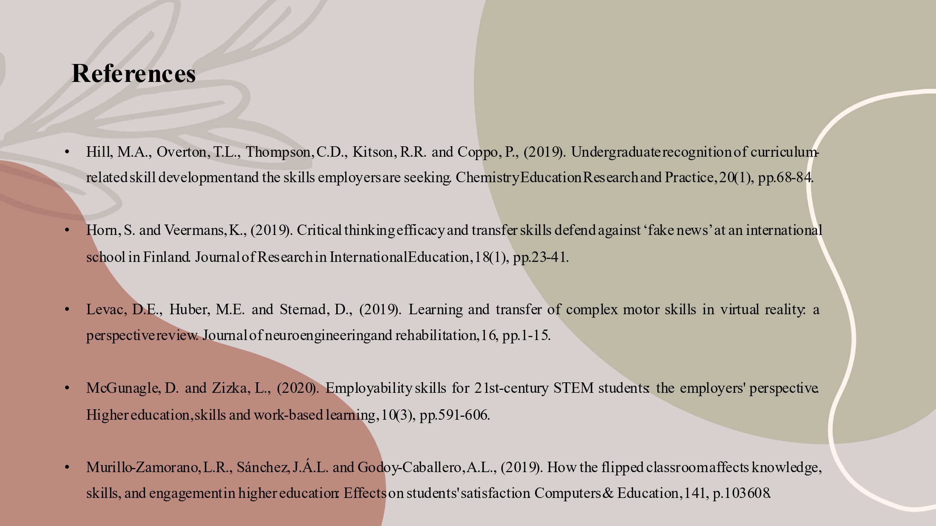
Notes
Transferrable skills include multiple other skills within them which I have mentioned earlier. Those particular skills are quite essential for me and other individuals as well. it helps us in the academic field, in life and also in our future professional careers. I can use my communication skill and also the teamwork skills in my professional field and gain recognition as well (McGunagle and Zizka, 2020).

Conclusion
Slide
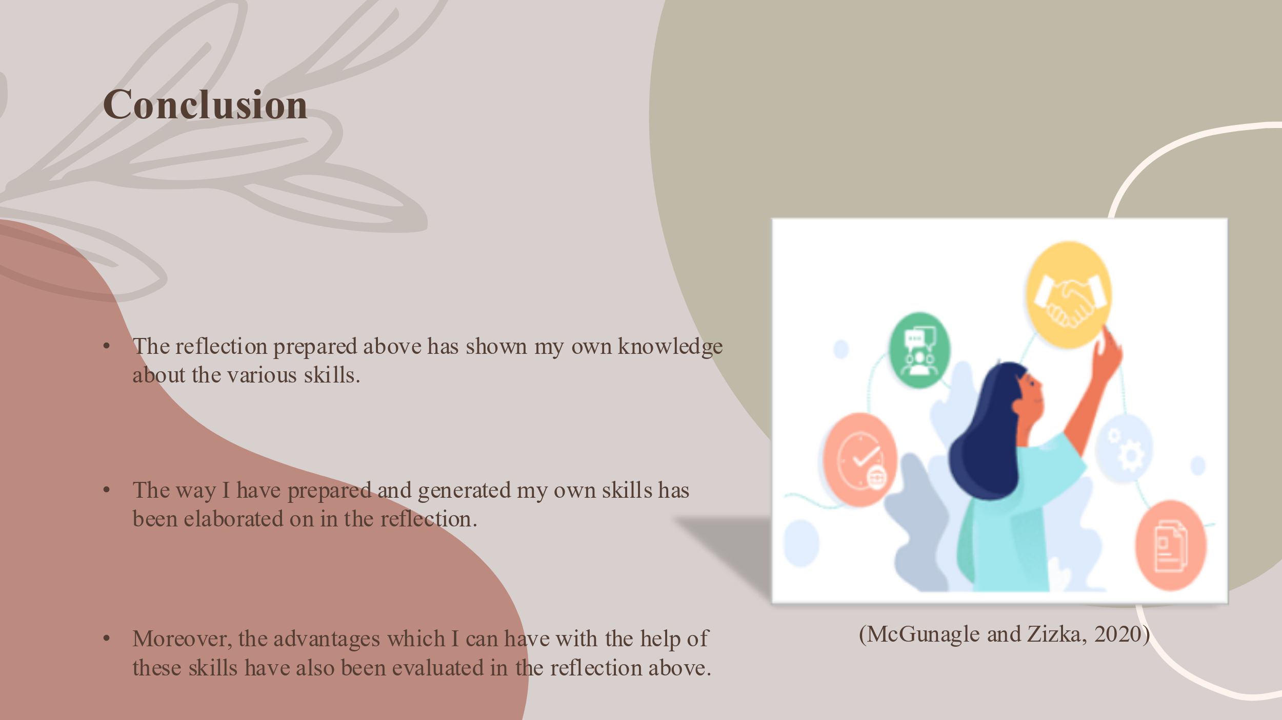
Notes
The reflection prepared above has shown my own knowledge about the various skills. The way I have prepared and generated my own skills has been elaborated on in the reflection. Moreover, the advantages which I can have with the help of these skills have also been evaluated in the reflection above.

Part 2

Introduction
There is a variety of skills that are necessary to be an independent and resilient learner. The regular practising of major skills such as transferable, understanding, literature, practical skills, time management, effective communication skills and so on will be effective for the individuals to receive new opportunities in future career development. Learners with the combination of these skills can aid them to be more efficient in their academic area as well as professional field that will be helpful for them to achieve their targets. The use of suitable modern technology and the support of teachers can escalate the learning experience of the individuals within a consistent and discipline area. Literature skills are a compilation of soft skills as well as technical skills that assist people to get insights and write multiple literary texts. Understanding skills address the dispositions and capabilities of the learners on the basis of knowledge from an object. These are sufficient to provide support for the intelligent behaviours and attitudes of the individuals. There are several transferrable skills including problem-solving, critical analytical, communication, creativity, leadership, teamwork, project management and many others that play a versatile role in growing the career of the students. Transferrable skills are referred to as the combination of soft and hard skills as well that provide enormous benefits to the learners to get better results in life. The following study is based on the different areas of reflection on the newly acquired skills such as literacy skills, understanding and knowledge and transferrable skills. The particular context will cover all aspects of those mentioned skills by applying a recognised model of reflection.

Understanding the learning experience of new skills by using a reflective model
There are several renowned reflective models among them is the one has been first introduced by Graham Gibbs in 1988. He has published his thoughts and perspectives about reflection in the book named Learning by Doing. The respective model is significantly essential for people to learn and acquire new things from regular situations as well as previous events that they have experienced in the past. It is also crucial for them to make sense of and attitudes of situations in a particular area so that the individual can realise their previous performance along with future betterment in the field of career. The mentioned framework of Gibbs assists people to examine and review their gained experiences (Roedema, et al.,2022). The cyclic nature of the model enables me as a learner to collect new facts and information from the accumulated skills and to make a plan regarding the ongoing situation of learning and future performance. It is composed of six stages that have been elevated in the below section as follows;
Description
I have got opportunities to assess the specified situations with a detailed discussion with the help of the particular stage of Gibb's reflective model named description. The primary element of the step is an ongoing situation that happened to get outcomes in future. It takes a pivotal part in remembering the provided information about the accumulated skills that are relevant and concise in form. I have realised that learning literacy skills are not an easy task. Literature skills include making inferences from the text through a better understanding of the social, political and historical context for the development of reading comprehension, writing skills, critical thinking as well as communication skills (Van Laar et al.,2020). I have prioritised my literacy skills to accelerate my writing abilities on the subjects of literature. I have also realised that the way of learning transferrable and understanding skills went wrong because of insufficient support from the teacher and other learning materials. There are chances to get minimal information after ending up in the description stage (Ardian et al.,2019).
Feelings
The second stage of the reflection approach of Gibbs is defined as the feelings and thoughts based on the particular situations that have experienced by me during the learning period of several skills. The detailed and honest discussion has escalated me to work harder in achieving my target of learning new things (Levac et al.,2019). I have realised from my past experience that little motivation will not be helpful in getting further opportunities. I need to concentrate on the core concepts and values of the literature and understand skills that will provide positive impacts on my area of learning. More concentration and a high level of smart thinking power have guided me to learn transferrable skills with complete satisfaction (Wallbridge, 2022).
Evaluation
The next step comes with the evaluation of the overall workings. I need to put focus on the favourable as well as negative impacts of the circumstances to deliver honest reflection on the basis of evaluation. I have felt difficult situations during the learning session of acquiring transferrable skills because of fewer mastery levels of my group as well as the teacher. It has led to facing negative sides for me. This skill will provide better chances to cope with the situations of the working settings. To overcome the knowledge gaps in particular skills I have to make the right strategies for learning such as priorities the work, managing time, communicating in an effective way and so on for further improvement. Gatherings of sufficient knowledge regarding literature skills, knowledge and understanding capacities have helped to receive good remarks on the literature subjects in my academic field.

Analysis
The fourth stage of the respective model is analysis. It has made sense and interest in the ongoing situation and its probable impacts. I have to increase my concentration power to analyse any situation critically. I was able to explore my strengths as well as shortcomings from the previous experience. The self-identified positive sides have influenced me to plan effective strategies for working harder in an organised way. The aforesaid stage is very significant to me to achieve a higher level of success. My learning gap has aided me to get poor marks that provide severe effects on my further career. It is expected that my quality decision-making system has helped me to remove my weaknesses in effective communication skills and intelligent behaviour.

Conclusions
It would have been easier to draw a conclusion for me after the learning program if I got relevant responses from my mentor and groups. I felt that the suitable actions based on the past events that I have been passed by my own abilities, need to be improved for attaining good outcomes in the literature subjects (Sweet et al.,2019). Apart from that, the group tasks will be effective for me to meet my career goals. The possible suggestions of my seniors can support my capabilities to gain knowledge from the abstracts and objects. My perceived experience of poor knowledge and understanding has enabled me to realise better strategies to overcome upcoming challenges in near future (Markkanen, et al.,2020).

Action plan
The last and final step of Gibb's model of reflection implies a proper way of action planning. Enough realisation might be helpful for making an appropriate action plan. To accomplish this step, I need to point out my potential to gain in-depth knowledge regarding learning programs for multiple skills. Moreover, I have to uplift my confidence level to grab huge opportunities in the professional sector. It leads to delivering good results throughout my career and afterwards, it will be useful for getting a better position and role in my working environment (Adeani, et al.,2020).

Conclusion

The respective study has shed light on the various learning aspects of new skills that help any kind of individual increase awareness. The reflective approach to learning can improve my overall performance at the present time. The structural process of the reflective model is used to guide me to analyse the situations and their regular improvement. Reflective learning emphasises our past experiences, beliefs, knowledge and skills. The report has illustrated the evaluation of new experiences in academic settings by constructing Gibb's reflective cycle. I have gained a wide range of knowledge and information from multiple skills such as literature, transferrable and other pivotal skills of life. Literature skills have allowed me to interpret the tasks of literature novels and stories and the way of the writing process in an efficient manner. Understanding skills can facilitate a learner like me to get insights into theoretical concepts as well as factual information. Transferrable skills are used to finish any kind of job in the professional field as well as academic settings. The multiple stages of the aforesaid reflective model have been demonstrated to understand the improvement area of learning those new skills.

References

Adeani, I.S., Febriani, R.B. and Syafryadin, S., (2020). USING GIBBS’REFLECTIVE CYCLE IN MAKING REFLECTIONS OF LITERARY ANALYSIS. Indonesian EFL Journal, 6(2), pp.139-148.
Ardian, P., Hariyati, R.T.S. and Afifah, E., (2019). Correlation between implementation case reflection discussion based on the Graham Gibbs Cycle and nurses’ critical thinking skills. Enfermeria Clinica, 29, pp.588-593.
Hill, M.A., Overton, T.L., Thompson, C.D., Kitson, R.R. and Coppo, P., (2019). Undergraduate recognition of curriculum-related skill development and the skills employers are seeking. Chemistry Education Research and Practice, 20(1), pp.68-84.
Horn, S. and Veermans, K., (2019). Critical thinking efficacy and transfer skills defend against ‘fake news’ at an international school in Finland. Journal of Research in International Education, 18(1), pp.23-41.
Levac, D.E., Huber, M.E. and Sternad, D., (2019). Learning and transfer of complex motor skills in virtual reality: a perspective review. Journal of neuroengineering and rehabilitation, 16, pp.1-15.
Levac, D.E., Huber, M.E. and Sternad, D., (2019). Learning and transfer of complex motor skills in virtual reality: a perspective review. Journal of neuroengineering and rehabilitation, 16, pp.1-15.
Markkanen, P., Välimäki, M., Anttila, M. and Kuuskorpi, M., (2020). A reflective cycle: Understanding challenging situations in a school setting. Educational Research, 62(1), pp.46-62.
McGunagle, D. and Zizka, L., (2020). Employability skills for 21st-century STEM students: the employers' perspective. Higher education, skills and work-based learning, 10(3), pp.591-606.
Murillo-Zamorano, L.R., Sánchez, J.Á.L. and Godoy-Caballero, A.L., (2019). How the flipped classroom affects knowledge, skills, and engagement in higher education: Effects on students' satisfaction. Computers & Education, 141, p.103608.
Roedema, T., Rerimassie, V., Broerse, J.E.W. and Kupper, J.F.H., (2022). Towards the reflective science communication practitioner. Journal of Science Communication, 21(4), p.A02.
Sweet, L., Bass, J., Sidebotham, M., Fenwick, J. and Graham, K., (2019). Developing reflective capacities in midwifery students: Enhancing learning through reflective writing. Women and Birth, 32(2), pp.119-126.
Van Laar, E., Van Deursen, A.J., Van Dijk, J.A. and de Haan, J., (2020). Determinants of 21st-century skills and 21st-century digital skills for workers: A systematic literature review. Sage Open, 10(1), p.2158244019900176.
Wallbridge, A., (2022). Gibbs Reflective Cycle – How To Learn From Experience And Become A Better Leader. [Online] Available at: https://www.tsw.co.uk/blog/leadership-and-management/gibbs-reflective-cycle/ [Accessed 21 March 2023].
Video Link : https://youtu.be/on2g1qJVC2Q

