
Digital skills research methods
Assignment
Lily chowdhury
Anly
1705997

Introduction
This report will be looking at the role of modern technology within the workplace and the use of social media as a tool for marketing, information gathering and communication within the workplace. The occurrence of social media has made it easier and convenient for people to communicate with thousands of other people about their businesses catered to the appropriate clientele. Therefore, customer relationships have been massively improved in the world of business.
(Mangold et al 2009).
Social media consists of various different types of websites and applications, such as Facebook, Twitter, Instagram, Snapchat etc. This allows users to create and share content via modern technology devices, such as IPhone, IPad, laptops etc. Marketing is promoting or selling a specific concept or product or services, through visual/physical aids such as advertisement. Social media can be used as a tool for marketing as it is quick and easy. Most social platforms are free; therefore anyone with access to internet can use it to directly engage with their preferred audience.
Technology has had a phenomenal influence over many aspects of society, it has been seen to have affected the workplace, people, relationships within society, however such developments within technology has been seen both in a positive light and negative light. The developments in technology have been on computers, telecommunications and satellites, which have been seen to have had a huge positive impact in regards to having a more productive and economically efficient society. The two areas where there has been an increase in the influence of such advanced technology would be the workplace and the global expansion of the media and communication industries.
The chief executive of the global media company News Corporation Limited, Rupert Murdock, made a statement in regards to the media, technology and world events. Stating that he has seen that over a period of thirty years the media has played a crucial role in liberating nations and also in having an influence on politics and culture around the world.
(Marjoribanks, 2000).

Modern technologies within the workplace
For businesses, technology is a vital tool as it drastically improves Communication within a workforce. Especially within an office environment, workers are not limited to phone calls or emailing to interact with one another.
Prior to the post-industrial era lots of manual work was carried out such as paperwork, that consumed a lot of money, man power and required more time. In addition, with advancing and progressing technology the presence of all individuals in a meeting is not required any more, as platforms such as skype and facetime has made it more flexible for people in the workplace to communicate. Furthermore, this progression has magnified many strengths of the technological era such as the increase in efficiency and effectivity of communication between colleagues, managers and consumers.
To add to this, technology has become revolutionary as it has created a vastly productive environment, which has aided in the survival of most businesses, as times have become a lot more advanced and fast-paced. This has been achieved due to the use of high-speed internet, tablets, cloud storage, smartphones etc. The easy and quick access to these technologies and media platforms means that managers have exceptional convenience in supervising the workplace communications and activities. It diffuses any workplace distractions, such as abusing mobile and internet use privileges and instead directs employees focus on work productivity.
Another positive use of technology is the proper security channels which have been implemented in almost every institute, which allows crucial information to stay secure. It also means that access to employee’s digital activities and usage can be viewed to guarantee they aren’t partaking in harmful practices which cause risks to the interests of the business.
Furthermore, social networking software’s can sometimes be used by professionals and the use of it is increasing very quickly, especially in the cooperate field. How it is used might enhance or reduce its efficiency and how organisations practise friendly designs might have an effect on the progress, as well as examine behaviours and attitudes in a wider range of technological organizations through multiple social networking platforms through surveys and interviews.
(Skeels, 2009).
In addition to this, there has been an increase in sociological studies which is related with work, technology, and the communication in an organisational environment. These studies look into workplaces such as air traffic control, emergency dispatch centres. These studies look into the social and interactional organization of workplace activities, and the role of these tools and technologies within these workplaces, from looking at paper documents to complex technological equipment, which is involved in the day to day work and association.
(Heath, 2000).
Social media as a tool for marketing
Social media has become a powerful tool to allow businesses to evolve and expand by promoting their goods and products to external buyers/consumers. ‘Social media marketing consists of the attempt to use social media to persuade consumers that one's company, products and/or services are worthwhile.’ When marketing their brand, business’ use marketing techniques using online communities, social networks, blog marketing and much more.
(Neti, 2011).
From research, many authors have expressed that the internet is a highly influential marketing tool and can be used to attract customers, it can also be utilised to build customer loyalty.
(Witzig et al. 2012).
Methods of communication have changed dramatically, and this has also in result changed the lifestyle of individuals. Social media has become a key method of statement in the 21st century, and this has allowed individuals to express their beliefs and opinions in a different way. This growth of social media has also extended into the workplace, and these places of work have come to a realisation that without a strong plan and social media strategy they will struggle when it comes to competitors and appealing to an audience who know are very technologically friendly. In order to perform well on these social media platforms, companies would need to take into consideration different marketing theories, which would enable them to boost their brands in a unique way. If the companies are able to produce a distinctive original method of communication with consumers then they would stand a very good chance at taking the lead within social media marketing. The huge growth of social media platforms such as Twitter, Facebook and LinkedIn has taken the world into a whole new era of social media. The usage of some of these social media platforms are so large, which goes to show the way that the world has moved forwards and the mannerisms and methods in which people are interacting with one another. So much so, that it has been stated that if Facebook were a country it would be the third largest in the world, next to China and India.
Some have even stated that this is the largest shift since the industrial revolution. Social media is any type of online media that encourages involvement of individuals into an open conversation. The usage of social media platforms has enabled brands to interact with their customers much better and increase the level of association they have with their customers. Not only has social media been beneficial in terms of communication amongst colleagues within the workplace and between companies and consumers, it has also been beneficial and is hugely used when it comes to advertising. When it comes to the promotions within companies, it allows companies to communicate with their consumers and allows the regular customers to speak to one another. This then allows the customers discussions to be shaped in a way that is aligned to the companies objectives. Marketers have stated that social media today is a good opportunity to increase market share figures. This works great with marketers, to use the social media as a new set of tools to market their good or services.

Social media marketing is a huge topic of conversation amongst companies, as it allows them to initiate a channel of interaction with their consumers and market their products and build their brand image and also increase clientele loyalty. However, it was also reported that it does require effort and care to maintain and manage this communication between the company and their consumers. Dissatisfied customers can make their opinion known which could consequentially damage the brand or company image. Especially when the company’s consumers have been provided with a platform within which they are able to discuss and exchange opinions with one another.
(Saravanakumar and SuganthaLakshmi, 2012).

Facebook
Facebook was founded by Mark Zuckerberg in 2004. It is a huge social media site that competes with other social media sites such as twitter and Linked in. Facebook has about two billion active users, which is about 1/3 of the world’s population they may come close to a global monopoly sometime soon. Facebook helps to connect thousands of millions of people such as family and friends, from your old classmates to your newest colleagues. You can add, poke and message friends depending on if they have a private or public account. Like twitter you can follow your favourite celebrities, athletes and public figures some examples of these are politicians. Facebook has also added a new marketplace where you can buy and sell things through your Facebook account, you can also set up a business page to promote just about anything, from a social movement to your own clothing brand. Facebook offers a liking/commenting aspect of the social website with liking you can show support and with commenting you can voice your own opinions and thoughts. You can also share posts with family and friends and they will be able to share with their family and friends.
At my own workplace I would use Facebook to communicate with my colleagues for work related issues as well as a social platform to help put myself out there, within my work environment. I also use Facebook to display my business and my business ideas. Facebook is also helpful as people can leave useful comments under any posts to help further the development of my business. I like this because it actually makes a positive difference to my work.
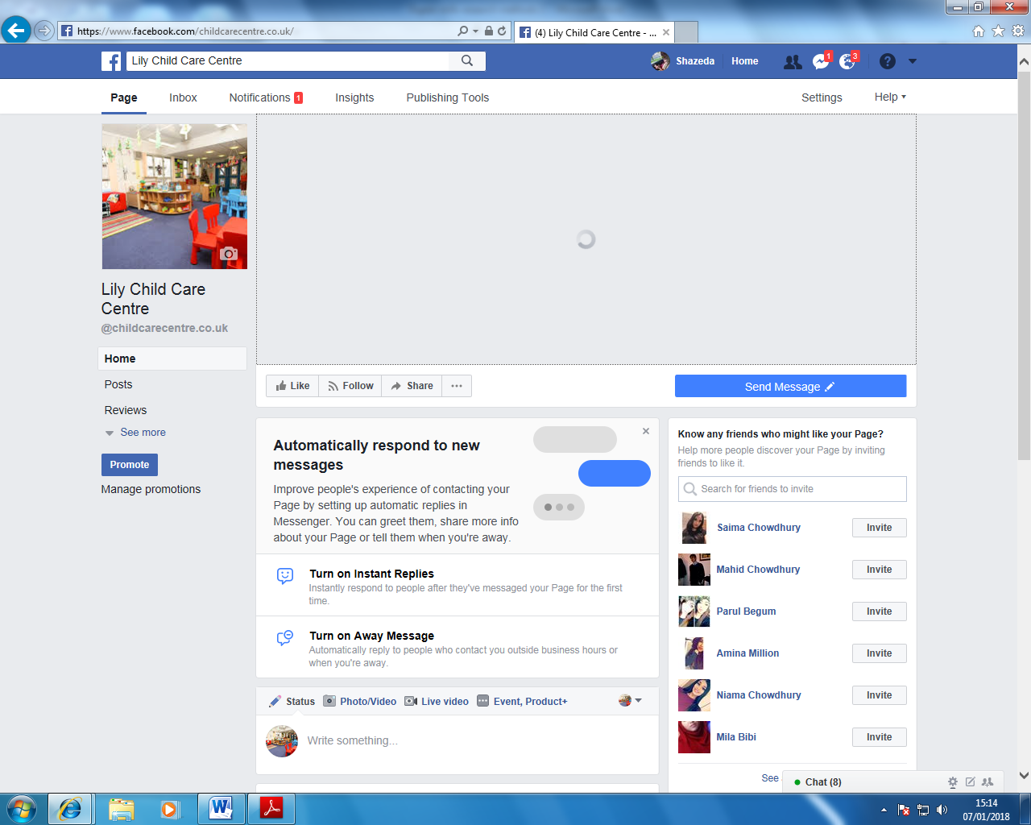

Twitter
Twitter was founded by Jack Dorsey in 2006. This is a social media application which allows people to connect worldwide and allow them to share their thoughts and opinions on the platform and allowing others to respond or share the tweet by retweeting it.

Other social media platforms
There has been an increase in the number of social media platforms that are available out there for people to network with other professionals, boost their profiles and make themselves available for work purposes.
The use of social media and professional networking can be seen as an essential tool within large and small businesses, even non-profit organisations. Barnes and Mattson (2010) displayed in their study that non-profit organisations are more active in terms of their social media usage in comparison to for-profit organisations; this is in regards to their use of blogs, twitter, podcasts, pictures and videos. Social media tool LinkedIn was released in 2011. This is an online professional network, it is used my users to interact with other professionals or trusted contacts and share knowledge, ideas and expertise. This social media platform has over 100 million users.
(Witzig et al. 2012).
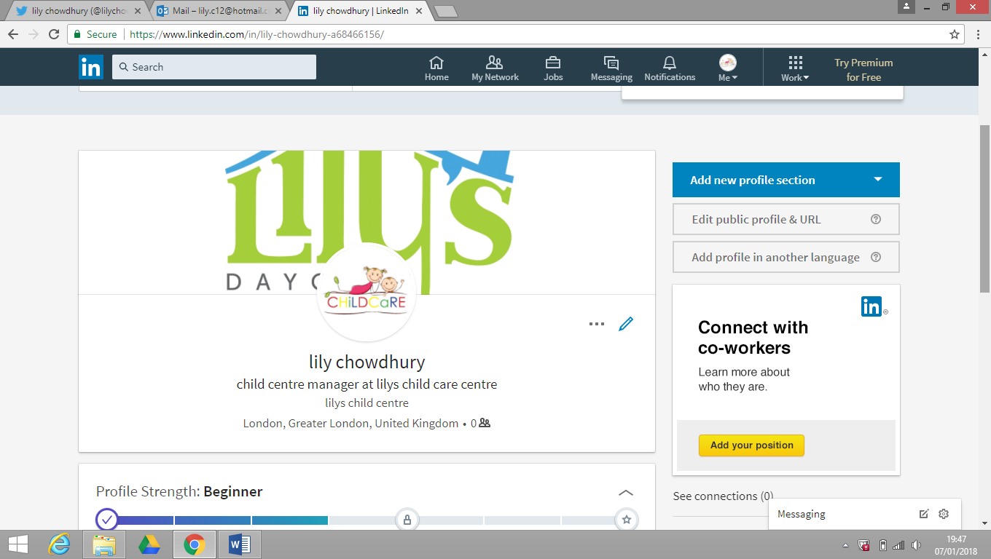

Conclusion
As we have seen that social media and modern technology have a huge influence over not only the workplace but within an individual’s daily life. It has been seen that the modern technology and social media is a great tool to use which does benefit companies in terms of productivity and financially. It has been a massive movement within the 20th and 21st century, and has fundamentally changed how people do things. For example, from no longer keeping records on paper files to keeping them within a secure database.

References

- Glynn, M. D., and Faulds, J. D. (2009) Social media: The new hybrid element of the promotion mix. Business Horizons. 52 (4) p357

- Heath, C., Knoblauch, H., and Luff, P. (2000) Technology and social interaction: the emergence of ‘workplace studies’. British Journal of Sociology. 51 (2) p299–320

- Majoribanks, T. (2000) News Corporation, Technology and the Workplace. New York. Cambridge University Press.

- Neti, S. (2011) SOCIAL MEDIA AND ITS ROLE IN MARKETING. International Journal of Enterprise Computing and Business Systems. 1(2) p 1-14

- Saravanakumar, M., and SuganthaLakshmi, T. (2012) Social Media Marketing. Life Science Journal. 9(4) p4444

- Skeels, M. M., and Grudin, J (2009). When social networks cross boundaries: a case study of workplace use of Facebook and LinkedIn. Association for Computing Machinery. p95-104

- Witzig, L., Spencer, J., and Galvin, M. (2012). ORGANIZATIONS’ USE OF LINKEDIN: AN ANALYSIS OF NONPROFITS, LARGE CORPORATIONS AND SMALL BUSINESSES. The Marketing Management Journal. 22(1) p113-121.

