CoexistentPerspectives.Essay
Coexistent·Perspectives(ADCD7001)

An Analysis of Yohji Yamamoto's
Role in contemporary Society---The critical analysis of
"anti-fashion" style
Question1·-·The Contemporary Condition

Name: Song zilong
Student number:1915389

Submission·Date:·Tuesday,December-13th,2022·Word·Count:·3766

Introduction
Anti-design is mainly reflected in the phenomenon of anti-fashion design in the following ways: Anti-fashion can refer to the rejection and abandonment of fashion by some social groups, the alternative fashion or street fashion contrary to the characteristics of some fashion trends, the anti-fashion design style of some fashion designers, or the way of social fringe groups to use fashion to fight for social power and social resistance. Yohji Yamamoto likes to design women's clothes based on the concept of men's wear. Yohji Yamamoto uses exaggerated proportions to cover the curves of women's bodies to reflect the aesthetic concept of androgynous. Yohji Yamamoto creates a loose flat, free-flowing, and unique rebellious anti-fashion aesthetic culture by simply using black and typical eastern style flat cuts. Neat and detailed tailoring, water-washing fabrics and black are among Yohji Yamamoto's signature design features.

As one of the least bright and most mysterious parts of pure black clothing, it is more pure and thorough compared with other color systems. But this extreme darkness is not without emotion and energy. Although pure black is the color system with the lowest brightness, it has the character of multi-sided, not only has the characteristic of introverted, but also has a unique tension. If used correctly, it can produce special effects that cannot be achieved by color systems. In this paper, the world famous fashion designer Yohji Yamamoto in the 2017 Paris Fashion Week spring/summer women's wear collection as an example, appreciation of his design works, and the use of design methods are analyzed. The paper points out that the exploration of modeling and material design techniques, and the continuous exploration and expression of the deep beauty of pure black should become the direction of designers to continue to explore and practice.

The pursuit and expression of beauty can be said to have reached its peak. As the "second face" of human beings, clothing is not only a simple object bearing practicality and beauty, but also contains some personal demands and expressions. But in the current popular era but often can hear the "anti-fashion" and so on, the article will be through the Japanese design master Yamamoto Yohji personal design concept and aesthetics of some shallow to comb, to talk about the "anti-fashion" phenomenon and through the phenomenon of the extension of the relevant voice.

The difference between Yohji Yamamoto and anti-fashion design is the rebellious aesthetic
Yohji Yamamoto draws inspiration from life. His idea of "designing for women" originated from his childhood observation of the role of mother in family life. The ponderousness and inlightness of the kimono prompted him to change the tradition and break the thought of tradition and bondage, which made him gradually germinate his aversion to authority and the oppression of women by the concept of ethics.

Traditional design, from the male perspective, includes the "gaze" and "look" of women. The design concept of outlining women's curves serves to create the so-called "perfect women in the eyes of designers", which makes it difficult for most contemporary fashion to escape from the circle of oppression against women. Yohji Yamamoto's tailoring is based on the concepts of "decolorization" and "gender ambiguity", which to a great extent liberates the wearer's "sense of bondage", thus achieving the purpose of freeing the body and aesthetic sense.
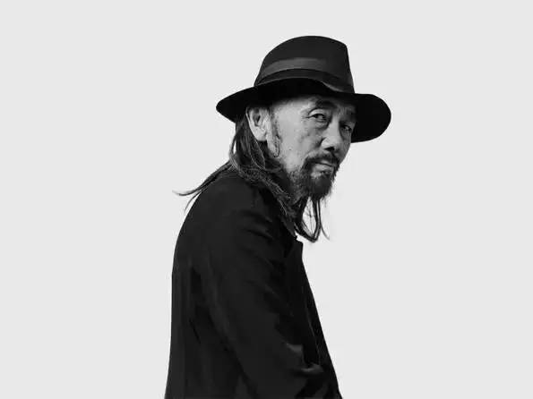
Figure 1.The aesthetic of costume design

As a result, Yohji Yamamoto's designs include a variety of clothing that blurs the gender line, such as men's skirts and women's trousers. Although Yohji did not use the term "genderless" himself, it is reflected in his designs. Yohji Yamamoto made clothes out of the circle of "flattery, flattery and pandering" and created his own personal style. His design concept of serving women has become one of the reasons why he is good for society.

Compared with the current anti-fashion design works, most of which tend to be internationalized and westernized, the biggest difference of Yohji Yamamoto's design is that it draws from the essence of Japanese local culture. In essence, the cultural connotation reflected by Yohji Yamamoto is Oriental, with the unique Zen culture of Japan. Inside Yohji Yamamoto's clothing, the label used to carry the slogan "What could be more boring than dressing properly?Different from other anti-fashion designs, most anti-fashion designs reflect the satire and refraction of the current society or culture through the deconstruction and distortion of the works. Yamamoto's design is used to burning, cutting, tearing and other intuitive methods to create; His design aesthetic is created from the weakness of resistance to human nature and mourning culture. In contrast to Western fashion design or other design industries that strive to create perfection, Yamamoto's pursuit of perfection is explained as "like a pile of pearls sorted by luster, size and perfection, keeping the good ones and leaving the bad ones behind, which is very cruel." "Perfection is ugly," Yamamoto says.I want to see flaws, failures, chaos, distortions in the things that humans make." In addition to Yohji Yamamoto's own character, such a defective aesthetic is related to the Japanese aesthetic of "light and harmonious, preferring incomplete"; The philosophy of Japan and even the things that are considered too perfect in various designs always make people feel unrealistic, while the defective things have the atmosphere of humanity and make people feel the infinite vitality here. Whether it is architecture, environment, animation, clothing, most of them are with a kind of romantic regret. "Perfection is ugly. Perfection is the manifestation of order and harmony, the result of coercive force. No free human would expect such a thing." It was Yohji Yamamoto who said it; Because of this, his design style gives people a sense of freedom and even decadence, which is exactly the most imperfect part of human nature that needs to be concealed and modified. Through Yamamoto's works, he is naked presented to the public.

Yohji Yamamoto's anti-fashion design uses a single black color almost entirely, compared with the colorful interlacing of most designs. Also known as the "black magician". He is very good at the use of cloth and all kinds of black, color itself as a perceptual material to form the beauty of form, has a unique aesthetic characteristics, the color itself has a symbolic association; The expression of color is expressed in people's eyes, and the color sense reflecting the heart is conveyed through vision, such as excitement and calm, light warm and heavy cold. The main expression of black emotion is emotional depression, grief, solemn and so on. Therefore, black is mainly used for funerals, and white is mostly used for weddings. Yohji Yamamoto has his own unique rebellious thoughts through his free and unstructured style of design. "Black is one of the most attitude colors, which clearly expresses" I don't bother you, you don't bother me." Therefore, the choice of black is the most consistent with Yamamoto design concept expression color; Secondly, there is no strict gender restriction on black, so it is natural to choose black as the main representative color.

Anti-fashion
The term "anti-fashion" is defined as "an idea that goes against the current fashion trends and prevailing ideas, or puts popular trends in a secondary position, and opposes the pursuit of the original form". It can be said that the development of fashion also drives the development of anti-fashion. Without mainstream fashion, there would be no anti-fashion. The European anti-fashion movement of the 1970s was a bold challenge to the structure of modern clothing. People from all walks of life emphasized their importance in the 1970s, when the society was full of rebellion and exploration. Young people pursue self-expression in their clothes, and anything weird and previously unacceptable can be accepted and respected at this time.

The deconstruction style brought by Japan in the 1970s and 1980s brought important changes to the fashion industry. A group of Japanese designers began to emerge on the international stage, and the influence of Japanese design was gradually increasing.

Figure 2.Anti-fashion design
Distortion scale, distortion shape, bold color, visual rhyme, deliberately hide the functional value of the product, more close to the pure art pioneer; Design works are often closer to aesthetic functions than to abstract socio-cultural meanings. Anti-design is reflected in the phenomenon of anti-fashion design: anti-fashion can refer to the rejection and abandonment of fashion by a certain social group, alternative fashion or street fashion contrary to the characteristics of a certain fashion trend, anti-fashion design style of some fashion designers, or the way of social fringe groups to use fashion to fight for social power and social resistance.
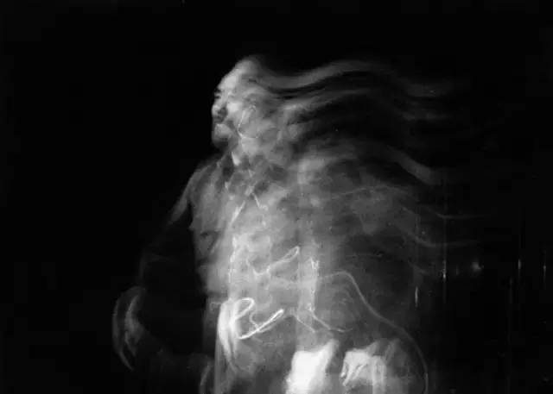
Yohji Yamamoto, one of the world famous Japanese fashion trio, has always implemented his unique gender ambiguity, minimalist tailoring, design concept, lines and folds, black aesthetics and other concepts in his design works.It is not difficult to find that its aesthetic ideas are contrary to the mainstream aesthetic at that time.

As the master of the world's mainstream aesthetic discourse power, the western fashion industry is almost harsh on the fashion design emphasis on the sense of design and the complexity of handcraft, believing that only the exquisite line and cutting, outstanding design expression is the soul of a fashion work.It was also closely related to the influence of the rapid economic development of the West after the war and the subsequent growth of the world status, individual voice and the awakening of power.

Combined with the influence of the "party culture" and the "Hollywood craze" in the 1980s and 1990s, the retro formal dress craze in the 1980s, the punk style brought by the pop music and rock music, as well as the avant-garde art and rebel art had a great influence on the fashion industry at that time.

However, from Yohji Yamamoto's works, it is not difficult to find that his works at that time did not have such fanatical party aesthetic elements, nor noisy Hollywood style, but more about thinking and fear of war trauma, calm and cold in the frenzy.It focuses on more traditional clothing preservation and transformation (such as Yohji Yamamoto's wedding dress and kimono collection), as well as more prominent design that breaks the bondage of suits, genderless and non-authoritative.

To simplify the processing and processing, so that the fabric and the body have more influence.Break the exquisite and perfect design, and achieve the sense of authenticity and alienation brought by the defect and destruction.

As an Oriental designer who has been on the Paris fashion scene since the 1980s, he has brought the world's attention to this "anti-mainstream anti-fashion" power.The unique pleated aesthetic, black and white minimalism, genderless design and deconstruction concepts also made waves in the mainstream fashion industry at the time.

Its design breaks the limitations of traditional design for the side and back design, giving you a perfect visual experience from any Angle; He says his clothes are not designed for high heels, his clothes are designed for women with flat shoes, women in flat shoes are free, he is designed for freedom. Yohji Yamamoto's anti-fashion designs and concepts are very different from other anti-fashion designs.

The formal language in Yohji Yamamoto's costume design
Color, shape and material make up the clothing. Yohji Yamamoto's collection expresses his love and obsession with black. His design works are simple and simple, and there is no visual color collision, which has a certain connection with the traditional Japanese aesthetic culture.

Yohji Yamamoto's costumes use rough fabrics and dark, solemn colors to create an otherworldly look. In-depth taste of Yamamoto's design style, the more you can feel the mysterious sense of endurance and exploration in his story.

Black itself is a very attractive color, can foil a variety of colors, more can make other colors appear more dazzling, is the most indispensable role. In addition, black can foil the sense of hierarchy and richness of the design, so that the work to show more connotation. Yohji Yamamoto's irregular silhouette complements black.
The most detailed makeup and hair became another highlight of expressive and visual tension. Yohji Yamamoto's models wore black and white lips with flamboyant, explosive black hair, adding modern elements to the typical Japanese geisha aesthetic.

If a terrible garment adopts extreme monochrome design, then the focus of the design will be shifted to the styling, and the overall silhouette and makeup will become another breakthrough for the designer to show the characteristics of personal style. The idea of Japanese Mukuai aesthetics is also to control the sense of balance through irregularity and asymmetry. The artistic conception and desire of black seem to be more intense than any other color, which makes the clothing produce an extremely deep expression desire and emotional atmosphere.

In the 20th century, European clothing aesthetics were still mainly based on the restriction of women's waist. The deformed aesthetic concept of vase style was also a great constraint on women's freedom. Many European countries restricted women with this deformed aesthetic concept. He is very good at using exaggerated silhouette design to cover women's bodies, not to highlight the graceful curves of women, but deliberately blur the boundaries of gender, making women slowly equal in clothing.In Yohji Yamamoto's designs, a lot of deconstruction and exaggerated folds are reorganized and stacked, as well as asymmetrical cuts, flaps and skirts, etc., the seemingly irrational works everywhere reflect the free world in his heart. Every one of Yamamoto's works is full of vitality and creativity.For example, add a splash of bright red on the white patchwork suit, which is a common design technique of Yohji Yamamoto. When giving people a relaxed and pleasant feeling, bright red appears again, like a beam of light, which appears suddenly but has traces, full of personality tension.

With the improvement of Yohji Yamamoto's design thoughts, he no longer focuses on the physical material of the fabric, but pays attention to the light texture and inner vitality of the fabric itself, to feel its ideas to think. He felt the natural contraction and change of the fabric, and the different textures revealed by the precipitation of time. Through this process, the fabric shows its unique vitality. Yohji Yamamoto mastered the characteristics of different fabrics to design, so that the black better show different levels of beauty, and apply to the most appropriate position. Yamamoto Yoji thinks that black cloth does not have charm, black is the most elegant existence, sending out indescribable danger signals, unconsciously produce vague feelings.

The West to highlight the feminine characteristics of beauty, while the East is reserved and reserved for the style. Yohji Yamamoto designed asymmetrical beauty on the basis of covering the curves of the human body, often deliberately making clothes look unfinished in order to defy stereotypes, challenge people's obsession with "perfection," and tell the public that this is the meaning and value of clothing itself. Yohji Yamamoto juxtaposes the pleated fabric with a distinctive asymmetrical cutting technique, preferring to use different textures in dark and monochrome. The unique texture treatment of the fabric is also full of destruction and creation of the material itself, inject unique visual beauty and touch, and convey a unique calm and adductive power.

From Yohji Yamamoto's "anti-fashion" extension of "anti-pleasure psychology" performance and thinking
First of all, we need to understand that "pleasure psychology" is the embodiment of an impulsive psychology in Freud's theory, especially a psychological appeal in the face of religious, moral constraints and other repression, such appeal is often the vitality of art and the core of expression.

This is precisely reflected in the field of fashion design, where designers use clothing as a media channel to express their own aesthetic appreciation, gain praise and affirmation, create new schools and doctrines, and thus obtain the pleasure of being recognized and releasing their own creative desire.

And the general public will obtain the aesthetic need to buy and aesthetic gaze to be satisfied, to improve the image of the pleasure. Therefore, although there has not been a clear theory of pleasure psychology in the field of fashion, it is closely related to the development and economy of the industrial age, and can even be said to be a reflection of consumer psychology and self-achievement psychology. The anti-design fashion design satisfies the fast psychology needed by the vast majority of minority groups, thus making many young people pay for the design.

At this time, the continuous emergence of the voice of "anti-pleasure psychology" is actually a criticism of the rapid development of cheap fashion and shopping fashion. With the development of FMCG culture, FMCG clothing changes very quickly, and people often cannot keep up with the changes in fashion and fashion. The emergence of the world factory has made design cheaper and more accessible, and plate-making and stitching have become the mainstream psychology of modern design. When the design does not need too much thinking, but also can obtain a lot of profits, naturally to the design and aesthetic damage.When it comes to luxury consumption, designers usually don't want buyers to fall into the satisfaction of explosive consumption. They don't care about the design, but only pay attention to the identity value and the current popularity of the brand. Although they have got rid of the cheap fashion of FMCG brands, in fact, such buying fashion psychology that only regards aesthetic and design concepts as purely displaying personal value is often abandoned by designers.

A piece of clothing often contains the condensation of a designer's lifetime experience and thoughts. Such expression can not be bought with value, but what consumers can buy is just the fabric cut out with thought and aesthetics as scissors. For those who cannot understand the designer's thinking, even if they wear it, they may lose the charm of the dress itself. Maybe we are not against fashion, but to become the new fashion.

Impact
Yohji Yamamoto's anti-fashion design also had a certain impact and influence on the Western fashion industry, which made the Western fashion industry pay attention to and accept the Oriental design and Oriental designers. And when it comes to his clothes, people like to quote Yohji Yamamoto's own words to explain: "What's more boring than dressing properly?"

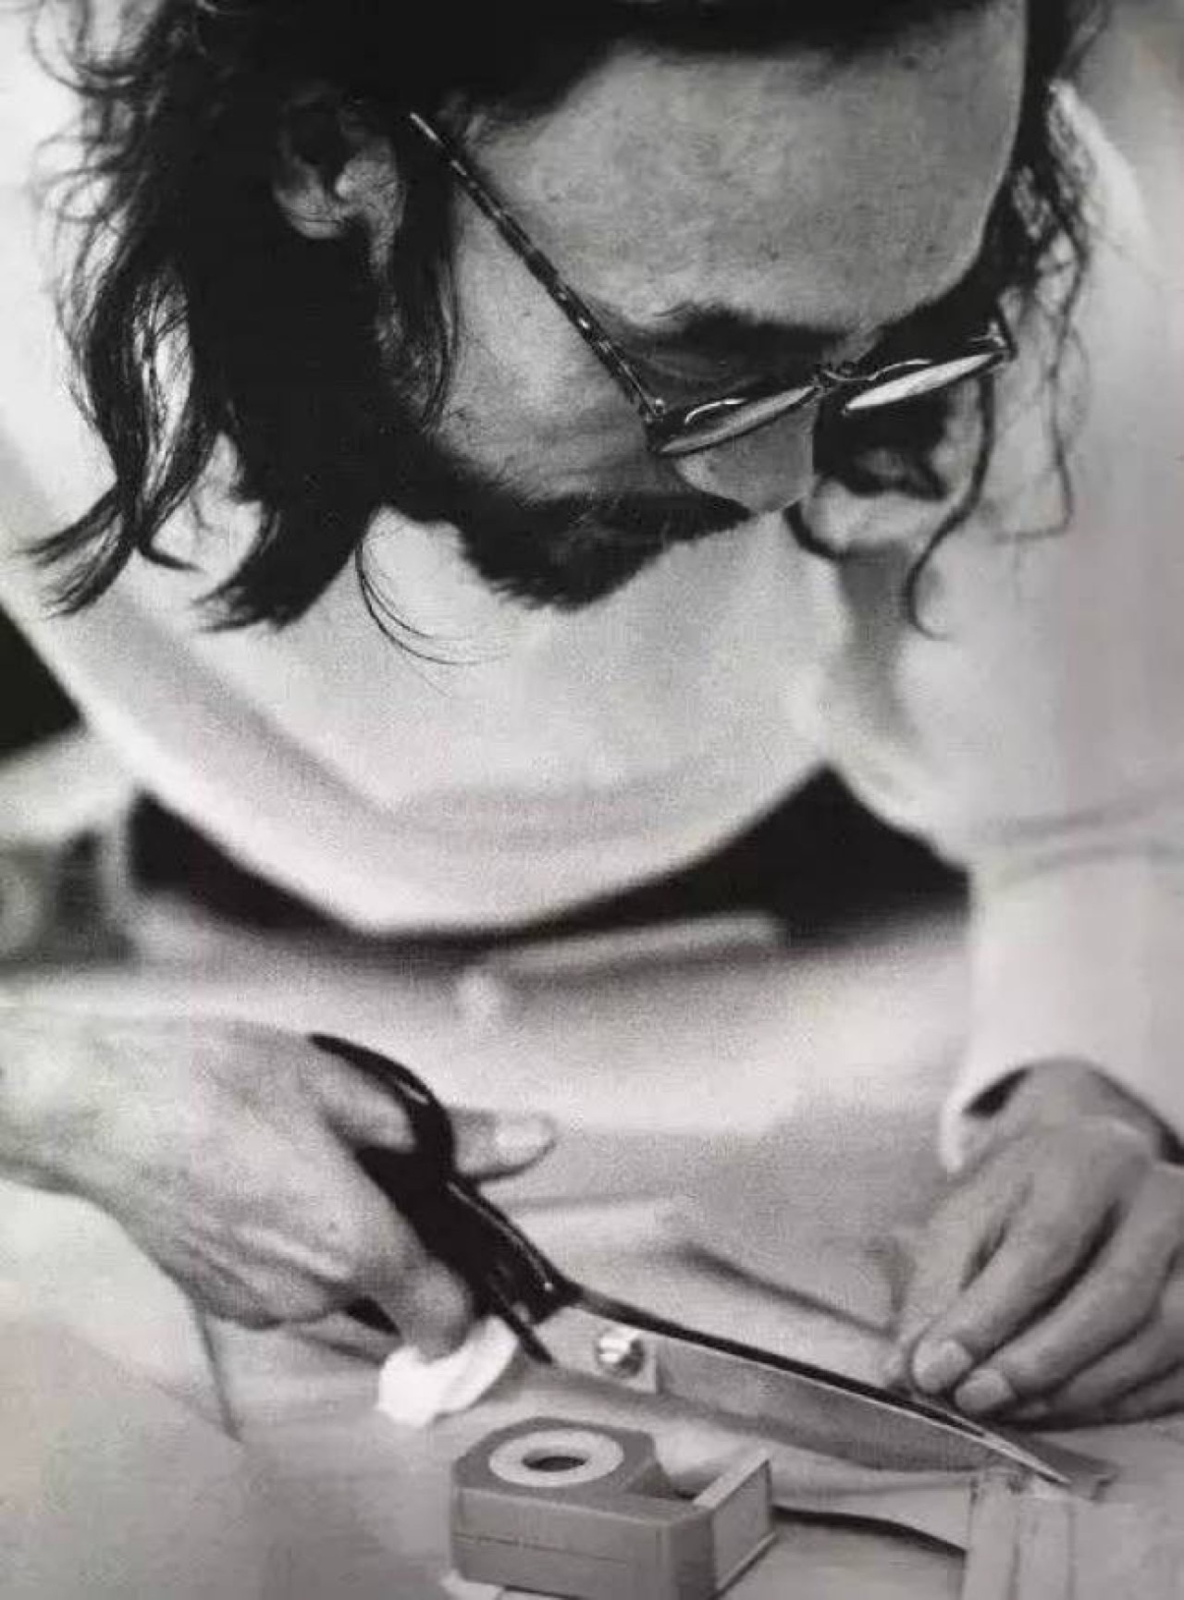
His own design concept for reverse design also has a certain inspiration and influence on current designers and design. Many contemporary designers have followed Yohji Yamamoto's reverse design style to carry out their own brand design ideas. His own understanding and concept of fashion are worth our deep thinking and learning. As Yohji Yamamoto said about fashion, "Fashion doesn't make you sexy. Your" experiences "and" imagination "do. And there's no easy way to get that. The only way is to live your life."
Yohji Yamamoto's personal design has not been assimilated by Western design, while
the current mainstream design is gradually influenced by Western design. His fashion is a borderless way to show the answer to the riddle to the public, serve the minority group, and make the people who understand

Figure 3.How to Make Clothes
him fall in love with him. Yohji Yamamoto, as a unique presence in the design industry, has been constantly working in the forefront of the fashion industry, which is not only a responsibility but also a kind of example, has been constantly telling us what is the real fashion design how to make a good dress, how to make their own, belong to the country, belong to the Oriental fashion design. The dedication and pursuit of a lifetime for design is also constantly encouraging every young designer.

For Yohji Yamamoto's anti-fashion design research that is endless, many designers are more concerned about Yohji Yamamoto's design techniques, design concepts, cutting methods, fabric design and style research, and for Yohji Yamamoto's life environment and personality growth and experience on the impact of the work is just simple. Yohji Yamamoto, as the most typical pioneer designer of postmodernism in Japan, has a strong sense of modern deconstruction in his works. His materials and tailoring are typical of Oriental culture -- he uses plane tailoring and mostly uses Oriental elements as inspiration.

He criticizes and negates the fashion aesthetics of women as decorative objects and the social system that locks women in the family. The first thing Yohji Yamamoto needs to do is to break through the Western style and how to make it break away from the previous values. At the same time, it is also a challenge to the Japanese who blindly follow the European and American culture. "Genderless" design is not only an anti-thesis of the West, but also a rejection of the status quo of Japanese fashion, which wants to integrate with Europe and the US.

、
Conclusion
Through Yohji Yamamoto's thinking and exploration of fashion design, it is found that against the background of rapid changes of The Times, the promotion of social culture also needs the voice of rebellion and negation, and constant innovation in the negation is the design thinking needed by this society. However, the anti-design design style has become the first hammer of this era.

The anti-design design style is used to create a new image with pure black as the main body. From Yohji Yamamoto's series of works, it can be seen that through various design means, each edge of the black character can be excavated, so that it can show the beauty of layers and personalities in the dark tones. Yohji Yamamoto is known for menswear design, and the black pieces in this collection can still be seen in his introduction of masculine style to women's design. Black, as a kind of colorless system without obvious character tendency, has a stable introverted character, but also has a personality publicity side. The world of black is broad and profound. Through the exploration of modeling and material design skills, designers should continue to explore and show the deep beauty of pure black, which should become the direction of further exploration and practice.

Only this revolutionary change will bring more creativity and cultural value to the society. Beauty is an attitude of care and concern for people, society and life, rather than gender discrimination and oppression of freedom. The value of design and the value of life must be interdependent. Yohji Yamamoto uses the anti-fashion aesthetic concept in his works and its value to envision the life style of people's infinite imagination in the future.Based on the "anti-design" style of Yohji Yamamoto's fashion design, this paper finds that in today's era of global integration, the promotion of social culture needs to be continuously denied. Only by constantly innovating in the process of denial, can we bring endless creative ideas to the society and enrich the spiritual world and cultural life of human beings.

Bibliography
- Zhang Han is inclusive. Modern clothing design view Yohji Yamamoto talk about anti-fashion [J]. Western Leather

- Robert Longo Yohji Yamamoto,(1988) Robert Longo/Yohji Yamamoto,BOMB

- Yaling Yu(2019),Yohji Yamamoto and anti-fashion design Western leather

- Moon Hee Park;Soon Young Go;Myoung Ja Park;Hye Soo Kim(2007) The Characteristics on Design Shown in Clothes of Achromatic Colors of Chanel and Yohji Yamamoto 한국색채학회 학술대회

- Jingyang lan (2021) The influence of the change of aesthetic concept of era design on Japanese fashion design in the 1980s Textile industry and technology

- Chen dingding (2019) Yohji Yamamoto's "genderless" style in fashion design Western leather

- Chen dingding(2019) Study on Yohji Yamamoto's costume design Soochow University

Fiaures

Figure 1.http://img.mp.itc.cn/upload/20160727/7d8223a80169435cbdb8bc85a593a58b_th.jpg

Figure 2 http://img.mp.itc.cn/upload/20160727/4ccd4c1a35a24b4a902c4ab6d1817230_th.jpg

Figure3 http://img.mp.itc.cn/upload/20160727/5016e2ec79254041a491d67ca2e75a4d_th.jpg

