Personal Development Portfolio
Programme: Certificate of Higher Education Skills for the Workplace (Health and Social Care)
Module: Professional Development within Health and Social Care (LCHS4009)
Assignment Title: Personal Development Portfolio

Table of Contents
Job Advertisement 2
Task 1: Curriculum Vitae (CV) 2
Task 2: Personal Statement 6
Task 3: SWOT Analysis and Personal Development Plan 7
Task 3a: Personal SWOT Analysis 7
Task 3b: Personal Development Plan (PDP) 8
Task 4: Critical Reflection Using Gibbs’ Reflective Cycle 11
Reference List 12

Job Advertisement
Esh Group – Personal Care and Family Care (Cardiff, Hybrid Work).
Job Type: Full-time | Salary: £55,000–£100,000 per year
This role involves providing companionship and emotional support to a female patient (aged 40) from India who is currently hospitalised and unable to walk or stand.
Duties include preparing nutritious meals tailored to dietary preferences, carrying out light housekeeping to maintain a safe environment, driving clients to appointments and social activities, and monitoring health status and reporting concerns to healthcare professionals or family.
Candidates must demonstrate excellent communication skills, patience, empathy and organisational abilities. Respectful and dignified care is essential, and applicants must undergo background checks.

Task 1: Curriculum Vitae (CV)
Personal Details

Name: Ronaldo Cristea
Address: 15 Rosedale Grove, Birmingham, B25 8UG, UK
Telephone: +44 7897 145770
Email: Ronaldocristea@yahoo.com
Nationality: Romanian
Personal Profile
A committed and compassionate Health and Social Care student at Trinity Saint David University. Experienced in helping individuals in care settings, I am dedicated to improving dignity and quality of life for vulnerable individuals (Indeed Editorial Team, 2025). My sensitivity, communication abilities, and respect for diversity help me create client trust (Skills for Health, 2025). I am seeking a full-time Personal Companion role with Esh Group to utilise my expertise for high-quality person-centred care (Skills for Care, 2026).
Education
Studying BA (Hons) Health and Social Care at University of Wales Trinity Saint David from September 2023 until present. Topics include safeguarding, mental health, social policy, and care ethics. The program highlights the UK health and social care system, person-centred care, and effective communication (CPD Online, 2025).
Romanian High School Diploma (Bacalaureat): September 2019 - June 2023.Studied maths, languages, and social sciences and gained study skills and discipline (CPD Online, 2025).
Work and Voluntary Experience
Care Assistant, [Placement Care Home], Birmingham February 2024-Present • Assist residents with daily living tasks like washing, dressing, and feeding while maintaining dignity and respect.• Encourage mental and social stimulation by providing emotional support and company (Indeed Editorial Team, 2025).• Protect service users using safeguarding and health & safety procedures (Skills for Health, 2025).• Facilitate multidisciplinary teamwork and communication among coworkers, families, and healthcare professionals.
• Supported adults with disabilities in daily duties, promoting independence and social inclusion as a volunteer at the Community Centre in Birmingham from January to June 2024.• Coordinated community and group events.• Gained patience and empathy by helping varied clients (CPD Online, 2025).
• Provided exceptional customer service and maintained a warm, approachable style as a Customer Assistant at Tesco in Birmingham from September 2023 to January 2024.• Effectively works under pressure in a fast-paced setting (High Speed Training, 2023).• Learned healthcare-relevant communication and teamwork.
Key Skills
Communication and interpersonal skills: Coursework and placement experience teach active listening and good verbal and written communication.Support clients with empathy and tolerance, respecting their sentiments and culture.• Effectively collaborate with colleagues and multidisciplinary teams to provide person-centred care.• Effectively manage time and coordinate academics, part-time work, and volunteering to fulfil deadlines.• Safeguarding knowledge: Know care rules' safeguarding and confidentiality requirements.Driving: A clean UK driving licence is needed to transport customers to appointments (CPD Online, 2025).
Certifications
First Aid Certification—Health Training Institute (2024)University of Wales Trinity Saint David (2024) Safeguarding TrainingManual Handling—[Training Provider] (2024)
Languages
• Romanian – Native
• English – Advanced (IELTS equivalent)
Interests and Hobbies
• Health and wellbeing; fitness and sport; volunteering; continuous personal development.
References
Available upon request.

Task 2: Personal Statement
I'm applying for Esh Group's Personal Companion position because I love helping others. As I pursue my BA (Hons) in Health and Social Care, I have a solid background in safeguarding, mental health, and person-centred care. I learned personal care, emotional support, and mobility help as a care assistant. Research emphasises that personal care typically requires physical assistance with dressing, grooming, and mobility while maintaining client comfort and safety. To prevent infections, I realise the need of cleanliness and hygiene.My history includes volunteering with disabled persons and part-time customer service jobs. These events improved my patience, resilience, and social abilities. According to Indeed, care worker CVs should emphasise personal care experience, first aid, and empathy. With training in first aid and manual handling, I can confidently address health concerns and assist clients in transferring securely (LSPM, 2022).Building trust with clients and their families requires communication and empathy. Empathy builds trust and allows for more personalised care, according to Skills for Health. I actively listen, validate feelings, and tailor my communication to individual needs. I work well with varied clients and coworkers because I speak Romanian and English.Continuous professional improvement is my goal. My personal development goal include finishing NVQ Level 3 in Health and Social Care, dementia care training, and English proficiency enhancement. High-Speed Training recommends setting SMART goals to maintain concentration and track progress. I aim to be a good friend by reflecting on my strengths, such empathy, communication, and organization, and improving my weaknesses, like public speaking confidence (Visiting Angels, 2026).In conclusion, my education, caring experience, and dedication to professional advancement match the Personal Companion position requirements. I believe my compassion and dedication will help me support clients emotionally and practically, providing polite and dignified care.

Task 3: SWOT Analysis and Personal Development Plan

Task 3a: Personal SWOT Analysis
See Figure 1 for a summary of SWOT analysis points by section (Skills for Health, 2025).
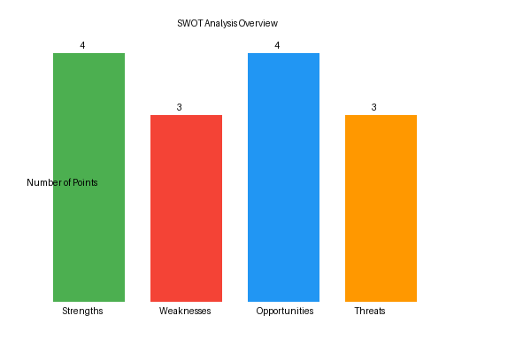
Category | Key Points
Strengths | • Strong empathy and communication skills  • Experience providing personal care and emotional support;  • Certified in first aid, safeguarding and manual handling;  • Bilingual (Romanian and English) and culturally aware.
Weaknesses | • Limited professional experience in a full‑time care role;  • Need to strengthen public speaking and confidence during presentations;  • Currently completing qualification (BA) and have not yet obtained NVQ Level 3.
Opportunities | • High demand for compassionate carers in the health and social care sector;  • Opportunity to obtain NVQ Level 3 and specialised training (dementia care);  • Ability to leverage bilingualism to support clients from diverse backgrounds;  • Development of professional network through university and volunteering.
Threats | • Competitive job market with experienced candidates;  • Risk of burnout or emotional fatigue due to demanding care duties;  • External factors such as changes in health policy or funding affecting roles.
Creating a realistic personal development plan requires identifying internal strengths and weaknesses and external opportunities and threats using SWOT analysis. CPD Online suggests a SWOT analysis for personal development, identifying elements that can aid or hinder success (Skills for Health, 2025).

Task 3b: Personal Development Plan (PDP)
Three goals for the next two years are in the personal development plan. These goals are SMART (specific, measurable, achievable, relevant, and time-bound) (Indeed Editorial Team, 2025). The table below lists goals, actions, timelines, resources, and evaluation techniques (Visiting Angels, 2026).
Figure 2 illustrates the planned timeline for achieving the goals over a two‑year period (Skills for Care, 2026).
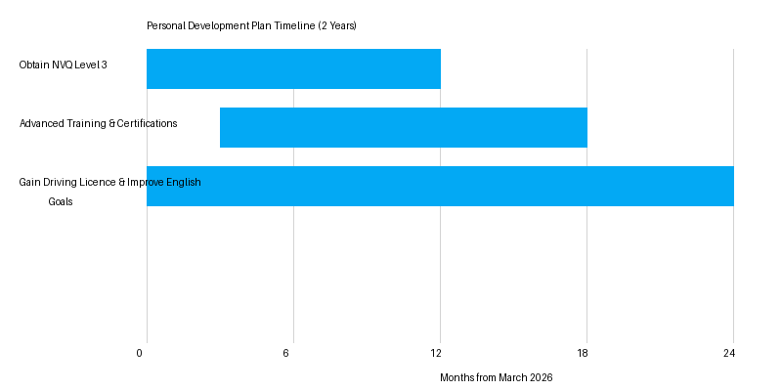
Goal | Actions | Timeframe | Resources | Monitoring & Evaluation
Complete NVQ Level 3 in Health and Social Care | • Enrol on NVQ Level 3 course  • Attend classes and complete assessments  • Apply theoretical knowledge to placement practice | Start: April 2026  Finish: March 2027 | University support services; financial aid; mentors | Monthly progress reviews with tutor; exam results; reflective journal
Undertake advanced training (manual handling, dementia care) | • Register for specialist training courses  • Participate in workshops and practical sessions  • Seek feedback from trainers and peers | Start: June 2026  Finish: September 2027 | Professional training providers; online courses; study materials | Certificates of completion; feedback forms; self‑assessment
Develop driving skills and advanced English proficiency | • Practise driving regularly and take advanced driving lessons  • Attend English language workshops and conversation clubs  • Read professional literature and engage in reflective writing | Start: March 2026  Finish: March 2028 | Driving instructor; language centre; academic library | Driving test results; language assessments; self‑reflection notes
Assessing progress requires regular monitoring. Monthly evaluations with mentors and instructors will discuss successes and challenges (LSPM, 2022). Setting deadlines and measuring results (passing tests, getting certificates, improving language scores) will motivate and require accountability. The PDP will be updated every six months to reflect progress and alter goals.

Task 4: Critical Reflection Using Gibbs’ Reflective Cycle
I spoke on Component 1 of the LCHS4009 module, focused on protecting vulnerable adults in health and social care. Gibbs' reflective cycle lets me critically analyze this experience through description, feelings, evaluation, analysis, conclusion, and action plan. The paradigm is commonly used in health and social care to structure learning from practice (Visiting Angels, 2026).
Description: The 15-minute talk included regulatory frameworks, abuse indicators, and effective practices for safeguarding. I presented slides with references to classmates and the professor (LSPM, 2022). Technical troubles delayed my start by one minute, so I spoke quickly to catch up.
I was scared but excited to show my knowledge. I grew nervous when the slides didn't appear properly. My pupils nodded as I explained safeguarding principles, which reassured me (High Speed Training, 2023). After finishing, I felt proud but realized my pace was too fast.
Evaluation: The presentation had correct content, a logical organization, and relevant references. A case study and confident responses engaged the audience. However, I spoke quickly and hardly looked at you. Reading my slides was challenging due to too much text (CPD Online, 2025). My lecturer advised me to modulate my voice and eliminate slide text to avoid cognitive overload.
Analysis - Skills for Care advises adjusting one's manner and showing empathy to communicate effectively. My quick speaking and scant eye contact may have confused the audience (CPD Online, 2025). Empathy research emphasizes active listening and validating emotions. I answered questions well, although my pace may have hindered comprehension (Skills for Care, 2026). Technical concerns were aggravated by insufficient presentation equipment practice.
Conclusion: I met assessment learning outcomes but need to enhance delivery and audience engagement. Preparing well-structured slides is not enough; I must also practise managing timing and technology. Pauses and eye contact keep the audience's attention and show confidence (Skills for Health, 2025).
Action Plan: I will practise using university presenting tools and rehearse my talk with peers to improve future presentations. Recording myself will assess tempo and body language (LSPM, 2022). I want to take a public speaking workshop to gain confidence and improve my performance. I will also develop slides with bullet points and graphs instead of massive blocks of text (LSPM, 2022). Reflective practise using Gibbs' cycle will help me track development and improve my professional skills (Skills for Health, 2025).

Reference List
CPD Online (2025) "What is a personal development plan?" Available at: https://cpdonline.co.uk/knowledge-base/business/what-are-personal-development-plans/ (Accessed: 25 March 2026).
High Speed Training (2023) "A Personal Development Plan (PDP) Guide & Template." Available at: https://www.highspeedtraining.co.uk/hub/personal-development-plan-template/ (Accessed: 25 March 2026).
Indeed Editorial Team (2025) "Care worker CV: How to highlight your skills." Available at: https://uk.indeed.com/career-advice/cvs-cover-letters/care-worker-cv (Accessed: 25 March 2026).
LSPM (2022) "Gibbs’ Reflective Cycle in Health and Social Care." Available at: https://www.lspm.org.uk/2022/news.aspx (Accessed: 25 March 2026).
Skills for Care (2026) "Effective communication." Available at: https://www.skillsforcare.org.uk/Support-for-leaders-and-managers/Developing-leaders-and-managers/Manager-induction-standards/4-Effective-Communication.aspx (Accessed: 25 March 2026).
Skills for Health (2025) "The importance of empathy." Available at: https://www.skillsforhealth.org.uk/article/the-importance-of-empathy/ (Accessed: 25 March 2026).
Visiting Angels (2026) "What skills matter most for personal care?" Available at: https://www.visitingangels.com/murrieta/articles/what-skills-matter-most-for-personal-care/467 (Accessed: 25 March 2026).

