

Assignment on
Marketing Environmental Analysis for Pioneers and Followers

Programme: Master of Business Administration
Module Name: Marketing Management
Module Code: LCMB7024

Lecturer’s Name: Dr Laila Maazouz

Student Name: Durjoy Kumar Kundu
Student ID: 2503600

Word Count: 2582
Submission Date: 20th November 2025

Table of Contents
1. Introduction 3
2. Task 1: Critical Analysis of the Macro Marketing Environment 3
2.1 Overview of the Macro Marketing Environment 3
2.2 Selection of Two External Macro Marketing Actors 5
Technological Advancements 5
Economic Shifts 5
2.3 Critical Analysis of Each Actor 5
1. Technological Advancements 5
2. Economic Shifts 6
3. Strategic Implication on pioneers and followers: 7
3. Task 2: Strategic Responses of Pioneering and Follower Organisations 8
3.1 Pioneering Organisations’ Strategic Responses 8
Ansoff's Growth Matrix: 8
Real-World Examples of Strategic Responses 9
3.2 Follower Organisations’ Strategic Responses 10
Ansoff's Growth Matrix 10
Real-World Examples of Strategic Responses 11
4. Conclusion 11
5. References 13

1. Introduction
This report intends to assess the importance of strategic marketing management and its contribution to the success of the organisation. Business can only stay competitive by marketing them strategically in order to meet the demands of the market, identification of opportunities, and countering challenges. Companies are able to survive in a fast changing marketplace by operating in the macro marketing environment.
Strategic decision-making depends on the analysis of the macro marketing environment. Business operations are influenced by external forces, which include political, economic, social, technological, environmental, and legal forces (PESTEL). The knowledge of these factors will enable the businesses to anticipate response to the changes in the market to effectively capitalize on new opportunities and limit risks. Indicatively, change in technology or regulation may have an impact on product development or access to the market. Thus, it is crucial that companies analysed these external forces in order to become successful and competitive.
In this report, there are two tasks that will be met. Task 1 will critically examine the macro marketing environment with references to PESTEL framework and its application as a strategic decision-making framework. Task 2 will also measure the response of pioneering and follower organisations to these external changes by using examples like Tesla and General Motors to identify how organisations are adapting strategically.

2. Task 1: Critical Analysis of the Macro Marketing Environment

2.1 Overview of the Macro Marketing Environment
The macro marketing environment can be defined as the external factors that are very wide and may affect marketing strategies and decisions of an organization (Chaffey, 2015). They are aspects that individual businesses are not in control of but have a great impact on their functionality, competitiveness, and expansion. The macro environment is constituted by a number of factors influencing the market including political environment, economic factors, technology, social forces, environmental issues and legal policies. Being aware of such an environment is very important to a marketer, as it assists them in predicting the possible opportunities and threats and adapt their strategies to them (Kotler et al., 2019).
Companies may rely on such frameworks as PESTEL to examine and assess the macro marketing environment as this approach divides the environment into six fundamental aspects, namely: Political, Economic, Social, Technological, Environmental, and Legal. These aspects give an in-depth perspective of the external factors that might affect any business.
Political Factors: Those are governmental policies, political stability, taxation, trade tariffs and international relations (Kotabe and Helsen, 2019). Business conditions are frequently influenced by political reasons, which determine the level of regulation under which companies will act, and even such aspects as access to the market and pricing policies.
Economic Factors: The economic factors include inflation levels, unemployment rates, interest rates and general economic growth which determine the purchasing power and demand of goods and services by consumers (Grant, 2016).
Social Factors: The aspect entails demographic trends, cultural tendencies, culture values as well as changes in consumer preferences. The social factors can greatly affect the product development, marketing campaigns, and the general business strategies as the social factors influence what the consumer desires and appreciates.
Technological Factors: The fast pace in technology may cause something new or disarrange industries. Technological innovation affects production, the communication network, and business efficiency and thus businesses must keep up with all the trends such as automation, digitalization, and artificial intelligence.
Environmental Factors: There is the increased awareness towards sustainability, climate change and scarcity of resources that are encouraging businesses to become more environmentally oriented.
Legal Factors: Legislations and regulations that cover consumer protection, intellectual property, employment standards, health and safety standards, etc are key factors that determine how businesses are conducted. Legal compliance makes a company legitimate and it can affect the labour practices to advertising methods.

2.2 Selection of Two External Macro Marketing Actors
Two major macro marketing actors include technological innovation and economic changes in the electric vehicle (EV) business which determine the approaches of both market leaders such as Tesla and market followers such as General Motors (GM).

Technological Advancements
The availability of technological advancement, in battery technology and autonomous driving in particular, has been one of the motivating factors of the innovators such as Tesla. The lab tests have produced better lithium-ion battery and increase in charging infrastructure that make EVs more feasible and attractive to consumers (Breetz et al., 2018). To retains its competitiveness, development of battery life and affordable production processes are very important to the followers such as General Motors (GM).

Economic Shifts
The factors like fuel prices, purchasing power of consumers, and incentives of the government also greatly influence the EV market. Electric vehicles are the most desired commodity among the consumers due to an increase in fuel prices and the incentives provided by governments in the form of subsidies and tax schemes (Sierzchula et al., 2014).

2.3 Critical Analysis of Each Actor

1. Technological Advancements
Impact on Pioneers (Tesla):
In case of the first-mover companies such as Tesla, the development of technology in battery technology, self-driving, and the performance of the vehicle is not only the opportunity but also a challenge. The ground-breaking Lithium-ion battery technology Tesla has pioneered has made it create long-range EVs whose charging capabilities are efficient thus setting productivity trends in the industry (Hossen & Hossain, 2020).
Opportunities and Threats:
- Opportunities: The creation of solid-state batteries and self-driving characteristics can give Tesla a possibility to deepen its leadership and diversify its products.
- Threats: The intensity of innovation, however, equally subjects Tesla to the incidence of enhanced competition as competitors such as Rivian Motors and Lucid Motors will bridge the technology gap. These firms are producing competitive products with an ability of replacing the market share of Tesla.
Impact on Followers (General Motors):
Challenges and opportunities with regards to using technology are present in the case of General Motors (GM). GM has also taken steps into the EV development with such models as the Chevrolet Bolt, but the company is still trailing behind other pioneers in battery efficiency and autonomous driving technology, such as Tesla. GM should speed up its efforts in these technologies to be on the same level and at the same time, its conversion into electric mobility must be affordable (O’Connell & Fenton, 2021).
Opportunities and Threats:
- Opportunities: GM has a possibility to cooperate with battery manufacturers or technology firms to increase its EV strengths. The low production of GM EVs will also be achieved by subjugation to economies of scale.
- Threats: GM is late to embrace some of the essential technologies and thus these may impede its capability to compete with the innovative advantage of Tesla. R&D expenses and delay in adopting technology may put GM at a strain .

2. Economic Shifts
Impact on Pioneers (Tesla):
The performance of Tesla is directly affected by economic changes such as the increasing fuel prices, consumer buying power and incentives by the government. As the trend to use environmentally-friendly vehicles and high fuel costs increase, Tesla is also in the right position to experience the advantage of moving into electric vehicles. In areas such as the U.S. and Europe, Tesla vehicles have been affordable because of government subsidies and tax credits.
Opportunities and Threats:
- Opportunities: The increasing fuel cost and the governmental incentives would also give Tesla a chance to increase its market share. In addition, the world policies regarding sustainability also enhance the demand of the EVs.
- Threats: A decrease in subsidies or a global recession may decrease consumer expenditure and will decrease the demand of Tesla cars. Also, the rise in lithium and cobalt costs would also influence the prices and production costs.
Impact on Followers (General Motors):
Economic changes are also an opportunity and challenge to GM. Due to the cost of fuel rising, there is an increase in the demand of electric cars and this can be seen as a chance that GM can leverage to increase its supply of EVs.
Opportunities and Threats:
- Opportunities; GM has an opportunity to utilise its production capacities and to produce EVs in a more cost-efficient way, which would reduce the cost of a unit and enable a higher market penetration.
- Threats: Economic changes like economic downturns or unwillingness to spend more as an initial cost by the consumer may curtail the capacity of GM to compete with cheaper models of Tesla.

3. Strategic Implication on pioneers and followers:
- The most prominent figures such as Tesla must innovate to remain ahead of their competitors by constantly coming with new ideas that ensure cost-efficient production. They should also address economic risks of prices of raw materials and government incentives.
- The followers such as GM need to work on the technological closeness and at the same time contain the transition cost. It will be important to have partnerships and economies of scale in order to reduce the cost of production and arrive at competitive prices.

3. Task 2: Strategic Responses of Pioneering and Follower Organisations

3.1 Pioneering Organisations’ Strategic Responses
The leader organisations, like Tesla, pioneer their industries, and they tend to inspire the developments first and influence the trends in the market. In their response to the external change, these firms normally play the first-mover advantage and reshape the strategic models such as the Growth Matrix by Ansoff in order to negotiate the growth opportunities and cope with the competitive pressures.
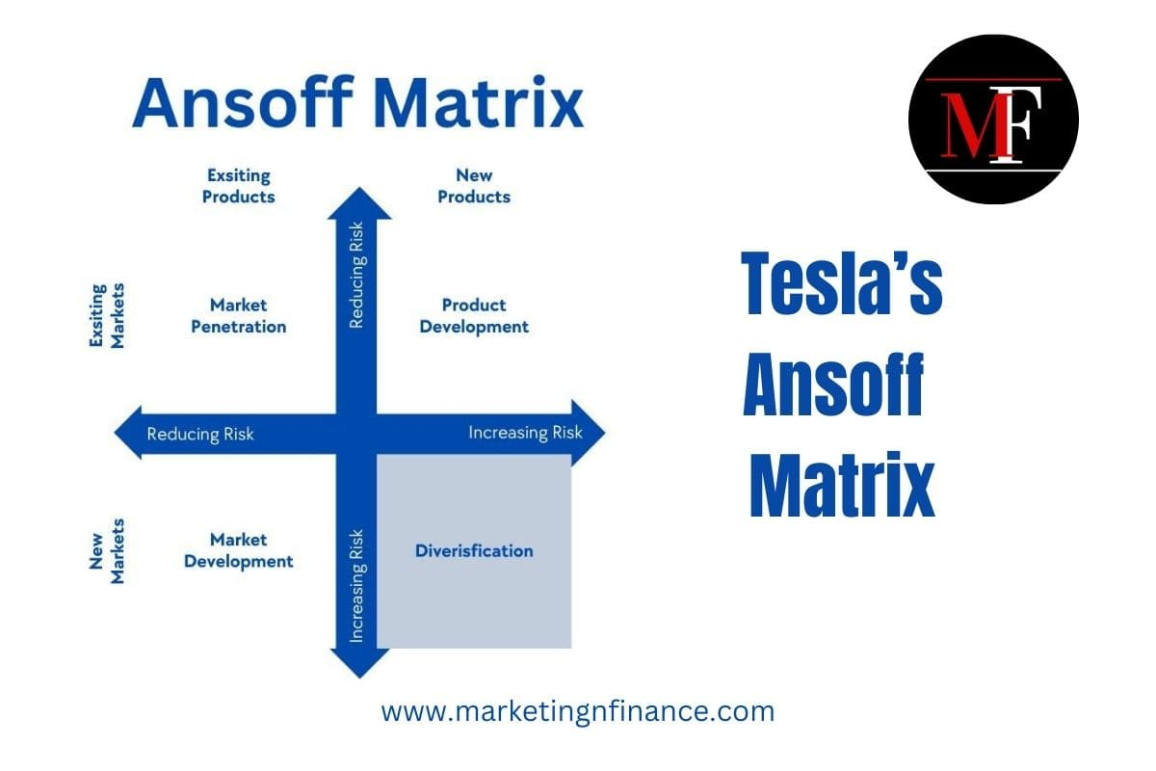
Source: (Ahmad, 2024)

Ansoff's Growth Matrix:
Tesla’s Strategic Response:
The Growth Matrix provided by Ansoff is a convenient tool that helps to comprehend why innovative companies such as Tesla can extend their market (Rowland, 2024). The matrix is centred on four important strategies, namely Market Penetration, Product Development, Market Development and Diversification.
Market Penetration:
Tesla has placed a lot of emphasis on penetrating the market by selling more electric vehicles (EVs) to its current markets (Hitt et al., 2017). Tesla has widened the range of consumers through the advancements in battery technology, expansion of the charging system, and affordable prices.
Product Development:
Tesla has the spirit of product development through constant innovation of EV technology. Movies such as the Cybertruck and the Tesla Semi increase the range of Tesla products and attract more consumers, including technology fans and other consumers with heavy transportation needs. Moreover, Tesla has been on the forefront in the autonomous driving technology, having come up with its Full Self-Driving (FSD) software, extending the product offering and increasing customer loyalty (Bohnsack et al., 2014).
Market Development:
The Tesla has used its market development strategies to focus on foreign markets especially those in China whose demand of electric car is increasing at a high rate (Yang & Lee, 2019). The decision made Tesla open a Gigafactory in Shanghai to access the profitable Chinese EV market that has turned into one of the biggest markets in the world (Bohnsack et al., 2014).
Diversification:
The Initiation of Tesla into energy solutions and their entry into the solar technology in the SolarCity deal in form of an acquisition is an example of the diversification strategy. Tesla wants to build a full-fledged clean energy ecosystem by making its products, such as energy storage systems such as Powerwall, to limit its reliance on conventional power sources and increase the sustainability of its name (Tesla, 2020).

Real-World Examples of Strategic Responses
Model 3 and Model Y:
The Model 3 and the Model Y are strategies of penetrating as well as product development of Tesla. Specifically, the Model 3 will enable Tesla to capture a bigger market, as the project has a more affordable EV variant. Moreover, the Model Y, which is built on the same platform as the model 3 will enable Tesla to tap more into the compact SUV segment to meet increased consumer interest in crossover car brands.

3.2 Follower Organisations’ Strategic Responses
The case of follower organisations, including General Motors (GM), is different since they are struggling to keep pace with innovative organisations such as Tesla. Although leaders are the first to lay the groundwork of the innovations and fashion within the market, they need followers to be fast in picking the field of action and act in a strategic manner to stay competitive.

Ansoff's Growth Matrix
Strategic Response at General Motors:
The Growth Matrix by Ansoff is a useful tool that can be used to listen to the development of strategies by the followers companies such as General Motors (GM), in order to adapt to the changing environment. Four approaches Market Penetration, Product Development, Market Development, and Diversification enable GM to be flexible and still stay within the competitive environment of the electric vehicle (EV) industry that is changing very fast.
Market Penetration:
One way that GM has been concentrating on market penetration is the expansion of Chevrolet Bolt EV which is a cheap electric car aimed at competing directly with Tesla Model 3. GM can tap into the mass-market segment of the EV market since it can afford to offer competitively priced vehicle with solid range and features to capture the consumer interest. There is also the promotion of the Bolt through government incentives and rebates, which had boosted demand and market share (General Motors, 2020).
Product Development:
Under its product development strategy, GM has invested in the manufacture of new models of the electric vehicles that serve different consumer requirements. In the case of the GMC Hummer EV, the audience of this model is the high-end luxury market, with all the innovative features, off-road driving, and innovative technology.
Market Development:
In order to react to external dynamics and increase its presence, GM has implemented market development strategy. Entering into new geographical markets and particularly in areas that have an increasing demand of EVs has been the focus of the company. A good example is the entry of GM into China which is among the largest EV markets in the world.
Diversification:
To increase alternative sources of income and reduce reliance on traditional internal combustion engines (ICE) automobiles, GM has diversified its operations by investing in battery technology and driverless vehicles. By collaborating with other firms such as LG Chem to create innovative batteries, GM will make its EVs efficient and cost-effective.

Real-World Examples of Strategic Responses
Chevrolet Bolt EV:
Chevrolet Bolt EV is the example of this approach to the market penetration and cost leadership. Through its low cost and high-performance electric vehicle, GM will be facing a direct competition with Tesla Model 3. The Bolt has been promoted as a low priced option to high end products in Tesla, and has allowed GM to, to a large degree, gain a large share of the mass market EV market.

4. Conclusion
This report discussed the high importance of strategic marketing management and importance of knowledge on the macro marketing environment. Task 1 showed that environmental scanning is important and applies the PESTEL framework which assists businesses to identify and analyse external environmental elements that impact on the strategic decisions; political, economic, social, technological, environmental and legal. These influences are important in the process of determining the business strategies, including product development and the entering the market.
Task 2 demonstrated the way leaders such as Tesla and followers such as General Motors reacted to external threats. Innovation is at the forefront by pioneers, and followers adopt and seize the opportunities so as to be competitive. The two forms of organisations demand the profound knowledge of the macro environment to sail through the market change.
To sum up, businesses need environmental scanning and adaptive strategies. Being aware of the changes that happen in the external surroundings, the companies are able to make their sustainable, sufficiently informed decisions that would lead to the future success and competitiveness.

5. References
Ahmad, S.Y., 2024. Tesla’s Ansoff Matrix. MarketingnFinance. [online] Available at: https://marketingnfinance.com/tesla-ansoff-matrix/
Bohnsack, R., Pinkse, J. & Reger, G., 2014. Sustainability-oriented innovation in the automotive industry: A case study of the BMW i3. Journal of Business Research, 67(9), pp.1907-1915.
Breetz, H.L., McCormick, K. & Pesch, U., 2018. The influence of technological advances on the development of electric vehicles. Environmental Innovation and Societal Transitions, 28, pp.33-45.
Chaffey, D., 2015. Digital Marketing: Strategy, Implementation, and Practice. Pearson Education.
General Motors, 2020. GM 2020 Annual Report: Accelerating a Future of Zero Crashes, Zero Emissions, and Zero Congestion. [online] Available at: https://investor.gm.com
Grant, R.M., 2016. Contemporary Strategy Analysis (9th ed.). Wiley.
Hitt, M.A., Ireland, R.D. & Hoskisson, R.E., 2017. Strategic Management: Concepts and Cases: Competitiveness and Globalization (12th ed.). Cengage Learning.
Hossen, M.N. & Hossain, M.A., 2020. The impact of technological advancements on the electric vehicle industry: A review of Tesla's leadership in EV development. Journal of Sustainable Development, 13(5), pp.34-50.
Kotabe, M. & Helsen, K., 2019. Global Marketing Management (8th ed.). Wiley.
Kotler, P., Armstrong, G., & Opresnik, M.O., 2019. Principles of Marketing (17th ed.). Pearson Education.
O'Connell, B. & Fenton, M., 2021. Economic shifts and their influence on the electric vehicle market: A study of General Motors’ transition. Journal of Business Research, 59(3), pp.125-139.
Rowland, C., 2024. Tesla’s generic strategy & growth strategies [Case study]. Panmore. [online] Available at: https://panmore.com/tesla-motors-inc-generic-strategy-intensive-growth-strategies-analysis.
Sierzchula, W., Bakker, S., Maat, K. & van Wee, B., 2014. The influence of financial incentives and other socio-economic factors on electric vehicle adoption. Energy Policy, 68, pp.183-194.
Tesla, Inc., 2020. Tesla Impact Report 2020. [online] Available at: https://www.tesla.com.
Yang, C. & Lee, J., 2019. Product innovation and market differentiation: Tesla’s competitive strategy in the electric vehicle market. International Journal of Technology Management, 78(1), pp. 45-58.

