
73%
APPENDIX GA36b

LEVEL 5 ASSESSMENT SPECIFICATION

Student name: | Matthew John Permintella | Student ID number: | PER18841948
Programme: | HND LEVEL 5
Module: | MECHANICAL PRINCIPLES
Module code: | M5X00926 | Contribution to Overall Module Assessment (%): | 50%
Lecturer: | EMILY NYATHI | Internal Verifier: | EDWARD HORNAGOLD
Assignment Title: | Power Transmission Systems | Word count (or equivalent): | (Nominal 2500)
Submission deadline: | 1/05/2020 | Return date of provisional marks & written feedback: | 8/05/2020
Submission method: | All written assessments, where practical and possible, must be submitted via Turnitin unless otherwise instructed by the Lecturer. (Please DO NOT put this assessment specification into Turnitin or it will match many similarities with other students’ submissions.)  Alternative submission method (if applicable):  Late submission of the assessment will result in a late penalty mark. Penalties for late submission: Up to one-week late, maximum mark of 40%. Over one week late, 0%. Only the Extenuating Circumstances Panel may approve a change to submission dates.
Academic honesty / referencing: | Academic honesty is required. In the main body of your submission you must give credit to authors on whose research and ideas your work is based. Append to your submission a reference list that indicates the books, articles, etc. that you have used, cited or quoted in order to complete this assessment.

Student FEEDBACK FORM

Generic Assessment Criteria | Marks available | Marks  awarded
1. Engagement with Literature Skills
.
You have engaged with a good range of literature relevant to the subject, however, the quality of your referencing needs to improve. |  | 16
 | 25 | 16
2. Knowledge and Understanding Skills

The report shows good effort and good understanding of the topics covered. Very good application of the governing equations. However, take extra care when rounding off your figures and transposing formulae. |  | 23
 | 30 | 23
3. Cognitive and Intellectual Skills

You have analysed your data using tables and graphs and reached some sound conclusions.  You have demonstrated that you can summarise scientific facts into your own words. There is a logical flow in the writing and the calculation process, and the analysis of the results is easy to follow. You have made an attempt to reach conclusions on your results. |  | 19
 | 25 | 19
4. Practical Application Skills

You have identified uses of the different types of gears used in industry and their advantages and disadvantages compared to each other. A good and appropriate application of established methods and techniques. You have demonstrated that you have a clear understanding of studies to date and you have the ability to work as an individual. |  | 12
 | 15 | 12
5. Transferable Skills for Life and Professional Practice

You have demonstrated basic skills for employment applicable to the exercise of personal responsibility and decision-making with a few minor errors. | 5 | 3

Assessment Mark (Assessment marks are subject to ratification at the Exam Board. These comments and marks are to give feedback on module work and are for guidance only until they are confirmed. ) | Late Submission Penalties (tick if appropriate) |  | 73%
 | Up to 1 week late (40% Max) |  | 73%
 | Over 1 week late (0%) |  | 73%

Belt Drive Friction

Matthew John Permintella | HND Mechanical Engineering | 03/04/2020

Contents

1.0 Introduction Page 2
2.0 Objectives Page 3
3.0 Theory Page 4
4.0 Equipment Page 5
5.0 Procedure Page 5
6.0 Data, analysis, calculations, results Page 5-11
7.0 Conclusions Page 12
8.0 References Page 12
9.0 Bibliography Page 14

1.0 Introduction

Belt drives are used in vast range of machines, they have been used in washing machines, cars. They are an effective solution of transmitting power from one machine to another. Flat belt are made of synthetic rubber and can utilise composite steel in there design, when using belt drives consideration needs to be made as these belt tend to slip, the co-efficient of friction plays a vital role between the pulley and the belt, the co-efficient of friction needs to be high enough in order to stop any slipping occurring during in operation. (Grosjean, 1986).

The aim of this lab session is to investigate the relationship between the tensions in a slipping pulley system and compare these with any theoretical valves calculated.

2.0 Objectives

This experiment has three objectives:

- To show that a constant angle of lap θ has a constant tension ratio of $\frac{T_{1}}{T_{2}}$
- To verify the relationship of $\frac{T_{1}}{T_{2}}= e^{μθ}$
- To determine the friction $μ$ between the Cast Iron pulley and the belt.
(Lab sheet handout).

3.0 Theory

As given in the lab sheet;

For a flat belt drive: $\frac{T_{1}}{T_{2}}=e^{μθ}$

T₁ = Tight side tension
T₂ = Slack side tension
µ = Coefficient of friction
θ = Angle of lap (radians)

If a dependence of T₁ is plotted against T₂ for a constant angle of lap θ then a straight line should pass through the origin because $e^{μθ}$ is constant.

$\frac{T_{1}}{T_{2}}= e^{μθ}=k$ or T₁ = k.T₂

The slope k can be measured, and it can yield a value for the coefficient of friction $μ$.

$\frac{T_{1}}{T_{2}}= e^{μθ}=k$ ln k = $μθ$ = $μ=\frac{1}{θ}\ln{k}$

If ln $\frac{T_{1}}{T_{2}}$ is plotted against θ then the resulting curve should be a straight line that passes through the origin.

The slope for this line equals µ: ln $\frac{T_{1}}{T_{2}}=µθ$

(Lab sheet handout).

3.1 Derivation of capstan equation

For a flat belt drive: $\frac{T_{1}}{T_{2}}=e^{μθ}$
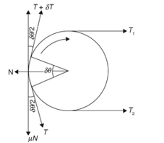
Let,

T₁ = Tight side tension of the belt
T₂ = Slack side tension of the belt
µ = Coefficient of friction between belt and pulley
θ = Angle of lap of belt over the pulley(radians)

Consider a short length of belt subtending an angle $δθ$ at the centre of the pulley as shown in Fig(1).

Let,
Fig (1): Tensions in Belt. (Fawcett and Burdess, 2011)

N = Normal reaction between the element length of a belt and pulley.
$δT$ = Increase in tension in tight side that that of slack side.
$T+ δT=$ Tension on the tight side of the element.

Resolve tangential forces,

$$μN+\frac{Tcosδ}{2}-\left(T-δT\right)\cos{\frac{δθ}{2}=0}$$

As,
$δθ$ is very small, $\cos{\frac{δθ}{2}≡1}$

$μN+T-T- δT=0$ or $δT= μN$ (Equation 1).

Resolve radial forces,

$$N-T\sin{\frac{δθ}{2}-\left(T+δT\right)\sin{\frac{δθ}{2}=0}}$$

As,
$δθ$ is very small, $\sin{\frac{δθ}{2} ≡\frac{δθ}{2}}$

$$N-\frac{Tδθ}{2}-\frac{Tδθ}{2}- δT\frac{δθ}{2}=0$$

Neglecting the product of two small quantities,

$N=T δθ$ (Equation 2).

From Equations (1+2).

$δT= μT δθ$ Or $\frac{δT}{T}= μδθ$

Integrating, we get

$\int_{T_{2}}^{T_{1}}{\frac{δT}{T}= \int_{0}^{θ}{μδθ }}$ $\frac{T_{1}}{T_{2}}=e^{μθ}$

(Fawcett and Burdess, 2011).

4.0 Apparatus

Below is a list of the Apparatus needed for the experiment to be completed:

- Belt friction rig
- Dial test indicator
- Weight carrier
- 2 – 25 kg weights

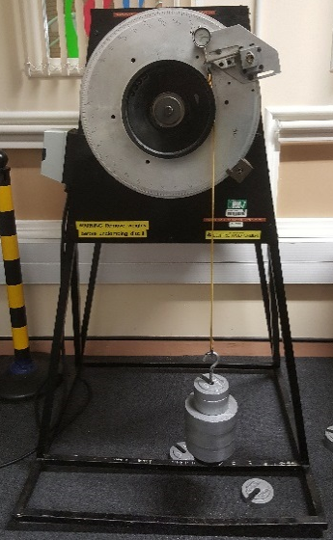
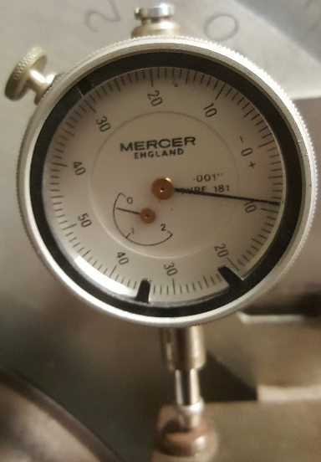

Fig(1): Dial test indicator Fig(2): Belt friction rig with weight
carrier and weights
(Lab sheet handout).

5.0 Procedure

As given in lab sheet;

5.1 Cantilever calibration

- Turn angle of lap protractor to 0.
- Hang belt and weight carrier on the cantilever.
- Set the dial test indicator to 0.
- Measure the deflection of the cantilever for masses from 0 – 24kg in steps of 3kg.
- Plot T₂ against deflection for the cantilever.
- Use the plot as a calibration curve to determine T₂ on the slack side against deflection.
(Lab sheet handout).
5.2 Constant angle of lap

- Set lap θ to 90⁰, attach the belt and set the dial indicator to 0.
- Switch the pulley motor on.
- Measure the deflection for masses 0-20kg.
- Using the calibration curve compute T₂ and plot T₁ against T₂.
- Calculate µ using first method in theory section.
5.3 Variable angle of lap

- Attach belt and set the test indicator to 0.
- Attach 20kg to the belt.
- Switch pulley motor on.
- Measure deflection for angle of lap θ from 240⁰ to 10⁰.
- Determine T₂ for each angle with aid of the calibration curve.
- Plot $ln\frac{T1}{T2}$ against θ, rad.
- Record µ from the slope of the curve.
(Lab sheet handout).

6.0 Results

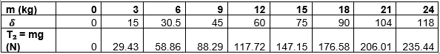
6.1 Cantilever calibration
Table 1: Cantilever calibration results.(Lab results).

6.1.1 Calculations

Example (1)

$T_{2}=m*g$ $$T_{2}=24kg*9.81$$$T_{2}=235.44$ N

Example (2)

$$T_{2}=m*g \\ T_{2}=12kg*9.81$$$T_{2}=117.72$N

6.1.2 Graph

Fig (3) Graph for slack side Vs. Deflection. (Excel).

6.2 Constant angle of lap
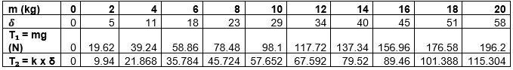
Table 2: Constant angle of lap results(Lab results).

6.2.1 Graph

Fig (4) Graph for T1 Vs. T2. (Excel).

6.2.2 Calculation
$$μ=\frac{1}{θ}\ln{k}$$

$T_{1}=k.T_{2}$ $T_{1}/T_{2}=K$

K = $\frac{21.86}{39.24}=1.794$

$$T_{2}=k* δ$$

$$T_{2}=1.794*11$$
$$T_{2}=19.73$$

Using Equation from lab sheet;

$$\frac{T_{1}}{T_{2}}= e^{μθ}=k$$

$$T_{1}=39.24 \\ T_{2}=21.86$$
$$k=1.794$$
$$θ= π/2$$

$$e^{μ}\left(\frac{π}{2}\right)=k \\ e^{μ}\left(\frac{π}{2}\right)=1.794$$
$$μ*\left(\frac{π}{2}\right)=ln⁡(1.794)$$

$$μ*\left(\frac{2}{π}\right)=0.584$$
$$μ=0.371$$

For flat belt, since $T_{1}= T_{2}e^{μθ}$, compare to $y=mx,$

$$T_{1}=y \\ T_{2}=x \\ e^{μθ}= m_{1} (gradient of the graph) \\ Therefore, \frac{T_{1}}{T_{2}}= e^{μθ}= m_{1}$$

Because the graph is T2 against T1, thus the gradient of the graph will be $\frac{1}{m_{1}}$.

(Fawcett and Burdess, 2011).

6.3 Variable angle of lap

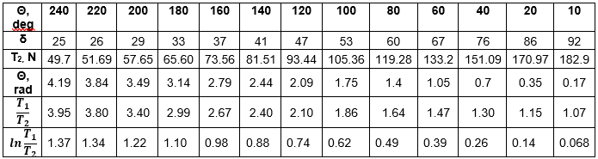
Table 3: Variable angle of lap results(Lab results).

6.3.1 Graph

Fig (4) Graph for T1/T2 Vs. Angle of lap ($θ)$.(Excel).

The above graph allows you to get values for T1/T2, this is represented by row 5 table: (3).

Fig (4) Graph for lnT1/T2 Vs. Angle of lap ($θ$) (Excel).

The above graph allows you to get values for T1/T2, this is represented by row 6 table: (3).

If ln $\frac{T_{1}}{T_{2}}$ is plotted against θ the angle of lap (θ) the resulting curve should be a straight line that passes through the origin. The graph shows this linear relationship which relates to y=mx+c.
6.3.2 Calculations

To calculate sliding coefficient, $μ$ for a flat belt, since:

$T_{1}= T_{2}e^{μθ}$ $T_{1}=m*g$ $T_{2}=K* δ$
$$ln\frac{T_{1}}{T_{2}}= μθ$$ $T_{1}=20kg*9.81$ $T_{2}=1.794* 26$

$μ =\frac{\ln{(\frac{T_{1}}{T_{2}}}) }{θ}$ $T_{1}=196.2 N$ $T_{2}=46.64 N$

$$μ =\frac{\ln\left(\frac{196.2}{46.6}\right)}{θ}$$

$$μ =\frac{1.44}{3.84}=0.375$$

(Fawcett and Burdess, 2011).
7.0 Conclusion

Throughout the experiment I realised several things could have been improved so the results were more accurate:

- Apparatus error could be minimised by utilising more accurate measurement devices, or maintaining equipment more often
- In-order to aid better results each experiment should be completed 3 times and average readings taken.
- An electronic device could have been used to aid more accurate results.
- Hysteresis may have occurred within the experiment this could have been prevented if a new belt were used.
- Random human error could have played a part during the experiment.
(Belt Drive | Belt (Mechanical) | Physics & Mathematics, 2020)

7.1 Is tension ratio of $T_{1}/T_{2}$ constant for the given lap angle? Confirm relationship between $T_{1}= T_{2}e^{μθ}$ is constant?

From table 2 you can see the tension ratio for a given lap angle is constant, this was solidified further during experiment 2. The coefficient of friction remained constant for all masses used. $T_{1}= T_{2}e^{μθ}$ confirms that $μ$ is indeed constant. Graph 2 confirms this further that there is a relationship between $T_{1}$and $T_{2}$ as the straight line is linear. However, with experiment 3 when the angle is changed the ratio of $T_{1}/T_{2}$ reduces as the lap angle increases. (Belt Drive | Belt (Mechanical) | Physics & Mathematics, 2020).

7.2 Determine the friction $μ$ between the Cast Iron pulley and the belt?

As you can see from experiment 2 and 3 the value $μ$ has a slight percentage error. However, they should be the same. This error can be improved by implementing changes/ improvements and completing the experiment once again. (Belt Drive | Belt (Mechanical) | Physics & Mathematics, 2020).

8.0 References

[1] Bird, J., 2015. Science for engineering. 5th ed. 2 Park Square, Milton Park, Abingdon, Oxon OX14 4RN: Routledge.

[2] Fawcett, J. and Burdess, J., 2011. Basic Mechanics with Engineering Applications. London: Routledge.

[3] Grosjean, J., 1986. Principles of Dynamics. Cheltenham: Thorne

[4] R. C. Hibbeler, 2010. Engineering Mechanics. 12th ed. Person Education south Asia Pte. Ltd.

9.0 Bibliography

Book used for research are below:

[1] Bird, J., 2015. Science for engineering. 5th ed. 2 Park Square, Milton Park, Abingdon, Oxon OX14 4RN: Routledge.

[2] Fawcett, J. and Burdess, J., 2011. Basic Mechanics with Engineering Applications. London: Routledge.

[3] Grosjean, J., 1986. Principles of Dynamics. Cheltenham: Thornes.

[4] R. C. Hibbeler, 2010. Engineering Mechanics. 12th ed. Person Education south Asia Pte. Ltd.

[5] Ferdinand, P. Beer, E., 1996. Vector Mechanics for Engineers, Static and Dynamics. International Ed. New York: McGraw-Hill Co.

[6] Scribd. 2020. Belt Drive | Belt (Mechanical) | Physics & Mathematics. [online] Available at: <https://www.scribd.com/document/397273498/Belt-Drive> [Accessed 14 April 2020].

[7] Scribd. 2020. Belt Friction Full Report | Belt (Mechanical). [online] Available at: <https://www.scribd.com/doc/290820876/Belt-Friction-Full-report> [Accessed 23 April 2020].

[8] Scribd. 2020. Lab 3 Belt Friction Experiment | Belt (Mechanical) Scribd. [online] Available at: <https://www.scribd.com/doc/127522615/Lab-3-Belt-Friction-Experiment> [Accessed 23 April 2020].

nbTask II: Gear trains
Introduction

Gear trains refer to a mechanism with two or more gears meshed in series to transmit power from from one shaft to another. The nature of the train used depends upon the velocity ratio required and the relative position of the axis of the shafts. A gear train may consist of bevel, spur or spiral gears.(Handout).

Research

Discribe in detail the the following types of gear trains, giving typical applications in industry. (1000 words)

Simple gear train
A simple gear train generally consists of only one gear on any shaft fig(1). The gears have pitch circles, when there is a small distance bewteen any two gears is small, gear 1 and gear 2 mesh together in order to transmit motion to the other shaft. Gear 1 will be known as the driver gear as it transmits motion to gear 2, gear 2 will be known as the driven or follower. The driven gear will have opposite rotation from driver gear unless a idler gear is implimented in order for the driver and driven to have the same orientation of motion. (Iitism.ac.in. (2020); Moodlearn.ariel.ac.il. (2020)).

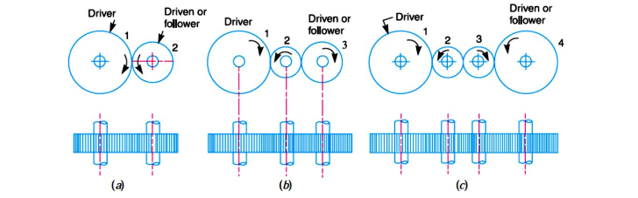
Fig(1): Simple gear train. (Moodlearn.ariel.ac.il. (2020)).

Simple gear train is a system which consists of gears with different module are meshed together to provide max torque can be transmitted without slip. If a simple gear train is used to give a large speed reduction, the last gear must be very large. (Bird, 2015).

Some of its applications in industry include gearbox of automobiles, heavy press machine and lathe machine. (Moodlearn.ariel.ac.il. (2020)).

Compound gear train

A compound gear train consists of more that one gear on any given shaft. Idler gear are useful in bridging a given distance bewteen the driver and driven gears. When the distance bewteen the driven and driver has to be bridged over by intermediate gears and at the same then speed ratio is needed, the advantage of ultilzing intermataite gears is intensified by providing compound gears on intermediate shafts. This system setup will have two gears fixed on it so they have the same speed. One of the two gears will mesh together with the driver and the other will attached to the next gears shaft as shown in fig(2). The advantage of using a compound gears system over a simple gear train system is a much larger speed reduction can be obtained, normally if the speed reduction is in excess of 7:1 then a compound gear train is used. (Iitism.ac.in. (2020); Moodlearn.ariel.ac.il. (2020)).
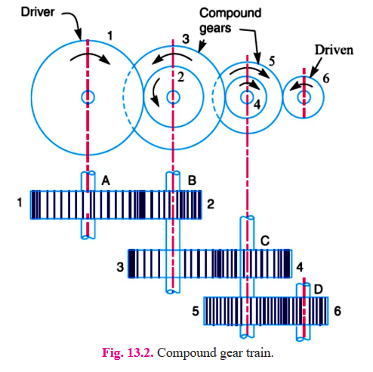
Fig(2): Compound gear train. (Moodlearn.ariel.ac.il. (2020)).

Some of its applications in industry include gearbox of automobiles, lathe machine, gear levers, clocks and watches; A device which needs extremely low rate of rotation in it. (Bird, 2015).

Reverted gear train
A reverted gear is shown in Fig(3). The axes of first gear (driver 1) and the last (driven) are co-axial. We can see that first gear drives second gear in the opposite direction. Secondly and third gear are mounted on the same shaft, they form a compound gear and the third gear will have the same orientation as that of the second gear. The third gear is now the scond driven gear it drives the forth gear which is driven in the same orentation of that of the first gear. This allow the motion of the first and last gear to be like. (Iitism.ac.in. (2020); Moodlearn.ariel.ac.il. (2020)).

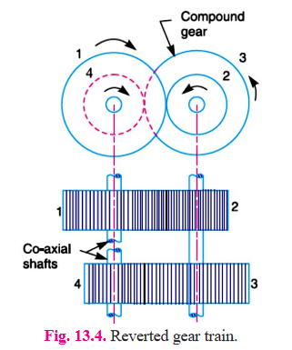

Fig(3): Reverted gear train. (Moodlearn.ariel.ac.il. (2020)).

Epicyclic gear train
In an epicycle gears train the axes of shafts wich are connected to the gear can move relative to a fixed axis. A epicycle gear train is shown in fig(4). Gear A and the arm C rest on the same axis which they can rotate about 01. As you can see gear A meshes with gear B has its axis on the arm at 02 which allows rotation at that point. If the arm is fixed then gear A can drive gear B or vice-versa. However if gear A is fixed then arm arm will rotate about this gear axis(01), which forces gear B to rotate around that gear. This motion is known as epicycle, gear trains are arrange so that one or more of their members move around or upon another member, these conbined are known as an epicycle gear train. They can be simple of compound. The advantages of using such a system is for trainsmitting high velocity ratios with gears of a standard size in a reletivity small space. (Iitism.ac.in. (2020).

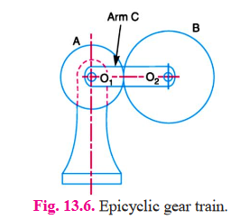
Fig(4): Reverted gear train. (Moodlearn.ariel.ac.il. (2020)).

These gear train system is used in many application some of these include: gear of lathes, hoists, pilley blocks and watches. (Iitism.ac.in. (2020).

Problem solving

- The gearing of a machine tool is shown in Figure 1 below. The motor shaft is connected to gear A and rotates at 1000r.p.m The gear wheels B,C,D and E are fixed to parallel shafs rotating together. The final gear F is fixed on the output shaft. What is the speed of gear F?.

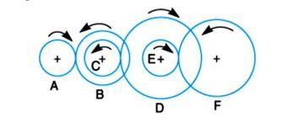

Fig(5): Gear train.

From Fig(5) we see that gears A, C and E are drivers while gears B, D and F are driven or followers. Let the gear A rotates in clockwise direction. Since the gears B and C are mounted on the same shaft, therefore it is a compound gear and the direction or rotation of both these gears is same (e.g. anticlockwise). Similarly, the gears D and E are mounted on the same shaft, therefore it is also a compound gear and the direction of rotation of both these gears is same (e.g. clockwise). The gear F will rotate in anticlockwise direction. (Iitism.ac.in. (2020))

The numbers of of teeth are given on each gear are shown in the table below.

Gear | A | B | C | D | E | F
No. Of teeth | 20 | 50 | 25 | 85 | 28 | 65
Fig(5a): Gear teeth Number’s.

Given:
$$T_{A}=20 ; T_{B}=50 ; T_{C}=25 ; T_{D}=85 ; T_{E}=28 ; T_{F}=65$$
Let, $N_{F}=Speed of gear F, i.e last driven or follwer.$

Thus,
$$\frac{Speed of the first driver}{Speed of the last driven[follower]}= \frac{Product of no. of teeth on drivens}{Product of no. of teeth on drivers}$$

Thus,
$$\frac{N_{A}}{N_{F}}= \frac{T_{B}* T_{D}* T_{F}}{T_{A}* T_{C}* T_{E}}$$
So,
$$\frac{50*85*65}{20*25*28}=19.73$$

$$\frac{N_{A}}{N_{F}}=19.73$$
So,
$$N_{F}= \frac{1000}{19.73}$$

$$N_{F}=50.68 r.p.m$$
(Iitism.ac.in. (2020)).

2 i. What type of gears are the best for applications that require speed reduction and torque multiplication?

Compound gears

2 ii. Two parallel shafts, about 800mm apart are to be connected by spur gears. One shaft is required to run at 360r.p.m and the other at 140r.p.m. Design the gears, given that the pitch is to be 25mm.

Given: $x=800mm ; N_{1}=360 r.p.m ; N_{2}=140 r.p.m ; P_{c}=25mm$

Let $d_{1}=Pitch circle diameter of the first gear,d_{2}= Pitch circle diameter of the second gear$.

We know that speed ratio,

$\frac{N_{1}}{N_{2}}= \frac{d_{2}}{d_{1}}= \frac{360}{140}= 2.57 or d_{2}= 2.57d_{1}$ ........(1)

Centre distance between the shafts (x),

$800= \frac{1}{2} (d_{1}+ d_{2})$ or $d_{1}+d_{2}=1600$ .....(2)

From equation (1) and (2), we find that

$d_{1}+2.57d_{1}=3.57d_{1}$
$$\frac{1600}{3.57}=448.179mm$$
$$d_{1}=448.2mm$$

$$d_{2 }= d_{1}*2.57=1151.82mm$$
$$d_{2}=1151.8mm$$
$$∴Number of teeth on the first gear,$$
$$T_{1}= \frac{{πd}_{1}}{P_{C}}= \frac{π*448.2}{25}=56.32$$

$$∴Number of teeth on the second gear,$$
$$T_{2}= \frac{{πd}_{2}}{P_{C}}= \frac{π*1151.8}{25}=144.73$$
Since the number of teeth on both gears need to be complete whole numbers, we shall take first gear 57mm and second gear 146mm.
Calculate pitch circle diameter of first gear,

$$d_{1}= \frac{T_{1}* P_{C} }{π}=\frac{57*25}{π}=453.59 mm$$

Pitch circle diameter of second gear,

$$d_{2}= \frac{T_{2}* P_{C} }{π}=\frac{146*25}{π}=1161.83 mm$$

$∴$ Exact distance between the two shafts,

$$x= \frac{d_{1}+d_{2}}{2}=\frac{453.59+1161.83}{2}=807.71 mm$$

Thus,

First gear must have 57 teeth, second gear 146 teeth. Pitch circle diameter of first gear must be 453.59 mm and second gear must be 1161.83 mm. The exact distance needed bewteen the two shafts must be 807.71 mm. (Moodlearn.ariel.ac.il. (2020)).

3.A riverted gear train is to be designed such that its speed ratio is 12, as shown in Figure 2.The module pitch of gears A and B is 3.13mm and of geras C and D is 2.5mm. What are the suitable numbers of teeth for the gears? No gear should have less than 24 teeth.

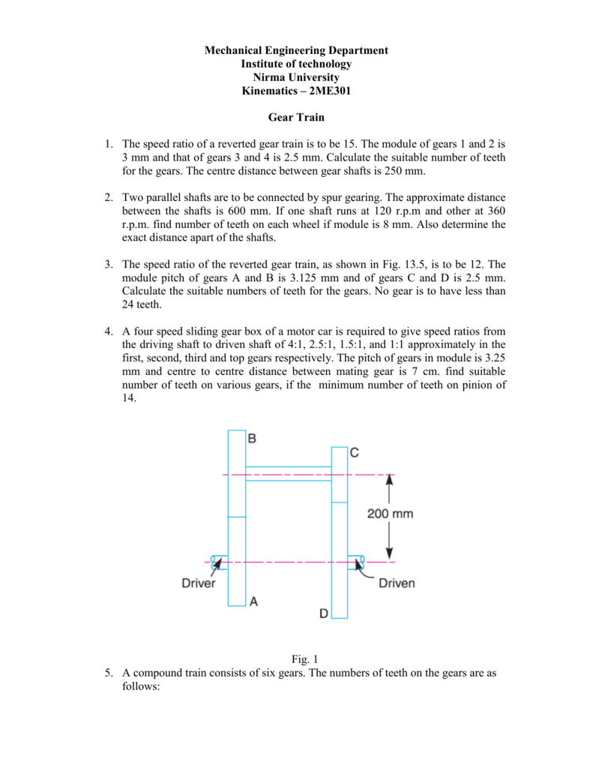
200mm
Fig (6). Reverted gear train.

Given:
Speed ratio, $\frac{N_{A}}{N_{D}}=12 ; m_{A}= m_{B}=3.13 mm ; m_{C}= m_{D}=2.5 mm$

Let,

$$N_{A}=Speed of gear A,$$
$$T_{A}=Number of teeth on gear A, \\ r_{A}=Pitch circle radius of gear A, \\ N_{B}, N_{C},N_{D}=Speed of respective gears, \\ T_{B},T_{C},T_{D}=Number of teeth on repective gears, \\ r_{B},r_{C},r_{D}=Pitch circle radii of respective gears.$$

We know that circular pitch,

$$p_{C}= \frac{2πr}{T}= πm or r= \frac{mT}{2} (m= the module)$$

$$∴$$

$r_{1}= \frac{{mT}_{1}}{2} ; r_{2}= \frac{mT_{2}}{2} ; r_{3}= \frac{mT_{3}}{2} ; r_{4}= \frac{mT_{4}}{2}$ .......(1)

From equation (1),

$$\frac{{mT}_{1}}{2}+ \frac{mT_{2}}{2}= \frac{mT_{3}}{2}+ \frac{mT_{4}}{2}$$
$$T_{1}+T_{2}= T_{3}+T_{4}$$

Since the speed ratio bewteen the gears are equal, therefore,

$$\frac{N_{A}}{N_{B}}= \frac{N_{C}}{N_{D}}= \sqrt{12}=3.464$$

Also the speed ratio of any pair of gears is the inverse of their number of teeth, therefore,

$$\frac{T_{B}}{T_{A}}= \frac{T_{D}}{T_{C}}=3.464$$

We know that the distance bewteen the shafts,
$$x= r_{A}+r_{B}= r_{C}+r_{D}=200mm$$
Or,
$$\frac{m_{A}*T_{A}}{2}+ \frac{m_{B}*T_{B}}{2}= \frac{m_{C}*T_{C}}{2}+ \frac{m_{D}*T_{D}}{2}=200mm$$

$\{∴ r= \frac{m*T}{2}\}$ {$∴ m_{A}=m_{B}, and m_{C}=m_{D}$}

$$3.13\left(T_{A}+T_{B}\right)=2.5 \left(T_{C}+T_{D}\right)=400$$
$$∴ T_{A}+T_{B}=\frac{400}{3.13}=127.79$$ ….(2)

$T_{C}+ T_{D}=\frac{400}{2.5}=160$ ….(3)

From equation (1), $T_{B}=3. 464{ T}_{A}$. Substituting this value of $T_{B} in equation \left(2\right).$

$$T_{A}=\frac{127.79}{4.464}=28.62 round up (29 Teeth)$$
$$T_{A}=29 Teeth$$

$$T_{B}=127.79-29=98.79 round up (99 Teeth)$$
$$T_{B}=99 Teeth$$

Again from equation (1), $T_{D}=3.464 T_{C}. Substituting this value of T_{D} in equation (3)$
$$T_{C}=\frac{160}{4.464}=35.84 round up (36 Teeth)$$
$$T_{C}=36 Teeth$$

$$T_{D}=160-36=124$$

$$T_{D}=124 Teeth$$

Check:

$$\frac{N_{A}}{N_{D}}= \frac{T_{B}*T_{D}}{T_{A}*T_{C}}= \frac{99*124}{29*36}= 11.87$$
$$The speed ratio of the reverted gear train=11.87$$
The value of 11.87 is very close to the value given in the question 12 proving that the answer is highely likely to be correct slightly off due to rounding errors.
(Fawcett. and Burdess (2011); Moodlearn.ariel.ac.il. (2020)).

References
[1] Fawcett, J. and Burdess, J., 2011. Basic Mechanics with Engineering Applications. London: Routledge.
[2] Grosjean, J., 1986. Principles of Dynamics. Cheltenham: Thornes.
[3] Iitism.ac.in. 2020. [online] Available at: <https://www.iitism.ac.in/~shibayan/MCC%2013103%20Kinematics%20of%20Machines/TOM%203BT%2014-15%20lecture%20set-6%20_Gear%20Train_KG.pdf> [Accessed 7 April 2020].
[4] Moodlearn.ariel.ac.il. 2020. [online] Available at: <https://moodlearn.ariel.ac.il/pluginfile.php/837913/mod_resource/content/0/%D7%9E%D7%9E%D7%A1%D7%A8%D7%95%D7%AA.pdf> [Accessed 8 April 2020].

Biblography
[1] Bird, J., 2015. Science for engineering. 5th ed. 2 Park Square, Milton Park, Abingdon, Oxon OX14 4RN: Routledge.
[2] Fawcett, J. and Burdess, J., 2011. Basic Mechanics with Engineering Applications. London: Routledge.
[3] Grosjean, J., 1986. Principles of Dynamics. Cheltenham: Thornes.
[4] Iitism.ac.in. 2020. [online] Available at: <https://www.iitism.ac.in/~shibayan/MCC%2013103%20Kinematics%20of%20Machines/TOM%203BT%2014-15%20lecture%20set-6%20_Gear%20Train_KG.pdf> [Accessed 7 April 2020].
[5] Moodlearn.ariel.ac.il. 2020. [online] Available at: <https://moodlearn.ariel.ac.il/pluginfile.php/837913/mod_resource/content/0/%D7%9E%D7%9E%D7%A1%D7%A8%D7%95%D7%AA.pdf> [Accessed 8 April 2020].
[6]https://books.google.co.uk/books?id=hpmA4Ch2bfwC&pg=PA441&lpg=PA441&dq=simple+gear+train+industry+application&source=bl&ots=OxoqJVvJdU&sig=ACfU3U2RqFtWkvFN7TEw202804KpYXQqnw&hl=en&sa=X&ved=2ahUKEwiUlrrnodjoAhWBVBUIHSI_DgkQ6AEwEXoECA4QKQ#v=onepage&q=simple%20gear%20train%20industry%20application&f=false

