Mohammed Rahman Student Number: 1702587

Component Analysis

Metal tap/faucet

1.

At the point when the handle is turned on, the valve opens and controls the water stream modification under any water or temperature condition. The faucet body is generally made of brass, but chrome plated plastic and die cast zinc are also used.

Most of the private faucets are single or double control cartridge faucets. Some single control types apply a metal or plastic centre, which works vertically. Others operate a metal ball, with spring rubber elastic seals recessed into the faucet body. A few faucets have a clay circle cartridge that is significantly more solid.

Brass is made out of copper, zinc, and lead. Brass contains between 50-63% copper and the remainder of zinc. Electroplating is a plating procedure that coats a conductive item with a slim layer of the material. Electroplating is principally utilised for saving a layer of material to give a favoured property to a surface that generally comes up short on that property. The most common issue with brass or chromed plated faucets and installations, which can drain critical measures of lead into the water, particularly high temperature water.

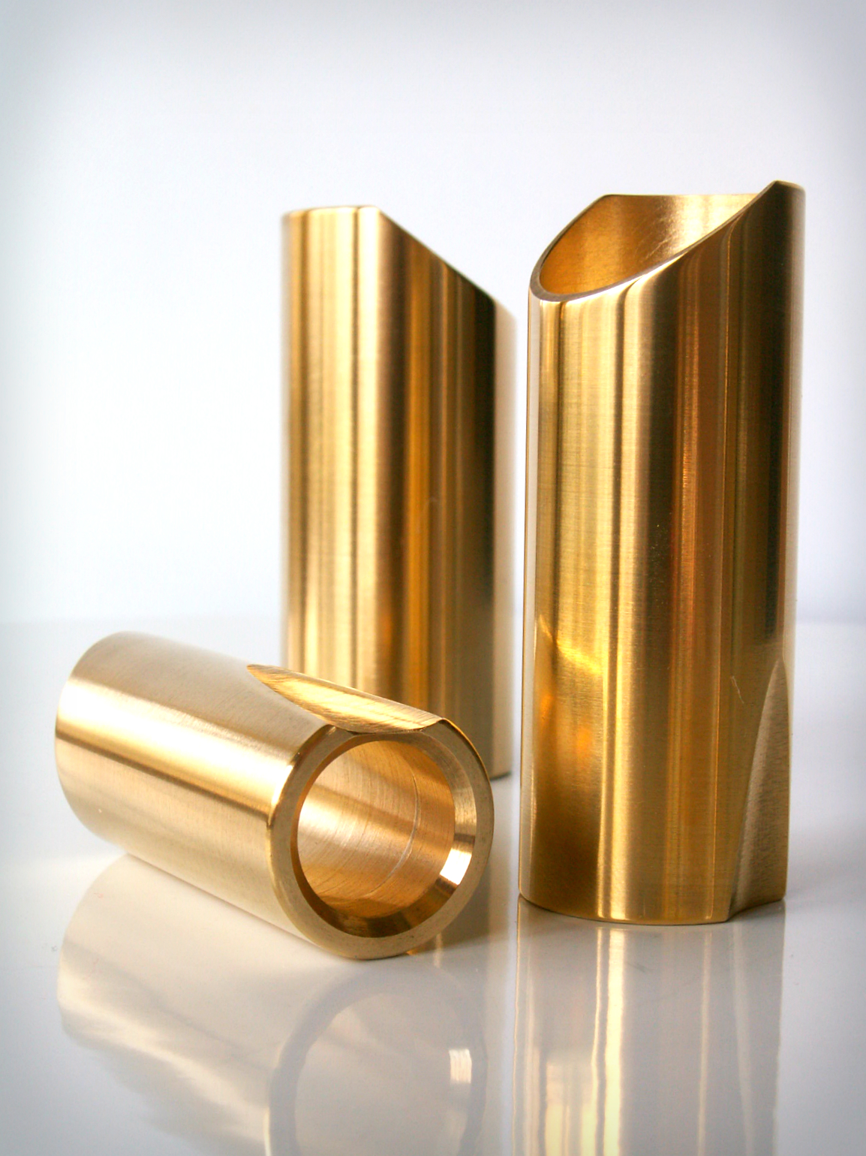
Brass has for some time been utilised as an essential material in the faucets, which for a large number of us who drink our water is a major health hazard. Brass is still in most of the current generation of faucets around the countries.

In the market, most taps are made of brass with stainless steel covered around it, a lot of people believe that it is made of stainless steel which is a massive problem in this world.

Stainless steel is used in all kitchen gear that has direct contact with food. It is the material of high quality because of its strong exterior and exception to the acidic impacts of food.

Stainless steel is the ideal material available in the industry because it is 100% strong completely through and 100% recyclable. The procedure for the creation of stainless steel is the most developed available, the melting point is more than 1700 degrees.

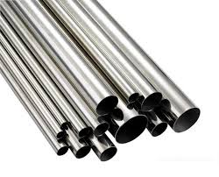

2.

The manufacturing process for faucets has moved toward becoming with robots controlling the vast majority of the machines. Profitability and effectiveness have improved throughout the years. The essential procedure consists of framing the main body of the faucets applying a completion and afterwards collecting the different components, trailed by inspection and packaging.

There are two techniques used to make faucets bodies. Most manufacturers utilise a machining procedure to shape the body into the required size and measurements. This includes first stopping the bars into small sticks and consequently sustaining them into a modernised numerically controlled machining focus. This machine performs turning, parting and grooving, threading, milling, drilling, reaming and boring operations. It typically takes about one minute to make a part.

Turning
The manufacturing process of turning includes pivoting a section while a solitary point cutting device is moved parallel to the axis of rotation. Turning should be possible on the outside surface of the part just as the inner surface which is known as boring. There are three sorts turning, which are tapered turning, Spherical generation and hard turning.

Tapered turning implies to deliver a tapered surface by continuous reduction or increase in diameter across from a circular shaped workpiece. This tapering activity has a wide range of development of machines.
Spherical generation is a machine to produce ball shapes on to the workpiece.

Hard turning turns with Rockwell hardness. Rockwell is a hardness scale based on the toughness of a material. The Rockwell test determines the hardness by measuring the depth of penetration of an indenter under a lot of weight compared to the penetration made by little weights. It is typically performed after the workpiece has been heating treated.

when hard turning is connected for absolutely stock grinding purposes, it contends positively with harsh grinding. When it is connected for completing basic structures and measurements, grinding is predominant. Grinding produces higher dimensional exactness of roundness. Also, cleaned surface finishes can't be accomplished with hard turning alone.

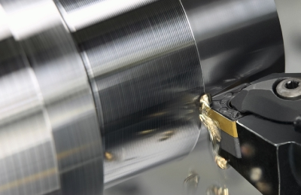

Parting and Grooving

This process, called parting off or cut off, is utilised to make profound grooves, which will remove a finished, or part complete piece from its stock.

Grooving is like a parting, except that grooves are cut to the exact specific depth instead of cutting a completed or part complete component from the stock. Grooving can be performed on internal and external surfaces, as well as on the face of the part.

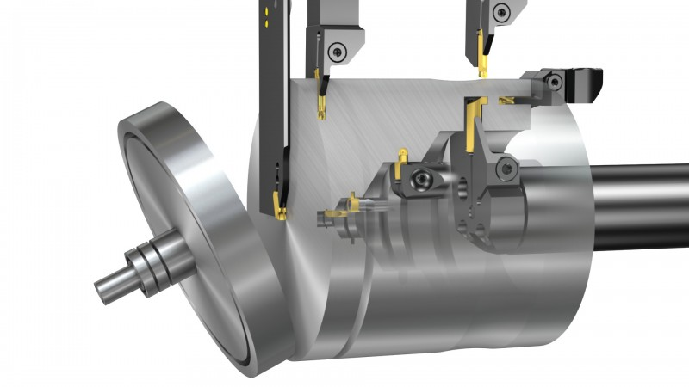

Threading

There are four different ways to the thread, which are thread turning, thread milling, tapping and thread whirling.

Thread turning is a useful threading method, it rotates components around the middle of the rotation. It gives a good surface polish and a standard thread quality. It is well known when it comes to this specific threading process and it covers one of the biggest thread shapes.

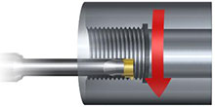

Thread milling is for components that threads outside the middle of rotation on rotating components and threads on non rotating components. It is possible to thread in long extensions and slim walled components when low cutting, it can be possible to thread close to the bottom which doesn’t need a groove. Lathe could not be able to be mounted on large pieces, which is why the machines that enable large pieces help out and also they use large thread widths with low supplies on power and rotation.

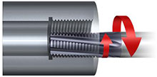

Tapping is easily used and recognised in the threading process, it's mainly for smaller threads and economical threading processes. It can cover most of the mutual thread profiles, which is suitable for any kind of machine tools, rotating and non-rotating components. It gives a high quality thread and can be easily threaded too deep holes.

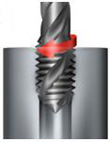

Thread whirling can create high quality threads without bending so they could be long and slim components such as screws. But it would be needing a machine that has thread rotating capabilities.
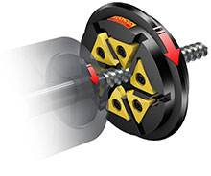

Milling

There are loads of different types of milling machines which are Shoulder milling, Face milling, Profile milling, Groove milling, Chamfer milling, Turn milling and Gear mulling.

The working process usually consists of a first roughing cycle in which the removal of material is done as quickly and economically as possible while leaving a sufficient layer of material for the following finishing stage, where the removal of limited material allows to respect of the initial project regards the tolerances of the dimensions and the degree of roughness of the surfaces. In this way it is possible to gets slots, crown mouldings, enlarging holes.

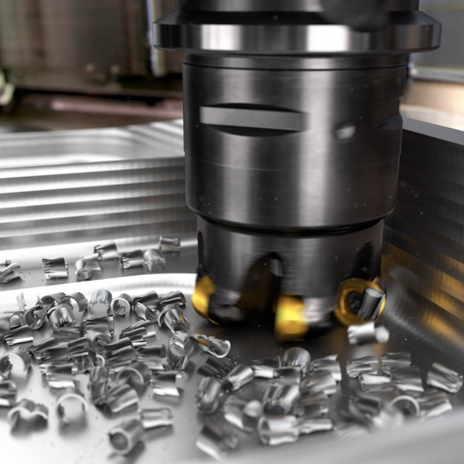

Drilling

Drilling is a cutting process that utilises a drill tool to cut an opening of the round area in strong materials. The drill is normally a rotational cutting device. The bit is squeezed against the item and pivoted at rates from hundreds to thousands of rates for every minute. This forces the cutting edge against the work-piece, cutting off chips from the hole as it is drilled.

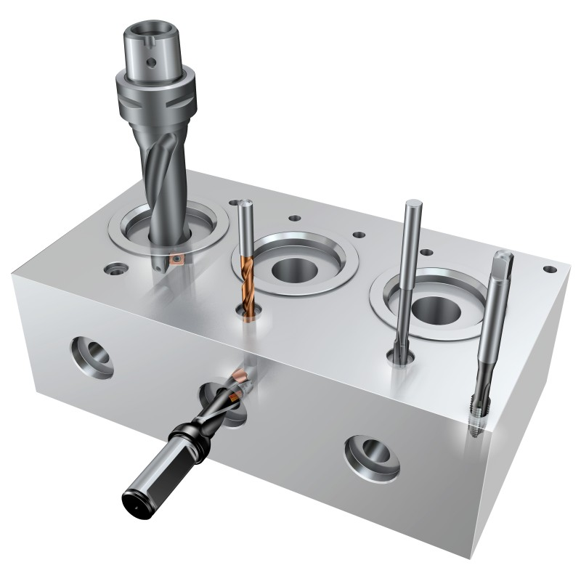

Reaming

Reaming is a cutting process with a multi edged cutting instrument which is continually in action. Reaming is functional to complete drilled holes precisely to size and with a decent surface completion. Reaming offers the favourable position that a number of holes can be delivered with reliably great quality. The benefit of this is it can have the accurate diameter required when needed and it is sharp.

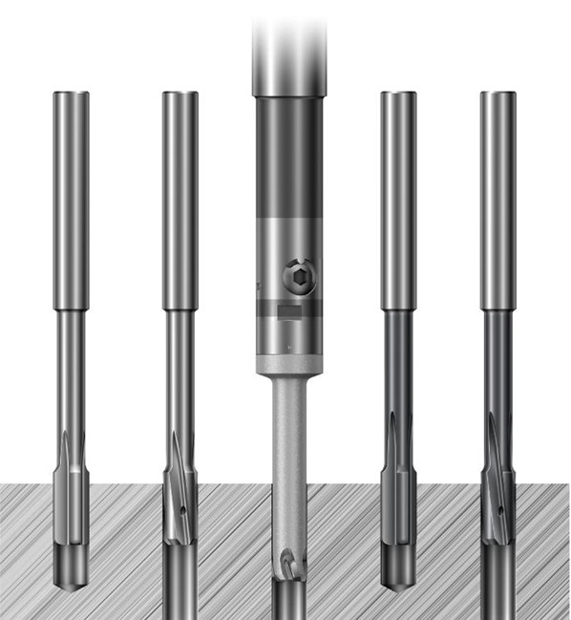

Boring

A boring tool enters the workpiece pivotally and cuts along the inner surface of a current gap to extend the distance across or acquire increasingly exact measurements. The boring device is a single point cutting equipment, which can be set to cut the ideal width by utilising a customisable boring head.
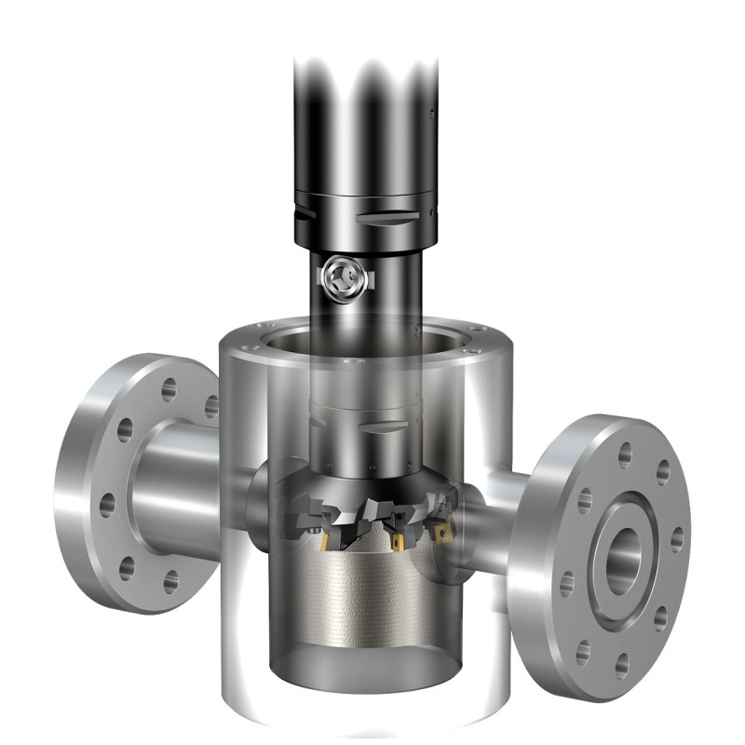

Certain faucet manufacturer utilises hot forging as opposed to machining since this technique can create a close net shape in around three seconds with minimal waste. Forging is the way toward forming metals by misshaping them here and there. A heat forging, heated metal is constrained into a die on that nearly a similar shape as the faucet body. The weight is gradually expanded through the span of a few seconds to ensure the die is totally loaded up with metal. Only minor machining is required to create the right measurements.

Once you machined, the parts are prepared for the completing process. Those parts that come into contact with water may initially require uncommon surface treatment to remove any outstanding lead. This includes a leaching procedure that dispenses with lead molecules from the brass surface. The customary completion is chrome since this material is the safest against corrosion. First, a base covering of electroplated nickel is connected, trailed by a slim covering of electroplated chromium. The chrome layer is kept from a plating bath containing certain added substances that improve consumption obstruction.

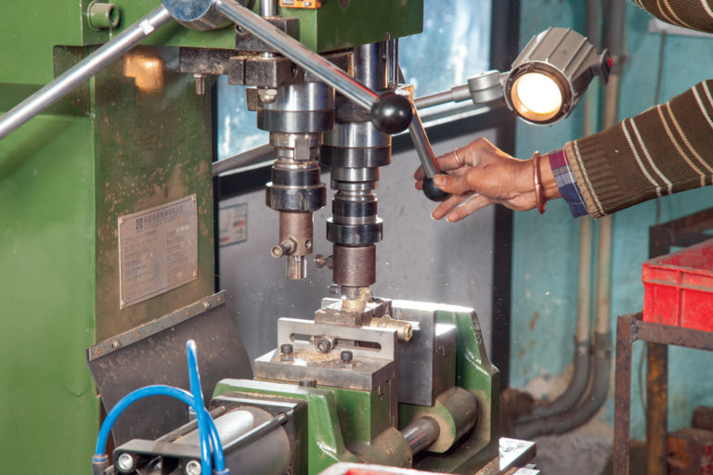

To accomplish a clean brass look, physical vapour removal is used, which applies the metal covering in a vacuum chamber. This chamber has four segments, a vacuum pump to give a controlled domain free of contaminants, a tank that transmits a few sorts of gases, a rod that goes about as the metal source and racks to hold the faucet parts. The objective is made of a corrosion resistant material such as zirconium.
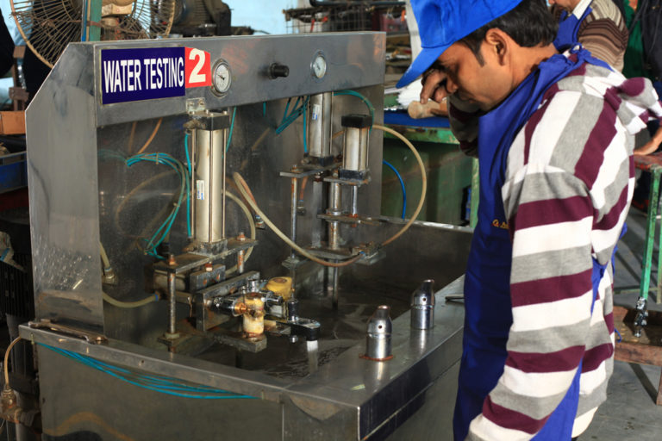
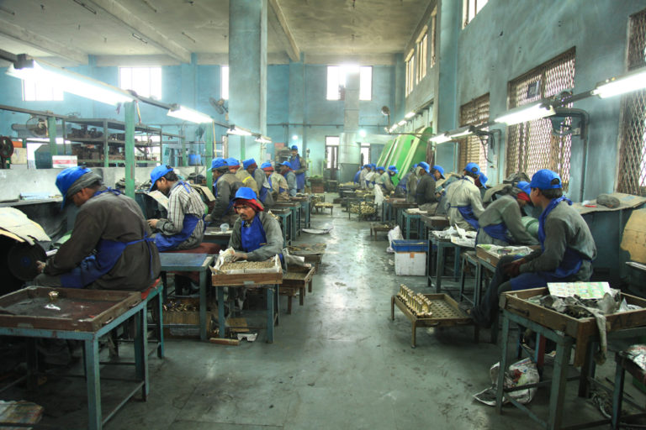
An electric bend warms the target to vaporise the material, at that point strikes the outside of the faucet at high speed and responds with the blend of gases. One gas gives the shading and another gives the corrosion resistance. As the objective material combines with these gases, it clings to the faucet part, making a bond that is for all intents and purposes indestructible. A few producers use a spiral coil around the object to give a uniform distribution of the coating.

Once you have done the plating, the parts are put away in canisters until they get attached together. Getting them attached together can include both manual and automated processes by machines. For certain faucet, O rings are fitted by hand or an elastic seals.

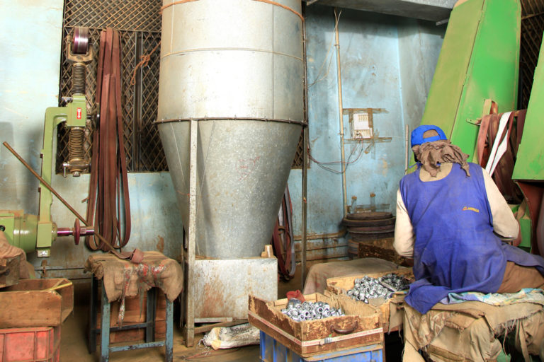

Lastly, the faucet and different segments are sent for a final check meeting. This procedure happens on rotating machines, which are accurately controlled or by automatic machine. The cartridge is screwed in place with brass using a pneumatic gun, and afterwards, the handle is supported by hand. Once in a while, the copper tubes are introduced before attaching. After attaching, the faucet is bundled in boxes alongside whatever other components that are required for final establishment.
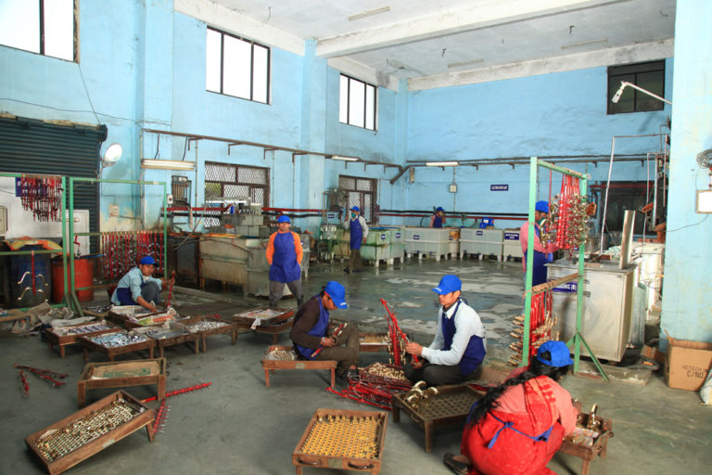

3.

To combine all the research I have done and how I would interact my option in developing this faucet is by not having brass as its not completely safe when it comes to drinking from it or using it for kitchen use, the main material first and that it should start is stainless steel as it safer than brass and that it is 100 per cent recyclable. Also when comparing the inside of the faucet stainless steel have it would not stain whereas brass it haves a lot of stains and that is a problem for health and safety.

To improve the faucet is that I would install an internal heating system in the tap where you could walk up to it and not have to worry about the germs in the faucet its self as it would have three sensors to detect when using it, one sensor would be on the left side of it and its for hot temperature water, another one would be in the middle where it would be a warm/ regular temperature and lastly another one on the right side where it will give you a cold temperature water. Once you hovered any one of the three sensors it will activate and to turn it off just hover back on whichever the sensor you used to stop, perfect for none germs awareness and its perfect for kitchen use when your hand is covered in seasoning or anything that’s makes a mess because the advantage of that would be not getting the faucet wet, sticky, dirty and then putting the effort to clean that up as well.
Bibliography

http://starcraftcustombuilders.com/sources.faucets.htm

https://www.clevertaps.com/production

https://en.wikipedia.org/wiki/Brass

https://www.bssa.org.uk/faq.php?id=1

https://www.sandvik.coromant.com/en-gb/knowledge/pages/default.aspx

https://agmeco.com/manufacturing-process/

https://www.slideshare.net/FelicityTopp/tap-and-faucet-casting

https://circabc.europa.eu/sd/a/3f3c459a-8d48-4e17-92fd-8eace3113a7a/09%20-%201.2%20User%20guide%20materials%20in%20contact%20with%20drinking%20water%20at%20home.pdf

https://www.youtube.com/watch?v=wROY1Lv9nz4

https://www.youtube.com/watch?v=IlcUyEV9jVI

https://www.housetrends.com/articles/bathroom-faucets-facts-made-simple/

