Name: Aliesha Sadaf
Student Number: 2441379
Module code: LCHS4008
Introduction to Public Health
Assessment 2 - Report on a Health Issue
Lecturer’s name: Hajra Mustasim
Assignment Title: Assessment 2 - Report on a Health Issue

Introduction
This report is about Asthma. Asthma is common chronic lung disease that affects your breathing, this can affect all people at any age. Asthma is triggered by inflammation or muscle tightening around the airways which makes it harder to breathe, it can differ from person to person, but some people may experience acute symptoms like asthma attacks, which can be life threatening whereas other people may experience more mild symptoms like a dry cough. The signs and symptoms of Asthma are the following, shortness of breath, coughing, wheezing when inhaling/exhaling, and tightness of the chest.
In the UK the prevalence of the population that lives with Asthma is approximately 8% which means over “7.2 million people as of 2025 live with Asthma”, according to (GOV.UK, 2025). The rate of incidences in England of emergency hospital admissions in the NHS (national health services) for Asthma in adults aged 19 years and over increased by 17% from the financial year ending 2024, this equalled to 41,369 admissions, and the rate was significantly higher than the previous year (Office for Health Improvement & Disparities, 2025). As shown in the graph below, which shows the severity of Asthma. The drop in the graph was during the COVID-19 pandemic due to lockdown restrictions. In the 1990’s to 2021 the number of deaths due to Asthma worldwide had a slight increase, and the level of incident cases of Asthma decreased.
This Graph shows Emergency hospital admissions for Asthma in adults aged 19 years and over, according to GOV.UK
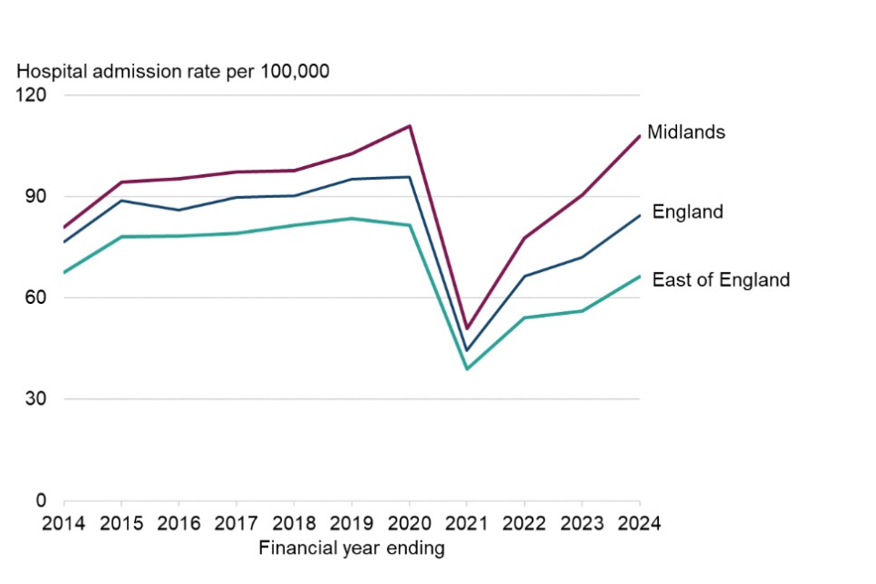

Consequences
The consequences of Asthma in the community are a reduced quality of life, environmental impact, and productivity loss. A reduced quality of life shows that 77% of the total economic impact is because of poor health people are not capable to carry out daily activities when the asthma is uncontrolled which leads to a reduced quality of life. Another consequence due to Asthma is the environmental impact because of uncontrolled Asthma it increases the use of inhalers especially high carbon footprint reliever inhalers; this results in high greenhouse gas emissions. “The use of inhalers indicates that inhalers are approximately 3% of the NHS carbon footprint, contributing toto climate change” according to (PrescQIPP, 2025). “Severe asthma patients produced around 0.54 tonnes CO₂e, highlighting a substantial environmental footprint linked to poor disease control” according to (Orlovic et al., 2024). Productivity loss can be attributed to worsening symptoms which causes missed work or school, and broader economic impacts.
Whereas the consequences of Asthma in the NHS (national health service) are negatively impacted, because of higher NHS costs, and treatment intensity rises. Higher NHS costs due to uncontrolled asthma creates a heavy workload on the NHS because it results in patients needing more appointments, prescriptions, and treatments therefore leading to higher overall costs. A patient with non-severe uncontrolled Asthma in 2022 would cost the NHS 22% more than a patient with controlled asthma. According to (NHS England) “The annual economic burden of asthma and COPD on the NHS in the UK is estimated as £3 billion and £1.9 billion respectively”. As Asthma cases get worse more patients will require frequent GP appointments, hospital visits, and emergency care which will put extra pressure on the NHS, leading to longer wait times, because the NHS wouldn’t be able to keep up with demands. Un controlled Asthma may need more intense treatment such as increased use of inhalers and other medication will further contribute to the rising strain on NHS resources.

How is it controlled
Asthma is controlled by monitoring your asthma, ways to avoid triggers, or taking medication. The patient should get check ups regularly to see if treatment is working, and to ensure that the patient is using inhalers correctly, and having a up to date treatment plan. The main treatment that can control asthma is inhalers; this treatment controls and prevents asthma symptoms and helps the patient with their breathing. There are 2 types of inhalers, one is used as a preventer that should be used everyday to help prevent symptoms, and the second inhaler that’s called blue reliever inhaler is meant to be used when the patient starts getting symptoms of Asthma.
In a emergency the patient gets a asthma attack, the patient would then need to go hospital to receive hospital treatments such as oxygen through a mask, using a nebuliser to breathe in high doses of medicine, and steroid tablets or injections. Things that are encouraged to control asthma are to always have your inhaler with you, avoid things that can trigger asthma symptoms like air pollution, smoke, pollen or animals, maintain a healthy weight, and flu vaccinations.
The factors influencing the health and well-being of people affected by Asthma and people around them, are health and body factors, environment, mental health and emotions, social life and support, lifestyle.
Health and body factors can influence the health and wellbeing of individuals living with Asthma such as how serious the asthma is that it could either be controlled or be severe causing asthma attacks, and hospital visits, other issues like allergies or weight gain may make the condition worse. It is important to frequently go to check-ups at the GP and ensuring that the individual is taking their inhaler or medicine correctly.
However, Environment can influence the health and wellbeing of individuals such as air pollution, smoke, dust, pollen, pets, Mold, or poor ventilation can all negatively impact a individual living with Asthma causing asthma attacks, worsening breathing, or symptoms which harms the health of the individual.
Emotions and mental health affect both the individual’s health and wellbeing and the people around them such as unable to get involved with family or friends during physical activity’s because the individual doesn’t want to trigger a asthma attack, causing them to isolate and can lead to depression and anxiety or maybe feel stressed out which could trigger the individual’s symptoms. Family and friends feel sad and upset when the individual cannot participate in activities. Not a good quality of life, unless they receive support with someone that understands the individual’s health condition.
Conclusion
In summary Asthma is a long-term condition that affects many people in the UK and worldwide. Some individuals have not serious symptoms, but some have more serious symptoms such as asthma attacks that require emergency care. In the UK asthma is increasing which shows asthma is still a big health problem. Asthma can make daily life harder, the individual may feel isolated and develop mental health, due to missing out on daily activities or physical activity which can lead to weight gain and cause more issues to their health essentially worsening asthma symptoms, leading to a low quality of life. The NHS are under immense pressure due to uncontrolled asthma which leads to more appointments and medication leading to higher costs. However, asthma can be controlled with the right treatment and help, and better understanding on the condition. With the right support and proper treatment individuals can live better lives.

References
NHS England (no date) ‘Respiratory disease’, NHS England website. Available at: https://www.england.nhs.uk/ourwork/clinical-policy/respiratory-disease/

england.nhs.uk
(Accessed: 18 November 2025)

UK Health Security Agency & Centre for Climate and Health Security (2025) *Asthma and airborne allergens*. GOV.UK. Available at: [https://www.gov.uk/guidance/asthma-and-airborne-allergens](https://www.gov.uk/guidance/asthma-and-airborne-allergens) (Accessed: 18 November 2025).

Orlović, M. and Tzelis, D. (2024) ‘Environmental, healthcare and societal impacts of asthma’, *British Journal of Clinical Pharmacology*, **80**(6), pp. 1245–1255. Available at: [https://pmc.ncbi.nlm.nih.gov/articles/PMC11261382/](https://pmc.ncbi.nlm.nih.gov/articles/PMC11261382/) (Accessed: 18 November 2025).

NHS England (no date) *Improving health outcomes for respiratory patients while reducing carbon emissions*, Greener NHS. Available at: [https://www.england.nhs.uk/greenernhs/whats-already-happening/improving-health-outcomes-for-respiratory-patients-while-reducing-carbon-emissions/](https://www.england.nhs.uk/greenernhs/whats-already-happening/improving-health-outcomes-for-respiratory-patients-while-reducing-carbon-emissions/) (Accessed: 18 November 2025).

PrescQIPP (2020) *Inhaler carbon-footprint briefing 20*. Available at: [https://www.prescqipp.info/media/5720/295-inhaler-carbon-footprint-briefing-20.pdf](https://www.prescqipp.info/media/5720/295-inhaler-carbon-footprint-briefing-20.pdf) (Accessed: **18 November 2025**).

National Institute for Health and Care Excellence (NICE), British Thoracic Society (BTS) & Scottish Intercollegiate Guidelines Network (SIGN) (2024) Patient decision aid on asthma inhalers and climate change. NICE guideline NG245. Available at: https://www.nice.org.uk/guidance/ng245/resources/patient-decision-aid-on-asthma-inhalers-and-climate-change-bts-nice-sign-pdf-13558151917
(Accessed: 18 November 2025).
Zhang, L., Jiang, H., Yang, G. et al. (2025) ‘Global, regional and national burden of asthma from 1990 to 2021: a systematic analysis for the Global Burden of Disease Study 2021’, BMJ Open Respiratory Research, 12(1), e003144. doi: 10.1136/bmjresp-2025-003144.
Office for Health Improvement & Disparities (2025) Respiratory disease profile: statistical commentary, June 2025. Available at: https://www.gov.uk/government/statistics/update-of-indicators-in-the-respiratory-disease-profile-june-2025/respiratory-disease-profile-statistical-commentary-june-2025
(Accessed: 18 November 2025) World Health Organization (WHO) (2024) Asthma. Available at: https://www.who.int/news‑room/fact‑sheets/detail/asthma
(Accessed: 18 November 2025).

