SAINSBURY’S

MANAGING PROJECTS

In the

ORGANISATION

STUDENT NAME: Stanica Claudia Ciubotariu
STUDENT ID: 1909631
MODULE CODE: BMSW 5104
MODULE NAME: Managing Projects in the Organisation
LECTURER NAME: DAN HART
UNIVERSITY NAME: University of Wales Trinity Saint David

Executive Summary

The report has shown that the allocation of resources and monitoring of the activities are the most important factors in project planning. The milestones of the project include financial investment and accumulation of the right technology for Smartshop of Sainsbury. The project has developed a professional experience in me about the planning of a project. It has made me learn communication skill. I have played the role of a plant and implementer in the project. The complete finisher role has not suited me much. In the personal development plan, it is shown that I will develop my time management, planning and writing skill.

TABLE OF CONTENTS

Introduction …………………………………………………………………... 4
Project Risk Management Plan ………………………………………… 5 & 6
Project Time Management …………………………………………….. 7 & 10
Project Implementation ………………………………………………. 10 & 11
Greiner’s Life Cycle Model …………………………………………... 12 & 13
Stakeholders Identification …………………………………………... 13 & 15
Stakeholders Mapping ………………………………………………... 15 & 16
Personal Development
- Gibb’s Reflective Cycle ………………………………………… 16 & 17
- Team Skills Model of Belbin …………………………………... 17 & 18
Personal Development Plan ………………………………………………… 19
Conclusion …………………………………………………………………… 20
References ……………………………………………………………... 21 & 24

INTRODUCTION
Business organisations often involve extensive projects that bring forth huge revenues. For this, project management is absolutely necessary to make sure the financial investment to the company generates the right outcome. Project managers deal with potential risks with their risk management abilities and carry forwards the project efficiently. After the outbreak of the pandemic, Covid-19 several organisations have adopted methods and new policies to combat the adverse challenges of the business environment (Whelan, et al, 2020). Companies has invested in new and innovative projects to generate high sales. This report will discuss Sainsbury's "digital-first business" approach which they have undertaken after the pandemic hit the world.
Sainsbury is one of the major retail brands in the UK that has been serving its customers items of regular use at an affordable rate. Due to the social restrictions applied by the state government after the pandemic, the company shifted to digital business and analysts have reported that the company is experiencing an increase in sales by a whopping 87% after the company provided online facilities. Online sales were extremely popular and profitable and have expanded its market position not simply as a retail brand but as a company with prolific technological innovation. This project undertaken by Sainsbury accelerated sales to 15 more cities in Britain. One of Sainsbury' technological innovation, known as "Smartshop" is a digital app, increases the pace of the shopper's or consumer's journey and this handheld personalised app is used for more than 37% of the overall transactions (Whelan, et al, 2020).
In this project management report, certain project management tools like JIRA and Kanban will be used for demonstrating the processes of management and techniques like the Agile method and waterfall methodology will be used to explain the structure of the project by Sainsbury. These tools and techniques are extremely efficient in understanding the concept of project management.

Project Risk Management Plan
The risk management plan is the combination of the various assessment including precise observation and calculation of the risks in a format of documentation which can create huge impact in any certain project. The risk management plan helps in proper evaluation and attenuating the processes involved in the risk and thus will create benefits for the overall project.
The current risk management plan is developed for identifying the risks related with the Sainsbury’s and to conduct this there are different steps related with the risk management plan which can be analysed in a proper way (Okonofua and Rahman, 2018). The various stages involved in the risk management plan are:
Identify Risk: The risk that has been identified in the Sainsbury’s is that the outbreak of the Covid-19 pandemic has created a huge problem in the job section as more than 35,000 jobs are at risk due to the pandemic. This created an additional workload for the already existing employees and thus a heavy pressure has been created due to the workload. A group of stakeholders are formed to identify the risk at the basic stage and thus helps in assessing and eliminating the different risks related with the projects (ETRetail.com. 2020).
Risk Register: Risk register is the process of keeping the record of the official documents of the total processes for managing the risk. The events or the tasks are tracked on the register which includes the project’s starting date, the identified risks or the threats, the impact of the risk and the intensity of the risk. Risk registers further contain a proper risk ID along with the name of the official under whom the task for manging the overall risk has been assigned (Szymański, 2017).
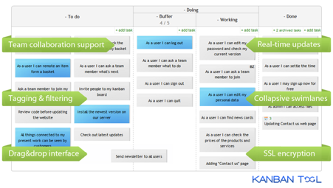
Figure 1: Kanban Tool for Project Management
(Source: Szymański, 2017)

Risk Analysis: The qualitative risk analysis is a vast idea and a concept which can be used in the overall project. However, the qualitative analysis needs certain data and information to identify the risk. The qualitative evaluation requires no particular software or any tools. The Kanban project management tool is used for organising the overall project in a proper way and the process is also flexible and helps complete the task within deadline (Jensen and Aven, 2018).
Risk Response: The strategies by which the different risks can be easily figured out along with the processes to eliminate its harmful impacts on the project is included is known as risk response. The impact of the risk on the project can be analysed by using qualitative evaluation which will help the risk managers to plan the risk management process in an effective way (Morris et al., 2020).
Mitigate Risk, Control Risk: The waterfall methodology will be useful to mitigate the issue as it helps in building discrete and proper risk management plan in order to achieve the objectives and the goals of the Sainsbury’s. This methodology can be beneficial for Sainsbury’s for allocating tasks to the employees within the given amount of time (The Economic Times. 2020).
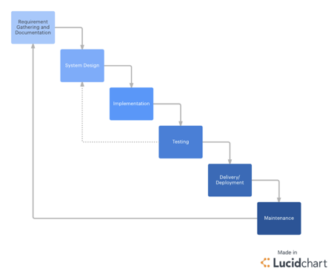
Figure 2: Waterfall Project Management Tool
(Source: The Economic Times. 2020).

Project Time Management
The plan schedule management involves scheduling the timing of the project. This is important to note that the project can be scheduled in the right manner through proper planning, management and execution of the schedule (Tonchia, 2018). The manager of the project should understand the importance of fixing a schedule of the digital business project. The digital business project of Sainsbury will begin in mid-April and finish by the end of August in 2021 approximately. The COVID-19 has urged the company to include a project plan of digital business that should be completed as soon as possible.
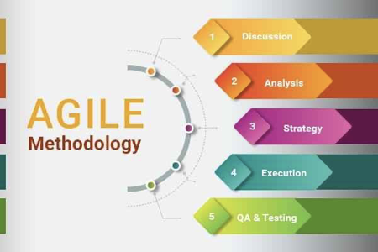
Figure 3: Agile project Management Tool
(Source: Tonchia, 2018).
Plan Activities
The digital business project will require Sainsbury to set goals at first. Objectives need to be set by the managers so that the employees can work on the basis of those objectives. The planning of the schedule or duration of the project should be analysed (Кадиковаet al., 2017). There should be other activities such as delegation of tasks, implementation of strategies, monitoring and reviewing of the activities. Allocation of resources should be done for the project. The cost required for a project like a digital business is huge. Sainsbury should keep a good amount of money in store for the investment.
Plan Resources
Resource planning is important to make sure that the project goes uninterrupted. The resources required of the project of digital business in Sainsbury is financial resources, human resources, technology resources and other tools and techniques. Project management tools such as Gantt chart, Pert chart, WBS diagram and so on should be done to keep the structure of the plan updated. Technology resource and financial resource will play the most vital role in this project. The budget should be fixed for the allocation of the resources (de Andrade et al., 2019). The human resource of Sainsbury should be active enough to arrange the resources evenly in the respective employees.

Milestones
Identification and fixing of milestones are important so that the members of the project are aware of the path they should follow. The manager should clear the milestones in the beginning and in the process of the project so that the members do not get deviated from their milestones. The milestones in this project are getting financial investment and accumulation of the right technology for SmartShop of Sainsbury. These milestones can be achieved by the initiatives by the higher officials of Sainsbury who know the usage of these milestones (Lachhabet al., 2017). These milestones will work as an alarm for working.
Monitoring and Control
The manager of the project has the most important job of monitoring and controlling the work of the project members. This should be done on a daily basis so that the employees can be rectified on time if mistaken. This is an important activity because this makes sure that the project will be completed on time without any error (Mojica and Daniel Jr, 2017). The work produced after a long effort should be productive and efficient. The manager needs to be active enough to monitor and control to prevent any time loss.
Plan, Monitor, Control
Production monitoring, preparation and coordination is a utilitarian strategy towards increasing the effectiveness of the performance of the employee base as it disposes of various techniques to promote the confidence of the workers. For this, numerous devices and tools of project supervision can be employed. JIRA Software is one of the most prevalent software that is usually employed for monitoring in project management. This assists in breaking down the complete assignment into shorter sections by implementing its ticket design (Safari and Kisimbii 2020). This assists the project supervisor in discerning and interpreting the assignment thoroughly and he can designate the tasks or liabilities to the relevant employee in a more practical custom. In addition to this, JIRA is budget friendly as a project management device as it integrates the performance of numerous people under a single program.
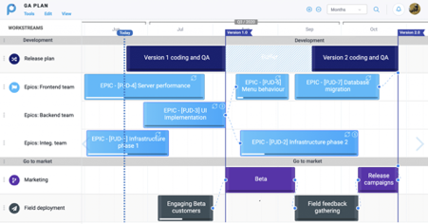
Figure: JIRA Software
(Source: Safari and Kisimbii 2020).
The effectiveness of JIRA in software development is extraordinary. Consequently, the project supervisor of Sainsbury can rely on JIRA and investigate the concerns of time management, efficient delivery, customer relationships and management of overwhelming online orders. Through the assistance of this software, the investment and utilisation of the firm's supplies or resources can be also be traced and documented. Consequently, it will be advantageous for performance management to control human capital as well.
The entire monitoring plan can be depicted in the following timeline and Gantt chart:
Gantt chart

Activities | 1st week | 2nd week | 3rd week | 4th week | 5th week | 6th week | 7th week | 8th week | 9th week | 10th week | 11th week | 12th week
Determining project plan
Identifying possible risks
Conducting risk assessment
Conducting risk analysis
Recording in risk register
Planning resources
Organising resources and budget
Monitoring resources
Implementation of monitoring activities
Table 1: Gantt chart
(Source: Created by the learner)

Project Implementation
Kotter’s 8-Step Model
With the help of Kotter's 8 step model, the project implementation of Sainsbury and its development of SmartShop to increase the sales of the retail brand during a pandemic can be well explained. This would guarantee improved productivity and efficiency in the performance of the workforce. The eight steps are discussed below:

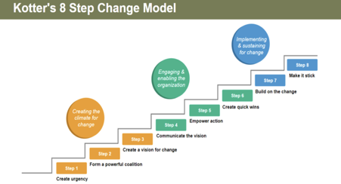
Figure: Kotter’s 8 Step Model (Source: Buzan and Whitehead 2021).

Step 1: Creating Urgency- The first stage entails the description of the possible risk that can influence the business processes. In this scenario, the collaborative effort of the technical analysts and service managers are required to avoid discrepancies in online transactions. It has been studied that the customers of Sainsbury who shop at both online and offline stores are likely to spend 2.4 times more than customers who only visit offline stores.
Step 2: Creating Strong Guidelines- Selecting technical analyst with high social media skills and SEO optimisation are required for the successful implementation of this change. Managers must monitor these business transactions to prevent mishaps (Buzan and Whitehead 2021).
Step 3: Developing a Vision- Although these modifications are important the threats from competitors like Tesco and Asda still exist. For this, the managers of the firm have emphasised retaining a cooperative approach among the employees. Hence, the vision of mutual assistance will survive among all segments of the employee base.
Step 4: Communicating the Strategy- The declaration of the modifications might appear threatening for the workers if the policies are not delivered efficiently. Therefore, the managers can assure them of job sustainability with the work from home options.
Step 5: Removing Obstacles- To favourably complete the reforms, it is important to eliminate the potential barriers and laws of resistance. For this, a precise study and analysis of the organisational concerns should be done to investigate the potential repellent forces like differences in employee performance or disputes among interdepartmental operations (Buzan and Whitehead 2021).
Step 6: Accomplishing Small Profits- Establishing short terms aims that are practical and effective will impart a sense of purpose and success among the employees. For instance, Sainsbury's hiring of professional analysts has led to an increase in the speed of page loading by 50% overnight (Kang, et al, 2020). The production release on the app SmartShop transformed from slow and unstable to fast and flexible.
Step 7: Consolidating the profits- The achievements that are obtained from the short-term victories must be strengthened as an open-ended system among the organisational arrangement. Individual accomplishments can be developed based on the structure of these variations.
Step 8: Consolidating the Change- Lastly this step demands the stabilisation of the different organisational innovation in approaches and strategies that have been introduced to the employees. The competitive advantage of Sainsbury will also increase with its improved effectiveness of performance. Consequently, production of the profits will be high for Sainsbury (Kang, et al, 2020).
Greiner’s Life Cycle Model
Greiner’s Life Cycle Model can be applied in the context of the project management in Sainsbury for estimating the maturity and growth of the company when they implement the design and experience effective outcomes. This will also detect the possible situations of crisis that the company will go through. The application of this model can be done in the following method:
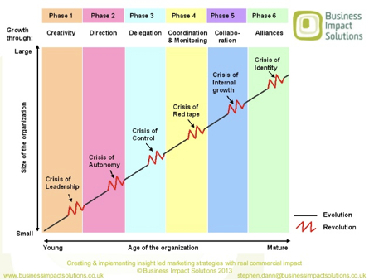
Figure: Greiner’s Growth Model
(Source: Medium 2020)

Phase 1: Growth through Creativity: The opinions of the design or the project must be communicated to small groups and selective members of the organisation who would be contributing the most to the project. This is usually done informally by the project managers to the employees. For Sainsbury, this will occur between the HR managers and project managers as the recruitment of the right technicians is necessary for digital development. The problem of inefficient leadership will arise in this growth stage.
Phase 2: Growth through Direction: As the design approaches its final stages, it would provide opportunities for new and upgraded business activities. Abiding by these changes absolutely necessary for the successful growth of the company. In this scenario, the employees must cater to the online demands of the customer with equal commitment as they did for customers who visited the offline stores. By the end of this phase, Sainsbury is likely to experience an autonomy crisis (Medium 2020).
Phase 3: Growth through Delegation: The several responsibilities owing to the current project would be allocated amongst various employees and candidates but will ultimately lead to a situation of control crisis as Sainsbury will be ushering new members in the organisation.
For this, strong leadership policies with formal interactions and a proper monitoring plan need to be introduced to overcome the crisis. The establishment of a new hierarchy will carry forward the business processes in an effective manner.
Phase 4: Growth through Coordination and Monitoring: Due to the implementation of monitoring and control plans the project management activities of Sainsbury will become organised and coordinated. Consequently, the business objectives of the company will be easily met, and the generation of profit will rise (MindTools 2020). Distribution of the incentives will be done equally. However, at the end of this stage, a red-tape crisis is likely to arise.
Phase 5: Growth through Collaboration: The red tape crisis can be mitigated by making various divisions within the company work collaboratively. Collaborative work or teamwork gives rise to a matrix structure and helps the company in formulating policies of team-based monetary rewards and information systems. However, the crisis of internal growth remains a possibility.
Phase 6: Growth through Extra-Organizational Solutions: The problem of internal growth can be mitigated by forming alliances with other digital brands that would accelerate the promotion of Smartshop. Making the interface of the app more user friendly will invite more users and thereby increasing the sales of Sainsbury (MindTools 2020).

Stakeholder Identification
The stakeholder circle methodology is applied by a company to meet the expectations and requirements of the stakeholders to maximise the profits of the business operations. Sainsbury can deploy this model to recognise and prioritize the stakeholders' expectations and needs to put them on the list of priorities while developing and implementing the new project of expanding business digitally. Through this model, the relationship between the company and its stakeholders are improved due to the establishment of effective communication and interactions. The steps that comprise the stakeholder circle methodology are discussed below-
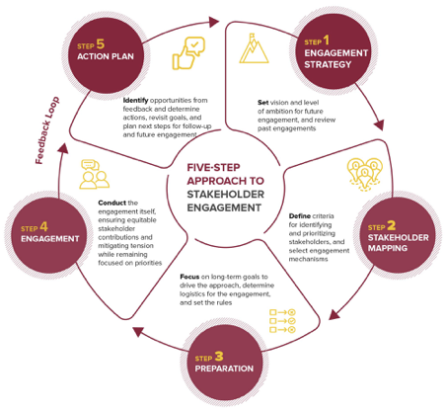
Figure: Stakeholder Circle Methodology
(Source: Ika,et al, 2020).

Identification of the stakeholders: This first important stage is identifying the stakeholders and their needs and demands that directly affect the business operations of Sainsbury. This encompasses all the sectors of the business functions like the monetary expenditures of the general investors or the managerial and authoritarian efficacies of the higher officials. The project owners fall under the category of the stakeholders as well. For having an effective understanding of comprehension of the possible stakeholders, Sainsbury can conduct an organisational survey to identify the list of stakeholders and their relevant demands or needs.
Prioritization of the stakeholders: After the process of identification of the stakeholders, their needs must be prioritised on the grounds of authority, vicinity and seriousness or urgency. For instance, the higher officials of the company and their particular interest will be of prior concern as they exercise the right to grant permission for the implementation of the project (Ika, et al, 2020). Without their call, the project cannot be employed within the company. Second, comes the interest of the financial investors who would be providing monetary support for the execution of the project. Special focus and attention will also be provided to the interests of the customers as their buying patterns and preferences of products will determine the rate of sales for Sainsbury. Customers form a significant driving force of the sales of a company.
Visualization of the stakeholders: In this model, the stakeholders can be visualised or reflected by arranging them in different coloured tones or shades according to tot the importance of their needs. Through this method, it will be easier to identify the matters of prior concerns owning to the pictorial presentation and can be attended to with accuracy.
Engagement with the stakeholders: The methods and policies of the design or the project have to be accurately conveyed to several stakeholders so that they can present their valuable feedbacks and recommendations. These constructive perceptions can be reviewed and examined by Sainsbury to check for incorporating the mentioned changes in the project structure which would lead to the development of the overall project (Ika, et al, 2020).
Monitoring the changes: Lastly, examining and monitoring whether the changes implemented prove to be favourable for the project. The relationship that is established within the company and its stakeholders must be maintained as it proves to be beneficial for progress and growth.
Stakeholder Mapping
Through the model of Stakeholder mapping formulated by Mendelow, the power dynamic and the areas of inclination of the stakeholders can be analysed. These interest or segments are capable of influencing the decision-making process of a company while implement and managing a new project. The Stakeholder mapping comprises a matrix with four quadrants and these are explained below:
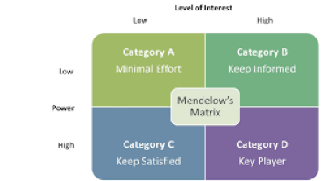
Figure: Stakeholder Mapping
(Source: Almutairi,et al, 2019)

High power and high interest: Stakeholders belonging to this category are considered to be the most influential and important stakeholders for the company. Their expectations revolve around high productivity and efficiency that must derive from the implementation of the project of online marketing in Sainsbury. They can also exercise power in the processes of the project management and hence must be assured of positive results.
High power and low interest: Stakeholders belonging in this category are usually the alliances or the companies with which Sainsbury might form an agreement. In the case of Sainsbury, the financial investors fall under this group as they are not much affected by the consequence of the project that can affect Sainsbury but with the outcomes of the project which must result in high profit. Their interest lies in financial transactions (Almutairi,et al, 2019).
Low power and high interest: The stakeholders like the members of the community who are not directly involved with the project and the rival companies fall under this category. Although they are not involved, they are aware of the progress of the project as the developments are likely to improve the business operations of Sainsbury and thus affect its rival companies.
Low power and low interest: Customers and buyers fall in this group as they have low-interest int in the internal operations of Sainsbury but has the power to influence the business decisions (Almutairi,et al, 2019). The buying patterns of the consumers and their preferences of online services is what propelled Sainsbury for the investment in this project in the first place.
Personal Development
Gibb’s Reflective Cycle
Graham Gibbs in the year 1988 first developed the Gibbs’ Reflective Cycle to provide a proper structure to the process of learning from different experiences along with the feelings and thoughts related to the experience. The cycle has six steps that are used to describe the experience gathered in the project.
Description
The project plan has been made in a short time. The plan was divided into three parts. The first part ascertains the risks involved in the project and how they can be solved, and the time management required for the project (Markkanen et al., 2020). In the second part, I have presented the project plan. This is done to follow the steps required for the right execution of the project. In the third part, I have discussed my personal development through this project planning.
Feelings
The project, in the beginning, created a sense of tension regarding whether the project plan will be rightly executed. When I started researching the topic, I understood that this project planning requires me to be positive and confident. I was equally nervous but gained strength after the work was completed well.
Evaluation
The work is completed properly on time because I divided the work into parts depending on the schedule and I have rightly executed all the routines that I made (Sekarwinahyuet al., 2019). The most positive part of the project as I have researched well on the company and the requirement of the company in the project.
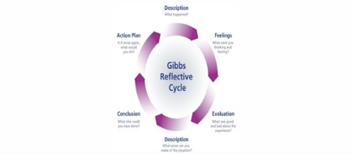
Gibbs Reflective Cycle Model
(Mike, 2020)
Analysis
The success factor of the project is the application of data and information and the use of the right models and theories for the explanation of the project. More evidence could be put to the research work but the shortage of enough data on the internet has prevented me from including more research (He et al., 2018).
Conclusion
I have learnt the importance of a project plan in a company to deal with a difficult situation. I have learnt the Harvard Referencing system in the project work for acknowledgement of the sources taken. I have developed a communication skill in me. I have communicated well with my classmates and some researchers for their idea about the subject.
Action plan
If I was given more word limit, I would have researched more and incorporated more data. I would have used primary research for the work for raw data about the project. The communication skill developed in me as a result of this project will be improved with more communication with my teachers and fellow classmates regarding how I can better my work (Tanaka et al., 2018).
Team Skills model of Belbin
In Belbin’s theory, he has remarked team role as an attempt to conduct, subscribe and interconnect with other team members in a definite manner. The initial eight roles have become nine later. From the feedback collected, I can evaluate my role in the project plan as a plant, implementer and complete finisher.
Plant- The duty of a plant is to make creative and innovative ideas to solve a problem. I have seen that there were problems related to the organisation of the research work. But I have spent enough time in the work to produce it properly. I am an innovator. I have innovated new ideas for the project. I have engaged my innovation in the risk assessment of the project. This is done to make sure that the work is creative and not following a traditional project planning method (Paulamäki, 2018). I am an introvert in general. But I have developed my communication skill to some extent for this project planning. The creative thinking power in me helps me in developing new ideas for a difficult subject.
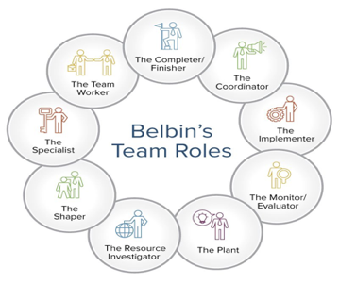
Belbin’s Team Roles
(Simon, 2017)

Implementer - I am quite aimed at finishing a task at any cost. I was nervous at first regarding the project work. But I gained all the confidence in me to understand that the project needs to be done by hook or by crook. I have a disciplined nature when it comes to creating a project plan. I have kept the project work organised (Bednár and Ljudvigová, 2020). There is no mismatch of concepts or poor arrangement of lines. I am a perfectionist when it comes to getting work done. With full effort and efficiency, I made sure that the project I do should be granted. This skill of practicality and systematic approach are my strengths.
Complete finisher - The role of a complete finisher is to check the work thoroughly. This required me to be very particular about the time. I have failed in maintaining proper time. I think that I would finish work in a certain period of time but fail to do so. This is perhaps due to my poor time management skill (Lynch et al., 2018). I cannot work on deadlines and thus, there is always an anxiety in me before taking up a project. This is a dangerous drawback that I have and that I should be rectifying at any cost.

Personal Development Plan

Academic Skill | Action | Future Implications
Time management skill | I can develop my time management skill by beginning early and day and keeping my tasks scheduled (Gregg, 2018). I need to have proper deadlines for all the tasks I do. | Time management skill is important to finish assignments on time. This will help me in my professional career if I become a manager in the allocation of tasks well (Sincheet al., 2017).
Planning skill | To develop this skill. I will create a to-do list. I will plan my assignments and exam preparations, maintaining time (Boyer et al., 2018). | This will develop the competitive strength. I will be able to finish my tasks on time if everything is pre-planned (Amodet al., 2018). Having good planning skill will place me in a reputed company as a manager.
Writing skill | I can develop my writing skill by writing at least 500 words every day. I will write on a variety of topics (Ramsha and Anwar, 2020). These topics will cover everything from business to politics. | Good writing skills will bring me good marks in examinations and assignments. This will also help my professional career in editing in future.
(Source: Created by Learner)

Conclusion
To conclude it can be observed that the relevant theories and models have been successfully implemented in the project management of Sainsbury where it aims to expand its business digitally because of the changing environmental conditions caused by Covid-19. The above study proved to be insightful with high considerable elaborations on the concepts of project management.

References

Ali, H., What Factors Contribute to Efficient Management of The Supply Chain of Supermarket Within UK Retailers? Case Study―Sainsbury Supermarket PLC Supply Chain.
Almutairi, A., Wheeler, J.P., Slutzky, D.L. and Lambert, J.H., 2019. Integrating Stakeholder Mapping and Risk Scenarios to Improve Resilience of Cyber‐Physical‐Social Networks. Risk Analysis, 39(9), pp.2093-2112.
Amod, Z., Heafield, D. and Seabi, J., 2018. Assessing a remedial intervention programme in developing the planning skills of grade 4 and 5 learners. International Journal of Disability, Development and Education, 65(4), pp.428-441.
Anon, 2020. Sainsbury's is "now a digital first business" according to analysts - Latest Retail Technology News From Across The Globe. Charged. Available at: https://www.chargedretail.co.uk/2020/07/01/sainsburys-is-now-a-digital-first-business-according-to-analysts/ [Accessed March 19, 2021].
Bednár, R. and Ljudvigová, I., 2020. Belbin team roles in a start-up team. In SHS Web of Conferences (Vol. 83, p. 01002). EDP Sciences.
Boyer, B.E., Geurts, H.M. and Van der Oord, S., 2018. Planning skills of adolescents with ADHD. Journal of attention disorders, 22(1), pp.46-57.
Boyle, G. 2017. Design Project Management. London: Routledge.
Buzan, S. and Whitehead, M.T., 2021. Moving communication and collaboration online: making changes for home-based learning with Kotter’s 8-Step Process.
de Andrade, P.A., Martens, A. and Vanhoucke, M., 2019. Using real project schedule data to compare earned schedule and earned duration management project time forecasting capabilities. Automation in Construction, 99, pp.68-78.
ETRetail.com. 2020. British supermarket Sainsbury's says 3,500 jobs at risk in restructuring - ET Retail. [online] Available at: <https://retail.economictimes.indiatimes.com/news/food-entertainment/grocery/british-supermarket-sainsburys-says-3500-jobs-at-risk-in-restructuring/79073651> [Accessed 9 April 2021].
Filimonau, V. and Gherbin, A., 2017. An exploratory study of food waste management practices in the UK grocery retail sector. Journal of Cleaner Production, 167, pp.1184-1194.
Galli, B.J., 2018. Change management models: A comparative analysis and concerns. IEEE Engineering Management Review, 46(3), pp.124-132.
Gregg, M., 2018. Counterproductive: Time management in the knowledge economy. Duke University Press.
Haas, M.R., Munzer, B.W., Santen, S.A., Hopson, L.R., Haas, N.L., Overbeek, D., Peterson, W.J., Cranford, J.A. and Huang, R.D., 2020. # DidacticsRevolution: Applying Kotter’s 8-Step Change Management Model to Residency Didactics. Western Journal of Emergency Medicine, 21(1), p.65.
Harris, J.W., 2020. A Confluence of Ideas and Experiments—A Tribute to Professor Walter Greiner. In Discoveries at the Frontiers of Science (pp. 285-301). Springer, Cham.
Hayes, J. 2018. The Theory and Practice of Change Management. London: Palgrave.
He, K.N., Parkinson, L. and Doyle, A.K., 2018. Gibbs’ Reflective Cycle.
Hillson, D and Simon, P. 2020. Practical Project Risk Management, Third Edition: The ATOM Methodology. London: Berrett-Koehler Publishers.
Ika, L.A., Söderlund, J., Munro, L.T. and Landoni, P., 2020. Cross-learning between project management and international development: Analysis and research agenda. International Journal of Project Management, 38(8), pp.548-558.
Jensen, A. and Aven, T., 2018. A new definition of complexity in a risk analysis setting. Reliability Engineering & System Safety, 171, pp.169-173.
Kang, S.P., Chen, Y., Svihla, V., Gallup, A., Ferris, K. and Datye, A.K., 2020. Guiding change in higher education: an emergent, iterative application of Kotter’s change model. Studies in Higher Education, pp.1-20.
Lachhab, M., Béler, C., Solano-Charris, E.L. and Coudert, T., 2017. Towards an integration of systems engineering and project management processes for a decision aiding purpose. IFAC-PapersOnLine, 50(1), pp.7266-7271.
Lynch, D.S., Lynch, M.J. and Clemens, C.M., 2018. Belbin Team Roles. The Handbook of Communication Training: A Best Practices Framework for Assessing and Developing Competence.
MacKay, B., Arevuo, M., Meadows, M. and MacKay, D. 2020. Strategy: Theory, Practice, Implementation. London: Oxford University Press.
Markkanen, P., Välimäki, M., Anttila, M. and Kuuskorpi, M., 2020. A reflective cycle: Understanding challenging situations in a school setting. Educational Research, 62(1), pp.46-62.
Medium. 2020. The Greiner Company Growth Model explained in simple terms. [online] Available at: <https://medium.com/@potherca/the-greiner-company-growth-model-ccc7e252b492> [Accessed 16 March 2021]
Mike, 2020. Here's A Complete Guide to Gibbs Reflective Cycle with Examples! Online Assignment Expert. Available at: https://www.onlineassignmentexpert.com/blog/guide-to-gibbs-reflective-cycle-with-examples/ [Accessed April 9, 2021].
MindTools. 2020. The Greiner Curve. [online] Available at: <https://www.mindtools.com/pages/article/newLDR_87.htm> [Accessed 16 March 2021]
Mojica, G. and Daniel Jr, D.D., 2017, November. An evaluative study on project management tools for managing engineering projects. In Ascendens Asia Journal of Multidisciplinary Research Conference Proceedings (Vol. 1, No. 1).
Morillon, Y.M., 2020. II, Smalley Rumfield C, Pellom ST, Sabzevari A, Roller NT, Horn LA, Jochems C, Palena C, Greiner JW and Schlom J (2020) The Use of a Humanized NSG-β2m−/− Model for Investigation of Immune and Anti-tumor Effects Mediated by the Bifunctional Immunotherapeutic Bintrafusp Alfa. Front. Oncol, 10, p.549.
Morris, J., Vi, C.T., Obrist, M., Forster, S. and Yeomans, M.R., 2020. Ingested but not perceived: response to satiety cues disrupted by perceptual load. Appetite, 155, p.104813.
Okonofua, H. and Rahman, S., 2018, August. Evaluating the risk management plan and addressing factors for successes in government agencies. In 2018 17th IEEE International Conference On Trust, Security And Privacy In Computing And Communications/12th IEEE International Conference On Big Data Science And Engineering (TrustCom/BigDataSE) (pp. 1589-1592). IEEE.
Paulamäki, E., 2018. Valued Manager Through Belbin Team Roles.
Ramsha, A. and Anwar, N., 2020. The Effect of Formal Feedback on the Improvement of Writing Skills of O-Level Students in Selected Private Schools in Lahore. Malaysian Journal of ELT Research, García, M.I.M., 2018. Improving university students’ writing skills in Pakistan. The European Educational Researcher Journal, 1(1), pp.1-16.
Safari, N.V. and Kisimbii, J., 2020. Influence of Monitoring and Evaluation on the Performance of County Government Funded Projects; A Case of Kwale County. Journal of Entrepreneurship & Project Management, 4(1), pp.42-58.
Sekarwinahyu, M., Rustaman, N.Y., Widodo, A. and Riandi, R., 2019, February. Development of problem based learning for online tutorial program in plant development using Gibbs’ reflective cycle and e-portfolio to enhance reflective thinking skills. In Journal of Physics: Conference Series (Vol. 1157, No. 2, p. 022099). IOP Publishing.
Simon, B., 2017. How to Use Teamwork Roles to Build Winning Teams. Smartsheet. Available at: https://www.smartsheet.com/how-to-use-team-roles-to-boost-performance [Accessed April 9, 2021].
Sinche, M., Layton, R.L., Brandt, P.D., O’Connell, A.B., Hall, J.D., Freeman, A.M., Harrell, J.R., Cook, J.G. and Brennwald, P.J., 2017. An evidence-based evaluation of transferrable skills and job satisfaction for science PhDs. PloS One, 12(9), p.e0185023.
Stern, T.V. 2020. Lean and Agile Project Management: How to Make Any Project Better, Faster, and More Cost Effective, Second Edition. London: CRC Press.
Szymański, P., 2017. Risk management in construction projects. Procedia Engineering, 208, pp.174-182.
Tanaka, M., Okamoto, R. and Koide, K., 2018. Relationship between Reflective Practice Skills and Volume of Writing in a Reflective Journal. Health, 10(3), pp.283-288.
The Economic Times. 2020. British supermarket Sainsbury's says 3,500 jobs at risk in restructuring. [online] Available at: <https://economictimes.indiatimes.com/news/international/business/british-supermarket-sainsburys-says-3500-jobs-at-risk-in-restructuring/articleshow/79058028.cms?from=mdr> [Accessed 9 April 2021].
Tonchia, S., 2018. Project time management. In Industrial project management (pp. 117-129). Springer, Berlin, Heidelberg.
Waldman, D.A. and O’Reilly, C. 2018. Leadership for Organizations. London: SAGE Publications.
Wasieleski, D.M. and Weber, J. 2017. Stakeholder Management. Bingley: Emerald Group Publishing.
Whelan, P., Stockton-Powdrell, C., Jardine, J. and Sainsbury, J., 2020. Comment on “Digital Mental Health and COVID-19: Using Technology Today to Accelerate the Curve on Access and Quality Tomorrow”: A UK Perspective. JMIR mental health, 7(4), p.e19547.
Winch, G., 2017. Megaproject stakeholder management. The Oxford handbook of megaproject management, pp.339-361.
Кадикова, І.М., Каліненко, Б.Д., Ларіна, С.О. and Чумаченко, І.В., 2017. Model of time management in the system of strategic project management. Innovative Technologies and Scientific Solutions for Industries, (2 (2)), pp.29-37.

