Danielle Tooze (1812486)
bmsk5002
DEVELOPING RELATIONSHIPS AND WORKPLACE ACHIEVEMENTS

Introduction
The following compiled report, will be critically analysing employee engagement theories, furthermore will cover tasks set on the case study in question. Part one will be evaluating how employee engagement develops needs of the individual at the workplace. Part two will be examples given on assessing the potential benefits to the organisation of the personal development of individuals in the workplace. Part three will include a detailed plan to meet identified development needs and expectations of the individual in the workplace and the management of performance. Also included will be examples of theorists and how they apply to an organisation.
There are many ways to monitor employee performance in the workplace, for example using the William Kahn’s theory of employee engagement, Fredrick Herzberg theory of motivation and David MacLeod and Nita Clark theory of employee engagement. Also included in this report will be an example of an organisational problem that has occurred and how the employer can resolve this.
Included in this report will be personal development plans and ability, motivation and opportunity (AMO) theory is used for it’s three characteristics that contribute to increased employee performance.

Organisation examples will be given with theories and models.

“Employee engagement had significant impact on employee performance” (pp. 308-323)

(Invista,2020)

Motivation in an organisation is very important, motivation has six factors including specific goals, attitude, success, ideas, support and performance. These key factors are supported by employee engagement theories, depending on which theory is chosen by the organisation. Managers in organisations want to embrace the employee and train them into competent team members.

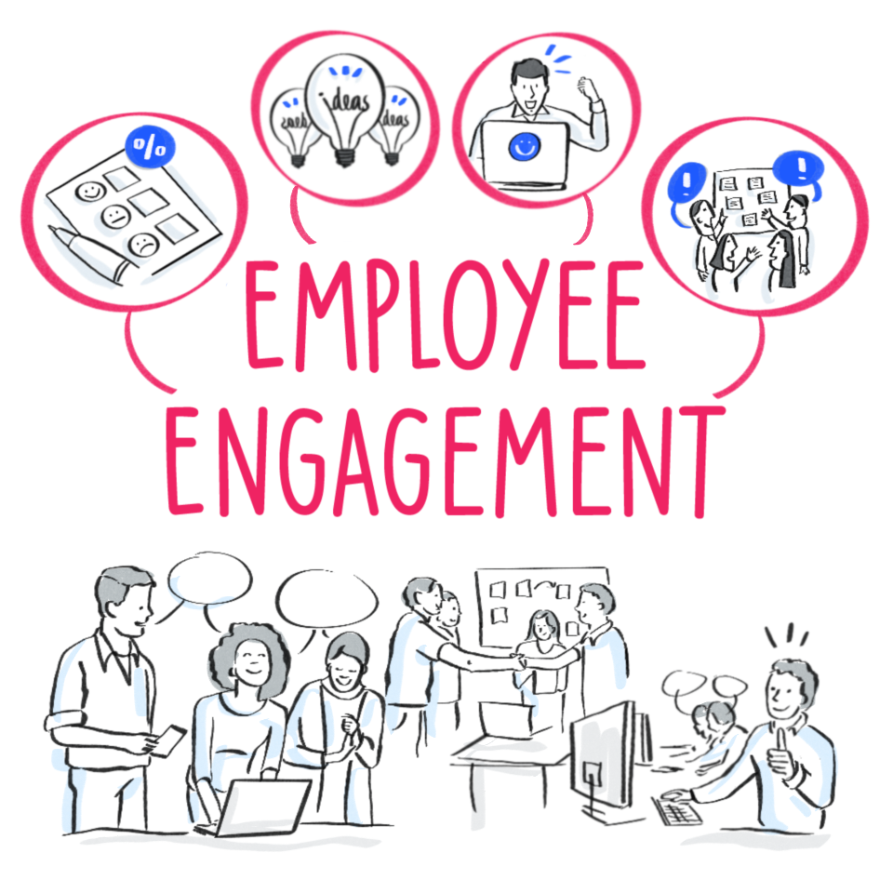 (Starfish Taylor, 2020)

Executive Summary

David MacLeod and Nita Clark – Employee Engagement

In recent years organisations have become, more aware of the importance of employee engagement. This was in the past driven by the MacLeod report ‘Engaging for Success: Enhancing performance through employee engagement’ of 2009. In the report David MacLeod and Nita Clark argued that employee engagement was fundamental in all organisations including The Edge Café.

There are four key enablers in the theory which are as follows, strategic narrative, engaging managers, employee voice and integrity.

When using the work place personal development plans (PDP), for any organisation, this shows how the employee will expand overtime, by attending mandatory training course, for example Health and Safety. Courses such as this will ensure the employee understands, what law and regulations they must adhere to and how they must act in case an emergency strikes inside the organisation.

During the recent Covid 19 pandemic, employee engagement seemed to have improved, employees have been more engaged, understanding and supportive of other employees during a tough time. Employees are engaging well with the manager and are using more self-motivational skills than previously.
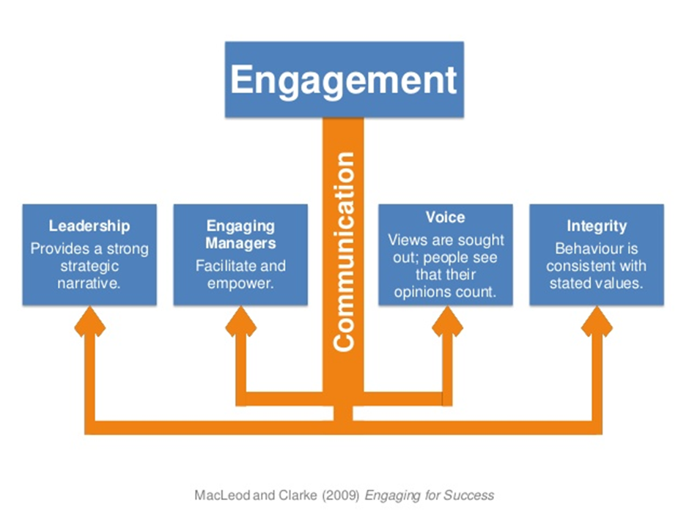
(SlideShare,2009)

When individuals are looking to join an organisation, they usually build a picture of the chosen company on feedback, for example what do people think of this company, do they have good reviews from employees, is this particular company good to work for, do they train employees well, do they give incentives. New employees undertake, research on companies before joining an organisation, individuals want to be content in the job chosen.

When employees are satisfied in their role, performance is up, engagement is excelled and team relationships are good. Which is great for an organisation, this means a satisfied employee will stay in a company for years to come, that means less employee turnover, less money spent on training and an employee who agrees with the companies traits, beliefs and future plans. some individuals may feel undermined by strong management and strict practice in place, so employers must take this into consideration when strict policies are in place and may loose competent employees due to this factor.

“By having a really strong continuous feedback loop through performance management, there are more opportunities to recognise performance. That’s something that keeps employees feeling fulfilled and engaged and it’s also what potential candidates are looking for when they’re making the decision of what company to join.”
(Culture amp, 2020)

Organisations who listen to employees needs and ideas, build good repour with employees, this makes employees feel appreciated, listened to and needed. Employees should always be given the opportunity to raise a question or new idea, this creates greater engagement in the organisation.

Fredrick Herzberg – Motivational and Hygiene factors

Herzberg believes that the following factors are extremely important including :
- High and low attitude (basically satisfaction and dissatisfaction, also defined as motivators and hygiene factors)
- Short and long term duration of feelings (of high/low attitude effect)
- First and second level factors (i.e., main causal factors, and secondary factors deriving from the main stimulus, identified by further probing during interviews)
- The interrelationship of factors (BusinessBalls,2019)
Fredrick Herzberg believes by using his two factors ‘hygiene and motivation’ will create better performing employees which will grow the organisation.

The Hygiene factors include :

- Company policy and administration
- Supervision
- Working relationships
- Status and security

The second factor is the ‘Motivation’ which includes :

- Achievement
- Recognition
- The work itself
- Responsibility
- Advancement and growth

When critically analysing this particular theory, research shows that the Herzberg motivational theory has been used in organisations all over the world and has had a positive impact on companies who want to put the employees needs first. When analysing different theories, it is clear to see, this particular theory has a variety of factors, which allow organisations to assess all aspects of development. by using this two factor theory, the employee will feel more engaged, satisfied, self-motivated, responsible and create great strength in the workplace.
Potential benefits of using theories such as the Herzberg theory and MacLeod theory is a frame-work technology build and learning factor. Employees are 80% less likely to leave the organisation, which indicates that engagement is linked to organisational performance. Engagement theories may seem like common sense but that’s how you get employees interested then learning begins while the employees are fully engaged. All team members must be fully engaged to understand exactly what is required of them and how the organisation will train them to become competent employees. Managers in the organisation should be empathetic, understanding and always willing to listen. This will form a workplace relationship, with trust and understanding. when problems arise in the workplace, employees should work as a team to overcome issues, when using engagement theories in any organisation, this creates higher impact on performance, personal growth, satisfied employees and feeling part of a work family or team.

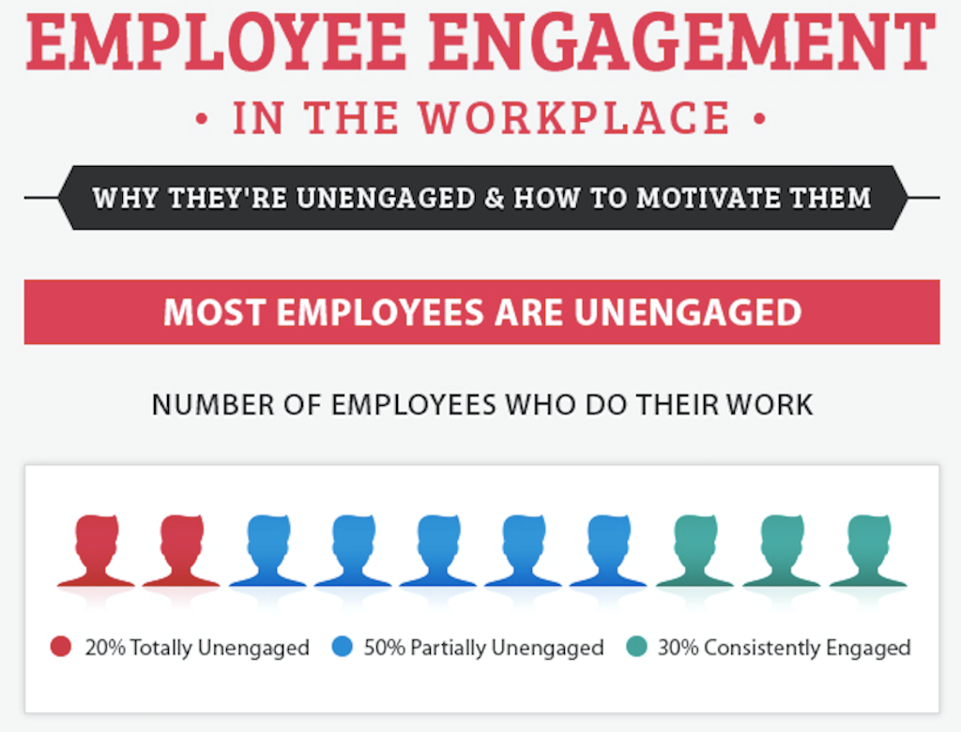(Zippia,2020)
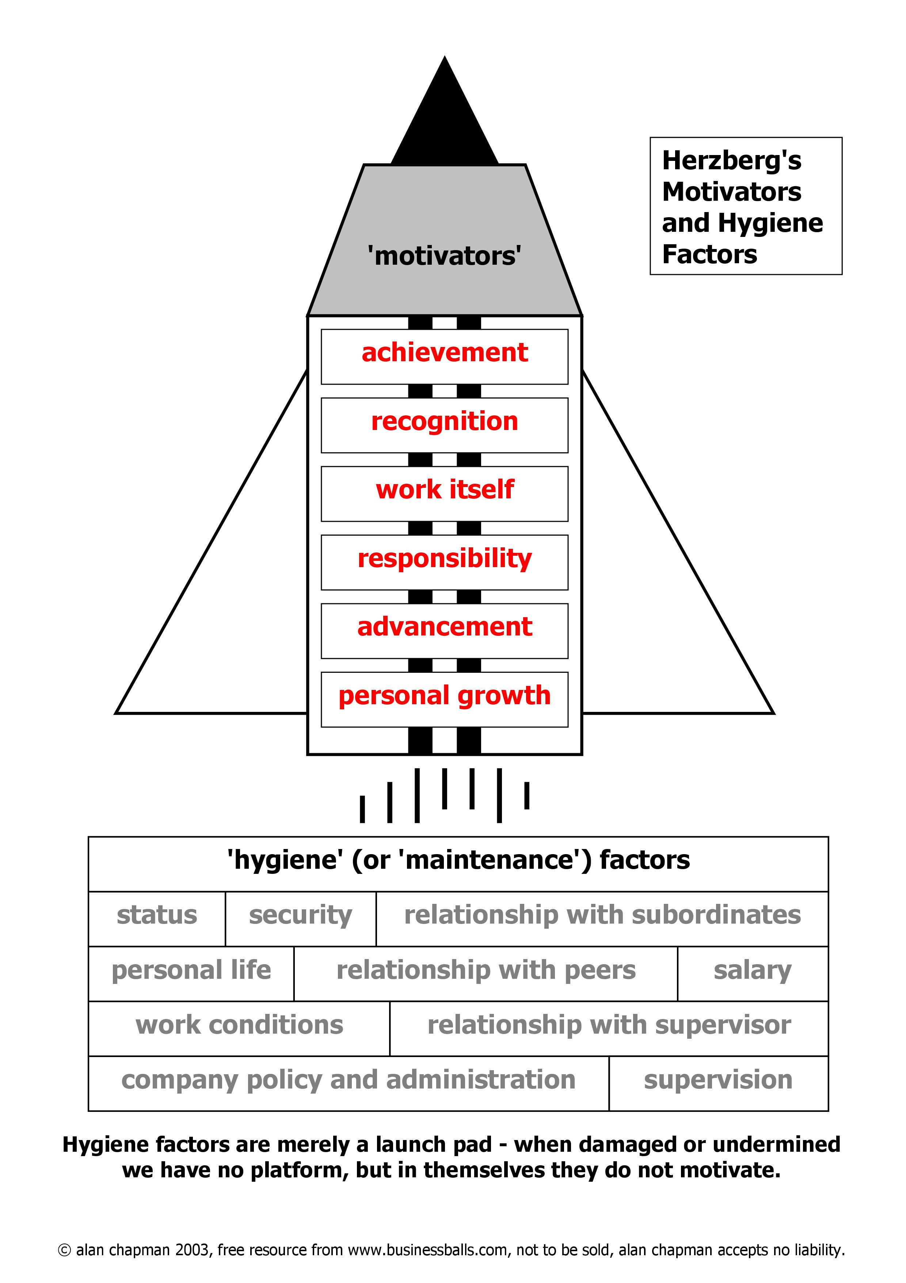 (BusinessBall,2019)

William Kahn’s theory of engagement theory

William Kahn believes having a different approach to employee engagement is the way forward. Kahn’s three dimension of meaningfulness has three factors, which includes the first factor, is challenging the employee, being creative and varied approach within the organisation.
The second factor is the role, how does the employee fit into a certain role and how can they be influenced. The third factor is interactions, how can this employee be respectful and what insight do they have to engage in to fit into this organisation. Furthermore, when employers use the Kahn theory its created around mental health and wellbeing. Mental health can affect your judgement, ability to work with others and productivity.
This can cause inability to work with others, fully concentrate and make costly mistakes or accidents. This theory should be mandatory in all organisations as this is the one that matters the most with self-care, when employees feel depressed or out of sorts, they can speak to managers about this, managers should engage with empathy and solutions to work through personal and work issues that occur.
Firstly organisations with high level support mental health awareness are more successful, secondly the company gains a lot of respect, honesty from employees and long term employees.
“The link between mental wellbeing and your organisation's success is enormous”. (Wellington Place,2019)
The researcher previously suffered with mental health from a traumatic experience, the organisation she was working for did not understand, when she explained her situation and what she was going through, the company added pressure to her mental health by allocating her more hours to work, she couldn’t sleep, couldn’t eat but still had to attend work to pay the bills, she was called into the office for failing to keep up with her performance and she eventually, had no choice but to leave her role. The organisation didn’t understand because mental health theories didn’t exist In this particular organisation. The organisation lost a competent employee who worked for the company over four years and the organisation now have to train a new employee to fill her duties, simply they could of saved time, effort and money by simply supporting an employee through a hard time. Mental health is very important in this day and age, high volumes of organisations are adopting the William Kahn theory, to support employees and help them overcome obstacles in life they may face. This is great to see in organisations such as Innocent Drinks. This company has a reputation of being a fun place to work, if you look at their Instagram page you can see, the company doesn’t take itself very seriously, the employees are central to the brand. They pay particular attention to the staff and their mental health wellbeing.
“They do this by offering a range of perks that indirectly ease their employees work stresses, including flexible working, free breakfast and a complimentary gym membership to encourage workers to stay fit and healthy in their mind and body”. (Anderson Hoare,2019)

(The Human Factor Inc,2020)
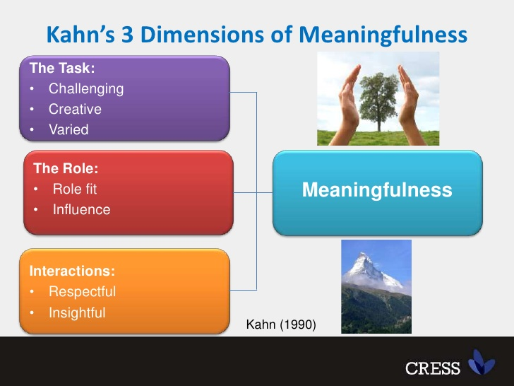 (Slide share,2020)

“By engaged learning, we mean that all student activities involve active cognitive processes such as creating, problem-solving, reasoning, decision-making and evaluation. In addition, students are intrinsically motivated to learn due to the meaningful nature of the learning environment and activities”. (pp20-23)

Argyris’s Theory of Motivation
Created by Chris Argyris in 1976. ​
​
How management practices affect one’s growth and behavior (M.ebrary.net, 2020). ​
​
Argyris’s theory is based on the maturity/immaturity factors, single and double- loop learning, organizational communication and the effects of these factors on an individual’s empowerment, motivation and accountability.​
​
Argyris suggested that organisations have taken the incorrect route as a result the theory was developed​
​
Open communication can obstruct learning in certain scenarios and hinder development (HRF, 2020). ​
​
Argyris theory is often avoided by organisations.

performance process:​
​
1.Planning
This phase of pM process includes establishing job description and​ identifying the employee's essential functions.​
​
2. Developing
This pm process includes developing performance standards.​
​
3. monitoring
This phase the pm process includes monitoring work performance and​ giving feedback about them.​
​
4. Rating
This phase includes conducting performance evaluation. This is critical​ aspect of pm process.​
​
5.Development
this phase pm process including establishing plans for improved employee ​planning performance and development goals.​
​
Case study “ the late waitress
​
as per case study two different aspect can be monitored1)manager role 2) waitress role.​
​
It is understood that the waitress is seldom being late & she has genuine reason being late.​
​
As a manager, performance management could get the waitress to serve on the next order without anyone noticing.
​
every case study varies, if she is an efficient worker and has good experience of her job,so there is always a good opportunity for her to create her own time management plan to overcome the issue .

AMO theory of performance

The current case study should be based on the AMO theory, regarding the work culture, depends on the ability, motivation and opportunity of the employee and to maintain the well-being. (Lederweb.dk, 2020)​

Managers can apply the AMO theory of performance in the Edge Café.

Ability - The capability of the waitress? How she can overcome the issue in the future.

Motivation - The motivation, the waitress to continue her good work in the Edge Café, in order to overcome all the odds and concentrate on the future progress.
Opportunity – Major opportunity, the manager can provide a detailed plan on behalf of the Edge Café, what kind of support is needed in order to gain development to get the desired goal. The development plan should be based on specific role and responsibilities of the waitress.
​
​Employee side and the waitress side :

- Consider everything that has an effect on a situation, so that fair judgement is made.

- Establishing a plan to improve the waitresses performance in the future.

- Expectancy theory of motivation – Employees performance is based on individuals factors, for example, knowledge, experience, abilities, applying engagement theories, to overcome the problem.

- Reward system, to engage the employee to do better.
​
​
​
​
Engaged employees are more likely to work productively and remain loyal to an organization. Find out how employee engagement is the key to developing a happy and healthy organization.(e-learning,2020)

Employee engagement from an employee perspective.
Employees like to have an informal environment, this has proven to effective for the business outcome.
Use of real time analytics, the application of gamified and big data will rose exceptionally in 2019.
Managers and business leaders have designed employee engagement programmes focusing on the young generation.
Use of social platforms in employee engagement, especially employee appreciation, will grow beyond expectations.
Companies will become more transparent in conflict management and resolution process.
This will help solve issues when conflict occurs and the employee will feel listened to.

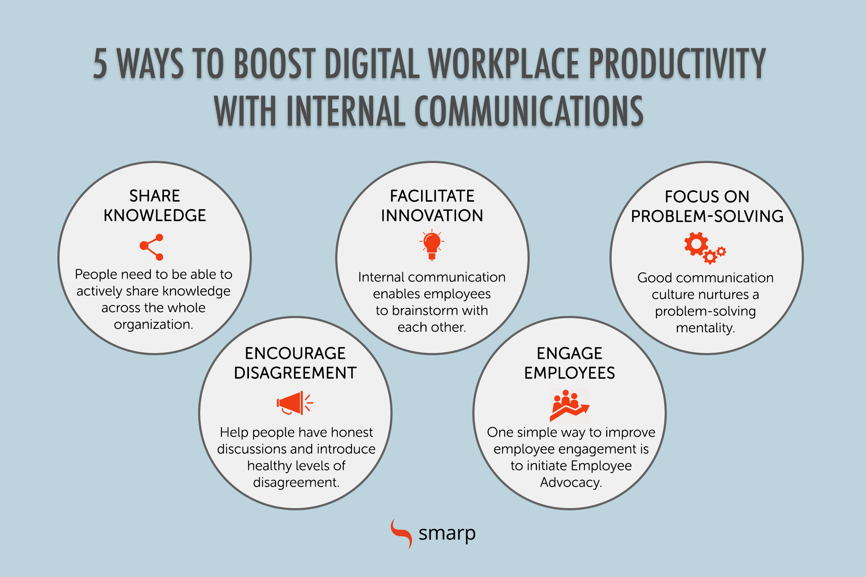 (Smarp,2020)

Engaged employees
“Engagement at the level of the individual employee is essential to unlocking the potential of your organisation. Engaged employees:
- Work proactively—they seek out opportunities for personal and organisational growth, and actively promote the organisation’s products and services.
- Go above and beyond—they embrace challenges and problem-solving, and work smarter as well as harder.
- Work and grow together—they are inclusive and innovative, promote the free flow of ideas and knowledge.
- Align with the organisation—they understand and support the company vision, values and goals”. (Date Group,2020)

The term ‘motivation’ is most likely described as a goal-director behaviour. One can enter the stage of motivation when one expects that an action is likely going to result in the attainment of the objective and a positive reward will await one upon completion of one’s goal (Armstrong, M. p18, 1998).

Conclusion

Research shows employee engagement theories such as David MacLeod and Nita Clarke’s engagement for success theory, is a variety of methods to create workplace relationships, between employees and managers, this theory is to create deep and meaningful attitudes for the employee so he/she feels a sense of worth, when an employee begins to feel part of a team and appreciated, the employees performance will grow dramatically. This is a good move for the business, as it increases production which makes more revenue.
Engagement is a two way relationship. Organisations need to engage if they want employees who really care about the goals and objectives and who are committed to giving their time, effort and ideas in a meaningful way.
An engagement workforce delivers, innovation, productivity and performance.
Some organisations still haven’t adopted the employee engagement theories, may feel it’s not important, time consumed, a waste of energy and spending time on courses for mental wellbeing, is less time producing products which means lower revenue. When in actual fact it’s the opposite, every person in the world at some point suffers with mental health, which could be grief due to loosing a loved one or a traumatic experience, you keep reliving in your mind, either way, every person will need support at some point. If your employer cant support you then you may loose your job, which would be life changing to say the least.
In years to come the researcher is certain there will be a mandatory law that organisations have to comply by, regarding the mental health awareness act, to support employees at work.
Performance management can improve the quality of the company, can also increase job satisfaction and develop professionalism and expertise, that would not only benefit the employee but will benefit the organisation.

Reference List

Starfish Taylor,(2020)Employee Engagement
https://www.starfishtaylor.com/employee-engagement/ (accessed on 10/06/20)

MacLeod and Clarke,(2009) Slide Share.
https://www.slideshare.net/ciprinside/cipr-inside-webinar-org-engagement151113 (accessed on 10/06/20)

Culture amp,(2020) Help managers and teams stay productive & aligned.
https://www.cultureamp.com/performance/lp/?gclid=EAIaIQobChMIvIz9wJCM6gIVDYuyCh0SWA5nEAAYAiAAEgKBHvD_BwE&utm_source=google&utm_medium=cpc&utm_campaign=Employee+Effectiveness-UK&utm_term=employee%20evaluation&hsa_acc=1222068845&hsa_cam=1643096776&hsa_grp=91288242671&hsa_ad=410501087475&hsa_src=g&hsa_tgt=kwd-327041424634&hsa_kw=employee%20evaluation&hsa_mt=p&hsa_net=adwords&hsa_ver=3&gclid=EAIaIQobChMIvIz9wJCM6gIVDYuyCh0SWA5nEAAYAiAAEgKBHvD_BwE (accessed on 10/06/20)

Business Balls (2019) Fredrick Herzberg Motivation Theory
https://www.businessballs.com/improving-workplace-performance/frederick-herzberg-motivation-theory/ (accessed on 10/06/20)

Slide share, (2020) Prof Katie Truss - PPMA Conference
https://www.slideshare.net/ppma/cfakepathprof-katie-truss (accessed on 16/06/20)

Wellington Place, (2019)The Importance of mental health awareness in the workplace.
https://www.wellingtonplace.co.uk/blog/importance-mental-health-awareness-workplace/ (accessed on 16/06/20)
Anderson Hoare,(2019) 5 Companies Leading The Way In Mental Health Support At Work.
https://andersonhoare.co.uk/blog/2019-06-14-5-companies-leading-the-way-in-mental-health-support-at-work (accessed on 17/06/20)
J., A. (2014), "Determinants of employee engagement and their impact on employee performance", International Journal of Productivity and Performance Management, Vol. 63 No. 3, pp. 308-323. https://doi.org/10.1108/IJPPM-01-2013-0008 (accessed on 18/06/20)

Educational Technology
Vol. 38, No. 5 (September-October 1998), pp. 20-23 (accessed on 17/06/20)

Invista, (2020) 7 key steps to motivation and inspire your team
https://www.invistaperforms.org/7-key-steps-to-motivate-and-inspire-your-team/ (accessed on 17/06/20)
The Human Factor Inc. (2020) Five steps to more engaged employees
https://thehumanfactor.biz/five-steps-to-more-engaged-employees/
(accessed on 17/06/20)
Zippia,(2020) How to improve employee engagement in the workplace.
https://www.zippia.com/employer/improve-employee-engagement-workplace-infographic/ (accessed on 17/06/20)
e-learning,(2020) Why employee engagement matters infographic.
https://elearninginfographics.com/why-employee-engagement-matters-infographic/ (accessed on 17/06/20)
Smarp,(2020) Improving Employee Engagement With Internal Communications
https://blog.smarp.com/the-secret-to-improving-employee-engagement-is-better-communication (accessed on 17/06/20)

Data Group,(2020)Employees and Teams in the Modern Workplace.
https://info.datacomgroup.net/modernworkplace/blog/employees-and-teams-in-the-modern-workplace (accessed on 17/06/20)
Armstrong.M, (1998) Managing people, A practical guide for line managers, London Kogan page 18.

M.ebrary.net (2020) Argyris’s Theory, Vroom’s Expectancy Theory- Organization behaviour​
https://m.ebrary.net/2842/management/argyriss_theory (Accessed on 22/2/2020)

HRF(2020) Argyris Theory Explained-HRF [Online] Available at: https://healthresearchfunding.org/argyris-theory-explained/ (Accessed on 28/2/2020)

