1.B Site Location
In order to establish the site Apex Construction wishes to build on, the history and the context of the site must first be investigated. The history of the site was investigated throughout the initial desk study to establish any concerns or risks during the feasibility study before moving forward. The context of the site includes the roads surrounding the site, the area built up around the site, the community surrounding the site and the accessibility of the site.
The site is in Port Talbot, Southeast of the River Afan. The site is currently a carpark located on Station Road and is behind Port Talbot shopping centre. To the North of the site there are two churches and running around the site there is a road with a roundabout. The road is currently used for deliveries to the shopping centre. As there are many shops nearby and residencies the area is busy with foot traffic.
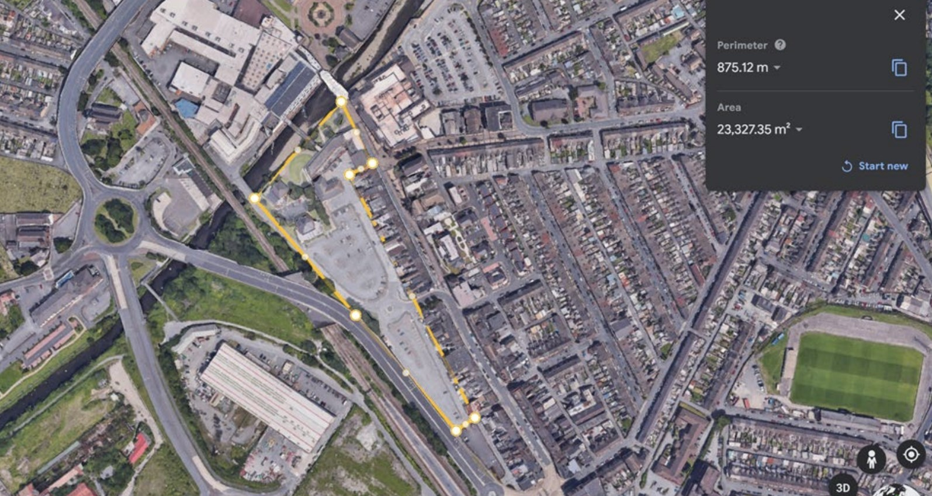
(Figure 1- Site boundaries from Google Earth)

Site History

The site was previously reserved for houses that are recorded being built as far back as 1870 and the houses remained on site until early the 1980’s when the houses were demolished and the carpark that is seen today was built.
There are no known construction or demolition records of the houses, this evidence was found using OS maps from the original desk study.
The original concerns of bad construction practice and little to no building regulations during the construction of the houses remains. As mentioned in section 1.d) the site investigation will involve a full subsurface investigation to ensure there are no weaknesses left from basements or coal chutes improperly backfilled as well as possible contaminated land from possible poor demolition methods when the carpark was constructed.
The main possible contaminants being searched for from historical findings are lead and asbestos.
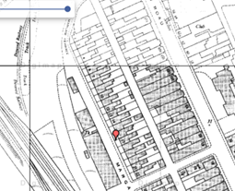 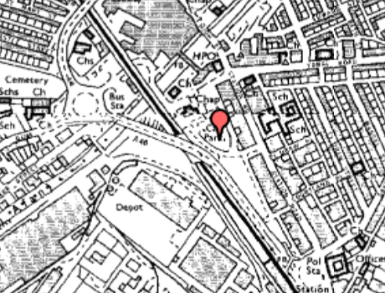
(Figure 2- Site in 1870.)
(Figure 3- Site in 1980.)

Site Context
From visual surveys conducted by Apex Construction it can be confirmed that the ground is fairly level so will need little treatment, is accessible and does have a steady flow of traffic passing nearby due to the shopping centre nearby.
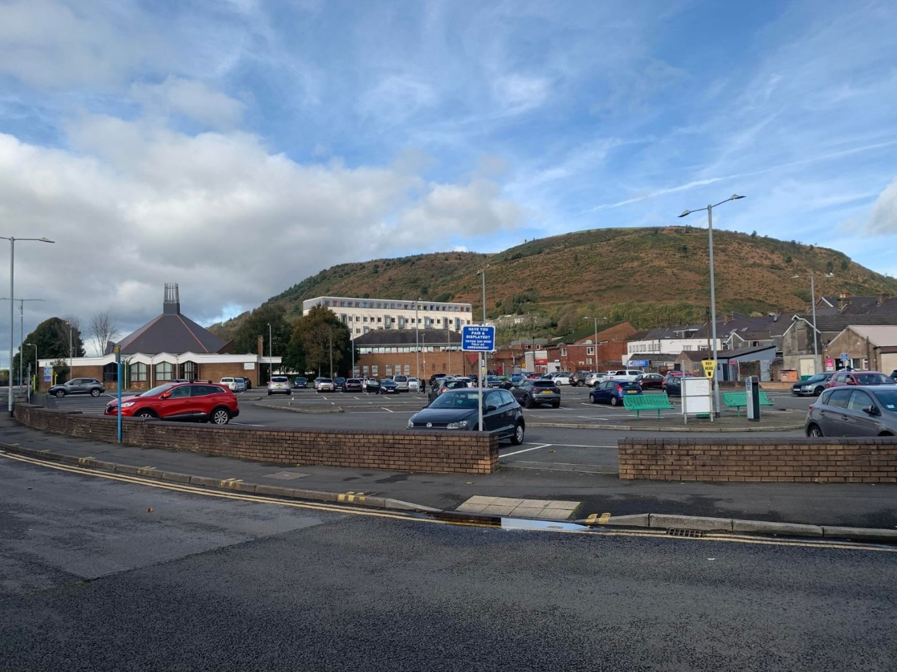
(Figure 4- Site photographed from Southern point looking towards North of the carpark. Taken by Samuel Griffiths)
As discussed in the feasibility report, there are 2 churches North of the site that are not owned by the client and the bridge over the river Afan is not owned by the client either so must remain a public right of way, not to be closed off unless there is an emergency.

Listed Buildings
There are no listed buildings in the direct vicinity of the site, the nearest listed building is Bethany Chapel behind other buildings across the road from the site. There is no cause for concern for this building unless gross negligence from the contractors occurs.
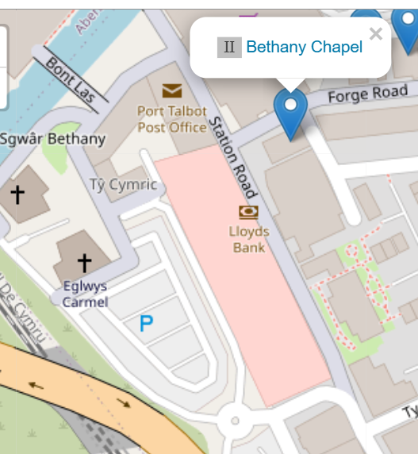
(Figure 5- Bethany Chapel)

Hedgerow & Tree Preservations
There are no hedgerows on the site nor trees directly on the site, as confirmed by the visual report.

Protected Animals
There are no protected animals residing on the site nor animal habitats as confirmed via the feasibility study.

Flood Risk
The site is at low risk to floods as the river Afan’s river level sits around 1.6m and has only reached 2.2m at its highest. In depth reports can be found in the feasibility study however there is no immediate risk or cause for concern as the rivers bank prevents water from breaching the site.
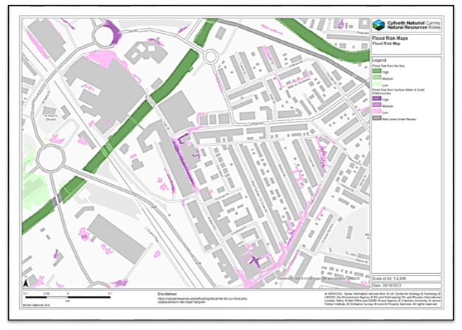
(Figure 6- Flood alert history taken from Flood Assist (2017) by Kelene Fredrick)

Services
As per the feasibility study it was reported that there are several services running below the site including a Vitrified Clat (VC) 305mm Sewer rising main, an underground LV cable, and a low pressure (21mbar-75mbar) pipe that will need to be relocated before construction begins. See section 1.C for full report.
As found on the feasibility report, there are concerns of Radon gas near to the site so full protective and remediation measures will be taken. See section 1.C.

