

Investigating effectiveness of various CNN architectures for medical imaging with a focus on Alzheimer’s studies
by
Amelia Kate Moseley

Supervisor: Gordon Dickers

Project submitted as part of the requirements for the award of
BSc (Hons) Computing (Software Engineering)

July 2021

DECLARATION

I, Amelia Kate Moseley declare that I am the sole author of this Project; that all references cited have been consulted; that I have conducted all work of which this is a record, and that the finished work lies within the prescribed word limits.

This work has not previously been accepted as part of any other degree submission.

FORM OF CONSENT

I, Amelia Kate Moseley hereby consent that my Project, submitted in candidature for the B.Sc. (Hons) Computing (Software Engineering) degree, if successful, may be made available for inter-library loan or photocopying (subject to the law of copyright), and that the title and abstract may be made available to outside organisations.

Contents
1 - Introduction 4
2 - Project Aim 5
3 - Background Research and Related Work 6
3.1 - Neural Networks - Brief Theory and History 6
3.1.1 - Weights and Activations 6
3.1.2 – Network Models and Implementations 7
3.2 - Previous Biomedical Imaging Machine Learning Projects 7
4 - Methods 8
4.1 - Development and Experiment Methodology 9
4.1.1 - Software 9
4.1.2 - Hardware 11
4.1.3 - Training Data 15
4.1.4 - Classification Method 16
4.2 - Validity and Reliability 16
5 - Analysis of Training Results 18
6 - Evaluation 19
7 - Discussion 20
References 21

The following documents the attempted use of MRI data acquired from the Alzheimer’s Disease Neuroimaging Initiative (ADNI) to train a convolutional neural network architectures to classify between classifications of potential Alzheimer’s disease: Cognitively Normal (CN), Mild Cognitive Impairment (MCI), Alzheimer’s Disease (AD). It ultimately shows the process of making a multitude of mistakes during the timeline of the project, discusses why these mistakes occurred, and how they meant achieving subpar training results. The documentation starts by outlining the main aims of the project, what was hoped to have been achieved, what opportunities to learn may arise, and a rundown on how this may be done. It continues with a brief background of some machine learning methods, and their uses in biomedical imaging, and then goes on to look at what methods were used in completing the project; this includes a thorough look at hardware mishaps that occurred with the system being used to conduct the training on. Finally, it sums up the results from the training, and discusses what could be done in future iterations of the project.

1 - Introduction
Automatic diagnosis for biomedical imaging tends to use the traditional machine learning models and methods which require people to build manually designed feature sets based on the raw data [1] [2] [3] [4], whereas Deep Neural Networks (DNN, the above mentioned CNNs being examples of DNNs) extract features automatically [5]. Attempts have been made in the 90s [6] to utilize CNNs for biomedical imaging but did not prove reliable enough to justify replacing traditional machine learning methods and manual feature extraction. As larger datasets become more readily available and accessible, and the processing power of GPUs increases, one must consider the use of CNNs for automatic diagnosis and other biomedical classification. For the purposes of this paper a comparison is to be made between to methods of classification using CNNs: 2D image classification based on slices of MRI volumes, like most methods of biomedical imaging in terms of the use of slice classification [1] [3] [6] [7], but using CNNs instead of manual feature extraction; and the second method is full 3D volume classification, classifying the whole volume based on given labels. The comparison in this paper is for the classification of Alzheimer’s Disease (AD); identifying between the three main categories of AD classification: AD, Mild Cognitive Impairment (MCI) – the prodromal stage of AD, and Cognitively Normal controls (CN) [8].

2 - Project Aim
There are two main aims for this project: 1 – exploring possible CNN architectures for biomedical imaging, 2 – training a model for the classification of MRI scans from the Alzheimer’s Disease Neuroimaging Institute (ADNI). Beyond those, a further aim for the project is taking advantage of the opportunity to learn more about Machine Learning and forms of Artificial Neural Networks (ANNs), and about automatic diagnosis for biomedical imaging.
For the exploration of CNN architectures, the idea is to look at 2-3 architectures for 2D classification, and 2-3 for 3D classification and compare the accuracy, sensitivity. At the end, the results are to be compared to see which architecture was best for 2D classification, and which was best for 3D classification, then after that see how the 2D classification compares to 3D classification.
Looking at the aim of classifying the data, the goal is to achieve accuracy, sensitivity, and specificity of around 75%; the expectation is that training using 2D slices from the 3D volumes will be more likely to give results close to the goal given the memory requirements for training ( [9] talks about the polynomial time complexity in neural network training). It is worth noting that the training that is taking place is a three-way classification rather than a binary classification, so there is a likelihood that the training accuracy may be lower than on a binary classification; the prediction is that there will be confusion between the AD and MCI classes, but very little confusion between those two and the CN class. A trained model that confuses AD and MCI would still be desirable providing there is little confusion between those two classes and CN, as there have been very few papers that go into identifying the differences between AD and MCI on MRI scans, and other forms of scans [10].

3 - Background Research and Related Work

3.1 - Neural Networks - Brief Theory and History

3.1.1 - Weights and Activations
The idea of neural networks and how neural networks in computing have been developed come from the findings of how mechanisms in the brain come together to “form the basis of learning” [11]. Like brains are made up of neurons connected by dendrites and axons, neural networks are made up of nodes connected by links. The brains mechanism of one neuron firing once the input from enough dendrites passes a threshold, is the idea behind weights in neural networks. These weights can be updated based on new information, which is how the neural networks are able to learn over time.

3.1.2 – Network Models and Implementations
Perceptrons are the name that was given to the initially studied Layered Feed-Forward Networks from the 1950’s. There are two main types of neural networks, feed forward (otherwise known as directed acyclic graphs (DAGs)), and recurrent. Layered feed forward networks are layers of units where units in one layer can pass their output to units in the next layer, but not to units in the same layer of previous layer, and layers may not be skipped [11]. Recurrent neural networks may have connections both backward and forward, and as such have an internal state to store information about the activation function and act as a short-term memory. Towards the end of the 50s, work at Stanford university brough into fruition two neural networks, ADALINE a model for detecting patterns in binary data, and its successor MADALINE which was used to clean up the signal on phone calls [12] [13].
The 80s brought along John Hopfield’s idea of bidirectional lines in neural networks with the aim of being able to store and retrieve memories like a human brain; the construction of this network is an assembly of Perceptrons to form a basic fully connected recurrent neural network [14]. It was around this same time that the Backpropagation algorithm (an algorithm that uses gradient descent to calculate the gradient of the error, working backwards from the final layer up to the first layer) started to gain popularity for the training of supervised learning models; this was largely is part to the 1986 work of Rumelhart [15] [16].

3.2 - Previous Biomedical Imaging Machine Learning Projects
Previous papers have looked at the ADNI (Alzheimer’s Disease Neuroimaging Initiative) [8] dataset as a classification problem, and plenty of previous works have been published more generally about automatic diagnosis for Alzheimer’s based on the widely accepted classification for Alzheimer’s progression – Cognitively Natural aging (CN), Mild Cognitive Impairment (MCI), Alzheimer’s Disease [17].
Based on the popularity of the ADNI set it makes a good set to compare methods for biomedical imaging and compare against previous results. Most recently there have been a number of papers published discussing the use of CNNs and other deep learning methods for biomedical imaging, focusing of the ADNI set [5] [7] [18] [19].
Based on the papers looked at for the research relating to this project, full volumes have not directly been used as input data to deep learning models, rather using segmentation (see section 1); this project therefore has been designed in part to look at the reasons why this is the case and think about the potential benefits to using the full volume compared to segmentation.

4 - Methods
Given the nature of this project, it primarily embodies an experimental way of working- running the network training but has aspects of a developmental project to it as well. The developmental aspects of this project exist to enable to experimental side; building and testing the network architectures, writing the MATLAB scripts to run the training, modifying scripts to correctly import and resize the data as needed. A repeat of this project would likely consist of similar development stages, to try to stay close to the projects design, but change certain aspects to achieve improved results.

4.1 - Development and Experiment Methodology

4.1.1 - Software
The network training, and the writing of scripts to aid in the process, was carried out using MATLAB [20]; more specifically, the Deep Learning Toolbox [21]. Most of the design for the network architectures was done using the drop and drag ‘Deep Network Designer’ (see figure 1) but for the sake of gaining experience some versions were written out by hand based on the code generated from previous versions using the Deep Network Designer.
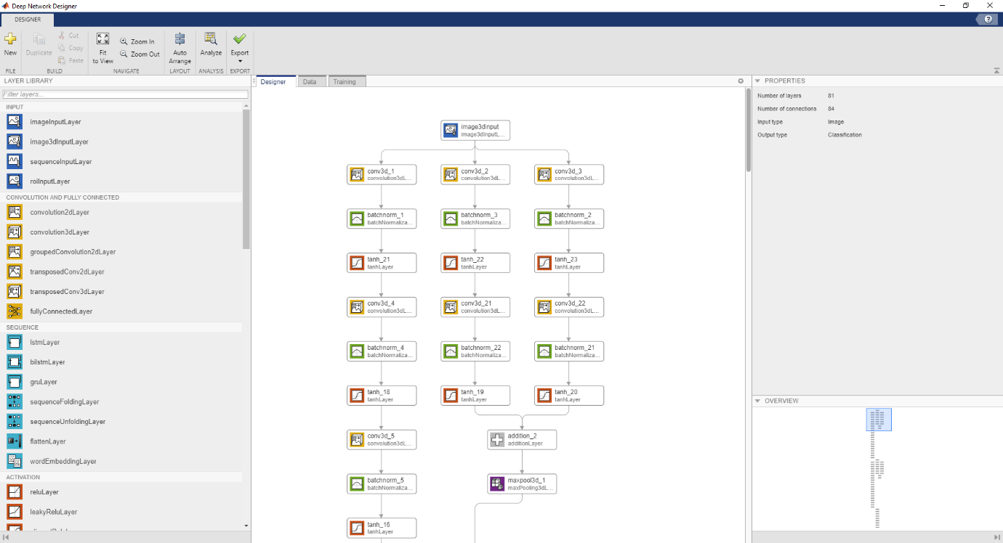
Figure 1 - Deep Network Designer

MATLAB was selected as experience was already held in the development environment and in using aspects of the deep learning toolbox; the use of Python with frameworks such as TensorFlow [22] or PyTorch [23] were considered but given the nature of the project it was decided that using an environment one was already familiar with (and that provides easy to use abstractions on the underlying framework) was the sensible decision.

A type of recurrent neural network, Long Short-Term Memory networks, are used for processing sequence data in which order is a concern e.g., time series sequences [24]. A custom hybrid Long Short-Term Memory Convolutional Neural Network (LSTM-CNN), based on the work of Nagda and Eswaran [25], was considered – the theory being that if an LSTM allows for a sort of memory between points in time in a time series sequence, that it could provide improved pattern recognition in volumetric image data (like an MRI). A model based on this work was put together in the MATLAB Deep Network Designer (with a script generated from this and node diagram output when this code is run (see figure 2)), using the U-Net/3D U-Net architectures as CNN aspect of the hybrid architecture.
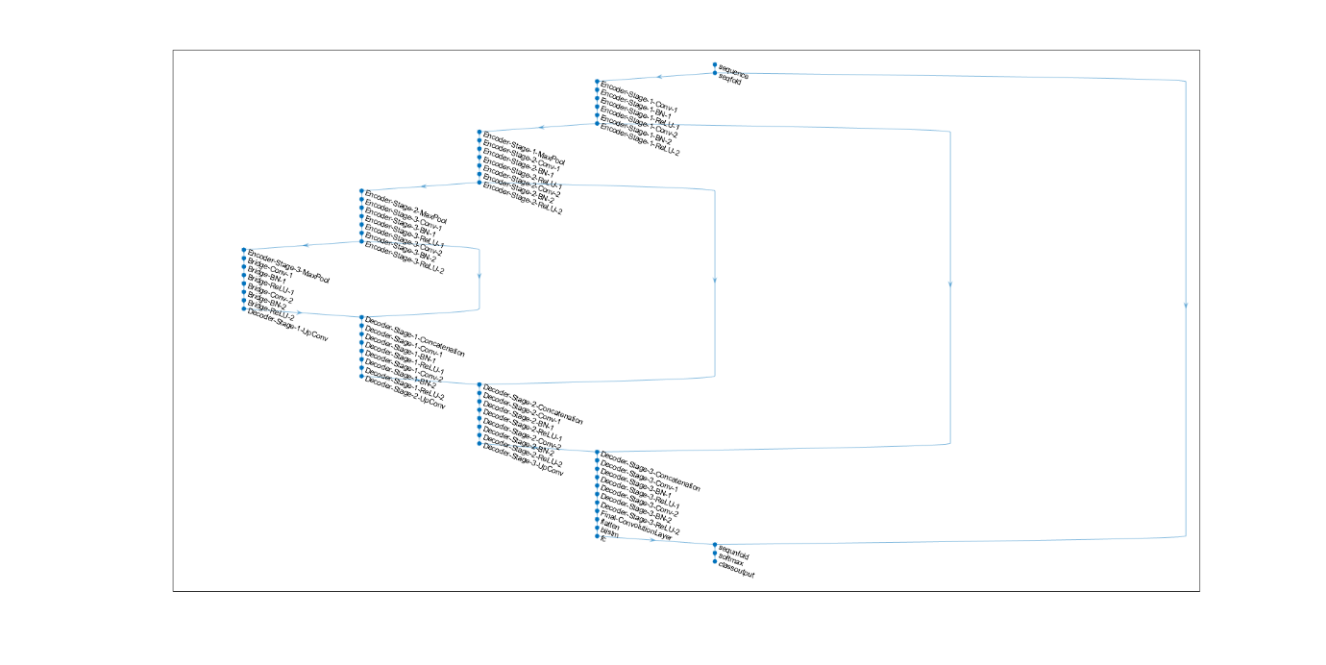
Figure 2 LSTM-CNN Node Diagram

When an attempt was made to run the training to the viability of the LSTM-CNN architecture, is became apparent that it would not work as intended in the MATLAB environment due the way the layers related to LSTM networks had been implemented. Looking at the source code for the LSTM specific layers in MATLAB, one was able to see that they were not compatible with image data being used as input to the network. Correspondence with MATLAB support on their forums (see figure 3) suggest that the desired functionality would potentially be implemented in a future version; they also mentioned the possibility of writing a custom layer, however this was determined to be outside the scope of the project and beyond current skill level. As a result of this, the LSTM-CNN was abandoned in favour of a regular feed forward CNN.
There are then two main architectures used in this project 3D U-Net [26], an existing variation on the U-Net architecture, which is already used for biomedical imaging through segmentation, and a somewhat custom architecture based on ResNet – no 3D variant of ResNet was found so one needed to be constructed via the MATLAB deep learning toolbox. 3D U-Net was used given its prior usage in biomedical imaging, ResNet was selected based on its success in 2D classification in the ImageNet competition.
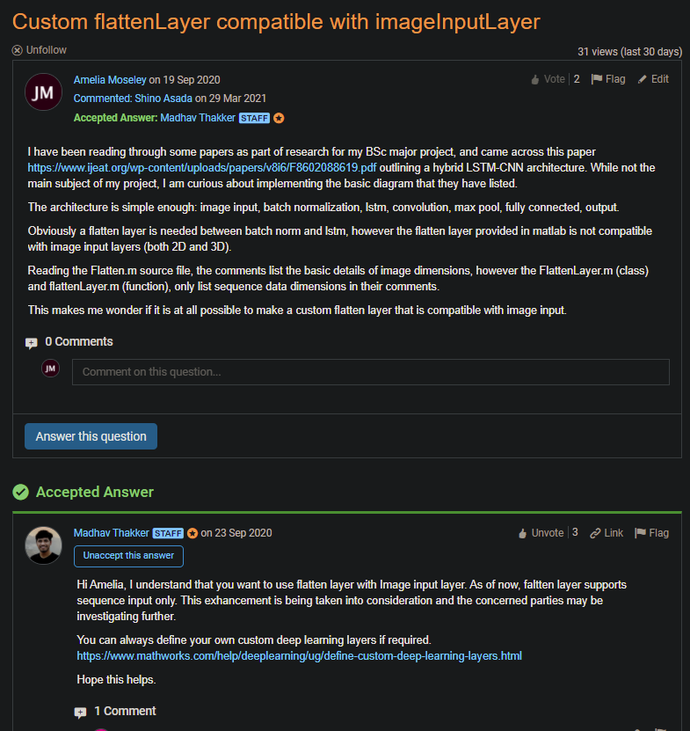
Figure 3 Correspondence with MATLAB Staff

4.1.2 - Hardware
The network training conducted as part of this project was carried out on a desktop PC belonging to one Amelia Moseley. Given the nature of the work being done, it would have been preferable to use a cloud computing solution such as those offered by Amazon, Microsoft, or Google (Amazon Web Services (AWS) [27], Azure [28], and Google Cloud [29] respectively); attempts were made to use some of these services making use of free trial offers however, due to current global circumstances at the time of writing, access to these services when attempts were made was not available.
The systems hardware is as follows:
- Motherboard – ASUS Z170-A Skylake
- CPU – Intel Core i7-6700K 4GHz
- GPU – Gigabyte Nvidia GTX 980Ti 6GB GDDR5 VRAM (Maxwell architecture, compute capability 5.3)
- Accelerator Card (Used for training instead of GPU from November 2020) – Nvidia Tesla K80 24 GB GDDR5 VRAM (dual processor design, 12GB VRAM to each processor. Kepler architecture, compute capability 3.7)
- RAM – HyperX Fury 32GB (4 x 8 GB kit) DDR4 2666MHz (running at clock speed of 2400MHz)
- SSD (for operating system, windows 10 pro) – Kingston A400 240 GB. Later replaced with Samsung 970 EVO 1TB NVMe M.2 drive in October 2020
- HDD – Seagate 3TB 5900RPM 64MB Cache. Later replaced with Seagate BarraCuda 4TB 5400RPM 256MB Cache, after original drive failed.
- PSU – Corsair CX600 (600 Watts, 80+ bronze). Later replaced with EVGA 750 B5 (750 Watts, 80+ bronze) at the end of October 2020
The network training for the project started shortly after access was granted to the data set (see section 4.2.3.1) and was initially carried out using the GPU. In mid-October 2020, the conclusion was reached that the VRAM capacity of the GPU was not enough as the MATLAB training was often crashing, and the resolution of the training data was needing to be reduced to nearly a quarter of the original (from 256x256x170 to 64x64x40).
The decision was made to purchase an ex-server accelerator card to perform the remaining training attempts on. The purchased card was selected due to availability and price, £120 for the K80. It was a refurbished unit from a reliable seller on eBay. Upon receiving the card and installing it in the PC, it soon became apparent that the PSU did not supply enough wattage to power the card and so the 750W PSU was purchased.
In the process of swapping out the old 600W PSU with the new 750W PSU, the old HDD became non-functional (a power surge damaged the PCB), and so the new drive was purchased; the PCB from the old drive was replaced and the data mirrored over to the new drive using Windows disk management tool.
Once the data had been successfully mirrored over to the new drive, the accelerator card could now be tested to see if replacing the PSU was enough to get the card working. The card was displaying correctly in device manager, and the device drivers were installed. A test run of the training was started in MATAB which ran for a short time before the PC rebooted; during this first test training using the accelerator card, both that card and the GPU were connected to the PC. The PC did not boot up after this test as it had caused resettable fuses in the new PSU to trip, so a wait of a couple of days was required to let the fuses return to their normal state. The conclusion was reached that having both the GPU and the accelerator card connected was drawing too much wattage, and so the GPU was disconnected and the monitors for the system were connected to the ports on the motherboard instead to utilise the integrated graphics of the CPU.
Further test training iterations with the accelerator card were now conducted, and a different problem was emerging. The training would run for a short amount of time, and then the system would reboot. Brief consideration determined that the cause of this problem was due to the thermals, the accelerator card was getting too hot, and the system rebooted as a safety measure. This did not come as a surprise as the card is an ex-server card which by itself is passively cooled with a large heatsink spreading across the whole surface of the card, and banks of fans cool the cards in the servers. Searching around led to a video [30] demonstrating a method of cooling by means of an airduct attached to the back of PC where the PCIe backplate of the accelerator card is; their method uses sheet aluminium and a USB powered fan to draw air away from the PC, pulling it across the heatsink of the card – study of the video led to the cooling solution pictured in figure 4.
The cooling solution used is constructed from cardboard wrapped in, and stuck together with, aluminium tape, and a USB powered fan secured with black electrical tape. As pictured in figure 5, a wooden posable hand was used to hold the airduct in place to prevent it from sagging.

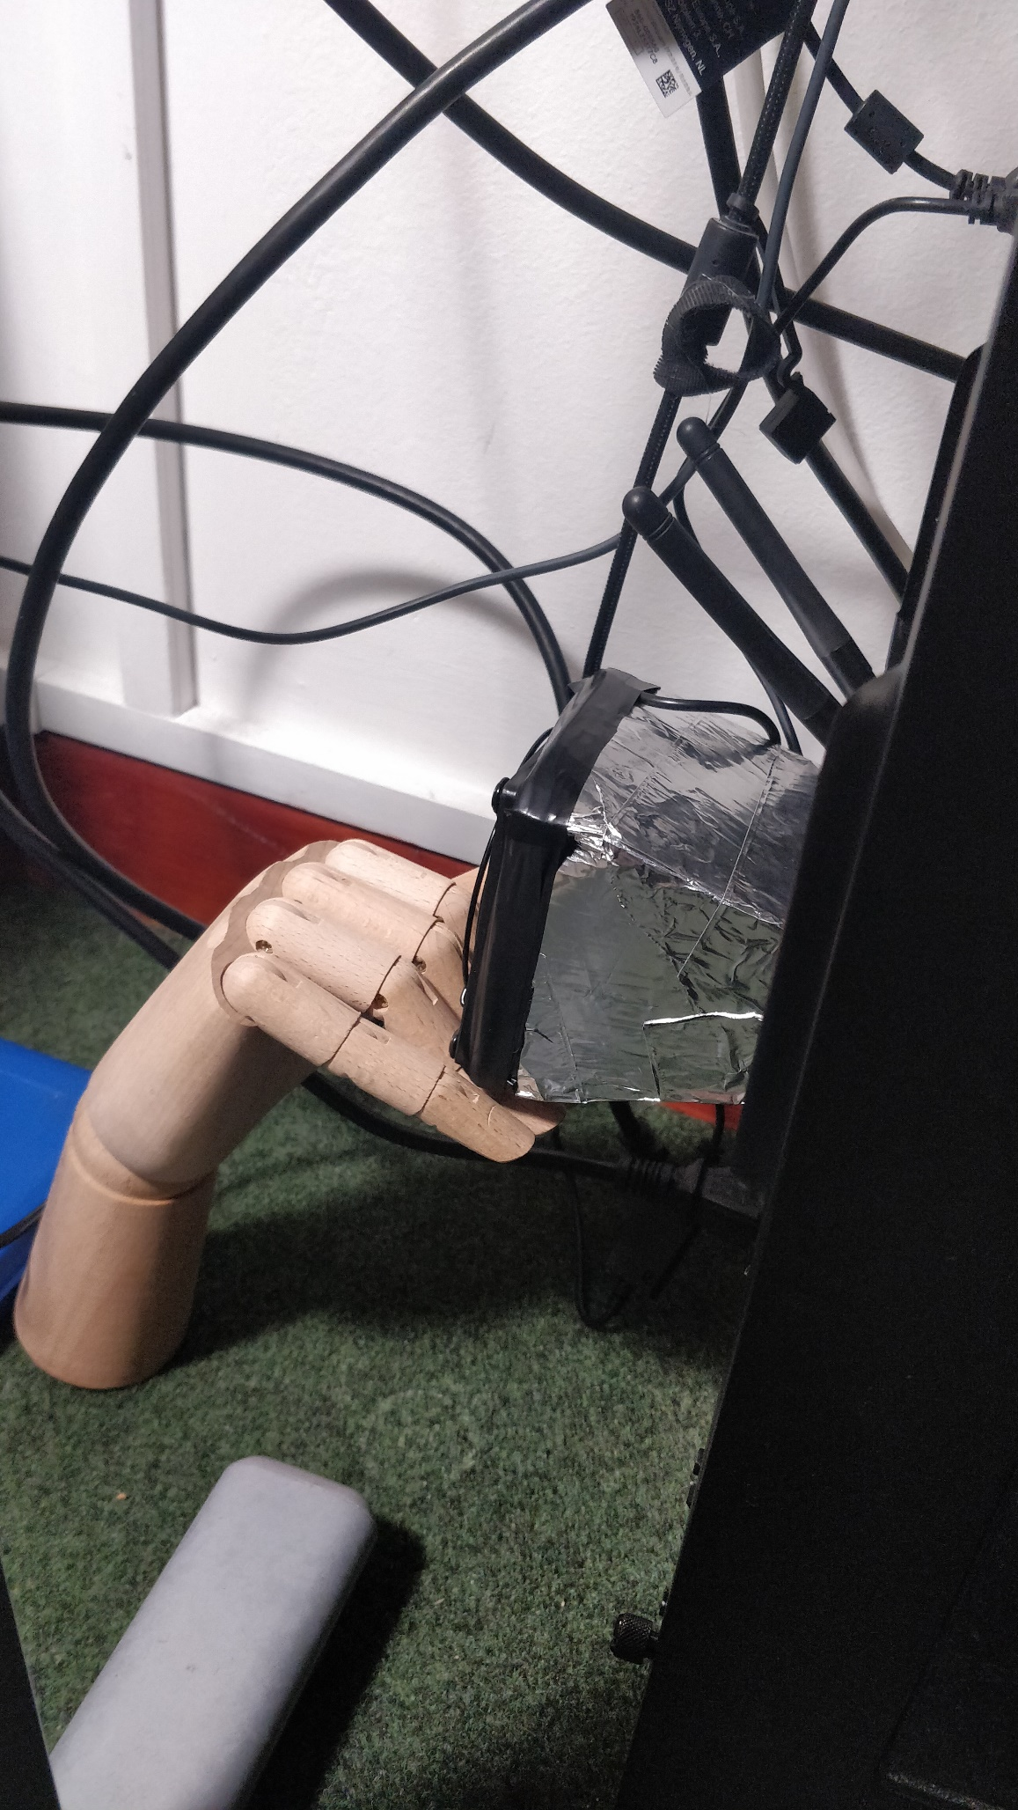
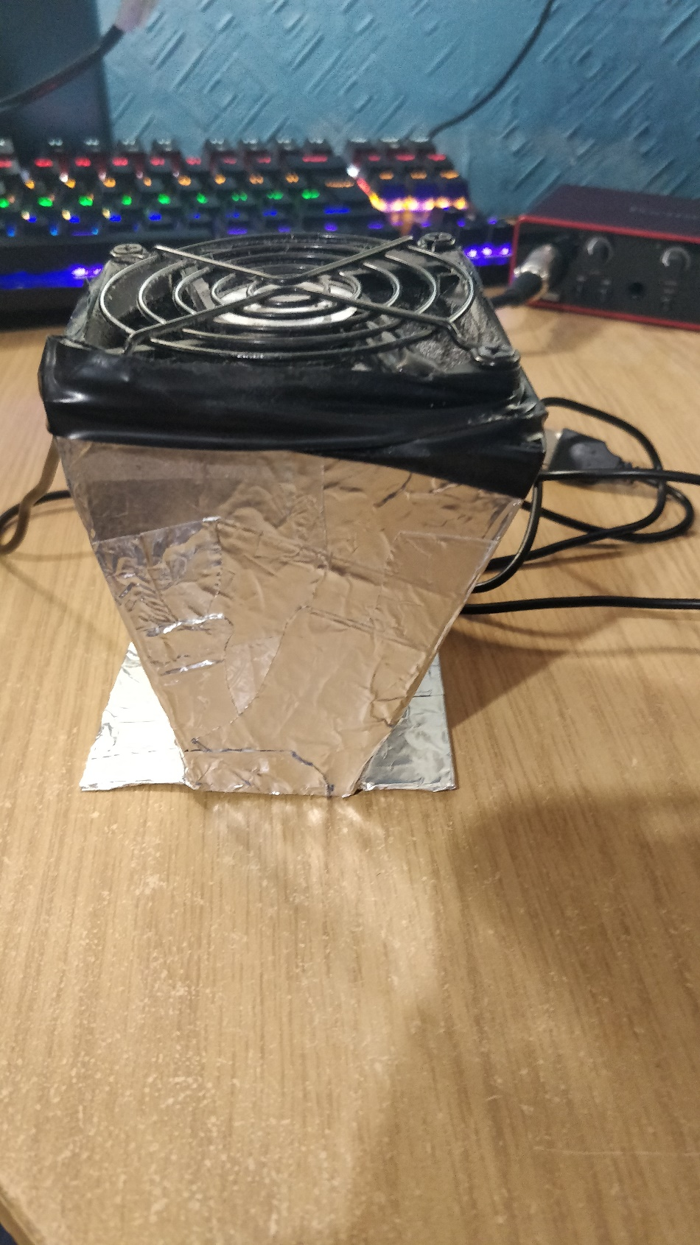
Figure 5 Airduct Help up by Hand
Figure 5 Custom Cooling Solution

The aim with the accelerator card was to use both processors and therefore the full 24 GB VRAM. To attempt this, a parallel pool was started using the MATLAB Parallel Toolbox and selecting the two accelerator card processors, training was then started with the execution environment training option set to parallel. With the parallel running, the training ran for roughly 30 minutes before the training crashed throwing a CUDA error; it is not known whether this is due to the improvised nature of the cooling solution, or whether it was a driver compatibility issue relating to the older architecture of the card. Whatever the reason for the crashes, it soon became apparent that only one processor on the card would be usable at any given time, effectively cutting the VRAM capacity of the card in half from 24 GB to 12GB. Compared to the GPU, the full 24GB VRAM versus 6GB VRAM would have justified trade-off in performance (the GPU having a higher compute capability but lower VRAM) and the increased training time may have been worth the improved training accuracy – with only one processor being usable, that trade-off was no longer worth it. Despite this, training was continued on the accelerator card as the strain the training puts on the card was not something wanted for the GPU; the GPU is bas been in the system for a little over 5 years and the risk of damaging the card to complete training faster did not seem worth the potential cost of replacing the card. So even though it meant training took longer, it was felt to be a fair trade for ensuring the GPU remains functional.

4.1.3 - Training Data

4.1.3.1 - Data Acquisition
A data access form was filled out for ADNI around September 2020, and soon after access was granted. Upon gaining access to the online repository, searches could be made for the desired datasets data sets. For the purposes of this project, the search was filtered by MRI scans (discarding search results for Positron Emission Tomography (PET) ect…). There were subsets of the search results based on the field strength of the scanner that was used to perform the scans. To try and get the largest amount of data for training, all the subsets were selected and then any duplicate entries, due to crossover between the sets, were manually deleted upon downloading the selected data.

4.1.3.2 - Ethical Consideration
The dataset used is anonymised to prevent people from knowing the identity of the subjects of the study and a data protection agreement was signed outlining steps to make sure the identity of the subjects is not obtained. The study the set comes from has long since concluded and so there are no considerations that need to be made about the status of the subjects. The subjects were studied at various stages of the AD progression but none at particularly late stages, one would imagine to lesser the strain on the subject and the families. The data used for the training was then deleted from all personal drives once the project was concluded.

4.1.3.3 - Pre-processing
Certain pre-processing steps had already been carried out on a subset of the data that was downloaded, mainly to do with cleaning up potential noise from the machine during the scanning process. For the purposes of the project, only one additional pre-processing step was carried out – resizing. The data is quite large, and so to be able to carry out the training on the hardware available (namely the amount of Video Random Access Memory (VRAM) available on the Graphics Processing Unit (GPU)), the data needed to be resized. To carry out the resizing, a basic function was written in the MATLAB environment, the handle of which gets passed to the built-in MATLAB function for reading in image datastores. The datastore calls the function when a request to read in the data is made, in this case the network training function, so as MATLAB prepares the training environment, and the data associated with the datastore is read, the data gets resized.

4.1.4 - Classification Method
The network models are being trained with a binary classification (two classes). Initially attempts were made to do a multi-class classification (three way), but the results were less than satisfactory. There are multiple instances of binary classification being done on the selected architectures, with the training options staying consistent between them. There are three instances per architecture in total, with the labels for the classes and subsequently the training/testing/validation set(s) changing between instances. The binary class labels for each instance are as follows: CN + AD, CN + MCI, and AD + MCI. The labels per instance totalling to three instances trained per architecture was chosen to try and follow the pattern for the previous studies that have attempted methods of classification on the ADNI set.

4.2 - Validity and Reliability
There are aspects of the projects undertaking that put the validity and reliability of the results gathered into question, most notably is the hardware issues discussed in 4.2.2.
Between the two of the critical factors that determine part of the success of the project, the experiment is arguably more valid than it is reliable. Multiple runs of the training were conducted, small changed in the settings between each run, with as many other potential variables being kept constant, from all of these runs the results were all similar. The project is not a reliable one though, with the main issue being the GPU or accelerator card being used for the training; hindsight suggests that the accelerator card should not have been purchased and that training reaming being conducted using the GPU.
The thought process at the time of getting the accelerator card was one of improving the training results, and in theory that would have been a good idea given the limitation of the VRAM, however the sensible thing to do would have been to continue the training on the GPU. Changing to the accelerator card introduced new variables to the experiment that should have remained constant, even if that meant the training results yielded low accuracy; it is largely this that makes the project an unreliable one and raises into question the validity of the project and data collected. Looking at the issues with the way the project was carried out, it gives the impression that it is not reliable, and potentially not all that valid, but that the reliability of the project is more of a problem than the validity; given better reliability, the validity would increase as well.

5 - Analysis of Training Results
The network training did not yield any suitably accurate models. The initial training attempt was carried out on the GPU using the standard 3D U-Net architecture and achieved the second highest accuracy, sensitivity, and specificity with each of those metrics sitting at ~61%; this training was while it was still using a three-category classification. This initial training attempt used the least training data, about 500 MRI scans with a field strength of 3T (tesla – the strength of the magnetic field created by the coils in the scanner); 80% used for training, 10% for validation during training, and 10% set for calculating the metrics. At this stage, the thought was that a more training data would yield better results, and so the set was increased to ~2500 scans with a mixture of 1.5T and 3T scans, split in the same 80:10:10 ratio. In most cases this assumption can be correct, however this proved to be a mistake as all subsequent training attempts yielded far lower metrics of ~33.21% for each attempt, only increasing back up to a still relatively low ~46.42% after the data set was reduced. When the classification method was switched to two possible classes, the metrics were an average of 55% for each training attempt; this was the same for each network architecture used, this being a binary classification puts the 55% at just over chance and therefore on par with the ~33.21 from the three possible classes.
At the time of writing, it became apparent as to the reason for the drop in training metrics after the initial ~61%. It was not strictly speaking the increased amount of data being used that caused the drop, but rather the set now being a mixture of 1.5T and 3T scans. This realisation led to a brief couple of training attempts going back to the original training options to try to satisfy curiosity. Using 346 scans at a field strength of 3T, setting the initial learn rate to 0.0075 compared to the initial attempts 0.005, setting the training to go for 150 epochs compared to the initial 100, and carrying out the training using the GPU. The results from this were mixed, carrying out the training resulted in a validation accuracy of 83.33% and metrics using test set put aside for that run of ~84%; but given a different test set of scans at 3T the metrics were far lower at ~34%. Part of this suggests overfitting but given that the test set that was set aside was separate from the training and validation sets, there is uncertainty as to the reason for this discrepancy. Whatever the case may be, it does suggest merit to the thought that datasets composed of both 3T and 1.5T scans resulted in lower performance metrics.

6 - Evaluation
Overall, this experiment has succeeded in demonstrating why 3D volume classification, by means of passing the whole volume as input, has not been explored particularly far. Given a more professional environment, likely with the training being conducted using python and running on a large server/datacentre, it is feasible that this sort of network training could yield satisfactory results; whether it would be sensible to do compared to conventional 2D classification and segmentation a whole other matter altogether. The results gathered from this project are not acceptably reliable or viable to base decisions on the use of the discussed methods for any real-world function, but it would be beneficial to continue the line of study to try and produce reliable and viable data to analyse.
A far more beneficial way to carry out this project would have been to use python machine learning frameworks, and to set a goal that is more achievable; this would have allowed for far more opportunities to learn new skills, whereas the way this project has been conducted has meant learning from mistakes made along the way instead.
The research carried out has proven to be the most fruitful aspect of the project, with avenues of future work presenting themselves, such as the implementation and testing of the hybrid LSTM-CNN; the potential for improvements to biomedical imaging with machine learning from such an architecture design holds significant merit and should be researched further by those far more capable of doing so.

7 - Discussion
Looking at the way the project unfolded in retrospect, there are plenty of areas for improvement, lessons that have been learned, and potential ways to carry out a derivative of the project in the future. From the start it should have been obvious that it was too ambitious a project to carry out at this level of study; the data being used and the decision to carry out the training using the full volumetric MRI was not a good idea. There is potential merit in full volume classification, it is just that that specifically should have been the focus of the project, removing the superfluous nature of the medical aspect of things; too many aspects of interest were being brought together for a project of this level. The implementation of the hybrid LSTM-CNN could have been an interesting way to look at using full 3D data as inputs to an architecture, the potential increase in accuracy gained from using the short-term memory to build connections between the layers of the 3D volume.
Feedback from the supervisor should have been addressed, specifically the suggestion that slices of the MRI volumes should have been used as the training data; at that point in the project’s timeline, it was starting to seem like a sunk cost fallacy, and the overcoming the self-imposed issues that arose from the acquisition of the accelerator card made the idea of changing directions to using volume slices feel like giving up.

References

[1] | L. Khedher, J. Ramírez, J. M. Górriz, A. Brahim and F. Segovia, “Early diagnosis of Alzeimer's disease based on partial least squares, principal component analysis and support vecter machine using segmented MRI images,” Neurocomputing, vol. 151, pp. 139-150, 2015.
[2] | C. Plant, S. J. Teipel, A. Oswald, C. Böhm, T. Meindl, J. Mourao-Miranda, A. Bokde, H. Hampel and M. Ewers, “Automated detection of brain atrophy patterns based on MRI for the prediction of Alzheimer's disease,” Neuroimage, vol. 50, no. 1, p. 162, 2010.
[3] | W. Crum, R. Scahill and N. Fox, “Automated hippocampel segmentation by regional fluid registration of serial MRI: validation and application in alzheimer's disease,” Neuroimage, vol. 13, no. 5, pp. 847-855, 2001.
[4] | S. Klöppel, C. Stonnington, C. Chu, B. Draganski, R. I. Scahill, J. D. Rohrer, N. Fox, C. R. Jack, J. Ashburner and R. S. J. Frackowiak, “Automatic classification of MR scans in Alzheimer's disease,” Brain, vol. 131, no. 3, pp. 681-689, 2008.
[5] | A. Lundervold and A. Lundervold, “An overview of deep learning in medical imaging focusing on MRI,” Zeitschrift für Medizinische Physik, vol. 29, no. 2, pp. 102-127, 2019.
[6] | B. Shih-Chung and M. Freedman, “Automatic lung nodule detection using profile matching and back-propagation neural network techniques,” Journal of digital imaging, vol. 6, no. 1, pp. 48-54, 1993.
[7] | P. Coupé, B. Mansencal, M. Clément, R. Giraud, B. Denis de Senneville, V. Ta, V. Lepetit and J. Manjon, “AssemblyNet: A large ensemble of CNNs for 3D whole brain MRI segmentation,” Neuroimage, vol. 219, 2020.
[8] | R. C. Petersen, P. S. Aisen, L. A. Beckett, M. C. Donohue, A. C. Gamst, D. J. Harvey, C. R. Jack, W. J. Jagust, L. M. Shaw, A. W. Toga, J. Q. Trojanowski and M. W. Weiner, “Alzheimer's Disease Neuroimaging Initiative,” Neurology, vol. 74, no. 3, pp. 201-209, 2010.
[9] | R. Livni, S. Shalev-Shwartz, O. Shamir, Z. Ghahramani, M. Welling, C. Cortes, N. D. Lawrence and K. Q. Weinberger, “On the computational efficiency of training neural networks,” in Advances in Neural Information Processing Systems 27, Curran Associates, Inc., 2014, pp. 855-863.
[10] | M. Grundman, R. C. Petersen, S. H. Ferris, R. G. Thomas, P. S. Aisen, D. A. Bennett, N. L. Foster, J. Clifford R Jack, D. R. Galasko, R. Doody, J. Kaye, M. Sano, R. Mohs, S. Gauthier, H. T. Kim, S. Jin, A. N. Schultz, K. Schafer, R. Mulnard and C. H. Dyck, “Mild Cognitive Impairment Can Be Distinguished From Alzheimer Disease and Normal Aging for Clinical Trials,” Archives of Neurology, vol. 61, no. 1, pp. 59-66, 2004.
[11] | S. J. Russel and P. Norvig, Artificial Intelligence a Modern Approach, Englewood: Prentice Hall, 1995.
[12] | N. A. Norani, K. Mohd, M. S and N. Khurizan, “Logic Learning in Adaline Neural Network,” Pertanika Journal of Science and Technology, vol. 29, no. 1, pp. 285-300, 2021.
[13] | B. Widrow and M. A. Lehr, “30 Years of Adaptive Neural Networks: Perceptron, Madaline, and Backpropagation,” Proceedings of the IEEE, vol. 78, no. 9, pp. 1415-1442, 1990.
[14] | W. Gerstner, W. M. Kistler, R. Naud and P. L, Neuronal Dynamic: From Single Neurons to Networks and Models of Cognition, Cambridge: Cambridge University Press, 2014.
[15] | D. E. Rumelhart, G. E. Hinton and R. J. Williams, “Learning Representations by Back-propagating Errors,” Nature, vol. 323, no. 6088, pp. 533-536, 1986.
[16] | J. McGonagle, G. Shaikouski, C. Williams, A. Hsu, J. Khlm and A. Miller, “Backpropagation,” [Online]. Available: https://brilliant.org/wiki/backpropagation/. [Accessed 17 July 2021].
[17] | R. Tarawneh and D. M. Holtzman, “The Clinical Problem of Symptomatic Alzheimer Disease and Mild Cognitive Impairment,” Cold Spring Harbor Perspectives in Medicine, vol. 2, no. 5, 2012.
[18] | C. Lian, M. Liu, J. Zhang and D. Shen, “Hierarchical fully convolutional network for joint atrophy localization and alzheimer's disease diagnosis using structural MRI,” IEEE transactions on pattern analysis and machine intelligence, vol. 42, no. 4, pp. 880-893, 2020.
[19] | S. Liu, C. Yadav, C. Fernandez-Granda and N. Razavian, “On the design of convolutional neural networks for automatic detection of Alzheimer's disease,” in Machine learning for health, 2020.
[20] | MathWorks, “MATLAB Documentation,” MathWorks, 2021. [Online]. Available: https://www.mathworks.com/help/matlab/. [Accessed 7 July 2021].
[21] | MathWorks, “Deep Learning Toolbox Documentation,” MathWorks, 2021. [Online]. Available: https://www.mathworks.com/help/deeplearning/. [Accessed 7 July 2021].
[22] | “TensorFlow,” [Online]. Available: https://www.tensorflow.org/. [Accessed 7 July 2021].
[23] | PyTorch, “PyTorch,” [Online]. Available: https://pytorch.org/. [Accessed 7 July 2021].
[24] | J. Brownlee, “A Gentle Introduction to Long Short-Term Memory Networks by the Experts,” 24 May 2017. [Online]. Available: https://machinelearningmastery.com/gentle-introduction-long-short-term-memory-networks-experts/. [Accessed 8 July 2021].
[25] | M. Nagda and P. Eswaran, “Image Classification using a Hybrid LSTM-CNN Deep Neural Network,” International Journal of Engineering and Advanced Technology, vol. 8, no. 6, pp. 1342-1348, 2019.
[26] | S. Ourselin, L. Joskowicz, M. R. Sabuncu, G. Unal, W. Wells, Ö. Çiçek, A. Abdulkadir, S. S. Lienkamp, T. Brox and O. Ronneberger, “3D U-Net: Learning Dense Volumetric Segmentation from Sparse Annotation,” in International Conference on Medical Image Computing and Computer-Assisted Intervention, 2016.
[27] | Amazon, “Amazon Web Services (AWS) - Cloud Computing Services,” Amazon, [Online]. Available: https://aws.amazon.com/. [Accessed 9 July 2021].
[28] | Microsoft, “Cloud Computing Services | Microsoft Azure,” Microsoft, [Online]. Available: https://azure.microsoft.com/en-gb/. [Accessed 9 July 2021].
[29] | Google, “Cloud Computing Services | Google Cloud,” Google, [Online]. Available: https://cloud.google.com/. [Accessed 9 July 2021].
[30] | M. Qasem, “How to cool the nVidia Tesla K80 Cheaply,” 4 May 2016. [Online]. Available: https://www.youtube.com/watch?v=UcyP3ASRgBc. [Accessed 11 July 2021].

