WHAT IS HIGH PERFORMANCE WORK SYSTEMS (HPWS)?
Taylor (2016) defines High Performance Work Systems as those which include a package of different human resource management procedures and policies which are established in an organisation at the same time, and which are equally supported.
KEY COMPONENTS OF HPWS
There are different studies such as Paauwe (2013), Boselie (2005), Datta (2005), among others, which establish that the most common key elements of HPWS to promote employee engagement are (Taylor, 2016):
- Thorough and highly developed recruitment: To promote applications from candidates from different fields and to base the selection on evidence that shows who would perform better in the job which they have applied for.
- Great investment in training and development: Employees are updated on the developments in their discipline, so they can improve their skills and progress in their careers.
- Pay based on performance: To interest high performers, to retain staff and to offer incentives to those employees who exploit their involvement.
- Internal promotion based on accomplishments: This encourages investment in human resource development and, at the same time, career opportunities for those who have profited from this investment to stay in the organisation instead of leaving.
- Grievance methods: To ensure employees feel supported in situations where they believe they may have been treated unfairly, so they can raise the issue with senior managers instead of resigning. This ought to lead to a reduction in unfairness.
- Team-based approaches: Groups of employees establish how they will accomplish their goals, allowing them to improve.
- Participation of employees in decision-making: It boosts commitment and increases the quality of decision-making.
- Information communication: Managers to be as transparent as possible about any company concerns and its future plans. This is an indication that employees are treated in a mature way.
- Effective performance appraisal system: To ensure every employee is working towards goals that line up with the organisation’s objectives.
- Flexible working: To ensure people can arranged effectively and adapt quickly to new opportunities.
- Job security: To interest and keep strong performers, reinforcing engagement and commitment.
- Good work-life balance: To not become overstressed and enjoy a high level of personal well-being.
- Harmonisation regarding terms and conditions of employment: Same policies apply to everyone.
These can be seen as ‘best practices’ and are associated with high levels of organisational performance since people want to work for companies that take this best practice approach, such as ‘Employer of choice’ (attract and retain), and once hired, they would be more likely to be committed and engaged (Taylor, 2016).

LINK BETWEEN HPWS AND ORGANISATIONAL PERFORMANCE
In the last three decades a vast amount of research has been performed to confirm that the implementation of high-performance working systems leads to positive business performance. The most known are Pfeffer (1994), Huselid (1995) and Combs et al (2006), where it was proved that there as a reduction in staff turnover, increase in sales, market value and profit, per employee (Taylor, 2016).
Recently, the research has been focused on finding out why exactly implementing HPWS has such a positive impact in organisations. The most outstanding research carried out is by Purcell and his collaborators from Bath University, funded by the CIPD and published in 2003 under the name of ‘Understanding the People and Performance Link: Unlocking the black box’ (Purcell et al, 2003).
The main findings of this research are:
- The implementation of progressive HR policies produces positive reactions from the employees in terms of job satisfaction, motivation, and commitment, which drives them to work harder.
- To promote the ‘big idea’ (mission and values embedded in policies) that sticks the company together. There is a strong sense of shared purpose between managers and employees.
- Line managers to implement the HR policies.
This research promotes the AMO model, as one of the conditions that must be met is if the bundle highlights high levels of performance. This is ABILITY, MOTIVATION and OPPORTUNITY to perform well (Taylor, 2016). This allows organisations to take full advantage of good HR practices.
Additionally, the Gallup Organisation has published another research study focused on engagement (Harter et al, 2002), ‘Well-Being in the Workplace and its Relationship to Business Outcomes: A Review of the Gallup Studies’. It consisted in a 12-question survey and the key conclusions were:
- The variation in employee engagement levels is superior in different business sections inside the same organisation than between organisations. In the majority of the cases this is attributable to the quality of the line managers.
- There is a remarkable connection between the employee engagement levels in a specific business unit and its success.
- A robust association between employee engagement and staff turnover was found after analysing the results.
There have been other recent studies on employee well-being and performance. Other professionals, such as Peceei et al (2013) have focused on the development of human capital and the employee relations climate (Taylor, 2016).

HPWS AND EMPLOYEE WELL-BEING
Boxall and Macky (2014) analysed how high-involvement and high-intensity work processes affect employee well-being. High-involvement work processes (HIWP) promotes the participation of employees in making decisions about their work. However, work intensity is a concept harder to define, as it is not just related to working hours, but also to work overload or pressure. Boxall and Macky’s approach is to assess the working hours along with the feeling of being overloaded with work and having the pressure of having to take work home.
After reviewing different sources, the study produced two hypotheses:
- More autonomous employees, who take advantage of better training opportunities, linking reward to performance and with a better reciprocal communication, will relate to better well-being regarding satisfaction, job-induced stress, fatigue, and work-life balance.
- Employees facing larger work intensity will be linked to inferior well-being concerning satisfaction, job-induced stress, fatigue, and work-life balance.
The data was collected from over 1000 individuals who were over 18 years of age, employed for at least six months and by a company with a minimum of 10 employees. After analysing the findings, both hypotheses are largely supported. In conclusion, employee well-being is more probable to improve when the possibilities for creativity are increased whilst making sure that workers can have a stable life with reasonable workloads.

PERFORMANCE MANAGEMENT
Performance Management (PM) consists in continually enhancing performance by establishing objectives (individual and team) which are in line with the organisation’s strategy, through planification, review and assessment of the progress, and development of knowledge, skills, and abilities of people (Armstrong, 2017).
MAIN STAGES OF PM

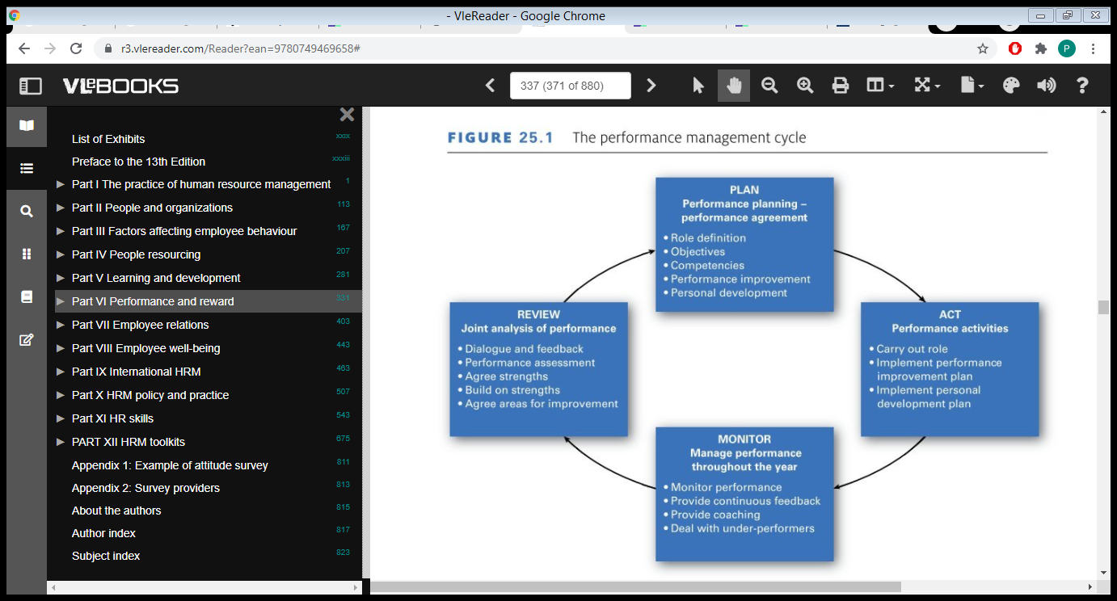
Armstrong and Taylor, 2014

This system emerges from the organisation’s goals to work as a self-renewing and continuous cycle after. This cycle is a resemblance of the continuous improvement cycle by William Deming (1986).
- Plan: Create a Performance Agreement which is the result of the decisions made by the manager and the employee during the planning part of the performance management course. It provides the grounds for managing performance and acts as a guide to improve and develop activities. It is a key factor of a performance management system and it may be used as a reference in performance planning and reviewing. This agreement is based on a role profile created by both parts and contains the objectives, competencies, performance and learning goals, and action plans for performance and skills development.

- Act: It’s the stage where the employees manage their own performance guided by their manager to meet the requirements of their role, described in the planning stage.

- Monitor performance: It consists in observing the outcomes in a regular basis implementing actions for improvement when required, through coaching or updating objectives. Feedback should be given immediately, and underperformers must be dealt with straight away.

- Review: Even if performance management is a continuous process, it is helpful to review it once or twice a year, as we can consider any key performance and development issues. In the performance review meeting we must ensure we promote the five primary performance management elements: agreement, feedback, assessment, positive reinforcement, and dialogue.
KEY PERFORMANCE MANAGEMENT ACTIVITIES
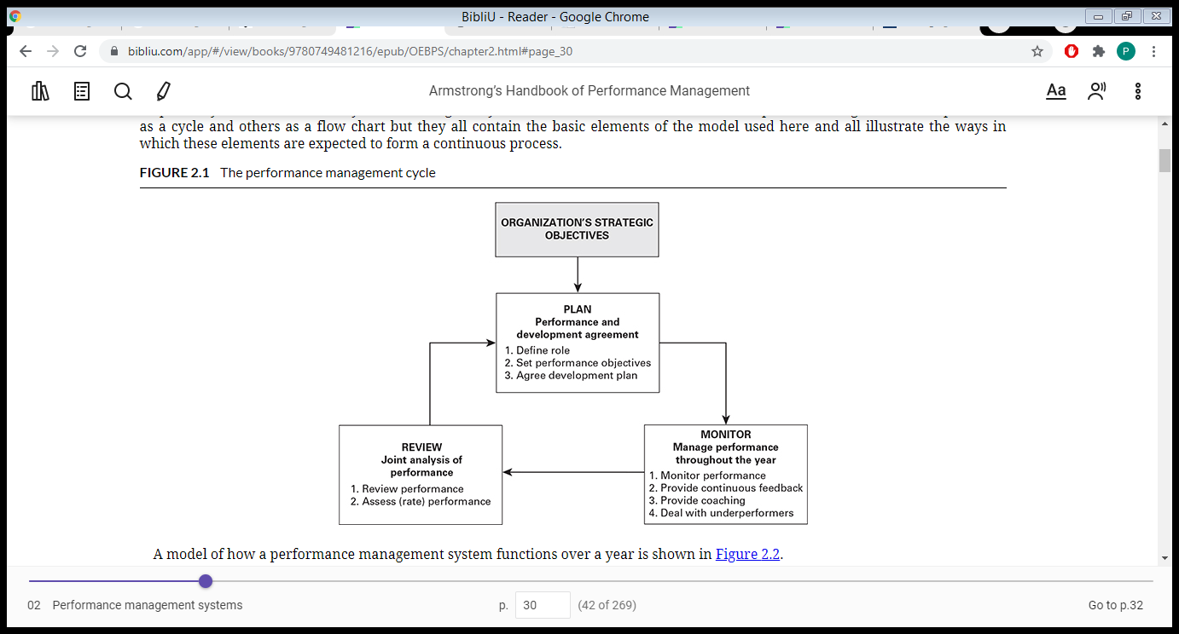
Armstrong, Michael 2017.
HOW CAN PERFORMANCE MANAGEMENT CONTRIBUTE TO EMPLOYEE CAPABILITY AND COMMITMENT
FORMAL PERFORMANCE MANAGEMENT SYSTEMS
Formal performance management systems are known by different names, such as appraisal, evaluation, or personal development review (Taylor, 2016). They do not have a standard way of operation, but they have common characteristics:
- Meeting between employee and line manager or supervisor on a regular basis.
- Outcome recorded and kept on file.
- Goals to work towards previous to the next review.
In 2012, Bloom et al published the results of a study which showed that organisations from both private and public sector are more productive (23%) when they had established a formal performance management system with the following criteria (Taylor, 2016):
- Targets
- Incentives
- Monitoring
Aims:
According to Taylor (2016), the main aims of performance management are:
- To improve collective and individual performance
- To increase morale
- To explain expectations and responsibilities
- To improve communication at all levels
- To distinguish developmental opportunities
- To emphasise management control
- To clarify wider organisational goals
- To gather information in which to base how managers select individuals for promotion or redundancy.
- To inform incentive-based payment systems.
THEORIES UNDERPINNING PM (Armstrong and Taylor, 2020)
Goal Theory: Developed by Latham and Locke in 1979. It supports the belief that performance management consists in setting and agreeing goals against which performance can be measured and managed. It underlines methods that connect goals to performance management:
- Focusing the direction to the priorities
- Encouraging effort
- Challenging people to use their skills and knowledge to increase their opportunities to success.
- The more challenging the goal, the more people will make use of their skills.

Control Theory: It consists in focusing on feedback to influence the behaviour. Feedback is considered a fundamental part of performance management process as people who receive feedback would understand the difference between what they are doing and what it is expected from them, so they may correct their actions achieve the expectations.

Social Cognitive Theory: Developed by Bandura (1986). When people are certain of what they can or cannot do, strongly impacts their performance.
IMPACT OF PERFORMANCE MANAGEMENT
Research has been carried out since the end of the 70’s decade to measure the impact of performance management in the productivity and achievement of the organisation’s goals (Armstrong and Taylor, 2014):
- Latham and Locke (1979)
- Mc Donald and Smith (1991)
- Rodgers and Hunter (1991)
- Gallup (2005)
- Institute of Personnel Management (1992)
The findings from the different studies are not conclusive. The majority of the researchers may confirm that when people are involved in evaluating their performance and achievement of goals, and they are implicated in the creation and implementation of plans for their skills development, they are predisposed to have a positive response and to improve and develop their capabilities. However, the Institute of Personnel Management found no evidence that an improvement in the performance was linked to formal performance management systems, although in their research it was suggested that thanks to performance management, the employees were aware of the demands of the organisation to perform.
PM AS A REWARDING PROCESS (ARMSTRONG, 2014, pp 348)
When performance management is carried out properly, it can reward people by acknowledgement through feedback, establishing the occasions to achieve, develop skills and guidance on career development (Armstrong and Taylor, 2014).
PERFORMANCE APPRAISALS
It is the most traditional performance review and it usually takes place once a year. They analyse and assess someone’s performance in their role. Led by managers who provide feedback, it is preferred that this is two-ways communication process, where both manager and employee discuss the goals set and how the individual performed (Armstrong, 2017).
PROBLEMS WITH THE TRADITIONAL ANNUAL PERFORMANCE REVIEW (Armstrong, 2017)
Budworth et al, (2015) referred to different studies to come to the following conclusions about traditional annual reviews:
- Ineffective for improving performance
- May have negative effect on job satisfaction
- Impression that someone’s performance can be managed in one hour (or the time agreed for the meeting)
- Mostly focused on recent events instead of looking at the whole picture.
- Fast-moving conditions require setting objectives more often, instead of yearly.
According to the CIPD (2020a), performance reviews should be more regular, depending on each job. Using a strength-based conversation may be beneficial as this is usually more focused on future actions and adopt a coaching style (CIPD, 2020b), without forgetting about underperformance (CIPD 2020a).
Kluger and Nir described how managers can lead strength-based conversations (CIPD, 2020b):
- Prompting a success story, asking the employee what they have been working well on, finding a specific example, and talking about it in detail.
- Discovering the personal success code, so they can explain how they contributed to this achievement and what support was needed.
- The feedforward question, where the manager asks them to contemplate their current priorities and think about how they can replicate this ‘success code’.
360-DEGREE FEEDBACK
A technique of appraising managers within organisations is the 360-degree feedback, or multi-rater feedback, where feedback is provided by not only their superiors, but also work colleagues and even subordinates. (Taylor, 2016).
It is used by a lot of organisations in the USA, and theoretically, looks very appealing, but it could lead to issues within the team, such as:
- Objectivity: feedback from colleagues and subordinates might be influenced by problems they have had in the past, or if they are competing for a role, and they may not rate the apraisee properly.
- Reprisal: Managers might punish employees if they perceived these have rated them poorly.
- Unnecessary actions to achieve high ratings.
It would be successful if:
- Feedback is given sensitively.
- It is used for developmental not evaluative purposes.
- It is kept confidential.
UPDATING PM
As stated by Taylor (2016), traditional performance management systems are being criticised for various reasons:
- Their impact on performance is limited.
- It is considered bureaucratic, where records are hardly reconsidered, and they do not influence in making decisions.
There have been some suggestions about ways of making performance management more effective and suited to a more competitive and faster-moving market:
Five Conversations Framework: Baker (2013) believes that five separate conversations should take place every six months, covering the following topics:
- Job satisfaction and commitment
- Training and development
- Effectiveness and efficiency
- Individual performance
- Long-term career development
Four Criteria and basic Likert scale: Developed by Buckingham and Goodall in 2015, they support the idea of reviewing the individual’s performance at least every three months. The system consists of rating the performance using a Likert scale (strongly agree, agree, neither agree or disagree, disagree, strongly disagree) and the following four criteria:
- ‘Given what I know of this person’s performance, I would reward this person with the highest possibility compensation increase and bonus, if it was my money.
- Given what I know of this people’s performance, I would always want him/her on my team.
- This person is at risk of low performance.
- This person is ready for promotion today.’
The COVID-19 pandemic has, once again, proved that the majority of the performance management systems are too inflexible for uncertain times (Wigert and Barret, 2020). There are three essential characteristics for modern performance management:
- Agile goals that adapt as conditions change.
- Ongoing feedback on a weekly basis.
- Quarterly progress reviews, with flexible metrics and incentives.
THE ROLE OF LINE MANAGERS IN PM PROCESSES
As Taylor (2016) explains, it is the responsibility of the line managers, and not HR specialists, to carry out performance appraisals, with the exception of the HR managers, who will be completing the ones for their own teams.
The success of the performance management systems on the commitment and skills of the line managers, but they should be supported with the guidance and training to develop any essential skills (Armstrong and Taylor, 2020).
WAYS HR AND LINE MANAGERS CAN WORK TOGETHER IN PM PROCESSES (Armstrong and Taylor, 2020)
- Providing support and training on developing appraisal interviewing skills, such as preparation, setting objectives, dealing with difficult conversations, providing evidence to prove negative comments, or how to end an appraisal interview in a positive and constructive way.
- Explaining the details of the competency levels that are expected on each role.
- Promoting performance management as a management tool which can be used at any time, not only annually.
- Analysing data to find out areas for improvement.
- Creating an easy paperwork focusing on a quality conversation between manager and employee.
- Keeping the reviews very simple to transform strategy to individual objectives.
CONCLUSIONS
In order to understand the link between Individual and Organisational Performance, I have firstly defined what High Performance Work Systems (HPWS) are, explaining the key components and analysing different research studies which establish the positive impact that HPWS have not only on organisational performance, but also on individual’s (job satisfaction, commitment, motivation). Other researchers have focused their studies on employee well-being when HPWS are in place, explaining the concepts of High Involvement and High Intensity Work Processes, how these can influence both positively and negatively on the individual’s performance and, ultimately, the organisation’s, too.
Subsequently, we have talked about Performance Management, its stages, activities, aims and theories which underpin performance management systems, exploring the impact that performance management systems have in the productivity and achievement of goals, and how it may be used as a way of rewarding the employees.
In terms of traditional performance reviews, particularly appraisal reviews, we have looked into their negative aspects and come across different suggestions about making the process more beneficial for both individual and organisation.
And lastly, I have touched on the importance of a skilled and committed line manager when carrying out performance reviews, and how HR can support in the process and work together along line managers.

