Programme: MSc (Operational and Strategic Leadership)
HANNAH DURHAM Student No. 2116876
Date:03.12.25
Dissertation Proposal

The Silent Divide: Gendered Stigma and Help-Seeking Amongst Emergency Personnel

Research Question:
The Silent Divide: Gendered Stigma and Help-Seeking Amongst Emergency Service Personnel.

Introduction:
This dissertation will investigate how gender influences stigma and the views on seeking help among emergency services personnel. Emergency service staff at first point of contact face significant levels of occupational stress, due to high demand levels, excessive exposure to traumatic incidents and mental health challenges. Despite increasing awareness, those seeking help remain low, particularly amongst males. The research aims to identify barriers that exist in seeking mental health support, specifically focused on gender, and to inform more inclusive and effective support.

Research Aim:
The overall aim of this research is to explore how gender influences attitudes towards seeking help with mental health support amongst emergency workers and to explore how stigma manifests differently across genders. To identify the cultural and organizational factors that reinforce or mitigate gendered stigma and to provide recommendations for gender-specific mental health interventions and strategies. This will be achieved through the setting of specific objectives.

Objectives:
- Conduct a literature review on mental health stigma, gender influence and help seeking amongst emergency service staff.
- Collect qualitative data through existing data, questionnaires and focus groups from emergency service staff across both genders.
- Analyze gendered narratives and how this impacts perception of stigma associated with seeking help and willingness to do so.
- Evaluate current mental health support within South Wales Police in comparison to other emergency services.
- Develop recommendations for improving the support available and reducing stigma amongst emergency service personnel.

Literature Review:
Emergency service personnel are routinely exposed to traumatic incidents, placing them at heightened risk for developing mental health challenges. Despite this, help-seeking behaviours remain relatively low, particularly among men. This disparity may be attributed to a range of factors, including entrenched cultural stigma and gender norms. Research suggests that occupational culture significantly shapes both the experience of mental health difficulties and the likelihood of seeking support, with notable gender differences in uptake.
Mental health-related sickness within policing is alarmingly high, with the Police Federation, reporting that policing has become the profession with the highest rates of mental health-related sickness, with ‘four in five officers’ having experienced feelings of stress, low mood, anxiety, or other difficulties with their mental health or wellbeing in 2024” (Police Federation, 2025). It is suggested that this issue is not exclusive to front-line officers. A survey conducted by Mind (2019) revealed that poor mental health also significantly affects front-line staff too. Parkes et al. (2024) found that sickness amongst police officers and staff varies according to several sociodemographic, occupational, and health-related factors, with women, non-uniformed staff, and those experiencing poorer mental health more likely to take sick leave.
Gendered stigma plays a critical role in shaping help-seeking behaviours. Kaitz et al. (2022) identified that societal patterns of masculinity may inhibit men from discussing mental health openly. Bradbury (2020) similarly noted that “females tend to respond more positively toward mental health issues,” suggesting that women may be more open and less stigmatizing in their attitudes, which could facilitate more frequent and open discussions.
The complex interplay between occupational roles, gender norms, and stigma is central to understanding help-seeking behaviours. Canfield (2019) argued that “self-stigma and masculine ideals may discourage help-seeking behaviours, as seeking support can conflict with the role expectations of strength and assertiveness commonly associated with male emergency personnel.” However, Smith et al. (2025) emphasized that “mental health concerns are ubiquitous and deserving of the same compassion and support offered for other health problems.”
Evidence suggests that men face greater internal and external barriers to discussing mental health issues compared to women. This is reinforced by gendered communication patterns. Stattin & Eriksson (2024) found that “communication patterns about mental health struggles differ between men and women, with implications for how these struggles are experienced and expressed.” Danielsson et al. (2009) further suggested that “men and women differ in how they experience, interpret, and communicate mental health struggles, influenced by social, familial, and clinical factors.”
Within policing, stigma surrounding mental health is deeply embedded in organisational culture. Velazquez & Hernandez (2019) noted that “the stigma within law enforcement culture around seeking mental health treatment is linked to organizational and social ideologies,” which may deter officers and staff from seeking support care due to fears of being perceived as unfit for duty. Bell & Eski (2016) highlighted that “discussing psychological injury is often perceived as potentially damaging to one’s career,” a perception reinforced by a macho culture, cynicism, and lack of empathy. Confidentiality concerns also play a significant role, with Newell et al. (2022) stating that “officers worry that disclosure may not remain private,” exacerbating fears of career repercussions and social exclusion.
While both men and women face barriers to help-seeking, the nature and impact of these barriers may differ. Addressing gendered stigma requires a multifaceted approach, including cultural transformation, organizational reform, and the development of gender-responsive mental health services. By understanding and addressing these nuanced dynamics, emergency service organisations can foster a more supportive and inclusive environment for mental health disclosure and care.
Methodology:
Research according to Cohen and Manion (1980) is defined as that which ‘employs empirical methods and empirical statements’. Cohen further states that an empirical statement is defined as a descriptive statement about what “is” the case in the “real world” rather than what “ought” to be the case. (Cohen, 1980). This proposal aims to explore and understand the real gender challenges around seeking help within the emergency services.
This proposal will adopt the research onion framework, which outlines the relevant and appropriate research phases. As Tengli (2020) states, ‘to develop sound research methodology scholarly research starts with the research question(s), the objectives followed by the series of decisions on choice of research philosophy, approach to research, then the research design.’
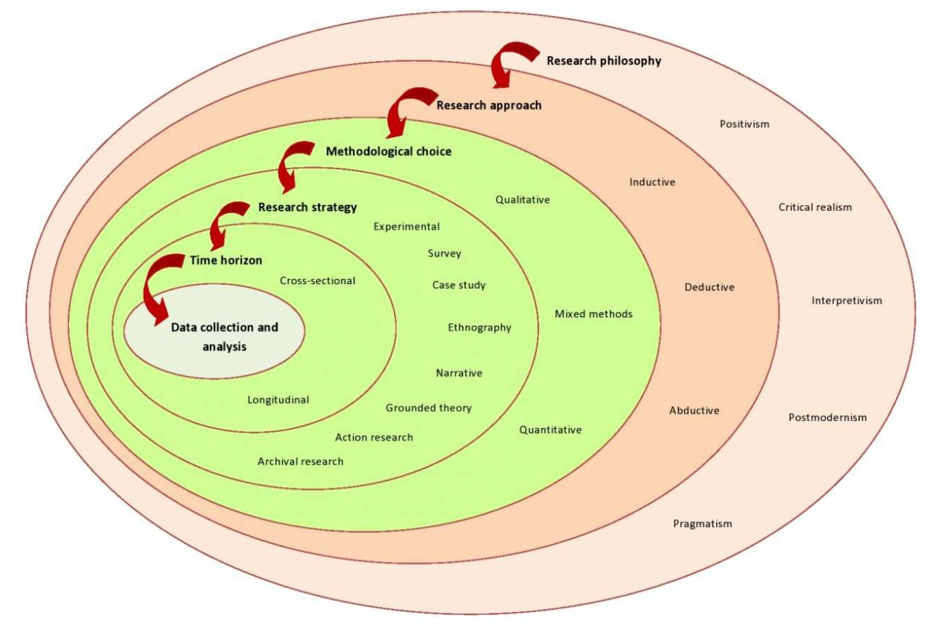
(Tengli, 2020)
The research will be underlined by both interpretivism and pragmatism. Interpretivism allows for the understanding of subjective experiences and gendered stigma among emergency personnel. Pragmatism supports the integration of qualitative and quantitative methods to thoroughly explore the research question.
An abductive approach will be employed, commencing with the observation of stigma and help-seeking behaviours. This will hopefully evolve into the identification of any emerging patterns or trends. The iterative process will provide opportunity to explore the complex issues and then refine through ongoing data collection.
The concurrent mixed methods design, outlined by (Creswell, 2003), explores quantitative and qualitative phases simultaneously. There are three types of concurrent mixed methods design: concurrent triangulation, concurrent nested and concurrent transformative’ (Hanson, et al., 2005). A concurrent triangulation mixed methods design will be adopted for this research. Concurrent triangulation, as described by Adu (2023) and Hanson et al (2005), involves collecting both types of data, with equal priority, and then determining whether both methods have yielded similar findings.
“Quantitative method is a research tool used to help measure variables or quantify observations” (Adu 2023). Quantitative research explains phenomena by collecting numerical data that are analysed using mathematically based methods” (Aliaga & Gunderson 2002). This will form part of the research.
Additionally, correlation analysis will examine relationships between variables such as gender, stigma perception, help-seeking behaviour, and length of service. In respect of quantitative data, a survey strategy will be developed, distributing Likert-scale questionnaires online to a broad range of emergency service staff. The questionnaires will seek to measure stigma, help-seeking behaviours and attitudes and the perceived gender norms. Descriptive statistics will then be utilised to analyse the data. Descriptive research involves collecting data to ‘answer questions or test hypothesis concerning the current status of the situation’ (Long et all 1985).
Qualitative data is ‘descriptive information that focuses on concepts and characteristics, rather than numbers and statistics. Qualitative data analysis tries to answer questions about why people behave as they do and what motivates that behaviour’ (Sheldon, 2024). The qualitative data for this study will be collected through focus groups, defined by gender. This will explore experiences, stigma, barriers to seeking help and any ingrained cultural influences. Data will be analysed using thematic analysis with manual coding. An ethnographic approach will be used to engage with persons in their natural setting, collecting rich data to help meet the purpose of the study. Engagement with participants will include conducting focus groups and one-to-one interviews. Adu (2019) notes that this ethnographic approach requires spending considerable time with the source(s) of the data.
Secondary data from existing statistics, including HR data, national police data and gender-specific mental health support uptake will be reviewed to contextualize the findings and to identify any trends or patterns. A cross-sectional time horizon will be adopted, with data collected at a single point in time to capture current attitudes and behaviours.
Informed consent will be obtained from all participants, with confidentiality and anonymity of participants maintained. Given the sensitivity of the topic, access to support resources will be ensured.
Proposed Timeline:

Anticipated Outcomes:
An improved understanding of gendered stigma and the barriers to seeking help, leading to recommendations as to how improvements could be made to break down the barriers.

References:
Adu, P., 2019. A Step-by-Step Guide to Qualitative Data Coding. s.l.:Routledge.

Adu, P. a. M. A. D., 2023. Dissertation Research Methods - A Step-By-Step Guide to Writing Up Your Research in the Social Sciences. 1st ed. London: Routledge.

Aliaga, M. a. G. B., 2002. Interactive Statistics. s.l.:Sage.

Bell, S. & Eski, Y., 2016. Break a Leg - It's all in the Mind: Police Officers' Attitudes towards Colleagues with Mental Health Issues. Policing: A Journal of Policy and Practice .

Bradbury, A., 2020. Mental Health Stigma: The Impact of Age and Gender on Attitudes. Community Mental Health Journal .

Canfield, B., 2019. Dissertation - Understanding The Role of Stigma, Gender, and Secondary Traumatic Stress on Emergency Department Healthcare Providers. s.l.:s.n.

Cohen, L. &. M. L., 1980. Research Methods in Education. s.l.:Groom Helm Ltd.

Creswell, J. &. C. J. D., 2018. Research Design: Qualitative, Quantative, and Mixed Methods Approaches. s.l.:Sage Publications .

Creswell, J., 2003. Research Design: Qualitative, Quantitative, and Mixed Methods Approaches. s.l.:Sage Publications .

Creswell, J. W., 2013. Qualitative Inquiry and Research Design: Choosing Among Five Approaches. 3rd ed. s.l.:Sage.

Danielsson, U., Bengs, C. & Arja, 2009. Struck By Lightning or Slowly Suffocating - Gendered trajectories into Depression. BMC Family Practice .

Hanson, W., Creswell, J., Plano, C. V. L. & Petska, K. &. C. J. D., 2005. Mixed Methods Research Designs in Counseling Psychology. Journal of Counseling Psychology, Volume 52(2), p. 224.
Kaitz, J. E., Steinhilber, K. M. & Harris, J. I., 2022. Influence of Provider Gender on Mental Helath Stigma. Community Mental Health Journal.

Long, T. & Convey, J. &. C. A., 1985. Completing Dissertations in the Behavioral Sciences and Education. s.l.:Jossey-Bass Publishers.

Mind, 2019. Mental Health in the Emergency Services. [Online]
Available at: https://www.mind.org.uk/media-a/4849/2019-survey-police-service-summary.pdf
[Accessed 20th October 2025].

Muijs, D., 2004. Doing Quantitative Research in Education with SPSS. s.l.:Sage Publications Ltd. .

Newell, C. J., Ricciardelli, R. & Czarnuch, S. M., 2022. Police Staff and Mental Health: Barriers and Recommendations for Improving Help-seeking. Police Practice and Research .

Parkes, S., Irizar, P. & Greenberg, N., 2024. Sickness absence associations with sociodemographic factors, health risk behaviours, occupational stressors and adverse mental health in 40,434 UK police employees. Epidemiology and Psychiatric Sciences .

Police Federation, 2016. [Online]
Available at: https://www.polfed.org/our-work/wellbeing/mental-health/
[Accessed 20th October 2025].

Police Federation, 2025. Pay and Morale Survey 2024 - Headline Report January 2025, s.l.: s.n.

Sheldon, R., 2024. Tech Target, Search CIO. [Online]
Available at: https://www.techtarget.com/searchcio/definition/qualitative-data
[Accessed 20th October 2025].

Smith, J. M., Knaak, S. & Smith, J., 2025. An Exploration of Mental Health-Related Stigma in an Emergency Setting. International Journal of Mental Health and Additction .
Stattin, H. & Eriksson, C., 2024. Person-Oriented Profiles Can Clarify Variable-Oriented Associations: The Example of Commuincation with Parents and Adolescents' Mental Health Problems. Youth.

Tengli, M. B., 2020. Blog 132- Research Onion: A Systematic Approach to Designing Research Methodology. [Online]
Available at: https://aesanetwork.org/research-onion-a-systematic-approach-to-designing-research-methodology
[Accessed 18th October 2025].

Velazquez, E. & Hernandez, M., 2019. Effects of Police officer Exposure to Traumatic Experiences and Recognizing the Stigma Associated with Police Officer Mental Health. Policing: An International Journal of Police Strategies and Management .

