Program: BEng (Hons) Mechanical and Manufacturing Engineering.

Student: Adam Hill.

Student Number: 1904039

Date : 6th March 2020.

Module : Engineering Science 1.

Assignment Title : Potential and Kinetic Energy.

Assignment No : 1

Lecturer : Abi Summerfield.




Contents page:

Introduction. - Page 3.

Procedure of Experiment. - Page 4-5.

Results. - Page 6.

Analysis. - Page 7.

Conclusion. - Page 8.

Evaluation - Page 9.

Further Work. - Page 10.

References. - Page 11.

Introduction.

This report is a precise explanation of the results and conclusions found when conducting an experiment relating to Kinetic and potential energy.

The experiment involves dropping a range of different weights attached to a fly wheel from a height of 280mm and examining the effect the different weights have on the kinetic and potential energy.

Using and Excel spread sheets and excel formulas the potential energy and potential energy lost was calculated to find the Kinetic energy (PE Lost + PE = KE). Graphs have also been included to give a more visual understanding of how KE and PE is affected when weight is increased. The Inertia of the fly wheel can also be determined by using the gradient of the graph.

Potential Energy.

A definition of potential energy would be, “Potential energy is the stored energy of position possessed by an object” [1](https://www.physicsclassroom.com/class/energy/Lesson-1/Potential-Energy) In the case of this experiment the potential energy would be the weights hanger loaded with weights prior to release. In an ideal situation the Potential energy can be calculated by using the formula Potential Energy = Mass x Gravity x Height(P.E=mgh).
In theory when the weight on the hanger is increased the potential energy should increase also. When the Potential energy increases the time, it takes for the weights to drop from (h1) and rise again to (h2) should decrease. Using our results from the experiment we were able to calculate the angular acceleration produced by the flywheel. It was apparent that when the time taken for the weights hanger to travel from (h1) to (h2) decreased the angular acceleration of the fly wheel increased.

Kinetic Energy

A Definition of Kinetic Energy could be. “Kinetic energy, form of energy that an object or a particle has by reason of its motion.” [2]( https://www.britannica.com/science/kinetic-energy). For instance, during this experiment the Kinetic Energy of the Flywheel was generated when the weights hanger was release from (h1). In turn the Kinetic energy increased when the weight on the hanger increased. To work out the Kinetic Energy the formula (ΚΕ = PE + PE Loss) can be used.

I will discuss the different factors which may have influenced the PE loss during the experiment and how that has affected the results.

Experimental Procedure

- Obtain equipment to conduct experiment;
- Perforated work panel
- Fly Wheel
- Bearing Block and string (String length was correct when obtained)
- Magnetic Rule
- Weight Hanger
- 300g of Weights (10g per disc)
- Slow Motion Camera (NOT COMPULASARY TO CONDUCT EXPERIMENT)
- 3 People to conduct the experiment
- Place work panel onto table top.
- Secure the Bearing block to the perforated work board. Ensure the bearing block is secured to the highest point of the work board to allow enough travel for the weights.
- Attach fly wheel to the short shaft on the bearing block using Allan key to secure.
- Hook the Weight hanger to the loop at the end of the string attached to the bearing block.
- Ensure the weights hanger is at the lowest point possible before positioning the magnetic rule.
- Place the magnetic rule onto the work board and ensure the “0” point of the magnetic rule is in line with the base plate of the weight’s hanger. The rule must also be set perfectly perpendicular to the table top to ensure accurate reading.
- Place 9x10g weights onto the weight hanger to create to the initial weight of 100g.
- 1 Person must be responsible for winding up and releasing the fly wheel. 1 Person must ensure the base plate of the weight’s hanger is in line with 280mm on the magnetic rule and record the height which the base plate returns to once released and 1 person to record the time taken for the weights to fully descend from initial height (h1) and ascend to final height (h2). (to get the most accurate recording of final height “h2” a slow-motion camera was used to determine where the base plate stopped)
- Wind the string onto the axel by turning the fly wheel until the base plate of the weights hook is in line with the 280mm mark on the magnetic rule. Ensure the string is reeled onto the axel in a uniform manor for consistency through the experiment. Now ensure everyone is ready to start the experiment.
- On the count of three Release the fly wheel and record the Time taken from the point of release (h1) to the time it takes the weights to reach final height (h2) as well as recording the figure for final height (h2).
- Repeat step 10 three times with the initial 100g weight to obtain an average.
- Repeat Steps 10,11 and 12 with the weight of 200g and 300g on the weight hanger.
- The team input the findings into mathematical formals to determine how different forces were behaving during the experiment. Such as Potential Energy = Mass x Gravity x Height and the value of potential energy lost. The moment of inertia can be calculated by using the gradient of the graph which can be produced from the results in the excel spreadsheet.
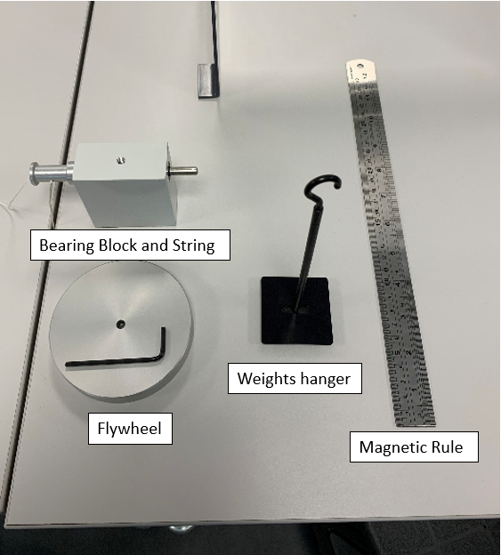

Figure 1 – Apparatus (Captured: UWTSD 2020)

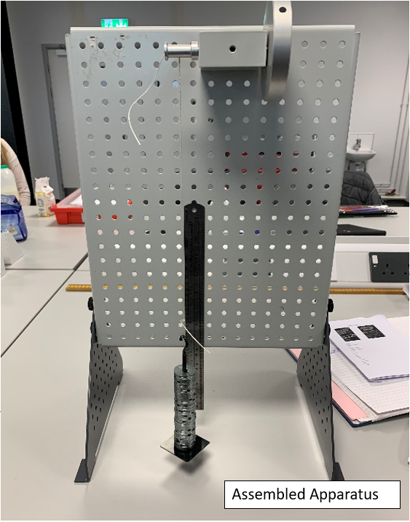

Figure 2 – Assembled apparatus (Captured: UWTSD 2020)
When the data was analyzed and put into formulas it soon become apparent that there were some sporadic results which drove the team to carry out a second experiment. After a small discussion it was decided that the sporadic results could have derived from human error. This could have occurred due to the amount of people taking the time for the base of the weights hanger to travel from Initial height (h1) to Final Height (h2). Three people were originally taking the results, the team then created an average from them results. If one person pressed the stop watch too early or too late this could throw the results.

Therefore, to minimize this level of human error the team then carried out the experiment with just one person capturing the time. The Results in this report are from the second experiment. We also took in consideration the different behaviors which the apparatus has with different weights applied such as jerking effects on the weight’s hanger. For example when the weight of 0.4kg and 0.5kg was released as it hit its lowest point the weights hanger wobbled considerably.

Table 1 - Results.

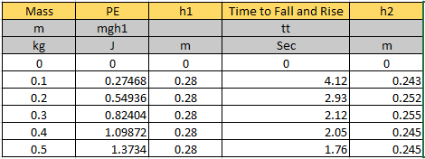

Figure 3: Raw Data from experiment
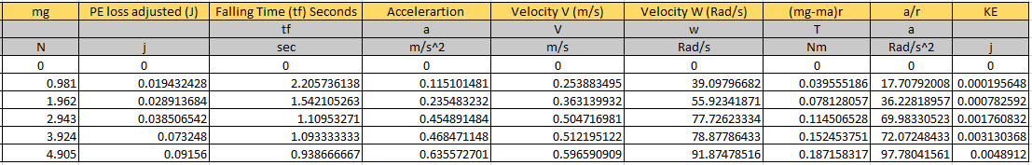
Table 2 - Analysis.
Figure 4: Data Output from formulas

Chart 1 – Torque.

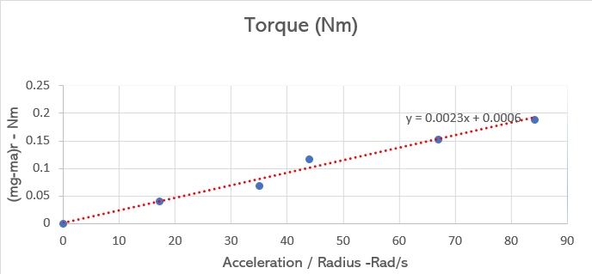

Figure 5: Chart showing trend line to calculate inertia

Using the data in the excel spreadsheet a graph can be produced to determine the flywheels average moment of inertia. This can be calculated by using the gradient of the graphs trendline using (mg-ma)r against a/r or in other terms the general chart equation “y = mx + c” (y=0.0023x+0.0006).

When transposing the equation, we are left with the average value of inertia as 0.0023Kgm².

Conclusion.

Ensuring that the calculations in excel were correct a discrepancy was picked up in the results. Theoretically when using the formula (KE = PE + PE Lost) to determine the kinetic energy the kinetic energy should always be greater than potential energy. When trying to understand where the potential energy was lost a correlation was detected. During the experiment as the weight increased the potential energy loss decreased. This could have been due to the fact as the weight increased it overcame the factors which may have influenced the kinetic energy to be lower than the potential energy.

Firstly, the bearing housing in which the string was attached to via and axel would have been a large factor. When the axel is spinning there would have been a degree of friction inside the bearing housing. The resistance of the friction would have been great enough to slow down the weights hanger therefor decreasing the kinetic energy. When conducting an experiment and energy is lost through certain apparatus it can be also be known as mechanical losses. The frictions would of also caused a fraction of heat transfer within the bearing block, heat transfer would have also contributed to the potential energy loss during the experiment.

Secondly, drag or wind resistance could also be a contributing factor to why the Kinetic energy is less. The base of the weight’s hanger was a flat circle and due to it not being a wind resistant shape drag was produced when the weights hand was falling. However, due to the short distance which the weights were falling it would be important to consider that the wind resistance force would not have been a large factor into why the kinetic energy was less than the potential energy.

The theory behind the kinetic energy being greater than the potential energy would relate more to a situation where no other factors could affect the energy transfer. As an example, you can use the following phrase in the situation of a free-falling object. [3]“When the object is released, its velocity increases as it falls. This increase in velocity results in an increase of the object's kinetic energy (KE). But it also results in a decrease in PE.” (https://www.school-for-champions.com/science/gravity_energy_falling.htm#.XmAZFeRvI0Q).

Therefor the gravitational potential energy that the weights hangers gained would have been at its maximum as it reached the point of (h1). The gravitational potential energy was then transferred into kinetic energy where it would have reached its maximum at the point of 0mm on the magnetic rule.

Evaluation.

When looking at the results produced from the raw data, you must take into consideration all factors which may have affected the accuracy of the results.

Mechanical losses would not have been the only factor why discrepancies were identified in the results. Factors such as human error could have also contributed. Although a slow-motion camera was used to increase the accuracy of the results it was still hard to pin point to exact height in which the weight hanger stopped when it reached (h2). Sometimes when the weights hanger reached (h2) it was swinging. This combined with the chance that the camera was not completely center to the base plate when it arrives at (h2) also increased the chance the reading was incorrect.

Also, the person responsible for operating the camera to capture (h2) had the job of determining when the hanger reached (h1) prior to release. If this person’s eye line was not directly central to the base plate or they did not pay attention and try to achieve the exact same height every time a margin of error could have carried over to the results.

Weight. | Time to ascend and descend. | Height (H2)
0.1kg | 4.12. | 2.43 (Smooth)
0.2kg | 2.93. | 2.52. (Smooth)
0.3Kg | 2.12. | 2.55 (smooth)
0.4Kg | 2.05. | 2.45 - 2.51 (wobble)
0.5Kg | 1.76. | 2.33 - 2.45 (Large wobble)

Figure 6 : Behavior of weights hanger on accent and decent

Looking at the table above it explains the behavior of the weights hanger when the base of the weight hanger leaves initial height (h1) and reaches final height (h2). As the weight increased, the behavior changed. When the weights hanger reached the point of 0mm it appeared to jerk and wobble on the assent to (h2). When this occurred, it made the reading for (h2) difficult to determine as the base swung away from the magnetic rule.

Further work.

In the future if another experiments was to be carried out a number of different methods could be adopted to minimize the potential errors which were carried through this experiment.

The apparatus which was used to conduct the experiment could be improved. Grease could be applied to the bearings to reduce the amount of friction within the bearing block. Also, the bearings within the bearing block could be changed for more efficient bearing. These changes would allow the weight fall more freely when released.

The base of the weights hanger as mentioned was a flat circle which was not a very wind resistant shape therefor drag was produced during the release of the weight’s hanger. Although, the conclusion was made that the wind resistance would have been a very small factor to why the kinetic energy was lost you could minimize the affect by creating a more wind resistant base to cut through the air more easily as the weight’s hanger fell.

When observing the experiment, it was apparent that the string being used was twisting due to it being constructed from three separate smaller strands twisted together. If a string was used that was not made of three separate strands and made of a singular stand it would eliminate the twist and potentially decrease the swing of the weight’s hanger. Therefore, this would allow the operators to identify a more accurate reading for (h2).

Although a slow-motion camera was used to take the reading of (h2) it was an inexpensive version of a slow-motion camera. To make more accurate readings a slow-motion camera which captured more frames per second would allow the operator to freeze the frames at a more exact point when the weights hanger reached (h2) therefor resulting in a more accurate reading.

References

[1] (1996-2020 The Physics Classroom) (https://www.physicsclassroom.com/class/energy/Lesson-1/Potential-Energy)

[2] (Erik Gergesene)
( https://www.britannica.com/science/kinetic-energy)

[3](Ron Kurtus)
(https://www.school-for-champions.com/science/gravity_energy_falling.htm#.XmAZFeRvI0Q).

