

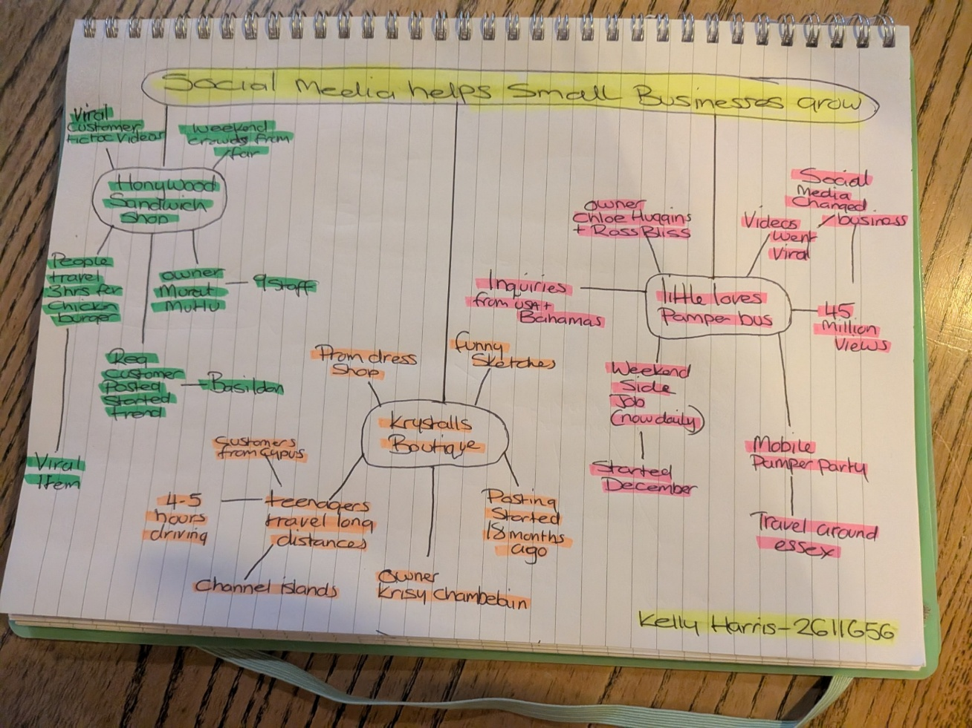

PART 2:
- Answer every question below in 1-3 full sentences.
- Use your own words. Do not use generative AI to answer these questions.
- Include a specific detail from the text when asked.
REMINDER
- The main idea is the overall message of the whole text.
- A key point helps to explain the main idea.
- A specific detail or example from the text shows that the key point is true.

- What is the main idea of the whole text?
According to the text, social media gives small businesses enormous publicity, draws in clients from far away, and boosts demand.

- What is one key point that supports the main idea, and which specific example from the text shows this?
One important thing to remember is that social media can significantly boost consumer demand. Customers travelled three hours to Honywood sandwich shop, when its chicken sandwich became well known due to popular TikTok video.

- What is a different key point that supports the main idea, and which specific example from the text shows this?
Another important factor is that social media makes it possible for small enterprises to connect with customers who live far away. After seeing their well-liked sketches online, teenagers from Cyprus and Channel Islands travelled to Krystalls Boutigue.

- Which part of the text do you think is most important, and why?
The most crucial aspect is how social media may totally change a company. After their films received 45 million views, Little Love’s Pamper Bus transformed from a weekend side gig to working nearly every day demonstrating the impact of social media.

Reflection:
- What did you find difficult in this task (including in-class components), and why was it difficult?
Because there was a lot of material in the text and it wants always obvious which aspects were crucial for the mind map, I had trouble selecting the main ideas.

- What helped you with this difficulty, and how did it help you?
I fund that using the mind map layout made the material easier to understand and arrange. It helped me better understand the material by demonstrating the connections between the overall idea, important points, and particular cases.

