Incest and inbreeding of the ancient Egyptian royal family during the 18th dynasty

Rachel Ann Hunt

Dissertation submitted in partial fulfilment of a
B.A. (Hons.) in Archaeology of Egypt and the Near East
University of Wales Trinity Saint David
May 2018

Abstract

The relationships of the ancient Egyptian royal family of the 18th dynasty has fascinated many. From Hatshepsut’s co-regency with Thutmose III and her ultimate erased history to Akhenaten and Nefertiti’s religious revolution to the arguably the most famous of the most famous boy king Tutankhamun. Incest was a prominent feature in the royal family of the 18th dynasty for countless reasons which will be explored. The physical condition of the royal mummies will also be discussed in relation to its possible links to incestuous relations of the royal family.

Acknowledgements

I would like to thank Dr. Katharina Zinn for her guidance throughout my degree and in writing my dissertation. I would also like to thank to thank my family for their constant support. My flatmates also deserve thanks for listening to me rant over the last three years, for sitting in procrastination with me and for the gatherings/game nights for the welcome break. I would finally like to thank BTS for their music which has kept me sane and their videos for providing me with comic relief throughout researching and writing my dissertation.

Table of contents

Abstract……………………………………………………………………….1
Acknowledgements…………………………………………………………..,2
Table of contents……………………………………………………………...3
Introduction…………………………………………………………………...4
Chapter One…………………………………………………………………...
Early 18th dynasty genealogy…………………………………………
Early 18th dynasty case studies………………………………………
Late 18th Dynasty genealogy…………………………………………
Late 18th dynasty case studies………………………………………..
Chapter Two…………………………………………………………………...
Chapter Three………………………………………………………………….
Conclusion…………………………………………………………………….
References……………………………………………………………………...
Images………………………………………………………………………….

Introduction

What is incest and inbreeding?
Incest is a culturally defined term which therefore leaves it to interpretation and is also highly biased. The term incest comes from the Latin word incestus which means unchaste (Shepher, 1983:27). One of the many modern definitions of incest is understood as “sexual intimacy and contact between relatives of the same nuclear family (mother, father, son, daughter) or between relatives sharing the same ancestors within two generation” (Middleton, 2005:433). A scientifically based definition is “[u]nions between couples known to share at least one common ancestor” (Bittles, 2004:38). Others suggest that a sexual relationship includes behaviour such as kissing, hugging and stroking and that only sexual intercourse can be classed as incest (Shepher, 1983:26). In this case, I would argue that the terms kissing, hugging and stroking are too general and that it is more the intent of the individual that determines if it is incest. By this I mean that when the intent of the individual is for sexual when engaging in the mentioned actions then I would argue that it constitutes as incest. However, if the intent is non-sexual then I would argue that it is not incest. Meza suggests two different types of how incest can be classified. Firstly, exogamic incest which only applies to relatives outside of the immediate family and secondly endogamic incest which means incest of relatives within the immediate family (Meza, 2003:119). Inbreeding could be described as “the production of offspring from two individuals who are genetically related to varying degrees” (Cartwright, 2000:349).

Incest has been the topic of many research projects undertaken on modern societies. They indicate that there is a lack of sexual feelings towards each other when individuals are raised closely throughout childhood whether they were related or not that due to the close bond shared (Wolf, 2004:95). This was suggested by Edward Westermarck in 1891 who provided a notion of avoidance of sexual relations or sexual attraction of those raised together since childhood. The reason for this might lie in an inherited mechanism which enables human beings against incest (Cartwright, 2000:83). There is some evidence to support Westermarck’s theory when looking on Sin Pua marriages in Taiwan. Here, young girls are adopted into the potential husband’s family and raised together from childhood. However, when they grow up and marry there seems to be lower fertility rates and lesser marriage stability (Bittles, 2004:47). However, a counter argument against this notion is Sigmund Freud’s research which states that within individuals there is an innate desire to have incestuous relations with relatives. Freud also suggests due to strict rules within many societies that these innate emotions are repressed. Furthermore, a mechanism within humans to avoid and repress the need for incest has not in evolutionary terms been created (Cartwright, 2000:83).

Issues with the study of incest
When discussing incestuous relations, it is important to think about modern incest taboos and how they could affect how we view past civilisations. There may be a modern cultural bias due to the way that our modern societies view incest because there is an understanding of the advantages such as to keep wealth within the family and the disadvantages such as the modern scientific knowledge e.g. DNA analysis that has uncovered medical conditions related to incest (Robins, 1993:15). There are many parts of the world where incest still occurs such as Sub-Saharan Africa, the Middle East, India and Central Asia. It should be noted that 50% of all marriages in Pakistan are first cousin marriages (Brittles, 2004:38). There are legal regulations within different countries on what types of incest can be allowed (Shepher, 1983:26). An example of this is the Sexual Offences Act 2003 which states that sexual intercourse with a parent whether biological or adoptive, a child whether biological or adopted, uncles and aunts, nephews and nieces is illegal in England and Wales (legislation.gov.uk, n.d.). The taboo started when societies began to realise that there may be some possible side effects of inbreeding (Wolf, 2014:14) such as miscarriage, child mortality or infertility later in life (Middleton, 2005:433). The modern view held by many cultures today which classes relationships of those closely related as wrong should not be considered when looking at ancient civilisations. Also, there may be a bias amongst modern Egyptologists as they possibly may not realise that they hold these biases, may be unwilling to overlook their bias or simply deny any existence of incest in ancient societies and pose other notions to explain evidence which suggests incest such as the relationships not being consummated (Robins, 1993:15). When undertaking my research, I need to be aware that these biases exists and aim to put them aside to present my findings in an unbiased manor as we do not truly know how the ancient Egyptians felt about the issue of incest or even if it was a concept that they thought about (Robins, 1993:15). Sex was not a taboo subject in ancient Egypt. It was a way of showing love, affection and a way to procreate. One important thing to note is that there is little evidence of concerning the issue of incest within ancient Egypt (Meza, 2003:119).

When looking at ancient Egypt one issue in need of being addressed when discussing possible incest are royal titles and relationships. There are many different titles that used to describe the royal women of the 18th and 19th dynasties such as ‘King’s Wife’, ‘King’s Daughter’ and ‘King’s Sister’. The title of ‘King’s Wife’ could also be given to a king’s daughter. It is difficult to ascertain whether this indicated that the father and daughter were married or if it was used ceremonially when the daughter would take the place of queen when she was not present (Robins, 1993:15). Princesses usually played a role of one of the goddesses in rituals or supported their father at court engagements (Green, 1996:7). It is possible that the title given to the daughter in such instance was used to give her a higher status in the ritual or ceremony and did not represent a marital union (Robins, 1993:15). Titles could be given to non-royal women to grant them higher status. Evidence suggests that the title of ‘King’s Daughter’ was not given to non-royal women which indicates that it was not given to help the social standing of commoners who marry into the royal family. Therefore, we can determine if incest and inbreeding took place based on the lack of ‘King’s Daughter’ (Watterson, 1996:26).

I have always had a keen interest in the relationships of the 18th dynasty and when choosing a dissertation topic, I knew that I would like to focus on aspects of the relationships between the royal family members. I have carried out my research using literature such as books and journal articles which have helped me put together this dissertation. In my first chapter I will present case studies which detail ways in which the ancient Egyptian royal family of the 18th dynasty (c. 1550 – 1295) (Hawass et al, 2010:638) engaged in incestuous unions or were the product of incest. I will do this by dividing the 18th dynasty into two sections. I will start with the early 18th dynasty from the reigns of Ahmose I to Thutmose IV and then the late 18th dynasty which is also known as the Amarna Period from the reigns of Amenhotep III to Horemheb. In my second chapter I will discusses why the ancient Egyptian royal family chose to engage in incest with examples such as to imitate the gods and to keep the divine nature of the royal family. In my third chapter I will discuss the effects of inbreeding. I will then discuss the stylistic revolution during the reign of Akhenaten and how this has garnered many suggestions of illness and disease among Akhenaten and his family. In relation to this I will then use the ‘King Tutankhamun Family Project’ study to discuss if these suggestions have any merit based on scientific research.

Chapter One – Case studies from the 18th dynasty

Early 18th dynasty genealogy
Using my references for my early 18th dynasty case studies I have created a genealogy.
Thutmose IV
Sekenenre Tao II
Ahhotep
Inhapy
Sitdjehuty
Ahmose I
Ahmose Nefertari
Ahmose Nebetta
Amenhotep I
Thutmose I
Ahmose
Mutneferet
Hatshepsut
Neferubity
Neferure
Isis
Thutmose III
Amenhotep II
Tiaa
Meryeramun
Thutmose II

(King’s name – Bold)

Early 18th dynasty case studies

It is important to understand when thinking about the idea of full siblings and half-sibling that the ancient Egyptians may not have had the same concepts regarding these titles as we do in the present day. It is thought that royal princesses of the 17th dynasty were only married to kings (Tyldesley, 1996:57). This trend seems to have continued into the 18th dynasty. This trend ends the 17th dynasty with the marriage of brother Sekenenre Tao II to his sister Ahhotep. This would mean that the first king of the 18th dynasty Ahmose I was the product of full sibling incest (Tyldesley, 1996:57). Sekenenre Tao II and Ahhotep also had at least two daughters called Ahmose-Nefertari and Ahmose-Nebetta. Sekenenre Tao II also married two other of his sisters Inhapy and Sitdjehuty (Dodson & Hilton, 2004:124). Looking at Ahmose I’s consorts we know that he married his full sister Ahmose Nefertari who became his ‘Great Wife’ (Tyldesley, 1998:43) and married other sisters who became secondary wives (Dodson & Hilton, 2004:125). It is to be noted that the royal princesses of the 18th dynasty were typically given the title of ‘God’s wife of Amun’ with Ahmose-Nefertiti being one of the first to hold this title (Hawass, 2006:10). The title was only used in the 18th dynasty by the king’s chief wife or by a king’s daughter. It may have been used in to create a divine link between the queen or princess with the gods (Ayad, 2009:4-6). Ahmose-Nefertari bore Ahmose I several children who were the product of full sibling incest. Their son Amenhotep I took the throne (Tyldesley, 1996:58) continuing the trend of his parents by marrying his full sister Meryeramum. However, it should be noted that no other wives or children of Amenhotep I are known which means that there is uncertainty determining if his successor was born from incest (Dodson & Hilton, 2004:127).

Due to this the father of his successor Thutmose I is uncertain. However, we should not rule out the notion that he was the father of Thutmose I due to lack of evidence (Hawass, 2006:11). It is suggested that he could have been the son of a lesser prince. Thutmose I’s mother was a woman called Senisonbe who was thought to be of non-royal blood as she is only given the title ‘King’s Mother’ and not ‘King’s Wife’. This could suggest that he is not the product of incest as it is very likely that Senisonbe was given the title after Thutmose I took the throne. A further notion that can be suggested is that Thutmose I was not royal and was selected by Amenhotep I to be the next king due to his lack of sons (Dodson & Hilton, 2004:128). When looking at the relationships of Thutmose I Hawass suggests that is that he married his sister Ahmose (Hawass, 2006:11). However, there is some debate as to whether she was his sister as the title ‘King’s Sister’ may apply to Thutmose I or a king before him. She does not hold the title ‘King’s Daughter’ which adds further confusion. Thutmose married his sister Mutneferet who held the title ‘King’s Daughter’ therefore Dodson & Hilton suggest that she was his sister (Dodson & Hilton, 2004:130). Thutmose I and Queen Ahmose had at least one daughter called Hatshepsut who would have been the product of full sibling incest (Hawass, 2006:11). It is unsure who the mother of Thutmose’s sons Amenmose and Wadjmose was but if we take the notion that it was either Ahmose or Muteferet then they may have been the product of full sibling incest also. A further child of Thutmose I named Neferubity is attested and is thought like her sister Hatshepsut to be the daughter of Queen Ahmose (Dodson & Hilton, 2004:130).

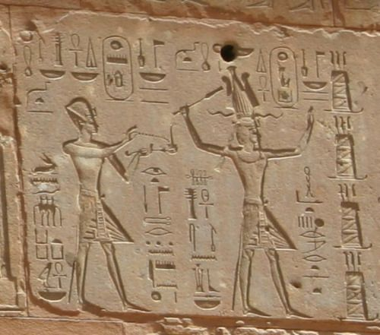
Thutmose I’s successor was his son with Mutneferet who would become Thutmose II. Thutmose II married his half-sister Hatshepsut and bore him at least one daughter named Neferure (Dodson & Hilton, 2004:131). His heir was born by his minor wife Isis about whom not much is known. (Hawass, 2006:13). During Thutmoses III’s reign his step-mother and aunt Hatshepsut acted as his regent (Hawass, 2006:14). It is possible that he married Hatshepsut’s daughter Neferure which would mean that he married he married his half-sister. However, it is unknown whether Thutmose and Neferure had any children as it is thought that she may have died before she was able to marry and have children (Dodson & Hilton, 2004:131). Neferure is one candidate to have given birth to his son Amenemhat just like other of his wives Meryetre-Hatshepsut, Nebtu or Sitiah with the latter being most likely (Dodson & Hilton, 2004:132-133). These three were non-royal so no incestuous relations occurred between them and Thutmose III (Dodson & Hilton, 2004:133). The lack of information regarding Neferure may be because she is the daughter of Hatshepsut whose many monuments were destroyed or removed after her death (Dodson & Hilton, 2004:132). To put this notion into more context Hatshepsut became the first regent of her step-son and nephew Thutmose III upon the death of Thutmose II (Tyldesley, 1998:1). During the 7th year of Thutmose III’s reign it seems that Hatshepsut called herself the king of Egypt (Tyldesley, 1998:99). However, it is possible that she considered herself king from the start of his reign (Tyldesley, 1998:100). It should be noted that kingship in ancient Egypt was always a male role even if the ruler was female (Tyldesley, 1998:1). To legitimise her rule as rule as king birth scenes were created which reinforced her divine nature (Tyldesley, 1998:103). There are differing notions as to whether Hatshepsut saw Thutmose as a threat. (Tyldesley, 1998:113). It would that this was the case due to the many of her monuments disappearing and being damaged. It is thought that Thutmose III attempted to remove all mention of his step-mother after her death because he could not challenge her during her life (Tyldesley, 1998:114). However, it is suggested that the destruction of Hatshepsut’s monuments was carried out into the later part of Thutmose III’s sole reign which would mean that both Hatshepsut and her daughter had been deceased for over fifteen years which brings one to question why the destruction was not immediate. It could be that Thutmose had no issue with Hatshepsut but later on in his reign there may have been some internal strife towards Hatshepsut’s co-regency (Robins, 1993:51-52).
Figure 1: Relief showing Thutmose III on the left and Hatshepsut on the right (Wikipedia, n.d.)

The next ruler of the 18th dynasty Amenhotep II was born to Meryetre-Hatshepsut who as previously mentioned was not a member of the royal family but was married to Amenhotep II’s father Thutmose III. Therefore, Amenhotep II was not the the product of incest (Hawass, 2006:18). Amenhotep II was thought to have had several children but none of his wives were given the title of ‘Great royal wife’. However, the mother of the next ruler Thutmose IV was Amenhotep II’s wife Tiaa who not much is known (Hawass, 2006:24). One of Thutmose IV’s most famous building works is the dream stelae which is positions between the paws of the Sphinx on the Giza Plataeu. Thutmose visited the Sphinx on a hot day and needed to sleep. As he slept he has a dream of a god telling him that he was the rightful person to inherited the throne. This could indicate that there was questions concerning the legitimacy of Thutmose’s rule which calls into question his parentage (Ashrafian, 2012:24).

Thutmose IV was known to have three wives. We know that he married his Iaret who we know was at least his half-sister due to her title ‘King’s daughter’ which was given to her likely being the daughter of Amenhotep II (Dodson & Hilton, 2004:135). Thutmose IV’s two other wives were Nefertari and Mutemwia who was the mother of his heir Amenhotep III (Dodson & Hilton, 2004:135). Mutemwia was never given the title of queen so it is thought that she was one of the minor wives (Hawass, 2006:27).

Late 18th dynasty (Amarna Period) genealogy
Using references from my case studies of the late 18th dynasty I have created a genealogy of the Amarna Period
Yuya
Tjuya
Muremwia
Thutmose IV
Iaret
Nefertari
Anen
Tiye
Amenhotep III

Ay
Sitamun
Henuttaneb
Nebetah
Thutmose
Isis

Kiya
Amenhotep IV/Akhenaten
Nefertiti
Meritaten
Ankhesenpaaten/Amun
Tutankhamun

Fetus 1
Fetus 2
Meritaten - Tasherit
Ankhesenpaaten - Tasherit
Horemheb

(Bold - King’s name)

Late 18th dynasty (Amarna Period) case studies
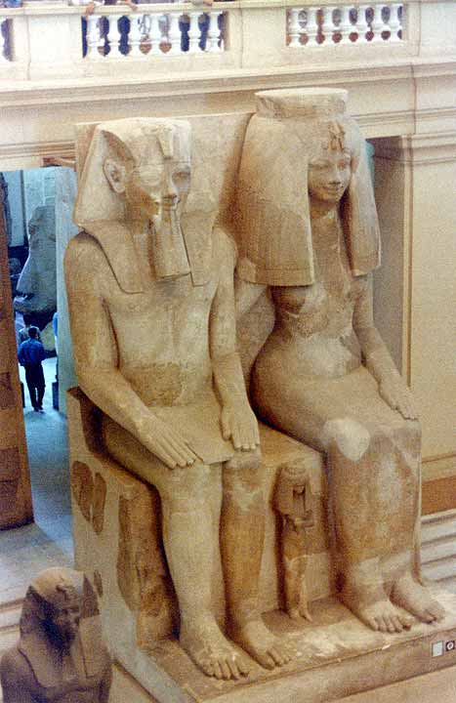

Figure 2:

Figure 2: Statue of Amenhotep III, Queen Tiye and daughters (Crystallinks, n.d.)

Amenhotep III was about age twelve when he inherited the throne from his father. In the second year of his reign being fourteen he married Tiye. Tiye was born a commoner. This decision by Amenhotep III to take a non-royal bride and give the title ‘Great Royal Wife’ which made her royal was a change compared to his father, grandfather and great-grandfather before him who chose to marry within the family (Hawass, 2006:27). Tiye was linked with the god Hathor which made her the divine counterpart of the king which in turn elevated her position (Zinn, 2016:256). Queen Tiye’s father Yuya held the titles of overseer of cattle, master of the horse and the commander of chariotry and her mother Tjuya was a priestess of Amun. Although, they were not of royal blood it is thought that a held a high level of power (Hawass, 2006:28). The couple had at least four daughters called Sitamun, Henuttaneb, Isis and Nebetah. Amenhotep III married his daughters Sitamun, Henuttaneb, Isis and Nebetah (Hawass, 2006:30). Sitamun was thought to be their eldest daughter and was given the title of ‘King’s Chief Daughter’ (Green: 1996:8) and was elevated to the rank of ‘King’s Chief Wife’ alongside Queen Tiye (Tyldesley, 1996:66). However, it is possible that she was the daughter of Thutmose IV which would mean that Amenhotep possibly married his sister and not his daughter (Dodson & Hilton, 2004:146). Henuttaneb was also married to Amenhotep III. However, on no inscriptions was she given the title of ‘Royal Wife’. There is archaeological evidence of the importance of the royal daughters in the form of the colossal statue of Amenhotep III, Queen Tiye and three of their daughters from Medinet Habu. This statue shows Henuttaneb wearing vulture cap which represents a queen and is described as ‘the companion of Horus, who is in his heart’ for which she is the only queenly figure to have this title. Further evidence of the marriage between father and daughter is that Henuttaneb and her sister Isis’s names have been found with a cartouche which was typical of royal wives. However, Isis was given the title of ‘King’s Wife’ unlike Henuttaneb. The forth of the daughters Nebetah was given the title ‘Lady of the Palace’ (Green, 1996:9) One thing to note is that there is no archaeological evidence that any of Amenhotep III’s daughters bore him any children (Green: 1996:7). Amenhotep III and Queen Tiye we know had at least two sons called Thutmoses and his successor Amenhotep IV who would become Akhenaten (Hawass, 2006:30).

Akhenaten’s principal wife was Nefertiti (Dodson & Hilton, 2004:146). Nefertiti like Tiye was linked to Hathor. This is important due to Hathor who could also be referred to as Isis was the mother of the god Horus (Zinn, 2016:259). Under Akhenaten’s rule there was a new divine triad made up of Aten who was the creator god, Akhenaten himself taking the place of the god Shu and Nefertiti who took the place of the god Tefnut (Zinn, 2016:260). There are many theories about the parentage of Nefertiti with some suggesting that she was of royal blood and some suggesting that she was a commoner. However, due to the lack of evidence neither notion can be proven as true (Hawass, 2006:35). There is a theory that a later a pharaoh Ay was her father. Ay’s parentage is not certain. However, there is a theory that he is the grandson of previously mentioned Queen Tiye’s parents Yuya and Tjuya through their son Anen (Hawass, 2006:28). If this is to be the case then Akhenaten and Nefertiti would have been both husband and wife as well as blood related as they were cousins (Green, 1996:10). However, it is also possible that Ay was the son of Yuya and Queen Tiye’s brother (Dodson & Hilton, 2004:145). Nefertiti’s mother is also uncertain but if the theory that Ay is her father is to be taken as true then Ay’s wife Tiy was her mother or step-mother. When Ay became king Tiy was given the title ‘Great royal nurse who became queen’ (Green, 1996:15).
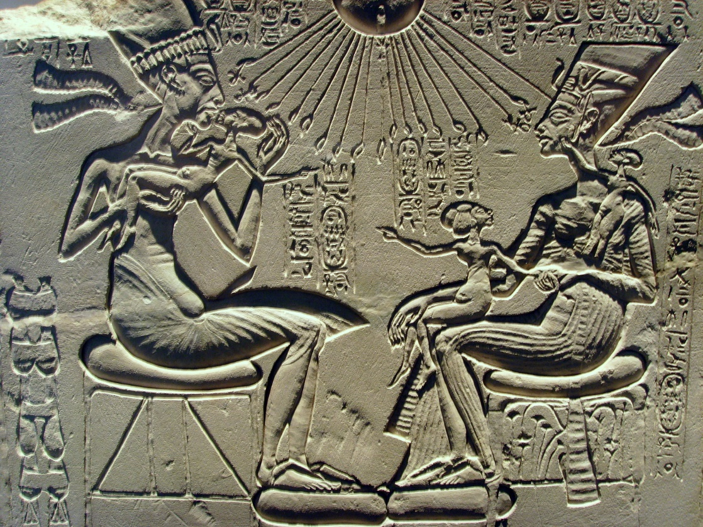
Figure 3: Akhenaten, Nefertiti and daughters (Wikimedia Commons, n.d.)

Akhenaten had at least nine daughters that were called the ‘Beloved King’s daughters of his flesh’ (Green, 1996:10). Six of them with wife Nefertiti were an important part of the divine family (Hawass, 2006:39). The possible eldest of these daughters was Meretaten and was given the title ‘King’s Chief Wife’. It is thought that at some point she rose in status and took over some depictions of Akhenaten’s second wife Kiya (Green, 1996:10-11). It is thought that Meretaten married once again after the death of Akhenaten. There are two possible theories which are that she married Neferneferuaten which was thought to be the ruling name of Nefertiti so this possibly would have been a ritual marriage (Green, 1996:11). Nefertiti is sometimes depicted as king by herself which draws questions regarding her role during both the reign of Akhenaten and after his death (Zinn, 2016:259). The second is Smenkhare who was thought to be Tutankhamun’s elder brother who ruled briefly after the death of their father Akhenaten and before Tutankhamun’s reign (Green, 1996:11).

However, the marriages of Akhenaten and his daughters may have produced offspring. There are princesses called Meritaten-Tasherit and Ankhesenpaaten-Tasherit whose parentage are unclear. Tasherit means ‘the younger’ which indicates that they may have had the same name as their mothers Meretaten and Ankhesenpaaten. Although, another theory is that they were the daughters of Akhenaten and Kiya and not his daughter’s children. However, there is no evidence definitive evidence to prove either theory (Green, 1996:14). It is likely that Akhenaten died in the 17th year of his reign. There is some debate over the successor to the throne. One notion is that Smenkhare of which little is known (Hawass, 2006:46). Although, it may be possible that he was the son of Akhenaten and the elder brother of Akhenaten’s other son Tutankhamun (Dodson & Hilton, 2004:150). It is possible that Smenkhare married his sister Meritaten and was the father of Meritaten-Tasherit (Dodson & Hilton, 2004:151). There is some debate on whether he was murdered by Ay due to a possible dislike of the religious changes made by Akhenaten (Hawass, 2006:46). However, this is purely speculative. It is possible that Nefertiti put the young Tutankhamun on the throne after Smenkhare’s short reign of two years. A further notion is that Smenkhare was a brother of Akhenaten or Nefertiti herself (Hawass, 2006:47).

It was known that Tutankhamun was the son of a king (Hawass et al, 2010:638). So, it was originally thought that he was either the son of Amenhotep III or Akhenaten with the latter being the most likely (Hawass, 2006:42). One suggestion of the mother of Tutankhamun is Sitamun (Green, 1996:8). Also, a further theory is that Akhenaten’s second wife Kiya is possibly Tutankhamun’s mother (Hawass, 2006:42). Kiya had the title of ‘Greatly beloved wife of the King’ (Hawass, 2006:42). A notion is that Kiya was a Mitanni princess called Tadukhipa who adopted the Egyptian name Kiya upon her marriage to Akhenaten. She had similar titles to Nefertiti but due to possibly being a foreign princess it is unlikely that she would not have been able to be called ‘King’s Chief Wife’ (Green, 1996:14). Kiya disappears from the archaeological record around the twelfth year of Akhenaten’s reign which is thought to be around the time of the birth of Tutankhamun. It is possible that she died in childbirth or was ousted or from royal court or murdered (Hawass, 2006:42). Tutankhamun married his sister or half-sister Ankhesenpaaten. As she was unlikely the first born of Akhenaten and Nefertiti’s daughters it draws a question as to why she became his queen. It is thought that she became his queen after the disappearance from the archaeological record of her mother, step-mother and older sisters (Green, 1996:11).
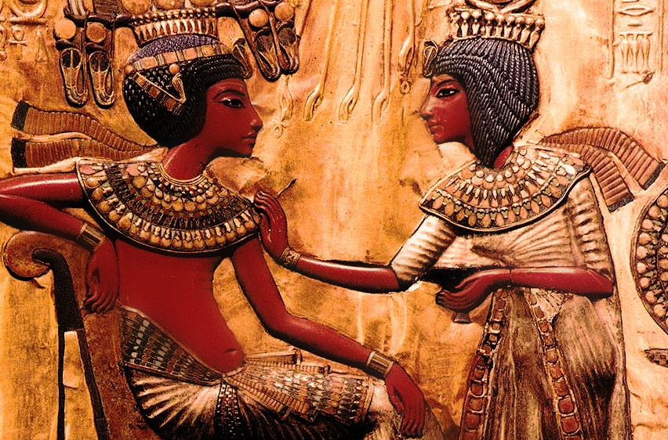
Figure 4: Tutankhamun and Ankhesenamun (KingTutOne, n.d.)

During Tutankhamun’s reign the religious ways of his father Akhenaten were reverted to the cult of Amun. Therefore, within the archaeological record Ankhesenpaaten’s name changed Ankhesenamun. Ankhesenamun was pregnant at least twice due to two foetuses found in the tomb of Tutankhamun. However, these two pregnancies which were stillborn (Hawass, 2006:58). After the death of Tutankhamun, Ankhesenamun may have married his successor Ay (Green, 1996:11) who was the vizier of Tutankhamun (Hawass, 2006:59). There is very little archaeological evidence which supports this theory although the evidence we do have is a ring which depicts the joined names of Ankhesenamun and Ay which indicates there could have been a marriage (Green, 1996:11). It might have been her who sent a letter to the king of the Hittites asking for him to send one of his sons to marry her and become king after Tutankhamun’s death. It is possible that she did this to avoid marrying Ay (Hawass, 1996:67). However, the prince did not arrive in Egypt and it is likely that he died on his journey due to assassination or illness. Although, it should be noted that there is no definitive proof that it was Ankhesenamun that sent the letter (Hawass, 2006:68).

Ay was given the title ‘God’s father’ which indicates that he may have been a member of either Queen Tiye or Nefertiti’s family. If this is to be taken as true then it is possible that Ankhesenamun married her grandfather if he was Nefertiti’s father or great-uncle if a brother of Queen Tiye. Although, it could have been a marriage with the purpose of legitimising the royal line (Hawass, 2006:59) Ay only ruled for three years before his death (Hawass, 2006:68). His successor was Horemheb who was a general of Ay and could have unroyal (Dodson & Hilton, 2004:153). He married Mutnedjmet who was also non-royal. However, it is thought that she may have been a sister of Nefertiti and that she died in childbirth (Green, 1996:15). Horemheb ruled for 59 years and was the last ruler of the 18th dynasty (Hawass, 2006:68).

Chapter Two – Why did the ancient Egyptian royal family engaged in incest?

One reason previously though by scholars such as Sir J. Gardener Wilkinson as to why the ancient Egyptians may have engaged in incestuous relations is a notion called the Heiress Theory. This theory states that royal males would need to marry a royal female typically a princess to gain the right to rule due to the notion that the right to rule passed from female to female through the generations of the royal family. If this were the case then for example a princess who married her brother who then became king would become queen and give birth to the future king and potentially a sister for him to marry or a half-sister if another royal wife of the king gave birth to a daughter. This would then be repeated when the son became king and continue throughout the generations (Tyldesley, 1998:67). If this notion were thought to be true then one would think that more emphasis would be put on the royal women as important aspects of kinship. However, as I will mention further in a later point the role of kinship is always male. The Heiress Theory states that even though the right to rule was passed from royal woman to woman it was in fact the male royal that she married that would take up the role as ruler of ancient Egypt (Robins, 1993:26). When looking at this theory there has proven to be many flaws which make this notion moot. Firstly, when looking at the parentage of some kings it has shown that some kings were born to non-royal born women such as Thutmoses I. Furthermore, some kings married non-royal women such as Amenhotep III with some of these women giving birth to future kings (Tyldesley, 1998:67). If the Heiress Theory is taken to be true then we should be able to trace the genealogy of the royal family from one royal woman to the next royal woman throughout the generations (Robins, 1993:26). Due to these points we can see that the Heiress Theory has proven to be unreliable. Therefore, we should think about why this theory came into being. The main reasoning could be to explain the incestuous relationships of the ancient Egyptians in a modern world where incest is a major taboo (Robins, 1993:27). Due to general distaste for these types of relationships in the modern world this theory may have been a way to find an excuse for the ancient Egyptians supposed transgressions of the past which it should be noted may not have been taboos for the ancient Egyptians (Tyldesley, 1998:67).
Creator God
Shu
Tefnut
Geb
Nut

Nephthys
Seth
Horus the Elder
Osiris
Isis

Horus

Anubis

A further notion as to why the ancient Egyptians engaged in incestuous relations was to imitate the gods. Archaeological evidence such as tomb paintings has shown that religion was an important aspect of ancient Egyptian daily life. Part of the ancient Egyptian religion was the worship of the deities. When thinking about incestuous relations of the gods it is important to start at what could be considered the start of ancient Egyptian mythology which would be the creation myth. The androgynous creator god was said to have swallowed his own semen to reproduce twins Shu who was sneezed out and Tefnut who was spat out (Pinch 2004:196.209). Shu was the god of air and light and it was thought that Shu ruled as the King of Egypt (Watterson, 1996:31). Shu and Tefnut were considered the first divine couple and second generation within the Ennead of Heliopolis which was comprised of many chief deities (Pinch 2004:195). Shu and Tefnut were married and engaged in a full sibling incestuous relationship which produced siblings Geb and Nut (Watterson 1996:34). One thing to note is that archaeological evidence in the form of the Phakussa stelae which indicates an incestuous encounter between Geb and his mother Tefnut. The stelae details of how Geb fell in love with his mother and lusted for her until the day that his father Shu died. Upon the death of Shu, Geb found Tefnut and proceeded to rape her. This is an example of an involuntary incestuous sexual encounter between a mother and son (Watterson, 1996:36). In terms of the siblings produced by Shu and Tefnut, Geb was the Earth God with his sister and wife Nut being the Sky Goddess. It could be said that they were the counterparts to each other due to the relationship between the earth and the sky (Watterson 1996:36). Furthermore, ancient Egyptian mythology states that Geb and Nut were forced to separate by their father Shu due to the two being so close with their embraces (Pinch 2004:135). It was these frequent embraces that prevented everything coming into existence therefore the separation was vital for things to be created. Once the two deities had been separated Nut then gave birth to the children she had previously conceived with her brother and husband Geb (Pinch 2004:174). Nut gave birth to five of Geb’s children which included Osiris, Isis, Seth, Nephthys and Horus the Elder (Watterson, 1996:37).
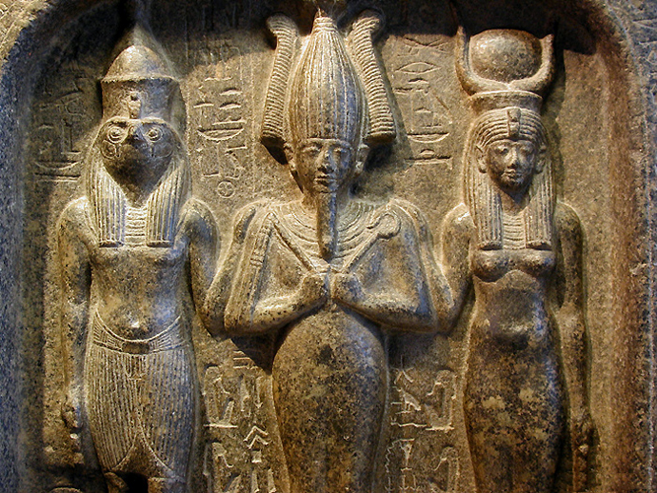

Figure 5: Horus (left), Osiris (centre), Isis (right) (The Ancient Bridge, 2015)

Osiris was married to his sister and wife Isis (Watterson, 1996:54). Ancient Egyptian mythology tells the tale of Seth’s overwhelming jealously of his brother Osiris due to him being a beloved ruler (Watterson, 1996:59). Isis was once regent over ancient Egypt (Watterson, 1996:56) which is thought to have infuriated Seth due to his belief that he should have been made regent. In his jealous state he planned a way to kill
Osiris. Furthermore, the story states that Seth had romantic feelings for his sister Isis so after killing Osiris he would do with Isis as he pleased. Seth was successful in his plan to kill Osiris and tricked the king into getting into a chest which he then closed and threw into the Nile which caused the death of Osiris. It is thought that the chest travelled down the Nile into the Mediterranean Sea before being found on the Byblos shore. The chest was then taken to the King of Byblos and later retrieved by Isis (Watterson, 1996:59). This leads into the question of the conception of Isis and Osiris’s son Horus in which there are many variations. One suggestion is that Isis was already pregnant before the death of Osiris therefore indicating that the marriage was consummated (Watterson, 1996:62). Another suggestion is that Isis may have been able to produce life without being in the presence of a living Osiris (Pinch, 2004:159). A story details how upset Isis was that she did not have a son to take over the throne after the death of Osiris. It was due to this state that she changed her body into that of a kite and therefore could make Osiris’s penis rise to take from him what was needed to become pregnant with Horus (Watterson, 1996:76. If this is to be the case then it could be said that the relationship between Isis and Osiris even though they were married may not be described incestuous by some as it may have not been consummated. However, regardless of the way that Horus’s conception occurred the deity would still have been the product of an incestuous relationship between brother and sister.

Once Isis had returned Osiris’s body to Egypt the mythology mentions that when Seth discovered this he took Osiris’s body and cut it into numerous pieces and scattered them across Egypt. It was then the mission of Isis and sister Nephthys who was married to their brother Seth to retrieve the remains of Osiris (Watterson, 1996:62). One thing to note in the mythology of the ancient Egyptian deities is the relationship between brother and sister Osiris and Nephthys. A story details Nephthys was in love with her brother Osiris and visited him in the dark of night. Due to the darkness Osiris thought that she was his sister-wife Isis and they engaged in a sexual encounter. The story details of how Nephthys became pregnant with Osiris’s child and gave birth to Anubis who was a funerary deity linked to the afterlife (Watterson, 1996:112,174). Sibling incest amongst the gods is shown to be common as there is another incestuous relation between brother and sister attested in ancient Egyptian mythology. Archaeological evidence in the form of coffin texts detail Horus the Elder and his sister Isis engaged in an incestuous relationship which produced the Sons of Horus (Pinch, 2004:145). Returning to the story of the Osiris’s death, after the sisters tried to retrieve all the parts of Osiris’s body he then become the ruler of the underworld (Pinch, 2004:178) due to the Sun God seeing the effort by the sisters and sympathised within them (Watterson, 1996:63). Horus then sought to avenge his father’s death by taking revenge on Seth (Watterson, 1996:54). Within Egyptian mythology there is a story that Horus who after the death of Osiris was successful in becoming King repaid his mother Isis’s efforts of her campaign to make her son king by raping her (Pinch, 2004:151). Furthermore, Egyptian mythology details an incestuous relationship between Seth and Horus. The tale details of how Seth invited his nephew Horus to his house (Watterson, 2004:106). Horus proceeded to visit his Uncle’s house and when night arrived “they lay down together – an unwise move on Horus’ part because, in the night, Seth made his penis become stiff, and he put it between the thighs of Horus. Thereupon, Horus put both his hands between his thighs and caught Seth’s semen in one of them.” (Watterson, 1996:107). Overall, incestuous relations of the ancient Egyptian royal family could have been a way to confirm the link between the gods and the royal family through the imitation of the gods for example brother and sister marriages which were frequent among the gods in the mythology. This would ultimately show the divide between the royal family and the ordinary ancient Egyptians as it is showing that there may have been different rules or expectations of royalty which enforce the idea of power and status of royalty over all ancient Egyptian subjects and beyond (Tyldesley, 1998:69).

Continuing from the imitation of the gods notion, it is important to look at the relationship between the gods and the king. The office of kingship was given to the king by the gods and the king was put ‘on the ‘throne of Horus of the living’, conferring ‘the entire world’ to his hands’ (Goebs, 2007:279). The king was thought of as both human and divine due to the living king being considered the reincarnation of the god Horus (Shaw, 2003:7). Evidence suggests that Horus was the last king of Egypt that was of divine nature and the living ruling king was the personification of the divinity of Horus on earth. Therefore, each king was given their own Horus name. Due to this connection with Horus it could be said that the king was a descendant of the gods dating back to the creator god (Goebs, 2007:281). The king was given the title ‘Son of Ra’ due to this link to the creator god (Goebs, 2007:283). Furthermore, Isis was thought to be the mother of each Egyptian king (Pinch, 2004:149) and Osiris was thought of as the father of each Egyptian king (Goebs, 2007:283). Osiris, Isis and Horus were thought of to be the perfect family. A family in which one should strive to be like and emulate (Watterson, 1996:54). This leads into the question of incestuous relations. If the king was divinely the product of an incestuous relationship then it could be suggested that the king be the product of a human incestuous relationship. Furthermore, this divinity of the king could possibly mean that the way in which the gods lived could be the same for the living king due to be a descendant and the reincarnation of Horus.

Another reason why incestuous relations may have occurred was to keep the royal blood line pure. Specifically, the king and the members of the royal family were of a higher social class than the ordinary people of ancient Egypt. Therefore, one could think that the practice of incestuous relations occurred to keep the purity of the royal family which would not include outsiders who may taint the royal blood. Furthermore, by keeping marriages within the royal family it would enable them to limit the number of people within the family to a smaller group who would all be quite closely related. By marrying brothers and sisters within the royal family it would ensure that each prince or princess would have a suitable husband and there would be no outside struggle for the throne (Tyldesley, 1998:68). In addition, it appears that brother and sister marriages were not popular among non-royals so this could further the notion that the royal family purposely attempted to set themselves apart from their subjects (Robins, 1993:27). A major flaw in this notion is that archaeological evidence has shown that some rulers and members of the royal family married outside of the family so the notion that incestuous relations keep the royal blood line pure is flawed. Also, when thinking about the marriages of the gods it could be said that they would have married each other due to the unavailability of others to marry. Whereas, the ancient Egyptians had the choice to marry outside of the family (Tyldesley, 1998:69).
In conclusion, the ancient Egyptian royalty may have participated in incestuous relations for an array of reasons that I have mentioned such as the Heiress Theory which has drawn many flaws, the imitation of the gods which links to the divinity of the king and to keep the royal blood line pure. It is important to remember that these notions draw further questions and criticisms due to lack of more concrete archaeological evidence regarding the rational of the ancient Egyptian royal family when choosing both their marital partners and those who they chose to pro-create with. It is vital that we do not put our modern taboos ancient beliefs which potentially could cause bias when looking at reasons why some of the ancient Egyptian royal family chose to engage in incest.

Chapter Three – Possible implications of inbreeding

Genetics of inbreeding
When looking at how genetics factor into inbreeding it should be noted that each parent contributes 50% of their genes to the child (Shepher, 1983:15). Therefore, first-degree relatives such as brother and sister share 50% of their genes. Relatives such as cousins share 12.5% (Brittles, 2004:38). Until the middle of the 20th century inbreeding was not considered a biological issue and it was thought that it did not cause any issues for the children of incestuous unions (Wolf, 2014:12). Nevertheless, children who are born from incestuous relationships could experience a larger variety of health issues than those who are born to non-incestuous parents. Incestuous pregnancies may result in miscarriage, stillbirth or the child may die during birth due to inherited genes present in both parents that are passed to the child (Middleton, 2005:433)

However, it is important to look at the age of life expectancy of the New Kingdom. The average life expectancy at birth was less than 30 years (Tyldesley, 1998:73). This is due to the high child mortality rate at birth and during early years development (Tyldesley, 1998:73). If inbreeding is repeated through multiple generations it may cause the children of each generations to be infertile later in life (Middleton, 2005:433). However, in the 18th dynasty there is no indication that the levels of fertility were reduced over generations (Brittles, 1983:48).

Akhenaten’s stylistic revolution
During the early part of Akhenaten’s reign, we see a stylistic change of the art. Depictions of the king tend to show more hallow cheeks, slanting eyes, a longer nose and larger lips. It could be said that the facial dimensions and the shape of the head in general could be considered not ‘normal’ of the general population (Arnold, 1996:17). Akhenaten also is depicted with an elongated neck with is usually only shown in animals (Arnold, 1996:18).

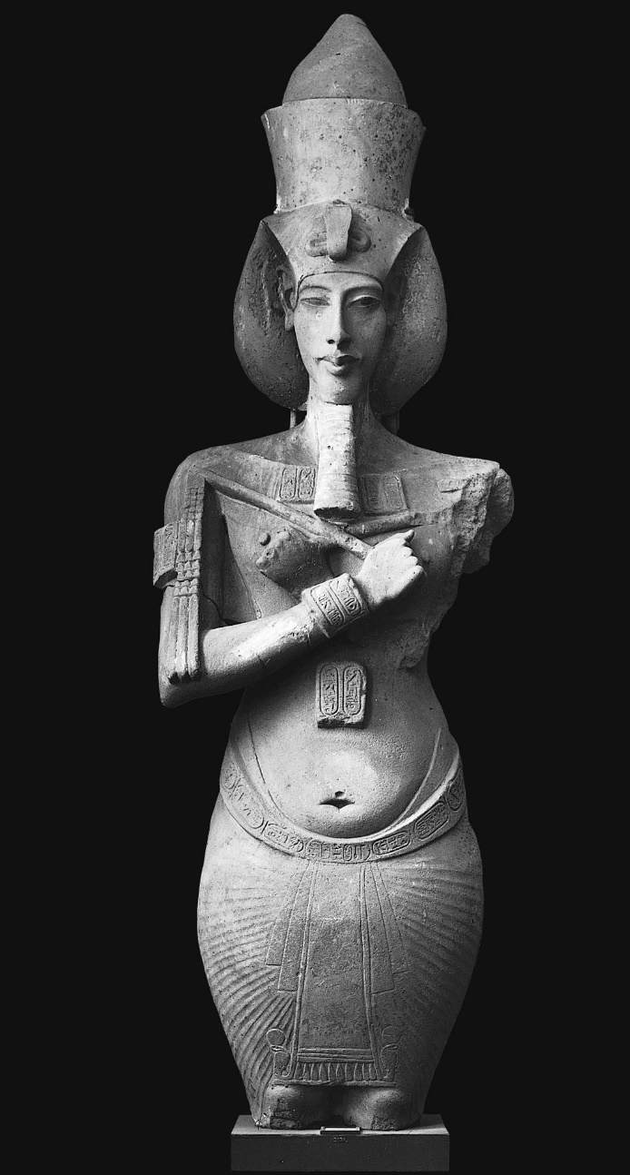
Depictions of Akhenaten show the king with exaggerated bodily features often connected with feminine physique: wide hips, thighs and breasts. The skull shape is also to be noted as both Akhenaten and Tutankhamun both were depicted with long skulls. There have been many attempts which try to explain why Amarna art was created this way. An early suggestion in 1855 by Auguste Mariette suggested the notion that Akhenaten was a eunuch (Habicht, 2011:47). A eunuch can be described as a ‘castrated human male’ (Encyclopaedia Britannica, n.d.). However, a flaw to his theory was the known fact that Akhenaten had at least six daughters. Due to this Mariette created a story which detailed how Akhenaten was captured in Nubia was castrated by members of Nubian tribes. There is no evidence that this event occurred and is considered purely fiction (Habicht 2011:47). Another suggestion is gynecomastia and craniosynostosis (Hawass et al, 2010:639). Gynecomastia is an enlargement of the breasts in males (NHS Choices, 2018) and craniosynostosis is a condition which affects the growth of a baby’s skull which causes the skull to be misshapen (NHS Choices, 2017). Other researchers put forward Marfan Syndrome, Wilson-Turner X Syndrome and Antley-Bixler Syndrome among others (Hawass et al, 2010:639).
Figure 6: Akhenaten (The Egypt Geek, 2017)

Statues from Karnak show the king and Nefertiti both half naked and genderless (Habicht, 2011:48). An earlier thought was that Akhenaten’s gender was female and not male due to the similarities between Akhenaten and Nefertiti in the depictions. To further this notion, it could be said that it is often difficult to tell Akhenaten and Nefertiti apart due to the similarities in facial, neck and breast shape and the style of clothing worn by both (Habichte, 2011:48). Fröhlich’s Syndrome which has possible side effects of obesity specifically on the chest and abdomen, public area and thighs and in males under developed genitalia has also been suggested (Habichte, 2011:47). Most of the notions suggested as based purely on artefacts discovered and have no scientific backing (Hawass et al, 2010:639).
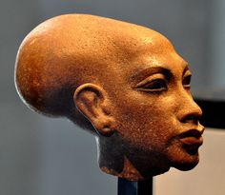
Figure 7: Daughter of Akhenaten (Pinterest, n.d.)

It should be noted that Akhenaten changed not just the artistic style but also the worship of the gods. The worship of the sun can be traced back to before the reign of Amenhotep III but became a more important aspect of religious beliefs of the 18th dynasty. Amenhotep III strongly supported the worship of the solar deity Aten but allowed other deities to be worshipped. Akhenaten did not immediately change the religion from monotheism to absolutism (Hanus, 2012:32). However, the abandonment of the worship of Amun can be traced to the first year of his rule. Evidence of this is the dedicating of temples to the Aten and limiting the ancient Egyptian pantheon to only solar deities. Also, the Aten became a deity in its own right and not just the sun disk aspect of the god Re. It is in his 6th year of his reign that he changed his name from Amenhotep IV to Akhenaten (Hanus, 2012:34). It was between the 6th and 9th years of Akhenaten’s reign that the religious belief was changed to the monotheism of the Aten. The god Amun was no longer the head of the ancient Egyptian pantheon and every temple dedicated to Amun was closed. Also, the move of the capital city from Thebes to Amarna took place (Hanus, 2012:35). Akhenaten could have used the stylistic change to differentiate from rulers who had come before him. He chose to depict himself in a more feminine way to separate himself from the masculine depictions of those before him. It was his way of showing that he and his religious changes were the correct way as opposed to the ways of those before him (Kemp, B. 2012:30).

What can the 18th dynasty royal mummies tell us?
The ‘King Tut Family Project’ was carried out between September 2007 and October 2009 which looked at the remains of 11 mummies from the New Kingdom who are thought to be a relative of Tutankhamun. Five mummies from the early 18th dynasty was also included. The study looked at possible familial relationships between the mummies using radiological methods and genetic studies to determine any inherited medical conditions, infectious diseases or murder as a cause of death (Hawass et al, 2010:638).

The mummy from KV55 and one of the mummies from KV35 (KV35YL) were the parents of Tutankhamun. Akhenaten and Tutankhamun’s mummies showed no signs of gynecomastia, craniosynostosis, Antley-Bixler syndrome or Marfan Syndrome amongst others as was previously suggested. It was determined that there were many malformations within the family of Tutankhamun such as Kohler Disease II which was present in Tutankamun. However, none of the malformations could have caused death (Hawass et al, 2010:638). Many suggestions have been put forward for Tutankahmun’s death such as an accident, fall or murder (Hawass et al, 2010:639). Tutankhamun likely died at the age of 19 of Malaria Tropica which was found testing of the king’s mummy as well as three other of the mummies (Hawass et al, 2010:638). Malaria Tropica is the worst form of Malaria. In spite of this we know what Yuya and Tjuya both lived into their fifties it is uncertain if the disease was fatal in the mummies tested. With Malaria it is to be noted that not everyone who contacts Malaria becomes ill due to being able to fight off the disease genetically (Hawass et al, 2010:646). Tutankhamun suffered from Avascular Bone Necrosis which is a side effect of Malaria Tropica. This is supported by the discovery of canes in the tomb of Tutankhamun (Hawass et al, 2010:638). Also, the penis of
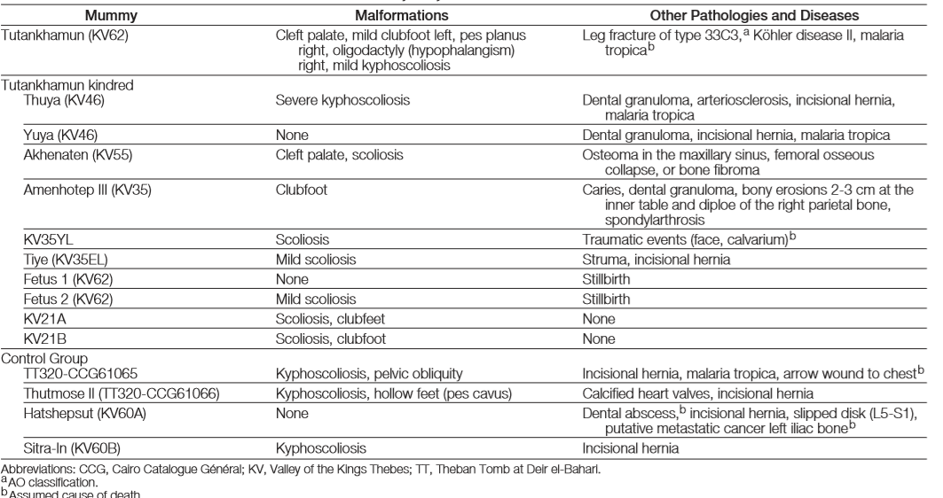
Figure 8: Table explaining the results of the ‘King Tut Family Project’ (Hawass et al, 2010).
Tutankhamun although no longer attached to the body was fully developed. Although, the pelvic bones of Tutankhamun were missing which slightly hinders the study into the possible feminine hips of Tutankhamun (Hawass et al, 2010:641). However, when looking at the pelvic bones of Akhenaten even though they are fragmented there is no evidence of feminine traits (Hawass et al, 2010:642). Both Akhenaten and Tutankhamun suffered from cleft palate. Club foot was apparent in both Tutankhamun and Amenhotep III. Scoliosis was present in many of the royal mummies such as Tutankhamun, Akhenaten, KV35YL, Tiye, Fetus 2 and KV21A and B (Hawass et al, 2010:645). The resukts also found no traces of the plague, tuberlercurosis and leproacy (Hawass et al, 2010:643).

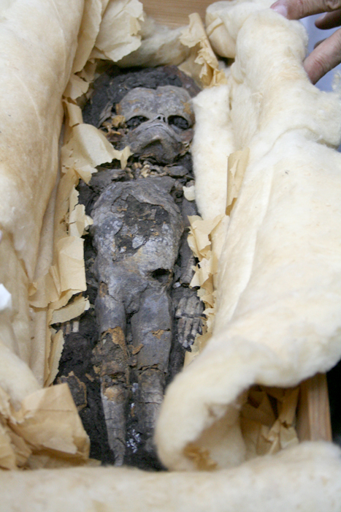
Tutankhamun has no heirs. (Hawass et al, 2010:639). In 1922, Howard Carter discovered 2 mummified foetuses in the tomb of Tutankhamun. Previous tests determined that they were two female foetuses with one aged approximately 5 months gestation and one 7 months gestation. We are not able to say that inbreeding caused the deaths of the two foetuses based on the results from the study (Hawass & Saleem, 2016:107).

In conclusion, it can be confirmed that the artistic style of the Amarna Period was a choice by Akhenaten and that based on the results from ‘King Tut Family Project’ there seems to be no indication of illness that would cause the malformations displayed in Amarna art. It is likely that the changes in the artistic style coincided with Akhenaten’s changes in religion. It should be noted that ‘art’ in ancient Egypt was represent in an idealised style. The ancient Egyptians may not have look like their depictions but they presented themselves in which in their mind was ideal regardless of authenticity. This is further displayed in the bust of Nefertiti as the layer underneath is less ‘beautiful’ than the outer layer for which the artefact is seen. The layer underneath shows that changes were made to the eye lids, creases were removed from around the mouth and there was a bump on the nose all of which are not apparent on the outer layer (Hawass et al, 2010:644).
Figure 9: 1 of the foetuses founded in the tomb of Tutankhamun (Pinterest, n.d.)

Conclusion
To conclude, my research looked at incestuous relationships and inbreeding of the ancient Egyptian royal family in the 18th dynasty. I gave definitions for both incest and inbreeding and discussed the issues that arise with the study of both such as modern bias and royal titles.

In my first chapter I gave case studies of incestuous relationships and inbreeding of the ancient Egyptian royal family of the 18th dynasty. I wanted to determine what types of incestuous relationships were present during the 18th dynasty and which members of the ancient Egyptian royal family engaged in incestuous relationships and who was the product of an incestuous relationship. I divided the 18th dynasty into two sections, the early 18th dynasty from the reigns of Ahmose I to Thutmose IV and the late 18th dynasty known as the Amarna Period which spans from the reigns of Amenhotep III to Horemheb. Within these case studies I displayed that there are many known incestuous relationships of the 18th dynasty with the first king of the dynasty Ahmose I who was the product of sibling incest as his parents Sekenenre Tao II and Ahhotep were brother and sister (Tyldesley, 1996:57). The trend continues throughout the dynasty with the marriage of full or half-siblings, fathers and daughters and the potential marriage of Akhensenamun and Ay which draws confusion regarding their possible familial connection (Green, 1996:11). However, incest was not the only martial practice carried out as some kings such as Amenhotep III who married Tiye who was non-royal who bore him the next ruler Akhenaten making him not the product of incest (Hawass, 2006:30). It would seem that there were no taboos amongst the ancient Egyptian royal family regarding incest due to the high levels of incest carried out over the 18th dynasty. However, there also seems to be no issue with marriage outside of the family as that also occurs through the 18th dynasty.

In my second chapter I provided reasons why the ancient Egyptians engaged in incestuous relations and inbreeding. I firstly discussed Heiress Theory which states that within the ancient Egyptian royal family royal princes married royal princesses due the right to rule ancient Egypt being passed down through the female line of the family. A prince would need to marry a princess to take the throne (Tyldesley, 1998:67). However, I discussed the flaws of this theory by stating that if this theory were true then we would be able to trace the genealogy of each king through their royal mothers which we are unable to do which is partly due to the archaeological evidence that shows that some kings were born to non-royal mothers (Tyldesley, 1998:67). I next discussed that the ancient Egyptians engaged in incestuous relationships and inbreeding to imitate the gods. I provided examples from ancient Egyptian mythology which shows that the gods of the Ennead of Heliopolis engaged in incest (Pinch, 2004:??). Through my research into the gods of the Ennead I discovered that there were many variations in the type of incestuous relationships such as brother and sister, mother and son and uncle and nephew. Inbreeding was the case as with the sibling incest that I have previously mentioned such as Osiris and Isis offspring were born to these relationships (Watterson, 1996:62). Also, the king was the living reincarnation of the god Horus and was the link between the gods and human beings (Goebs, 2007:279).

My third chapter discussed the possible implications of inbreeding such as the stillbirth and low life expectancy of children (Middleton, 2005:443). However, we have to take into account that the low life expectancy of children may be due to living conditions within ancient Egypt and not implications of inbreeding (Tyldesley, 1998:73). I focused on the Amarna period as an example of how illnesses and diseases have been suggested based purely on artistic styles. Illnesses and diseases such as gynecomastia and craniosynostosis were suggested (Hawass et al, 2010:639) to explain the typically feminine features displayed by the art of Akhenaten and his family (Habicht, 2011:47). However, through the ‘King Tut Family Project’ these illnesses and diseases were found in the results of the study. An illness that was found that were more likely to cause death especially in the case of Tutankhamun was Malaria Tropica (Hawass et al, 2010:638). The findings suggest that the artistic style of the Amarna period was a choice by Akhenaten in order to coincide with his new religious changes (Hawass et al, 2010:644) Finally, we are not able to say whether inbreeding was a detrimental factor biologically to the ancient Egyptians based on lack of evidence.

Bibliography
Arnold, D, 1996, An artistic revolution; The Early Years of King Amenhotep IV/ Akhenaten, In: Arnold D, The Royal Women of Amarna Images of Beauty from Ancient Egypt, New York, Metropolitan Museum of Art.
Ashrafian, H, 2012, Familial epilepsy in the pharaohs of ancient Egypt’s eighteenth dynasty, Epilepsy & Behaviour Vol 25:1, pp23-31 [Available from: https://ac-els-cdn-com.ezproxy.uwtsd.ac.uk/S1525505012004441/1-s2.0-S1525505012004441-main.pdf?_tid=ca044741-81a6-4b59-b920-a6e54af4de0e&acdnat=1525822414_3bf087a2014097e056ab555c25af4d58] Accessed: 8th May 2018.
Ayad, M F., 2009, God’s Wife, God’s Servant The God’s Wife of Amun (c. 740 – 525 BC), Oxon, Routledge.
Bittles, A H., 2004, Genetic Aspects of Inbreeding and Incest, In: Wolf, A P., Durham. W H. (eds), Inbreeding, incest and the incest taboo: the state of knowledge at the turn of the century, California, Stanford University Press.

Cartwright, J, 2000, Evolution and Human Behaviour Darwinian Perspectives on Human Nature, Basingstoke, PALGRAVE.

Dodson, A, Hilton, D, 2004, The Complete Royal Families of Ancient Egypt, London, Thames & Hudson.
Goebs, K, 2007, Kingship, In: Wilkinson, T A. H (ed), The Egyptian World, London, Routledge.
Green, L, 1996, The Royal Women of Amarna: Who Was Who, In: Arnold, D, The Royal Women of Amarna Images of Beauty from Ancient Egypt, New York, Metropolitan Museum of Art.
Habicht, M E., 2011, Nofretete und Echnaton: Das Geheimnis der Amarna-Mumien, Leipzig, Koehler & Amelang.
Hanus, C, 2012, Before and after Amarna – The beginnings and consequences of the cult of the Aten, In: Seyfried, F, In the light of Amarna 100 years of the Nefertiti discovery, Petersberg, Imhof.
Hawass, Z., Gad, YZ., Ismail, S., Khairat, R., Fathalla, D., Hasan, N., Ahmed, A., Elleithy, H., Ball, M., Gaballah, F., Wasef, S., Fateen, M., Amer, H., Gostner, P., Selim, A., Zink, A., Pusch, CM., 2010, Ancestry and Pathology in King Tutankhamun's Family, JAMA, [Online: https://jamanetwork.com/journals/jama/fullarticle/185393] [Accessed: 1st May 2018].
Hawass, Z, 2016, The Golden King The World Of Tutankhamun, Cairo, American University in Cairo Press.
Hawass, Z, Saleem, S N., 2016, Scanning the Pharaohs CT Imaging of the New Kingdom Royal Mummies, Cairo: New York, The American University in Cairo Press.
Kemp, B, 2012, The City of Akhenaten and Nefertiti Amarna and its people, London, Thames & Hudson.
Legislation.gov.uk, n.d., Sexual Offences Act 2003, Available from: www.legislation.gov.uk/ukpga/2003/42/part/1/crossheading/sex-with-an-adult-relative] Accessed: 8th May 2018.
Meza, A I., 2003, Research in Anthropological Topics, Connecticut, Routledge.

Middleton, J, 2005, World Monarchies and Dynasties Volume 1-3, Oxon, Routledge.
NHS Choices, 2018, What is gynaecomastia? [Online] [Available from: https://www.nhs.uk/chq/Pages/885.aspx?CategoryID=61] Accessed: 2nd May 2018.
NHS Choices, 2017, Craniosynostosis [Online] [Available from: https://www.nhs.uk/conditions/craniosynostosis/] Accessed: 2nd May 2018.
Pinch, G, 2004, Egyptian Mythology A Guide to the Gods, Goddesses, and the Traditions of ancient Egypt, Oxford: New York, Oxford University Press.
Robins, G, 1993, Women in Ancient Egypt, London, British Museum Press.
Shaw, I, 2003, The Oxford History of Ancient Egypt, Oxford, Oxford University Press.
Shepher, J, 1983, Incest A Biosocial View, New York, Academic Press.
The Editors of Encyclopaedia Britannica, n.d., Eunuch, Encyclopaedia Britannica [Online] [Available from: https://www.britannica.com/topic/eunuch] Accessed: 1st May 2018.
Tyldesley, J, 1998, Hatshepsut The Female Pharaoh, London, Penguin.
Watterson, B, 1996, Gods of ancient Egypt, Gloucestershire, Sutton Publishing.
Wolf, A P., 2004, Explaining the Westermarck Effect or, what did natural selection select for?, In: Wolf, A P., Durham, W H. (eds), Inbreeding, incest and the incest taboo: the state of knowledge at the turn of the century, California, Stanford University Press.

Wolf, A P., 2004, Ancient Egyptian Sibling Marriage and the Westermarck effect, In: Wolf, A P., Durham, W H. (eds), Inbreeding, incest and the incest taboo: the state of knowledge at the turn of the century, California, Stanford University Press.

Wolf, A P., 2014, Incest Avoidance and the Incest Taboos Two Aspects of Human Nature, California, Stanford University Press.

Zinn, K, 2016, Women in Amarna Legendary royals, forgotten elites, unknown populace?, In: Lynn, S, Turfa J M, Women in Antiquity Real Women across the Ancient World, Oxon, Routledge.

Images
Crystalinks, n.d., Statue of Amenhotep III, Queen Tiye and daughters [Available from: http://www.crystalinks.com/Amenhotep_III.html] Accessed: 17th April 2018.
Hawass, Z., Gad, YZ., Ismail, S., Khairat, R., Fathalla, D., Hasan, N., Ahmed, A., Elleithy, H., Ball, M., Gaballah, F., Wasef, S., Fateen, M., Amer, H., Gostner, P., Selim, A., Zink, A., Pusch, CM., 2010, Table explaining the results of the ‘King Tut Family Project’ [Available from: https://jamanetwork.com/journals/jama/fullarticle/185393] Accessed: 1st May 2018.
KingTutOne, n.d., Tutankhamun and Ankhesenamun [Available from: http://kingtutone.com/queens/ankhesenamun/] Accessed on: 1st May 2018.
Pinterest, n.d., Daughter of Akhenaten [Available from: https://www.pinterest.co.uk/pin/343962490270095469/] Accessed: 7th May 2018.
Pinterest, n.d., 1 of the foetuses found in the tomb of Tutankhamun [Available from: https://www.pinterest.co.uk/pin/209910032605614027/] Accessed: 27th April 2018.
The Ancient Bridge, 2015, Horus (left), Osiris (centre), Isis (right) [Available from: http://theancientbridge.com/2015/05/confronting-pseudo-archaeological-memes-pt-1-does-ihs-really-refer-to-the-isis-horus-set-trinity/] Accessed: 4th May 2018.
The Egypt Geek, 2017, Akhenaten [Available from: https://www.theegyptgeek.com/single-post/2017/07/23/Akhenaten-Religious-Revolutionary] Accessed on: 4th May 2018.
Wikipedia, n.d., Relief showing Thutmose III on the left and Hatshepsut on the right [Available from: https://en.wikipedia.org/wiki/Hatshepsut#/media/File:Thutmose_III_and_Hatshepsut.jpg] Accessed: 14th April 2018.
Wikimedia, n.d., Akhenaten, Nefertiti and daughters [Available from: https://commons.wikimedia.org/wiki/File:Akhenaten,_Nefertiti_and_their_children.jpg] Accessed on: 9th April 2018.

