

NAME OF STUDENT: DENIS AKWANGA

STUDENT ID: 1807935

NAME OF LECTURER: MOLLY JACK

MODULE NAME: EFFECTIVE TEAM WORKING AND COMMUNICATION

MODULE CODE: BMSW4002

SUBMISSION DATE: 6ND JANUARY 2019

TABLE OF CONTENT
- Introduction………………………………… 3
- Types of communication………………….. 4
- Theories of communication……………….. 6
- Conclusion…………………………………... 9
- References………………………………….. 10

INTRODUCTION
Teamwork is a word derived from two words: Team and work. According to Kozloswki (2003) team is defined as “group of people who exist to perform organisationally relevant task and share one or more common goals”.
According to Muchinsky (2003), a team consists of individuals working together to accomplish something. Work on the other hand can be defined as doing something to achieve a set goal.

Teamwork refers to two or more people working together as one to accomplish an identified task. According to (Maud et al 2017), teamwork can be defined as working together as one to derive a solution to a given task. Working as a team is very important in an organization because extraordinary results can be achieved. It also promotes cohesion and productivity. Not only that, Tasks can be completed quickly, efficiently and effectively within a stipulated time schedule if properly managed.

Communication is the sending and receiving of information between two or more parties. It can also be defined as conveying of meaningful ideas or thoughts between two or more persons. The Oxford Learners’ dictionary 9th edition, defines communication as the process of expressing ideas and feelings or of sending information. Maund et al (2017), describes communication as “The exchange of thoughts, ideas or information that results in mutual understanding between two or more people”.
Communication can be verbally (oral) or non-verbal. For communication to take place, the following must be present, sender, message, channel and the receiver facilitated by an encoder and decoder.
Encoder is a device, which converts the sounds and words in to an electronic signal containing zeros and ones, which is transmittable through the sound wave. A decoder on the other hand converts the zeros and ones back to words and sounds, which can be understood by man.
The sender, who can also be referred to as the source, is the one who formulates the message which is then placed into an encoder or transmitter to be relayed to the to the decoder or interpreter then finally to the receiver (intended recipient of the message).
The channel is the medium through which communication is conducted. This can be a telephone, letter, book, newspaper, radio, and television etcetera
Diagrammatically, communication can be explained as below.
SENDER
MESSAGE
RECIEVER
FEEDBACK
-Face to Face
-Telephone
-Letter
-E-mail
Etc.
CHANNEL
Encodes
Decodes
Decodes
Encodes

Reference: www.skillsyouneed.com/communication

TYPES OF COMMUNICATION
There are two major types of communication namely; Verbal and Non-Verbal communication. These two can again further be broken down into other types or forms.

Verbal Communication;
Refers to the use of sounds and words to convey information from one person to another. According to Quintanilla and Wahl in (Maud et al 2017) Certificate in Higher education: skills for the work place student yearbook, verbal communication involves the use of both words and verbal fillers to put across information. It can be through a face-to-face, a device such as telephone call or even through audio-visual medium such television.
Verbal communication is used at my work place during hand over briefing to inform the staff starting their shift of what has transpired in the shift that is ending. It is also used to give instructions, pass information or to inform another person. Example: informing a service user (resident) to get ready to go for medical appointment. “Peter, it is nearly time for your doctor’s appointment, please go and dress up”.
To pass information to a client. Example: “Mary, your vehicle is waiting outside”.

Non-verbal communication;
Refers to conveying of information from one individual to another without the use of spoken words or sounds. It involves the use of written words, gestures, facial expressions, and or general body language.

According to Quintanilla and Wahl in (Maud et al 2017) Certificate in Higher education: skills for the work place student yearbook, Non-verbal communication include all the means we use to transmit information without using words.
Ivy and Whal (2014), defines non-verbal communication as “communication other than written or spoken language that creates meaning to some one”.

Staffs and clients, frequently use non-verbal communication, at my work place both consciously and unconsciously. Consciously, it is often used to communicate to clients with hearing difficulties using sign language. It is also often unconsciously used to express an agreement or disagreement with whatever has been expressed by parties who have or do not have hearing difficulties. Example: shaking the head up and down to express an agreement, and then side ways to show disagreement.
Written signs and symbols are also put up in the building to inform or give instructions.


Informs a person to take care when coming into contact with the object
Informs a person of where to go in case of a fire outbreak

Example;

For one to achieve the desired goals when conveying information, the communication method chosen has to be effective. This led me to inquire into what an Effective Communication is.

Effective communication is a verbal or non-verbal way of conveying information from the source (sender) to the recipient (receiver) in a clear and understandable form or format.
It can also be defined as the act of delivering information for the purpose of creating an understanding.
According to Thompson N. (2018), Effective communication simply means the ability to be simple and clear when communicating so that the message is not misunderstood. This therefore requires the sender to put in mind the 7Cs of communication which are: - Clear, Concise, Concrete, Correct, Coherent, Complete and courteous. With these in consideration, the task of choosing the medium or channel to use to relay given information becomes a lot easier.

THEORIES OF COMMUNICATION
In communication, a model is a diagrammatic representation of a concept, thought or idea.
According to Mortensen (1972), A theory or model can be described as a systematic representation of an event or idea in an abstract form.

There are several theories or models of communication however in this occasion, the focus is on three models namely: -
- Shannon-Weaver model
- Berlo’s model
- Schramm’s model

THE SHANNON-WEAVER MODEL
Is a cyclic model of Communication, which emphasizes the effects of noise in a communication channel.
The authors Shannon and Weaver say that, communication can be broken down into seven important bits namely; the sender, encoder, channel, noise, decoder, receiver and feedback.
Shannon came up with this model in an attempt to find out what happens to bits of information as it travels from the sender to the receiver in a telephone line (Akinfeleye et al 2010). In his original model, he did not have the Feedback element of it. His colleague Weaver later added it.
It is also some times referred to as the “mother of all models” in some circles because of its popularity in the field of communication.
The model is very much revered because of its emphasis on the effects of “Noise” in effective communication.

The term Noise here simply refer to any thing that distorts proper information flow from the sender to the receiver or vice versa resulting into loss of messages along the way during transmission.

Diagram of Shannon-Weaver model.
Transmitter
(Encoder)
Information Source
Feedback
Receiver
(Decoder)
Noise
Source
Received Signal
Si
Message
Message
Signal
Channel

Destination

Reference: International Journal of soft computing 7(1): 13, 2012

In a workplace, the Shannon-Weaver model is used mainly when communicating through telephone, fax and emails. These channels are often affected by noise.

BERLO’S MODEL OF COMMUNICATION
This model is also referred to as the Berlo’s SMCR model.
David Berlo formulated this theory in 1960 as improvement on the Shannon-Weaver model. It presents communication in a simple format.
David Berlo is a communication theorist and consultant who emphasized the role-played by psychology (attitude) in a communication process (Akinfeleye et al 2010).

The acronym SMCR stands for Sender-Message-Channel-Receiver. These also make up the components of this model. According to Berlo, each of these components are affected by several factors or elements such as: - communication skills, attitude, knowledge, culture, social systems, structure and content.

Diagram of Berlo’s model
SENDER
MESSAGE
CHANNEL
RECIEVER
-Communication skills
-Attitude
-Knowledge
-Social systems
-Cultures
-Content
-Element
-Treatment
-Structure
-Codes
-Hearing
-Seeing
-Touching
-Smelling
-Tasting
-Communication skills
-Attitude
-Knowledge
-Social systems
-Cultures
Encodes
Decodes
Reference:
Https://www.businesstopia.net/communication/berlo-model-communication

This model of communication is used in a workplace mostly when communicating to one another face to face, through instruction manuals and body language.
It is used in the medical sector in hospital to curb medical errors resulting from poor communication between the doctor, nurse and patients.

Schramm’s model of communication
This model is constructed on the theory that communication is circular and not linear. It is a two-way process comprising of a sender and a receiver just like in the two earlier models however, Schramm emphasizes the importance of commonality (what is mutually understood between the sender and receiver) for effective communication to take place.
The components of this model of communication are; Sender, Message, Receiver and Semantic barrier.

The Sender formulates and encodes the information or message then sends it. The Receiver decodes (interprets) the information or message received. A semantic barrier refers to background, values, beliefs and experiences that influence how the sender puts across information and how the receiver interprets it.

In Schramm’s model, messages travel back and forth between the sender and the receiver. Implying that during the communication, the sender and receiver keep interchanging status as they receive information and responds to it.

Diagram of Schramm’s model
Message
-Encoder
-Interpreter
-Decoder
Message
-Decoder
-Interpreter
-Encoder

Reference: http://www.personal.psu.edu/wlm103/insys581/commu/contr.html

Schramm’s model of communication is one of the most common model used in workplaces daily because it encompasses the normal person to person conversation physically or on a telephone.

CONCLUSON
Communication is the sending and receiving of information. It involves encoding and decoding a message. Encoding means to convert and transmit whereas Decoding means to analyse and interpret.
There are two major types of communication namely: - verbal and non-verbal.
Verbal involves the use of sounds while non-verbal involves the use of letters, e-mail, books and gestures etcetera.
Information or message relayed either in verbal or non-verbal form should be done in a simple, clear and understandable form for it to be considered effective.

Several communication theorists have come up with theories or models to identify how to make communication effective.
A theory or model is a graphical representation of an idea or event. some of the theories looked at here include: - Shannon-Weaver, Berlo’s and Schramm’s models.
The Shannon-Weaver model puts emphasis on the effect of Noise in a communication channel.
Berlo’s model emphasizes the effect of psychology (Attitude) in communication.
Schramm’s model on the other hand looks at the effect of common knowledge (commonality) between the sender and receiver in a communication process.

Communication is a vital element in the day-to-day life of an individual as well as an organization. Effective communication reduces confusion, enhances efficiency, teamwork, and promotes productivity. For communication to be effective, it has to be Clear, Concise, Concrete, Correct, Coherent, Complete and courteous.

REFERENCES
- Akinfeleye R.A (2010), Mass Communication: A matter of Reading, Lagos, Nigeria.

- Codier E. and Codier D. (2015), ‘A model for the role of emotional intelligence in patient safety’, Asia-Pacific Journal of Oncology Nurse 2(2); Accessed: 16th December 2019.

- Dwyer J. and Hopwood N. (2019), The business communication handbook, Cengage Publication, Melbourne, Australia

- https://www.businesstopia.net/communication/berlo-model-communication, Accessed: 15th December 2019.

- http://www.personal.psu.edu/wlm103/insys581/commu/contr.html, Accessed: 15th December 2019.

- International Journal of soft computing 7(1): 13, 2012,Accessed: 15th December 2019

- Maud A., Schreik M. and Tinkler P.K (2017), Certificate in Higher education: skills for the work place student year book, Sage Publication, London.

- Morgan P. (2017), The business student’s guide to study and employability, Sage Publication, London.

- Oxford Advanced learners’ dictionary, Oxford, OUP Oxford.

- Shaba Al-Fedgahi (2012), ‘A conceptual Foundation for Shannon-Weaver model of Communication’, International Journal of Soft computing 7(1), Accessed: 15th December 2019.

- Thompson N. (2018) 3rd Ed, Effective Communication: A guide for the people professions, Macmillan International Higher Education, London.

APPENDIX 1: In-class Exe 1


— Term 1
BMSW4002
In-class exercise
Student Name; S Student ID:
Time allocated: 1 hour- return your paper to the completion. It Wii/ be returned to you ot the next session. You need ro scanned copy oftl'is exercise in the form ofon appendix together "ith yor..'r Task (pert cf the Assignmentfor this "nodule).
Ex.l. Read the following brief and write a business email according to the instructions. are the Director of Corn murications your company and you would like Supervisor, December, to on a training course in non-verbal communication because you have observed thét her non-verbal skills sometimes the message.
- Tell Mary why yau are writing
- Say what yau have observed about her communication skills
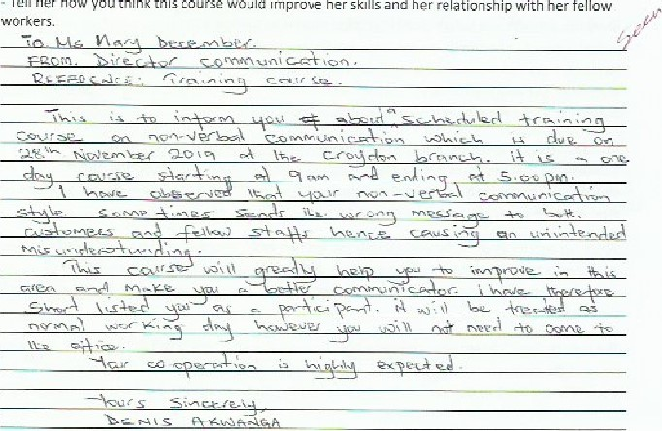- Tell her how you think this course would
prove
her
skills
and

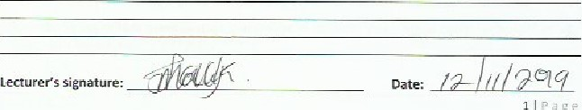

—Tern

BMswa002
In-class exercise 1
Exercise2: COMMUNICATION; A CASE STUDY
As you t their Case, think about how you might help communicate with the employee to remedy the conflict. Answer the tritical thinking questions at the end of the case and, wherever possible, say whose communication model is relevant.

BARRY HIS STAFF
Berry is a 27-year old who is the manager af a restaurant He is responsible for supervising and managing all employees in the kitchen. Employees working range trom IG years to 55 years old. In addition. the employees come from varied cultural and ethnic back:rounds_ For many, English is not their primary laneuage.
Barry has a Health and Safety (Food] end tries his best to keep up with facd safety issues in the kitchen, but he admits it's not easy. Employees receive "on thejabtrainins-•" 2bautfood safety basics (for erample, appropriate hygiene and handwashing, time,/temperature, end cleaning and sanitizi ngl_ But with hiEh turnover of employees, train is often hurried, and some new emplgvees are put rient into the job without traininz if it is z Busy eey_
One day Barry averslept because he had Seen workin= cn his & runtil 2 a.m. He was rushing around and realized th3t he didn't h•ve uniform, However, he managed to tind one that was not very dirty- As he dressed, he realized that he needed a haircut anu a good hand scrubbing, especially gfterworking on his car.
When he erriued et work, he dashed into the kitchen snd noticed several trays of uncooked moat on the work toos_ They appeared to have been sitting at room temperature aver n ight. He called one ofthe kitchen staff and asked: 'Why did you leave the chicken out when I told •you to put them in the fridge?
The men re.lied; 'l heard you screaming but I thouxh: were trying to talk to the chef öbove the noise of the food miner he using. didn't know you were talking to me". garry is frustrated and doesn't know what ta He like he was beating his head against a brick wall in trying to get his employees to precise food safety.
He has made many efforts to get them to learn how to handle food safely. He hes put large signs
All over the kitchen: KEEP HOT FOOD HOT ANC COLD and WASH YOUR HANDS OFTEN,
Questions:

What the communication challenges and obstacles that Barry faces ?
- Which carnmunication models can you use to explain Barry's problems?
- What solutions lmight Barry consider in addressing each of these challenges or
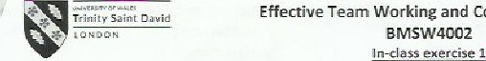 — Term 1
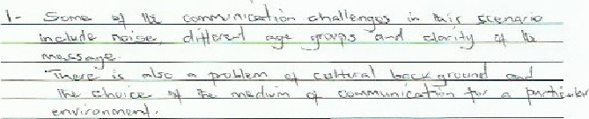
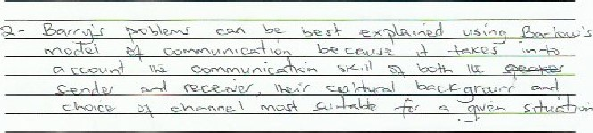
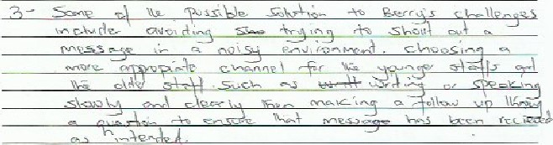

Lecturer's comments:


— Term
BMSW400Z
In-class exercise 1




Lecturers comments:

APPENDIX 2: In-class Exe 2


Effective Team Working and Communication — Term 1
BMSW4002
In—class exercise
Student Name:Stu dent15 allocated; 1 hour. ple•se return your poverto the jecturer upon completion. It be rerumeø to you at the next session need to include o setnneff copy of this exercise in the form appendjx together with your Task 1 (port nesignrnent for this module).
Read the cases and answer the questions that follow
CASE 1: Mary was working on some paperwork when her daughter came into the room upset. Asthe child told Mary What was wrong and how she felt, Mary kept tyging on her keyboard and said, "tt'll be OK," and IEve0'thing will he all riEht_' She was confused when the child only continued to become more and rtore trustræted_ Just then, Vary's phone rang and she was all excited when she her friend"' They spoke for fifteen minutes and when the call ended, she turned and said to her daughter, 'Oh, darling, that was Susan. I'm so excited seeing her tomorrow!'. The child broke down and cried.
1. Why weren't Marv's calming words having any effect on her daughter?
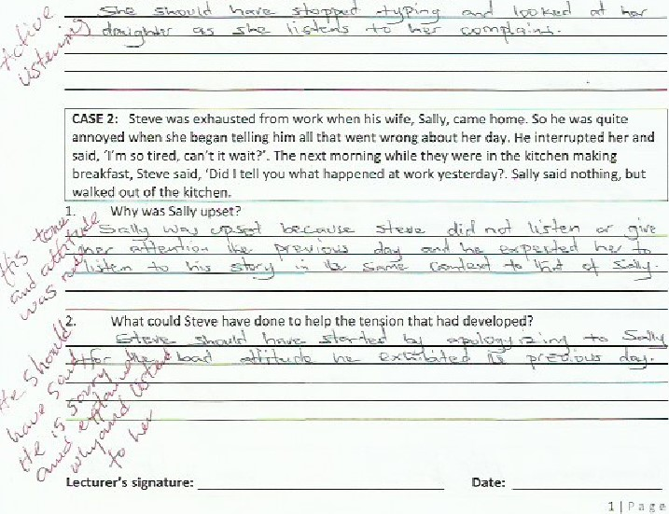

Effective Team Working and Communication —Term 1
BMSW4002
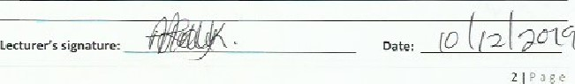
In-class 2xerzise 2
Exercise'; Writing an e-mail.
You are a teacher cf Com munfcation and have received this e-mail from ane of your students:
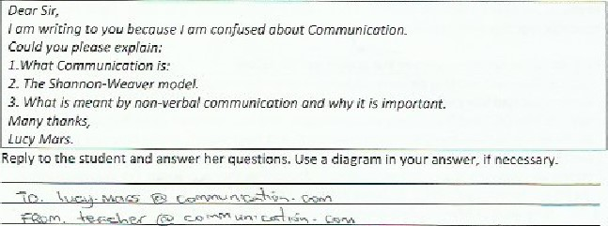
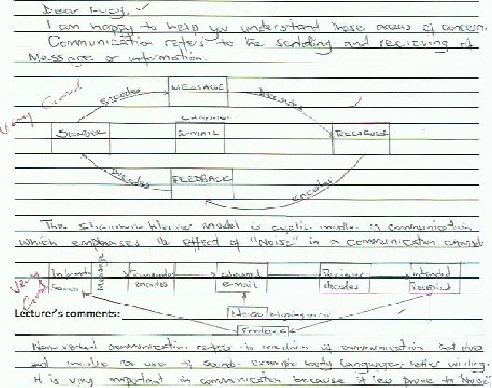

. What could she have Sone to make the situation Better? exhausted from work whan his wifer Salty, came home. So he was quite hegan telling him all that went wrang her day, He interrupted her wait?. The next mornins while they were in the kitchen making Oid I tell you what happened at work yestcrday?. Sally said nothing,

