TASK 1
1.Information Technology Infrastructure Library (ITIL)
ITIL, the full name of Information Technology Infrastructure Library, originated in the 1980s
At the end of the decade, it was hosted by Britain's National Computer and Telecommunications Authority (CCTA)An item entitled "Government Information Technology Infrastructure Management Methodology" The objective of the project is to develop a standardized,A financially measurable use of IT resources. This method should be It is vendor-independent and can be applied to different sizes and technologies And the organization of business requirements. Its core philosophy is "focus on business needs Standard is oriented by process control and means by service management ". A lot of Successful practice shows that implementing ITIL can improve the IT department by 25% to 30% Operational efficiency.
ITIL is an open domain, an application of management science to IT, and a process-based approach. IT defines an IT quality of service standard for customers to request services and for providers to meet them. The purpose of ITIL is to provide best practice guidelines for IT service management, integrating business services with IT; ITIL creates a management framework that manages four aspects: people (division of responsibilities Position, etc.), flow path (design related flow path), product (or technology, process needs technical support) and partner (or supplier relationship); ITIL also improves efficiency and cost-effectiveness, reduces process risk, and simplifies the quality management of IT services. ITIL has two distinctive features: customer orientation and holistic process management. Because ITIL theory covers a large area of knowledge, it is difficult to fully implement in a short time in the enterprise. Therefore, enterprises should choose implementation priorities according to the actual situation and gradually improve the process.
The core module of ITIL is "service management", which includes a total of 10 processes and a function. These processes and functions are summed up into two major process groups, namely "service provision" process group and "service support" process group. The service support process group summarizes a management function related to IT management and five operational level processes, namely incident management, problem management, configuration management, change management and release management. The service delivery process group summarizes five tactical processes related to IT management, namely, service level management, IT service financial management, capability management, IT service continuity management and availability management.For example:
- Service desk: the service desk is a single point of contact between the IT department and it service users.
- Accident management: accident management is responsible for recording, classifying and arranging experts to deal with accidents and supervising the whole treatment process until the accident is resolved and terminated.
- Problem management: problem management refers to investigating and analyzing the weak links of IT infrastructure and identifying the causes of accidents the potential causes of the accident, and formulate plans to solve the accident and measures to prevent the recurrence of the accident service management processes that minimize the negative impact on the business.
- Configuration management: configuration management is to identify and confirm the configuration items of the system, record and report the status and changes of configuration items the process of checking the correctness and integrity of configuration items.
- Change management: change management is to complete any aspect of the infrastructure or service within the shortest interruption time service management process to control the change.
- Publishing management: publishing management refers to the management of newly added or modified configuration items imported into the actual application after testing management process of distribution and publicity.service level management: service level management is the planning, drafting, and implementation of service level agreements (SLAs) negotiation, monitoring and reporting, and evaluation of service performance after signing service level agreements a service management process.
- IT service financial management: it service financial management is responsible for budgeting and accounting. IT service providers provide IT services the management flow of the required cost and charging customers the corresponding service fee.
- IT service financial management: it service financial management is responsible for budgeting and accounting. IT service providers provide IT services the management flow of the required cost and charging customers the corresponding service fee.
- Capability management: capability management refers to the allocation of reasonable service capabilities under the dual constraints of cost and business requirements service management process to maximize the efficiency of the organization's IT resources.
- Availability management: availability management is to optimize and design by analyzing the availability requirements of users and business parties availability of IT infrastructure to ensure a management flow that meets growing availability requirements at a reasonable cost.

2.Committee of Sponsoring Organization(COSO)
Some companies and corporate managers have established a series of processes for identifying and managing risk within their organizations, and many have already started or are currently doing so consider establishing your own processes for identifying and managing risks. Although managers already have a lot of information on enterprise risk management (including a lot of publicly published information literature), but there is no uniform terminology in practice, and there are few generally accepted principles for managers to construct an effective risk management framework as a guide.
The COSO Committee has recognized the need for conceptual guidance on enterprise risk management and has initiated an initiative to establish a conceptual, appropriate a program of risk management frameworks designed to support projects that establish or evaluate enterprise risk management processes provides complete principles, usable terminology, and practical guidelines. In the south. A related goal is to build a framework for managers, directors, executives, academics, and other stakeholders to better understand the ethos of the enterprise risk management and its advantages and limitations provide a unified basis for effective communication on risk management issues.
COSO risk management framework divides the elements of risk management into eight: internal environment, goal setting event identification, risk assessment, risk response, control activities, information and communication, supervision.For example:
- Internal environment:The internal environment of an enterprise is the basis of all other risk management elements and provides rules for other elements and structure.
- Goal setting: According to the tasks or expectations determined by the enterprise, the manager determines the strategic objectives of the enterprise and selects the strategic party case, determine relevant sub objectives, decompose and implement them at all levels within the enterprise, and all sub objectives shall follow the enterprise and link with the strategic plan.
- Event identification: Managers are aware of the existence of uncertainty, that is, managers cannot know exactly what a matter is No, when, or if so, what is the result.
- Risk assessment:Risk assessment can enable enterprises to understand how potential matters affect the realization of enterprise objectives. The risk is assessed from two aspects - the possibility and impact of the risk.
- Risk response: Managers can formulate different risk response schemes and implement them under the principles of risk tolerance and cost-effectiveness on the premise, consider how each scheme affects the possibility of occurrence and the impact of the event on the enterprise, and design and implement risk response plan.
- Control activities: Control activities are relevant policies and procedures to help ensure the correct implementation of risk response plan. Control system activities exist in all parts, levels and departments of the enterprise.
- Information and communication: Relevant information from inside and outside the enterprise must be in a certain format and time interval identify, capture and deliver to ensure that employees of the enterprise can perform their respective responsibilities.
- Monitor: Monitoring enterprise risk management refers to evaluating the content and operation of risk management elements and a period of time a process of execution quality in the period.

3.ISO27000
This International Standard has been prepared to provide a model for establishing, implementing, operating, monitoring, reviewing, maintaining and improving an Information Security Management System (ISMS). The adoption of an ISMS should be a strategic decision for an organization. The design and implementation of an organization’s ISMS is influenced by their needs and objectives, security requirements, the processes employed and the size and structure of the organization. These and their supporting systems are expected to change over time. It is expected that an ISMS implementation will be scaled in accordance with the needs of the organization, e.g. a simple situation requires a simple ISMS solution. This International Standard can be used in order to assess conformance by interested internal and external parties.
This International Standard adopts a process approach for establishing, implementing, operating, monitoring, reviewing, maintaining and improving an organization's ISMS. An organization needs to identify and manage many activities in order to function effectively. Any activity using resources and managed in order to enable the transformation of inputs into outputs can be considered to be a process. Often the output from one process directly forms the input to the next process. The application of a system of processes within an organization, together with the identification and interactions of these processes, and their management, can be referred to as a “process approach”. The process approach for information security management presented in this International Standard encourages its users to emphasize the importance of:
a) understanding an organization’s information security requirements and the need to establish policy and objectives for information security;
b) implementing and operating controls to manage an organization's information security risks in the context of the organization’s overall business risks;
c) monitoring and reviewing the performance and effectiveness of the ISMS;
d) continual improvement based on objective measurement.
This International Standard adopts the "Plan-Do-Check-Act" (PDCA) model, which is applied to structure all ISMS processes.This International Standard covers all types of organizations (e.g. commercial enterprises, government agencies, non-profit organizations). This International Standard specifies the requirements for establishing, implementing, operating, monitoring, reviewing, maintaining and improving a documented ISMS within the context of the organization’s overall business risks. It specifies requirements for the implementation of security controls customized to the needs of individual organizations or parts thereof. The ISMS is designed to ensure the selection of adequate and proportionate security controls that protect information assets and give confidence to interested parties.
The requirements set out in this International Standard are generic and are intended to be applicable to all organizations, regardless of type, size and nature.
Any exclusion of controls found to be necessary to satisfy the risk acceptance criteria needs to be justified and evidence needs to be provided that the associated risks have been accepted by accountable persons. Where any controls are excluded, claims of conformity to this International Standard are not acceptable unless such exclusions do not affect the organization’s ability, and/or responsibility, to provide information security that meets the security requirements determined by risk assessment and applicable legal or regulatory requirements.
SO has reserved ISO / IEC 27000 series numbers for information security management system standards, similar to ISO9000 series of quality management system and ISO14000 series of environmental management system standards.The planned ISO27000 series includes the following standards:
- ISO 27000 principles and vocabulary.
- ISO 27001 Information Security Management System - isms requirements (based on BS 7799-2).
- ISO 27002 information technology - Security Technology - Code of practice for information security management (ISO / IEC 17799:2005).
- ISO 27003 information security management systems - implementation guidelines.
- ISO 27004 information security management system - indicators and measurement isms metrics and measurement.
- ISO 27005 information security management system - isms risk management.
- ISO 27006 information security management system - accreditation requirements for the accreditation of bodies providing certification.
- ISO 27007 information technology - Security Technology - Guidelines for auditors of information security management systems.

SUMMARY
The above three Information Security frameworks or models have their own advantages and have high reference and use value in their respective fields; At the same time, the coverage is not fine enough, which needs further refinement and standardization.

TASK2
Based on the case of CoffeeBlue ------a composite governance model of data security is proposed
Abstract：CoffeeBlue company is a global multinational enterprise with a large number of branches. The company has a large number of customers and partners, resulting in a large number of continuous data streams all the time. Therefore, the protection of data and privacy is particularly important. Aiming at the case of the company, this paper explores a new composite data management model framework.This management model designs a set of practical management scheme from three aspects: data security strategy, data security operation management, data security governance technology. This aspect emphasizes that starting from the top-level design, all staff participate, data exchange and different access rights. Technology is the basis of this management mode. In order to achieve the purpose of data protection, a scientific and technological capability combining product capability, data capability and computing capability is conceived,So as to ensure the safe and stable operation of data and the interests of the company and relevant persons are not infringed.
0.introduction
As a successful multinational company, coffee blue has countless branches all over the world to sell their products and provide services to customers. It is precisely because of the company's huge business volume that the company has a large amount of data transmission all the time, so data security is particularly important.
Specifically, the data storage of coffee blue company almost completely depends on cloud servers, and allows global employees and customers to access the company's database and resource library from their own terminals. In such a huge and complex information flow, it is necessary to not only ensure that the business is not affected, but also protect the personal information of customers and employees from disclosure, And the company's confidential data and intellectual property rights are perfectly protected.
In view of the above situation, this paper designs a composite, top-down data security protection and management model.The model consists of four aspects: data security strategy, data security operation management, data security governance technology and system evaluation. Each part is indispensable. The details and structure of the four aspects are introduced in turn below.

Figure 1 design idea and framework
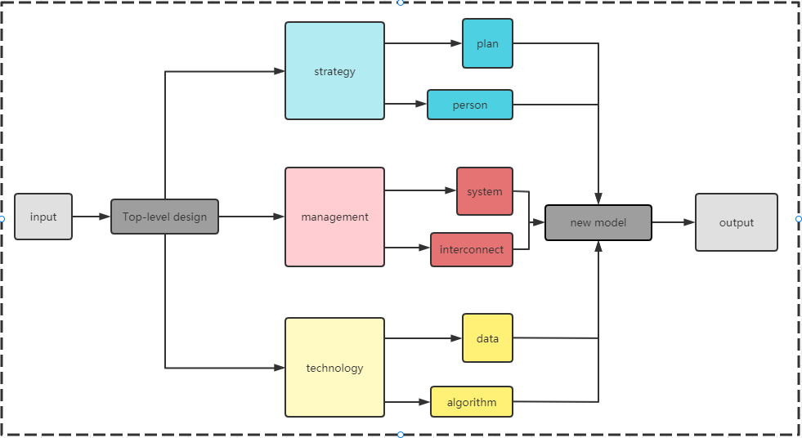
1. Data security strategy
1.1 Data security planning and objectives
First of all, it is necessary to formulate data security policies at the organizational level, improve the top-level design, and form a consistent consensus on the organizational level of the importance of data security. In the security policy, the overall objectives and principles of data security should be clarified, and the senior attention and support for data security should be strengthened. It is suggested to set up special data security decision-making institutions at the organizational level. In addition, the first responsible person mechanism for data security can be established in the security policy, to clarify the obligations of business, applications and data owners and employees as the first security responsible person for the managed data.
Figure 2 data security strategy
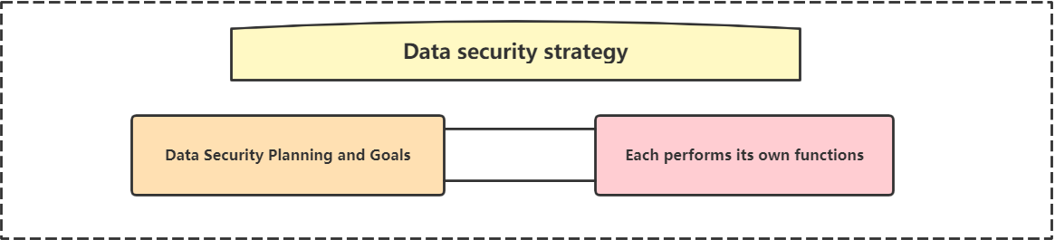
In the case of CoffeeBlue, both openness and privacy of data need to be taken into account. In the presence of the company, information protection mode must be under the condition of ensure the flow of data to ensure that the database security and personal visitor information is leaked, at the same time also has a stable and fast data transfer function, vulnerability of the system can also make a feedback and put on record, in short, data upload download and store does not produce confusion leads to loss of data.

1.2 Full participation
In terms of organizational structure, it is necessary to establish a top-down data security governance organizational structure covering all staff, and to clarify the structure hierarchy, responsibility division and personnel division to ensure clear data security responsibilities. The organization can establish a data security governance structure including the decision-making level, management, executive level and supervision levels from top to bottom, and rely on the data security interface mechanism to strengthen the communication, coordination and work coordination at all levels. In addition, all the personnel of the organization should be regarded as the executors of the data security responsibility, and should actively participate in the data security mental education, enhance the awareness of the data security, and fulfill the data security obligations.
2. Data security operation management
2.1 Construction of safety management mechanism
In terms of system norms, the organization should fully analyze the compliance requirements such as laws and regulations based on the current situation and needs of data security, and formulate the corresponding system and standard system according to the overall goal of data security governance, so as to realize the clear safety requirements and the safety governance has rules to follow.
Figure 3 data management operation framework
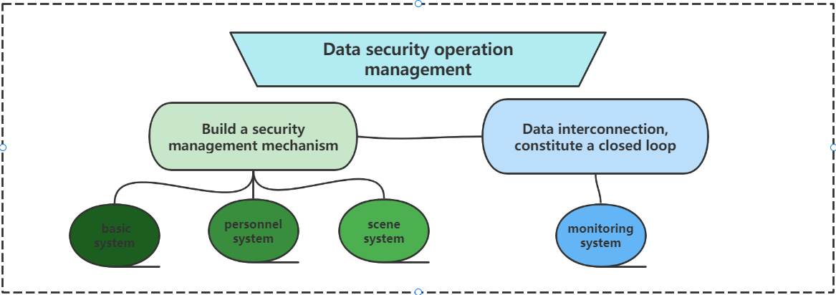
Figure 4 composition of data security management system
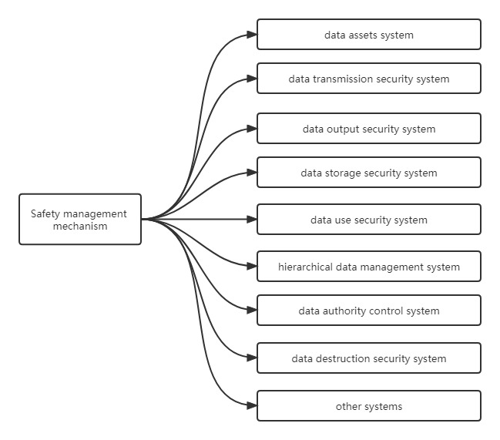
Information security management mechanism should include basic system, personnel system and scene system. Basic systems refer to specific data management systems, including data assets system, data transmission security system, data output security system, data storage security system, data use security system, hierarchical data management system, data authority control system and data destruction security system and other systems. The establishment of personnel system aims to reduce man-made data security problems, including employee data security management system and partner data security management system. The scene system is more macroscopic, mainly including Cloud data security management system and database security management system.

2.2 Data interconnection to form a closed loop
With so many systems created, in order to make the entire system run stably and smoothly, it is necessary to connect the systems and information packages represented by the various systems in series. You can try to set up a monitoring system for data flow, which can monitor and report data errors, abnormalities and loss at any time. At the same time, the system limits user rights so that specific people can access specific information. Not only can it prevent accidental data leakage, but it can also make data management easier and more efficient.
2.1 Data security management technology
Figure 4 technical framework and composition of data governance
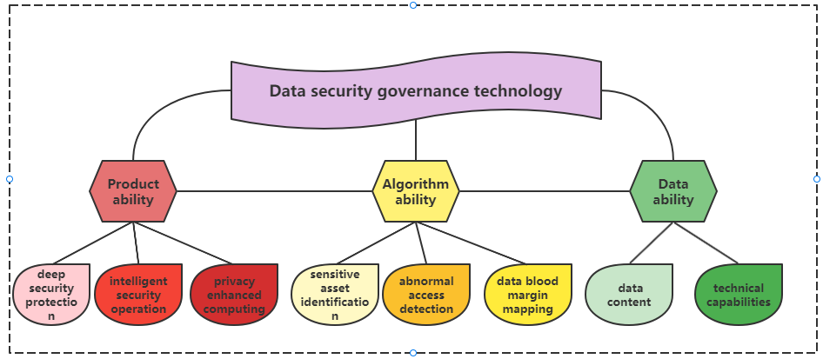

3.1 Product capability
Product capability is based on the underlying algorithm capabilities and data capabilities, focusing on deep security protection, intelligent security operation, privacy enhanced computing and other fields, to build a systematic and intelligent security technology capability.
In-depth security protection provides dynamic security monitoring and in-depth protection for data. It mainly includes two aspects: access control and data reinforcement. Access control is the most basic, most important and effective means of data security protection, usually including account management, account information authentication and account access and other functions. Data reinforcement is to take security reinforcement measures to the data itself, including data encryption, digital watermarking, data desensitization and other technologies.
Intelligent security operation, through the construction of efficient and intelligent operation technology capabilities, transforms the knowledge of risk identification and monitoring accumulated manually into rules and strategies that the system can execute, such as simple identification rules, complex rules based on behavior accumulation and algorithm models.
rivacy-enhanced computing technology is mainly aimed at scenarios such as data exchange and sharing. This technology combines multi-party secure computing and confidential computing to perform differential privacy processing on the data set, and perform fusion computing tasks on the processed private data set, which can further enhance the privacy protection effect.

3.2 Algorithmic capability
Algorithmic capability is mainly aimed at key issues such as sensitive asset identification, abnormal access detection, and data blood margin mapping. A reusable basic algorithm capability system can be built at the lower level, and customized algorithm capabilities for specific business needs should be provided at the upper level. The reusable algorithm basic ability system can be constructed from the five dimensions of retrieval ability, expansion ability, index ability, recognition ability and induction ability.

3.3 Data capability
Data capability is composed of data content and technical capabilities. Through the construction of a systematic security data market, it provides data capability support for data security governance.
According to the different description objects, the data content can be divided into two categories: physical data and behavioral data, which can describe the business entities and circulation records in the process of data circulation respectively.
Physical data in CoffeeBlue company mainly refers to all kinds of data assets, such as operating system in data flow, information flow channel, network interface, company account, operation authority and terminal, etc.
Behavioral data mainly depends on all kinds of behavior logs of data flow, and records the data flow behavior, usually including system log, network traffic log, personnel operation log, call link log, etc.

4.Summary and evaluation
Due to the huge volume of coffee blue company, the demand for all aspects of data is also increasing. For the head office and important databases, the primary consideration of data security is that the company's secrets, including financial reports, intellectual property rights, personnel information and ownership structure, will not be leaked. Therefore, starting from the top-level design, we have formulated corresponding protection strategies and built a set of composite defense system of access authority - data transmission - data acceptance - data monitoring to ensure the company's information security.
From the front-line stores and factories, what is more important is the customer experience and the fluency and convenience of data transmission. Since the company mainly relies on the cloud system for data upload and download, in the face of a large number of customers around the world, there is no need to consider the size of traffic. The main consideration is the rapid and safe transmission of data, Therefore, the system has also set up a more user-friendly customer and partner system.
For this system, first of all, it is necessary to make the login system fast and convenient. Combined with the existing technology, it can log in by using the combination of mobile phone verification code and face recognition, which not only ensures the security, but also reduces the login threshold. Secondly, it is to restrict the customer's permissions, limit the web pages and data they can access, and do a good job in page design to ensure a good experience of data interaction; For partners, more commercial transactions and interactions are involved, and the system setting should be more targeted. While ensuring data security, transfer and information interaction should be faster and official. In a word, a composite information protection system contains not only data protection function, but also convenient and fast interaction.

