MODULE NAME: ACADEMIC AND EMPLOYALBLE SKILLS.
MODULE NAME: (BMSW4001_LON)
LECTURER NAME: ANITA NAN
STUDENT NAME: MARY OLUSEYE
STUDENT ID NUMBER: 1906246

CONTENT
INTRODUCTION
SWOT ANALYSES
ACADEMIC SKILLS
EMPLOYALBLE SKILLS
STRENGTH
WEAKNESS
CONCLUSION
REFFRENCES

INTRODUCTION
The purpose of this study is to analyse the several academic and employable
skills at university and at my workplace. I would be showing the importance of SWOT analysis and how it is being implemented in my career and how it has been useful to me both in academics and work. I will also stretch out the usefulness of personal development plan (PDP), how it helps me to reach my goals and target, how it works on my weakness and strengthens me.
Understanding the creation and use of PDP is a valuable opportunity which offers the right to self-esteem, since personal development planning and goal setting are the pillars of human well-being for both large populations and large territories in the UK. So far, my PDP has been linked to my success (Butchibabu et al., 2016)
Academic skills are the foundation of future education. Both academic and employable skills are pathways to success. The existence of a PDP is not just the perfection of a future job or profession, but it is equally important to individual’s life and progress (Nancarrow et al., 2013). This refers to an objective fact and the creation of a specific, quantitative, reasonable and timely indication (SMART) of how it should be obtained

SWOT ANALYSIS
SWOT expertise helps to distinguish between my different qualities, opportunities, weaknesses and the risk of achieving my goals (Boies, Fiset and Gill, 2015).
Purpose: To ensure the best condition in a big organization and assist to create your own organization in the future.

ACADEMIC SKILLS
Academic skills are acquired via formal education (university or college) level, which helps in developing the research and study skills that will help in future. This form of skills will help in achieving academic success that will help your potential and this form of skills is transferable to future careers. (Staffordshire University, [online]).
This kind of skills result in having a degree or certificate in a specific discipline that gives chances of employment in your chosen carrier.
Currently, I found it necessary to boost my carrier in my field and proceed to have these skills by going to university to add these skills to my portfolio in other to progress in my carrier. Diagram below shows how academic skills work.
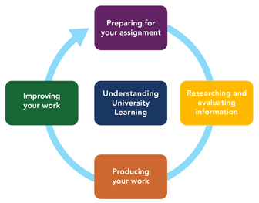

EMPLOYABLE SKILLS
skills in future These skills are acquired through transfer of practical knowledge and ability from one person to another. These skills are needed by person to get an employment, along with good technical understanding of the job, which employers outlined in their job descriptions. ( www.exeter.ac.uk, [online]).
These skills are gained through work experience and training. It also refers to foundational skills and helps to solve problem in work environment and the achievement are always successful. These skills are categorized into three parts, transferable skills, hard skills and soft skills.
As a health care professional of over thirteen years with NHS, I have gained these skills, which will give me the opportunity to gain employment anywhere in health field. The improvement I need is to further gain academic to make me more sellable and secured.
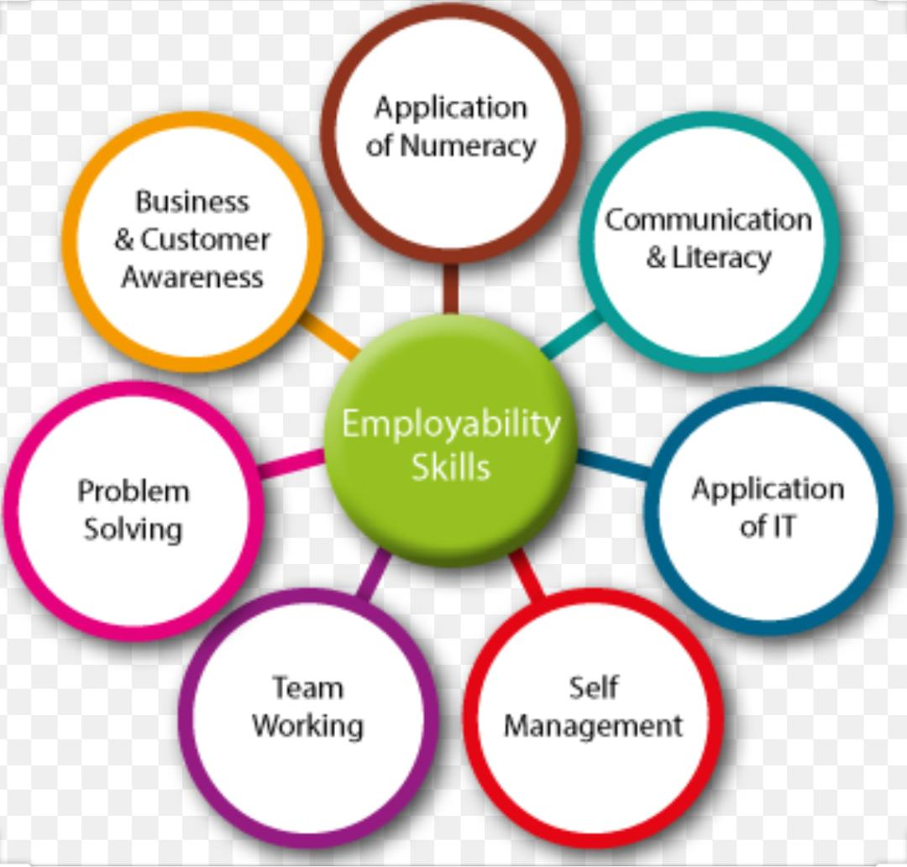

STRENGTH
Communication skills
Communication can be defined as the act of transferring information from a person or place to another via speaking, body language, signs, gestures, written (print or digital, books, magazines, website or email) et al. (skillyouneed, 2020).
This skill is essential in all forms of life, be it academics or employment. It is a must have in my line of work - health section because I work with many people of diverse backgrounds. Also, could communicate verbally, nonverbally, body language etc. as these are forms of getting and passing information to achieve goals, aims and objectives both in academics and in employment. Due to my years of experience on my current job, I am well- grounded in this area.
Problem solving skills.
Problem solving skill is the ability to solve problems in an effective and less time-consuming way, without any complication. (cleverism.com, 2019).
This skill involves identifying and defining the problems. This skill lets you have an insight to a problem and rather than dwelling on the problem you think of possible solutions. It makes the impossible possible, by helping individual or organization overcome challenges. It also makes you stand out and have more confidence, because you are familiar with this skill, you will be a quick problem solver, easily recognized by the organization.
I acquired this skill overtime because I have encountered several challenges at work which I solved before they escalated to irredeemable situations.

CRITICAL THINKING SKILL
The Critical Thinking Center emphasizes: “The main reason is the ability to practice intuition, such as perception of its characteristics and shortcomings and analysis of intuition in an improved structure. Part of the main process involves reflection (Lynch, Lynch and Clemens, 2019).
Skill you need also emphasizes that “critical thinking is the ability to think clearly and rationally, understanding the logical connection between ideals” skillsyouneed, 2020 [online]).
In a health sector, this skill is very paramount as any slightest mistake could put someone at a high risk, could cost the organization its reputation and could lead to litigation. Critical thinking skills enable you to analyse and evaluate situations, to think fast and reasonably for a positive outcome or conclusion in order to avoid risks, problems or costly mistakes.
As a lone worker in the community, this skill has assisted me severally as I needed to make decisions under pressure in a situation between live and death to save lives.
WEAKNESSES
Time management skill is the process of organizing and planning your time within a set program. It lets you work smart and efficiently within a time frame, under pressure. (Mind set,2020, [online]).
According to Britton, good time management is vital, crucial and important in so many ways. It is good for student research. (Britton and Tesser,1991).
Time management at university can help in time framing your work such as assignments, reading time, attending lectures etc. with this, you can create a slot for every educating stuff.
Time management in employment can help in short time frame without being under pressure and making unnecessary mistakes, it helps to manage travel time to work, it reduces time wastage, you priorities activities, map out time for planning and solving problems.
Unfortunately, I lack this skill due to the nature of my job. I work in health sector with NHS as a lone worker, I choose when I see my patients with very less supervision. Because I do not manage or priorities my timing, I end up working behind schedules.
Changes needed in this aspect in order to manage my education, family life and job effectively with less stress and complication.

Teamwork skill is the ability to work with others in order to achieve a collective success in a project, meeting or other goals. (Indeed.com 2020).
This skill is good and essential at university as it will help in group work with peers, it also helps to gain ideas from your lecturer and co students. It helps to know and study your team members, their strength, weakness and behaviors
With nature of my job, teamwork is very paramount as my team work collectively to make the Trust a success. Due to my lack of time management, my contribution towards the team contribution is low. As a result of this weakness, I handover my shift and progress note late which is a big challenge.
If I can work well on my timing this will improve and help me both in academics and employment areas.

DIGITAL SKILL.
Digital skill is all about knowledge acquisition to enhance information necessary for digital technology. This includes use of digital tools to compute and enter digital resources in order to advance a new knowledge and develop a media expression and communication. (Rewind4technology.com, 09.12.2013[online]).
This skill is essential both in academics and employment as the globe has gone digital with the help of technology. Digital skill includes creating and editing, using of devices and handling information, communicating, transactions and being safe and responsible which make work easier and faster. In today’s employments, most employer want employees with digital skills in term of business analysis, marketing, project management and social media. This skill helps in all organizations.
This skill is sensitive and implicative if not well secured. For example, if information leaks to a wrong hand, it can be disastrous for the organization and jeopardize its reputation and fortune.

CONCLUSION
In concluding this study, I hold firmly the conviction that academic skills and employable skills, combined in an individual are essential to an individual’s growth and progress, as well as our collective economic growth and progress, even as a country.
Academic skills are meant to develop us educationally, sharpen our intellect and thinking faculties, develop our ability to view issues from broader perspectives and teach us to have a balanced and objective approach to issues.
On the other hand, employable skills guarantee a near automatic employment in an overcrowded labor market. Employable skills afford one an edge over others and give an assurance of good service delivery to the employer.
Finally, the ability to combine academic skills with employable skills is of great advantage and benefit to both the employer and the employee.
It also guarantees a rapid development for the nation's economic growth in management, production and manufacturing sectors.
Academic skills and employable skills are the keys to future economic growth of any country.
Personally, the course has given me an in-depth knowledge on academic and employable skills and deep understanding of SWOT.
It avails me the opportunity to reflect on and identify my strength and weaknesses with a view to bettering my best and improving on my weaknesses.
This course has highlighted my potentials and things I took for granted - meeting new people and gaining knowledge from lecturers and students at the university

REFFRENCES
Britton, B K. and Tesser, A (effective of time management practices of college grades; Journal of Educational psychology, 83, 405-10.

Butchibabu, A. et al. (2016) ‘Implicit Coordination Strategies for Effective Team Communication’, Human Factors. doi: 10.1177/0018720816639712.
Lynch, D. S., Lynch, M. J. and Clemens, C. M. (2019) ‘Belbin Team Roles’, in The Handbook of Communication Training. doi: 10.4324/9781315185859-28.
Nancarrow, S. A. et al. (2013) ‘Ten principles of good interdisciplinary teamwork’, Human Resources for Health. doi: 10.1186/1478-4491-11-19.
Available at : www.straffordshireuniversity.ac.uk (academic skills) [Accessed on 29.04.20].
Available at : www.skillsyouneed.com( interpersonal skill and communication skills)[ Accessed on 27.04.20].
Available at :https:// www.mindtools.com (Communication definition) [Accessed on 26.04.20].
Available at : https://www.indeed.com (Teamwork skills definition) [Accessed on 27.04.20].
Available at : https://www.staffs.ac.uk/support_depts/library/academicskills/. [Accessed on 29.04.20].
Available at : https://www.exeter.ac.uk/employabilityskills.[ Accessed on
01.05.20].
Available at :https://www.skillsyouneed.com (critical thinking skills).[ Accessed on 02.05.20].
Available at : https://www.rewired4technology.com (definition of digital skills). [Accessed on 03.05.20].
Available at : https://images.app.goo.gl/NRAR2RFxKZxNWrpj8 (skills for employment). [Accessed on 03.05.20].

