

LCBB4010
GLOBAL BUSINESS ENVIRONMENT

Student Name: Gabriel Chirosca
Student ID: 2244324
Module Tutor: Rita Ukachi-Lois Zainab Atta
Submission Date: 23/08/2024
Word Count: 1500 words

Table of Contents
Introduction 2
PESTLE analysis 2
Portes 5 Force analysis 7
Shareholders analysis 8
Conclusion 8
References 9

Introduction
PESTLE analysis is known as a business strategy that aims at analysing the corresponding conditions and factors affecting the business environment. It includes Political, Economic, Social, Technological, Legal, and Environmental factors where each of these factors impacts various operations and strategies of a firm. Awareness of such factors is important to ensure that changes are expected, risks are mitigated, and opportunities exploited. However, the essay will analyse the PESTLE factors in relation to the retail industry. The essay will further provide shareholders analysis and Porters five force analysis to better understand the retail industry.

PESTLE analysis
Political Factors
Political factors that affect the UK retail industry include government policies, trade agreements and political stability. Brexit has been a significant change that shifted some of the regulations scrapping the preferential status of the UK in relation to the European Union creating new barriers to trade. Customs checks and tariffs have been a major factor in the rising cost of imported goods that impact product pricing strategies and the supply chain systems. Also, a new tax policy, the Digital Services Tax launched in 2020, draws the government’s attention to large e-commerce platforms like Amazon and eBay and influences their cost structure (Upadhyay, Kumar, and Akter, 2021). The measures taken by the UK government in the form of grants and loans given to SMI’s during the COVID-19 pandemic have also influence the retail sector as such funds are a source of financial help for suffering almost all the businesses.

Economic Factors:
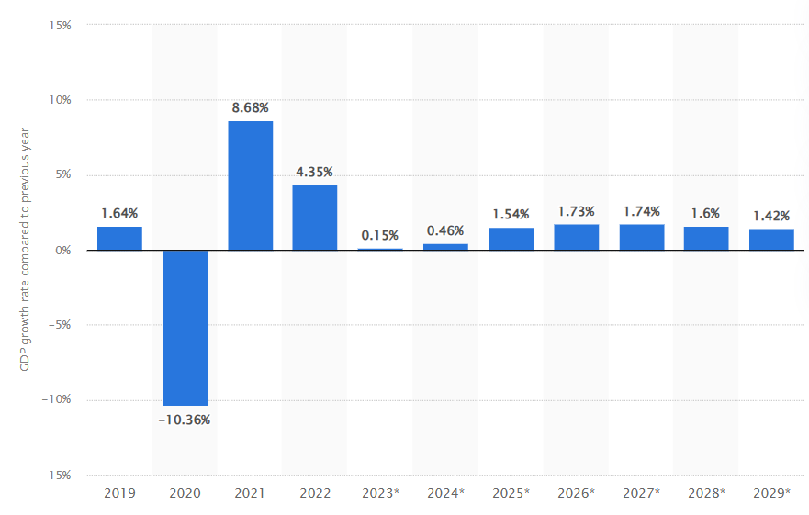
Figure 1: GDP growth rate in UK
(Source: Statista, 2024)
Various economies greatly affect the retailers within the United Kingdom. The UK economy has proved rather stable with the growth of its GDP at 4.8% in 2021 having contracted in 2020 due to Covid-19 pandemic. Nevertheless, inflation rates, which stood at 9.4% in June 2022, have constrained the consumer income available for expenditure thus altering their expenditure pattern. The contraction in individuals’ purchasing power due to increased costs including energy costs and poor wage growth have made consumers sensitive with prices, thus affecting retailers’ pricing strategies and their profit (Arefin et al., 2024) This has also seen the retail sector increase both the cost of and availability of labour due to the Brexit immigration change and the pandemic. Nevertheless, the sector is one of the key employers in Britain and, as of 2023, there are over “2. 9 million” people employed in the retail industry.

Social Factors:
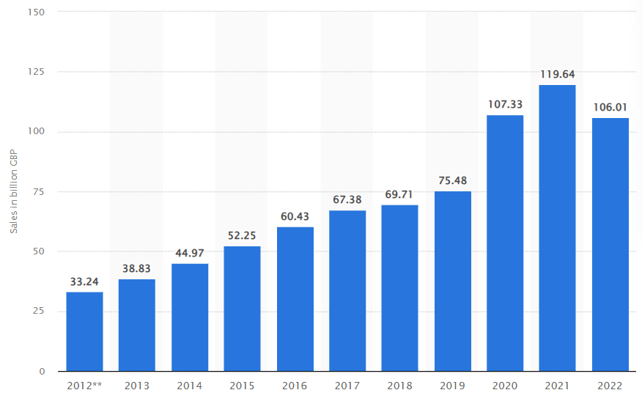
Figure 2: Online retail sales
(Source: Online Retail Sales, 2024)
Social factors and consumer behaviour are critical determinants of retailing developments. The Covid-19 pandemic boosted the growth of online shopping, in 2021, online sales comprised of 30.20% of total retail sale as against 19.20% of total retail sale in 2019 (Youssef, Eid, and Agag, 2022). This has pushed most traditional stores to step up their online capabilities and go omnichannel. Moreover, the consumer consciousness of sustainability and the use of the ethical method is a rapidly evolving factor. A survey carried out by Deloitte in the United Kingdom in 2022 further showed that 43% of the consumers will only purchase products from brands that are sustainability devoted. Such a trend has seen retailers implementing strategies that are environmentally friendly, for instance, the use of minimal plastics, the purchase of sustainable merchandise, and carbon-neutral delivery (Har et al., 2022). The latter also impacts product range and promotion whereby the aging population as well as cultural diversities affects the targeting of consumers
Technological Factors:
Sustaining of advances in technology is altering the retailing systems to improve on efficiency and customer satisfaction. AI and machine learning are now commonly used for smart marketing, inventory, and customer service points. Marketing and inventory managers are using big data to measure customers’ buying habits and forecast the trends to make smarter marketing strategies and stock orders (Law et al., 2020). The use of Internet of Things (IoT) devices in the supply chain and smart stores is also enhancing operations’ productivity and eliminating expenses (Nyame-Asiamah and Ghulam, 2020).
Legal Factors:
The retail industry in the UK is saddled with the following legalities of the law such as consumer rights, data protection and employment laws. The Consumer Rights Act 2015 entails adequate consumer protection since products must be of reasonable quality, meet the intended use, and must meet the description. The GDPR act that began in 2018 has placed high standards of the retail company on the policy to collect store and use personal data and there are repercussions in case of a violation of this policy (Dolega et al., 2021). Others are the requirements of laws such as the National Minimum Wage, and National Living Wage that are decisive in calculating the controllable labour cost. Further, health and safety act, especially after the onset of the COVID-19 pandemic, orders requirements into the retail environment in order to protect employees as well as the consumers which affects operations and expenses.
Environmental Factors:
The issue of the environment is becoming relevant in the retail sector due to consumer awareness and expectations and due to the rules and requirements of the state. The applicable retail operations in the United Kingdom have been pushed towards decreasing the involvement of their activities on the climate because of the government’s efforts towards achieving net zero carbon emissions by mid-century (Alam et al., 2021). Currently, there are noted tendencies towards sustainable practice implementation in the field of minimization of waste, the use of renewable energy, as well as recycling, that have been prescribed to retailers. The plastic packaging tax, effective since April 2022, is a charge on plastic packaging that does not contain at least 30% recycled content to encourage retailers to find other materials (Yoo and Kim, 2021).

Portes 5 Force analysis
Force | Description | Impact
Threat of New Entrants | The competitive threat in the retail sector is moderate due to low barriers to entry. Despite capital requirements and brand recognition being important factors, e-commerce alleviates these barriers. In addition, newcomers can hardly attain scale economies, and this makes them struggle to compete with the existing firms (Rouyendegh, Yildizbasi and Yilmaz, 2020). | Moderate
Bargaining Power of Suppliers | The relational power of suppliers also differs. This is the case because the large retail stores are able to negotiate heavily with the suppliers based on the sheer volume of business that goes through them. However, industry forces may differ in that niche and specialty retailers may have a higher supplier power index since they have fewer choices of suppliers (Ying et al., 2021). | Moderate to Low
Bargaining Power of Buyers | Bargaining power of buyers is high because the buyer has many options available, and information is easily accessible. The existing innovation in the kind of enable tools such as price comparison and aid in e-commerce has enhanced the buyers’ bargaining power towards the retailers (Savio, 2021). | High
Threat of Substitutes | The threat of substitutes is high because there is always a possibility that the consumers move to other goods or services. This threat is facilitated by the increasing cases of e-commerce and new styles of outlets (Kumar, Singh and Modgil, 2023). | High
Industry Rivalry | The current competition in the retail sector is cutthroat because of many players, price slash and ever-changing technological advancement. Information availability furthers rivalry due to the competition ranging from traditional retailers to those operating in cyberspace (Nikolaos et al., 2020). | High
Table 1: Portes 5 Force analysis
(Source: Learner)

Shareholders analysis
In the retail industry shareholders have a very important role, and these roles and influence depends on some factors. Shareholders financiers are usually institutional financiers and private investors and at times employee financiers. It involves matters of revenue, returns, and sustainability of the concentrations selected. Large investors, for instance, mutual and pension funds, makes their investment decisions based on the company’s profits, return on equity ratios and market share (Zhan et al., 2021). They demand steady returns in terms of ﬁnance and have a say in business policies through proxy votes and interactions with the managerial team. They are less concerned by fluctuations in stock prices as well as the short-term returns such as dividends.
They are market related or company performance indicators, which are determinants of investment worth of such structures. It is also essential to shareholders to focus on various trends that may affect the performance of a specific company, including the shift towards e-commerce, the global emphasis on green practices, and the latest tendencies in buyers’ attitudes (Lu, Kuo and Tran, 2023). Retailers are often faced with shareholder demands that must be achieved alongside the operational challenges involving competitors’ influence and legal criteria. Buyer–seller communication and awareness of the information they exchange are critical success factors, especially in terms of enhancing the shareholders’ confidence and interests in the company’s strategies. Therefore, this means that the analysis provided herein on shareholders in the retail sector combines both this monetary examination and the understanding of the general conditions of the industry.

Conclusion
Therefore, the analysis of the retail industry highlights a sector characterised by dynamic challenges and opportunities. These include political, economic, social, technological, legal and environmental factors crucial in the current and future performance of industries and their strategic directions. Using the theoretical framework of industrial organization, Porter’s Five Forces breakdown intensively competition and transferring buying power; shareholder viewpoint concentrates on overall financial performance and strategy fit. Innovative, sustainable strategies shared among key stakeholders can help retailers overcome these challenges and continue to grow and remain competitive in a changing market environment.

References
Alam, S.S., Susmit, S., Lin, C.Y., Masukujjaman, M. and Ho, Y.H., (2021). Factors affecting augmented reality adoption in the retail industry. Journal of Open Innovation: Technology, Market, and Complexity, 7(2), p.142.
Arefin, S., Parvez, R., Ahmed, T., Ahsan, M., Sumaiya, F., Jahin, F. and Hasan, M., (2024), May. Retail Industry Analytics: Unraveling Consumer Behavior through RFM Segmentation and Machine Learning. In (2024) IEEE International Conference on Electro Information Technology (eIT) (pp. 545-551). IEEE.
Dolega, L., Reynolds, J., Singleton, A. and Pavlis, M., (2021). Beyond retail: New ways of classifying UK shopping and consumption spaces. Environment and Planning B: Urban Analytics and City Science, 48(1), pp.132-150.
Har, L.L., Rashid, U.K., Te Chuan, L., Sen, S.C. and Xia, L.Y., (2022). Revolution of retail industry: from perspective of retail 1.0 to 4.0. Procedia Computer Science, 200, pp.1615-1625.
Kumar, A., Singh, R.K. and Modgil, S., (2023). Influence of data-driven supply chain quality management on organizational performance: evidence from retail industry. The TQM Journal, 35(1), pp.24-50.
Law, C., Cornelsen, L., Adams, J., Penney, T., Rutter, H., White, M. and Smith, R., (2020). An analysis of the stock market reaction to the announcements of the UK Soft Drinks Industry Levy. Economics & Human Biology, 38, p.100834.
Lu, W.M., Kuo, K.C. and Tran, T.H., (2023). Impacts of positive and negative corporate social responsibility on multinational enterprises in the global retail industry: DEA game cross-efficiency approach. Journal of the Operational Research Society, 74(4), pp.1063-1078.
Nikolaos, Z., Christos, K., George, T. and Efstratios, L., (2020). Financial analysis of major retail chains within a turbulent economic environment. Studies in Business and Economics, 15(3), pp.208-222.
Nyame-Asiamah, F. and Ghulam, S., (2020). The relationship between CSR activity and sales growth in the UK retailing sector. Social Responsibility Journal, 16(3), pp.387-401.
Online Retail Sales (2024) UK Online retail sales 2012-2022 | Statista. https://www.statista.com/statistics/315506/online-retail-sales-in-the-united-kingdom/ (Accessed: August 4, 2024).
Rouyendegh, B.D., Yildizbasi, A. and Yilmaz, I., (2020). Evaluation of retail ındustry performance ability through ıntegrated ıntuitionistic fuzzy TOPSIS and data envelopment analysis approach. Soft Computing, 24(16), pp.12255-12266.
Savio, R., (2021). Organizational behaviour and firm performance. A study of Italian retail industry. Risk Governance & Control: Financial Markets & Institutions, 11(1), pp.49-60.
Statista (2024) Gross domestic product (GDP) growth rate in the United Kingdom 2029. https://www.statista.com/statistics/263613/gross-domestic-product-gdp-growth-rate-in-the-united-kingdom/ (Accessed: August 4, 2024).
Upadhyay, A., Kumar, A. and Akter, S., (2021). An analysis of UK retailers’ initiatives towards circular economy transition and policy-driven directions. Clean Technologies and Environmental Policy, pp.1-9.
Ying, S., Sindakis, S., Aggarwal, S., Chen, C. and Su, J., (2021). Managing big data in the retail industry of Singapore: Examining the impact on customer satisfaction and organizational performance. European Management Journal, 39(3), pp.390-400.
Yoo, B.K. and Kim, S.H., (2021). A Study on Competition Analysis in Retail Distribution Industry Using GIS in Seoul. Journal of Distribution Science, 19(3), pp.49-60.
Youssef, M.A.E.A., Eid, R. and Agag, G., (2022). Cross-national differences in big data analytics adoption in the retail industry. Journal of Retailing and Consumer Services, 64, p.102827.
Zhan, Y., Han, R., Tse, M., Ali, M.H. and Hu, J., (2021). A social media analytic framework for improving operations and service management: A study of the retail pharmacy industry. Technological Forecasting and Social Change, 163, p.120504.

