

Volvo Cars Transition to the Age of Electric Vehicles

Module Code: LCBB 4005
Assignment Title: Environmental Analysis of an Industry- Assesment 2
Module Lecturer’s Name: Dr Kenny Tang
Student Name: Simona Mocanu

Student ID: 1905164

Table of Contents
Executive Summary 3
Introduction 4
Analysis 4
Volvo Analysis 4
Swot Analysis 6
PESTEL Analysis 7
New And Emerging Business Opportunities 8
Other Business Analysis 9
Product Life Cycle 9
Impacts On Businesses Linked To Auto motives 10
Conclusion 11
References 12

Figure 1: A screenshot with a plotted performance of Car brands about the ownership and product excellence as in 2001. (Johnson et al., 2004). 5
Figure 2:SWOT Analysis 6

Executive Summary
This report reviews the automotive company Volvo. Volvo is one of the Key Players in the Automotive industry. The report explores the impact of the electrification of Volvo products on the related businesses and exposes opportunities that may arise from the same for related businesses. The electrification of cars in Europe and probably in all global automotive firms is a key shift in the industry of car manufacturing. Volvo Cars, the premium automobiles, is among the leading car brands in the automobile industry to claim electrified mobility since 2019 (Lambert, n.d.). This paper uses business analyst tools such as the SWOT analysis, MOST analysis, among others in discussing the impact of car electrification to the Volvo cars and other car brands as well as other subsidiary investments related to the automobiles. Generally, customer demands, Industry development, and government stimulus are the key components that are pushing the automobiles to change to electrified mobilit. The impact of the electrified mobility on the business world is commendable in both positive and negative ways, as illustrated in this paper.

Introduction
Every business unit in the corporate business world is devoted to keeping abreast of the advancing technology and other upgrades in the industry; it lies on to minimize competition. The first automobiles were manufactured in the US in the late 19th Century. Later on, in the early 20th Century, the Automobile industry spread to Asia, especially Japan. Since then, many automobile manufacturers have chipped in the industry, and the idea of providing unique and quality products is crucial to remain stable in the market. Due to stiff market competition, automobiles are diversifying their products, including Volvo Cars, which have the move to electrified mobility. There are increased sales of the electrified cars, which has been related to customer relations through; Carbon footprint Emissions (customers willing to reduce the rate of carbon emission), Driving and Usage benefits, and Cost Savings. Industry development has also initiated the adoption of electrified vehicles due to technological advancement that can suit the car electrification. Electrified mobility has both advantages and disadvantages. The electrification of cars creates new and emerging business opportunities for the business world and as well as shuts other premises linked to the automotive industry rendering them less profitable or completely non-profitable (Mock & Yang, 2014).

Analysis
This section provides the applied business frameworks in analyzing the impact of car electrification on both Volvo cars and other car brands. It also comprises an analysis of the impacts of car electrification on other businesses (Morrison, 2016).

Volvo Analysis
Volvo Cars mark one of the oldest car brands, launched its first vehicle in 1927. Recently, many automobile firms are gearing to shift from internal combustion engines to electrified cars (Worthington & Britton, 2014). Volvo automobiles in the attempt to fulfill the customer demands, they are among the car brands that have and are still upgrading to the electrified mobility. Since 2019, the Volvo cars being manufactured have factored in the electrified mobility diversely. Electric vehicles have an electric motor as the primary source of propulsion. Electricity is enabled in cars through different ways including; Plug-ins in Hybrid Electric Vehicles, and Range Extended electric vehicles and Fuel-Cell electric vehicles (Amsterdam Roundtable Foundation;Amsterdam Roundtable Foundation, 2014). Volvo cars have taken the form of hybrid or full-electric modes since 2019, having several successful launches.
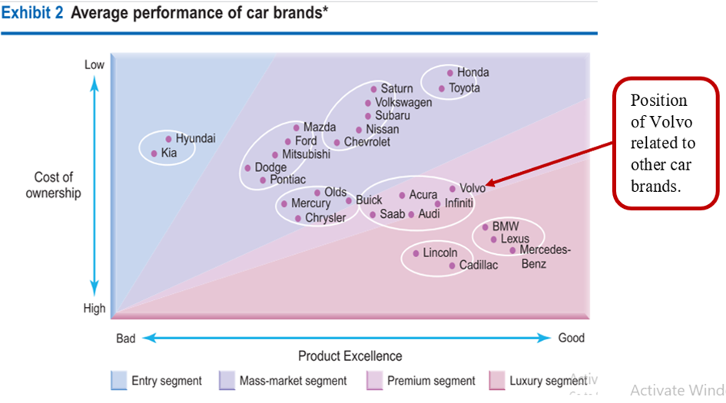
Figure 1: A screenshot with a plotted performance of Car brands about the ownership and product excellence as in 2001. (Johnson et al., 2004).

Swot Analysis
SWOT analysis is an analysis method used to evaluate; Strengths, Weaknesses, Opportunities, and Threats involved in a business unit, greatly playing a very important part in strategic planning and strategic management in an organization. Every investment stands to have all the four categories that are comprised in the SWOT analysis when both internal and external business environments are put into consideration (Chen & Kodono, 2012; Agustos, 2017). SWOT analysis can, therefore, be applied to analyzing Volvo cars in terms of its market progress since its first launch, as shown in the image below.
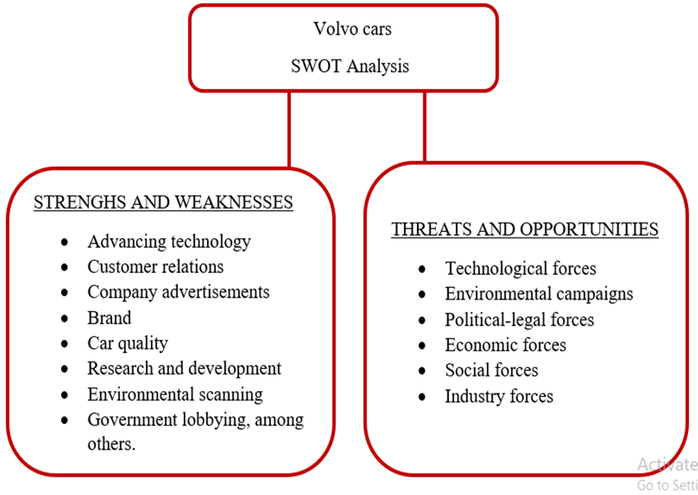
Figure 2:SWOT Analysis
Strengths are the unique characteristics that give a firm advantage over others, while the Weaknesses are internal incapability that may affect the performance of a firm (Agustos, 2017). Volvo cars, like any other firm, enjoys their strengths, as shown in figure 2 above. Poor handling of strengths means weaknesses; for instance, poor company advertisements will mean low sales. The best explanation on the strengths of the Volvo cars is based on customer loyalty, and the provision of quality products to fulfill customer demands through programs such as the shift to electrified mobility. Consumer demand has been the key driver to initiating the car electrification program since the consumers dictate the market (Daniels, et al., 2014). The growing technology has prompted car electrification with Volvo cars adopting the technology to suit them as an advantage. Volvo cars also enjoy the move of the government stimulus, which has impacted its adoption of electrified vehicles through the introduction of tax incentives, subsidies, among other mechanisms trying to educate the public on the importance of the electrified cars. The ultimate impact of Volvo cars enjoying more strengths than Weaknesses is that new firms are introduced with the following serving as examples.
Opportunities are the external-environment advantages or support, while threats are the disadvantages resulting from the external environments of a firm. A good illustration of an opportunity for Volvo cars is the environmental campaigns on the fueling of greenhouse gases. Volvo cars have shifted to electrified mobility from the use of non-renewable sources of power, such as petroleum, to use renewable resources such as water and solar. Internal combustion engines use organic sources of energy such as petroleum, which ends up fueling carbon(IV)oxide, Nitrogen oxides, among other greenhouse gases to the atmosphere. Greenhouse gases result in global warming, which is a significant threat to the worldwide climate.

PESTEL Analysis
PESTEL analysis is a business analysis tool that complements SWOT Analysis discussed above. PESTEL refers to Political, Economic, Social, Technological, Environmental, and Legal issues that impact the implementation of projects. Volvo cars, in particular, can be analyzed using the PESTEL method to assess its market progress. Environmental and legal issues can be observed as key factors that are pushing the growth of Volvo cars, especially on the current issue of car electrification (Griffiths & Stuart, 2011). Environmental campaigns against fueling greenhouse gases in the atmosphere have raised legal, political, and social concerns into adopting electrified mobility; this has been necessitated by the government educating the public and the customers preferring electric cars (Alvarez, n.d.). Some nations in Europe as well have passed legal laws requiring few cars to be used on the roads to minimize the filling of greenhouse gases to the atmosphere. The laws, therefore, are forcing customers to opt for electrified mobility.

New And Emerging Business Opportunities
Firms for offering recycling and maintenance services for the electrified cars become business opportunities when electric cars are considered. Electric vehicles and car parts for electric cars will need to be repaired and maintained. The use of navigation software and applications embedded on the electrified vehicles is presumed to be highly applied since the electric car drivers need to understand the location of the charging stations, it as well means that the development of such software will be a business opportunity (Flah & Mahmoudi, 2014).
Secondly, electrified mobility increases electricity sales opening up electricity generation firms for investors. While organic fuels are abandoned, Electric cars will need to be charged via the use of electricity, and this involves both the fully electric and hybrid cars. There will, therefore, be high demand for power to charge and propel the cars in Europe will, and this will initiate investments to sell electricity and offer charging systems (Delhi, Springer India-New, 2016).
Also, The step of car electrification creates demand for charging infrastructure and related services. Additional to the increased electric sales, the electricity must be made available to the vehicles for easy charging. Different business entities are therefore set to install the appropriate infrastructural technology to enable ease running of the electric systems that charge the vehicles. The public sector in many of the European nations has taken in charge of supporting the electrical systems with the charging technology. The deployment of a reliable charging system for the electrified system sets to be the most challenging part of adopting the technology. The fact that the public sector in many of the European nations has willingly volunteered to provide the facilities, the public sector can't offer the services sufficiently. Despite the welcoming note that the electric vehicles are receiving of late, many European nations have not got a correctly set charging system with only a few countries such as Germany, the UK, France, among others registering average performance.

Other Business Analysis
The automobile industry is related to other investments whose survival and its state determines progress. As electrified mobility is adopted, some investments will have to be impacted in several ways, as illustrated below, using business models.

Product Life Cycle
Product Life Cycle is a Normative and Descriptive Model for the life of products in general. Product Life Cycle model defines any investment to have four stages, including; Introduction, Growth, Maturity, and Decline. During the introduction stage, the product is unknown, selling at generally high prices, selective placement, and promotion are personalized and informative. The next stage is The Growth Stage, where products experience declining prices, widespread placements, and product capabilities are being recognized. Then, the Maturity stage comes where the product is competing with other similar products in the market, Intense placements, and promotion based on the competition and repeat purchasing. The last phase is the Product decline when the product faces reduced competition; promotion is based on reminding the consumers and Prices rise as volume declines

Impacts On Businesses Linked To Auto motives
As the adoption of electric vehicles becomes massive, petroleum-based investments will be declining since combustion Engines will not be used anymore. This means firms such as petroleum exploitation sites, petrol stations, among others, might collapse due to low market demand. There will be very few petroleum products on the market. The existing products, especially diesel that is used to propel car engines currently are experiencing maturity stage now, and they will probably decline to the extinction of use if electrified mobility is fully implemented. The nations' economy that depends on the exploitation of petroleum resources such as the Asian countries will be significantly affected. Setting up businesses that are related to trading the petroleum products will not be viable in the long run since, with time, all the car brands might have adopted the production of electric vehicles (Svahn, et al., 2017).
Secondly, the adoption of electrified cars will lead to diminished sales of car engines since cars will need rechargeable batteries to propel them rather than an Internal Combustion Engine. Engine manufacturing, therefore, as per the MOST Analysis illustrated below, will not be a viable investment to set up in the long run due to inconsistencies on the firm's missions and Tactics, especially market-wise (Johnson, et al., 2017). Opening a garage for maintaining engines will, therefore, not be a viable business to open, especially when electrified cars are fully implemented in Europe. Other subsidiary products to the functionality of engines such as engine oils will also experience diminishing sales due to low demand.

Conclusion
In conclusion, there is a reasonable explanation that can base the industrial shift of automobiles such as Volvo automobiles from the Internal Combustion Engines to electrified cars, as discussed in the main body of this paper. The reasons include; environmental campaigns to reduce global warming that results from carbon(IV)oxide emissions, government involvement to encourage members of the public to buy electrified cars, consumer passion, and interests, among others. The electrification of vehicles comes with a handful of advantages in the world of business. The benefits are based on the understanding that the adoption of electrified cars will ultimately result in new business opportunities for innovation and invention. The opportunities include; high electric sales, demand charging platforms, service providers in the charging platforms, among others. However, like any other unit, car electrification will also negatively impact the business sector and the economic sector as a whole. The negative impacts are basically because the shift to the car electrification will mean that the old means of operating vehicles will have to be ditched, therefore, as the old ways are abandoned, business premises based on them will surely collapse. The negative impacts include; destabilizing petroleum related services, reduced sales on engines, and other subsidiary products, among others. Despite the negative impacts, the transition to the use of electric cars has the ultimate advantages in the business world that cannot be outweighed by the demerits. Therefore, the transition should be supported by the private and government sector, all trying to put in place the requirements as well as educating the members of the public on the advantage of appreciating car electrification.

References
Agustos, P., 2017. SWOT ANALYSIS: A THEORETICAL REVIEW. The Journal of International research, pp. 6-11.
Alvarez, E. A., n.d. PESTEL FRAMEWORK. s.l.:s.n.
Amsterdam Roundtable Foundation;Amsterdam Roundtable Foundation, 2014. Electric Vehicles in Europe. s.l.:Amsterdam Roundtable Foundation.
Chen, F. & Kodono, Y., 2012. SWOT analysis and five competitive forces of chery automobile company. s.l., IEEE.
Daniels, D., Radebaugh, H. & Sullivan, D., 2014. International Business- Environments and Operations. 15th ed. s.l.:Pearson.
Delhi, Springer India-New, 2016. Automotive revolution & perspective towards 2030. Auto Tech Review, 5(4), pp. 20-51.
Flah, A. L. S. & Mahmoudi, C., 2014. Overview of Electric Vehicle Concept and Power Management Strategies. s.l.:ENIG National School of Engineerin.
Griffiths, A. & Stuart, W., 2011. Economics for Business and Management. 3rd ed. s.l.:Prentice Hall.
Johnson, et al., 2017. Exploring Strategy: Text and Cases. 11th ed. s.l.:Pearson Education.
Lambert, F., n.d. Volvo clarifies electrification plan, aims for 50\% of sales to be’fully electric’by 2025’.
Mock, P. & Yang, Z., 2014. Driving electrification. A global comparison of fiscal incentive policy for electric vehicles.(White Paper). Washington, DC.
Morrison, J., 2016. The Global Business Environment The Global Business Environment. 4th ed. s.l.:Palgrave.
Palmer, A. & Hartley, B., 2012. The Business Environment. International Edition ed. s.l.:McGraw-Hill.
Svahn, F., Mathiassen, L. & Lindgren, R., 2017. Embracing Digital Innovation in Incumbent Firms: How Volvo Cars Managed Competing Concerns. Mis Quarterly, 41(1).
Worthington, I. & Britton, C., 2014. The Business Environment. 7th ed. s.l.:Pearson.

