

Student Name | Mohsin Mahmood
Student ID | 2616632
Module Name | New Academic Skills
Module Code | (LCLM4001_BIRM)
Assignment Title | AS1
Submission Date | 04 October 2026

Assessment 1 – Reading Task Template
PART 1: Upload your photo of your A3 in-class notes here:
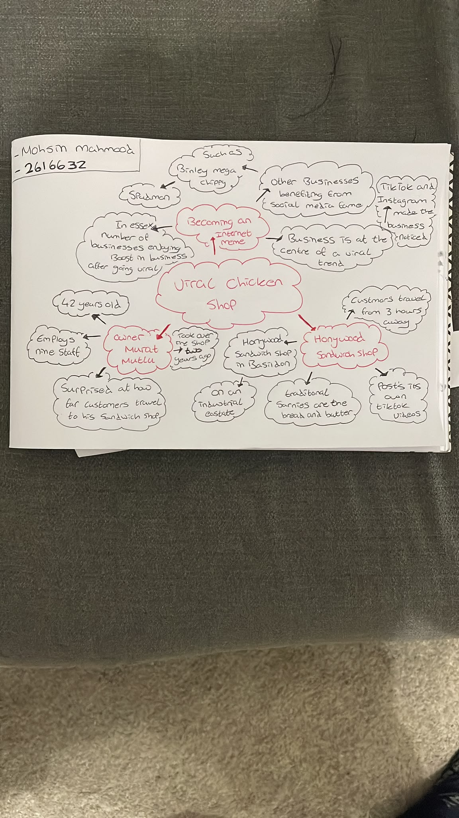
PART 2:
- Answer every question below in 1-3 full sentences.
- Use your own words. Do not use generative AI to answer these questions.
- Include a specific detail from the text when asked.

- What is the main idea of the whole text?

After reading the article, “If you post it, they will come: The businesses turning likes into livelihoods”, written by Elliot Deady and published on the BBC website on 19 October 2025. I learned that small businesses are becoming more popular on social media sites like Instagram and TikTok, which helps them gain more customers and increase profit. The Honywood Sandwich Shop in Basildon is mentioned as an example of how going viral can turn likes into revenue.

- What is one key point that supports the main idea, and which specific example from the text shows this?
A key point that supports the main idea is that customers' posts shared online can bring new customers from far away to a small local business.
For example, according to Murat Mutlu, the 42-year-old owner of Honywood Sandwich Shop, customers have come from three hours away to try his chicken burger. Although the store makes its own TikTok videos, videos shared by customers have increasingly helped boost sales. The improvement is clear: he became the store owner two years ago and now has nine workers.
- What is a different key point that supports the main idea, and which specific example from the text shows this?
A different key point that supports the main idea is that, through social media, the company can expand its operations to other countries outside its local area.
For example, during the pandemic, Linda Hunter's online clothing store used social media effectively by sharing posts on Instagram for Lindy Loo's Boutique. She moved completely online after selling in stores for 46 years. She ships clothes all over the UK and even to Australia, and she has 320,000 followers on Facebook and Instagram.

- Which part of the text do you think is most important, and why?
In my view, the Honywood Sandwich Shop is the main example in the article. It's about how a customer tweeted about the shop, and it went viral. After that, people travelled far to try the sandwiches. I think this is the most important part of the article. The effect is really clear and memorable because someone mentioned that people will travel three hours just to get a chicken burger. It strongly supports the main idea that a small business can change because of its popularity on social media.
Reflection:
- What did you find difficult in this task (including in-class components), and why was it difficult?
It was my first time extracting information from the article and using a note-taking activity like a mind map, which I had to draw on paper. I found that the most difficult part of this practice was figuring out the main idea and which supporting points mattered most. It was hard to tell which business examples in the article mattered and which ones didn't. It was also hard to take notes in class while reading quickly because I needed to find the most noteworthy ideas and organise them into a mind map at the same time without missing anything important.

- What helped you with this difficulty, and how did it help you?
Creating the A3 mind map was a fantastic activity because it helped me organise the information into main points and understand how the examples connected to the main topic. I learned that writing down information on paper or on a digital device helps me remember the important points, and it also triggered brainstorming in my mind. I realised after the activity that many ideas came to mind, and the article became more informative to me about using social media to grow small businesses.
By reading the text again after class, I could identify which ideas were important or mentioned more than once. Instead of trying to write down everything, I found it easier to focus on the main idea, important details, and examples when I used the guiding questions to help me read.

