
Renewable Energy solutions for Building Services
Mark Jones

Assignment 2
School: Built Environment
Subject: Built environmental services
Hand In date: 29th March
Lecturer: Allan Nantel
2019

Page index
Contents
Introduction 3
Solar thermal panels 3
Flat Panels 4
Advantages and Disadvantages 4
Advantages 4
Disadvantages 5
New development 5
The renewable heat incentive (RHI) 6
Storage for energy 6
Heat storage 6
Concentrated Solar power storage 7
Case study 8
Bristol Lido 8
Shower block 8
Cost 9
Pool cost 9
Environmental conditions 10
Conclusion 11
References 11
Picture references 11
Appendixes 13
Appendixes 1 13
Appendixes 2 14

Introduction
There are many different types of renewable energy sources that can be incorporated into the new development at the SA1 site. Sports leisure building are a huge contributor to Carbon emissions being released into the atmosphere in the UK, around 10 million tonnes a year, spending £700 million on energy each year. The aim of this report is to give the university committee a knowledge of Solar thermal, describe why solar thermal would benefit the new development and what types of panels would best suit the building. The report will outline similar case studies and give an estimate on how much money can be saved by installing thermal panels. The location and orientation are all variables that will be considered when considering installing thermal panels. Solar thermal panels are widely used across the UK, they can provide a building with most of their hot water needs and give a building a sustainable factor (with regards to BREEAM and passive house). Solar thermal has many benefits, although the building will need to have a back up source of energy as solar thermal heat can’t be produced year around in Swansea.

Solar thermal panels
Solar thermal panels are similar to solar Photovoltaic (PV) panels although instead of using the sunlight to provide electricity, solar thermal is used to turn sunlight into heat. Energy saving trust (2019) describes that solar thermal panels collect heat from the sun, which heats water that is then stored in a hot water cylinder.
Solar thermal panels can be used to produce electricity, they are used to reflect the sunlight to a central collector which will gets very hot, this will then produce steam, which is used to turn a turbine and produce electricity, this system is called concentrated solar power (CSP). CSP is commonly used on very large-scale energy production as a large area of space is needed, and this system can become very expensive as it’s so large scale.
Solar thermal panels can work on cloudy/rainy days although they will be less efficient at producing heat than on sunny cloud free days. Solar thermal panels are usually placed on top of buildings or in open fields/ areas of space where they can be most effective at absorbing solar energy, meaning there should be no nearby buildings or objects that obstruct the sunlight. As solar thermal is weather dependant there may need to be a backup source of heating in the building for example boiler or immersion heater.
There are two types of panels that can be used to absorb the sunlight. “Flat plates are pipes running through shallow metal boxes coated with thick black glass. The glass collects and traps the heat (like a greenhouse), which the water running through the pipes picks up and transfers to your hot water tank.” Woodford, C (2018) Evacuated tubes “look like thicker versions of fluorescent strip lights, but work more like vacuum flasks. Completely empty, they collect and trap the heat from sunlight. This flows to a collecting device at the top (or at one end) through which water or another fluid flows, carrying the heat to the hot water tank. Unlike flat-plate collectors, they don't let as much heat escape back out again, so they're more efficient” Woodford, C (2018).
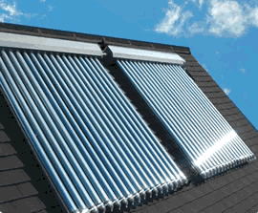
Flat Panels Evacuated Panels
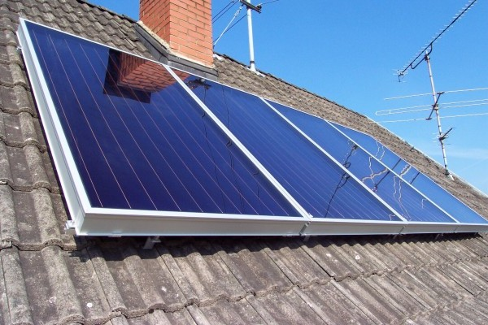
Image sourced at GreenHome (2019) Image sourced at solar thermal panels (2018)

Advantages and Disadvantages

Advantages
- There is an initial cost for installing the Solar thermal panels although after that there is no more cost for running the system.
- You can save money on energy bills by installing a solar thermal system
- By installing this system, you reduce the carbon footprint.
- Depending on what thermal panels you install it can be cheaper than other renewable sources.
- Usually used to heat water although if needed can produce electricity (normally to sell to grid)
- Solar thermal panels have a long-life expectancy usually 20 years.
- A company usually installs these systems with a warranty of around 10 years.
- Solar thermal can be integrated with other forms of heating e.g. boiler, gas, electric heater etc, important when in locations where sunlight is not certain year around.
- Having solar thermal give a building a sustainable factor.
- Solar thermal systems usually have their own controls meaning they don’t need to be controlled manually.
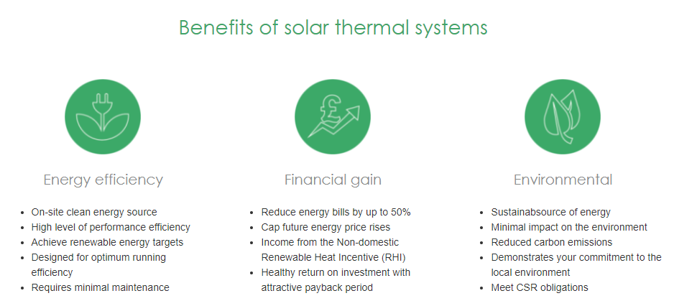
Greenmatch (2017)

Disadvantages
- Maintenance may be needed, although this isn’t often.
- Not all building has enough space for the panels or aren’t in the correct location to utilize the sun.
- The solar thermal panels are most affective at producing heat in the summer months, although this is often the time of the year they are needed less.
- If the panels get damaged, they will produce very little energy.
- If the suns not shining, the water may not get hot enough to use, therefore the backup source of energy will be needed.

New development
As the new development is open from 7am to 6pm, 6 days a week, the building will benefit from thermal panels as they are most effective throughout the middle of the day. There is going to be a large need for hot water in a building with a Gymnasium and a swimming pool therefore solar thermal can potentially supply most of the buildings hot water needs. There is a swimming pool in the building, meaning a large amount of hot water is going to be needed for showers, sink taps, heating, pool warming etc. Solar thermal is commonly used for heating water, if there are enough panels and they are installed correctly near the building, a system can be made to provide the new development with most of its hot water demands. “A solar thermal heating system that is integrated into a swimming pool can meet up to 80% of your pool’s heating and energy requirements” The renewable source hub (2018).
Flat panels are more commonly used for swimming pools, although as the building is large and will have a high demand for hot water during the day, in my opinion evacuated panels would best suit the new development as they are more efficient at retaining heat and heating water faster, they are usually better in colder conditions due to the Vacuum in the glass. The only downfall is evacuated panels are usually more expensive.
Eco living UK (2018) states that usually having the panels south facing is the most efficient way, as the panels will receive direct sunlight throughout the day, although they can be positioned east or west and still utilize the sunlight.

The renewable heat incentive (RHI)
The RHI is a scheme set up by the government to encourage more people to invest in renewable technologies, this scheme applies for domestic and non-domestic buildings in Wales, England and Scotland.
Over recent years the government have set targets they aim to achieve to have a more sustainable approach on buildings in the UK, Caplor energy (2018) states the government aim to achieve 12% of heating being produced to come from renewable sources by 2020. The RHI scheme will contribute to the targets set significantly.
The incentive of this scheme is that for every KW of heat generated from a renewable heat source, the government will pay out a certain amount over the period of 20 years.

Storage for energy
As solar thermal panels work by heating water that is then taken to a copper cylinder, the heat cannot be stored for future use, if the copper cylinder is well insulated the heat will remain although after a while the water will lose heat if the panels stop producing energy.

Heat storage
New Energy TV (2016) states that heat storage is a new technology being discovered, recently ‘Merits’ have designed a system that allows heat to be stored for future use, the design is European based. Solar thermal panels absorb heat through the Summer months which gets distributed into the system that stores the energy, a chemical reaction is created between the salts hydrate tank and water tank using thermochemical storage, this allows the heat to be stored in a compacted way.
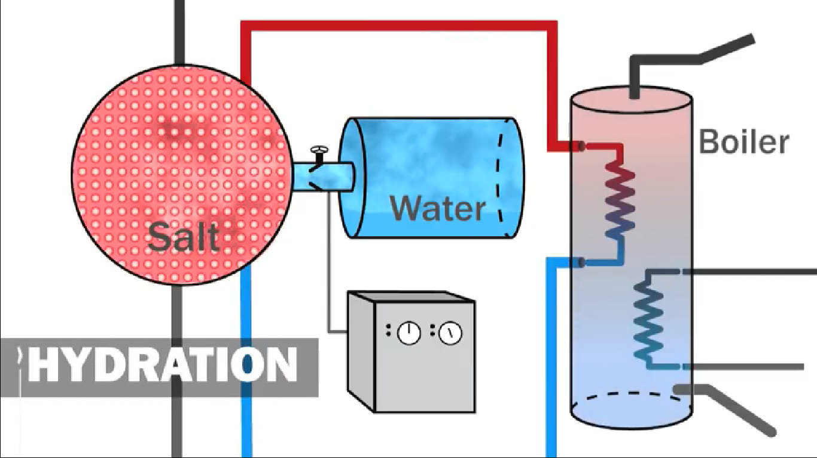
Sourced at New Energy TV (2016)
A test container was set up by ‘Merit’ that allows the engineers to monitor how heat is transferred from the system to a ‘test house’, this project was successful. Cylinders must be installed in a building which will allow the heat to be stored for up to a complete year, although this system is new meaning there may be undiscovered faults to the system.
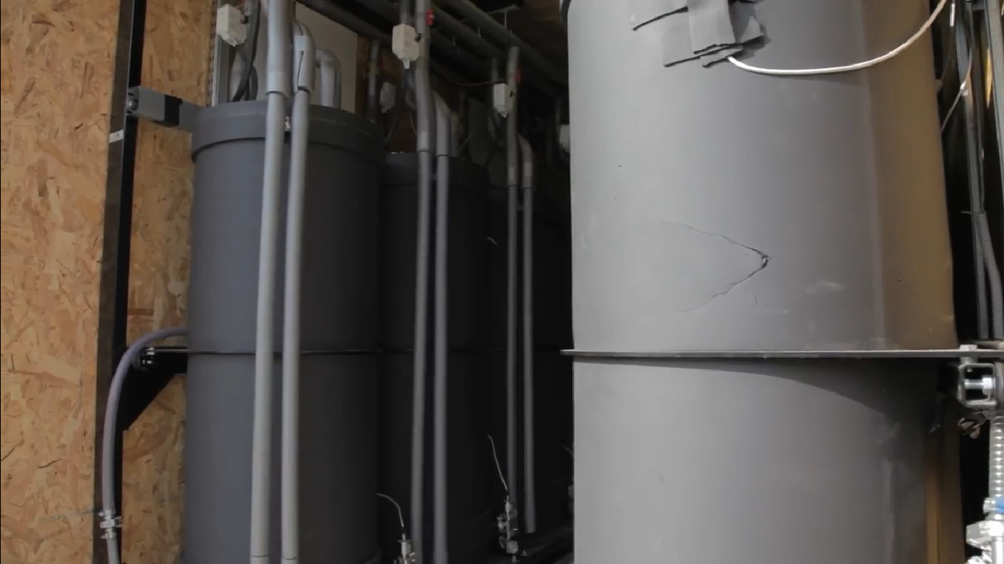
Sourced at New Energy TV (2016)

Concentrated Solar power storage
Concentrated Solar Power (CSP) can be used to store energy, although the system is used to heat water and create steam to turn a turbine, meaning the energy that can be stored is electricity, not heat.

Case study

Bristol Lido
Futurerenewables.eu. States that Bristol lido is a recent renovation of a large outdoor swimming pool. The owners of the lido decided to introduce a renewable energy source for all the hot water needs of the new development. The renewable energy source used was thermal energy (Thermomax) using vacuum tubes rather than the usual flat panels which in this case are 30% more efficient in capturing energy from the sun, they are ideal for insulating and protecting its heat from rain, wind and snow. The Solar thermal panels are south facing covering 80 square meters in total. Using thermal energy, the lido now self generates more than 70% of its hot water needs and reduces its carbon footprint massively.

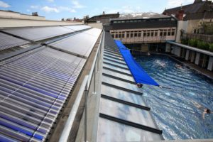
The Generation energy (2018)

Shower block
In an isolated busy campsite in Scotland, a shower block was needed, there were no services nearby to connect to, meaning solar thermal energy will supply the hot water demands from the shower block with a backup oil boiler. There Is a high demand for hot water in the morning and evening as that’s when showers are most in use. The renewable energy source will reduce bills and even generate an income as it is eligible for the renewable heat incentive.
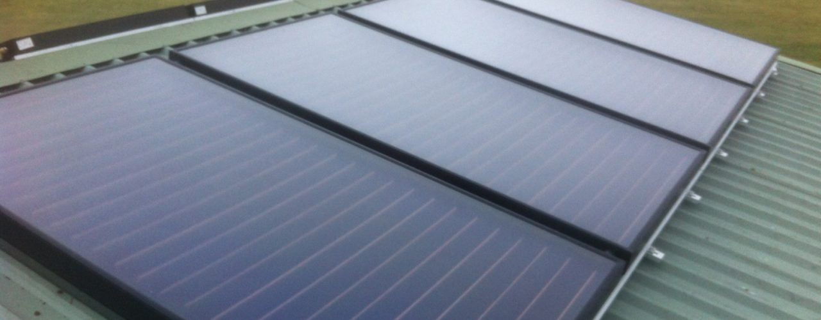
Mcinnesgroup (2016)

Cost
The cost to install solar thermal panels on a 6000m2 non domestic building will vary immensely depending on how much hot water needs the building will encounter, as it is a public building with a swimming pool and gym, a lot of hot water will be needed.
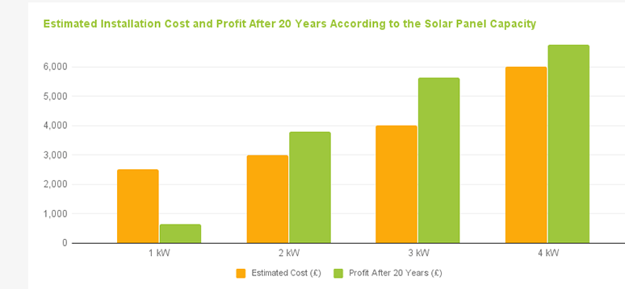
Figure 3 was sourced at Greenmatch (2017)
Figure 3 shows the annual save of money over a 20-year period, compared to the estimated cost.
A table for cost of a sports centres facilities is described in appendixes 2.

Pool cost
Typical cost of solar thermal panel to accommodate different size pools in a building:

10m² to 20m² Pool | £6,420-£8,270
20m² to 30m² Pool | £7,220-£12,240
30m² to 40m² Pool | £10,140-£14,310
40m² to 50m² Pool | £12,240-£18,050
50m² to 60m² Pool | £16,730-£19,950
60m² to 70m² Pool | £16,730-£21,560
70m² to 80m² Pool | £19,950-£25,990

Table sourced at SolarUK.com (2019)

Environmental conditions
As the new development is going to be constructed in SA1 Swansea, the building needs to ensure no obstructing buildings or objects are nearby. The site already has many large buildings and on-going construction projects meaning potential risk could occur with blocking sunlight.
Appendixes 1 shows the average high and low temperatures that Swansea encounters over the period of one year, also the average amount of sunlight throughout each month of the year.

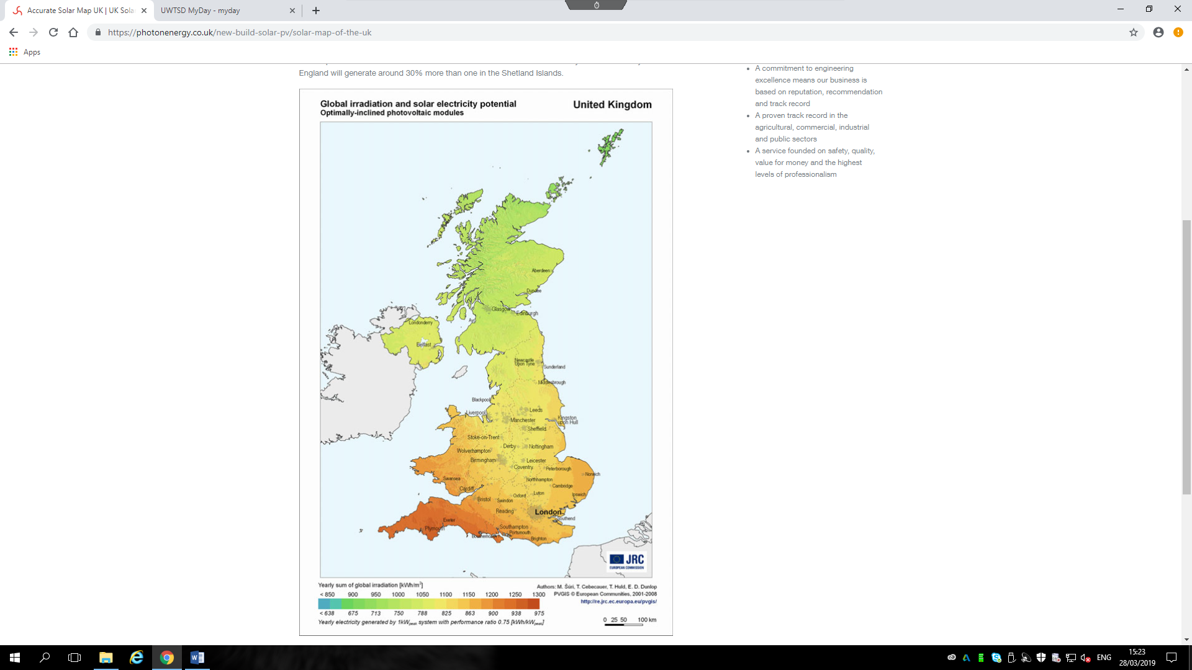
Photoenergy (2018)
The image above shows the irradiation of the UK, stating the amount of sunlight in each area and the potential gains for solar thermal. Swansea area reads around 1200 kWh/m2 of irradiation, meaning it is a good location to install solar thermal panels.

Conclusion
The new development would benefit integrating a solar thermal panel system into its design as there are many benefits especially in the proposed area of Swansea, there is incentive to using the system and it will save the building energy costs over time along with having a short payback period. Other forms of energy e.g. Gas and electrics prices are constantly growing, meaning as the energy produced from solar thermal is completely free, prices don’t increase or change for 20 years (the life expectancy of the panels). The new development will need a considerable amount of hot water throughout the day, year around, meaning the building will need a backup source of heating.

References
Caplor Energy. (2018). Renewable Heat Incentive (RHI) - Whats is the Renewable Heat Incentive?. [online] Available at: https://www.caplor.co.uk/renewable-heat/renewable-heat-incentive-rhi/ [Accessed 21 Mar. 2019].
Ecolivinguk (2018). Solar Thermal Panels | Solar Thermal Collectors | Ecoliving. [online] Available at: http://www.ecolivinguk.com/solar-energy/solar-thermal-panels/ [Accessed 20 Mar. 2019].
Energy Saving Trust (2019). Solar water heating. [online] Available at: https://www.energysavingtrust.org.uk/renewable-energy/heat/solar-water-heating [Accessed 22 Mar. 2019].
Futurerenewables.eu. [online] Available at: http://www.futurerenewables.eu/wp-content/uploads/2015/04/Kingspan-Case-Studies-Solar.pdf [Accessed 23 Mar. 2019].
Greenmatch (2017). Solar Panels for Pool Heating (2019) | GreenMatch. [online] Available at: https://www.greenmatch.co.uk/solar-energy/solar-water-heating/solar-panels-for-swimming-pools [Accessed 21 Mar. 2019].
New Generation Energy. (2018). New Generation Energy Bristol Lido Solar Thermal - New Generation Energy. [online] Available at: http://newgenerationenergy.co.uk/solar-thermal/bristol-lido/ [Accessed 24 Mar. 2019].
The Renewable Energy Hub (2018). Solar thermal systems for swimming pools - The Renewable Energy Hub. [online] Available at: https://www.renewableenergyhub.co.uk/main/solar-thermal-information/solar-thermal-systems-for-swimming-pools/ [Accessed 20 Mar. 2019].
Woodford, C. (2018). How do solar hot water panels work?. [online] Explain that Stuff. Available at: https://www.explainthatstuff.com/solar-hot-water-systems.html [Accessed 25 Mar. 2019].

Picture references
Cibse.org. (Undated). [online] Available at: https://www.cibse.org/getmedia/34def23a-c65b-405e-9dff-ce181c0b1e0d/ECG78-Energy-Use-in-Sports-and-Recreation-Buildings.pdf.aspx [Accessed 21 Mar. 2019].
Holiday weather.com. (2019). Swansea, United Kingdom Average Annual Weather - Holiday Weather. [online] Available at: https://www.holiday-weather.com/swansea/averages/ [Accessed 20 Mar. 2019].
Mcinnesgroup (2016). Case Study : Solar Thermal - McInnes Group. [online] Available at: http://mcinnesgroup.co.uk/case-studies/case-study-solar-thermal [Accessed 24 Mar. 2019].
New Energy Tv. (2016). Heat battery - a breakthrough in the storage of renewable energy. [online] Available at: https://www.youtube.com/watch?v=poSWhurtK04 [Accessed 24 Mar. 2019].
Photonenergy (2018). Accurate Solar Map UK | UK Solar Mapping. [online] Available at: https://photonenergy.co.uk/new-build-solar-pv/solar-map-of-the-uk [Accessed 22 Mar. 2019].
Solar thermal panels (2018). Solar Thermal Panels – Flat bed or Evacuated Tubes. [online] Available at: https://greennav.wordpress.com/2008/06/16/solar-thermal-panels-flat-bed-or-evacuated-tubes/ [Accessed 21 Mar. 2019].
Solaruk.com. (2019). Solar UK - Sample prices for Domestic and Commercial Solar Heating. [online] Available at: http://www.solaruk.com/pricing.asp [Accessed 20 Mar. 2019].
The GreenHome (2019). Flat Plate Solar Thermal Collectors: Overview - The Green Home. [online] The Green Home. Available at: http://thegreenhome.co.uk/heating-renewables/solar-panels/flat-plate-solar-thermal-collectors-overview/ [Accessed 21 Mar. 2019].

Appendixes

Appendixes 1
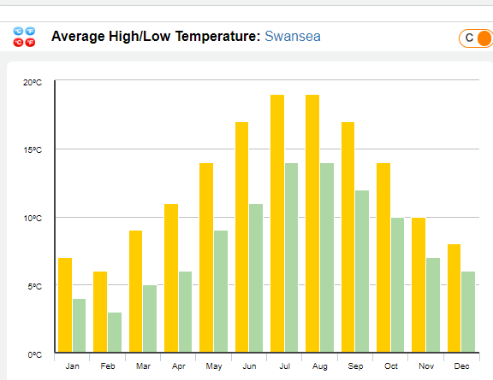
Holiday weather.com (2019)
The image above shows the high/low temperatures of Swansea throughout the year, showing that May – October would be potentially the best months for harvesting the sunlight.
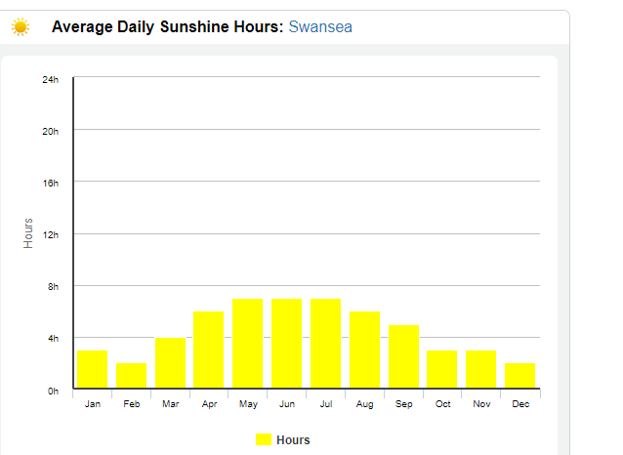
Holiday weather.com (2019)
This image above shows the usual amount of sunlight in hours per month, this means the most beneficial months for sunlight in Swansea will be in summer, allowing more sunlight being absorbed by the solar thermal panels.

Appendixes 2
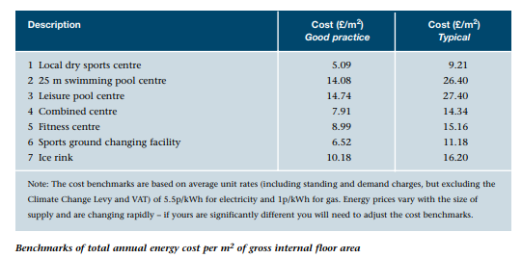
CIBSE.org (UD)
The table above shows the average cost for a good and typical practice of different facilities in a sports Centre, the cost is per m2.

