Self-reflection | The report below discusses a student’s experience throughout the academic year. Use of Gibbs Self-reflection model to analyse the situation and make it better for future tasks. Evaluation of negativity and willing to adapt positive behaviour to succeed academically and implement in employment.  Tehreem Arshad (2120566)  Academic and Employability Skills-BMSW4001_BIRM Lecturer-Isaiah Oino

Table of Contents
Introduction 2
Self-reflection as a Student 2
Model of Reflection 2
Experience of Writing Task 1-Academic Report 3
Group Work 3
Feedback from the Peers 4
Feedback for Group Work…………………………………………………...…………………….5
Personal Development Plan……………………………………………………………………….6
Conclusion……….……………….………………………………………………………………….6
References……………………………………………………………………………………………8

Introduction-
The following reflective report discusses my learning journey through out the Academic and Employability Skills Module. Self-reflection is to question yourself and to be able to adapt the changes to improve (Bager-Charleson, 2010).Self-reflection is a way to improve and to do better next time. Self-reflection as it says in the name is to reflect, take a deeper look within ourselves and acknowledging the defects and to ponder over the removal of faults to make us better (Takano & Tanno, 2009). It is all a mental process but slightly different to looking in a mirror. “Self-reflection is to look through a mirror and look way deeper within yourself” (L.B.Gilmore, 2020).To understand the root cause and to have the will power to change it and make it better. However, this report is about what I have learnt over this module, the mistakes I made, not just working as a group and being a group leader, receiving feedback and willing to accept the flaws in me as a leader, and to improve my work and my leading skills. Receiving feedback from peers and to acknowledge the changes and to develop a strong will to implement in future learning journey.

Self-Reflection as a student-
In the Academic and Employability skills module BMSW4001_BIRM I learnt the importance of note taking. There was a time when I would write all down and I learnt how to just put the main points down. This helped to improve my ability to write less and remember more. I developed new skills such as using references.in the past, during my educational journey I have written reports however I didn’t know how to add references. I learnt how to add references using Harvard references system. In this module we covered how to cite text. In level 2 I always struggled when it came to write a report however during this module, I learnt the structure of an academic writing whether it is a report or an essay.

Model of Reflection-
A model of reflection is a diagram used to identify what or why it happened and how to avoid or how one can be improved. In this report we will explore the “Gibb’s Reflective Cycle (Gibbs, 1988)”.
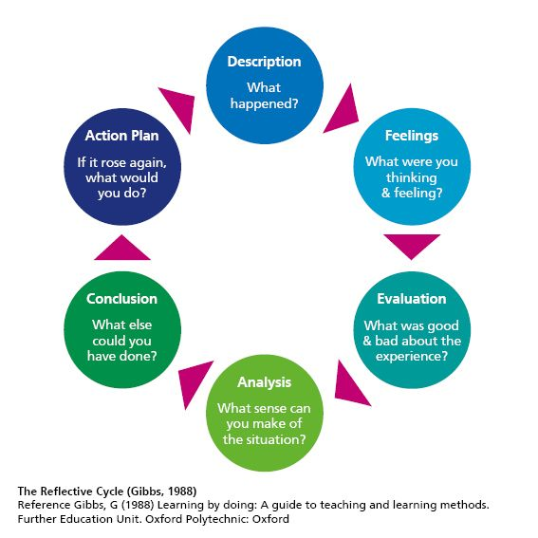

The model of reflection shown above was created by Gibbs in 1998. By following these steps one can reflect over what happened, how did it make you feel, it helps to identify the positive and negative of the situation, what one may think of it, and to question yourself what could have been done different to better situation. For instance, the task given was to create a job advert, I took all responsibility on myself as I didn’t feel confident trusting group members.by doing this I did most of the work myself and I felt hesitant to share as I didn’t think I will be happy if they made any changes however they were not bothered at all I felt really devastated even though I found difficult to work as a group I allowed them to make changes with a heavy heart that is my weakness and I have to work on that. I took a step back when one of the members asked to present on behalf of all the team that was another difficult thing that I overcame yet I was disappointed to see how the presentation was led by this individual member. Once it was over, we all analysed that if we all had given an input and spoke on each section, we could have done a lot better.
These are the basic but very important steps to make changes whether it’s an academic task or day to day life. By following these steps, I realised the task and how I felt when I was going through it, all the feedback from peers and to accept the need to improve in future tasks.

Experience of Writing Task 1-Academic Report-
The very first Academic Report I completed for Academic, and Employability Skills module was very challenging. To structure the report subject to 2000 words was a bit difficult as I had less to say for example in one section and a lot more words in another. I prefer the work to be handwritten as I am not 100% confident using the technology. Day 1, The first hour my mind was complete blank I couldn’t write down a simple introduction for staff motivation. Day 2, I managed to work on the task for 3 hours. As I mentioned earlier it took about 30 minutes just to make a title page. As time went on, I became better at using the MS word for my writing task. Day 3 into writing Ms word decided not to respond which resulted as a loss of 2 hr work. My initial response was to scream then I realised I needed some break as I had been working on the task since morning. Day 4 with a fresh mind and restarted laptop I managed to complete my task. Day 5 I added references list and read the task over and submitted a draft. My first draft attempt, it was very time consuming to add references and to add multiple authors in a reference and get it right. Writing of task 1 required to read roughly 8 pieces of literature which was something new for me. I have always struggled to read a book however this module made me read a lot which helped to train my mind and I realised it is not bad at all. I have started to read other books to improve my reading skill and looking forward to implementing in my life.

Group Work-
During this module I had an opportunity to work as a group. We formed a small group of 5. This was my 2nd time working in a group. I was chosen to be the group leader which I took the role happily. I have always found it difficult to work as a group as it is very hard for me to trust others when it comes to my grades. However, I showed leadership by assigning tasks to other group members. I was disappointed to see that one of them came back to me with a screenshot from google as an answer to her designated task. Through communication information can be shared and new ideas can be discussed (Suprapto, et al., 2015).It was a bit challenging to keep all group members on board as some of them joined online. Due to internet problem I struggled to communicate with one of the group members. This certain group member responded harshly, and I had to step up as a leader and inform the member of the technical issue. Being a group leader, I combined all of work to create an advertisement. Upon completion, the work was shared with all the group members, and they were given the right and were asked to make changes. In response, they all didn’t make any change or gave feedback. That made me feel a devastated as all I received from them ok. The spokesperson who volunteered from our group was advised to go over the advertisement multiple times, yet they didn’t and when it came to present, they were not aware of the background of the company being advertised. I wasn’t happy how the presentation went as we had practised among ourselves; we certainly would have achieved better marks from peers. As I reflect, I feel that I could have taken the role a bit better by dividing the section of presentation. If all of us 5 members had spoken about our work, we would have done better. By looking at the work of other groups I realised the mistakes and flaws in our advertisement and how I should improve and do better next time working as a group.

Feedback from the peers-
As we were given the chance to complete the assignment and submit the draft. I was hesitant to submit the draft as I was aware that I will be needing to make changes. In other words, I was not willing to accept that I could make a mistake, or my work needs to be better. Once I received the feedback, I was told to align the content page, as simple as it may sound, I struggled creating a simple content page. This gave me a chance to develop my skills and to learn how to create content page. I was given feedback to add reference on few lines which I wrote them down using my own mind however when I researched there were many articles that discussed same idea as mine. I acknowledged their work and referenced them using google books.

Feedback from the peers- (group work)
We received feedback on our group work which was slightly different than expected. As we only had one spokesperson our fellow groups were generous to mark us highly on speaking skills.

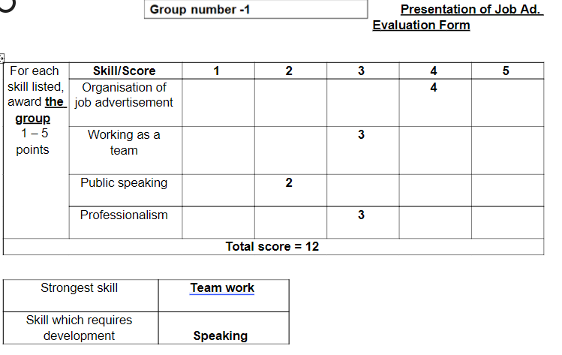

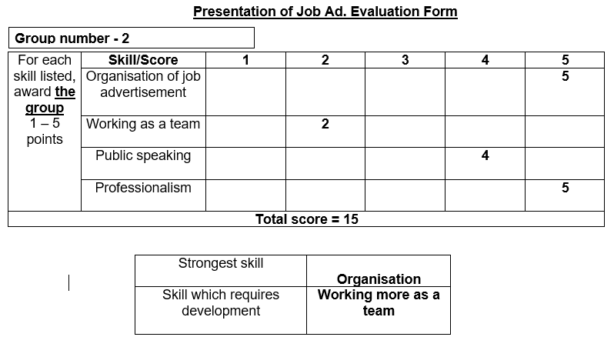

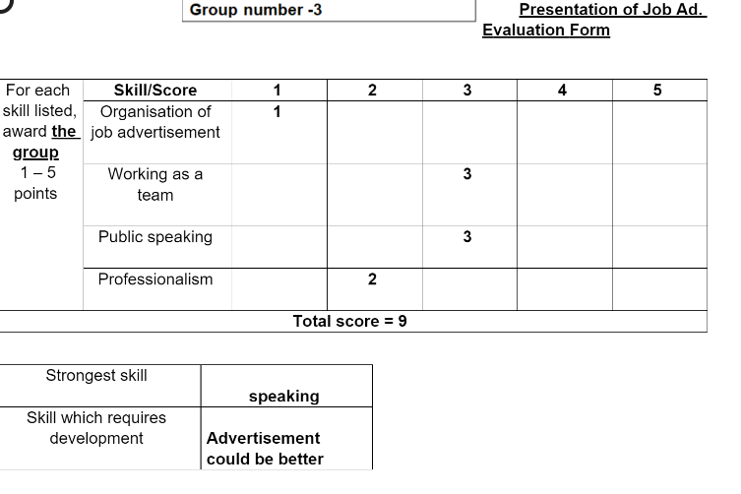
We were given high marks on organisation of job advertisement by two groups and a very low mark by group 3. As seen in above charts we must improve working as a team.in fact I noticed myself that our team was not fully involved in forming the whole task. Some of them didn’t want to give their input or were not bothered to make or suggest any changes. Public speaking scores differed some were high, and some were low. As mentioned above one member of our group was determined to speak and didn’t allow rest of us to even introduce ourselves. In future tasks I will make sure all the group members have something to say about the work presented. We received low scores on professionalism which can be based on multiple reasons.
- as the spokesperson didn’t read through the job advertisement
- group members didn’t suggest any changes
- all the group members weren’t present when the ad template was chosen

The areas we need to improve on is first we all must participate to design and to research and to present. We all must give new ideas or when given right to edit we must make changes. We must encourage each other to present each section individually. We must give our input and not just rely on leader to do all the work and research and put the advert in place. We must improve our team working skills which is to make sure all of us design and research and make changes.

Personal Development Plan-
A personal development plan differs person to person. Personal development plan is to ponder over past and to make changes to improve and gain more in future (Anon., 2017). This plan is basically to set a goal and to reach it by an appointed set time. It can be challenging but it is important to reflect and set a new target. Therefore, I have set some targets in my personal development plan to better myself in terms of reading, by mastering referencing, team working and by getting a degree and a job.
Personal Target | How will I achieve this? | How will this improve my academic or employability prospects? | How will I know that I have achieved this? | When will I achieve this by?
Work as a team | By listening to others, by trusting others | Improve working as a team in academic and employability | When I feel happy to accept and add others’ ideas | MAY 23,2022
Read Books | Reading online or visiting a library | It will improve my vocabulary and will help writing and speaking skills | When I implement new words and able to write better | Started already and ongoing task
To add reference | By reading | This will improve my writing assignments | By submitting draft | June 20,2022
To complete my degree | By attending all the lessons, by completing all my work assigned by the lecturers | This will better my chance to get a job | Once I have a job, I will be fully independent | By 2025

Conclusion-
In conclusion self-reflection is a way to move forward. By identifying the root cause of a situation, analysing what to do and how it can be handled better is all the basic concept of reflecting with in oneself. I have acknowledged that my weakness is to trust others when it comes to team working. By not trusting team members I put all the work on my own self which gave my team a reason not to help or even a suggest any change as they got happy that the work was being done for them. I have come to realise to make myself better academically I must trust others which will make me better when it comes to team working and that is very important in employment. I must read books and improve my reading and writing and it will be beneficial in work environment. I must reach my set targets and become independent.

References
Anon., 2017. Imroving Performance Appraisal. Development and Learning in Organization, 31(4), pp. 36-39.
Bager-Charleson, S., 2010. Reflective Practice in Counselling and Psychotherapy, s.l.: Exter Learning Matters.
Gibbs, G., 1988. Learning by doing : a guide to teaching and learning methods. Great Britian: Oxford Brooks University,Oxford.
L.B.Gilmore, 2020. Mirror Mirror on the Wall:A Self-reflection Notebook for the Brave. 1st ed. s.l.:Independentally Published.
Suprapto, M., Bakker, H. L. & G.Mooi, H., 2015. Relational factors in owner–contractor collaboration: The mediating role of teamworking. International Journal of Project Management, 33(6), pp. 1347-1363.
Takano, K. & Tanno, Y., 2009. Self-rumination, self-reflection, and depression: Self-rumination counteracts the adaptive effect of self-reflection. Behabiour Research and Therapy, 47(3), pp. 260-264.

