


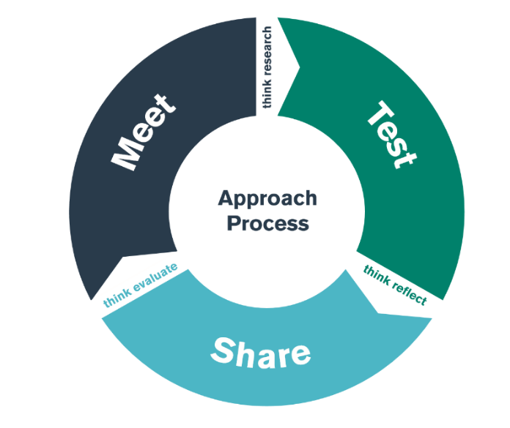

PGCE Module ECAD6007C
Case Study and Critical Incident Methodology Steer

Student-Teacher Enquiry Evidence Record

26th, 27th and 28th September 2022

What is the purpose of the ‘case study’ and ‘critical incident’’ bridging activity?

You will recall that a ‘case study’ can be thought of as ‘an instance in action’ according to Nisbet and Watt (1984 p.72 (in Cohen, Manion and Morrison 2006 p.253) and that Tripp (2012) observes that deep analysis of ‘critical incidents’ can inform teacher judgement and practice and although they can be serious in nature, they may also be observed moments that are ‘funny, sad, witty…..boring, good’ or possibly even ‘trivial.’ For Tripp, observation and deeper analysis of the implications of the observed incident offers rare opportunity for deeper understanding of your development and pedagogy.

By the end of the test phase, you will have identfied a small handful of incidents that hold the potential to open up deeper reflection and study (for the assignment) in relation to two or three areas that have been highlighted at university in the module content. In this way, it is you as the researcher that makes the incident ‘critical.’ You will have observed up to three lessons recalling the central importance of maintaining the respect, dignity and anonymity of all participants (staff and pupils) at all times (BERA 2018).

The form below can be used as a framework for observing learners and learning experiences. As is often advised (Cohen Manion and Morrison 2006), you may wish to make short notes only during the obervation in case you miss an important element of a potential ‘incident’ whilst writing. Researchers are advised to make detailed notes as soon as is practically possible following the observation.

IMPORTANT:
Use the forms below for your observations and to record incidents. You will need to observe three teaching episodes and identify four potential incidents. It is a requirment of the assignment that these be included with the appendices to your research assignment. You will be able to access copies of these forms on Moodle.

OBSERVATION / FIELD NOTES

Record 1
Date and time, year group:
Year 7 – 3rd lesson of the day
Where and When: Context of the observation – subject/AOLE, general classroom context

Media Studies lesson, students are in a food tech lab however. Students are working on chrome books to design new logos for NASA. Smaller group of only 15 students

What happened: a detailed description of the critical incident(the more detail the better to refer to in your later work)

One student sat on their own while all others are in groups of at least 5. Whilst the teacher is giving instructions, they are listening carefully and fully engaged in what the teacher is saying, whilst other students are not looking/paying attention.

Areas of possible exploration: what you think could be” under the hood” in these incidents? What avenues of research could you consider?

Would look at the impact of distraction in a classroom. Also perhpas the importance of implementing a seating chart – would mean that students are not excluded, also would provide oppurtunities for students to make relationships with their peers that they might not have before.

Notes: any details you can note (is it a busy environment, is it after lunch, are there lots of distractions, are directions made explicit - the more you can refer to the better here)

Right after break time

Record 2
Date and time, year group:
Year 7 – lesson 4
Where and When: Context of the observation – subject/AOLE, general classroom context

English lesson, group of 22 students. Students were overall well behaved, but were understandably excited by the different-style of the lesson.

What happened: a detailed description of the critical incident (the more detail the better to refer to in your later work)

The teacher called back to the previous lesson at the end of the task and built upon what was already taught. Also introduced students to what they will be focusing on in the next lessons. When reminding students of different word groups, the teacher used colour coding to differentiate the different groups.

Areas of possible exploration: what you think could be” under the hood” in these incidents? What avenues of research could you consider?

I would look into the benefit of retrieval practice being used at the end of lessons and its effect of STM and LTM in students.

Notes: any details you can note (is it a busy environment, is it after lunch, are there lots of distractions, are directions made explicit - the more you can refer to the better here)

Lesson before lunch. The researchers were informed that this lesson would be a bit unorthodox, as students were participating in a group activity where they sampled foods from different cultures as a part of European Day of Languages

Record 3
Date and time, year group:
Year 8 Welsh Lesson – lesson 4
Where and When: Context of the observation – subject/AOLE, general classroom context
Welsh lesson taking place in period 3, right before the students break for lunch. This lesson occured aftet the same form group was in a very disruptive lesson, as a student was sent out of the lesson for disrupting others’ learning

What happened: a detailed description of the critical incident (the more detail the better to refer to in your later work)

In this lesson, the teacher used a consistant amount of repetition to ensure that students were correctly pronouncing newly-introduced welsh terminology. This ensured that students heard any errors they were making and were able to self and peer-correct

Areas of possible exploration: what you think could be” under the hood” in these incidents? What avenues of research could you consider?

Repitition in a second language classroom would be a pertinent area in which to conduct furthe reasearch on. Also the effect of repetition on LTM when asked to recall terms previously discussed

Notes: any details you can note (is it a busy environment, is it after lunch, are there lots of distractions, are directions made explicit - the more you can refer to the better here)

Lesson right before lunch time

A SYNOPSIS OF SOME CRITCAL INCIDENTS OBSERVED BY LAST YEAR’S COHORT

Here are some examples of incidents from a 3-19 range, made critical by some students and the areas of further study this led them towards in their assignments.

- The researcher observed an adult speaking firmly to a child at a table set out for an individual task. ‘You’re not listening, you need to listen, you need to learn to listen,’ said the adult. The child sat in ‘quiet tears.’ Later the researcher asked the child why they were there. ‘I got it wrong’ was the reply. Analysis of this incident led to further study of how the use of AfL might serve to understand and avoid similar incidents in personal practice. The researcher also studied how approaches to Health and Well-being might usefully relate to the issues raised by the incident.

- The researcher observed a pupil initially disengaged, playing with a pencil case and swinging on the back legs of the chair. When the pupil saw the teacher start a practical activity involving individual whiteboards, the beahviour ceased and the pupil became highly engaged. The researcher observed this enjoyment of practical engagement at several different times throughout the day. This led to deeper study of behaviour management and the theoretical underpinnings of scaffolding as a pedagogic technique.

- A child diagnosed with Autistic Spectrum Disorder (ASD) was observed with a 1:1 support TA trying to engage him apart from the other learners in the class. As the child was not engaging at this time, it raised questions in the researcher’s mind as to the purpose of the pupil being in the mainstream setting. This led to further study of what learning theories might tell us about developing confidence and socialisation skills in ASD pupils and a deeper analysis of the usefulness of scaffolding as a pedagogic technique.

- A pupil was observed arriving late and joining a group involved in a shape cutting task. On arrival the pupil cut paper randomly and when asked offered some help before again becoming distracted back into random cutting. An adult arrived and engaged the pupil gently in discussion. Soon the pupil rejoined the others and completed the learning task. Later the researcher asked why the pupil was late and was informed that he was returning from a support session with the Emotional Learning Support Assistant (ELSA). This led to further study on emotional well-being and relevance of learning theories (with an emphasis on holistic theory) to future personal practice.

