Programme: Master of Business Administration
Module: International Marketing: Principles and Practices
Module code: LCMB7026

Lecturer’s Name: Tushara Balandran
Student Name: Divyesh Desai
Student ID: 2510655
Term 2

Table of Contents
Section 1 3
1. Introduction 3
2. Macro Environment Analysis 4
2.1 (PESTEL Comparison: USA vs India) 4
2.2 Cultural Analysis using Hofstede 7
3. Comparative STP Analysis 9
3.1 International Marketing Mix (7Ps) 11
4. Directional Development Strategy 17
5. Ethical Issues in KFC’s Marketing Mix 19
6. Recommendations for Future International Marketing Strategy 20
7. Conclusion 22
Section 2 23
Reflective Account Using Gibbs Reflective Cycle 23
References 27

Section 1

Introduction
The purpose of this report is to critically compare and analyse the international marketing strategy of KFC in the United States and India. KFC, a subsidiary of Yum! The brand is among the most successful quick-service restaurant (QSR) brands in the world, with operations in more than 150 countries (Yum Brands, 2026). KFC, being an international organisation, presents an international marketing strategy that balances standardisation as well as adapting to different consumer needs within the various markets. This is much so in terms of comparing the United States, a high-income, well-established market, with that of India, which is an emerging market of great diversity in terms of its cultural behaviour among people. The current report opens with a comparative analysis of the macroenvironment provided by the PESTEL analysis, focusing on the social and cultural elements with references to the Hofstede model. It then uses the STP model in analysing the market approach and looks at the international marketing mix (7Ps). The report also considers the overall directional strategy and ethical issues of KFC and offers future growth recommendations.
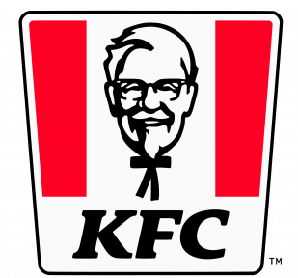
Figure 1: KFC Brand Logo
(Source: KFC, 2026)

2. Macro Environment Analysis

2.1 (PESTEL Comparison: USA vs India)

Figure 2: PESTLE Factors
(Source: By Author)
Political Factors
The political environment in the United States is stable and predictable, and the regulatory systems are strong, which helps big multinational companies like KFC to operate (Segel, 2026). The surrounding policies by the government concerning food safety, labour and taxation are already in place, enabling KFC to run smoothly. On the other hand, India provides political stability also, but with more complicated laws and rules, such as the presence of regional variations and a higher level of compliance in various other fields, such as food standards such as FSSAI (FSSAI, 2026). Also, the policies and bureaucracies on foreign direct investment (FDI) may lead to operational difficulties. Nonetheless, the presence of governmental aid to economic development and urbanisation opens up the expansion prospects in the fast-developing quick-service restaurants industry in India.
Economic Factors
The USA is an economy with a high income, and consumers can afford to spend on a regular basis on fast food (Financial Times, 2026). This justifies the pricing policies of KFC, such as high-end and low-end food. By comparison, India is a developing economy whose average consumers are much lower and thus more price-elastic (Majumdar, 2024). Consequently, KFC will have to provide low prices, reduced portions and value meals in India. Nonetheless, the increase in the middle-income and rise in urbanisation in India offer high potential for growth in the long-term (Kouamé, 2024). There are evident economic disparities between the two nations that affect the pricing and expansion strategies of KFC.
Social Factors
The social factors are essential in determining the approach of KFC. Fast food is a daily routine in the USA and is very convenient and time-saving (Ducharme, 2018). Consumers are becoming more personal and are willing to engage in fast food restaurants. On the contrary, India has strong cultural and religious factors on food intake such as a large percentage of vegetarian users and beef prohibition (Biswas, 2018). The eating habits are considered more family-oriented than individual ones. Such differences require KFC to change its menu and marketing strategy greatly in India and provide vegetarian food and food choices that are culturally appropriate to cater to the local tastes.
Technological Factors
The USA enjoys a high-technological infrastructure with high numbers of digital ordering, mobile applications and delivery services (Yahoo Finance, 2026). KFC is using the technologies to enhance customer experience and efficiency within its operations. Smartphones and online delivery services like Swiggy and Zomato are also making their way into India very fast as Smartphones and other digital technologies gain popularity (Inamdar, 2026). Nevertheless, access to technology in urban and rural regions may be different. KFC primarily targets metropolitan markets in India with high levels of digital customers. In general, the usage of technology helps KFC to develop both nations; however, it is more developed and regular in the USA.
Environmental Factors
In both markets, concern is rising about environmental issues. The USA is putting a lot of pressure on companies such as KFC to cut off waste, enhance packaging reuse and sustainability and reduce carbon emissions (Railey, 2024). Consumers are increasingly becoming conscious of the environment, and this is affecting brand perception. The level of environmental awareness is growing in India, and regulations may not be applied so regularly (Wang and Azam, 2024). Waste management and plastic use are some of the issues of concern. KFC has to manage the cost-saving and sustainability initiatives in India, and counter the stiffer demands in the USA. This poses some difficulties and opportunities for environmentally responsible practices.
Legal Factors
The legalisation principles in the USA concerning food safety, labour rules and advertising standards are also extremely rigorous (NIH, 2025). These are laws that are not ambiguous and that are applied. Legal requirements in India are also important though this may differ according to state and hence complicates the compliance. The most important regulations are food safety regulations by the Food Safety and Standards Authority of India (FSSAI, 2026). There are also the labour laws and the laws that govern franchising, which affect the operations. Although both nations demand adherence, both countries have a more dynamic regulatory environment which is unpredictable in some instances and demands more fluidity on the KFC part.

2.2 Cultural Analysis using Hofstede
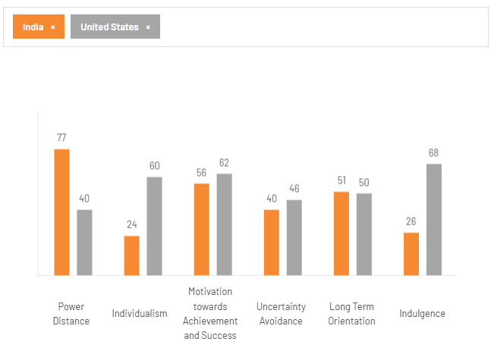
Figure 3: Hofstede Cultural Scores
(Source: The cultural factors, 2026)
The cultural dimensions described by Hofstede are useful to explain the major differences between the USA and India that affect the marketing strategy of KFC. Among the principal differences, individualism and collectivism can be noted. The USA is high in individualism (80), as the consumers here emphasise their own preferences and convenience. This benefits the fast-food industry of KFC, in which people tend to buy food on their own. India, on the contrary, is more collectivist and family and group values are valued. This has an impact on KFC in terms of providing sharing meals and family promotions in the Indian market. The other significant difference is power distance. India has a stronger power distance (77), which implies that people are more comfortable in accepting hierarchical structures and authority. This can affect consumer behaviour and workplace practices. Power distance in the USA (40) is lower and this encourages equality and informal communication, which is compatible with the casual dining culture.
In both nations, uncertainty avoidance is lower (40-46), although Indian customers might uphold their comfort foods that are familiar and not offensive to their culture. This is the reason why KFC is modifying its menu in India to provide vegetarian versions and local taste, although the USA menu is more uniform. Despite the usefulness of the Hofstede model in the comparison of cultures, it also has limited aspects (Minkov and Kaasa, 2021). It makes complete generalisations about a nation and fails to take into consideration regional variations or emerging changes in consumer behaviour in India especially in urban regions where younger generations are more outbound. Nevertheless, despite these drawbacks, the model is quite useful in learning how cultural differences impact the marketing strategies used by KFC in both countries.

3. Comparative STP Analysis
In this analysis, the Segmentation, Targeting and Positioning (STP) framework is applied by assessing the approaches KFC uses in targeting the various consumer groups in the United States and India as opposed to implying that the company follows a formal STP strategy. The strategy will assist in interpreting how KFC has been adjusting its offerings based on the differing market situation, consumer behaviour and cultural expectations.

Figure 4: STP Framework
(Source: By Author)
Segmentation
KFC can be observed to divide the market in the United States with the help of demographic and behavioural variables. The main segments are the young adults, working professionals and families who are concerned with convenience and fast food (Fortune Business Insights, 2026). On the psychographic segment, the consumers are likely to be busy and prefer ready-made fast foods. In behavioural aspects, most of the customers are regular visitors to the quick-service restaurants, where they buy food on the move or individually (Rofgers, 2023). The market can be considered fairly developed, and fast food is integrated into the daily consumption habits.
On the contrary, segmentation in India is indicative of a more developed and diverse market. It is seen that KFC is targeting a city population, especially in the tier 1 and tier 2 cities, where the population is more exposed to international brands (Shyam Future Tech, 2025). The target is also demographically composed of the younger consumer and the growing middle class, with increasing disposable income. Indian consumers psychologically are still under the influence of the Western lifestyle, although they do not fail to uphold strong cultural and traditional values (Shah, et al., 2023). The fast food consumption behaviour is less frequent and can be linked to social get-togethers or family outings as opposed to daily activities. Such differences indicate that a better differentiation strategy should be applied to India.
Targeting
KFC in the United States is seemingly pursuing a broad market framework with a target that cuts across a wide market (Oches, 2026). This is an indication that it is more of an undifferentiated or a moderately differentiated strategy in which the brand is aimed at providing convenience, low cost and reliable quality of its products to the mass-market consumer. The fact that the market is mature means that KFC does not have to customise the message to reach a wide audience (Carroll, 2025).
However, the targeting strategy appears more selective and differentiated in India with KFC. The brand is mainly targeted at urban middle-class consumers and younger customers who are more receptive to the global food brands and have more purchasing power (Aziz, 2021). This is indicative of the economic and socio-cultural levels of the Indian market, where not every part of the population is equally likely to consume and be interested in fast food. Consequently, KFC is able to focus its attention on segments that have a higher likelihood of embracing its products.
Positioning
KFC has a different position in the two markets. The brand is considered a convenient and affordable fast-food brand, primarily in terms of taste, speed and familiarity in the United States (KFC, 2026). It is also competing directly with other well-established fast-food chains and it is positioned in a way that is more functional in terms of value and efficiency.
KFC would be established in India as a forward-looking and progressive brand that provides both a Western touch and a local focus. KFC does not lose its global brand image but changes its image to conform to the expectations of the Indian culture. As an example, the possibility of having vegetarian dishes as well as flavours that are inspired by the cultural elements serves to develop an illusion of cultural sensitivity (Nemec, 2020). This cross-positioning enables KFC to attract people who want to be exposed to something new but familiar.
In general, in the analysis through STP, it can be seen that KFC uses a comparatively standardised strategy in the United States but a more modified and oriented strategy in India. Although the STP model offers an appropriate analysis tool, it must be acknowledged that the strategies applied by KFC are more adaptable in practice and are guided by the market statistics instead of being based on theoretical frameworks.

3.1 International Marketing Mix (7Ps)
The KFC international marketing mix shows how it balances the global uniformity and customisation of the United States and India. The strategic difference seems to indicate the dissimilarity in the culture, economic conditions and consumer behaviour, underscoring the significance of a localised strategy in international marketing.

Figure 5: 7 Ps of Marketing
(Source: By Author)
Product
The KFC product range in the United States is relatively standardised where the products are based on fried chicken which incorporates burgers, wings and bucket meals. This is aimed at ensuring uniformity in taste and quality in the outlets, enhancing a good brand identity. The menu is based on the local tastes, with fast food, chicken being a commonly accepted local food.
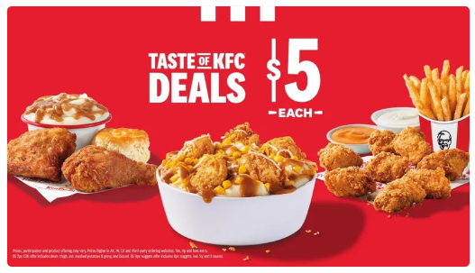
Figure 6: KFC Menu in the US
(Source: Canham-Clyne, 2024)
Comparatively, KFC makes considerable changes to its product approach in India to suit the cultural and religious orientations. One of the main changes includes the introduction of a high number of vegetarian products, including veggie burgers and wraps, which serve a huge population of non-meat-eaters. Moreover, the products can be customised to the local tastes, where they have better spicier flavours and seasoning, which suit the Indian cuisine. The lack of beef and pork products also points to the religious sensibility. Such a level of adaptation makes cultural awareness important in developing products.
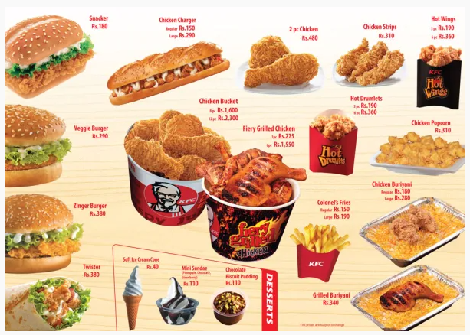
Figure 7: KFC Menu in India
(Source: KFC, 2015)
Price
The two countries have quite different price strategies based on the state of the economy. KFC in the United States employs competitive pricing strategies in the mature market and provides combo meals, discounts and offers (Bhaimiya, 2023). The consumers are also more likely to have more disposable income, which would allow KFC to continue offering a variety of prices and remaining competitive. In India, KFC has been having a value-oriented pricing approach to deal with the low average income and sensitivity of prices (Lau, 2025). The company has a lower-priced menu, reduced portion sizes and buy-ins to appeal to a wider market. The pricing strategy will be strategically attached on the buying capacity of the target market, making it affordable and profitable. This illustrates the effect of economic variables on pricing policies in international markets.
Place (Distribution)
In the United States, KFC boasts a well-developed distribution system that consists of individual outlets, drive-through services and a good deal of integration with the digital ordering system. It is concentrated on convenience so that one can get the products fast and without any problem. The prevalent distribution of outlets promotes high-frequency consumption.
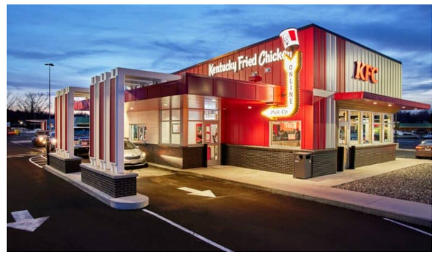
Figure 8: Next Gen KFC in USA
(Source: QSR, 2022)
The distribution strategy of KFC is more centralised towards the cities in India particularly shopping malls, high streets and commercial centres.
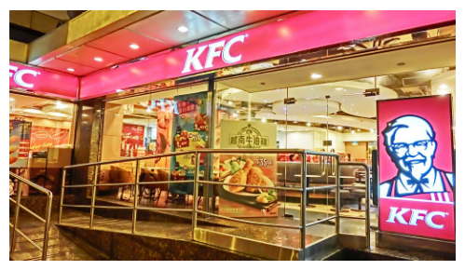
Figure 9: KFC Outlet in India
(Source: Restaurant India, 2015)
Another area that the company highly depends on is online food delivery platforms like Swiggy and Zomato, which have gained popularity in the urban parts of India. Part of the expansion strategy at KFC centers around franchising, where new locations can easily be developed using the local market expertise. Such a strategy indicates disparities in infrastructural systems and consumerism across the two nations.
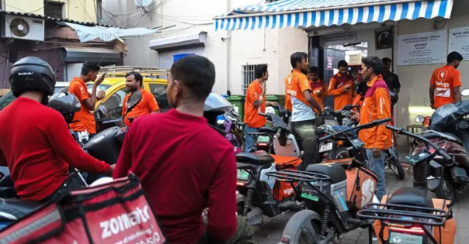
Figure 10: Modes of Food Delivery in India
(Source: Inamdar, 2026)
Promotion
The strategies used in the United States regarding promotions are mostly simplistic, and they are much more concerned with product quality, taste and value. Offers, new products and convenience are the many ad campaigns that are witnessed through both traditional and digital media (Jayasinghe, et al., 2025). The ads are straightforward and practical, just like what consumers need in a highly advanced market. KFC is more localised in its approach towards promotion in India. Marketing campaigns usually use a cultural touch that makes use of humour and emotional appeal in trying to reach the end users. Resonance of the brand is achieved by the use of the regional languages and topics that are culturally relevant to various audiences (Musonda and Siame, 2025). Digital marketing is also important with the younger consumers who are targeted using social media. This shows the necessity of changing the advertisement tactics to fit local cultures.
People
KFC in the United States has had a consistent staffing strategy and was preoccupied with efficiency and consistency in the provision of services. The employees are trained to deliver fast and quality service that is aligned with the requirements of customers who need speed and convenience (Kozhevnikov, 2023). The factor of culture is more culturally caused in India. The staff is also trained to offer a more interactive and service-oriented customer experience that is in line with the local demands of hospitality. Dietary preferences and communication styles are related to cultural awareness, which is essential in achieving customer satisfaction (Miguel, 2024). This emphasises the place of interaction between human beings in the general service experience.
Process
The United States is very standardised in its operational processes and its focus is on speed, efficiency and automation (Rao and Malhotra, 2025). This enables the high customer turnover and fits the dynamism of the market. In India, although efficiency is relevant, there is a differentiation of the process to suit dine-in as well as delivery experience (Nusra, 2026). This has increased the significance of online ordering and the introduction of digital systems in the operations of KFC. But different infrastructures and consumer expectations demand service delivery flexibility. This is an indication of the requirement to adjust the operation processes to the local circumstances.
Physical Evidence
Physical evidence consists of all the things that are touched and touched in the store including the design, layout and the entire ambience of the store. KFC restaurants in America are generally utilitarian and aimed at speed with efficiency as their primary drawing point, as opposed to experience (Kelso, 2025). Most of the outlets in India are usually more attractive and aimed at young consumers and households (Mintel, 2023). The dining experience is increased by contemporary interior, comfortable seating, and a pleasant ambience. Also, KFC's online operation (using mobile applications and web platforms) can be considered a valuable component of the physical evidence in both markets. Generally, the marketing mix comparison depicts that KFC uses a more standardised strategy in the United States and makes major adaptations in India. This represents a balance of strategic balance between the need to have a uniform global brand presence and the need to meet the needs of local markets.

4. Directional Development Strategy
The directional development strategy adopted by KFC in India can be analysed using the Ansoff Matrix. This model provides an organised framework for evaluating growth strategies across product and market combinations (Wei, 2025). India is one of KFC's key growth markets, owing to its large population, middle-income status, and ongoing urbanisation.
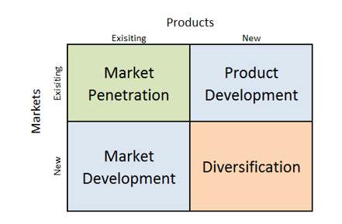
Figure 11: Ansoff Matrix
The market development versus product development describes the strategy that KFC has adopted in India. The development of the market is reflected in the diversification of the company into new cities, mainly tier 2 and tier 3 cities. KFC is expanding its reach to new groups of customers by expanding its physical presence in the form of franchised outlets and delivery platforms (Verdict Food Service, 2023). The plan is based on the fact that the population of India is increasingly favouring quick-service restaurants and the practice of online food delivery. Simultaneously, KFC applies product development through the introduction of menu items that are specifically aimed at the Indian business. This also comes with vegetarian products and localised reforms, which are necessary as the culture and religious eating style dictates. The adaptations show that the cultural differences have a direct impact on strategy choice, especially compared with the more standard model in the United States.
Nevertheless, as much as the Ansoff Matrix is useful in the categorisation of growth strategies, it has limitations. It does not consider completely the outside environmental conditions like competition or regulatory issues which are critical in India. Thus, the strategy of KFC can be interpreted as a dynamic process that depends on the opportunities of the market, as well as cultural limitations. Altogether, the directional strategy of KFC in India points to the significance of market expansion and product adaptation as the tool of attaining sustainable growth in a new market.

5. Ethical Issues in KFC’s Marketing Mix
The marketing practices of KFC in the United States and India put several ethical issues, especially on the issues of health, labour practices and cultural sensitivity. These problems represent larger questions that are connected with the process of globalisation as multinational firms should be able to balance profitability and social responsibility. A major ethical concern is associated with health concerns. Fast food products have been accused of containing high fat content, salt and calories which lead to obesity and other health issues (Mitchell, 2026). KFC is under pressure to bring out healthier food in the United States where the consumption of fast food is common. In India, consumption of fast foods is lower but with increased urbanisation, similar concerns are emerging particularly among the younger consumers.
The other problem is associated with labour practices. KFC is very dependent on frontline service employees in both countries. The issues to be considered include wage concerns, working conditions and job security, especially in franchise operations. Whereas laws are more stringent and well enforced in the United States, labour practices in India are also subject to local circumstances, which can present some ethical dilemmas (Vaidyanathan, 2020). Cultural sensitivity is also an issue. KFC has localised its menu to adhere to religious and dietary preferences, including not serving beef or accommodating vegetarian tastes (McDougall, 2018). This is evidence of ethical sensitivity and cultural sensitivity. The opponents could however say that Western fast foods could also help in the demise of the traditional eating habits.
Overall, KFC has tried to overcome ethical issues, but constant enhancement is still required. The company has a role to strike a balance between its business interests and its duty to enhance health, fair labour practices as well as the cultural diversity in markets.

6. Recommendations for Future International Marketing Strategy
Based on the discussion, some strategic suggestions can be offered to improve the performance of KFC in international marketing in India. The recommendations are guided by the TOWS framework which aligns the internal strengths and weaknesses with the external opportunities and threats.
Table 1: TOWS Matrix
 | Opportunities (Market growth, digital demand) | Opportunities (Market growth, digital demand)
Strengths (Brand, scale) | Expand into tier 2 cities and strengthen digital platforms | Use brand strength to compete and promote healthier options
Weaknesses (Health image) | Introduce a plant-based menu | Improve nutrition and address health concerns
- KFC needs to develop its strategy of product development by diversifying to a healthier and plant-based menu. This will serve to address the increasing health concerns as well as attract a larger customer base in the two markets. This fits in very well with Indian culture, which favours vegetarian food and in the United States, it responds to the growing preference for healthier options.
- KFC needs to enhance its digital marketing and delivery especially in India. As online food delivery services continue to expand at a very high rate, an investment in mobile apps, data-based marketing and collaboration with delivery services will enhance customer interaction and convenience. This would help to develop the market since consumers can access it even outside the conventional physical outlets.
- KFC needs to improve on its sustainability measures such as environmentally friendly packaging and minimisation of waste. This would enhance brand image and address the rising awareness in the environment in the two countries.
- KFC needs to be more integrated in its glocal strategy and still keep its global brand identity and adjust to the situation in the local market. This balance is critical to the success in the long-term in various markets.
All these recommendations are geared towards reinforcing KFC in the competitive market by balancing its strategies with the cultures, economies and ethics in global markets.

7. Conclusion
Altogether, the analysis shows that the international marketing strategy of KFC in the United States and India differs dramatically because of the differences in the cultural, economic and market environment. The results indicate that KFC has a more or less standard strategy in the USA, where consumers behave in a similar manner and the market is developed. Conversely, its approach in India is more flexible culturally because of the sensitive Indian pricing and changing preferences of the consumers. PESTEL, Hofstede, STP and the 7Ps are some of the models that have been used to identify how external and internal environments influence strategic decision-making. Additionally, the analysis of the ethical concerns and strategic advice indicates the necessity of the middle way between international uniformity and local sensitivity. All in all, the ability of KFC to execute a glocal strategy successfully in various markets can determine its success.

Section 2

Reflective Account Using Gibbs Reflective Cycle
This reflective report assesses the procedure that I undertook to research, analyse and write the international marketing report on KFC in the United States and India. The part critically analyses my strategy in applying theoretical constructs like PESTEL, cultural dimensions of Hofstede, STP and the 7Ps marketing mix, using the reflective cycle created by Gibbs. It remarks on my experience, insights and learning experiences during the assignment. The purpose is to evaluate the extent to which I was able to combine theory and practice, to be able to think critically and further my academic writing, as well as to pinpoint the points of further growth in performing marketing research and analysis.

Figure 12: Gibbs Reflective Cycle
(Source: By Author)
1. Description
This evaluation involved doing research and analysis of international marketing strategies of KFC in the United States and India with the help of some of the key frameworks of PESTEL, the cultural dimension model by Hofstede, STP and the 7Ps marketing mix. I started by gathering secondary information using academic journals, textbooks, and trustworthy online websites to know both the markets and the positioning of KFC in the market. It was necessary to construct the report based on the assessment brief and make sure that every part presented the necessary comparisons. I concentrated on the connection of theoretical frameworks to practical cases to immerse the analysis. Saunders et al. (2019) state that to create a credible piece of academic work, systematic research is a must, which is what I attempted to do throughout the assignment.
2. Feelings
At the start of the assignment, I was confused by the complexity of putting many models into practice and ensuring that there was a clear comparison between the two countries. It was not easy to maintain various structures and keep the flow logical at first. However, I got more confident as I went on in relating theory to practice. The cultural analysis was of particular interest to me because it enabled me to know how consumer behaviour is different in different markets. I had some instances of uncertainty on whether my work was critical enough, which made me go through academic material once again in order to polish my arguments. With time, I became more at ease with the process of analysis and was confident in my ability to present structured and evidence-based information.
3. Evaluation
The general procedure was productive in shaping my analytical and research skills. One strength that I have applied well in my work was the combination of various frameworks to give a complete analysis. Indicatively, integrating the Hofstede model with the marketing mix enabled me to describe how cultural differences make strategic choices. According to Zeithaml et al., (2020), the key to successful marketing analysis is the connection between theory and practice. One of the limitations was, however, my initial inclination to concentrate more on the description, as opposed to critical evaluation. I also had a hard time creating a depth of analysis with limitations on word count. Nevertheless, these challenges helped me to improve my skills in the organisation of arguments and the elaboration of information.
4. Analysis
This assignment has shown how the application of theoretical models as an analytical tool and not a fixed structure should be used. As an example, the STP model was used to explain the strategy of KFC instead of believing that the strategy was directly implemented. The views of Blank (2020), suggested that marketing models are supposed to lead analysis, and not spell it out, which was clearly found in this task. Cultural dimensions developed by Hofstede helped in the explanation of the differences between the USA and India in consumer behaviour. Nevertheless, the model has its limitations, since it does not capture the diversity within regions, as it generalises the national cultures (Bouderbala, et al., 2020). Furthermore, credible secondary sources were also used to reinforce the analysis as credible data is the key to successful decision-making (Padhye and Hastaket, 2024).
5. Conclusion
To sum up, the given assignment helped me to deepen my knowledge of the field of international marketing, as well as to gain experience in applying theoretical models in practice. I acquired even better research, critical, and comparative analysis skills. It also assisted me to value the significance of approaching global marketing strategies through cultural, economic and strategic aspects. Although it was difficult to balance between description and critical evaluation, I managed to work on this issue with constant revision. In a general way, the application of the reflective cycle proposed by Gibbs allowed me to take a systematic review of my learning experience and define my strengths and areas of improvement, which will contribute to my academic and professional growth.
6. Action Plan
In the future, I will be more critical in my assignments instead of being descriptive by questioning the constraints of models and offering more profound insights. I will start my research at an earlier stage so that I will have enough time to analyse and revise it. The improvement of better capabilities to synthesise information within various frameworks is also going to be a priority. As well, I would like to work with more academic literature in order to enhance the validity of my work and enhance referencing. The perspectives of Mlambo, et al., (2021) noted that ongoing learning is a key aspect in research development. Through these enhancements, I am hopeful that I will be able to come up with more critical, well-organised and quality academic writing in the future.

References
Aziz, M. (2021) Research on KFC Consumer Satisfaction in UK and India [Online]. Available at: https://www.researchgate.net/publication/359861215_Research_on_KFC_Consumer_Satisfaction_in_UK_and_India [Accessed on: 18 March 2026].
Bhaimiya, S. (2023) KFC owner says its 2-for-$5 deal on fried chicken wraps is winning over low-income shoppers that are being pummelled by rising costs [online]. Available at: https://www.businessinsider.com/kfc-discount-deal-fried-chicken-wraps-attracts-low-income-shoppers-2023-5 [Accessed on: 18 March 2026].
Biswas, S. (2018) The myth of the Indian vegetarian nation [Online]. Available at: https://www.bbc.co.uk/news/world-asia-india-43581122 [Accessed on: 18 March 2026].
Blank, S. (2020) The four steps to the epiphany: successful strategies for products that win. John Wiley & Sons.
Bouderbala, R., Eljammi, J. and Gherib, J. (2020) Relevance of Hofstede's model in identifying specific national cultural character: the case of a North African country. Social Business, 10(3), pp.247-279.
Canham-Clyne, A. (2024) KFC expands $5 meal deal [Online]. Available at: https://www.restaurantdive.com/news/kfc-5-dollar-value-menu-nuggets-famous-bowl/723934/ [Accessed on: 18 March 2026].
Carroll, N. (2025) Where does market share fit in the long-term growth equation? [Online]. Available at: https://www.marketingweek.com/market-share-long-term-growth/ [Accessed on: 18 March 2026].
Ducharme, J. (2018) Almost 40% of Americans Eat Fast Food on Any Given Day, Report Says [Online]. Available at: https://time.com/5412796/fast-food-americans/ [Accessed on: 18 March 2026].
Financial Times. (2026) What fast food’s downturn says about the US economy [Online]. Available at: https://www.ft.com/content/9643e9b8-a4d8-49e2-8c16-20c1a1c5ca4b [Accessed on: 18 March 2026].
Fortune Business Insights. (2026) Fast Food Market Size, Industry Share & COVID-19 Impact Analysis [Online]. Available at: https://www.fortunebusinessinsights.com/fast-food-market-106482 [Accessed on: 18 March 2026].
FSSAI. (2026) About FSSAI [Online]. Available at: https://fssai.gov.in/cms/about-fssai.php [Accessed on: 18 March 2026].
Inamdar, N. (2026) India's thriving online delivery platforms face a year of reckoning [Online]. Available at: https://www.bbc.co.uk/news/articles/cx20qlglgw5o [Accessed on: 18 March 2026].
Jayasinghe, S., Byrne, N.M. and Hills, A.P. (2025) Cultural influences on dietary choices. Progress in cardiovascular diseases.
Kelso, A. (2025) KFC U.S. has big plans for a ‘brand transformation’ this year [Online]. Available at: https://www.nrn.com/quick-service/kfc-u-s-has-big-plans-for-a-brand-transformation-this-year [Accessed on: 18 March 2026].
KFC. (2015) Krazy KFC Mumbai Deals [Online]. Available at: https://kfcaskme.wordpress.com/tag/kfc-menu-prices/ [Accessed on: 18 March 2026].
KFC. (2026) Our company [Online]. Available at: https://global.kfc.com/our-ambitions [Accessed on: 18 March 2026].
Kouamé, T. A. (2024) Gearing up for India’s Rapid Urban Transformation [Online]. Available at: https://www.worldbank.org/en/news/opinion/2024/01/30/gearing-up-for-india-s-rapid-urban-transformation [Accessed on: 18 March 2026].
Kozhevnikov. S. (2023) Delivering Convenient, Personalized And Seamless Retail Experiences [Online]. Available at: https://www.forbes.com/councils/forbestechcouncil/2023/10/20/delivering-convenient-personalized-and-seamless-retail-experiences/ [Accessed on: 18 March 2026].
Lau, S. (2025) KFC Pricing Strategy: Insights into Fast-Food Economics [Online]. Available at: https://newswirejet.com/kfc-pricing-strategy/ [Accessed on: 18 March 2026].
Majumdar, R. (2024) India economic outlook, April 2024 [Online]. Available at: https://www.deloitte.com/us/en/insights/topics/economy/asia-pacific/india-economic-outlook-04-2024.html [Accessed on: 18 March 2026].
McDougall, M. (2018) Kentucky Fried What? KFC will test a vegetarian alternative in UK [online]. Available at: https://edition.cnn.com/2018/06/08/news/kfc-vegetarian-chicken [Accessed on: 19 March 2026].
Miguel, B. (2024) Effects of cultural diversity and intercultural communication on the quality of service and customer satisfaction in hospitality and tourism settings in Brazil. International Journal of Modern Hospitality and Tourism, 4(1), pp.26-37.
Minkov, M. and Kaasa, A. (2021) A test of Hofstede's model of culture following his own approach. Cross Cultural & Strategic Management, 28(2), pp.384-406.
Mintel. (2023) Indian consumer spending trends: Younger generations seek pleasure, preventive health on the rise among parents [Online]. Available at: https://www.mintel.com/press-centre/indian-consumer-spending-trends-younger-generations-seek-pleasure-preventive-health-on-the-rise-among-parents/ [Accessed on: 18 March 2026].
Mitchell, A. (2026) Junk food TV and online advert ban comes into force [online]. Available at: https://www.bbc.co.uk/news/articles/cq5y2vzlyldo [Accessed on: 19 March 2026].
Mlambo, M., Silén, C. and McGrath, C. (2021) Lifelong learning and nurses’ continuing professional development, a metasynthesis of the literature. BMC nursing, 20(1), p.62.
Musonda, N. and Siame, P. (2025) The impact of language on branding: A comprehensive analysis. Linguistic Exploration, 2(1), pp.37-46.
Nemec, K., 2020 Cultural Awareness of Eating Patterns in the Health Care Setting https://pmc.ncbi.nlm.nih.gov/articles/PMC7727853/ [Accessed on: 18 March 2026].
NIH. (2025) Ensuring Safe Food: From Production to Consumption. [Online]. Available at: https://www.ncbi.nlm.nih.gov/books/NBK209121/ [Accessed on: 18 March 2026].
Nusra. (2026) Experience, Efficiency, Expansion: 3 Keys to Reinventing Growth in 2026 [Online]. Available at: https://www.restaurantindia.in/article/experience-efficiency-expansion-3-keys-to-reinventing-growth-in-2026.15233 [Accessed on: 18 March 2026].
Oches, S. (2026) KFC’s secret weapon in U.S. comeback could be its strength in global markets [Online]. Available at: https://www.nrn.com/quick-service/kfc-s-secret-weapon-in-u-s-comeback-could-be-its-strength-in-global-markets [Accessed on: 18 March 2026].
Padhye, S. and Hastak, M. (2024) A framework to evaluate information and source credibility: International construction decision-making. Journal of management in engineering, 40(1), p.04023046.
QSR. (2022) The Next Generation of KFC is Already Here [Online]. Available at: https://www.qsrmagazine.com/operations/fast-food/next-generation-kfc-already-here/ [Accessed on: 18 March 2026].
Railey, S. (2024) KFC Pledges to Eliminate Non-Recoverable/Non-Reusable Plastic Packaging [Online]. Available at: https://www.packworld.com/sustainable-packaging/article/22916488/kfc-pledges-to-eliminate-nonrecoverablenonreusable-plastic-packaging#:~:text=KFC%20Pledges%20to%20Eliminate%20Non,major%20suppliers%20and%20franchisees%20worldwide. [Accessed on: 18 March 2026].
Rao, N. G. and Malhotra, K, J. (2025) What’s Coming for US Manufacturing in 2025 [Online]. Available at: https://www.nist.gov/blogs/manufacturing-innovation-blog/whats-coming-us-manufacturing-2025 [Accessed on: 18 March 2026].
Restaurant India. (2015) KFC outlets in parts of North India non-operational from over a month [Online]. Available at: https://www.restaurantindia.in/article/kfc-outlets-in-parts-of-north-india-non-operational-from-over-a-month.6528 [Accessed on: 18 March 2026].
Rofgers, E. (2023) 75+ Fast Food Consumption Statistics [Online]. Available at: https://www.driveresearch.com/market-research-company-blog/fast-food-consumption-statistics/ [Accessed on: 18 March 2026].
Segel, E. (2026) Why Political Risk Is Now A Top Threat For Companies [Online]. Available at: https://www.forbes.com/sites/edwardsegal/2025/10/20/why-political-risk-is-now-a-top-threat-for-companies/ [Accessed on: 18 March 2026].
Shah, P., Agrawal, S., Joby, J., Ansari, S., Bhandari, R. and Bhatt, I. (2023) Prevalence of Indian Culture over Western Culture in 21st Century. Integrated Journal for Research in Arts and Humanities, 3(5), pp.230-239.
Shyam Future Tech. (2025) KFC [Online]. Available at: https://shyamfuture.com/kfcs-marketing-strategy-actions-that-led-to-kfcs-success/?srsltid=AfmBOopVR3T2tS1RIusoYMT1JOdKstYfHdlQnZA8o_QIz_gkrxwgoxxw [Accessed on: 18 March 2026].
The Cultural Factors. (2026) Country Comparison tool [Online]. Available at: https://www.theculturefactor.com/country-comparison-tool?countries=india%2Cunited+states [Accessed on: 18 March 2026].
Vaidyanathan, R. (2020) Indian factory workers supplying major brands allege routine exploitation [Online]. Available at: https://www.bbc.com/news/world-asia-54960346 [Accessed on: 19 March 2026].
Verdict Food Service. (2023) KFC to bolster its presence in Romania and India [online]. Available at: https://www.verdictfoodservice.com/news/kfc-bolsters-presence-romania-india/#:~:text=The%20opening%20of%20its%201%2C000,and%20data-informed%20artificial%20intelligence. [Accessed on: 19 March 2026].
Wang, J. and Azam, W. (2024) Natural resource scarcity, fossil fuel energy consumption, and total greenhouse gas emissions in top emitting countries. Geoscience frontiers, 15(2), p.101757.
Wei, Y.M. (2025) A hybrid multi-criteria decision-making framework for the strategic evaluation of business development models. Information, 16(6), p.454.
Yahoo Finance. (2026) North America Online Food Delivery Market Report 2025-2033: Healthy Meal Demand, Convenience Culture and Improved Delivery Logistics Propel the Market Toward $105.8 Billion [Online]. Available at: https://finance.yahoo.com/news/north-america-online-food-delivery-135100782.html [Accessed on: 18 March 2026].
Yum Brands. (2026) KFC [Online]. Available at: https://www.yum.com/wps/portal/yumbrands/Yumbrands/company/our-brands/kfc [Accessed on: 18 March 2026].
Zeithaml, V.A., Jaworski, B.J., Kohli, A.K., Tuli, K.R., Ulaga, W. and Zaltman, G. (2020) A theories-in-use approach to building marketing theory. Journal of Marketing, 84(1), pp.32-51.

