Student Name: Krinalben Rajeshbhai Patel

Student ID: 2531474

Module Code: LCHS7002

Module Title: Health Care System Organisation and Leadership

Lecturer’s Name: Shaila Hussain and Tonia Babalola
Assignment Title: Leadership, Governance and Systems Thinking in Improving Patient Safety: A Case Study Analysis of Infant Morphine Overdose in the NHS

Academic Year/Semester: 2026 Semester 1

Table of Contents

1. Introduction 4
Background and purpose of the chosen case study 4
Leadership in health and social care 4
Centralisation, decentralisation, and leadership theories 4
Importance of an appropriate leadership style 5
Overview of the report 5
2. Main Body and Analysis 5
a. Identifying the Problem and Setting the System Context 5
Central Problem in the Case Study 5
Global Statistical Perspective 6
Systemic Weaknesses Reflected in the Morphine Overdose Case 7
Governance Levels Influencing the Incident 7
Underlying Challenges Contributing to the Error 7
b. Centralisation or Decentralisation within the Case Study 9
Centralised System in NHS Medication Governance 9
Decentralised System in NHS Practice 10
Critical Comparison: Impact on Crisis Management and Accountability 11
c. Leadership Theories and Application to the Case Study 12
Transformational Leadership 12
Transactional Leadership 13
Situational Leadership 14
Emotional Intelligence and Safety Culture Leadership 16
d. Improvement and Lessons Learned 17
Problem–Data–Improvement Analysis 17
Feedback, Interaction and Structure of the System Leadership 19
Health Organisation Lessons 19
Evidence and Data Role in Continuous Improvement 20
Recommendation 20
Next steps in the organisation 20
Improved leadership style for sustaining improvement 20
Strengthening governance, communication, and systems integration 21
Enhancing technical and allocative efficiency 21
Continuous learning, stakeholder engagement, and co-production 21
Conclusion 22
References 23

1. Introduction

Background and purpose of the chosen case study
The current report focuses on an infant morphine overdose incident at the National Health Service (NHS), where a dose of the drug, which was four times higher, was administered, leading to a risk of an even more life-threatening scenario. The issue of unsafe medication practices has produced a large amount of harm and financial loss worldwide, and research has shown that the expenses of medication errors are estimated to approximately equal $42 billion annually and are the foremost reason of avoidable injury (WHO, 2022c). In the UK, medication-related events are high, which means that there are inherent risks within the system of prescription and dispensing (England NHS, 2025). Thus, the chosen case study can evaluate the reasons and prevalence of medical error by analysing infant morphine overdose and generate effective recommendations to mitigate these types of complications.

Leadership in health and social care
The skills to impact, direct, and coordinate individuals and teams to achieve shared goals, particularly patient safety, care quality, and service efficacy, can be considered leadership in health and social care (Huang et al., 2022). Effective leadership is not only essential in complex health care centres that demand the use of multidisciplinary groups in stressful situations. Effective leadership is linked with enhanced staff engagement, fewer errors, and superior patient outcomes.

Centralisation, decentralisation, and leadership theories
The healthcare systems have different types of governance frameworks which influence decision-making and accountability. Centralisation refers to the process in which the levels at which decisions are made are moved higher towards the organisation, and the process leads to standardisation, regulation and uniformity (Wale, 2025). Decentralisation, in its turn, dilutes the power to local units, and the process of decision-making becomes more adaptable (Wale, 2025). The leadership theories provide important guidance as to how the leaders operate within such systems. Transformational leadership is vision-focused, innovative and motivating as opposed to transactional leadership that is compliance-focused, structure and performance management (OFENIMU, 2025). The situational leadership emphasises the importance of flexibility, by changing leadership strategy based on the situation (Wang et al., 2024). The theories play a pivotal role in the analysis of the effect of leadership behaviours on the outcome of healthcare.

Importance of an appropriate leadership style
The appropriate leadership style to adopt during a period of crisis or where there is a lot of risk, such as medication safety, is particularly worthy of selection. Lack of effective leadership can lead to inadequate communication, slowness in decision-making, and accountability, which eventually introduces risks and bias in workplaces (Modise, 2024). However, effective leadership could have a positive effect on the alignment of the team, improve risk management, and offer timely interventions (Olatoye et al., 2024). Therefore, the leadership level has a direct impact on the performance, safety culture and organisation resilience of healthcare. Thus, the level of leadership directly influences healthcare performance, safety culture and organisational resilience.

Overview of the report
The case in this report is analysed using systems thinking so as to establish the gist of the issue and the bigger picture. It analyses the influence of centralisation and decentralisation in decision making, uses the important theory of leadership in evaluating effectiveness and also looks at failures to govern. It then indicates the innovations and learning, which ends with evidence-based recommendations that may enhance the safety of the patients, leadership practice and organisational performance.

2. Main Body and Analysis

a. Identifying the Problem and Setting the System Context

Central Problem in the Case Study
The key issue in this case study is a serious medication safety incident concerning an infant patient who received a dose of morphine that was about 20 times greater than the desired dose because the wrong concentration was dispensed (NHS North Yorkshire, 2023). This happened due to the incorrect distribution of a high-risk RED drug, which is not supposed to be used by anyone but specialists in hospitals, and due to poor communication with the nursing staff (NHS North Yorkshire, 2023). This points to a failure in the prescribing, dispensing, and patient education process that proves that the problem was not a single human error but a system-wide failure of various actors and guards. The similarity of occurrences that happened after the year 2018 also demonstrates that there is a trend of uncontrolled systemic risk in medication safety systems.

Global Statistical Perspective
Medication errors are one of the significant and sustained patient safety issues at the global level. The number of patients who suffer harm due to unsafe care is estimated at 1 per 10 patients worldwide, of which over half of the damage is deemed to be preventable and a sizeable fraction is directly associated with medication-related problems, reflecting the systemic nature of unsafe care in healthcare systems (WHO, 2023). Moreover, the costs of medication errors are enormous, which underscores the proportion of ineffectiveness and damage of unsafe medication practices (WHO, 2022c). These statistics support that what happened in this case study is a trend in the world in terms of system weaknesses, or not an individual incident.
In the UK, medication safety incidents remain a major issue for the healthcare system. Medication errors, especially at the stages of prescribing and dispensing, are linked to large amounts of reported patient safety incidents and are highly prone to both human and system-related failures. Opioids, such as morphine and similar, provide temporary relief but might lead to addiction and severe health problems when used continuously, such as overdoses and heart disease (NHS, 2023). Among the possible side effects, one should single out excessive sleepiness, constipation, slowed breathing, and hormonal imbalance (NHS, 2023). The use of opioids in England is given to more than 1 million individuals in a period of over three months without any consideration of the dangers involved. NHS England strives to resolve it with its Medicines Safety Improvement Programme (NHS, 2023). This is more devastating to infants, as they are likely to be morbid due to a lack of proper medicine.
The case of infant morphine overdose represents a broader trend of medication safety failures revealed by national and international organisations. Medication incidents are most often supported as a patient safety issue in England. Conventional attempts to identify adverse events have emphasised voluntary reporting and error monitoring (IHI, 2025). Nevertheless, researchers in the field of public health have confirmed that fewer than 10 to 20 per cent of errors are actually reported, and those reported do no harm to patients (IHI, 2025). This concurs with the world in which the World Health Organisation asserts that medication-related harm impacts millions of patients annually and is a major cause of preventable harm. Recurring similar cases of morphine overdose among infants in the NHS case study suggest that high-risk drugs, especially opioids, continue to pose a serious vulnerability in both national and global health care systems.

Systemic Weaknesses Reflected in the Morphine Overdose Case
The morphine overdose episode indicates the systemic flaws in the communication, accountability, and safety design. The false dispensing of a high-concentration morphine solution, a high-risk RED drug, and ambiguous guidelines to the caregivers illustrate deficiencies in communication between the professionals and in patient education. Medication safety studies have demonstrated that errors in dosing are especially prevalent in paediatric practice, as weight-based strategies and formulation variability present greater risks of serious harm in case of morbid safety failures (Hannibal et al., 2025). The lack of a good system of double-checks and failing risk communication permitted, in this situation, the delivery of the mistake to the patient, indicating a problem with the overall system design instead of targeting human error.

Governance Levels Influencing the Incident
Various levels of governance failed to complement one another, which led to the overdose. NHS policies at the national level make it clear that high-risk drugs, such as concentrated morphine solutions, are not prescribed and dispensed in settings of experts (NICE, 2020). But these preventive measures were not, in reality, brought into force. Local pharmacy and prescribing procedures were not followed according to safety regulations, which demonstrated a lack of organisational supervision and responsibility in the NHS England framework. Such a disconnect between policy on the national and local levels indicates the shortcomings of governance structures and surveillance measures. On the whole, bad governance on various levels was a contributing factor to the incident.

Underlying Challenges Contributing to the Error
A number of inherent problems led to the morphine overdose, and they include strains on the workforce, a complex system, and medications that are dangerous to handle. It has been shown that Insufficient drug checks, communication challenges among staff, staffing deficiencies, communication gaps and high workload workplaces provide more opportunities to cause dispensing and prescribing errors, especially in complicated medication procedures (Alrowily et al., 2025). Moreover, high-alert medications include morphine as well because of their low therapeutic index and high toxicity and must be highly controlled and monitored (Arauj et al., 2025). A further factor that puts children at a disadvantage is the complexity involved in dosing since even the slightest error can result in some serious consequences.
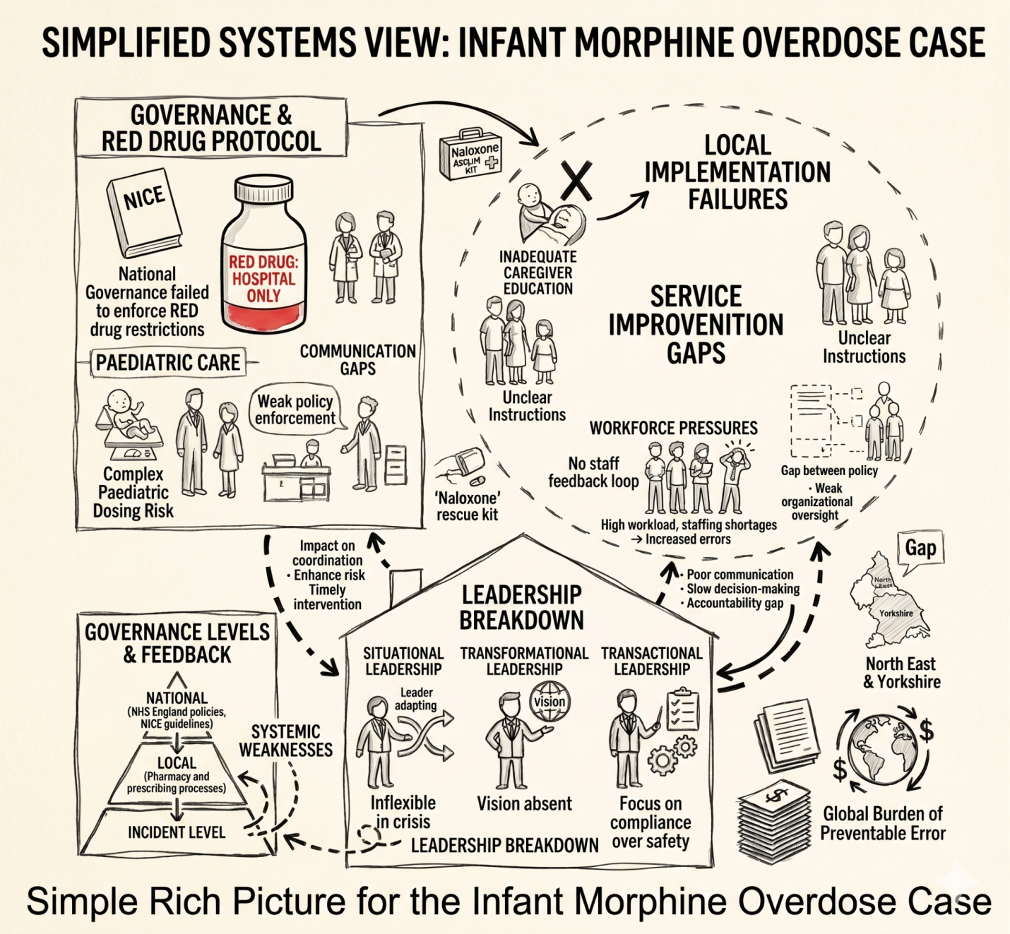
Figure 1: Rich Picture
(Source: Author)

b. Centralisation or Decentralisation within the Case Study
The NHS has a hybrid system of governance that is a mixture of centralised national policies and decentralised local implementation. In an infant morphine overdose scenario, dysfunctions had occurred in several levels of this system. This section examines how either centralisation or decentralisation led to the error, and the effect of governance structures on patient safety outcomes.

Centralised System in NHS Medication Governance
Centralisation is a type of governance in which the power of decision-making is centralised at a national level and in which organisations like NHS England and the National Institute of Health and Care Excellence (NICE) are mainly involved (Perin, 2025). For the NHS, this implies that the clinical policies, drug classification and medication safety standards are centrally formed to create the uniformity, regulation and safety of patients across all health care environments in the UK. The case study features morphine sulphate oral solution, a high-risk drug known as a RED drug, the 100mmol/l formulation, and is not prescribable to anyone but experts in the field. According to NHS and NICE guidelines, specialists should initiate high-risk opioids, dispensing them rigorously in secondary care, not providing them in the community, due to the possibility of making fatal dosage mistakes (Wickremsinhe et al., 2024). Though there was this apparent national limitation, the erroneous higher concentration preparation (10mg/5ml) was given, which was a direct cause of the overdose incident. The benefits of centralisation are also the standardisation of safety measures throughout the UK, so all healthcare systems adhere to the same guidelines(Gupta et al., 2023). It also minimises differences in practice in prescribing and reinforces national patient safety models like the NHS Medicines Safety Improvement Programme. The aim of these systems is to reduce unnecessary damage and enhance medication control.
There are, however, drawbacks to centralisation. The policy-practice gap was evident in this instance, with no advice provided nationally to deter recurring occurrences. There are at least five reported similar morphine overdoses since 2018, one of which involves the death of an infant (NHS North East and Yorkshire Integrated Care System, 2023). Also, according to the WHO (2022a), medication errors lead to the estimated annual global healthcare costs of $42 billion, which demonstrates the extent of failure in the system. The centralised controls in practice are further reduced by poor enforcement, lateness of safety communication, and non-compliance of the frontline due to workload pressures.

Decentralised System in NHS Practice
Decentralisation is a form of government where the decision-making power is disseminated to the local level, i.e. NHS trusts, hospitals, community pharmacies and individual clinicians. This implies that frontline healthcare professionals must prescribe, dispense, administer, and convey directives on medication to patients and their caregivers in the NHS (Durham, 2023). In the current case study, there is an element of decentralisation in the administration of morphine sulphate in the community, in which the infant received an incorrect concentration (10mg/5ml rather than 100 micrograms/ml) of morphine sulphate. This should be considered an example of local-level pharmacy verification, prescribing, and caregiver-patient communication failure and allows a risky medication error to be made. There are a number of benefits of decentralisation. It allows clinical decision-making to be made faster in an emergency care or urgent care scenario, and the treatment to be individualised to the needs of the patient. It also lessens the burden on the central NHS institutions and enhances adaptability when it comes to service provision. These advantages, however, are highly reliant on effective local systems of safety.
Although this is the case, significant drawbacks are emphasised in this case. Decentralised systems can lead to a lack of uniformity in the application of national guidelines and a higher risk of human error, especially in weight-calculated dosing, such as in paediatrics. Poor communication among hospital services, pharmacists and caregivers is another factor contributing to the risk. Moreover, there were no effective checks and balances at the local chart which added to the collapse. The volume of the problem is evidenced by supporting data all over the world. According to the reports of the World Health Organisation, in hospitals across the world, at least one out of every ten patients is harmed in the process of hospital care, almost half of the cases being avoidable (WHO, 2019). Moreover, it has been estimated that medication errors alone incur about US$42 billion per year (WHO, 2022b). These results underline the observation that decentralised medication systems necessitate more effective protection, particularly in regard to high-risk medications, like opioids.

Critical Comparison: Impact on Crisis Management and Accountability
NHS centralisation offers a significant safety framework to aid in crisis prevention and standardisation. National policies here, like the national schedules of RED drug, which classifies morphine sulphate, clearly limit the prescription of high-concentration formulations of morphine as an opioid to specialist hospital settings. It has been supported by national medicines governance programmes such as the NHS Medicines Safety Improvement Programme, whose aim is to minimise the harm posed by high-risk medicines by carrying out standard controls and national governance.
Nevertheless, the centralisation is also quite weak in crisis management. Proper enforcement strategies had been laid down at the national level, though there were weak enforcement mechanisms at the local level, thus enforcing could not always be enforced. The fact that similar morphine overdoses were reported in five cases since 2018, with one of the cases being an infant death, proves that central policy alone could not save repetitive harm (NHS North East and Yorkshire, 2023). Moreover, real-time monitoring is weak across NHS regions, thus hindering timely identification and response to any safety hazards arising. Decentralisation also helped to create failure at the front-line level. The wrong concentration of morphine was dispensed through the local pharmacy and prescribing system, which suggests that there was a misunderstanding of the evidence or non-observance of the national recommendations. Miscommunications among health care providers and caregivers also contributed to a higher risk of misdosing. Local practice lacks standardised systems of double-checking, and the error was not intercepted at several stages.
There was great fragmentation of accountability in this case. Prescribers, pharmacists, and caregivers shared adequate responsibility, and there was no apparent area of failure. This spreading of responsibility made organisational learning weaker and postponed action by correcting the situation. Evidence is inclusive of broader systemic concerns. Every 10 patients are harmed in the course of healthcare services around the world, and a great part of these cases can be avoided (WHO, 2023b). No medication errors are also estimated to be reported, which means that systems learn less and improve less (Institute for Healthcare Improvement, 2026). These results affirm the continued flaws in centralised control and decentralised implementation, specifically of high-risk drugs like opioids.

c. Leadership Theories and Application to the Case Study

Transformational Leadership
Transformational leadership is a type of leadership that is aimed at developing a common vision, inspiring employees, promoting innovation, and empowering medical workers to work better (Mohammed and AL-Arrow, 2022). Transformational leadership would be desired to help advance open communication in the infant morphine overdose case, foster incident reporting, and instil lessons on the prior medication errors to practice. It would also be the role of leaders to be sure that system redesign is done in case of repeated safety incidents, especially in high-risk settings like, but not limited to, opioid prescribing, as well as paediatric medication management. Nevertheless, the fact that similar cases involving morphine have occurred since 2018 shows that the lessons of failure were not successfully learned to be translated into an enduring change (Gan et al., 2026). This points to the loopholes in the implementation of transformational leadership-based concepts into the daily practice of clinical governance and safety. The NHS Patient Safety Strategy (2019) supports the idea that good leadership and learning cultures are critical in diminishing preventable harm and states that unsafe care has already remained a major burden on NHS resources and staff performance (NHS England, 2026).
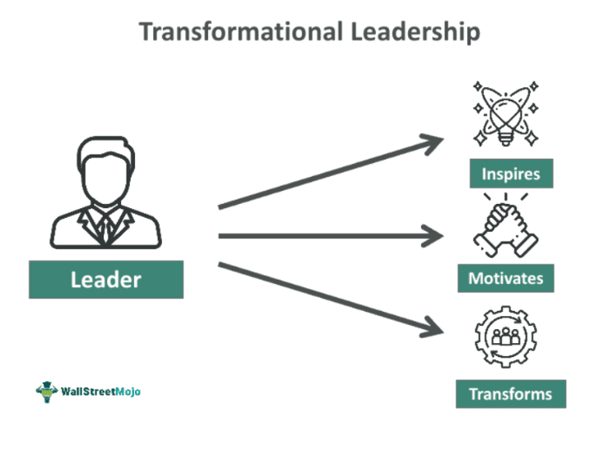
Figure 2: Transformational Leadership
(WallStreetMojo, 2026)

Transactional Leadership
Transactional leadership is a type of management that is structured in terms of rules, compliance, performance monitoring, and accountability (OFENIMU, 2025). The transactional leadership is noted in the NHS infant overdose of morphine case, where the drug classification system (red) was used to classify high-risk drugs that needed absolute control. According to the NHS and NICE prescribing guidance, concentrated morphine preparations do not have to be started by specialists and should be dispensed only in a secondary care environment, with a great limitation on supplying them in the community (Martus et al., 2024). But one of the problems mentioned in the case is a serious failure in enforcement. There were, however, some explicit national policies, although these were not always enforced locally, which meant that central directions and local practice were not in agreement. This indicates that leadership was more rule-oriented, but there were no effective monitoring, auditing, and enforcement to enforce compliance. More importantly, the number of morphine overdoses since 2018 has provoked the repeat of the event, which only illustrates that transactional measures were not enough to avoid damage (Foojan Zeine et al., 2024). The recurrence of high-risk medication errors in spite of severe policies is a manifestation of deficiencies in implementation and not policy design. According to the safety data available at NHS England, medication incidents are one of the most frequently reported patient safety events, and prescribing and dispensing errors still play a major role in causing preventable harm (NHS England, 2026). This underscores the fact that transactional leadership that lacks effective enforcement and secondary regulations cannot be able to guarantee medication safety on a comprehensive basis.
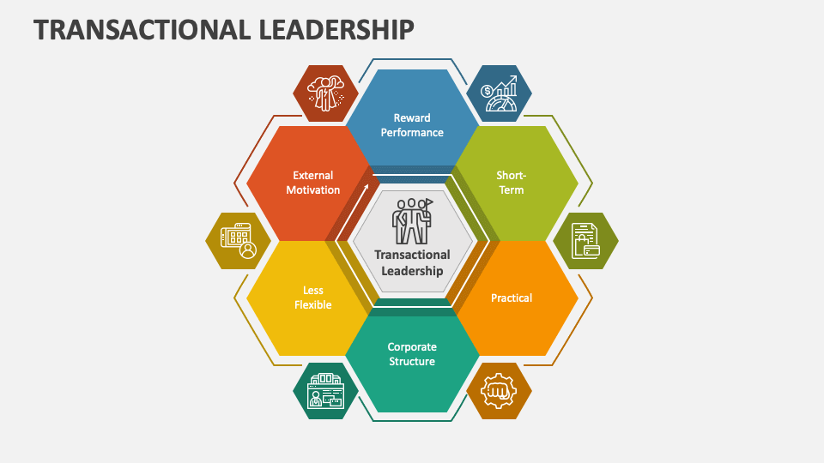
Figure 3: Transactional Leadership
(Source: Collidu, 2026)

Situational Leadership
Situational leadership is a situational leadership style, according to which leaders are able to change the flexibility of the leader style and respond to the situation, urgency, and degree of risk (Klarström et al., 2025). Situational leadership is very applicable in the case of the infant morphine overdose since paediatric opioid prescribing is a very risky area. Morphine is a light-sensitive drug whose therapeutic index is very limited, and any error in the amount of morphine administered to a child may cause fatalities (Alyami, 2025). This necessitated closer controls with improved checks and balances, expert supervision, and increased dispensing precautions. Nevertheless, the fact that the mistake occurred implies that there was a lack of sufficient methods of leadership to adjust to the increased risk level.
The most important issue is that there seems to be a lack of escalation of paediatric medication management safety measures. There was a weak dynamic risk assessment and poor adjustment of controls to the clinical context, with standard procedures being implemented in the face of higher vulnerability of the patient group. This is an indication of deficient situational awareness and responsive leadership in the medication governance systems. The World Health Organisation says that medication errors continue to become one of the most common causes of avoidable harm in the healthcare sector worldwide, with paediatric patients being especially susceptible since giving them a dose based on weight is a complex matter (WHO, 2023b). Medication errors in NHS patients indicate that they often arise at the stages of medication prescription and dispensing as well, which explains the necessity of more context-specific leadership and risk heightening in the high-anxiety medication management.

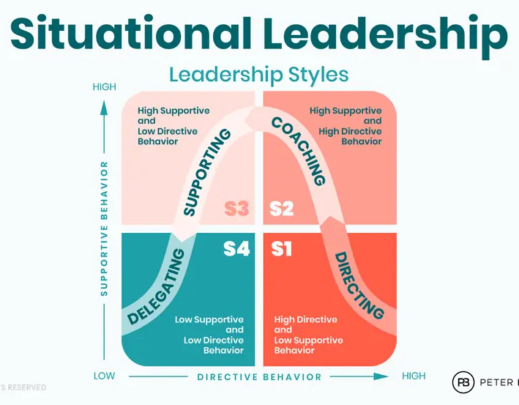
Figure 4: Situational Leadership
(Source: Boolkah, 2026)

Emotional Intelligence and Safety Culture Leadership
Emotional leadership intelligence is a trait describing how leaders are able to identify and respond to their emotions and also identify and address the emotions of others (Drigas et al., 2023). The infant morphine overdose case would have heavily relied on emotional intelligence to promote open dialogues between the healthcare personnel and the caregivers, and to make the staff report near misses or drug mysteries in the initial stages. Effective multidisciplinary communication between the prescribers, pharmacists, and nursing staff would be the basis of a strong safety culture to guarantee accurate dosing and checking on high-risk medicines like morphine.
Nevertheless, weaknesses in safety culture and psychological safety are addressed in the case. The fact that the same incidents were reported multiple times implies that the errors might not have been reported, discussed, and used to learn about the system consistently (Rezazade Mehrizi et al., 2022). This implies less openness and possibly fear of irresponsibility that may deter the frontline personnel from raising issues. Recent studies indicate that reporting under-reporting is a big problem within the healthcare systems. According to the Institute of Healthcare Improvement, up to 80 to 90 percent of medical errors are not officially reported, and this prohibits organisational learning and system enhancement (Health Data Management, 2022). The World Health Organisation also discusses that unsafe care is one issue that causes a substantial amount of preventable damage in the world, and further supports that it is necessary to have better safety cultures and leaders who are emotionally intelligent (WHO, 2023). NHS patient safety models also point to continuing difficulties with building open, blame-free reporting systems.
An analysis of the theories of leadership used in this case brings out the fact that there was no single leadership style that was efficiently implemented in a combined form. Transactional leadership was characterised by strict rules and guidelines, whereas transformational leadership took the goal of enhancing a learning and safety culture, yet both lacked practical essence. Cyclical leadership was unable to reduce controls to high-risk environment of paediatric medication, and emotionally intelligent leadership proved deficient in encouraging open communications and reporting.

d. Improvement and Lessons Learned
The case of the infant morphine overdose shows that there was a severe lack of interaction between leadership and governance, where there were great policies on the national level, but they were not great policies in translating into safe frontline practice. NHS governance mechanisms have provided adequate clarity as to the high-risk nature of morphine as a so-called RED drug limited to the specialist environment, but were not sufficiently effective in enforcing policy at the local level. Only after recurring incidents were all these measures, such as issuing safety alerts and reinforcing policies, implemented, implying that the leadership style adopted was reactive and not proactive. This paradox between governance purpose and execution by leaders enabled systemic risk to endure and eventually lead to patient harm, proving that policy functionality is reliant on the executability of leadership and its monitoring.

Problem–Data–Improvement Analysis
Problem 1: Policy–practice gap due to weak leadership enforcement
The wrong concentration of morphine was dispensed in a community environment despite the hard national guidance demonstrating a clear failure of centralised governance and local implementation. In England, it is estimated that 237 million medication errors are committed every year, 66 million being clinically significant, suggesting that a great number of healthcare systems face significant challenges when it comes to implementation (Elliott et al., 2021). It is estimated that avoidable adverse drug events cost the NHS 98M a year, occupying 181,626 bed-days, and 1708 deaths (Elliott et al., 2021). Leadership was not able to operationalise governance by ensuring it was monitored, audited and prevented this by enforcing compliance so that deviation towards the set protocols would not occur.
Improvement: Mandatory audit systems, electronic prescribing to alert, and strong double-check systems should be introduced for the use of high alert drugs. Enhancing leadership responsibility at the operational level would ensure that policies of governance are regularly put into practice and minimise disparity in clinical practice.
Problem 2: Reactive leadership and missed opportunities for prevention
The case shows that most of the leadership acts were reactive, as interventions were only taken on the case after the damage had been done, and other similar incidents were reported since 2018. This implies that it is not utilising the available data to detect and prevent risks early. According to the Institute of Healthcare Improvement, 10-20 per cent of healthcare errors are only reported, which does not provide organisations with the opportunity to learn and act (IHI, 2022). This is a lost opportunity to proactively redesign medication management systems that are highly risky.
Improvement: The proactive, data-driven leadership should take place, which can be improved through the early warning system, trend analysis, and constant monitoring of medication errors. This would facilitate organisations in detecting risks at an earlier stage and eliminating them before they cause damage, instead of rectifying them after they have caused damage.
Problem 3: Communication failure and inadequate caregiver engagement
Poor communication between the healthcare professionals and caregivers was a major factor in the overdose, as morphine was administered incorrectly. Accidental overdoses are frequent in 1- to 4-year-olds, and the number of overdoses due to opioids has risen to more than half in the recent past. Fatal overdoses involving opioids jumped from 24.1% in 2005 to 52.2% in 2018 (Sandelich et al., 2024). This can be significantly attributed to a failure to communicate and educate caregivers to help in safe use of medicine in a paediatric setting.
Improvement: Instigate systematic communication standards, such as simplified labelling, obligatory caregiver counselling, and digital prescribing systems and visible dosage directions. Such precautions would ensure minimization of misinterpretation and enhance safety, especially to the patient groups that are vulnerable like infants.

Feedback, Interaction and Structure of the System Leadership
The combination of a centralised governance structure, a decentralised implementation process, and reactive leadership influenced the result of this case. As governance offered defined policies, leadership lacked enforcement across local environments. Decentralised systems could enable flexibility, but did not provide enough control with the risk of error. The system also had weak mechanisms of feedback and underreporting that helped to strengthen a cycle of repetitive failure due to limited chances to learn. It goes to show that the governance structures incorporated with system feedback and operational practice through effective leadership affect patient safety outcomes.

Health Organisation Lessons
The case teaches valuable lessons to healthcare organisations all over the world. To start with, support for governance structures should go hand in hand with good leadership in order to facilitate implementation and adherence. Second, leadership should be transformed into both reactive and proactive strategies, leveraging the use of data and evidence to predict and avoid risks. Third, the communication networks should be enhanced, especially in the areas where there is a high risk, like in paediatric medication management settings. Lastly, organisations should focus on developing a safety culture where transparency, accountability and learning are promoted. These teachings emphasise the significance of integrating leadership, governance, and system design to enhance patient safety outcomes.

Evidence and Data Role in Continuous Improvement
It is through evidence and data that the healthcare systems are ensured to continuously improve and develop accountability. Data helps organisations to track trends, measure performance, and take specific interventions to minimise harm. Evidence-based practice can help enhance patient safety and mitigate avoidable harm across the world (Cascini et al., 2021). Leadership needs to make sure that data is proactively utilised to make more informed decisions, enhance the system design, and track the long-term results. This confirms the effectiveness of integrating evidence, leadership, and governance as crucial to sustainable improvement.

Recommendation

Next steps in the organisation
The organisation ought to focus on enhancing medication safety mechanisms by ensuring that high-risk drug protocols, especially the use of morphine in paediatrics, are strictly adhered to. This involves the introduction of electronic prescribing systems with inbuilt alerts, limitation of access to specialist-only drugs in use, and the use of mandatory double-checking processes before dispensing and administration. Enhancing system checks at the point of care would guarantee safer medication practice and minimise harm that can be prevented. For further developments, some impactful strategies are recommended below.

Improved leadership style for sustaining improvement
A transformational leadership that surrounds an adaptive leadership approach is suggested to maintain long-term change. With the assistance of transformational leadership, fostering a culture of safety, innovation and continuous improvement through staff engagement and incident learning, and adaptive leadership, making sure leaders adjust their way to high-risk situations such as the management of paediatric medication, one can do so. The NHS England points out that patient safety and organisational performance should be optimised with strong and adaptive leadership (Eshete and Kassahun, 2025). This synergised leadership style would make it possible to take an active risk management stance and improve organisational resiliency.

Strengthening governance, communication, and systems integration
Regular compliance audits, real-time monitors and proper accountability structures against laxity of compliance to national safety standards should be established to strengthen the governance structures. There ought to be standardisation of communication systems, such as proper medication labelling, designed caregiver counselling, as well as enhanced decentralisation of information among healthcare providers (Adelsjoe et al., 2022). Secondly, the integration of digital health systems at primary and secondary care may help to eliminate fragmentation and enhance coordination. These areas would be enhanced to enhance patient safety and improvement of the reliability of the systems.

Enhancing technical and allocative efficiency
Enhancing efficiency needs more efficient utilisation of resources and technology to reduce errors and maximise care delivery. Automation, such as electronic prescribing and barcode medication administration systems, may be used to improve technical efficiency by minimising human error when dispensing and administering medications (Lindén-Lahti et al., 2022). Directing resources to high-risk areas such as staff training, paediatric safety systems and medication safety programmes are ways to enhance allocative efficiency. The lack of safety in medication practices has been confirmed to be a major contributor to healthcare expenditure across the world, and thus, the necessity to improve the allocation of resources in the healthcare system (WHO, 2022). Such actions would be in place to make sure that the resources utilised are effective in enhancing patient safety.

Continuous learning, stakeholder engagement, and co-production
In achieving sustainable improvement, the organisation should take a continuous learning approach and be backed by efficient data systems and stakeholder involvement. This involves the encouragement of a non-punitive reporting culture, designing staff to report incidents and near misses, and data to inform system redesign. The co-production of patient and caregiver activities, by including them in the creation of communication tools and safety procedures, can also help better understand and prevent mistakes (Sarkhosh et al., 2022). The Institute of Healthcare Improvement emphasises that both learning systems and the involvement of stakeholders are fundamental in enhancing both healthcare quality and safety. Such strategies would reinforce organisational learning and help to maintain improvements in the long-term.

Conclusion
The infant morphine overdose was analysed in this report, to explore how lapses in leadership, governance and system design have led to an avoidable patient safety incident. The results revealed that despite extensive national policies in place in the NHS, there was an apparent disconnect between policy and practice in the local context. The giving out of the wrong morphine concentration led to failures in signal, responsibility, and implementation of the risky medication protocols. Statistics also indicate that medication errors are a common problem in the country and internationally, which supports the view that the case in question is indicative of systemic or broader issues, rather than an isolated one.
The analysis highlighted that leadership was imperative for developing outcomes, and indications suggested that the approach was mainly reactive. Although measures such as safety alerts and policy enforcement were taken, they followed only after repeat tragedies, suggesting a lack of initiative in risk mitigation. Governmental systems offered straightforward guidelines, but a lack of proper implementation and poor oversight curtailed the impact of this occurrence. This centralised and decentralised interaction between policies and execution created vulnerabilities in the system, leading to the error.
In general, the case highlights the need to combine leadership, governance, and systems thinking to achieve significant change in healthcare. The leadership should not only be compliance-oriented but also proactive and data-driven, and the governance should ensure consistent enforcement and accountability at all levels. Systems thinking also enables organisations to see how processes relate to one another to achieve more comprehensive and sustainable improvements in patient safety.

References
Adelsjö, I., Nilsson, L., Hellström, A., Ekstedt, M. and Lehnbom, E.C. (2022) ‘Communication about medication management during patient–physician consultations in primary care: a participant observation study’, BMJ Open, 12(11), p. e062148. Available at: http://dx.doi.org/10.1136/bmjopen-2022-062148 (Accessed: 15 April 2026).
Alrowily, A., Alfaraidy, K., Almutairi, S., Alamri, A., Alrowily, W., Abutaleb, M., Zaitoun, M., Sarawi, W. and Aljead, M. (2025) ‘High-risk medication errors: insight from the UK national reporting and learning system’, Exploratory Research in Clinical and Social Pharmacy, 17, p. 100531. Available at: https://doi.org/10.1016/j.rcsop.2024.100531 (Accessed: 15 April 2026).
Alyami, A. (2025) ‘Assessment of medication dosing errors in paediatric intensive care units: a prospective observational study’, Vascular and Endovascular Review, 8(1s), pp. 364–372. doi: https://doi.org/10.64149/J.Ver.8.1s.364-372.
Araújo, J.L., Moraes, E.B.D., Chistovam, B.P. and Magalhães, A.L.P. (2025) ‘Safety of palliative cancer patients using morphine for pain control: scoping review’, BrJP, 8, p. e20250006. Available at: https://doi.org/10.5935/2595-0118.20250006-en (Accessed: 15 April 2026).
Boolkah, P. (2026) Situational leadership: The effectiveness of the situational leadership model. Available at: https://boolkah.com/situational-leadership/ (Accessed: 15 April 2026).
Cascini, F., Santaroni, F., Lanzetti, R., Failla, G., Gentili, A. and Ricciardi, W. (2021) ‘Developing a data-driven approach in order to improve the safety and quality of patient care’, Frontiers in Public Health, 9, p. 667819. Available at: https://doi.org/10.3389/fpubh.2021.667819 (Accessed: 15 April 2026).
Collidu (2026) Transactional leadership PowerPoint template. Available at: https://www.collidu.com/presentation-transactional-leadership (Accessed: 15 April 2026).
Drigas, A., Papoutsi, C. and Skianis, C. (2023) ‘Being an emotionally intelligent leader through the nine-layer model of emotional intelligence’, Sustainability, 15(10), p. 8103. Available at: https://www.mdpi.com/2071-1050/15/10/8103.
Durham, W. (2023) Factors affecting the implementation of best practice in medication administration by nurses in a UK NHS trust. Available at: https://aru.figshare.com/articles/thesis/Factors_affecting_the_implementation_of_best_practice_in_medication_administration_by_nurses_in_a_UK_NHS_trust/23761608 (Accessed: 15 April 2026).
Elliott, R.A., Camacho, E., Jankovic, D., Sculpher, M.J. and Faria, R. (2021) ‘Economic analysis of the prevalence and clinical and economic burden of medication error in England’, BMJ Quality & Safety, 30(2), pp. 96–105. Available at: https://doi.org/10.1136/bmjqs-2019-010206 (Accessed: 15 April 2026).
Eshete, B.A. and Kassahun, T. (2025) ‘Adaptive leadership, organizational culture and patient-perceived service quality in private healthcare: evidence from Addis Ababa’, International Journal of Health Care Quality Assurance, pp. 1–16. Available at: https://doi.org/10.1108/IJHCQA-09-2025-0136 (Accessed: 15 April 2026).
Foojan Zeine et al. (2024) ‘Solving the global opioid crisis: incorporating genetic addiction risk assessment’, Journal of Addiction Psychiatry, 8(1), p. 50. Available at: https://pmc.ncbi.nlm.nih.gov/articles/PMC11615735/.
Gan, T. et al. (2025) ‘Fifth consensus guidelines for the management of postoperative nausea and vomiting’, Anesthesia & Analgesia, Appendix 1. Available at: https://cdn-links.lww.com/permalink/aa/f/aa_1_1_2025_09_14_gan_aa-d-25-00465_sdc1.pdf (Accessed: 20 February 2026).
Gupta, S. et al. (2023) ‘Implementing standardized health protocols for enhanced occupational safety’, Health Leadership and Quality of Life, (2), p. 196. Available at: https://dialnet.unirioja.es/descarga/articulo/9956006.pdf.
Hannibal, G.D., Vithanage, N.V.N.N., Madhushika, M.T., Sinhabahu, T.K., Kankananarachchi, I. and Liyanage, P.L.G.C. (2025) ‘A systematic review of prescription errors in paediatric care’, BMC Health Services Research, 25(1), p. 967. Available at: https://doi.org/10.1186/s12913-025-13109-6 (Accessed: 15 April 2026).
Health Data Management (2022) How patient safety incident reporting improves care. Available at: https://www.healthdatamanagement.com/articles/how-patient-safety-incident-reporting-improves-care?id=130936 (Accessed: 15 April 2026).
Huang, C.H., Wu, H.H., Lee, Y.C. and Li, X. (2024) ‘The critical role of leadership in patient safety culture: a mediation analysis of management influence on safety factors’, Risk Management and Healthcare Policy, pp. 513–523. Available at: https://doi.org/10.2147/RMHP.S446651 (Accessed: 15 April 2026).
Institute for Healthcare Improvement (2025) IHI global trigger tool for measuring adverse events. Available at: https://www.ihi.org/library/white-papers/ihi-global-trigger-tool-measuring-adverse-events (Accessed: 15 April 2026).
Institute for Healthcare Improvement (IHI) (2026) Patient safety incident reporting improves care. Available at: https://www.ihi.org/resources/Pages/ImprovementStories/PatientSafetyErrorReporting.aspx (Accessed: 15 April 2026).
Klarström, L., Adnan, S. and Ek, A. (2025) Leadership adaptation in organizational crises: a situational leadership perspective on decision-making. Available at: https://www.diva-portal.org/smash/record.jsf?pid=diva2:1964704.
Lindén-Lahti, C., Kivivuori, S.M., Lehtonen, L. and Schepel, L. (2022) ‘Implementing a new electronic health record system in a university hospital: the effect on reported medication errors’, Healthcare, 10(6), p. 1020. Available at: https://doi.org/10.3390/healthcare10061020 (Accessed: 15 April 2026).
Martus, I. et al. (2024) ‘Private prescribing of controlled opioids in England, 2014–2021’, British Journal of General Practice, 74(739), pp. e126–e132. doi: https://doi.org/10.3399/BJGP.2023.0146.
Modise, J. (2024) Ineffective leaders are unable to carry out leadership actions successfully and exhibit incompatible leadership traits. Available at: https://www.researchgate.net/publication/385182567_Ineffective_Leaders_are_Unable_to_Carry_Out_Leadership_Actions_Successfully_and_Exhibit_Incompatible_Leadership_Traits (Accessed: 15 April 2026).
Mohammed, A.A. and AL-Abrrow, H. (2022) ‘The impact of transformational leadership on organizational performance and innovation’, International Journal of Organizational Analysis, 31(7). doi: https://doi.org/10.1108/IJOA-08-2022-3380.
National Institute for Health and Care Excellence (2020) Controlled drugs: safe use and management. Available at: https://www.nice.org.uk/guidance/ng46/evidence/full-guideline-pdf-2427186353 (Accessed: 15 April 2026).
NHS England (2023) Reducing long-term opioid use. Available at: https://www.england.nhs.uk/long-read/reducing-long-term-opioid-use/ (Accessed: 15 April 2026).
NHS England (2025) Medication safety. Available at: https://www.england.nhs.uk/patient-safety/patient-safety-insight/patient-safety-alerts/enduring-standards/standards-that-remain-valid/medication-safety/ (Accessed: 15 April 2026).
NHS England (2026) Patient safety. Available at: https://www.england.nhs.uk/patient-safety/ (Accessed: 15 April 2026).
NHS North East and Yorkshire Integrated Care System (2023) Serious incident case study: infant morphine overdose – investigation summary and learning. Available at: https://northyorkshireccg.nhs.uk/wp-content/uploads/2023/07/July-2023-NHS-NEY-INFANT-MORPHINE-OVERDOSE-CASE-STUDY.pdf (Accessed: 15 April 2026).
NHS North Yorkshire (2023) Serious incident case study: infant morphine overdose investigation summary & learning. Available at: https://northyorkshireccg.nhs.uk/wp-content/uploads/2023/09/11.07.23-NHS-NEY-INFANT-MORPHINE-OVERDOSE-CASE-STUDY.pdf (Accessed: 15 April 2026).
Ofenimu, O.P.Y. (2025) ‘Comparative analysis of transformational and transactional leadership in organizational growth: implications for business organizations in Nigeria’, Kontagora International Journal of Educational Research, 2(2), pp. 260–276. Available at: https://doi.org/10.5281/zenodo.15104576 (Accessed: 15 April 2026).
OFENIMU, Y. (2025) ‘Comparative analysis of transformational and transactional leadership in organizational growth’, Kontagora International Journal of Educational Research, 2(2), pp. 260–276. doi: https://doi.org/10.5281/zenodo.15104576.
Olatoye, F.O., Elufioye, O.A., Okoye, C.C., Nwankwo, E.E. and Oladapo, J.O. (2024) ‘Leadership styles and their impact on healthcare management effectiveness: a review’, International Journal of Science and Research Archive, 11(1), pp. 2022–2032. Available at: https://doi.org/10.30574/ijsra.2024.11.1.0271 (Accessed: 15 April 2026).
Perin, F. (2025) The role of health technology assessment in reimbursement decisions and pricing of new medicines. Available at: https://www.open-access.bcu.ac.uk/16465/1/Perin%20-%20WP36%20CAFE%20-%20HTA%20medicine%20reimbursement%20and%20pricing.pdf.
Rezazade Mehrizi, M.H., Nicolini, D. and Rodon, J. (2022) ‘How organizations learn from information system incidents’, MIS Quarterly, 46(1), pp. 531–590. doi: https://doi.org/10.25300/misq/2022/14305.
Sandelich, S., Hooley, G., Hsu, G., Rose, E., Ruttan, T., Schwarz, E.S., Simon, E., Sulton, C., Wall, J. and Dietrich, A.M. (2024) ‘Acute opioid overdose in pediatric patients’, JACEP Open, 5(2), p. e13134. Available at: https://doi.org/10.1002/emp2.13134 (Accessed: 15 April 2026).
Sarkhosh, S., Abdi, Z. and Ravaghi, H. (2022) ‘Engaging patients in patient safety: a qualitative study examining healthcare managers and providers’ perspectives’, BMC Nursing, 21(1), p. 374. Available at: https://doi.org/10.1186/s12912-022-01152-1 (Accessed: 15 April 2026).
Wale, H. (2025) Centralization vs. decentralization. Available at: https://corporatefinanceinstitute.com/resources/management/centralization/ (Accessed: 15 April 2026).
WallStreetMojo (2026) Transformational leadership. Available at: https://www.wallstreetmojo.com/transformational-leadership/ (Accessed: 15 April 2026).
Wang, X., Liu, Y., Peng, Z., Li, B., Liang, Q., Liao, S. and Liu, M. (2024) ‘Situational leadership theory in nursing management: a scoping review’, BMC Nursing, 23(1), p. 930. Available at: https://doi.org/10.1186/s12912-024-02582-9 (Accessed: 15 April 2026).
WHO (2019) Patient safety: facts in pictures. Available at: https://www.who.int/news-room/facts-in-pictures/detail/patient-safety (Accessed: 15 April 2026).
WHO (2022a) WHO calls for urgent action by countries for achieving medication without harm. Available at: https://www.who.int/news/item/16-09-2022-who-calls-for-urgent-action-by-countries-for-achieving-medication-without-harm (Accessed: 15 April 2026).
WHO (2022b) World Patient Safety Day 2022 global virtual event: Medication without harm (Part 1). Available at: https://cdn.who.int/media/docs/default-source/patient-safety/wpsd/2022-global-event/who-wpsd-2022-global-event-15-september-2022_final_part1.pdf (Accessed: 15 April 2026).
WHO (2022c) Medication Without Harm. Available at: https://www.who.int/initiatives/medication-without-harm (Accessed: 15 April 2026).
WHO (2023a) Patient safety. Available at: https://www.who.int/news-room/fact-sheets/detail/patient-safety (Accessed: 15 April 2026).
WHO (2023b) Patient safety. Available at: https://www.who.int/news-room/fact-sheets/detail/patient-safety (Accessed: 15 April 2026).
Wickremsinhe, M. et al. (2024) ‘Improving hospital care for people who use drugs’, Harm Reduction Journal, 21(1). doi: https://doi.org/10.1186/s12954-024-01127-2.

