

Assessment 1 – Reading Task Template
PART 1: Upload your photo of your A3 in-class notes here:
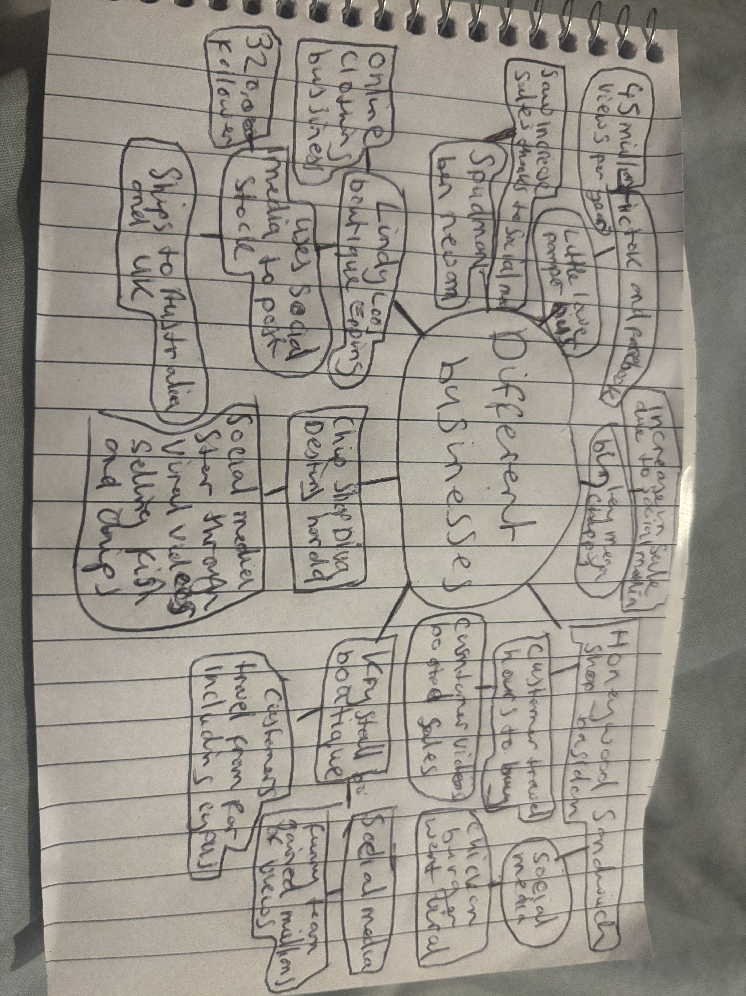

PART 2:
- Answer every question below in 1-3 full sentences.
- Use your own words. Do not use generative AI to answer these questions.
- Include a specific detail from the text when asked.
REMINDER
- The main idea is the overall message of the whole text.
- A key point helps to explain the main idea.
- A specific detail or example from the text shows that the key point is true.

- What is the main idea of the whole text?

That social media can help small businesses go viral due to exposure and help with overall sales

- What is one key point that supports the main idea, and which specific example from the text shows this?
Social media brings a wider range of customers. For example, Honeywood sandwich shop in Basildon became more known after a customer posted a video online
- What is a different key point that supports the main idea, and which specific example from the text shows this?

Viral moments and exposure can reach people all around the world such as little loves pamper bus received 45 million views plus from different counties

- Which part of the text do you think is most important, and why?
I feel like brand awareness; authentic and relatable content play a big part for businesses to succeed because if customer feel connection to the content they more likely to spread the word
Reflection:
- What did you find difficult in this task (including in-class components), and why was it difficult?
I found the task challenging because there were lots of examples and businesses to choose from

- What helped you with this difficulty, and how did it help you?
Having a understand of the article and taking notes of the examples helped me grasp the main idea and decide how I’m going to support my answers

