


School of Engineering
Mechanical and Manufacturing Engineering

Designing a Kiteboard: Structural Design
October 2024
Emyr Hunnam
2216571
Structural and Fluid Analysis
ACMA6010
Word Count: 3192

Table of Contents
Designing a Kiteboard: Structural Design 1
Table of Contents 2
List of Tables 2
List of Equations 2
Introduction 3
1. FEA Optimisation Techniques 4
1.1. Historical Development of FEA Optimization Techniques 4
1.2. Modern FEA Optimization Techniques 4
1.3. Future Developments in FEA Optimization 5
1.4. Impact of FEA Optimization on the Design Process 6
2. Design Studio Model Creation 7
3. Structural Optimisation of composite Layers 11
3.1. Discrete Composite Optimisation 13
3.2. Summary 15
4. Prototype Testing Procedure 16
5. Relationship to Technical Literature 18
6. References 20

List of Tables
Table 1 - Kiteboard Size Chart (Crawl Bars, 2022) 7
Table 2 - Design History Variable Thickness Table Optimised Composite 13
Table 3 - Design History Variable Thickness Table Discrete Optimised Composite 14
Table 4 - Design Studio Summary Table 15
Table 5 - Kiteboard Riders Weight to Board Size Table (ccalculators.co.uk, 2024) 17

List of Equations

Equation 1 - Kiteboard Force Calculation 7
Equation 2 - Steel Kiteboard Stiffness Calculation 9
Equation 3 - Steel Kiteboard Stiffness to Weight Calculation 9
Equation 4 – Composite Kiteboard Stiffness Calculation 10
Equation 5 - Composite Kiteboard Stiffness to Weight Calculation 10
Equation 6 - Optimised Composite Kiteboard Stiffness to Weight 11
Equation 7 - Discrete Optimised Composite Kiteboard stiffness to Weight Calculation 14

Introduction
As engineering advancements call for increasingly efficient structures, FEA-based optimisation has become indispensable. This report examines the optimisation techniques discussed in class, specifically their applications to composite structures in the context of designing a kiteboard. The goal is to use UD CFRP to achieve a stiffness equivalent to a 2 mm steel board, minimizing material weight in the process. The study includes setting up a model, applying fluid flow forces from prior research, optimising lay-up structure, and finally proposing experimental validation.

FEA Optimisation Techniques
Finite Element Analysis (FEA) optimisation techniques have advanced dramatically, changing engineering design by increasing accuracy, lowering costs, and boosting product performance. The evolution of these approaches has coincided with advances in computer power, algorithmic methodologies, and engineering materials, making FEA an essential tool in industries such as aerospace, automotive, civil engineering, and biomedical devices. This essay will go over the historical evolution of FEA optimisation techniques, their impact on the design process, and probable future trends.

Historical Development of FEA Optimization Techniques
According to Combden (2023), FEA dates back to the 1940s and 1950s, although it became more common in the 1960s. Early pioneers, such as Olek Zienkiewicz, introduced the basics of FEA to solve complex structural issues by breaking down continuous systems into discrete elements (Swansea University 2020). This early version of FEA allowed for detailed structural analysis, but it needed large computing resources which restricted its practical application.

Later in the 80’s shape optimisation was developed in General Motors research lab for the automotive industry (Liu, Li and Park, 2022). This technology enabled designers to select optimal geometric structures to enhance mechanical behaviours, all whilst adhering to constraints. This automated design optimisation allows designers to explore numerous variables and promotes creative solutions (Amir Hossein Gandomi et al., 2013, pp.79–102).

Modern FEA Optimization Techniques
Today's FEA optimisation employs generic algorithms, machine learning, and multi-objective optimisation. According to Brookhouse and Freitas (2023) generic algorithms study vast design domains, but machine learning enables predictive modelling and real-time decision-making, which speeds up the design process and reduces expenses. Multi-objective optimisation balances multiple criteria such as weight, strength, and manufacturability, resulting in improved overall design performance (Yokoyama, Ferro and Schulze, 2024).

Horse Herd Optimisation (HHA) is a meta-heuristic algorithm based on horses' social and herding behaviours (Awadallah et al., 2022). It simulates how horses communicate and move in a herd to tackle complicated optimisation problems. HOA is effective at dealing with high-dimensional data while balancing exploration and exploitation, making it suitable for tasks such as feature selection in machine learning and other complicated systems. Variants such as Binary HOA and Multi-Objective HHA address specific optimisation demands, increasing its adaptability and robustness. Figure 1 on the following page shows the flow of the HHO technique.
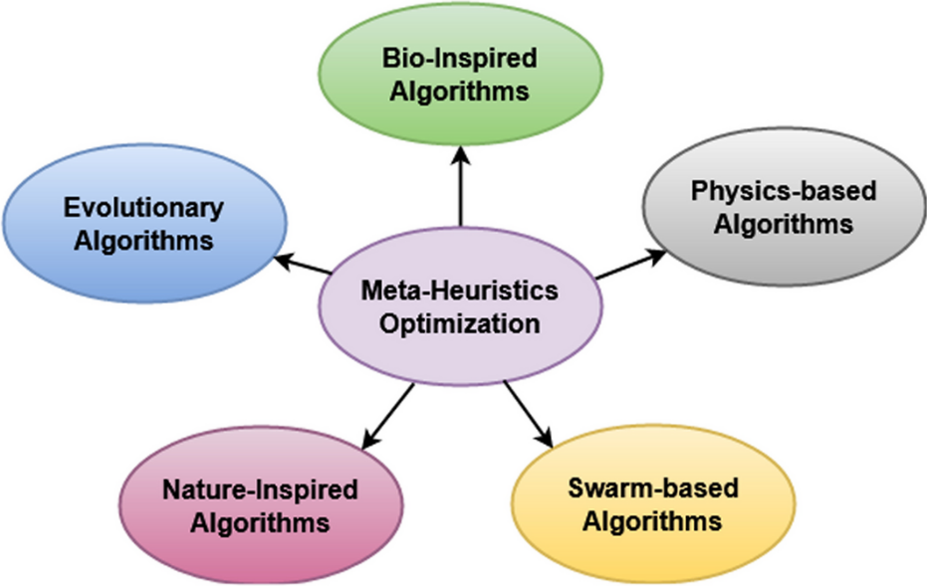
Figure 1 - Types of optimisation techniques (Selvarajan, 2024)

Future Developments in FEA Optimization
Future FEA optimisation will more likely interact with AI and cloud computing. AI, particularly deep learning, can quickly scan large data sets and generate optimal design solutions (Ciccone, Bacciaglia and Ceruti, 2023). Cloud-based FEA will allow for collaborative, large-scale simulations without the limits of local hardware, making advanced optimisation more accessible to smaller enterprises. Additive manufacturing will have a greater impact on FEA, enabling the fabrication of complicated, lightweight structures (Saimon, Amirul Islam et al., 2024).

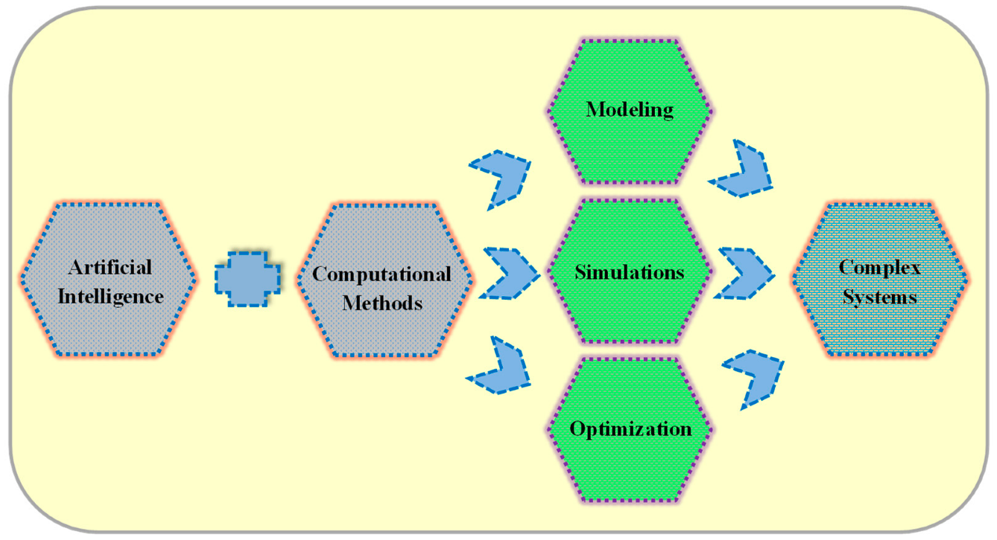
Figure 2 - A combined approach using artificial intelligence and computational methods for modelling, optimizing, and simulating complex systems (Krzywanski et al., 2024)

Impact of FEA Optimization on the Design Process
FEA optimisation minimises the requirement for physical prototypes, shortens design cycles, and encourages inventive design (E3K Engineering, 2024). It reduces material usage, improves product performance, and lowers prices. In the aviation, it results in lighter components and fuel savings, while in the automotive industry, it improves crashworthiness and safety. Furthermore, according to Rishabh Engineering (2024) FEA optimisation encourages sustainability by lowering waste and energy use.
Finally, FEA optimisation has evolved into a useful tool for streamlining the design process, making it faster, more cost-effective, more inventive. These gains are likely to continue as computing and manufacturing technology improve.

Design Studio Model Creation
The first phase of composite optimisation involved development of a precise model of the kiteboard in Design Studio, which included specific material attributes and configuration factors to emulate actual operational situations. The primary goal was to create a composite lay-up using unidirectional carbon fibre reinforced plastic (CFRP) that had the same stiffness as a 2 mm steel board. This constraint necessitates a stiffness-weight balance, with the goal of limiting deflection while using as little material as possible.

Table 1 - Kiteboard Size Chart (Crawl Bars, 2022)
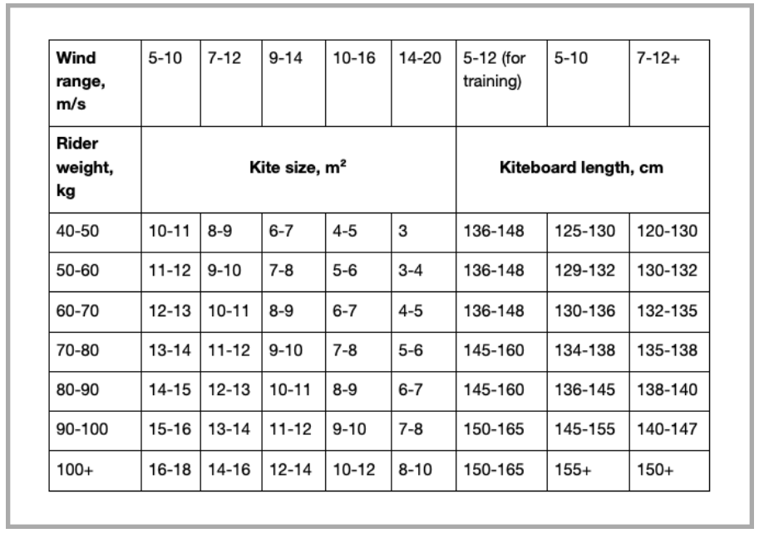

The data from assignment 1, including fluid flow forces and geometric parameters, served as the basis for the model setup in Design Studio. The graphic chart, used in assignment 1, illustrates that the average weight of a kiteboarder is around 75kg. This means that the kiteboard will have a load of 735N, as calculated below. Using gravitational force of 9.81m/s^2, a force of 735N was calculated. The force was applied to an area of 1115 grids to reproduce the image of a kiteboard rider below, therefore, the magnitude was 0.66N on each grid.

 | $$F=M×A$$  $$F=75×9.81$$  $$F=735N$$ | (1.2)
Equation 1 - Kiteboard Force Calculation
The model's boundary conditions were carefully designed to match the restrictions that the kiteboard faces during operation, notably around mounting points and places sensitive to typical loading. The photos overleaf show a kiteboard rider in action and the Design Studio model, with highlighted areas indicating where loads are applied. This configuration was critical for creating correct stress and deflection profiles. To establish consistency, the fluid dynamic pressures previously examined were converted into equivalent forces applied at certain sites in the model. This approach was used across all simulations, allowing for direct comparison of the findings.
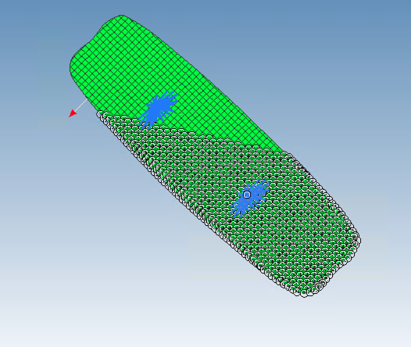

Figure 3 - Kiteboard rider (skywalkkiteboarding, 2020) & Design Studio Model

The proposed material, unidirectional CFRP, consisted of 0.1mm plies. CFRP is distinguished by its directional qualities, which may be customised to respond to certain stress orientations. This feature enables optimised ply orientations in accordance with the board's key load directions, increasing stiffness in some directions while maintaining flexibility in others, as seen in task 3.
The steel kiteboard was used in the initial simulation to establish a mass and deflection baseline. When subjected to a 735 N force, the 2 mm thick steel kiteboard exhibited a maximum deflection of 31 mm and weighed 8.1 kg.

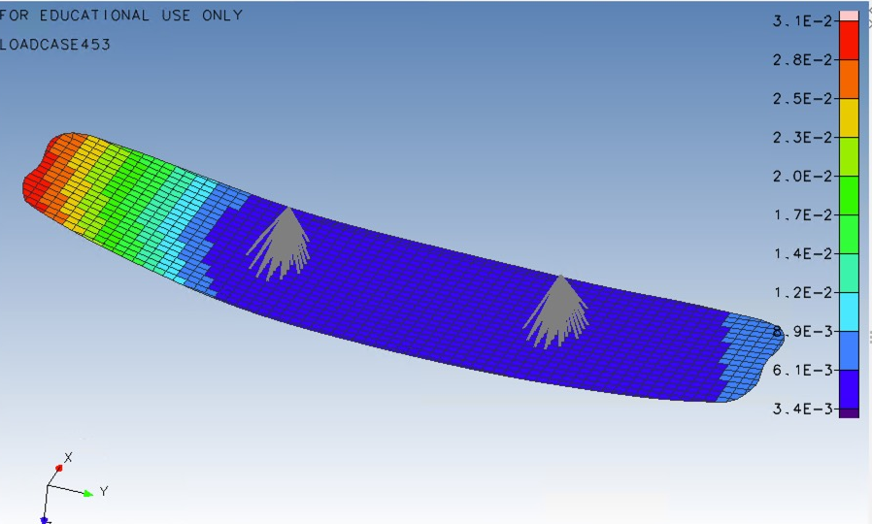
Figure 4 - Deflection of Steel Kiteboard under a 735N load

The second simulation was of the composite board with the provided ply configuration. Each ply measured 0.1 mm thick, for a total of 25 plies. The lay-up included five ply is at -90°, -45°, 0°, 45°, and 90°, resulting in a balanced structure that could withstand multi-directional loads. The 0° plies aligned longitudinally down the board, contributing much of the bending stiffness, whilst the angled plies distributed the shear load, which is critical for stability under torsional and bending pressures. The maximum deflection for 2.5mm thick unidirectional composite boards under the same 735N was 69mm. The board's bulk was 4.05kg. The board has a stiffness of 23.71N/mm and a stiffness-to-weight ratio of $0.3N^{2}/mm$, as shown in the equation below.

 | $$F=kx$$  $$k=\frac{F}{x}$$  $$k=\frac{735}{31}$$  $$k=23.71 N/mm$$ | (2.2)
Equation 2 - Steel Kiteboard Stiffness Calculation

 | $$Mass=8.1kg$$  $$\frac{Stiffness}{Weight}=\frac{23.71}{(8.1 × 9.81)}=0.3N^{2}/mm$$ | (3.2)
Equation 3 - Steel Kiteboard Stiffness to Weight Calculation

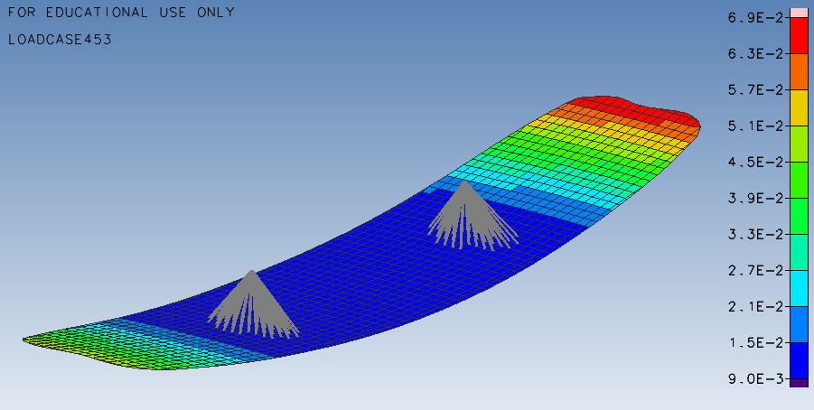
Figure 5 - Deflection of Composite Kiteboard under a 735N load

When comparing the performance of steel and composite kiteboards under a 735 N load, significant differences in deflection and mass are shown. The 2 mm thick steel board had a maximum deflection of 31 mm and a mass of 8.1 kg, suggesting great stiffness but a significant weight. In contrast, the 2.5 mm thick unidirectional composite board, albeit lighter at 4.05 kg, showed a substantially higher deflection of 69 mm, suggesting lesser rigidity. This comparison demonstrates the stiffness-weight trade-off, with steel giving greater rigidity but a higher mass, whereas composites offer a weight saving at the expense of increased deflection. This means that the board's stiffness is 10.65N/mm and its stiffness-to-weight ratio is $0.53N^{2}/mm$, as shown in the following formulae.

 | $$F=kx$$  $$k=\frac{F}{x}$$  $$k=\frac{735}{69}$$  $$k=10.65 N/mm$$ | (4.2)
Equation 4 – Composite Kiteboard Stiffness Calculation

 | $$Mass=2.03kg$$  $$\frac{Stiffness}{Weight}=\frac{10.65}{(2.03 × 9.81)}=0.53N^{2}/mm$$ | (5.2)
Equation 5 - Composite Kiteboard Stiffness to Weight Calculation

Structural Optimisation of composite Layers
After the preliminary model was completed, the composite lay-up needed to be improved to reduce weight whilst still keeping deflections of no more than those of a 2 mm steel board. The goal was to find a design that required the least amount of material to achieve the specified rigidity.
Design Studio used optimisation techniques to continually enhance the ply configuration. The number of plies at various orientations (-90°, -45°, 0°, 45°, and 90°) was one of the optimisation criteria. Each orientation was selected for its impact on the board's overall rigidity. According to the research (Berkeley Lab, 2016) plies orientated at 0° are most resistant to bending along the board's longitudinal axis, while ±45° plies improve shear resistance and reduce torsional deformations. These layers were limited to a minimum thickness of one ply, 0.1mm, and a maximum thickness of thirty plies, 3mm thick. By balancing these orientations, the board can achieve the required rigidity while minimising total ply count.

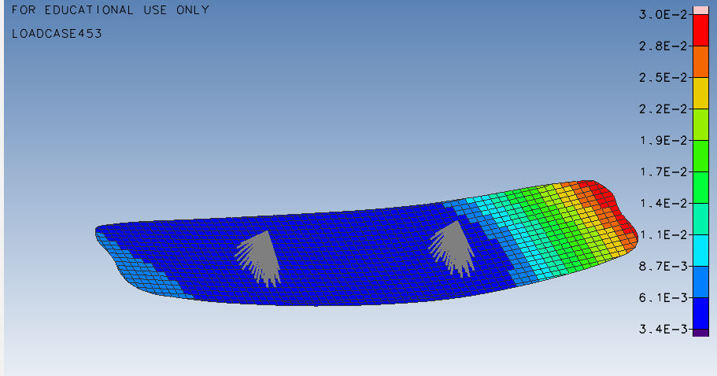
Figure 6 - Deflection of Optimised Composite Kiteboard

As indicated above, the displacement for the optimum composite board was 31mm due to the constraint imposed to match the stiffness of the steel board. However, the bulk of the non-optimised composite board is noticeably lower, at 2.78kg. The stiffness-to-weight ratio is $0.86N^{2}/mm$, which is much higher than that of steel and composite kiteboards.

 | $$\frac{Stiffness}{Weight}=\frac{23.71}{(2.78 × 9.81)}=0.86N^{2}/mm$$ | (6.3)
Equation 6 - Optimised Composite Kiteboard Stiffness to Weight

The optimisation progress is broken down in the graphs overleaf, with cycle thirteen representing the ideal configuration. The objective chart displays the board's mass during the course of optimisation, and it is clear that the mass increases significantly in the early phases of optimisation before decreasing as the design studio adjusts the ply orientations. The displacement constraint was first exceeded, but as the mass increased, the displacement constraint was met, as the constraint violation graph demonstrates.
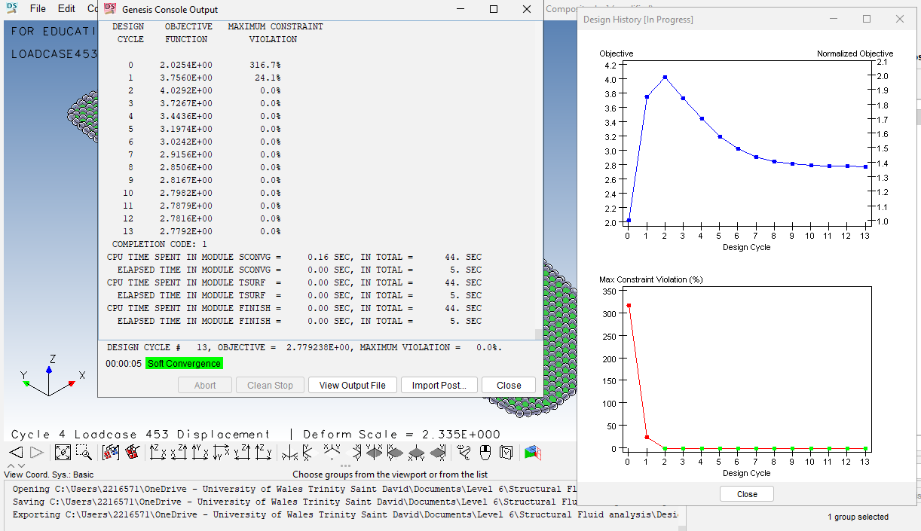
Figure 7 - Design History Graphs for Optimised Composite Kiteboard
To display the history of the variables during the optimisation process, Design Studio additionally generates a design history plot. As the figure below illustrates, all layers are initially 0.1 mm. After that, Layer 3 thickens to 3 mm while the other layers decrease to about 0.1 mm. This indicates that the longitudinal strains are largest in layer 3, which runs at 0 degrees to the board, and that it needs more plies than the other layers.

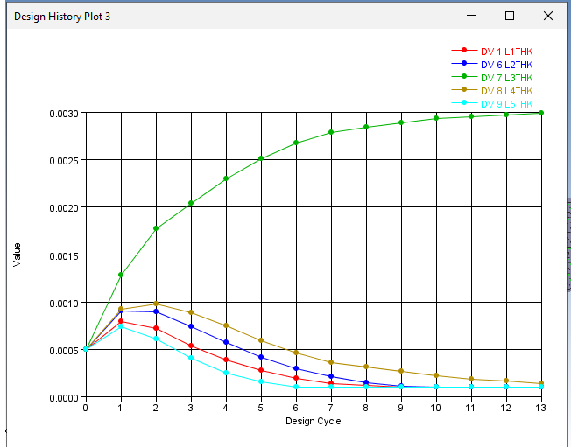
Figure 8 - Design History Variable Thickness Graph

The design history, which details how the design variables, goals, and constraints have evolved during the optimisation process, is also saved by Design Studio as a text file. The variable thicknesses at cycle 13 of the optimisation process are displayed in the table below. We can get the number of plies in each layer by dividing the layer thicknesses by the ply thickness using this data.

Table 2 - Design History Variable Thickness Table Optimised Composite
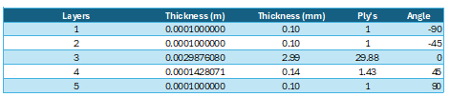

Discrete Composite Optimisation
Discrete optimisation uses discrete numbers, such as integers, rather than continuous ranges to discover the best solutions. It guarantees that characteristics such as ply counts are practical and attainable in composite engineering. Discrete optimisation simplifies manufacturing without substantially sacrificing structural integrity, even though theoretical optimisation may recommend fractional ply thicknesses. Discrete optimisation aligns designs with real-world constraints, making them feasible, affordable, and manufacturable—even though it might produce less ideal theoretical solutions.

Figure 9 - Deflection of Discrete Optimised Composite Kiteboard

As demonstrated above, the displacement for the discrete optimised composite board was also 31mm due to the constraint imposed to match the rigidity of the steel board. However, the mass is slightly higher than the optimised composite board, at 3.08kg. The stiffness-to-weight ratio is $0.78N^{2}/mm$, which is much greater than both steel and composite kiteboards, but somewhat lower than the optimised composite kiteboard.

 | $$Mass=3.08kg$$  $$\frac{Stiffness}{Weight}=\frac{23.71}{(3.08 × 9.81)}=0.78N^{2}/mm$$ | (7.3.1)
Equation 7 - Discrete Optimised Composite Kiteboard stiffness to Weight Calculation

The figures below illustrate a breakdown of the optimisation progress, with cycle seventeen being the optimal configuration. The objective chart depicts the board's mass during the optimisation process and the mass increases significantly in the early stages of optimisation before decreasing as design studio configures the ply orientations. The surge in mass near the conclusion of the optimisation process is caused by the design studio using discrete values to make the thickness whole numbers. The constraint violation graph indicates that the displacement constraint was originally exceeded but as the mass rose, it was met.
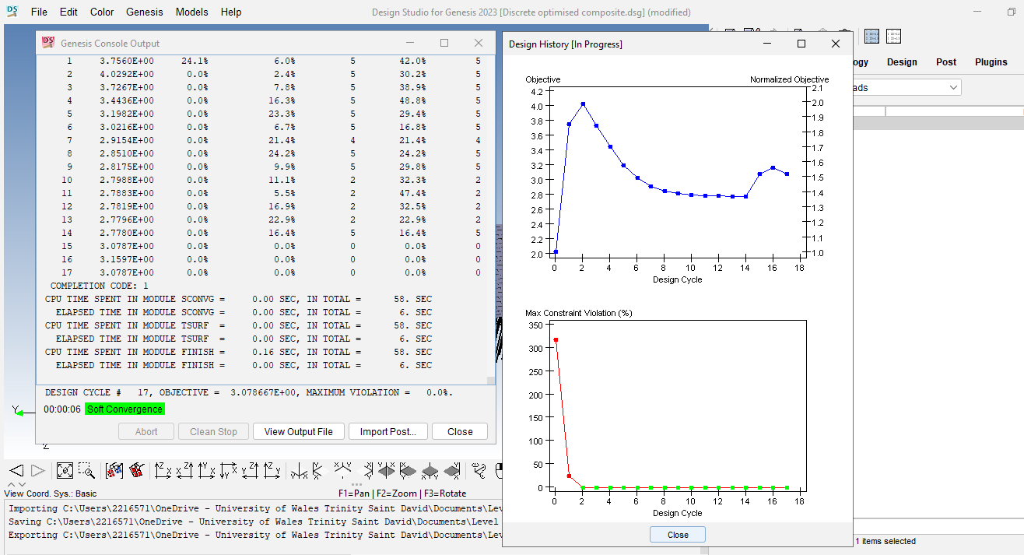
Figure 10 - Design History Graphs for Discrete Optimised Composite Kiteboard

As seen in the table below, the thickness of each layer is expressed in entire plies rather than fractions. Once more, Layer three has the most plies because it is the direction that is subjected to the most stress.

Table 3 - Design History Variable Thickness Table Discrete Optimised Composite
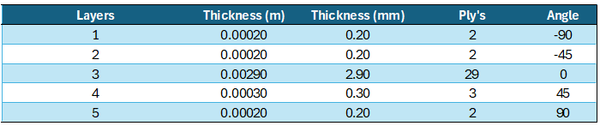

Summary

Table 4 - Design Studio Summary Table
Run | Thickness (mm) | Deflection (mm) | Mass (kg) | Load (N) | Stiffness (N/mm) | Stiffness/Weight (N²/mm)
Steel | 2 | 31 | 8.1 | 735 | 23.71 | 0.3
Composite | 2.5 | 69 | 2.03 | 735 | 10.65 | 0.53
Optimised Composite | 3.43 | 31 | 2.78 | 735 | 23.71 | 0.86
Optimised Composite (Discrete) | 3.8 | 31 | 3.08 | 735 | 23.71 | 0.78

The advantages of composites in balancing stiffness and weight are demonstrated by comparing steel with composite materials for a kiteboard. Steel is ineffective for weight-sensitive applications because, despite its stiffness, it has a low stiffness-to-weight ratio because of its mass. Unidirectional composites are less stiff, yet lighter. Steel-like rigidity with a much improved stiffness-to-weight ratio can be attained by optimising composite thickness. Composites are therefore perfect as a kiteboard material, where it's important to reduce weight without sacrificing stiffness. Despite the minor mass increase required for manufacturing, the optimised composite board enhances rigidity by 260% and weighs just 38% of the steel board.

Prototype Testing Procedure
Experimental testing is necessary to confirm the accuracy of finite element analysis (FEA) results, especially in terms of stiffness and deflection under applied forces. This step generates empirical data, allowing for direct comparison with the simulation and finding any differences that may indicate additional refinement in the model or material configuration. The testing approach will be similar to that utilised by Cambell Designed, a surfboard manufacturer. The figure below depicts Campell Designed's test rig.
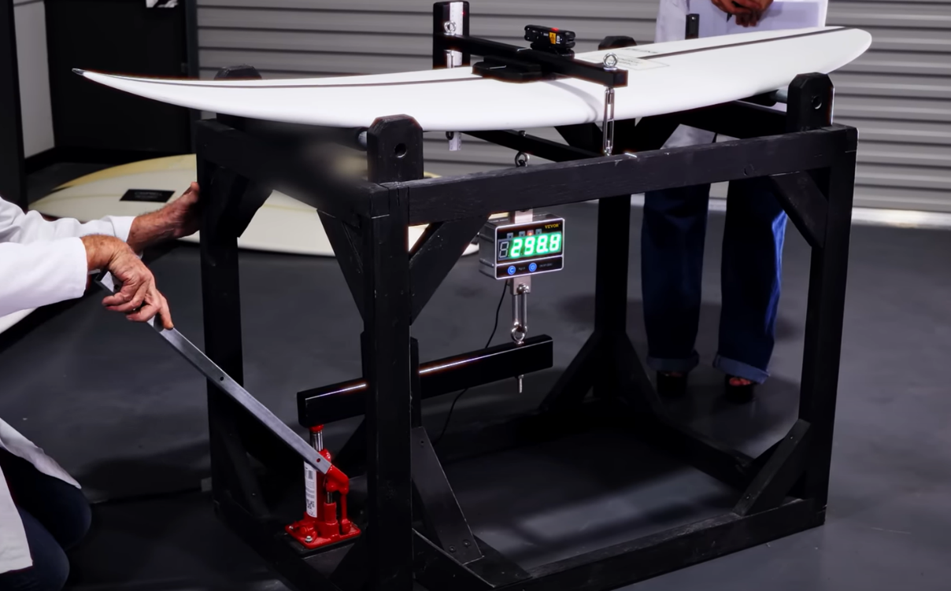
Loadcell
Scale
Laser
Hydraulic Cylinder
Pivot Point
Supports
Cradle
Figure 11 - Surfboard Test Fixture (CAMPBELL DESIGNED, 2023)

Once the prototype has been built, a series of tests will be performed in a controlled laboratory environment to imitate real-world situations. CFRP's mechanical properties are thermally affected, hence the laboratory must be temparature controlled to simulate real-world circumstances (Ou et al., 2016). The forces applied during the test will simulate the fluid dynamic pressures felt by the board, as estimated in assignment 1. The tests aim to mimic the stress and deflection responses anticipated in the FEA by closely imitating the operational environment.

The board will be simply supported at both ends, and a hydraulic cylinder will provide a load to a cradle that houses the board's middle. An inline loadcell that shows the force in kilogrammes is then used to measure the load. The aforementioned technique uses a laser that is fixed to the top of the board and points at a scale to show flex or displacement in millimetres. However, because recordings must be made by hand and parallax mistake may happen, this approach is vulnerable to human error (BBC, 2019). Using a loadcell that measures both displacement and load, like a Mecmesin force tester, would be a preferable option.

To establish a baseline, 2mm thick steel boards will be subjected to a load until plastic deformation occurs. This will be followed by a 2.5mm thick unidirectional CFRP board and a 3.8mm thick discrete optimised CFRP board, respectively. The CFRP boards will be loaded until they break and the maximum number recorded by the load cell will be used. Because the CFRP fibres run perpendicular to the load, core crushing and kinking failure may occur (Stier et al. 2015). The biggest kiteboard riders can weigh up to 110kg, as mentioned in table five, so the force tester will be set to a maximum of 1000 N.

Table 5 - Kiteboard Riders Weight to Board Size Table (ccalculators.co.uk, 2024)
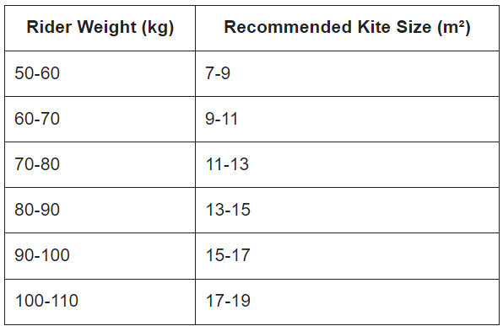

Experimental testing is critical for confirming FEA results, especially stiffness and deflection under applied forces. This phase gives real-world information for comparison with simulations, highlighting discrepancies that can be used to refine the model. Because CFRP qualities are temperature-sensitive, the testing will be done in a temperature-controlled facility to simulate real-world conditions, as Campbell Designed does.

An inline load cell will be used to measure the load applied by a hydraulic cylinder during testing of the prototype. Displacement will be measured with a laser however, this method may be subject to human error. A better solution would be to use a load cell that can monitor both displacement and load. Baseline testing will be performed on a 2mm steel board, followed by 2.5mm and 3.8mm CFRP boards, all subjected to stresses until they break. The maximum load will be set at 1000N to allow for the weight of the heaviest kiteboarders.

This testing procedure guarantees that the improved kiteboard meets real-world performance standards. It also verifies the dependability and robustness of the FEA-based optimisation and contributing to best practices in developing lightweight, high-strength composite constructions.

Relationship to Technical Literature
The optimisation of composite structures used in this kiteboard project is based on considerable research and best practices in composite materials engineering. This approach is consistent with well-established methodologies for designing high-performance, lightweight structures by strategically orienting and configuring material layers. The usage of unidirectional CFRP in this project highlights current engineering design trends in which material qualities are precisely customised to fit the requirements of specific applications.

Research on CFRP lay-ups demonstrates the benefit of employing ply orientations to control directional stiffness and enhance structural performance under specified loading circumstances. This project's utilisation of several orientations aligns with technical literature, which recommends 0°, ±45°, and 90° orientations to balance axial, shear, and transverse stiffness (Jahami and Issa, 2024). As previously mentioned, the optimisation technique used in this study, which reduces material usage while retaining stiffness is a typical goal in the aerospace, automotive, and sporting industries, where weight reduction leads to performance gains (Davila et al., 2017).

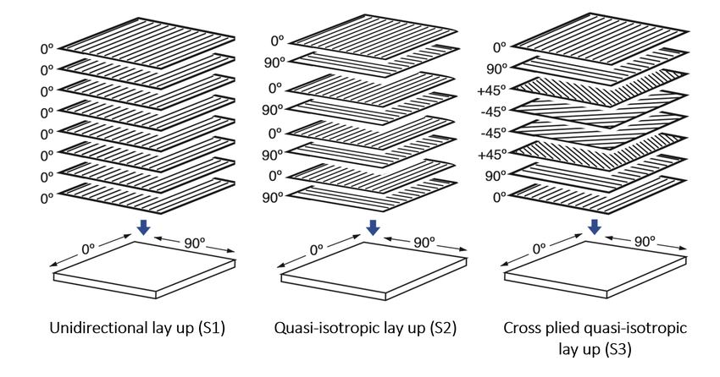
Figure 12 - Carbon Fiber Ply Orientations (Aspinall, 2024)

The significance of computational optimisation in composite engineering is frequently discussed in technical literature, including examples of how FEA-based approaches improve ply configuration and orientation precision. Computational tools like Design Studio allow for the iterative adjustment of the amount and orientation of plies which allow for the creation of optimised designs that match performance objectives whilst using fewer resources. This project's use of computational optimisation shows how modern engineering uses FEA to do comprehensive analysis and improvement of composite structures, an approach that has grown in popularity as processing power and software capabilities have advanced (Sherak, 2024).

Furthermore, the empirical validation step proposed for this project is consistent with best practices in composite design, which involve cross-checking simulation results against real-world data to ensure correctness (Camburn et al., 2017). The literature regularly highlights the significance of this stage in guaranteeing reliability, particularly given the potential inconsistencies between projected and actual material behaviour. Composite materials, despite providing various benefits, frequently display complex stress-strain responses due to their anisotropic nature, needing extensive validation to guarantee that optimised designs perform as predicted. This project follows industry practices by completing a prototype test, which prioritises empirical testing as a crucial supplement to FEA (Murray-Smith, 2019).

The link between experimental validation and computational simulation is a common issue in technical literature, emphasising the importance of a comprehensive approach to design and optimisation. According to studies, FEA provides a useful initial approximation of structural behaviour (Wibowo, 2024), but physical testing is still required to capture aspects that are not always accounted for in models, such as microstructural faults or differences in material quality. This project's iterative approach of developing the FEA model based on prototype results is compatible with the dual-method approach, guaranteeing that the final design is optimised and confirmed.

Furthermore, the literature on material and structural optimisation indicates that CFRP-based designs can benefit greatly from developments in optimisation techniques (Zhang et al., 2024). Emerging advances in composite engineering propose that machine learning and artificial intelligence could improve optimisation skills by automating lay-up configuration and more efficiently evaluating complex loading situations (Shunmugesh et al., 2024). These advancements point to a future in which designs might be revised more quickly and with more precision, increasing the practicality of optimised CFRP structures across industries.

To summarise, this kiteboard project follows existing technical literature on composite design and optimisation, incorporating ideas from both FEA and empirical testing to construct a dependable, lightweight kiteboard. The strategies used are consistent with best practices in the area, demonstrating how computational and experimental approaches can combine to produce high-performance solutions. This effort adds to the increasing body of knowledge on composite material optimisation by demonstrating how strategic ply arrangement and orientation in CFRP lay-ups allow engineers to achieve strict stiffness and weight constraints across a variety of applications.

References
- Amir Hossein Gandomi, Yang, X.-S., Siamak Talatahari and Amir Hossein Alavi (2013). Metaheuristic applications in structures and infrastructures. [online] Amsterdam: Elsevier, pp.79–102. Available at: https://www.sciencedirect.com/science/article/abs/pii/B9780123983640000048.

- Aspinall, T. (2024). Figure 1: An illustration showing the carbon fibre orientations used in... [online] ResearchGate. Available at: https://www.researchgate.net/figure/An-illustration-showing-the-carbon-fibre-orientations-used-in-this-study_fig1_365302629 [Accessed 4 Oct. 2024].

- Awadallah, M.A., Hammouri, Abdelaziz I, AlBetar, M.A., Braik, M.S. and Elaziz, M.A. (2022). Binary Horse herd optimization algorithm with crossover operators for feature selection. Computers in Biology and Medicine, [online] 141, p.105152. doi:https://doi.org/10.1016/j.compbiomed.2021.105152.

- BBC (2019). Obtaining, analysing and evaluating results – WJEC - Revision 5 - GCSE Physics (Single Science) - BBC Bitesize. [online] BBC Bitesize. Available at: https://www.bbc.co.uk/bitesize/guides/z8fq6yc/revision/5.

- Berkeley Lab (2016). Carbon Fiber Laminate Theory. [online] LAWRENCE BERKERLY NATIONAL LABORATORY. Available at: https://indico.cern.ch/event/571362/contributions/2311953/attachments/1422130/2179850/Carbon_Fiber_Anderssen_20170306.pdf.

- Brookhouse, J. and Freitas, A. (2023). Fair Feature Selection: A Comparison of Multi-Objective Genetic Algorithms. arXiv (Cornell University), 1. doi:https://doi.org/10.48550/arxiv.2310.02752.

- Camburn, B., Viswanathan, V., Linsey, J., Anderson, D., Jensen, D., Crawford, R., Otto, K. and Wood, K. (2017). Design prototyping methods: state of the art in strategies, techniques, and guidelines. Design Science, [online] 3(13). doi:https://doi.org/10.1017/dsj.2017.10.

- CAMPBELL DESIGNED (2023). Surfboard Science by CAMPBELL DESIGNED ‘surfboards’. [online] YouTube. Available at: https://www.youtube.com/watch?v=C5bLXExKtwU [Accessed 4 Oct. 2024].

- ccalculators.co.uk (2024). Kiteboarding Size Calculator – Calculator. [online] Ccalculators.co.uk. Available at: https://ccalculators.co.uk/kiteboarding-size-calculator/ [Accessed 4 Oct. 2024].

- Ciccone, F., Bacciaglia, A. and Ceruti, A. (2023). Optimization with artificial intelligence in additive manufacturing: a systematic review. Journal of the Brazilian Society of Mechanical Sciences and Engineering, [online] 45(6), p.303. doi:https://doi.org/10.1007/s40430023042002.
- Combden, L. (2023). The History of Finite Element Analysis - Pi Engineering. [online] Pi Engineering. Available at: https://www.piengineering.ca/blog/the-history-of-finite-element-analysis/ [Accessed 3 Oct. 2024].

- Crawl Bars (2022). What Size Kite and Board Do You Need for Kiteboarding? [online] Trycrawl.com. Available at: https://www.trycrawl.com/common-questions/how-to-pick-the-right-size-kite-for-kiteboarding-the-ultimate-guide [Accessed 2 Oct. 2024].

- Davila, Y., Crouzeix, L., Douchin, B., Collombet, F. and Grunevald, Y.-H. (2017). Identification and Modelling of the In-Plane Reinforcement Orientation Variations in a CFRP Laminate Produced by Manual Lay-Up. Applied Composite Materials, 25(3), pp.647–660. doi:https://doi.org/10.1007/s10443-017-9642-4.

- E3K Engineering (2024). Finite Element Analysis and New Product Design Revolution. [online] e3k.com. Available at: https://e3k.com/blog/how-finite-element-analysis-revolutionises-new-product-design/ [Accessed 4 Oct. 2024].

- Jahami, A. and Issa, C.A. (2024). An Updated Review on the Effect of CFRP on Flexural Performance of Reinforced Concrete Beams. International Journal of Concrete Structures and Materials, [online] 18(1), p.14. doi:https://doi.org/10.1186/s4006902300651y.

- Krzywanski, J., Sosnowski, M., Grabowska, K., Zylka, A., Lasek, L. and KijoKleczkowska, A. (2024). Advanced Computational Methods for Modeling, Prediction and Optimization—A Review. Materials, 17(14). doi:https://doi.org/10.3390/ma17143521.

- Liu, W.K., Li, S. and Park, H.S. (2022). Correction to: Eighty Years of the Finite Element Method: Birth, Evolution, and Future. Archives of Computational Methods in Engineering, 29. doi:https://doi.org/10.1007/s11831-022-09784-x.

- Murray-Smith, D.J. (2019). The Use of Experimental Data in Simulation Model Validation. In: C. Beisbart and N.J. Saam, eds., Computer Simulation Validation: Fundamental Concepts, Methodological Frameworks, and Philosophical Perspectives. [online] Cham: Springer International Publishing, pp.357–382. doi:https://doi.org/10.1007/9783319707662_15.

- Ou, Y., Zhu, D., Zhang, H., Yao, Y., Mobasher, B. and Huang, L. (2016). Mechanical properties and failure characteristics of CFRP under intermediate strain rates and varying temperatures. Composites Part B: Engineering, [online] 95, pp.123–136. doi:https://doi.org/10.1016/j.compositesb.2016.03.085.

- Rishabh Engineering (2024). FEA Optimization: Need, Techniques, Steps and Use Cases. [online] Rishabh Engineering Services - Quality Engineering Solutions. Available at: https://www.rishabheng.com/blog/design-optimization-with-fea/.

- Saimon, Amirul Islam, Yangue, E., Yue, X., Zhenyu, Kong and Liu, C. (2024). Advancing Additive Manufacturing through Deep Learning: A Comprehensive Review of Current Progress and Future Challenges. arXiv (Cornell University), 1(1). doi:https://doi.org/10.48550/arxiv.2403.00669.

- Selvarajan, S. (2024). A comprehensive study on modern optimization techniques for engineering applications. Artificial Intelligence Review, [online] 57(8), p.194. doi:https://doi.org/10.1007/s10462024108299.

- Sherak, M. (2024). Intro to CAD-Connected Composites FEA: A Game-Changer for Composites Design. [online] Available at: https://www.goengineer.com/blog/intro-to-cad-connected-composites-fea.

- Shunmugesh, K., Paul, B., Sarker, B. and Chakraborty, S. (2024). Parametric study and multiobjective optimization of milling of CFRP composite laminates. International Journal on Interactive Design and Manufacturing (IJIDeM). [online] doi:https://doi.org/10.1007/s12008024021304.

- skywalkkiteboarding (2020). Kiteboarding Hamptons, NYC | Kiteboarding School | Skywalk Kiteboarding. [online] Skywalkkiteboarding.com. Available at: https://www.skywalkkiteboarding.com/ [Accessed 4 Oct. 2024].

- Stier, B., Bednarcyk, B.A., Böddeker, T., Springmann, R., Simon, J.W. and Reese, S. (2015). Analysis, manufacturing, testing, and structural optimization of a novel composite kiteboard design. Proceedings of the Institution of Mechanical Engineers, Part P: Journal of Sports Engineering and Technology, [online] 229(4), pp.248–265. doi:https://doi.org/10.1177/1754337115584874.

- Swansea University (2020). Olek Zienkiewicz - Swansea University. [online] Swansea.ac.uk. Available at: https://www.swansea.ac.uk/centenary2020/navy-plaques/olek-zienkiewicz/ [Accessed 3 Oct. 2024].

- Wibowo, M. (2024). What Is FEA (Finite Element Analysis), and How Do Companies Use FEA for Products? | Cad Crowd. [online] Cad Crowd | CAD design services, 3D modeling, 3D animation, CAD drafting, engineering & 3D printing design. Available at: https://www.cadcrowd.com/blog/what-is-fea-finite-element-analysis-and-how-do-companies-use-fea-for-products/ [Accessed 4 Oct. 2024].

- Yokoyama, A.M., Ferro, M. and Schulze, B. (2024). Multi-objective hyperparameter optimization approach with genetic algorithms towards efficient and environmentally friendly machine learning. AI Communications, 37(3), pp.429–442. doi:https://doi.org/10.3233/aic-230063.

- Zhang, M., Zhang, H., Yan, W., Zhang, L. and Jiang, Z. (2024). Multiobjective optimization enabling CFRP energyefficient milling based on deep reinforcement learning. Applied Intelligence, [online] 54(23), pp.12531–12557. doi:https://doi.org/10.1007/s10489024058008.

