

A Comparative Analysis of Louis Vuitton’s International Marketing Strategies in France and China

Programme: Master of Business Administration
Module: International Marketing: Principles and Practices
Module code: LCMB7026
Lecturer: Dian Mayasari
Assignment Title: Assessment component 1: Individual report
Student name: MD Abdul Kadir Chowdhury
Student ID: 2435894

Table of Contents
Section 1: Louis Vuitton: Market Entry and Strategy 1
1.0 Introduction 1
1.1 Overview of Louis Vuitton 1
1.2 Purpose of the Report 1
1.3 Chosen Markets 2
2.0 Comparative Analysis of the Market in Both Countries 2
2.1 PESTEL Analysis 2
2.2 Social Factors: Consumer Behavior and Culture 3
3.0 Comparative Analysis of STP and 7Ps Strategies 6
3.1 STP 6
3.2 International Marketing Mix (7Ps) 8
4.0 Analysis of the Brand’s Directional Development Strategy in China 12
5.0 Evaluation of Ethical Issues Related to the Marketing Mix 13
6.0 Recommendations on How Louis Vuitton Should Go Forward 15
6.1 Customize the Products to the Local Tastes. 15
6.2 Enhance the digital marketing efforts and e-commerce. 15
6.3 Accelerate Sustainability Efforts 16
6.4 Cultural Transparency and Sensitivity. 16
7.0 Conclusion 17
Section 2: Reflective Account 18
1.0 Introduction to the Reflective Process 18
2.0 Reflection Using Gibbs’ Cycle 18
2.1 Description 18
2.2 Feelings 19
2.3 Evaluation 19
2.4 Analysis 20
2.5 Conclusion 20
2.6 Action Plan 21
3.0 Conclusion of Reflective Account 21
References 22

Table of Figures
Figure 1: Louis Vuitton Logo(LVMH, 2025) 1
Figure 2: Social Factors Influencing Louis Vuitton's Marketing Strategy in France (Author) 4
Figure 3: Social Factors Influencing Louis Vuitton's Marketing Strategy in China (Author) 5
Figure 4: STP Analysis for Louis Vuitton in France (Author) 6
Figure 5: STP Analysis for Louis Vuitton in China (Author) 8
Figure 6: Louis Vuitton Red Monogram Handbags Collection (Vassy, 2025) 8
Figure 7: Gibbs Reflective Cycle (Williams et al., 2012) 18

Table of Tables
Table 1: Comparative PESTEL Analysis for Louis Vuitton in France and China (Author) 3
Table 2: Comparative International Marketing Mix (7Ps) for Louis Vuitton in France and China (Author) 10
Table 3: Key Recommendations for Louis Vuitton’s Marketing Strategy (Author) 16

Section 1: Louis Vuitton: Market Entry and Strategy

1.0 Introduction

1.1 Overview of Louis Vuitton
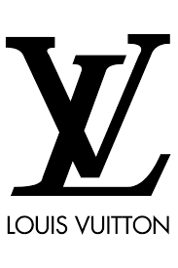
Beginning as an eponymous brand in Paris in 1854, Louis Vuitton (LV) has since grown to become one of the leading brands of luxury in the world, characterized by legendary handbags, luggage, and accessories (LVMH, 2025). Being part of the bigger LVMH conglomerate (Moët Hennessy Louis Vuitton), the brand achieved iconic status in the industry, representing the epitome of chic and exclusivity; its history is pegged on exquisite craftsmanship, consistent innovation, and the use of superior materials, which further support the position of LV as a high-end participant in the luxury clothing market (Kapferer, 2025). Over the last several decades, LV has actively diversified its brands and extended its presence on the international level, opening flagship locations in major metropolises across the globe, and clearly balanced traditional mastership with the current trends of the luxury market, which has allowed the brand to maintain its leading position and gain the largest share of the global luxury market (D'Arpizio et al., 2021).
Figure 1: Louis Vuitton Logo(LVMH, 2025)

1.2 Purpose of the Report
This report will be aimed at making a comparative study of the marketing strategies used by Louis Vuitton in China and France. The report will seek to give an insight into the flexibility and effectiveness of Louis Vuitton in various cultural and economic settings by studying the manner in which the brand adapts its marketing strategies to develop appropriate marketing strategies in such markets.

1.3 Chosen Markets
The home market of Louis Vuitton, France, provides a precondition for long-term brand loyalty and luxurious consumption habits. Conversely, China is a fast-developing market with younger and wealthier consumers who are becoming more interested in luxury brands (Euromonitor, 2025). These two markets' comparison will bring out the differences in their consumer behavior and marketing mix needed to suit local tastes.

2.0 Comparative Analysis of the Market in Both Countries

2.1 PESTEL Analysis

2.1.1 France
France is an advanced economy as far as luxury goods are concerned, and hence enjoys a stable political environment that helps in doing business. High-income levels and the purchasing power of consumers make up the French economy, which is the basis of the lasting success of Louis Vuitton. The high demand of high-end products is based on a well-established luxury consumer culture. The consumers of France are quality conscious, craft conscious, and fame conscious, which are part of the Louis Vuitton brand identity (Kapferer, 2025). The French retail industry is developed, and omnichannel and e-commerce are gaining importance as strategies that a brand should provide in order to remain relevant. In Europe, sustainability standards have become stricter, and Louis Vuitton has had to pay attention to eco-friendly activities and sourcing in a sustainable way (D'Arpizio et al., 2021). The French legal system is so strong that it provides good intellectual protections, which are also necessary in protecting a luxury brand like Hermès against counterfeits.

2.1.2 China
China is the market with the fastest economic development, which poses opportunities and challenges to luxury brands. It has seen a wealth boom increase in the country, which has established a vast and growing high-end consumer market. Nevertheless, increased inequality of wealth has given rise to their market segments. Government regulations also contribute to this, as the Chinese government has strict policies regarding foreign companies and, in this case, distribution and taxation (Euromonitor, 2025). In addition, the changing legal framework, including the intellectual-property laws, remains a threat to the brands such as Louis Vuitton. The retail landscape in China is changing due to technological innovations with regard to digital platforms and e-commerce, as people move to online shopping platforms, in which they favor shopping for luxuries. The Chinese consumers are also increasing their worries about sustainability, but there is still a gap in their awareness when compared with the Western markets (Girod, 2026). This means that the strategies of luxury brands need customization in order to sail through these complex factors.
Table 1: Comparative PESTEL Analysis for Louis Vuitton in France and China (Author)
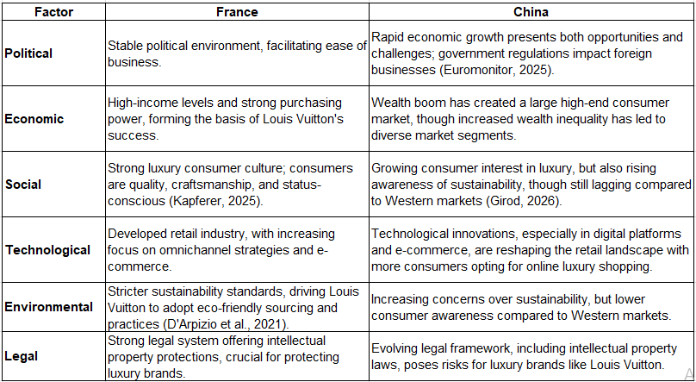

2.2 Social Factors: Consumer Behavior and Culture

2.2.1 France
Luxury consumption has strong roots in French culture. In their consumption behavior, French consumers see luxury as one of the symbols of social status as well as high-level aesthetic sensitivity and show a strong preference for legacy-based brands like Louis Vuitton that presuppose foregrounded craftsmanship, historical background, and exclusivity (Kapferer, 2025). The concept of savoir-faire (know-how) becomes an important decisive factor in developing purchase intentions since consumers attribute authenticity and the story that a brand describes. In addition, the brand loyalty of the French luxury buyers is significant, which makes them more willing to connect to the organizations that appeal to their values, specifically, those that ensure quality and tradition (D'Arpizio et al., 2021). The French luxury market, being a mature one, often depends on in-store communications and face-to-face interactions to make purchase decisions. As a result, the French strategy of Louis Vuitton emphasizes the level of high-touch clients and the unique atmosphere in the store.
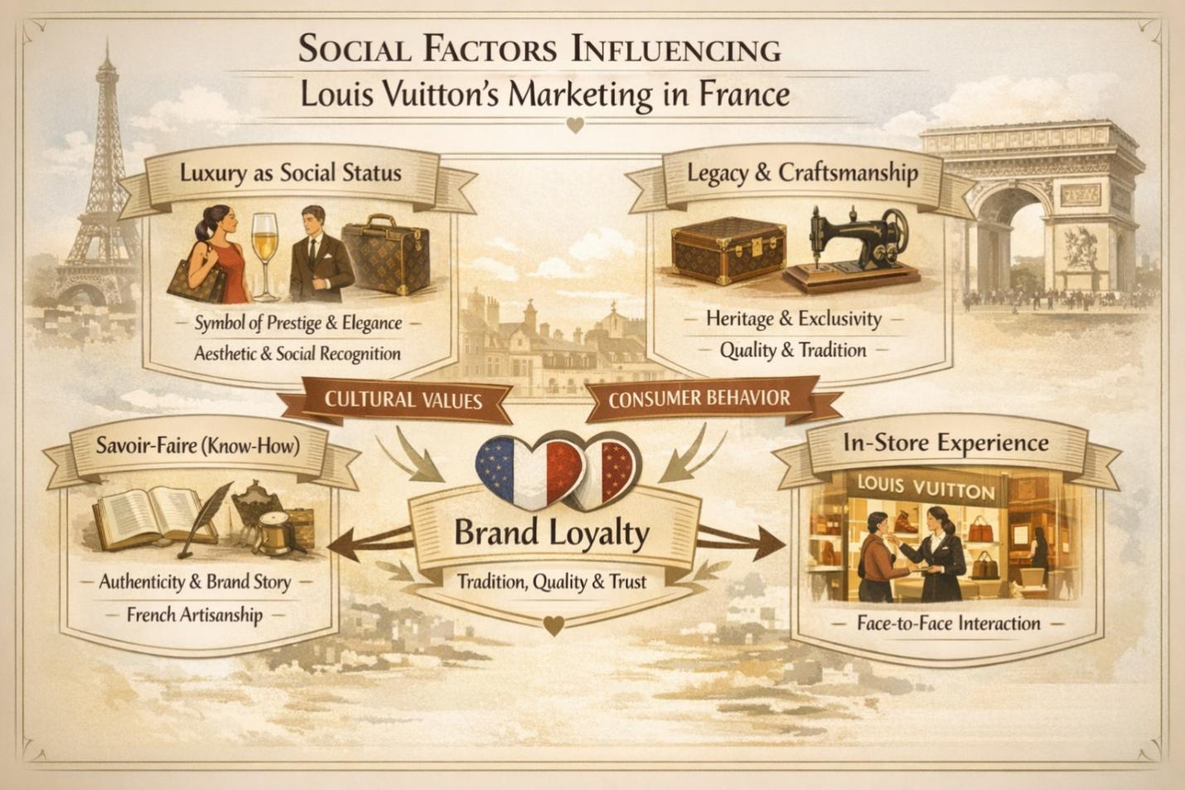
Figure 2: Social Factors Influencing Louis Vuitton's Marketing Strategy in France (Author)

2.2.2 China
The Chinese luxury market is changing at an exceptionally high pace, driven by a young, high-tech, and wealthy consumer population. This younger audience, specifically the Millennials and Generation Z, has been showing an increasing trend in liking luxurious brands, not just due to their inherent quality but also their social status (Girod, 2026). Social media and influencer marketing can be defined as key components in buying patterns, and websites like WeChat and Weibo can be considered vital media of brand recognition. The same applies to e-commerce, whose role becomes predominant, and most consumers resort more to online shopping platforms to buy luxury goods. Although the importance attributed to the quality of the product has not decreased, Chinese consumers are increasingly embracing the brand image, internationalization, and integration with global trends, and the productive use of digital and social media (Euromonitor, 2025). Unlike the French focus on tradition and exclusivity, Chinese consumers are better influenced by modernity, innovation, and the ability to show off their status in digital spaces. In this regard, the Louis Vuitton approach to China needs to be very dynamic with its emphasis on digital marketing and online shopping systems to appeal to more young customers but maintain its luxury image.
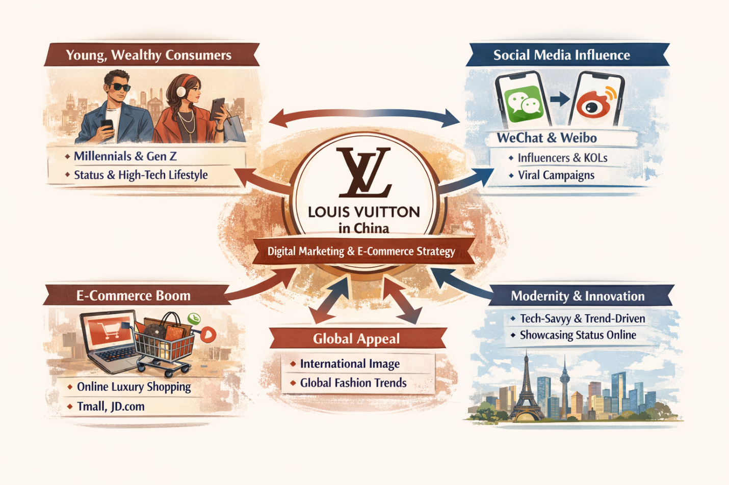
Figure 3: Social Factors Influencing Louis Vuitton's Marketing Strategy in China (Author)

3.0 Comparative Analysis of STP and 7Ps Strategies

3.1 STP

3.1.1 France
The segmentation and positioning of Louis Vuitton in France can be associated with the levels of hierarchy of needs by Maslow, especially the esteem and self-actualization ones. France: The consumers in the high-income category of the population look into status, prestige, and self-expression by purchasing exclusive products of high quality (Poldma, 2016). This is in line with the imperative of Louis Vuitton that demanded unswerving quality and its up-market brand image, which satisfied the esteem desire by signifying social position (Kapferer, 2025). Furthermore, the emphasis on personalization and exclusivity among younger and wealthier consumers is associated with the self-actualization need, which enables the individuals to display their individuality in limited-edition collections (D'Arpizio et al., 2021).
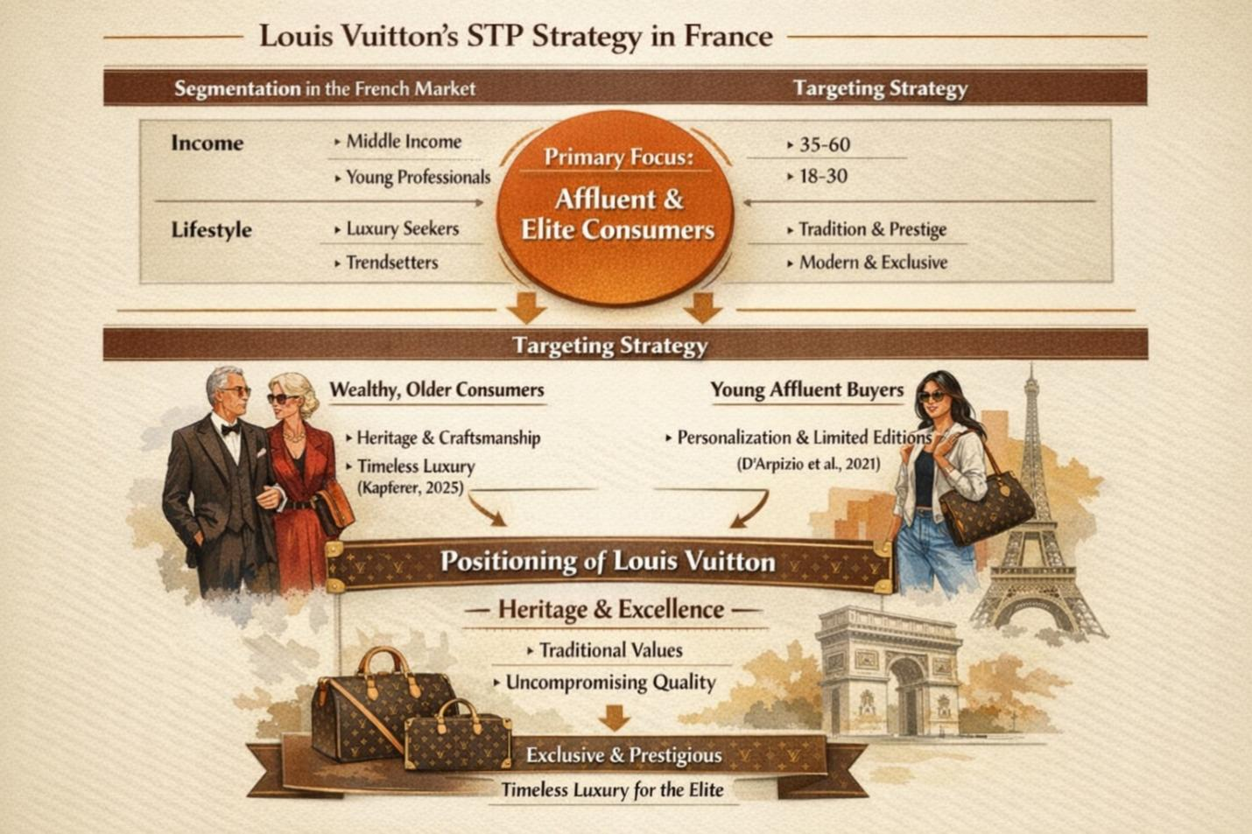
Figure 4: STP Analysis for Louis Vuitton in France (Author)
As well, the French strategy employed by Louis Vuitton fits within the differentiation strategy of Porter, wherein the brand differentiates itself on the basis of high-quality craftsmanship and tradition and thus provides products that are perceived to be better and more unique than others in the luxury market. This positioning helps to create brand loyalty in consumers addressing themselves as being traditional and exclusive.

3.1.2 China
The segmentation strategy of Louis Vuitton in China is a dynamic reaction to the fact that the middle and upper classes are expanding fast, primarily among the younger generation of consumers who are more tech-savvy. Such segmentation is consistent with the Hierarchy of Needs suggested by Maslow, namely the esteem and the self-actualization levels (Poldma, 2016). The need to identify with luxury products is becoming an obsession among the young Chinese consumers, especially the Millennials and Generation Z, who are often after the status and self-expression with their purchases (Girod, 2026). They desire to be perceived as successful persons and are governed by social networks, the use of celebrities, and the inspirational price of luxuries. The emphasis by Louis Vuitton on the technological as well as the social demands of this group identifies with their aspiration to belong and be recognized in a global culture.
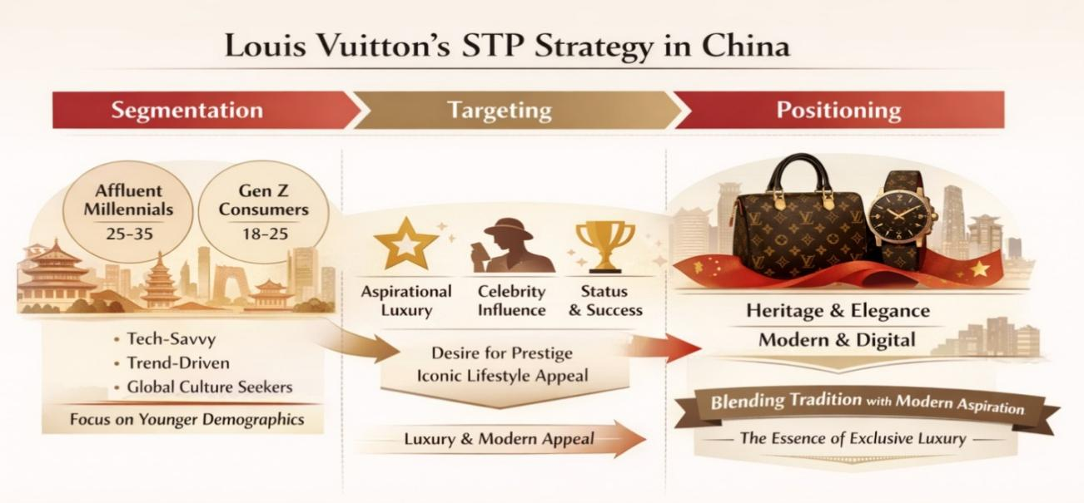
Figure 5: STP Analysis for Louis Vuitton in China (Author)
Also, the consumer behavior theory offered by Schiffman and Kanuk states that consumer behavior is motivated by the psychological and social elements, which include the necessity of social acceptance and celebrity promotion (Schiffman and Wisenblit, 2019). The personalization of the products, including the use of local color palettes and engagement with local celebrities, is addressed to the customized luxury consumption and corresponds with the growing role of online interactions in the development of purchasing intentions (Euromonitor, 2025). The Chinese positioning of Louis Vuitton incorporates the traditional and positional with the current generation, who see an attractive image by blending heritage and prestige with modernism.

3.2 International Marketing Mix (7Ps)

3.2.1 Product
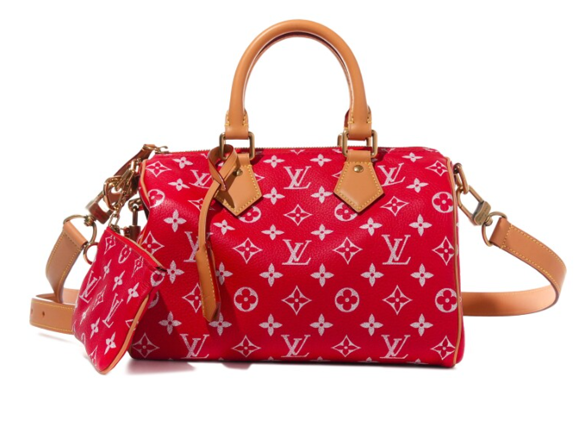
The product strategy of Louis Vuitton in France revolves around traditional heritage, quality material, and classic designs, including the legendary Monogram canvas bags, which represent the age-old French style of luxury (Kapferer, 2012). By opposition, Louis Vuitton designs its products in China based on domestic preferences, designing limited-edition products and collaborations with celebrities, such as the 2020 Kris Wu collection (McKinsey and Company, 2025). The Chinese consumers are fed on cultural aspects like the use of the red color, which represents good luck and prosperity, in the designs of the products. To illustrate, the Louis Vuitton red bags that combine both luxury and localism demonstrate the strategic customization of the brand but, at the same time, retain its global luxury image.
Figure 6: Louis Vuitton Red Monogram Handbags Collection (Vassy, 2025)

3.2.2 Price
The values of pricing used by Louis Vuitton in France support the brand image of luxury and exclusivity, and high price points are implied to be the signs of its tradition and prestige. To illustrate, an average shoulder bag Monogram Canvas Speedy 30 bag sold in France currently costs approximately 900 Euro (Louis Vuitton, 2025). Louis Vuitton does not have any attempt to reduce the price similar to its high levels in China because of the existence of wealth inequality. Nevertheless, it applies the psychological pricing strategies, including the releases in limited edition, to have them gain a feeling of urgency and exclusiveness. As an example, a Louis Vuitton bag in China with limited edition may cost as much as ¥16,000 (China Briefing, 2025). This positioning will be in line with the wants of young consumers with high incomes who have a tendency to value exclusivity.
Table 2: Comparative International Marketing Mix (7Ps) for Louis Vuitton in France and China (Author)
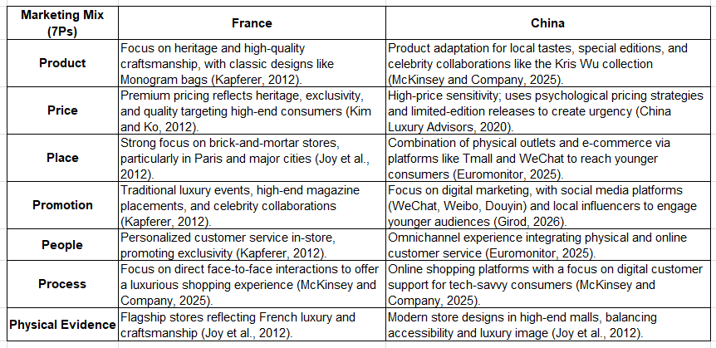

3.2.3 Place
The distribution mix of Louis Vuitton in France incorporates the selective distribution model as it targets flagship boutiques in Paris and other big cities, which is in accord with the channel intensity theory (Wirtz and Lovelock, 2022). Such selectivity makes it a luxury brand and focuses on craftsmanship and exclusivity (Joy et al., 2012). Instead, the China strategy of Louis Vuitton is based on intensive distribution, combining both the physical stores (high-end shopping centers) and online platforms (Tmall and WeChat) that serve young and digitally advanced young people (Euromonitor, 2025). Both physical and e-commerce integrations also serve to match the increasing demand for luxury products on the sites via the digital channel, indicative of adaptation to the rapidly dynamic retailing environment in China.

3.2.4 Promotion
Moreover, Louis Vuitton still implements traditional marketing strategies, such as luxury events, placement in posh magazines, and collaboration with famous musicians in France, which, again, emphasizes the brand itself, its tradition, and its luxury (Kapferer, 2012). On the other hand, in China, the promotion strategy of the brand focuses on the digital platform, and the target audience is represented by a younger generation, a socially media-engaged population, meaning WeChat, Weibo, and Douyin (Chinese TikTok). PGs with local influencers and celebrities also increase the brand appeal of aspirational buyers, thus developing a strong presence in the online world (Girod, 2026).

3.2.5 People
Louis Vuitton understands customer service and in-store experience with a significant emphasis on both the French market and the Chinese market. In France, sales assistants undergo training to deliver service of high intensity of personalization, thus promoting the image of a luxury brand. Customer service is also a primary concern in the Chinese environment, but another emphasis is made on digitalization; sales associates are advised to provide a cohesive omnichannel experience that will accommodate factors in both a physical and online touch (Euromonitor, 2025).

3.2.6 Process
The sales process of Louis Vuitton is focused on direct, face-to-face contact in retail settings, creating an opportunity to provide customers with a lavish buying experience. In comparison, in China, there is a growing interest in the e-commerce platform, and the growing reliance on online customer support to cater to younger and technologically advanced consumers who have a stronger tendency to make transactions via digital platforms (McKinsey and Company, 2025).

3.2.7 Physical Evidence
The presence of the Louis Vuitton brand in France physically is represented by the iconic flagship stores that reflect the meaning of the concept of elegance and French luxury. These outlets are specifically built to give the consumer a feel of the craftsmanship of the brand. Louis Vuitton in China alters the design of stores to have sleek and modern designs that appeal to the younger generation; the stores are normally placed in the more high-end shopping centers, and therefore, they focus on accessibility and modern luxury but retain the luxury image of the brand (Joy et al., 2012).

4.0 Analysis of the Brand’s Directional Development Strategy in China
The scenario in which the strategic development of Louis Vuitton in the Chinese market has developed has moved through an initial foray to a detailed, more culturally scrupulous method of growing towards the long term in one of the most dynamic luxury markets of the world (Stegemann and Denize, 2021). The brand was launched in the mainland in 1992 and then continued its expansion with the opening of flagship outlets in major cities like Beijing and Shanghai, and as a result, this has made it a major player in the Chinese luxury market, which has been on the rise. This glamorous early appearance prepared the market of Louis Vuitton among the wealthy consumers and indicated the intent of the company to penetrate the East Asian market.
One of its primary aspects in China's development strategy is the localized product innovation and exclusivity. Louis Vuitton in China is able to customize its products to fit the local preferences, such as limited-edition collections, culturally evocative motifs, and jointly designed products that make reference to Chinese culture, like color symbolism or festival releases, unlike the domestic French market, where heritage products dominate. Such localization helps generate stronger emotional ties with Chinese consumers, as well as utilizes the capital of cultures to make the brand stand out in a competitive luxury environment (McKinsey and Company, 2025). Louis Vuitton has also broadened its retail experience and changed formats as well. An example of a plan to enhance experiential interaction other than the usual sales involves the opening of the concept store, The Louis, in Shanghai, a unique ship-shaped store that encompasses retailing, exhibition, and luxury meals. These flagship innovations integrate the heritage of the brand with local cultural stories and are attractive to experience-driven, younger consumers in particular (Joy et al., 2012).
Another foundation of LV's growth strategy is digital engagement. Upon the understanding that China is leading in e-commerce and social products, the brand has increased communication channels via omnichannel tactics, especially in Tmall and WeChat, to make the resources more accessible and foster brand communities among high-income Millennials and Generation Z consumers. This electronic orientation cannot be provisionalized, as the popularity of online luxury purchases in China is growing, and it exceeds most of the Western markets (Kim and Ko, 2012). Moreover, Louis Vuitton has become strategic in terms of the long-term cultural implantation instead of a brief sales burst. New campaigns and cultural collaborations are indicative of trying to make the brand story live in the Chinese environment so as to bridge the global luxury brand image and the Chinese local.
In general, the China strategy allows Louis Vuitton to combine product localization, new retail experiences, and digital engagement to continue its growth. This dimensional approach does not simply indicate how well the market is penetrated, but it indicates a greater blend of brand and market, which is aimed at achieving long-term consumer retention, given the changing Chinese luxury consumption.

5.0 Evaluation of Ethical Issues Related to the Marketing Mix
Moral concerns have risen to relevance across the luxury brands, with customers requiring frankness, awareness, and cultural empathy more and more. In the case of Louis Vuitton, the ethical issues are unique in its mature home market in France and its expanding growth market in China, but both badly require strategic interventions incorporated in the marketing mix.
In France, the issues of sustainability and ethical sourcing are mainly prominent. The environmental impact of luxury fashion is carefully audited by European consumers and regulators in areas like the acquisition of raw materials, such as leather and exotic skin. Despite the emphasis Louis Vuitton places on high-quality craftsmanship, the luxury industry must deal with accusations of carbon emissions, depletion of resources, and intricacies of having entirely traceable supply chains (Joy et al., 2012). Accordingly, Louis Vuitton and its parent company, LVMH, have launched sustainability programs, which include the pledges to reduce greenhouse gas emissions and increase the use of recycled or sustainably obtained sources. LVMH has created the LIFE (LVMH Initiatives for the Environment) program that focuses on product life cycles and eco-design principles, which was launched in 2021 (LVMH, 2025). However, critics point to the fact that these measures are rather incremental in an industry in which the effects of material consumption and manufacturing in the industry are opaque (Kaivonen et al., 2024). Moreover, the ethical labor practice is subject to questions in France, which makes luxury brands showcase fair working conditions as well as carry out end-to-end supply chain due diligence, in line with EU directives.
When it comes to China, ethics intermingle with sourcing imperatives and cultural sensitivity in marketing communication. Corporate transparency and consumer protection are some of the aspects that have been reinforced by Chinese regulatory frameworks, so foreign brands are now required to disclose information about the sourcing of a particular product, manufacturing standards, and environmental effects (The Drum, 2025). The dilemma facing Louis Vuitton in China is therefore two-fold: how to maintain ethics in procurement and, at the same time, avoid cultural blunders in the marketing materials. Chinese consumers are more vigilant on cultural appropriation or insensitivity; hence, the need to localize their products or services that embrace cultural values. As an example, companies that have never conducted alignment of the images or messaging of the Chinese cultural context have faced widespread criticism, thus compelling organizations to emerge as more culturally sensitive (Fashion China, 2023).
Comparing the two markets, however, sustainability issues have a greater effect in France due to the increased regulation scrutiny and the more developed awareness of the consumer, as in China, ethical openness and cultural delicacy in branding become an urgent demand. Louis Vuitton has followed a differentiated strategy: in France, introducing environmental sustainability to the product development strategy; in China, focusing on the transparency of sourcing criteria and culturally sensitive promotional stories.
Ethical concerns in both contexts permeate key elements of the marketing mix, such as sourcing of product, promotion, and message, and require ongoing adjustment to changing expectations and the regulation of consumers.

6.0 Recommendations on How Louis Vuitton Should Go Forward
Louis Vuitton, as a leading luxury brand, has perfected the need and ability to combine ancient and modern tendencies; furthermore, its ability to maintain market leadership requires further development. Using a case study based on international consumer behavior and global market dynamics, the recommendations that follow are designed with the view to correcting already existing international marketing strategies by Louis Vuitton.

6.1 Customize the Products to the Local Tastes.
Local partnerships and limited editions have proven to be advantageous to the interests of Louis Vuitton, especially in the Chinese market. However, the brand would benefit further by expanding its localization efforts in other emerging luxury markets, especially in Asia and the Middle East, where people seek products that would appeal to their cultural beliefs (Borstrock, 2014). This plan may involve design features and material novelties, which are region-specific and may include traditional motifs, partnering with local artists and designers, and making unique collections. Louis Vuitton can develop more substantive emotional values among varied consumer groups by offering what the locals prefer and preserving the brand name as a high-end item (Kaivonen et al., 2024).

6.2 Enhance the digital marketing efforts and e-commerce.
Louis Vuitton needs to embrace the digital transformation that will enable its further development, especially among younger luxury clients. Although the brand has adopted digital platforms in countries like China, it needs to intensify its digital marketing efforts in the world market, with its focus being on social media such as Instagram, TikTok, and WeChat. Incorporation of the younger demographic by working with influencers, immersive virtual-reality moments, and exclusive online launches will strengthen the brand in terms of its relationship with the Millennials and Gen Z (Godart and Zhao, 2014). Furthermore, Louis Vuitton must work on its online and offline (O2O) integration to facilitate a seamless shift between online communication and in-store levels, so that customers will be able to stroll easily in the online research setting and move to the physical store to make a purchase.
Table 3: Key Recommendations for Louis Vuitton’s Marketing Strategy (Author)
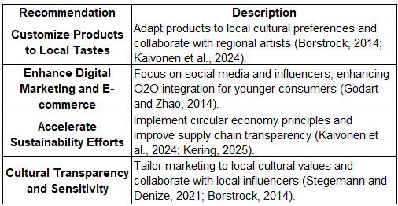

6.3 Accelerate Sustainability Efforts
Consumers start to view sustainability as not just an adjunct concept but as a core value, which is drawn from the luxury segment, particularly. It is recommended that Louis Vuitton proceed to accelerate the sustainability agenda development (Kaivonen et al., 2024). Specifically, it should prioritize the incorporation of the principles of the circular economy, namely, the designs of products to extend their life cycle, the enhancement of upcycling programs, and the offering of repair services to its after-sales products (Kering, 2025). Also, the company ought to reduce the level of obscurity in its supply chain, especially when it comes to the sourcing of materials and the environmental effects. Good publicity of these sustainability efforts is likely to attract eco-conscious customers and strengthen the position of the brand against increasingly eco-sensitive markets.

6.4 Cultural Transparency and Sensitivity.
Market orientation in the Asian markets, like China and India, has cultural sensitivity as a critical factor in marketing. Louis Vuitton should tailor its promotional efforts to local cultural principles, thus preventing the violation of the message or image that may cause reputational risk. Such initiatives can be successfully resonated by the associations with domestic influencers and artists who will have a fine cultural literacy and, at the same time, keep the brand in the high end (Stegemann and Denize, 2021). At the same time, as the demands of the current consumers are moving towards transparency, Louis Vuitton has to increase its reporting standards that can be related to the ethical sourcing standards and sustainability to ensure that its global customers are aware of how this corporation is committed to social and environmental stewardship (Borstrock, 2014).

7.0 Conclusion
The ability to fit in local tastes and styles, capitalize on digital marketing, further sustainable development, and cultural sensitivity will be the foundations of further success of Louis Vuitton in the global luxury market. These are strategic actions that should help to maintain the relevance of the brand, create an interest among younger generations, and satisfy the growing demand of the twenty-first century, namely, ethically oriented luxury.

Section 2: Reflective Account

1.0 Introduction to the Reflective Process
To accomplish the evaluation of the marketing strategies of Louis Vuitton, the researcher chose the theoretical framework in the form of the Reflective Cycle of Gibbs (Williams et al., 2012) to perform the reflection. The model organized the analysis process through guiding the investigation step by step, namely, descriptions, feelings, evaluation, analysis, conclusion, and an action plan. It, therefore, helped in critically evaluating the process, the challenges related to it, and the outcome based on it.

Figure 7: Gibbs Reflective Cycle (Williams et al., 2012)

2.0 Reflection Using Gibbs’ Cycle

2.1 Description
The research and preparation of the report were a process that had different steps. To start with, I sought secondary data on authoritative sources of information like academic journals, market reports, and industry analysis to know how Louis Vuitton has been operating in France and China. I used models such as PESTEL analysis of the macro-environment and STP analysis of segmentation, targeting, and positioning, as well as 7Ps analysis of the marketing mix. All these frameworks assisted me in deconstructing the complexities of the international market and making direct comparisons between the two states.
When organizing the report, I sought to incorporate a coherent flow that linked together every part of the report, where I started off with an overview of the brand, proceeded to conduct an analysis of the markets, and finally gave my recommendations. My main problem was to find an order in the abundance of information and squeeze it into a manageable story. There were also difficult parts in some sections, including the PESTEL analysis of China, which took into consideration government regulations and market dynamics that needed a more complex synthesis of different sources of data (D'Arpizio et al., 2021). Proformatting and providing consistency in referencing was also time-consuming stage.

2.2 Feelings
The affective experience during this assignment went both ways, being frustrating as well as rewarding. At first, I was so overwhelmed by the scope of information that I needed to process, especially when trying to compare two different markets: France, a mature market, and China, a rapidly developing one. It was particularly difficult to find credible information on the luxury market of China because of the extremely high rates of change, as well as the insufficient presence of English-language information regarding the market (Euromonitor, 2025). Nevertheless, when I started working with such tools as STP and 7Ps, I was much more confident because the given tools provided the systematic means to examine the differences and similarities between the two markets. The final version became somewhat satisfying because the research fell into a consistent analysis, and concrete recommendations were articulated.

2.3 Evaluation
The report had some of its strengths, especially in the comprehensive study of the macro-environmental factors based on the PESTEL framework. Such a methodological approach allowed situating the strategic initiatives of Louis Vuitton in larger political, economic, and cultural environments. However, there were some obstacles. Data gathering, particularly on the topic of certain consumer inclinations in China, was mainly constrained, as the necessary data is usually gained by conducting a survey or communicating directly with the consumers. Although there were a lot of secondary sources, there was a lack of first-hand consumer information to better understand the local behavioral pattern (Girod, 2026). The organization of the report was also tricky, especially in making sure that the 7Ps were applied efficiently in both markets without repetition.

2.4 Analysis
The frameworks were useful tools of analysis. PESTEL also revealed that key environmental influences, including the fast economic development in China and the growing concern about sustainability in France, affect the positioning of the strategic directions of Louis Vuitton. The STP model played an essential role in comprehending the unique differentiation and targeting of the brand in each of the markets. The market of France is described as more mature and focused on the wealthy and older generations, whereas the Chinese market is full of younger and aspiring buyers wanting to experience a touch of luxury with both heritage and modernity in their products (Fashion China, 2023). The 7P model was especially handy in the context of comparing the product offerings and marketing mix of Louis Vuitton and understanding how the brand is willing to adapt its place mix and promotional mix to digitalization challenges in China without affecting the traditional in-store experiences in France.
A comparative review of the two nations shows that Louis Vuitton should find a balance between its culture and flexibility. Chinese consumers embrace innovation and digital interaction, unlike French consumers, who appreciate exclusivity and craftsmanship. These observations highlight the need to have local market understanding and adaptability in global branding.

2.5 Conclusion
The assignment gave the possibility to implement marketing frameworks in the real world, especially when it comes to analyzing complex international markets. It provided a more in-depth insight into the way international luxury brands respond to the local consumer preferences and market forces in their strategies. The practice has also contributed to improve critical thinking and has made it clear how the global strategies of brands can be localized so as to suit different settings.

2.6 Action Plan
The expertise and experience gained on this evaluation would be useful in my career in the future, especially in carrying out market research and preparing a strategic plan. Through the enhancement of the primary research techniques like surveys and interviews, I will be in a position to acquire more insights in consumer behavior, which would be applicable in the context of marketing and business strategy roles. Also, improving my organization of the report and preventing the repetition of information will contribute to my skills of providing clear and concise findings in the professional environment. The implementation of frameworks fitting to the market will also be useful in terms of my customizing analysis that suits cultural and socioeconomic contexts and contributing to decision-making and strategic planning in my upcoming career.

3.0 Conclusion of Reflective Account
The assignment has greatly influenced my approach to the international market analysis in the form of my capacity to summarize complicated data through the application of the regulated structures. It has demonstrated the essentiality of flexibility in international branding and the need for primary research to have a deeper insight into the local market forces. In the future, I am planning to incorporate such learnings into analyses.

References
Borstrock, S. (2014) ‘Do contemporary luxury brands adhere to historical paradigms of luxury?’, Global Fashion Brands: Style, Luxury andamp; History, 1(1), pp. 231–248. doi:10.1386/gfb.1.1.231_1.
China Briefing (2025) Exploring China’s luxury market: Emerging trends and prospects. Available at: https://www.china-briefing.com/news/chinas-luxury-market-emerging-trends-prospects-strategies/ (Accessed: 24 March 2026).
D’Arpizio, C. et al. (2021) The future of luxury: Bouncing back from covid-19, Bain. Available at: https://www.bain.com/insights/the-future-of-luxury-bouncing-back-from-covid-19/ (Accessed: 06 March 2026).
Euromonitor (2025) Luxury goods in China | market research report | Euromonitor, Euromonitor. Available at: https://www.euromonitor.com/luxury-goods-in-china/report (Accessed: 06 March 2026).
Fashion China (2023) Louis Vuitton in China: Online marketing case study, Fashion China. Available at: https://fashionchinaagency.com/louis-vuitton-china-online-marketing-case-study/ (Accessed: 06 March 2026).
Girod, S.J.G. (2026) Luxury and China: Will the next decade be back to the future? - I by IMD, IMD business school for management and leadership courses. Available at: https://www.imd.org/ibyimd/industry/consumer-goods/for-luxury-and-china-will-the-next-decade-be-back-to-the-future/ (Accessed: 06 March 2026).
Godart, F. and Zhao, Y. (2014) ‘Drivers of china’s desire for luxury and consequences for luxury brands’, Luxury Brands in Emerging Markets, pp. 119–129. doi:10.1057/9781137330536_11.
Joy, A. et al. (2012) ‘Fast fashion, sustainability, and the ethical appeal of Luxury Brands’, Fashion Theory, 16(3), pp. 273–295. doi:10.2752/175174112x13340749707123.
Kaivonen, I., Mesiranta, N. and Närvänen, E. (2024) ‘“I do what I do to drive change”: The social-symbolic work of sustainable fashion influencers’, Fashion Theory, 28(1), pp. 85–115. doi:10.1080/1362704x.2024.2327252.
Kapferer, J.-N.B., VINCENT (2025) Luxury strategy break the rules of marketing to build luxury brands. S.l.: KOGAN PAGE.
Kering (2025) Sustainability strategy and initiatives, Kering. Available at: https://www.kering.com/en/sustainability/ (Accessed: 06 March 2026).
Kim, A.J. and Ko, E. (2012) ‘Do social media marketing activities enhance customer equity? an empirical study of luxury fashion brand’, Journal of Business Research, 65(10), pp. 1480–1486. doi:10.1016/j.jbusres.2011.10.014.
Louis Vuitton (2025) Speedy Bandoulière 25 monogram - women - handbags | Louis Vuitton ®, Louis Vuitton. Available at: https://us.louisvuitton.com/eng-us/products/speedy-bandouliere-25-monogram-nvprod5320019v/M46977 (Accessed: 24 March 2026).
LVMH (2025) Our commitment for environment- LVMH, LVMH. Available at: https://www.lvmh.com/en/commitment-in-action/for-the-environment (Accessed: 06 March 2026).
McKinsey and Company (2025) The state of fashion 2020 coronavirus update, McKinsey and Company. Available at: https://www.mckinsey.com/~/media/mckinsey/industries/retail/our%20insights/its%20time%20to%20rewire%20the%20fashion%20system%20state%20of%20fashion%20coronavirus%20update/the-state-of-fashion-2020-coronavirus-update-final.pdf (Accessed: 06 March 2026).
Poldma, T. (2016) ‘Hierarchy of needs (maslow)’, The Bloomsbury Encyclopedia of Design, pp. 150–150. doi:10.5040/9781472596161-bed-h038.
Schiffman, L.G. and Wisenblit, J.L. (2019) Consumer behavior. BoD–Books on Demand.
Stegemann, N. and Denize, S. (2021) ‘Luxury brand extensions and perceived luxury’, The Oxford Handbook of Luxury Business, pp. 248–272. doi:10.1093/oxfordhb/9780190932220.013.14.
The Drum (2025) China’s luxury market: Current trends and future opportunities for brands, The Drum. Available at: https://www.thedrum.com/opinion/2024/04/18/chinas-luxury-market-current-trends-and-future-opportunities-brands (Accessed: 06 March 2026).
Vassy, A. (2025a) Takashi Murakami X Louis Vuitton: The fashion collaboration that defined a generation, Sothebys.com. Available at: https://www.sothebys.com/en/articles/takashi-murakami-x-louis-vuitton-the-fashion-collaboration-that-defined-a-generation (Accessed: 24 March 2026).
Vassy, A. (2025b) Takashi Murakami X Louis Vuitton: The fashion collaboration that defined a generation, Sothebys.com. Available at: https://www.sothebys.com/en/articles/takashi-murakami-x-louis-vuitton-the-fashion-collaboration-that-defined-a-generation (Accessed: 24 March 2026).
Williams, K., Woolliams, M. and Spiro, J. (2012) ‘Using a framework for Reflection: Gibbs’ reflective cycle’, Reflective Writing, pp. 90–102. doi:10.1007/978-0-230-37724-0_16.
Wirtz, J. and Lovelock, C.H. (2022) Services marketing: People, technology, strategy. New Jersey: World Scientific.

