

LOCATION: Swansea | LLEOLIAD: abertawe
LEVEL 5 | LEFEL 5
EXAMINATION PERIOD | CYFNOD ARHOLIADAU
OCTOBER 2021 | HYDREF 2021

MODULE CODE: ACMA5006
STRUCTURE AND PROPOERTIES OF MATERIALS

TIME: 2 HOURS
answer all questions

Equipment or materials required – None
Adnoddau neu ddefnyddiau sydd eu hangen - Dim

$$APF=\frac{Volume of atoms in unit cell}{Volume of unit cell}$$ | $$Density=\frac{nA}{{V_{C}N}_{A}}$$
$$u=\frac{1}{3}(2u^{'}-v^{'})$$  $$v=\frac{1}{3}(2v^{'}-u^{'})$$  $$t=-(u+v)$$  $$w=-w^{'}$$ | $$N_{A}=6.022×{10}^{23}mol^{-1}$$

ANSWER ALL QUESTIONS

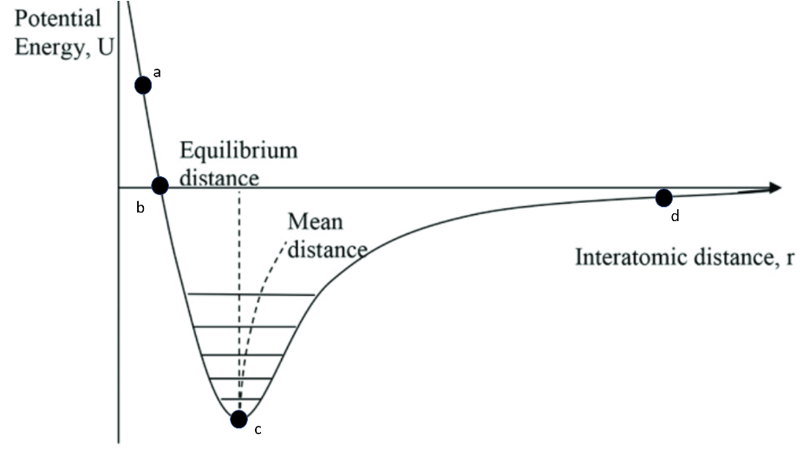

- Consider the four points a, b, c and d on the figure above.
- Give a brief description of how the forces change as you move from a – b – c – d
[4]

ii. How would the crystal structure differ between points c and d [2]

- Show that the APF for FCC and BCC are 0.74 and 0.68 respectively [10]

- Considering the table below

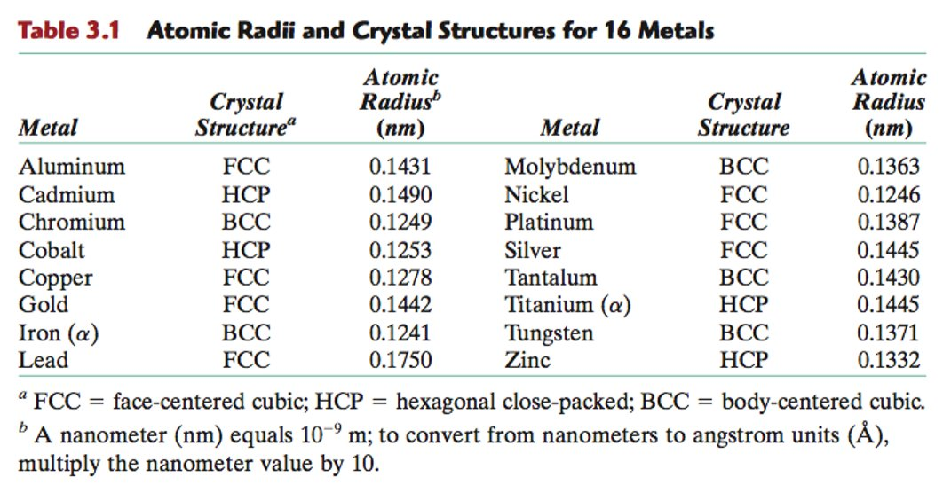

- Calculate the unit cell volume of Gold [3]
ii. Which element has a cell volume of $6.0376×{10}^{-29}m^{3}$ [4]
iii. Calculate the theoretical density of Aluminium given its atomic weight is $26.98{gmol}^{-1}$ [3]
iv. Show that the radius of a Chromium atom is 0.1249nm given it has a density of $7.19gcm^{3}$ and an atomic weight of $51.99{gmol}^{-1}$ [4]

- Calculate the indices of the vectors 1, 2 & 3 [9]
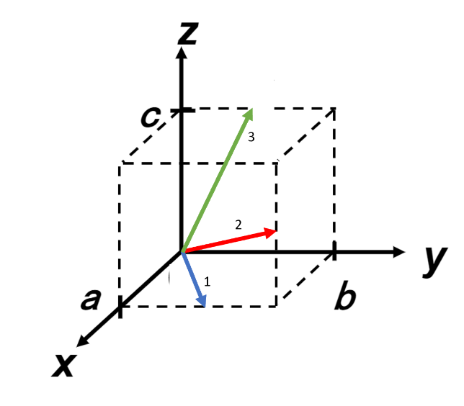

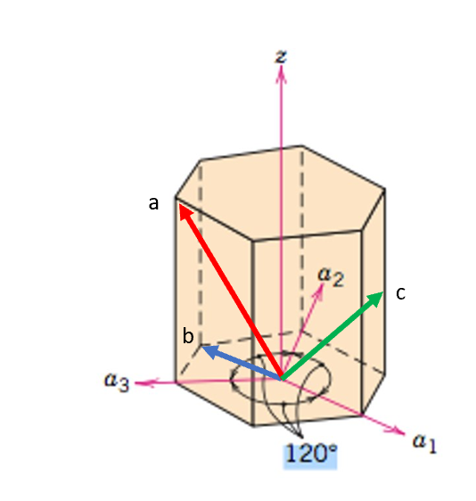

5.

Determine the Miller-Bravais indices of vectors a, b and c [12]

6. Write down the plane directions of the planes shown below [18]

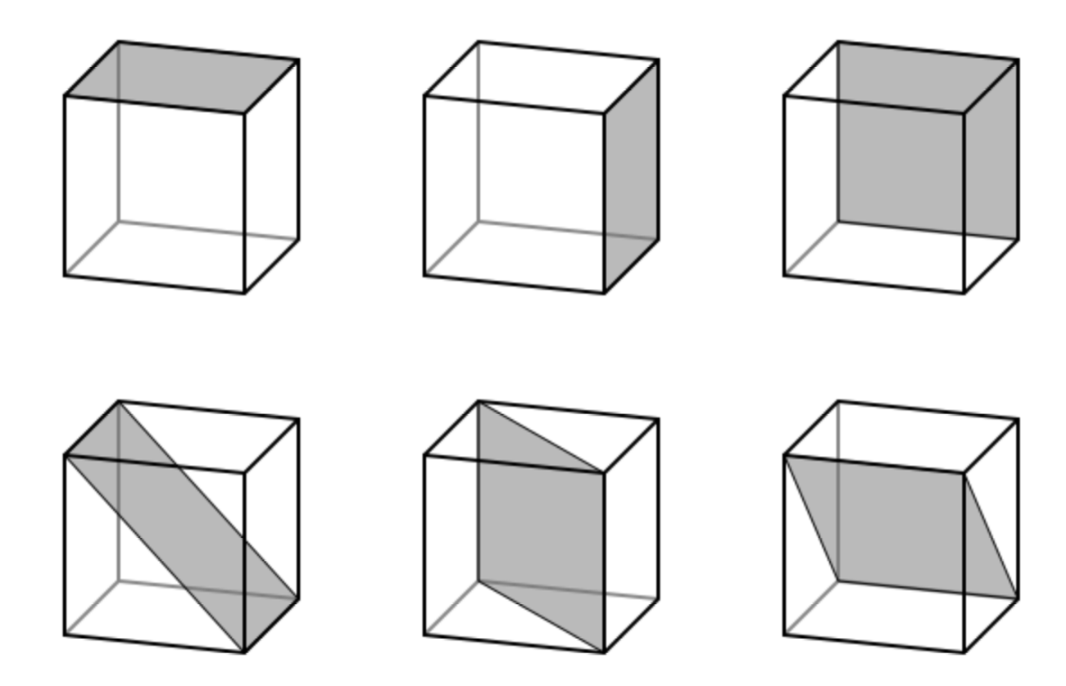

8. a. Is it possible to have a Cu-Ag alloy that, at equilibrium, consists of:
i. a β phase of composition 95 wt% Ag – 5 wt% Cu, and [2]
ii. a liquid phase of composition 70 wt% Ag – 30 wt% Cu? [2]
iii. what are the temperatures of i and ii respectively [2]

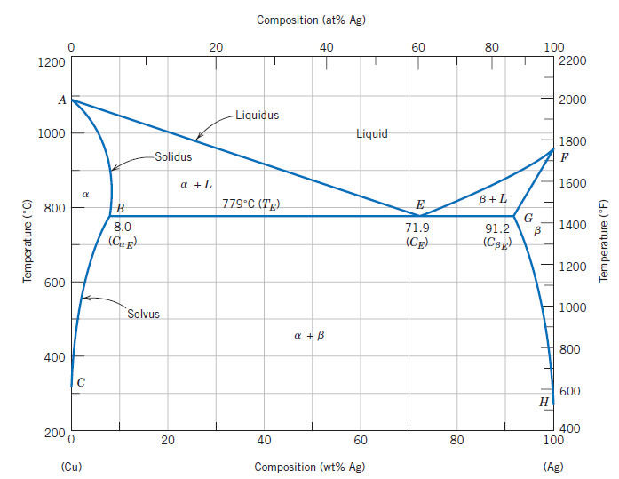
Figure 3

Diwedd/End

