
Skills for the Workplace
Module Assignment Submission
Student Name: | Emma Nightingale
Student Number: | 2008693
Module No: | BMSK4007
Module Title: | Digital Skills and Personal Branding

Statement of Confirmation of Authenticity
By the act of making this submission, the student declares that this is the work of the student named above. The work has not, in whole or in part, been knowingly presented elsewhere for assessment, or where assessment has been built on a previous assessment, this has been identified. Where materials have been used from other sources it has been properly acknowledged. If this statement is untrue, the student acknowledges that an assessment offence has been committed.
Attention is drawn to the plagiarism and unfair practice policies of both the University and of ILM.
Permission for ILM to use this script
ILM uses learners’ submissions – on an anonymous basis – for assessment standardisation. By submitting, both the centre and the learner agree that ILM may use this script on condition that identifying information is removed. However, if you are unwilling to allow ILM use this script, please refuse by ticking the box: □

Table of Contents

What has been the impact of 21st Century Technologies on the modern workplace? 3
Evaluate the appropriate use of modern technologies and social media in the workplace generally 3
Explore the use of modern technologies and social media in own workplace 4
How can Personal branding help YOU? 6
Your LinkedIn Profile to promote your Personal Brand 6
Evaluate the value of other social media platforms to enhance networking and career prospects 6
Examine the impact of Personal Branding on your own employability 7
Discuss personal and professional security and safety online. 7
References 9
Appendix 1 11
Appendix 2 11
Appendix 3 12

What has been the impact of 21st Century Technologies on the modern workplace?

Evaluate the appropriate use of modern technologies and social media in the workplace generally

Modern technology has had a major impact during the 21st Century. I believe almost every job (if not all) has some use of technology. I use technology on a daily basis it assist me being able to complete my duties in an efficient and productive manner.

According to an article in Avocor (Harries-Briggs 2018) they suggest the positive impact on modern technology outweighs the negative impact. It can give employees a greater lifestyle choice and future opportunities. It suggests it can have a positive impact on production including communications.

An article on Best Cloud Storage 2020 reviews (Casserly 2020) explored the best storage systems available. It reviewed 10 of the cloud storage systems available and listed the benefits and disadvantages of each facility available. I have attached a screenshot of their suggested results. It was very interesting and informative.
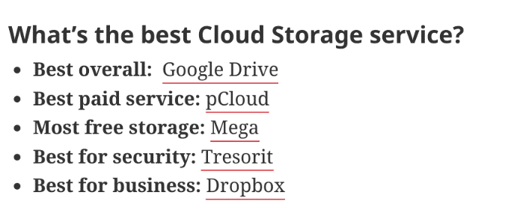
On a personal level I use Google Drive to store photos, videos and files on my personal phone. It has a generous amount of storage at 15GB on the free plan. I like that I can keep my photos, videos and files safe so should my phone breakdowns or get lost I can always retrieve my personal photos and files on another device.
We use HWB, Sharepoint and the One Drive in my workplace. I read an article (Phillips 2017) that talks about the benefits of 365 and SharePoint in education. It indicates the importance of being able to access files on any device and being able to share files. This is extremely important now particularly with our staff and pupils having to adapt to online learning and the need to be able to have a good and safe line of communication.
Our School staff must also use One Drive for all storages of files thus allowing us to access our files safely and remotely. Our files are backed up regularly and we grant access to authorised individuals only. We regularly create documents and share them with other colleagues so we can all work on the same documents if needs be. We are encouraged to use this form of storage/sharing to ensure the information is shared safely and efficiently. The files are backed up regularly and can be accessed from any devices. Our Organisation is encouraging the use of SharePoint more now than ever due to remote working. I found an interesting article (TCC Support 2020) about the benefits and facilities on offer by using SharePoint in the workplace. This is more important any ever with the current situation as lots of our staff are encouraged to work remotely so sharing of files are extremely important to keep all team members working with up to date information. Our students also use One Drive to complete their home learning and this can all be shared back to the teachers in a safe and efficient manner.
Explore the use of modern technologies and social media in own workplace

I use a large range of different technologies to enable me to complete my work efficiently every day. These include computer/desktop, laptop, tablet, printer, photocopier, fax, phone and mobile phone.

The software I use to be able to undertake tasks include Office 365, Word, FMS, SIMS, Excel, Edunet and Sharepoint.

I have given examples below in which ways the software is used and how it is beneficial to my workplace.

- Office 365 ~ emailing and booking appointments.
- Word ~ drafting letters, documents and policies.
- FMS ~ processing invoices and running the school budget.
- SIMS ~ accessing and updating pupils details and taking class registers.
- HWB ~ share documents, email & communicate via Teams.
- Excel ~ creating and monitoring spreadsheets.
- Edunet ~ sending text to parents with updates.
- OurSchool App ~ uploading letters and events to update parents.

Whilst our desktops computers are connected to the main school network all other devices can be used remotely. This has proved extremely important and has provided to be paramount during the current pandemic. My colleagues and I have had to undertake a lot of remote working. An article on Office Reality (Hurd 2020) explores the advantages and disadvantages of working from home WFH. It suggests it could contribute to increased productivity for employers and be more cost effective for the employer and employee. It explored the disadvantages and how it could have a negative impact on employees' stress level by not being able to sign off from work and to continue working after hours. It also highlighted how it could be difficult for employers to monitor employees’ progressivity and it could be difficult to create a feeling of team spirit. I feel my employee has overcome this issue by having weekly teams meetings over Teams where employees can caught up with one another and be given any necessary updates. It helps all staff feel part of the teams and it has proved extremely popular and helps maintain good morale amongst staff.

Whatsapp
We used to have a "Hafod Primary Staff" whatsapp group. We used this to communicate and keep staff up to date with new events coming up and new ideas. The positive side of WhatsApp was that it is the fastest way to connect to all staff and it had a backup feature should you not have access to your phone. The downside to this form of communication was not all our team members are able to access this due to not having a smartphone, internet access or not confident using this form of communication. Our Organisation does not encourage this form of communication for sharing any information as they do not deem this as a safe method of sharing information due to GDPR. We have closed the group and are discouraged to use WhatsApp. They would encourage the use of HWB for sharing such information. An online article (Friedlein 2019) strongly advises due to GDPR not to use WhatsApp in the workplace. It indicated that WhatsApp’s Terms & Conditions do not allow the use for professional use and Data Protections breaches would occur unintentionally.

HWB & Teams
Our Keystage 2 pupils have access to HWB and Teams can use this form of communication to get in touch with other students and their teacher. This has been very popular during recent months to keep teachers and pupils connected. All home learning is through this method and pupils can complete their work/tasks and return to the teacher for marking. The downside is some of our pupils might not have access to the internet or a laptop, chromebooks or tablets. We have been able to overcome this by providing pupils with a dongle with 6 months free internet access and a chromebook borrowed from the school.

Website
Our school website, Hafod Primary, (2020) is an excellent source of online communication. All of our up to date and current information is on this site. It can be accessed by anyone and does not require any log in details or permissions. We also have the facility to translate the website in over 1000 different languages which is vital in order to keep all families up to date with what is ongoing in our school.

An article on Tech Times (Hamilton, 2019) looked at the benefit of using mobile apps. He indicated there is a high demand for mobile apps in the modern times. He suggests it can move your business on and boost sales.

We use various apps in my workplace some of these are new Apps which have only recently been used and they have proved very popular. It's great for fast and accurate information to be communicated to all users. I have listed some of the Apps used below:-

Swansea Ednuet Texting Service
We use the above texting service to keep staff and parents up to date with any announcements or upcoming events. Parents must keep their mobile numbers up to date. The downside is only one parent per pupil can receive the text and we are limited to 160 characters.

Classdojo
This is a mobile app we use to keep our pupils & parents updated. We can share videos, photos and student updates. This is a very popular form of communication. All parents are encouraged to join by providing their email address and staff, parents and carers can privately message each other to keep communications flowing. Teachers can put class updates on their page and can also see who has seen and responded to the same. Keystage 1 pupils have been set assignments and worksheets via this method during periods of home learning. Pupils can download and complete the same and return back to teachers for marking. The downside is parents must provide their email addresses and ensure they are kept up to date and have internet access. To overcome this we can access grants to support our families with this issue. We also have interpreters and a Family Liaison Officer at our school to assist any of our families to access the same if they have any difficulties.

OurSchoolApp
Our SchoolsApp is available on Google Play Stores and App Stores. All parents can access this without having to have approval from the school. All our letters and information is uploaded onto this app. All events are also added to the diary facility and this can be linked to your phone so reminders of events will go into parents’ calendars.

Squid
This app allows parents and staff to pay for lunch, trips and uniforms. This app is very good as it keeps an audit trail also and helps us run an efficient service as we run a zero debt policy.

How can Personal branding help YOU?

Your LinkedIn Profile to promote your Personal Brand

Is an exceptional way to reach and connect with companies and organisations, as well as fellow professionals in your own field. I have created my own LinkedIn account (see Appendix 3). I created a bold and striking banner to capture potential recruiters' attention. I included a brief headline of my values and ethos to allow potential recruiters to get to know a bit about me and what is important to me. CareerSidekick (Clark 2020) explores the need to create an eye-catching and an impressive Linkedin Profile to attract potential recruiters. It gives tips to create a successful profile that will be appealing to potential organisations. This includes using keywords in your skills sections to allow potential recruiters to review your profile if they undertake a search by skills only. Your photos and banner are important and the article suggest it should be friendly and professional and your headline needs to be bold and eye-catching, so potential recruiters will want to learn more about you. It also states that recommendations can have a positive impact on your profiles and can create a positive impression on the reader thus creating more opportunities. It talks about the importance of using keywords such as driven and led and also the importance in researching other profiles to learn what works for them.

Evaluate the value of other social media platforms to enhance networking and career prospects

There are lots of benefits of using Social Media Platforms and they have become increasingly popular over the last decade. I have listed below a couple of the most popular social media platforms.

Facebook
Facebook was created in 2004 they have lots of functions to include Facebook live, updating photos/stories, messenger, marketplace & group. It is a free social media platform and is extremely popular. I use this on a personal level and to promote and sell personalised crafts which is part of my personal hobby, (Nightingale, 2020) please see Appendix 1. This is a free service and it is great for promoting my crafts as my customers are able to privately message me, ask any questions and see my gallery of my designs already created and also leave reviews.

I read an interested article in Lifewire (Nations 2020) it explores and gives tips on using Facebook. It suggests it is an easy to use social media platform and is extremely popular.

Twitter
We use Twitter in the School I am employed in, @hafodprimary, (Twitter, 2020). Please see Appendix 2.

It is a great fast and free way of keeping our families updated. Our parents are able to follow the school and retweet posts if they so wish. An article on Hubspot (Hahn, 2020) was extremely informative and it explored the benefits of using Twitter for business. It outlined the importance of being diverse and different and being able to reach your audience this can be through a creative and eye catching design or name. It suggested the importance of good communications and ensuring tweets are relevant, regular and not repetitive. It indicated that regular reviews by undertaking analytics on twitter can help in ensuring you reach your professional goals. I feel Twitter could be beneficial to some businesses in reaching customers in order to reach a wider geographic audience.

Examine the impact of Personal Branding on your own employability

I strongly believe personal branding can have a positive impact on my employability but there are steps that must be adhered to. I reviewed an engrossing article on Reed (Rolfe 2020) and it explored the importance of Personal Branding and the areas it can affect you in your professional and personal life. It explored the need to promote yourself in a positive manner and highlighted various elements to include such as your interests, life goals, education, matters that are important to you and your abilities. It proposed it can help to keep developing your knowledge by attending courses and keeping full appraised of matters surrounding your professional career. The article suggested the importance of ensuring that your personal social media accounts don't have a negative impact on your personal branding by inappropriate photos and status. It indicates the importance of building good solid relationships and networking and how keeping a good online presence can help increase your personal branding and thus helping your employability.

Discuss personal and professional security and safety online.

General Data Protection Regulation GDPR can have a massive impact on workplace and personal life. It's extremely important that staff in the workplace are compliant to the regulations and law surrounding GDPR and storing of personal data. An article by ACAS Working for Everyone (ACAS 2020) explores the laws and rules surrounding storing personal data. It indicated and listed the 6 principles' regarding GDPR including clear and lawful storing of data and how you should only obtain relevant information which must only be used for this sole purpose and kept regularly updated. Companies must store the data in a secure and safe manner for an appropriate timeframe. The GDPR laws complies too all organisations where personal data is held and all staff have a responsibility to ensure GDPR is adhered to at all times. It also detailed the laws surrounding employees requesting their own personal data stored regarding them including disciplinary and monitoring and if such request is not granted a Subject Access Request can be made which should be adhered to within 1 month.
I believe GDPR is an extremely serious matter. I receive regular training and it has given me a clear understanding of the importance of GDPR. It can have an extremely negative impact on your career and the organisation if you fail to comply with the GDPR laws.

References

ACAS (2020), GDPR - The General Data Protection Regulation [online] available at: https://archive.acas.org.uk/index.aspx?articleid=3717#whatisgdpr accessed 20.01.2021

Casserly,M (2020) Best Cloud Storage 2020 [online] available at: https://www.techadvisor.co.uk/test-centre/internet/best-cloud-storage-3614269/ accessed 22.12.2020

Clark, B (2020) 5 Best LinkedIn Profile TIps From a Recruiter available at: https://careersidekick.com/best-linkedin-profile-tips/ accessed on 30.01.2020

Friedlein, A (2019) 8 dangers of using WhatsApp for business [online] available at: https://guild.co/blog/10-dangers-of-using-whatsapp-for-business/ accessed 02.01.2021

Hafod Primary (2020) Hafod Primary School [online] available at: https://www.hafodprimary.co.uk/ accessed 10.12.2020

Hahn, I (2019/updated 2020) The Ultimate Guide to Using Twitter for Business in 2020 [online] available at: https://blog.hubspot.com/marketing/twitter-for-business accessed on 18.01.2021

Hamilton, E (2019) Why Mobile Apps Are Important for Your Business [online] available at: https://www.techtimes.com/brandspin/242588/20190504/why-mobile-apps-are-important-for-your-business.htm accessed on 08.01.2021

Harris-Briggs, N (2018) How Does Technology Impact the Workplace? [online] available at: https://www.avocor.com/uk/blog/how-does-technology-impact-the-workplace/ accessed 28.01.21

Hurd, M (updated 2020) Advantages & Disadvantages of working from home [online] available at: https://www.officereality.co.uk/blog/advantages-and-disadvantages-of-working-from-home accessed 18.01.2021

ICO (2018) Guide to the UK General Data Protection Regulation (UK GDPR) [online] available at: https://ico.org.uk/for-organisations/guide-to-data-protection/guide-to-the-general-data-protection-regulation-gdpr/ accessed on 24.01.2021

LinkedIn (2021) Emma Nightingale Public Profile [online] available at: https://www.linkedin.com/in/emma-nightingale1106/ accessed on 24.01.2021

Nation, D (2020) What is facebook? [online] available at: https://www.lifewire.com/tutorial-how-facebook-works-2654610 accessed on 21.01.2021

Nightingale, E (2020) Christmas Crafts by Emma Facebook [online] available at: https://www.facebook.com/Christmas-crafts-by-Emma-xxx-110858230738445 accessed on 10.01.21

Phillips, T (2017) The benefits of Office 365 and SharePoint in Education [online] available at: https://www.tonyishere.co.uk/why-sharepoint-and-office-365-make-sense-in-education/ accessed 08.01.2021

Rolfe, A (2020) Personal Branding: What you need to know [online] available at: https://www.reed.co.uk/career-advice/personal-branding-what-you-need-to-know/ accessed on 29.01.2021

TCS Support (2020) SharePoint it takes Cloud Computing to a different level! [online] available at: http://www.tcssupport.co.uk/business-it-support-news/sharepoint-it-takes-cloud-computing-and-storage-to-another-level/ accessed 22.12.2020

Twitter (2020) Hafod Primary School @hafodprimary [online] available at: https://twitter.com/hafodprimary?lang=en accessed on 24.01.2021

Appendix 1

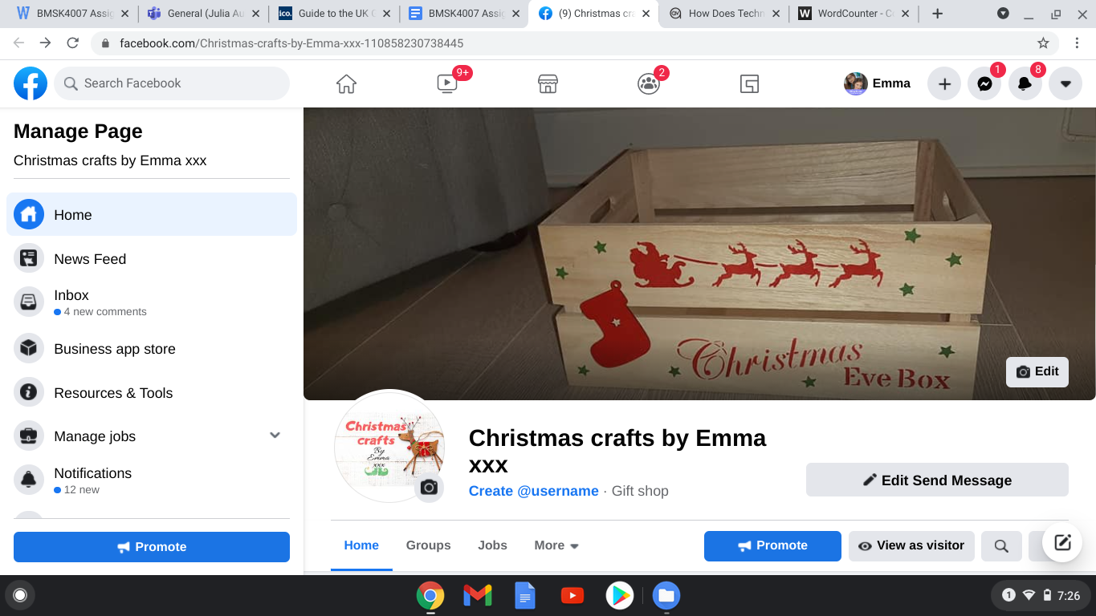

Appendix 2

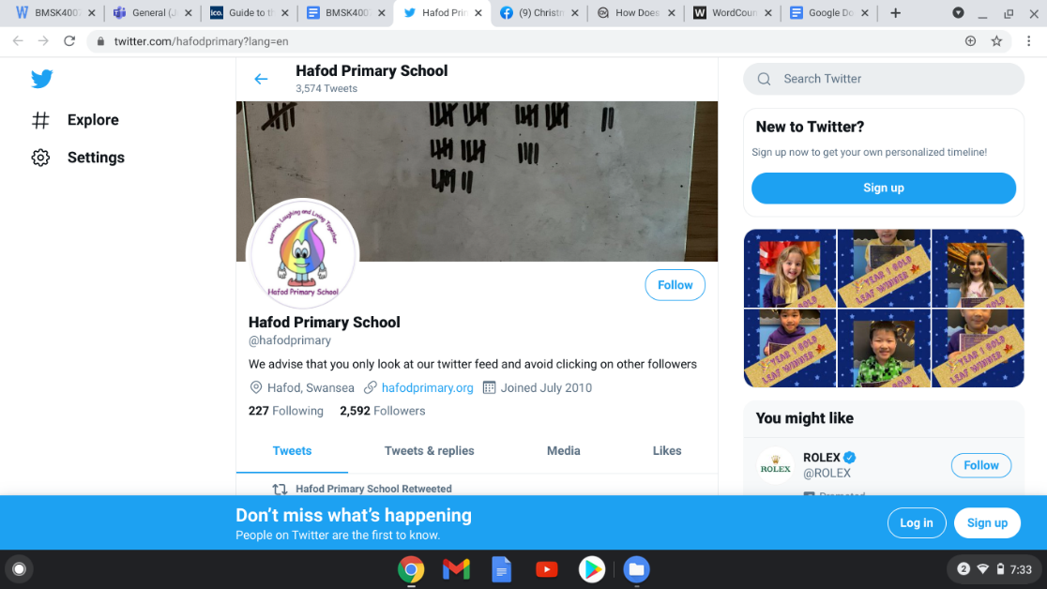

Appendix 3



