PD14 A3 ASSIGNMENT

SERVICE PLANNING AND CONTROL

Lecturer: Mr Graham Orr
Student: Mr Martyn York
Student ID: P152361

I declare that this assignment is all my own work and that I have acknowledged all materials used from the published or unpublished works of other people. All references have been duly cited.
Introduction

Using the design and evaluation framework question based approach that Transport for London (TfL) use when designing a new interchange terminal, this assignment will evaluate the design of Birmingham New Street Railway Station, using the principles as outlined in the Usability Theme.

1. Accessibility

Birmingham New Street station complies with the Equality Act 2010, demonstrating the ability to provide facilities ease access, especially to people with reduced mobility.

1.1 Can all interchange areas be reached by avoiding steps?

1.1.1 There are 12 platforms in the station and all platforms have level access (figure 1). There are ramps/slopes and lifts/escalators to access all areas/services (figure 2). These are often a longer route for abled bodied passengers, so steps are designed to bypass the ramp/slope features. Stepped and sloped areas are integrated to make best use of space, aiding to the flow of passengers.

1.2 Is Level Boarding offered on all Services?

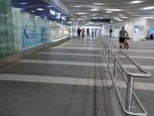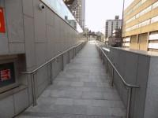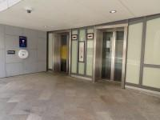
(Fig 1) (Fig 2) (Fig 3)

1.2.1 There is a lift for public use (figure 3), the lift is a standard lift, the floors which are accessible by this lift are Ground to Concourse and Staff do not need to be notified for use of the lift. The clear door width is 140cm (4ft 7in) and the dimensions of the lift are 160cm x 160cm (5ft 3in x 5ft 3in). There are separate entry and exit doors in the lift but there is not a mirror to aid reversing out of the lift or a visual floor indicator. The lift does have an audible announcer but the lift does have Braille markings. The lift does have tactile markings and lighting level in the lift is medium. All key concourse shops and services have level access by means of the ramp/slope designs and lifts.

1.3 Are step and obstacle free routes clearly designated/Are lift and escalator locations and designs optimised?

1.3.1 The footpath to the entrance from Hill St is step free, (figure 2) and there is level access from the drop off point. All platforms have lifts and escalators and all are clearly marked in the concourse, lifts are located adjacent to steps on cater for all platforms respectively.

1.4 Are members of staff available to assist passengers?

1.4.1 There are generally 10+ members of staff on duty. Staff do receive disability awareness equality training and there is an office to obtain help, the office to obtain help is 60m (65yd 1ft) from the Hill Street entrance (located to the left of Starbucks Coffee).

2. Safety and accident prevention

2.1 Does the interchange meet with all emergency and security requirements?

2.1.1 Interchange facilities are designed and operated to be in compliance with the Health and Safety at Work Act 1974, including compliance with fire regulations. Staff are trained in emergency management including the use of firefighting equipment and assisting passengers locate fire exits. Fire exits are visibly marked and an alarm system is in place in the event of a fire.

2.2 Have potential hazards been minimised?

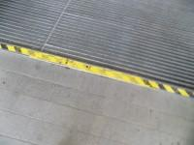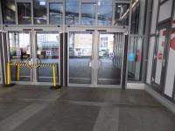
(Fig 4)
2.2.1 There is a small raised threshold in the doorway which is clearly marked with yellow and black warning markings (figure 4). The design of the interchange avoids uneven or lose surfaces, but in the event of maintenance or when part of the design is compromised it will be clearly cordoned to minimise accidents with yellow and block temporary cordons (figure 4). Slippery floors when wet (through either cleaning or a compromise leading to a leak) are cordoned off in the same fashion, or by means of a floor wet sign in accordance with the Health and Safety at Work Act 1974. Hand Rails have been integrated into the design of the station at ramps/slopes stairs/escalators.

2.3 Are locations where passengers and vehicles meet safe?

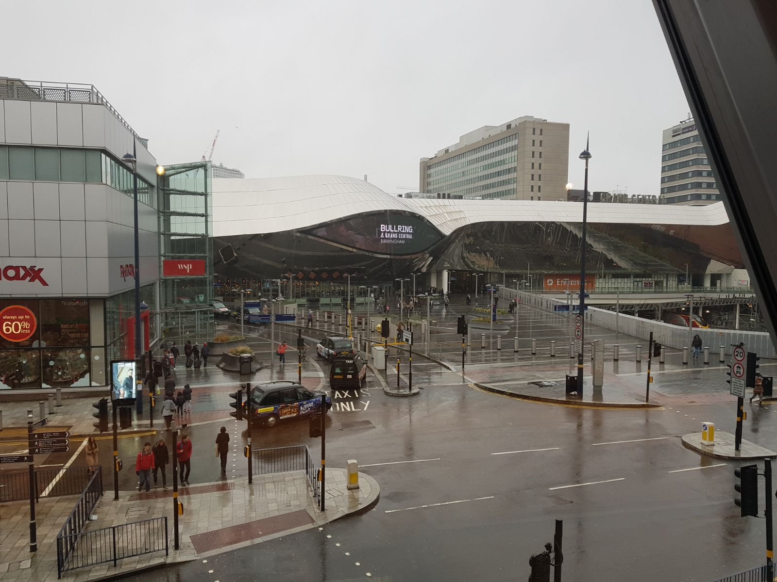(Fig 5)

2.3.1 The station has specific interchange zones for use including a drop off facility, taxi rank and Cycle-Park. These facilities in there design are used for the sole function and primary use, segregated form general space within the station. In places where they may be conflicts, clear signage is used, including surface treatments, indicates vehicles are in operation in these zones, and pedestrian crossings (zebra type) dictate priority for passenger crossing areas. Tactile materials such as metal rails are used to avoid passengers walking in the road, conflicting with the city’s traffic and used for the drop off facility and around entrances where the entrance is adjacent to roads surrounding the area. Pedestrian areas are implemented in the design around the entrances to the station, with cycle routes segregated to avoid crossing natural flows of human and cycle traffic. Figure 5 Illustrates measures to reduce risk of pedestrian/vehicle clash including bollards, crossings and the 20mph speed limit around the local vicinity.

2.4 “Speed limits must be low”

2.4.1 The risk of pedestrian conflict is highest where the drop off facility is. In order to minimise risk, safety measures are implemented in the form of traffic calming measures. These measures include a 5 mph speed limit and speed bumps. To access the car park on the roof the ramp is for single use of motor vehicles, pedestrian walkways are completely segregated. The car park has a 5 mph speed limit and has designated walkways to minimise risk of passengers coming into conflict with motor vehicles. Around the station is central Birmingham’s road network, implemented is a 20mph speed limit with many traffic lights used to regulate the flow of traffic and control speed. All entrances have adjacent signal-controlled crossings spanning all directions, to the city centre, bus stops where people are alighting and towards the Bullring. The most popular destination for tourists is Birmingham’s renowned shopping centre, the Bullring therefore incorporated into the design of New Street Railway Station is internal access to the Bullring via means of a walkway accessible from the concourse, again, a measure to reduce the risk of conflict with passengers and vehicles.

3. Personal Security

3.1 Has specialist Crime Prevention through Environmental Design advice been sought?

3.1.1 As a major transhipment point with vast footfall, which may be of interest and attractive to potential extremist attacks, Birmingham New Street Station has been architecturally designed in such a way to minimise and restrict terrorist attacks. Major choke points are wide and open, entrances are vast with a number of doors and the overall design is one where vehicle-borne attacks will not be a viable action due to raised entrances, walls and bollards.

3.2 Are there isolated locations?

3.2.1 Interchanges, including the immediate areas surrounding them, are well lit, walkways are visible from main concourses and the overall architectural design is made up of one, main, vast space which encompasses most isolated areas, greatly enhancing personal security by including areas where other passengers and staff are present. The station is covered by state-of-the-art facial recognition CCTV, which is illustrated in figure 7. Waiting areas on platforms are made of a glass composite, increasing visibility from other passengers, police and safe to achieve a sense of security for passengers waiting for their transport.

3.3 Does the interchange zone provide good levels of natural surveillance?

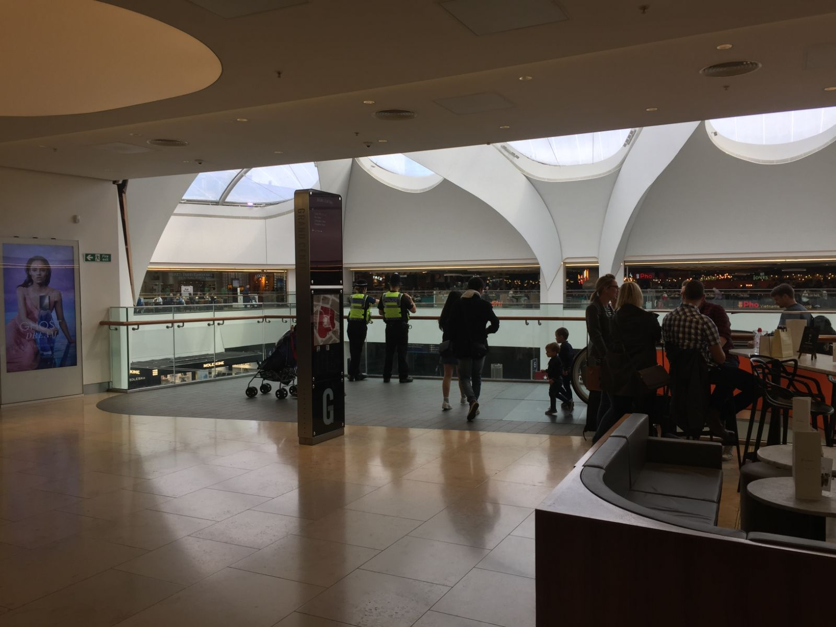
(fig 6)

3.3.1 The majority of the interchange is incorporated in a two-floor design which gives a natural vantage point, as demonstrated in fig 6, which the British Transport Police use to their advantage. The concourse can be scrutinised from above, and the police patrol this area to ensure safety and show presence to reassure citizens, especially with armed police in response to the heightened security aspects inherent of recent terrorist attacks. As a newly developed station, it is apparent this design has been purposely augmented in light of recent events. The central area on the concourse is used for a mix of purposes including decision making, and waiting and scrutiny of information boards. Therefore having the visible police force above watching over this main area offers reassurance to the general public, producing a feeling of well-being and safety, without an excessive show of force and wasted resources.

3.4 Is CCTV used effectively?

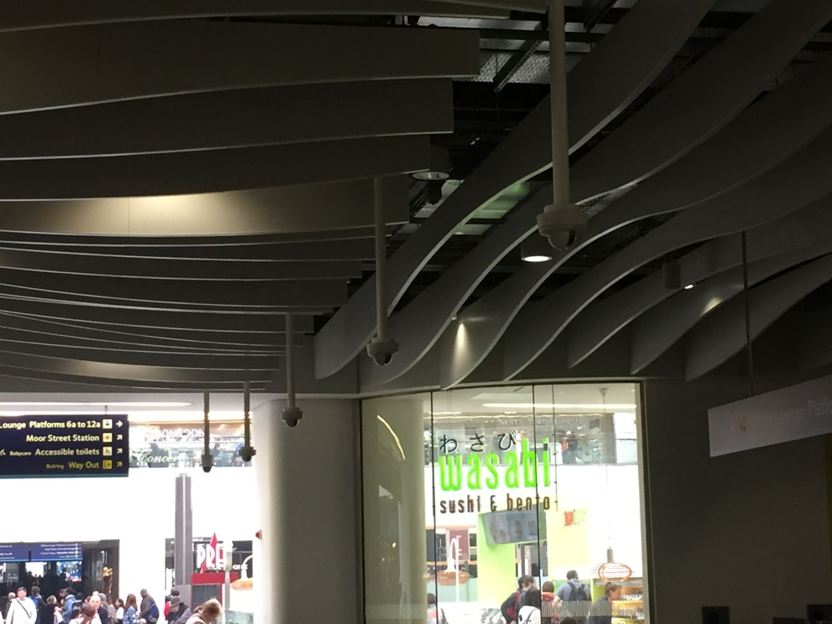
(Fig 7)

3.4.1 As aforementioned, the use of CCTV to supplement additional security measures is clear and visible throughout the station and at entrance areas this is noticeably heightened due to the state-of-the-art facial recognition cameras. These are doubled up and are not only used for security purposes, but also used for demographic, advertising and data collection purposes. As the CCTV is used so brazenly, as seen in figure 7, it is an obvious deterrent from potential criminal activity, subsequently reducing fear of crime in the area.

3.5 Are fixtures and fittings vandal-proof?

3.5.1 Materials used are of a composite that graffiti can be removed with ease. This is apparent through use of ‘smooth surfaces’ in and around areas of susceptibility, for example the lift facilities. The rapid removal of graffiti contributes to a high quality of finish as outlined in the TfL’s question set, which ultimately deters further vandalism or graffiti. With these measures, including aspects of security like high level of CCTV and presence and increased surveillance of staff (including the police), vandalism and petty crime of that nature are greatly minimalised.

4. Protected environment

4.1 Does the interchange zone provide effective climate protection and control?

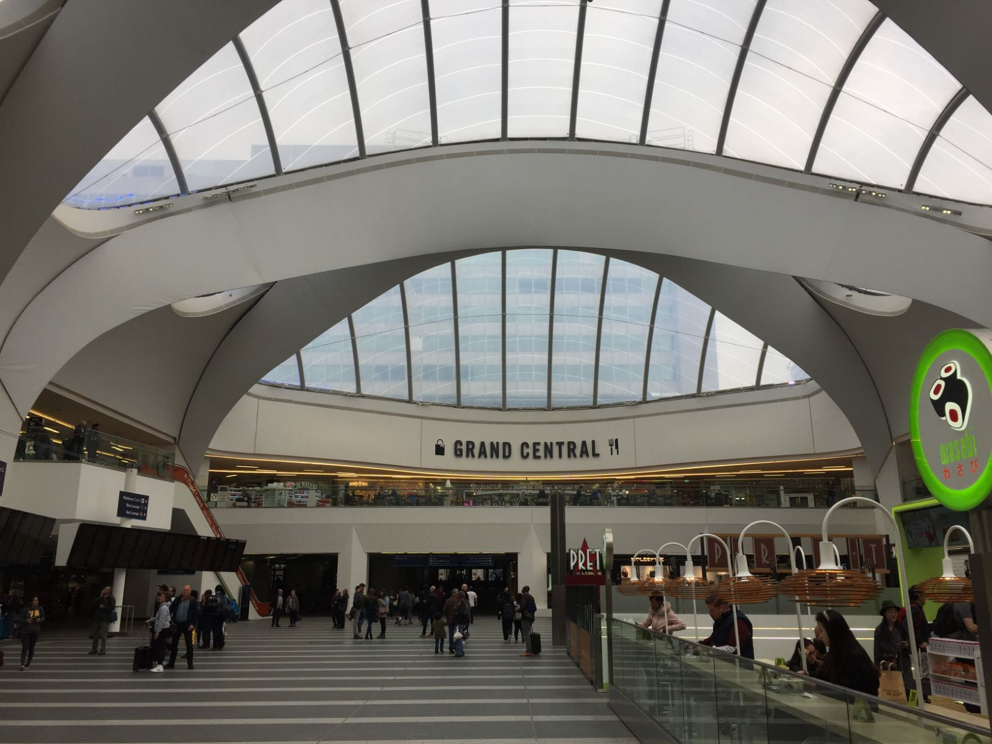
(Fig 8)

4.1.1 The main interchange is sheltered from the elements with its unique roof structure. As demonstrated in figure 8 the composite of the roof materials is designed to harness rays of sunlight to produce heat in times of colder climate, and the panes have the ability to open to release heat in times of hotter climate. Platforms are sheltered as the main concourse is situated above it, although parts of the platform infrastructure are under the elements, there are sheltered waiting areas where passengers can wait in comfort and feel secure. The sheltered areas are heated, and air conditioned as is the station in its entirety. Sheltered areas, although secluded, are well lit, have CCTV equally as distributed in other areas and are constructed of a composite similar to glass, so vision from other passengers and staff is not compromised, contributing to the safe environment felt throughout. Real-time information is displayed throughout the station by way of digital screens just above eye level, contributing to a sense of control by way of crowd control measures. Regular maintenance of these areas is implemented to ensure all areas including waiting zones are kept in good order.

Conclusion

Birmingham New Street Station not only provides for “seamless and efficient movement of passengers and public transport vehicles” (TfL), but also interchange zones that offer accessibility for all potential users and an environment that is safe, secure and comfortable. Birmingham New Street Station is a newly developed interchange zone, with modern requirements realised and measures integrated to reduce risk of accidents and crime.

Birmingham New Street Railway Station has had the opportunities inherent of recent developments, including augmented realised strategies for both security and mobility measures. For example, natural observation points such as the overhang purchases over the main concourse for police and staff to monitor is an example of purposeful design implemented for that sole purpose. Lifts incorporated into the central design, with maximum observation in the form of glass composites, using smart projection of light contributes towards a safe environment for passengers. Slopes, ramps and steps incorporated into the design with levels accessible for disabled or users with reduced mobility further add to the attractiveness of the station, with trained staff frequently accessible for assistance.

All mentioned measures, outlined in the infrastructure design guidelines as used by the TfL, contribute to a pleasant experience, increasing usability of the interchange zone, ultimately positively contributing to the economic growth of the region, by way of using public transport over automobiles relieving congestion of Birmingham.

References

Transport for London, Urban Planning and Construction, Tfl Website, (www.tfl.gov.uk/info-for/urban-planning-and-construction)

Disabled-Go, Birmingham New Street Station Access Guide, Disabled-Go Website, (https://www.disabledgo.com/access-guide/birmingham-city-council/birmingham-new-street-station)

