Elizabeth A Papadopoulos
MA Medieval Studies 2025-2026
The Cloister and the World: Studies in Medieval Cistercian History
Assessment One: Commentary on a visual source

Fontenay Abbey: The Cloister

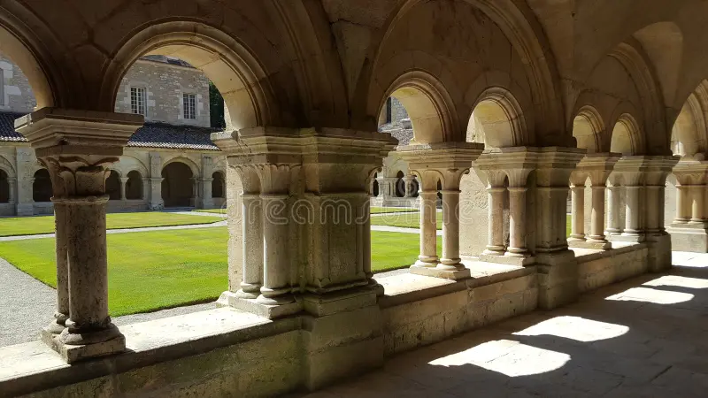

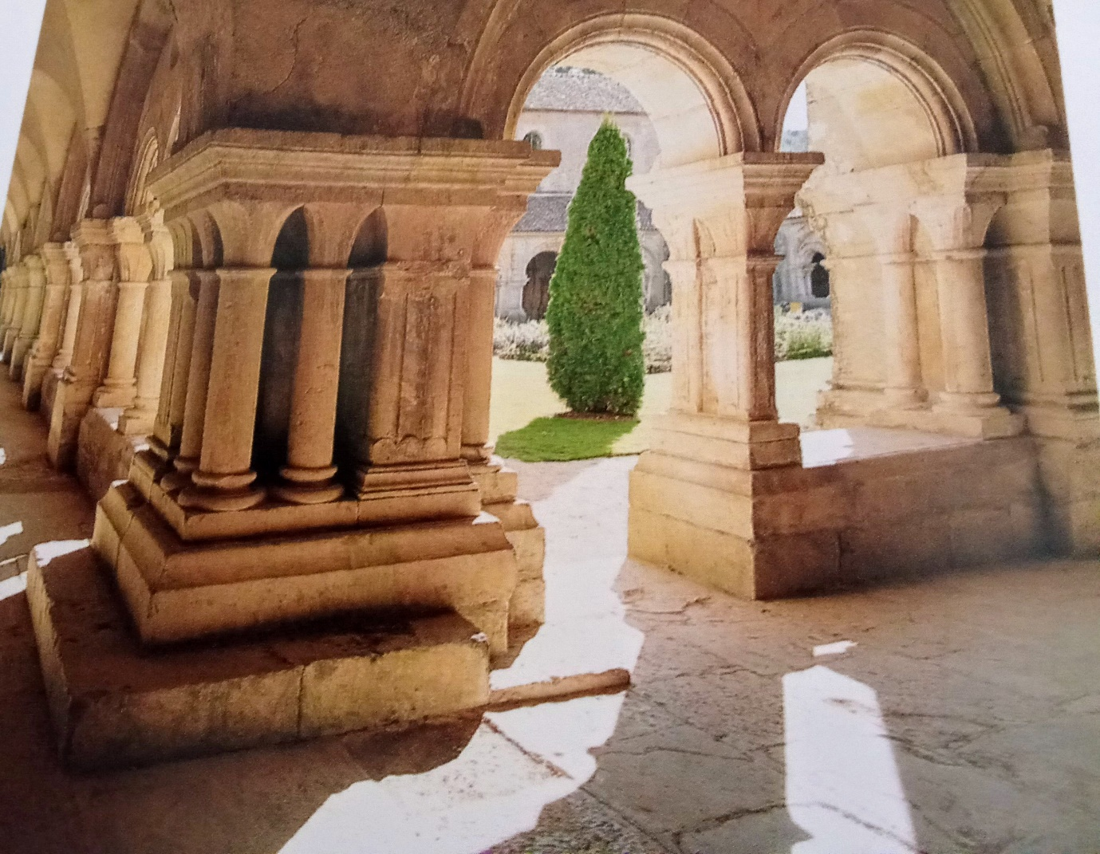

Founded in c.1118 by St Bernard of Clairvaux and said to be the abbey ‘closest to his heart’, the French Cistercian Abbey of Fontenay, Clairvaux’s second ‘daughter’ house, is situated in the Chastelun forest, north-west of Dijon in the region of Burgundy. Built on the site of an earlier hermitage owned by Molseme Abbey, the lands had been gifted by Raynard de Montebard, maternal uncle of St Bernard, whose financial input enabled the swift construction of the abbey with quality building materials, and showcasing the spirit of Cîteaux through St Bernard’s vision of Cistercian architecture as a haven of silence, restful simplicity and, spiritual renewal. As the focus of this commentary, the cloisters of Fontenay are of particular significance, yielding a multi-layered interpretation of early medieval Cistercian thought on religion, monasticism, architecture and art, social and ecclesiastical obligations, and the everyday life of a Cistercian abbey.
The significance of the cloister’s position within the claustral buildings of the abbey, is essential to an understanding of the daily life of the abbey, and to the Cistercian desire for simplicity and order. Situated physically at the very heart of the abbey, its design mirroring a Roman atrium, the cloister was at the heart of the monks’ daily existence on a physical, practical, ritual, and psychological level, a symbolic centre of the monks’ lives. Rectangular and measuring 118ft by 125ft, the cloister garth at Fontenay is an example of both functional planning and spiritual importance. The beauty of Nature contained within that small area has been described as ‘Paradise’ or as ‘a paradise’, an expression of Divine creation equally revered and respected and, fundamental to Cistercian beliefs. For the monks Paradise was their ultimate destination, a reminder both physical and spiritual of their goal, a physical symbol of their hope for eternal life. Although there is no longer a fountain at the centre of the cloister garth, (today there is a fountain in the park to the east of the abbey), it is likely one existed given the etymology of the name ‘Fontenay’ as deriving from the word for ‘fountain’. Given the value the Cistercians placed on water, not only on a practical level but on a spiritual level too, its importance within the heart of the abbey complex, is not to be underestimated. On a practical level it was essential to self-sufficiency, a foundational value of the Cistercian way of life, and essential to the daily chores of everyday life that would have been carried out within the cloister complex, and the central cloister garth. The centrality of water to life and for purification imbued it with spiritual significance, and it is easy to imagine the soothing sound of water falling within a basin as aiding spiritual contemplation within the cloister. Indeed, St Bernard in his treatise “On Consideration” uses the metaphor of a well, as encouragement for inward reflection and spiritual growth. The flow of water, symbolic of the progression of the soul on its journey, is an embodiment of God’s Grace and essential to both physical and spiritual life.
Giving direct access to other buildings of the abbey, such as the church, the Chapter House, the Sacristy, the Refectory and the kitchen, and the small and large Calefactory, the functionality (intrinsic to architecture) and utility of the cloister, reflected not only the spatial integrity of Cistercian architecture, but also the simplicity of Cistercian design, a simplicity reflected in Cistercian liturgy, spirituality, and way of life and which further signified the depth of devotion to both God and the Cistercian monastic ideal. With the cloister being sited to the south of the church, and protected beneath the right arm of the cross in the east-west alignment of the church, the bulk of the church does not, therefore, obstruct sunlight from reaching the northern side, where sacred reading and writing took place, and where the walkway was equally protected from the cold winds of a northern European climate. A stone bench, running around the inside of the cloister, allowed for the gathering of the community for the nightly collation reading. Ritual processions of monks making their way around the cloister before entering the church, were participating in the cloister’s central symmetry, reflective of the truth and light of both aesthetic ideals and theological beliefs. The play of light and shadow engendered by the construction of the arches and columns of the cloister, reinforced God’s presence, and echoed the words of Thomas Aquinas, that “beauty is the light of truth”, and the Cistercian association of light with God. The intensity of the light filtering through the arches of the cloister arcade would vary with the seasons and time of day, the light highlighting the purity of the stone, and its material simplicity reinforcing the integrity and simplicity of Cistercian spirituality. The long shadows of the evening light would create an atmosphere of tranquility inviting introspection and contemplation. Removed from the outside world and protected from it by the cloister, the monks would thus have found the peace and security conducive to contemplation and the search for union with God within their own hearts.
The cloister in the Romanesque style is barrel-vaulted and consists of semi-circular arches in pairs resting on a low plinth wall, with relieving arches which rest on solid piers. The plinths of the corner columns are solid, stable and simple, recalling the vow of stability taken by the monks and the simplicity of their life and solidity of their faith. They reflect the excellence of the masons who designed and built them which would suggest that highly trained masons were primarily used even if supported by lay brothers and the choir monks themselves. Variations in style in other Cistercian monasteries would suggest that local craftsmen were also used, tying the abbey to its locality. The limestone and other stone used in the construction was a ‘reflection of [the abbey’s] geological surroundings’ and thus blended well into the surrounding local environment. Beauty and praise of God can be seen in the raw material, the stone an example of God’s creation, reflecting the light, and made perfect in the arrangement of the columns and quality of their dimensions. The ordered beauty of the architecture, the symmetry of the arcading and the construction of the cloister, translates the mathematical concept of proportion into tangible harmony, a beautiful concept to the medieval mind and one which the Cistercian monks strove to emulate in their devotions, striving for perfect harmony with God. Although earthly beauty and the human form are transient, the durability of the stone encompasses the Laus Dei, praising God in a building where the monks’ search for eternal rest is reflected in a construction that itself seems built for eternity. As the cloister columns was not originally intended to be seen by anyone other than the monks themselves, no ostentatious decoration was allowed to distract the monks from the serious business of lifting the mind towards spiritual union with God. True to the Cistercian ideal of poverty, no excessive or elaborated carvings are to be found on the stone capitals, or in fact any decoration, that would indicate that money had been spent on a frivolous show. No excessive decoration was permitted to distract the monks from prayer and spiritual purpose, or to hinder their reception of the Word of God. ‘Interior beauty, is more comely than external ornament’, as St Bernard reminded his readers. The muted leaf decoration on the capitals, indicative of the earlier design of Cistercian monasteries, depicted Nature which existed through participation in the Divine, and which as an organic and living element would thus seem to direct the monks reflection on God’s hand in all creation.
The Abbey of Fontenay, its construction and architecture overseen by St Bernard himself, is a product of Cistercian spirituality. For enclosed monks, the cloister in particular, bears the imprint of this Cistercian spirituality, thereby exercising a profound influence over the men who lived their lives within this space. The detachment of the cloister from the stimulation, distractions and anxieties of outside life, allows for an inner, peaceful and silent interior, both physically and mentally. The simplicity of the architecture of the cloister is translated through its form, light and shade, and ordered proportions, providing an environment suited to the way of life envisaged by St Benedict, and providing a setting that promoted inner quiet, reflection, and prayer. St Benedict’s Rule and St Bernard’s interpretation and teachings are expressed through the architecture, which is an expression of Cistercian faith. The cloister particularly is therefore, a translation of the architectural vocabulary of Cistercian beliefs and ideals, transmitted to the monks who lived within this symbolic and tranquil space.
1446 words

Bibliography

Primary Texts
St Bernard, Sermones in Cantica, XXV, 6, (PL. 183, col. 901)
———— On Consideration, Book II, Chapter iii, trans. George Lewis, (Clarendon Press, 1908)

Secondary Texts
Brooke, Christopher, The Age of the Cloister: The Story of Monastic Life in the Middle Ages (Sutton Publishing, 2003)
Bruun, Mette Birkendal (ed)., The Cambridge Companion to the Cistercian Order ( Cambridge University Press, 2013).
Burton, Janet, Monastic and Religious Orders in Britain, 1000-1300 (Cambridge University Press, 2002)
Burton, Janet and Julie Kerr, The Cistercians in the Middle Ages (The Boydell Press, 2011)
Dhuys, Jean François Leroux, Cistercian Abbeys: History and Architecture (h.f. ullman, 2013)
Duby, Georges, Art and Society in the Middle Ages, trans. Jean Birrell (Polity Press, 2000)
Eco, Umberto, Art and Beauty in the Middle Ages, Trans. Hugh Bredin (Yale University Press, 2002)
Jotischky, Andrew, The Monastic World: A 1,200 Year History (Yale University Press, 2024)
Lekai, Louis J., The White Monks: A History of the Cistercian Order (Cistercian Monastery of O.L. of Spring Bank, Cistercian Fathers, 1953)
Milis, Ludo J. R., Angelic Monks and Earthly Men (The Boydell Press, 1992)
Tobin, Stephen, The Cistercians: The Monks and Monasteries of Europe (The Herbert Press, 1995)
Toman, Rolf, (ed)., Monasteries and Monastic Orders: 2000 Years of Christian Art and Culture (h.f.ullmann, 2016)
Williams, David H., The Cistercians in the Early Middle Ages (Gracewing Fowler Wright Books, 1998)

Fontenay Abbey, Marmagne (Côte-d’Or), Burgundy, France. The Cloister from the Chapter House. Image Alamy.com. d.o.a 08.03.2026.
The cloister at the corner of the north and east walks of Fontenay Abbey. Photograph Henri Gaud in Jean -François Leroux-Dhuys, Cistercian Abbeys: History and Architecture, h.f.ullmann, 2013, p. 192.
See Jean-François Leroux-Dhuys, Cistercian Abbeys: History and Architecture, h.f.ullman, 2013, p.51.
See J. Burton and Julie Kerr, The Cistercians in the Middle Ages, The Boydell Press, 2016, p. 71.
St Bernard, On Consideration, Book II, Chapter iii, trans. George Lewis, Clarendon Press, 1908, p. 42.
David H. Williams, The Cistercians in the Early Middle Ages, Gracewing Fowler Wright Books, 1998, p. 195.
St Bernard, Sermones in Cantica, XXV, 6 (PL. 183, col. 901).

