Airbnb as an example of the Sharing Economy


This Photo by Unknown Author is licensed under CC BY

Report

By Laura Davies
1910723
Roisin Mullins
Digital Business

Contents

- Introduction 3
- Airbnb Landscape 3
- BMC 3, 4
- SFF 4, 5
- Tools/Systems 5, 6
- Conclusion 6
- References 7

Introduction

This report will critically examine Airbnb as an example of the sharing economy. Airbnb will be discussed. Airbnb’s business model, their financial landscape, strategy, challenges, target groups and current situation to allow for future growth recommendations.
The sharing economy will be discussed and how it compares to traditional business and how peer to peer trading has grown in recent years and how it has enabled Airbnb to become the rapid success that it is today.
A business Model Canvas will be created for Airbnb and Grand Strategy Matrix to show how it forms part of the Strategy Formulation Framework.
The tools and systems Airbnb use to function and improve will be examined

Airbnb Landscape
The sharing economy is defined as peer-to-peer transactions via on online platform that allows the acquiring, providing, and sharing of goods and services (Sharing Economy, 2020).
The sharing economy accommodates for many different niches and generally use their platforms to gather big data (“big data is data sets that are larger and more complex, especially from new data sources that allow businesses to tackle problems they would not have been able to previously (Big Data Defined, 2022)) and algorithms to grow it. Marr (2016) suggests that the sharing phenomenon is more than just a new outlook or business offering and that it holds the power for businesses to offer their services with specifics down to when and where their customers want them. Marr (2016) explains that within the sharing economy it is more likely that the company acts as a facilitator rather than a service provider making it possible for the customer to participate as a service provider also.
Airbnb is a both a classic and prominent example of the sharing economy. As a commercial peer-to-peer accommodation trading platform or marketplace. Airbnb gained competitive advantage as first movers with their focus on trust, reliability and offering personalisation options (STEVE WU, 2012).
Airbnb is a platform based digital business that people to advertise their space to stay in as short-term accommodation option and always people to book these places to stay in. Airbnb take a service fee charge from both hosts and guests and have expanded to allowing hosts to advertise as tour guides and provide other unique experiences. A commission feel is taken for this service.

Business Model Canvas (BCM)
(the Business Model Canvas, 2022) Alex Osterwalder, a ‘business thinker’ designed the Business Model Canvas to help companies simplify complex challenges along with other tools. The BCM allows a company to describe its business model, design or invent one. Osterwalder states there are 9 building blocks to the BCM (Darus, 2015). The building blocks are;
- Key Partners
- Key Activities
- Key Resources
- Cost Structure
- Customer Segments
- Value Proposition
- Customer Relationship
- Channels
- Revenue Streams

Below is a BCM for Airbnb

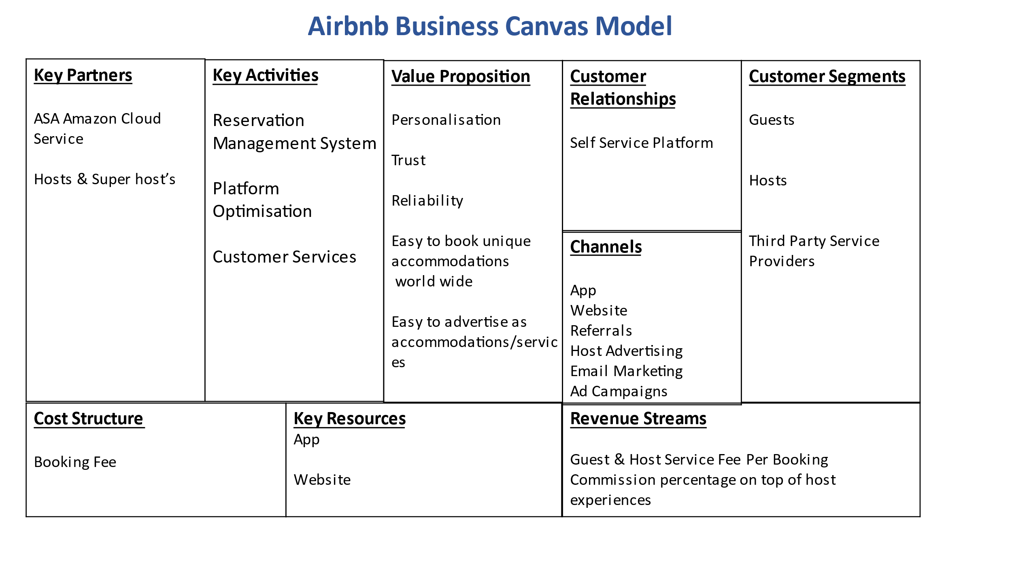
Strategic Formulation Framework (SFF)

Fred David’s Strategic Formulation Framework was designed to narrow down the strategy a company is best suited to or to help a company choose a strategy(s) to commit to. As there are limitations to most organisations regarding resources, the SFF puts a company through a 3-stage process of analysis: strategy formulation, strategy implementation and strategy evaluation. Strategy formulation looks at where a company wants to go, what it envisions for itself. It identifies external threats and opportunities and internal strengths and weaknesses. Strategy formulation looks at the bigger picture and what the company’s long-term goals are and how to be reactive to ensure short term goals are met. Stage 1 of the SFF revolves around decision making and committing to strategic direction for stage-2 strategy implementation to be applied. The second stage of the SFF focuses in on the short-term goal and looks at the annual objectives a company has. It ensures all the actions required to successfully realise a strategy are in order, such as, employee morale and encouragement, policy making, effective use of resources, organisational structuring, and the overall culture of the organisation. All these factors fuel the engine in terms of a strategy bringing profitable success to a company. Within this stage there are a number of analysis tools that can be used to aid in these realisations. These are SWOT analysis,
Lastly, stage-3 strategy evaluation is making sure the plan is working. There are three activities with the evaluation stage that are paramount to the SFF. Activity 1 is the reviewing of the external threats and opportunities identified in stage 1 as the world is ever changing a company cannot control what the external environment is like, but it can be proactive in its efforts to reacting to its changes. Activity 2 is about measuring performance; this activity looks at the current strategy and analyses how well it is working in all aspects. Activity 3 is taking corrective action. Problems within the strategy can be identified and the reactive measures looked at in stage-1 can be implemented (David, 2011).
Below is a Grand Strategy Matrix (GSM) for Airbnb (Ismail, 2017);
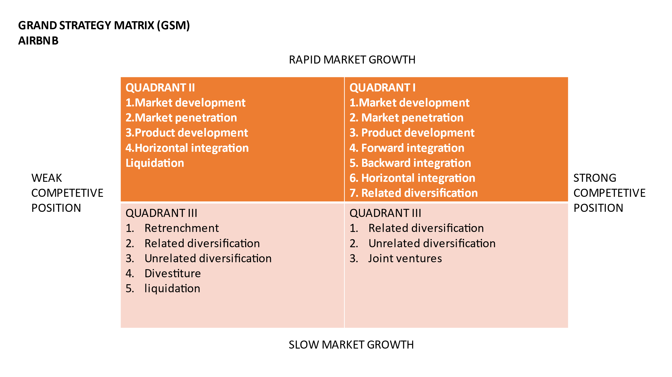

Tools and Systems used by Airbnb
The Supply Chain Management (SCM) system is designed to capture all the supply activity information from a company to filter it through to other parts of its network. The system allows the company to coordinate all these activities from its suppliers to manufacturers to distributors to the final customer (Chaffey, 2015).
Enterprise Resource Planning (ERP) systems are used to generalise all the data captured by way of organising, decoding, and standardising the data. The ERP system is designed for all departments of an organisation to be able to access and use with ease that contains the mass data for a company (Markus, 1983).
The Customer Relationships Management (CRM) System gathers information from the customer and how they feel so they can improve on their offerings and increase value to the customer.

Conclusion
This report has discussed Airbnb’s position as part of the sharing economy. It has delved in the sharing economy concept and what it offers. Airbnb have managed to soar to a profitable advantage amongst its competitors through designing a business model that answers all of the questions customers have on a sharing economy through they trust model. They have managed to keep momentum through their reliability and are staying successful due to their constant ability to personalise their offerings and let their customers be a part of the process.
Using the SCM, ERP and CRM systems Airbnb can continue to provide customer value and increase their target audience.

References
Big Data Defined. (2022, Jan 5th). Retrieved from www.oracle.com: https://www.oracle.com/big-data/what-is-big-data/
Chaffey, D. (2015). Digital Business and E-Commerce Management, 6th Edition. Essex: Pearson.
Darus, D. (2015, November 15th). Osterwalder explaining the Business Model Canvasin 6 Minutes. Retrieved from www.YouTube.com: https://www.youtube.com/watch?v=RpFiL-1TVLw
David, F. R. (2011). Strategic Management Concepts and Cases. New Jersey: Prentice Hall.
Ismail, M. (2017, February 25th). Airbnb, Inc. Strategic Plan 2017-2021 MBA - strategic Management Assignment (Harvard case study June 2017). Retrieved from slideshare.net: https://www.slideshare.net/mohieismail9/airbnb-inc-strategic-plan-20172021-mba-strategic-management-assignment-harvard-case-study-june-2017
Markus, M. (1983). “Power, politics and MIS implementation”. Communications of the ACM vol 26 no 6, 430-44.
Marr, B. (2016, October 21st). The Sharing Economy - What It Is, Examples, And How Big Data, Platforms And Algorithms Fuel It. Retrieved from www.forbes.com: https://www.forbes.com/sites/bernardmarr/2016/10/21/the-sharing-economy-what-it-is-examples-and-how-big-data-platforms-and-algorithms-fuel/?sh=8a869997c5af
Sharing Economy. (2020, October 3rd). Retrieved from www.Investopedia.com: https://www.investopedia.com/terms/s/sharing-economy.asp#:~:text=What%20is%20the%20Sharing%20Economy,a%20community%2Dbased%20online%20platform.
STEVE WU, F. L. (2012). Airbnb. UCLA Economist 106T, 1-13.
the Business Model Canvas. (2022, January 8th). Retrieved from strategyzer: https://www.strategyzer.com/canvas/business-model-canvas

