ACCB5029 – Network Programmability
Assignment 1

Name: Callum J Warwick
Student Number: 1809785
Date: 10.04.23

Contents
Stage 1 3
Introduction 3
1.1 - Team Name 3
1.2 - Team Member Roles 3
1.3 - Ice-breaker Questions 3
Stage 2 5
2.1 - Team Name 5
2.2 - Scrum Leader 5
2.3 - How did your team select the scrum leader? 5
2.4 - Did you define any other agile team roles? 5
2.5 - Which communication tools did your team decide to use and for what purpose? 6
Stage 3: Implementation 6
3.1 What were the reasons your team selected this option? 6
3.2 Describe your team's application and its deliverables. What are the specific objectives of this application? 7
3.3 - Team Members and knowledge bases 7
3.4 - Project Plan 8
3.5 What is the link to your GitHub repository? 9
3.6 Describe how GitHub was used in your project? (Address creating branches, adding team members, pull requests, code review, code merge etc) 9
3.7 List of future enhancements 9
Functionality Examples: 10
V0.0 10
V1.0 10
V2.0 11
Stage 4: 11
Reflection: 11

Stage 1

Introduction
The following report aims to outline the creation, design, development, and implementation of a Weather App utilising an open-source API.
The first section of the report seeks to outline the project creation phase including role selection utilising the agile methodology while also considering the overall project plan which has been broken down into its respective phases.
The second section of the report aims to demonstrate a detailed overview of steps taken from initial code development and testing to application release. Areas which have been documented include research, development, testing, and troubleshooting.
Screenshots have been provided to demonstrate functionality of the final application.

1.1 - Team Name

MDDCA

1.2 - Team Member Roles
Role | Name | Skillsets, Interests
Facilitator | Dave Cornelius (2023506) | Solutions, Development, Organisation
Recorder | Callum J Warwick (1809785) | Troubleshooting, Problem Solving
Team Member | Mark Williams (2022279) | Coding, design, and troubleshooting,
Team Member | Ashley Rees (2009258) | Coding, design, and troubleshooting,
Team Member | David Corner (Jonney) (1809784) | Diagnosis and troubleshooting

1.3 - Ice-breaker Questions
Member Name | Question | Answer
Callum Warwick | Coffee or tea? | I enjoy coffee more than tea.
Jonney Corner | Pizza or Pasta? | Pizza is one to be my favourite over Pasta.
Mark | Dogs or cats? | Dogs, I have a golden retriever named Buddy.
Ashley | Pepsi or Coca Cola? | Coca Cola, much prefer coke over Pepsi
David | Favourite Game? | Escape from Tarkov

Stage 2
Agile Team Formation

2.1 - Team Name
MDDCA

2.2 - Scrum Leader
David Cornelius

2.3 - How did your team select the scrum leader?
As a group we decided to appoint David Cornelius as he has previous work experience leading teams in relation to dev environments and has previous knowledge when building code. Furthermore, he has previous experience working with APIS and understands the requirements of implementation.
Other members of the team felt their skills were more suited to the creative aspects of the project such as developing and testing the code and would rather focus on this direction as opposed to the organizational and administration aspects of the task.
Everyone in the group contributed to the overall selection of roles and there was a clear objective to make sure everyone felt suited to their tasks.

2.4 - Did you define any other agile team roles?
Yes, we defined roles as they are useful for directing effort and making sure all areas of implementation receive the correct amount of consideration and attention. Each member of the team has a specific role with certain responsibilities which have deliverables. This also allows for a more equal spread of the work so no single person is being overwhelmed.
Name | Role
David Cornelius | Scrum Leader – Architecture
Mark Williams | Developer
Ashley Rees | Developer
Callum Warwick | Testing
Jonney Corner | Testing

2.5 - Which communication tools did your team decide to use and for what purpose?
Tools | Function
Teams | Used to communicate and share documents as a team. Allowed for dynamic interaction and quick questions which everyone can pitch in with. Allowed for the use of video meetings periodically throughout the project.
Email | Email was utilised to set meeting times using the calendar to make sure everyone was in attendance.
In-person | Utilised initially for the set up the team. Also played a big part in the overall project as when on compass this was the primary mode of communication
GitHub | GitHub was employed for code sharing and version control. Making it easy for everyone in the team to contribute.

Stage 3: Implementation
3.1 What were the reasons your team selected this option?
Team Choice: Option 2
Before deciding we took the opinions of everybody in the team. Unanimously was the decision to go with the more creative and open-ended option of creating an application and implementing an API of our choice.
An overview of the consensus of the team and why option 2 was more applicable was as follows:
- Larger creative impetus
- Able to work the code from the ground up lending to more learning and greater knowledge gained.
- The idea of building code from scratch was appealing.
- We all agreed on the direction we would take the application which helped us be more decisive when picking option 2.
- We could be more selective with what we utilised.

3.2 Describe your team's application and its deliverables. What are the specific objectives of this application?
Application:
Weather Application
Main Objective:
Create an application that can accurately represent the weather for any given location.
Key Deliverables:
- Finding an open-source weather API
- Create code that successfully interacts with an open-source API to display the weather for one hard coded location.
- Expansions of the code to successfully allow the user to interact and choose whatever location they would like.
- Accurate and easy to read results.
- User interface.
- Last version would include rudimentary GUI for user to interact with in the form of a box where they can type in their location and be presented with the weather.

3.3 - Team Members and knowledge bases
Team Member | Role/ Knowledge/ Skillset
Dave Cornelius (2023506) | Scrum Leader / Solutions – Code creation, Interacting with APIS, Troubleshooting / Problem solving / General organization and management of project.
Callum Warwick (1809785) | Tester & Solutions - Troubleshooting & Problem Solving / Researching & Logical Thinking
David Corner (1809784) | Tester & Solutions – Troubleshooting / Creative solutions / Ensure correct implementation.
Mark Williams (2022279) | Developer / Architect - Code creation, providing solutions, research
Ashley Rees (2009258) | Developer / Architect – Code creation, creative thinking, research

3.4 - Project Plan
Project will be split into a couple of distinct phases as follows:
- Planning Phase:
  - Utilised to discuss roles / responsibilities and expectations in combination with drawing up of project scope and Gant chant.
- Research & Mock Up:
  - Dedicated to scoping out ideas. What to do want to build? What's already out there? What's practical and Deliverable?
- Development scope:
  - Taking into consideration the output of the research section. We can look to solidify the scope of what is to be built. Set further clear expectations and timescales.
- Initial Development:
  - Initial development phase used to create code.
- Testing:
  - Testing of the initial development with consideration to providing feedback which can be worked upon.
- Further development:
  - Enveloping of the feedback into the overall project taking into consideration practicality and functionality. Ensuring all previous bugs have been eradicated.
- Final Testing:
  - Final testing with a view to find any obvious issues which may hinder the use of the application. Any additional features suggested at this time would be added as further improvements.
- Release:
  - General release. The app in a useable state without issues.
- Discussion of Further features / work – Close down current cycle of work.
  - Lastly, any future improvements discovered during the development can be mapped out with clear timescales and approach. While also crossing off all key deliverables of the current project to ensure completeness.

While working through the project the aim will be to utilise commonly employed methodologies to ensure efficient and optimal working. Strategies to be utilised are:
- Agile methodology for roles and project planning
- Gant for visual representation of project phases
- Active use of communication platforms to ensure coherent working.

3.5 What is the link to your GitHub repository?
https://github.com/project-mddca/Weather-App
3.6 Describe how GitHub was used in your project?
GitHub was used for team collaborating and to provide a central store house for code changes and to provide redundancy. It was also used for pushing and pulling between developers Mark and Ashley as different version of the code was developed. Utilised by the testers to check over any implementation and provide feedback in the form of comments.
Branches, pull requests, code reviews were not really utilised as they could have been. Project scope was quite small and decided against adding this level of complexity.

3.7 List of future enhancements
UV Index – This feature would list UV radiation levels in a potential chart to the application user, so they are aware of how dangerous or mild levels are in the area they are searching for based on colour schemes based on its severity.
Expanding to less populated areas – This feature can be included into the search facility where the user is able to search for more rural areas to get accurate weather rather than relying on their nearest town or city forecast.
Precipitation listings – Precipitation charts to show the rain fall levels and duration based on a graph.
Wind listings – Option to expand wind listings in a graph format so the speed is measured with the highs and lows.
UI – Look to potentially have key weather indicators such as precipitation levels, high and low temperatures, wind speed included on the main display for the area being searched for, along with key changes to the overall interface to give it a more modern and minimalist appearance.
Icons – Along with the modern approach changes for the UI, there is potential to have further icons and graphical improvements added into the program to give it a more professional look.
Input box – These improvements could be the potential to have auto-populate features enabled on the input box, where it should pre-define the location name based on what the user is typing.
5 Day forecast – The ability to provide the user a 5-day forecast which will include the temperature, precipitation levels and wind speed for the duration in advance as the user will have an insight what to expect.
Publishing of the app – Future expansion of the app would be to have this published on the Google Play, Apple App store for further use on other platforms such as mobile devices etc.

Functionality Examples:

V0.0
The image below shows Version 0.0 that was created by Ashley, this was our first attempt to create the Weather Forecast API, unfortunately it failed but with the assistance of GitHub and our testing team members we were able to locate some of the issues some of which were the API key and the endpoint code being incorrect this information helped us develop a version which worked.
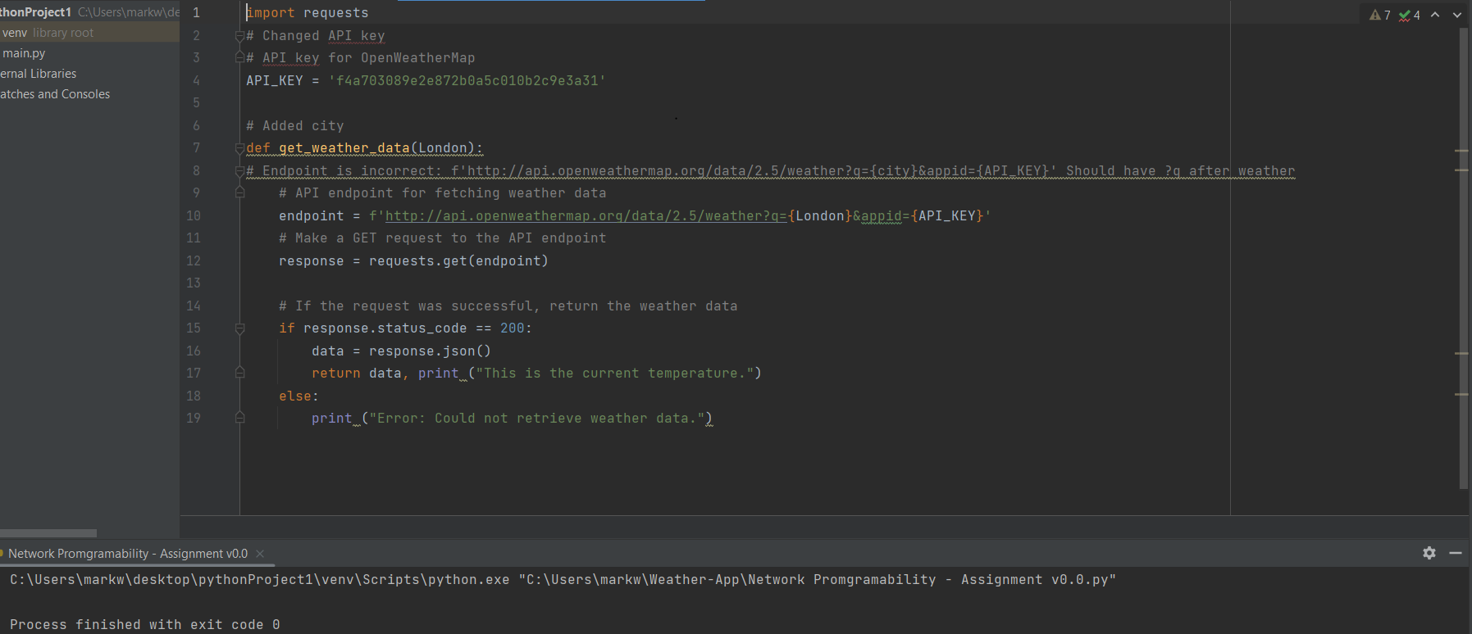

V1.0
This version of the Weather API was our first design to work which was created by Mark, it’s a basic version that presents no input for location as shown in the image below. This version provided us with the building blocks for the next version of the application which allowed us to express our creativity without the worry of breaking the initial code.
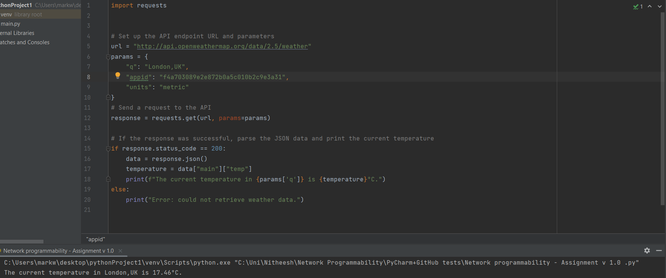

V2.0
The below image is the final version of our groups effort of the weather forecast API, it allows for user input within the GUI that appears and provides accurate weather forecast and a “feels like” forecast for most cities around the world. This was a group effort and used the skills of all members of our team to create an API that progressively advanced from the previous stages.
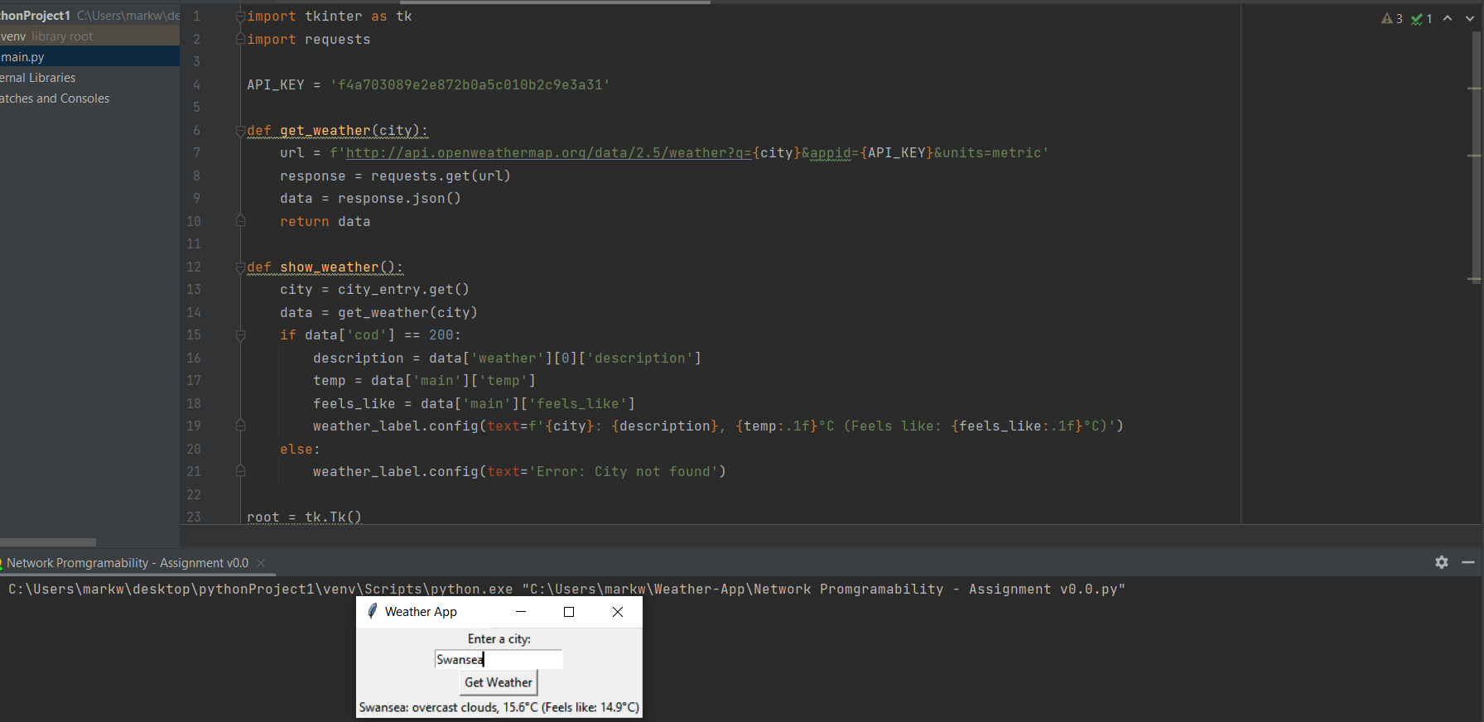

Stage 4:

Reflection:

My role in this project was a Tester. I therefore was responsible to test the application versions after my team had developed these in Python. I did this by running the applications to see if the expected outcome was achieved and using Unit Testing to test if each function was working as intended. If any errors of unexpected outcomes where located, I would write this up in the form of a word document and sent to my teams shared GitHub repository. We faced several issues throughout the project, such as issues syncing to our API and parsing the information into a readable format and an issue with making sure the data entered into the application matched up with what information should be provided. When testing version 0 of the application, I noticed an issue with the API key, where if the URL was put into a browser an error stating connectivity issues was located, this was then patched in version 1, by regenerating the API key from source and entering the code back into the application. I have learnt a lot throughout this project; I have had the opportunity to work on my team working, communication and listening skills to allow me to effectively work with my colleagues on this project. I have also had the opportunity to learn how to use Unit Testing with Python code, to ensure all expected outcomes are received. If they are not, how to progress and make the required changes/ improvements.

