Name: Raluca Georgiana Rogoz

Student Number: 2221755

PART 2: Menu Design



Menu

Thank you very much for choosing our Hotel Trinity for your accommodation and dining. We warmly welcome you to Hotel Trinity and wish you a comfortable and enjoyable visit. Hotel menus and food options are available at your room desk. Also, bookings are accepted to celebrate various programs or festivals. That is why you are invited to the hotel's program and contact us for any special needs you may have. A menu of the hotel's cuisine is available for your reference.

Necessary Guidance

- Please for booking to celebrate any kind of event or festival.
- Contact us to order any type of food from our menu.
- We provide free home delivery within a 0.3km radius.
- Offering a 9% discount on any type of food.
- 24-hour food service is provided in hotel rooms.

Contact Us: +44 6734 347197
Celebrate your Special time with joy. We are by your side to make your moment more joyful and enticing with delicious food.
Starters
To make your celebration even more interesting, our starter items have some tempting food pairings that will entice you.

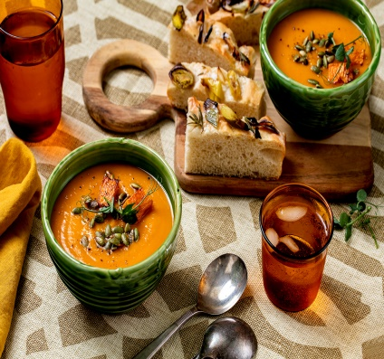

Mixed Garden Salad £ 15
Fresh green vegetables, red onion, dairy-free dressing, tomato, and cucumber.
Vegetable soup £24
The soup is made with a mixture of different types of vegetables and especially fresh seasonal vegetables are used. (Vegan)

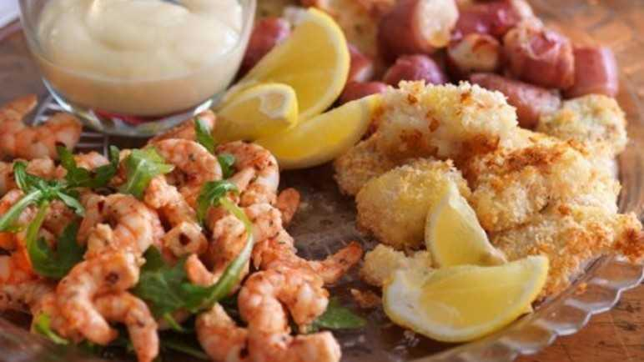
Prawn cocktail £30
The cocktails are served with fried bread and are very tasty.
Green Beans Almondine £35
This recipe is vegan-free and made using green beans which is why it's so refreshing. Nuts, slivers, garlic, butter, salt, pepper, and sauce are used with it.

Caprese Salad £18( lactose free, gluten-free)
Fresh mozzarella and slid tomatoes and basil drizzled are used.

Mains
Our main menu includes food items that you can comfortably enjoy with your whole family. This will help you enjoy the unique dimension of the food.
Honey glazed ham £50
Several protein-rich ingredients are used to make this butter-rich sweet and savory ham including sweet brown sugar, and glazed honey
Turkey chicken Roast £30
Fried potatoes, tomato sauce, roasted chicken vegetables, and green peas are used.
Roasted Rack of Lamb £60
This delicious dish uses roast lamb, a combination of garlic and herbs, and mint sauce.
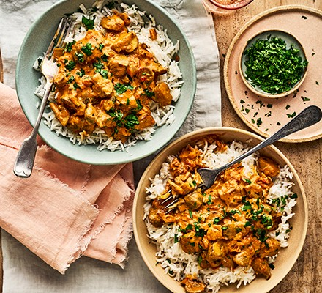
Crab cakes
This dish controls the appetite of the whole family as a staple food. It is made with lemon juice, crab meat, mayonnaise, seasoning, Ritz crackers, and other ingredients.

Cream cheese mushrooms £25
Cream cheese, stuffed mushrooms, and parmesan filling are used to make this item.

Vegetable curry£20
A variety of vegetables, fragrant rice, gluten-free, and noodles are used to cook the curry. (Vegan)

Gluten-free pasta items £25
It is made with gluten-free pasta, light olive oil, and a variety of fresh vegetables and vegan cheese
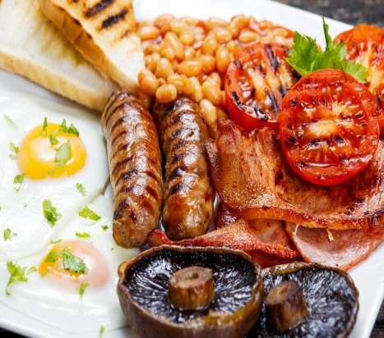

Lentil Shepherd's Pie £20
This vegetarian diet is very healthy, it uses mashed potatoes, lentils, vegetables, green vegetables

Easy stuffing £45
A unique taste dinner item and it uses some herbs along with celery and stuffing cubes.

Grilled salmon with lemon sauce£60 (lactose-free, gluten-free)

Steamed greens with grilled salmon and gluten-free roasted potatoes create the atmosphere.

Fish and chips £55
This recipe uses fresh fish and combines it with chips and some seasonal vegetables to create a unique item.

Grilled chicken Breast with vegetables £58 (gluten-free)
This item is served with stir-fried vegetables along with delicious grilled chicken and rice which is completely gluten-free.

Sausages and Mash £45
It is a traditional dish and is made with mashed potato, peas, and gravy and served with sausage.

Dessert Items
Get sweet and indulge with our dessert items to share the joy
Cherry Chocolate cake (per slice £15)
Cherries are used with chocolate cake mix to make this dessert and the classic combination is used.
Chrismas Crack (per slice £10)
Chocolate, peanuts, butter, and sugar are used.
Cinnamon apple Dessert £25
Baked apples, caramelized sauce, ice cream.
Linzer cookies £5
A classic cookie and it uses flaky bread and fruit jam.
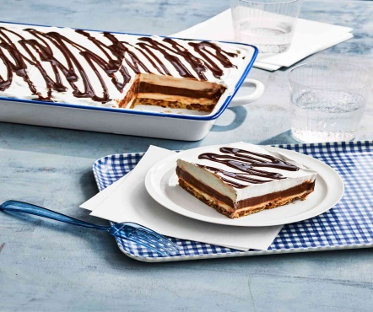


Fruit salad £30 ( Gluten-free, vegetarian)
A variety of fresh and seasonal fruits are used.
Mixed berry parfait £25 (Lactose-free)
Topped with unique flavors of fresh berries, lactose-free yogurt, and gluten-free granola.
Strawberry Fool £35
This dish features strawberries layered with a creamy base.
Jam roly roly £30
Jam Roli Polly is a very delicious pudding, it is a cake served with ice cream which is made with a sponge.
Heart-shaped pudding £45

Beverages
Our delicious and healthy beverage items will make your happy moments more enjoyable.

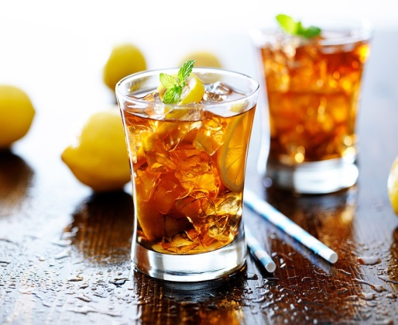
_{Almond milk latte £10 A}
wonderful drink combined with almonds and milk. (Vegan, lactose-free)
_{Crockpot Apple Cider£15}
This drink is very refreshing and sweet because it is easy to like and it will calm the whole family on the occasion.
_{Sweetheart Cocktail £50}
This drink is made with lime, cranberry, and rose petals.

Lactose-free Smoothies £10 (ve, lactose-free)
Almond milk and oat milk are used as milk substitutes to make this drink lactose free.
Diet Coke £8
Hot chocolate £5
Cold chocolate £6
Mineral water £6
Soft Drinks £8
Squeezed orange juice £15 (ve, lactose-free)

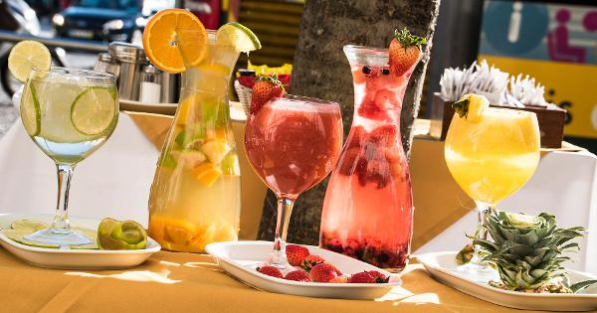

END
Make your celebration more interesting by savoring these unique items. We sincerely hope you will come again in the future and best wishes. To receive any of our services, contact the given contact number and highlight your requirements.

Thanks, come again

References

Andersen, V., M., L.H.L. and Motarjemi, Y. (2022) Food Safety Management: A practical guide for the food industry. Amsterdam: Academic Press.
Boussard, S. (2021) Food and beverage management in the luxury hotel industry. New York, United State of America: Business Expert Press, LLC.
Brotherton, B. (2013) ‘Hospitality and hospitality management’, Key Concepts in Hospitality Management, pp. 60–63. doi:10.4135/9781526435606.n14.
Casado, M.A. (2014) Food and beverage service manual. New York: Wiley.
Cousins, J. (2016) Food and beverage management. Goodfellow Publishers Ltd.
Dobson, N. (2015) Hospitality management. Sheffield: Sheffield Hallam University.
Foster, D.L. (2023) Food and beverage: Operations, methods, and cost controls. Lake Forest, IL: Glencoe.
Gladwin, D. (2019) ‘Introducing le menu’:, Gastro-modernism: Food, Literature, Culture, pp. 1–18. doi:10.2307/j.ctvpj7hf3.6.
Ninemeier, J.D. (2022) Beverage Management: Business Systems for restaurants, hotels, and Clubs. New York: Chain Store Pub. Corp.
Rule, C.S. and Phlipot, P. (2021) Ripe: A fresh, colorful approach to fruits and vegetables. Philadelphia, PA: Running Press.

