

Changemakers: Creativity and Value Creation
Professions (BMHP5014)

Component 1: Online portfolio of set exercises

Student name: Kizzie Joseph

Student number: 2328389

Lecturer’s name: Dr Laila Surani

Table of Contents
Introduction 3
Defining Key Concepts in Practice 3
Innovation 3
Creativity 3
Value Creation 4
Change 4
Mind Map 4
Self-Reflection of Group Activity 6
Case Study Analysis of a UK Innovation 6
Research Task 7
Exploring Digital Innovation in Health and Social Care 8
Benefit of Wearable Health Technologies 8
How Electronic Health Records Improve Communication 8
Digital Technology for Preventative Care & Health Promotion 8
Understanding the NHS Leadership Framework 9
(Part 1) Summary of the NHS Leadership Framework 9
(Part 2) Leadership Behaviour - Leading with Care 9
Reflection 10
References 11

Introduction

This portfolio is a collection of assignments exploring health and social care systems to understand and to analyse problems with the service. To create this portfolio, I worked on individual reflections, group work, and the technological use of digitised systems of modern care. I researched creative service improvements, and I added to the portfolio a case study of a modern innovation of the NHS. The last section of the portfolio includes me reflecting on the NHS leadership framework. The main purpose of the portfolio was to display the creative and innovative knowledge I learned during my studies, and the positive effects on staff and service users that come from modern care and innovative systems.

Defining Key Concepts in Practice

Innovation

Innovation refers to creating or improving ideas, services, or processes in a way that adds value or solves problems. Bessant and Tidd (2015) explain that innovation is about making useful changes that improve outcomes. In health and social care, innovation is important because services face constant challenges such as rising demand, staffing pressures, and the need for better patient experiences. Innovation helps organisations adapt and offer safer and more effective care. An example in practice is the introduction of virtual GP appointments during COVID-19, which helped patients continue accessing care safely (Topol, 2019).

Creativity

Creativity is the ability to generate new ideas or think in different ways. Rickards and Jones (2009) describe creativity as a process of using imagination to solve problems. Creativity is important in the health and social care sector because professionals are often faced with genuinely challenging problems where the usual responses are insufficient. Innovative thinking enables staff to consider problems in different ways. For example, care staff can create individualised activities for, and with, individuals experiencing dementia to reduce distress and enhance overall wellness.

Value Creation

Value creation means producing something that benefits patients, staff, or services. Bessant and Tidd (2015) note that value can be financial, social, or practical. In health and social care, value creation is essential because resources are limited and must be used effectively to improve outcomes. For example, digital health tools that reduce appointment times create value by saving time for staff while improving patient access and satisfaction (NHS Innovation Accelerator, 2021).

Change

Change refers to adapting or transforming current ways of working. According to West et al. (2015), change is a normal part of improving health and social care systems. Change is important because services must respond to new policies, technologies, and patient needs. A common example is the shift from paper records to electronic health records (EHRs), which improves communication across teams and reduces mistakes (NHS England, 2022).

Mind Map

In health and social care, a mind map is a visual instrument or diagram used to create and arrange ideas necessary to solve a specific issue. At the centre of a mind map is the specific issue. For instance, access to health services for vulnerable people is central to the mind map. From this central point, key branches can be formed on access barriers, service-user needs, available resources, and potential creative solutions. Under barriers, some of the issues may include long waiting times, language problems, and lack of transport. Under needs, culturally appropriate support, clearer communications, and personalised care. Solution or value branches can expand to include ideas such as community outreach, digital appointment reminding, mobile clinics, and local organisation partnerships. Then value branches, such as improved patient experience, reduced discriminations, and earlier intervention, may highlight the benefits. The mind map assists in the organisation of the user's thoughts and assists in the actualisation of creative problem solving.

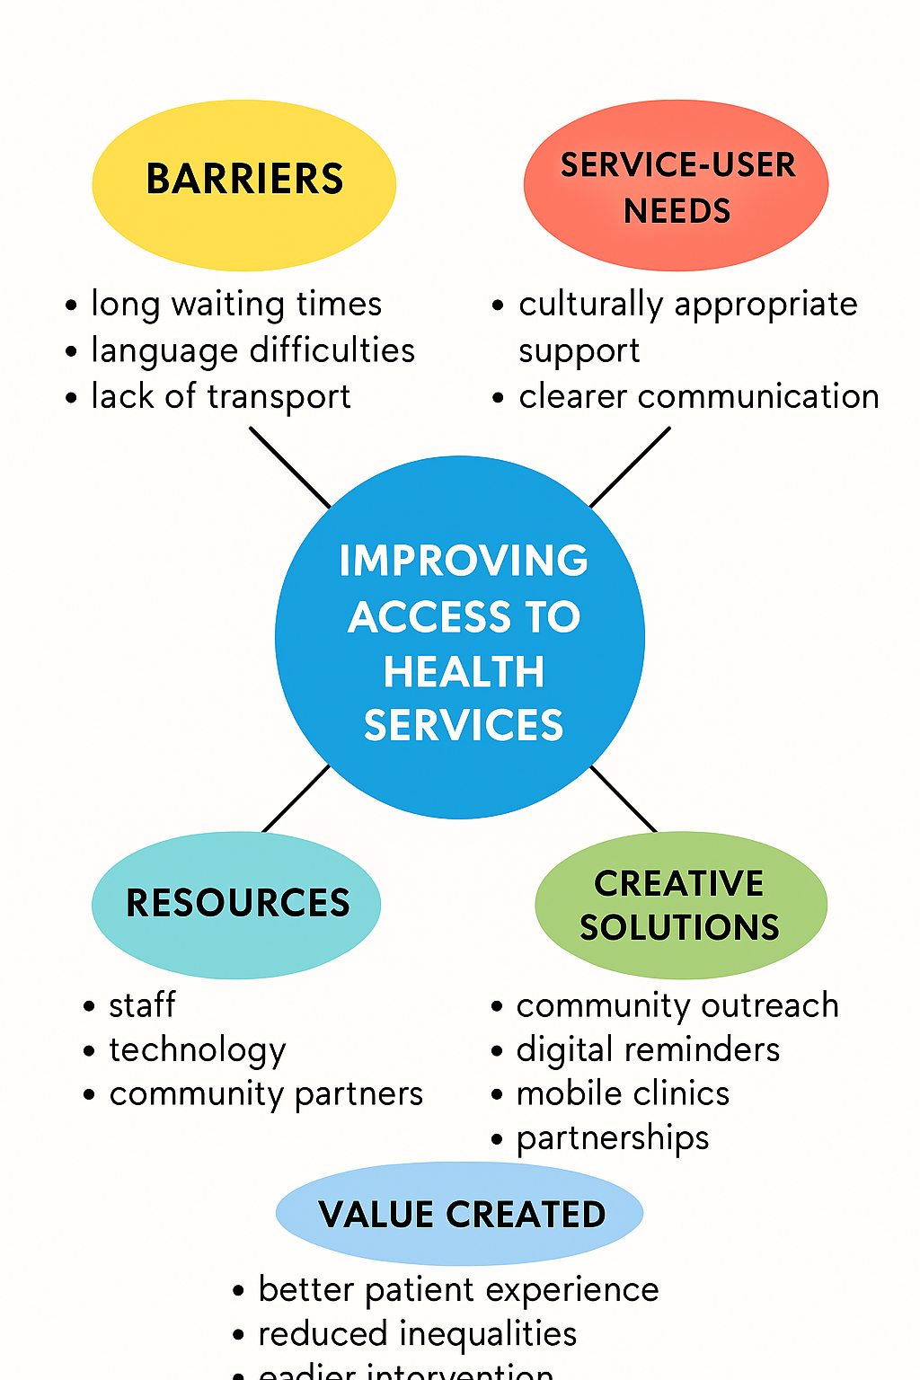

Self-Reflection of Group Activity

During the group activity on convergent and divergent thinking, I learned how these two styles can be used together when solving problems in health and social care. Divergent thinking is about exploring many different ideas without judging them, while convergent thinking focuses on selecting the best idea and narrowing choices down (Kesting & Parmar, 2016). At the start of the task, my group used divergent thinking by sharing a range of suggestions about improving access to services. I noticed that everyone had different experiences, which helped us think more creatively. This part felt open and relaxed because there were no wrong answers.

For the convergent stage, we identified the more realistic and possible ideas. It was more structured as we needed to eliminate the options further until we reached one solution the whole group was able to agree on. I tend to hold back when the group moves to the decision-making stage, as I fear my suggestion is the weakest. I was encouraged to participate more, and I reflected on the Gibbs cycle, more on the “evaluation” and “analysis” parts, on what went well and what I can do better next time. I recognised that when working as a team, more people need to team up and I noticed that I need to express my ideas more freely when working with a group to make a decision.

Case Study Analysis of a UK Innovation

One useful example of innovation in the NHS is the NHS Virtual Wards programme. This initiative was created to support patients with long-term conditions, such as respiratory illness or heart failure, by allowing them to receive hospital-level monitoring at home. The main problem it aimed to address was the pressure on hospital beds and the difficulty patients face when travelling to hospital during illness (NHS Innovation Accelerator, 2021). Instead of only depending on traditional in-person visits, the concept used innovation by integrating digital technologies, remote observation, and routine employee monitoring, and created a new model of care.

Creativity was applied through the use of wearable devices, mobile apps, and automatic alerts that helped clinicians identify changes in a patient’s condition more quickly (Piwek et al., 2016). This helped staff respond earlier and prevented some hospital admissions. The value created for patients included improved comfort, better communication with staff, and a sense of independence. For the NHS, the innovation reduced demand on services and helped staff manage their workload more effectively (Topol, 2019).
Evidence from early service reports shows improvements in patient outcomes and satisfaction, showing how creative digital ideas can make a practical difference in health and social care practice (NHS Innovation Accelerator, 2021).

Research Task

One current issue in health and social care is staff burnout, which affects the quality and safety of care delivered to patients. Burnout is often caused by high workloads, long shifts, emotional strain, and staff shortages. Research by West and Coia (2019) explains that burnout develops when healthcare staff face constant pressure without enough organisational support. Their report shows that poor working conditions, lack of rest, and emotional demands can reduce staff wellbeing and lead to higher sickness rates. This affects the whole service because teams become short-staffed, which increases stress even more (West and Coia, 2019).
Another study by Rickards and Jones (2009) suggests that limited creativity in problem-solving can also add to burnout. Staff may feel powerless and frustrated when they feel they cannot make an impact or find new ways to better the services. The research suggests that motivating staff to think creatively would help staff overcome challenges and frustrations. This shows that burnout relates to more than simply workload, but also if the staff feel they are appreciated and supported to give input.

Both articles tell the same story and that is burnout is a complex issue, a concerning crisis that comes from a blend of emotional, organisational, and real-world challenges. Addressing the root of these issues would enable services to create better support systems for their staff which would then positively impact the delivery of care for the patients.

Exploring Digital Innovation in Health and Social Care

Benefit of Wearable Health Technologies

Smartwatches and other similar devices let people with chronic illnesses track their health in real-time. These devices let users monitor their symptoms daily, including their heart rate, sleep patterns, daily activity, and blood sugar. Users are made aware of any changes in their health faster, allowing them to intervene before an escalation occurs. These devices also aid healthcare providers by allowing them to track the patient's health over time. Some devices are even able to track and notify users about atypical heart rhythms which provides an extra layer of preventative healthcare. Wearing these devices also helps users to stay active which is encouraged with health conditions like diabetes and heart disease. Research shows that consumer wearables can support self-management and increase awareness of health behaviours (Piwek et al., 2016). Overall, wearables improve long-term care by giving patients more control over their health and helping professionals make better decisions.

How Electronic Health Records Improve Communication

EHRs (Electronic Health Records) enhance communication among healthcare specialists as they can efficiently and securely obtain the same patient data at the same time. Rather than use paper notes or messages that get passed down among teams, each digital system saves data in one place. This allows nurses and physicians, as well as other specialists, to view and understand a patient’s medical history, medications, test results, and care plans. With easily accessible and updated information, medical staff can make better, safer, and more low-risk decisions. Also, referral and service handoffs are faster and seamless since the information is always with the patient. According to NHS England, EHR systems help improve coordination by ensuring that all teams have the right information at the right time (NHS England, 2022). Better communication leads to better patient experience, fewer delays, and more efficient teamwork across health and social care.

Digital Technology for Preventative Care & Health Promotion

Digital technology is very helpful in promoting positive health behaviours and identifying potential health threats. Automated tips sent from health promotion apps and online health resource sites can encourage people to take part in healthy activities and motivate them to improve their eating behaviours. While people can be reminded to practice mental and emotional exercises daily. Health apps can notify users to manage their symptoms and to monitor and alert them to detect concerning symptom patterns. Studies show that digital health tools can increase patient engagement and help reduce the risk of long-term conditions (Topol, 2019). These resources are very beneficial to people when they can’t access in-person preventative health resources. They can also promote preventative health technology to wide audiences quickly. Overall, these technologies encourage people to take preventative actions to improve and maintain their wellness.

Understanding the NHS Leadership Framework

(Part 1) Summary of the NHS Leadership Framework

The NHS Leadership Framework describes the behaviours that all health and social care staff should show when working with patients, service users, and colleagues. Its purpose is to improve communication, teamwork, and the quality of care across services. The framework is built around seven key behaviours: inspiring shared purpose, leading with care, evaluating information, connecting services, sharing the vision, engaging the team, and holding others to account (West et al., 2015).

These actions encourage employees to promote responsibility, compassion, and wellness related decision making. The framework is necessary because leadership is not just the role of the managers, leadership can be any staff member who helps with the advancement of daily practices. In any health and social care practice, effective leadership builds safe practices, sustains mentors’ professional development, and improves patient care. It also encourages openness and problem-solving, which are essential in a complex system such as the NHS (Bessant & Tidd, 2015).

(Part 2) Leadership Behaviour - Leading with Care

To lead with care is to demonstrate compassion and support the wellbeing of others while promoting a respectful culture. This behaviour can lead to the encouragement of creativity by creating a space where individuals feel secure enough to express and share ideas without the threat of judgement. A community health setting example is where a team leader monitors staff support by regularly checking in and acknowledging their contributions. This kind of emotional support helps staff feel valued, which increases motivation and encourages them to think more openly when solving problems. Leading with care also improves patient experiences, because staff who feel supported are more confident and better able to focus on delivering quality care (West & Coia, 2019).

Reflection

During the module, my views on innovation and value creation have shifted and expanded quite a bit. At first, I viewed innovation mainly in the context of coming up with new ideas. I now appreciate that problem resolution, service enhancement, and creation of value for patients and service users are equally, if not more, important. The lesson activities explained how minor adjustments, such as changes in communication and service tailoring, creatively made a difference. The concepts of divergent thinking, value creation in the social and medical context, and digital innovation have changed how I picture the improvement of care and social services. I feel more equipped to use innovative strategies in my future work, especially in collaborative settings. The module has helped me realise that everyone has the potential to make a difference, however minor, that adds value to a situation. I have learned the significance of innovation as a functional skill and have appreciated the need for innovation in my future work.

References

Bessant, J. & Tidd, J. (2015) Innovation and Entrepreneurship. 3rd edn. Chichester: Wiley.
NHS England (2023) Electronic Health Records (EHRs). Available at: https://www.nhs.uk/using-the-nhs/nhs-services/gps/electronic-health-records/ (Accessed: 3 December 2025).
NHS Innovation Accelerator (2021) Innovation Case Studies in the NHS. Available at: https://nhsaccelerator.com/(Accessed: 3 December 2025).
Piwek, L., Ellis, D.A., Andrews, S. & Joinson, A. (2016) ‘The Rise of Consumer Health Wearables’, PLOS Medicine, 13(2), pp. 1–8. Available at: https://journals.plos.org/plosmedicine/article?id=10.1371/journal.pmed.1001953(Accessed: 3 December 2025).
Rickards, T. & Jones, R. (2009) ‘Creativity and Problem-Solving in Health Care’, Journal of Health Organisation and Management, 23(3), pp. 265–277.
Topol, E. (2019) ‘Digital Medicine: Empowering Patients’, Nature Medicine, 25, pp. 44–50.
West, M., Collins, B., & The King's Fund (2015) The NHS Leadership Framework. London: NHS Leadership Academy.
West, M. & Coia, D. (2019) Caring for Doctors, Caring for Patients: How to Transform UK Healthcare by Improving Staff Wellbeing. General Medical Council. Available at: https://www.gmc-uk.org/-/media/documents/caring-for-doctors-caring-for-patients_pdf-80706341.pdf (Accessed: 3 December 2025).

