BSc Health and Social Care
Mental Disorders and Psychopathology

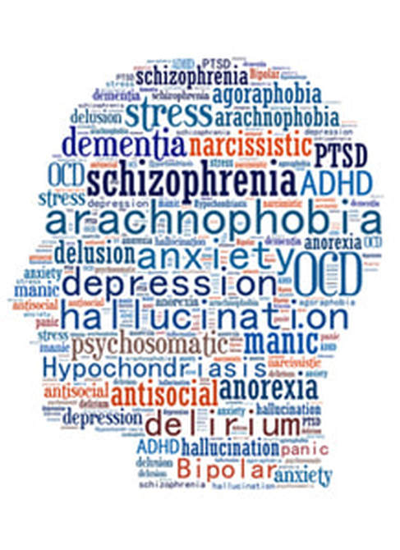

BMHP6006_BIRM
Donna Holder
Assessment - 2
21st July 2023

Carrie jelfs 1912214
Table of Contents

Introduction 2
Defining and Classification 2
Diagnosis 4
Treatment 6
Measurement of Rehabilitation 7
Recommendations for future practice 8
Conclusion ………………………………………………………………………………………………………………………………………9
References ……………………………………………………………………………………………………………………………………….9
Appendices………………………………………………………………………………………………………………………………………14

Introduction
The critical analysis of this report will be to highlight key aspects of a mental disorder called Dementia. Some of these key points are defining the signs and symptoms for diagnoses and manging these, preventing a fast cognitive and functioning decline and lastly recommendations for Future practice. This is done by health professionals and supported up by published literature, reports and assessments – the international classification for diseases details a diagnoses process for health professionals to follow (WHO 2023). This will include distinctive symptoms enabling a critical evaluation and comparison with other diagnostic tests, for effective treatment to allow service users to live and sustain a better quality of life and promoting independence whilst coping and living with this disorder.

Defining dementia is challenging as there are many procedures in diagnosing what type of dementia a-service user may have a list of the most common forms of dementia will be provided according to the international classification of diseases (ICD-11 2016). A discussion will briefly state the definition and classification for the disorder according to the ICD. This will determine the relationship between diagnoses and treatment for future practice, health and wellbeing.

A person with a diagnosis of dementia will begin to show alarming signs that can become distressing for the service user as well as family. Currently there are 850,000 people living with dementia in the UK, Alzheimer’s Research UK (2023). Some other forms of dementia are Alzheimer’s disease, Vascular disease, Dementia with Lewy Bodies Frontotemporal Dementia, Mixed Dementia, Alzheimer’s Research UK (2023).

Symptoms can vary, they can be identified with other mental disorders such as schizophrenia, so it is important to recognise the expectations during dementia diagnostics assessments. With a diagnosis of dementia changes in the begin to occur causing a huge effect on behaviour, thoughts and feelings ICD (2016). Treatment can vary also. It is important the right interventions are put in place when treatment is decided by a psychiatrist for the best interests of the service user.
Definition and Classification
According to Dementia UK (2023) Dementia is a decline in cognitive and functional behaviour, thoughts and feelings. It is a progressive condition that affects cognitive brain cells (neurones) causing a particular protein that develops in the brain which is known as Amyloid (see appendix 1). Dementia UK explains how this disease affects a person’s ability to remember things, speak and their ability to make decisions. Amyloid is considered but not indefinite, a reaction to psychological depressive, anxiety states although more research is needed to confirm this, Dyck, et al (1969). The classification for this disease is the diagnostic assessment criteria for specialists to use when diagnosing and treating WHO (2023).

Symptoms vary at each stage of dementia particularly during stages of the disease as it progresses, ICD (2016). During diagnosis specialists will be able to determine what stage of the dementia they may be experiencing. According to the International Classification for diseases diagnostic; F00* Dementia with Alzheimer’s G30.o+, is early onset. At this stage, age is considered with relatively, rapid deterioration ICD (2016).

Classification for Dementia WHO (2016) ICD 11 fo3, chapter 5 (Dementia with behaviours) Stages of dementia. The ICD states that someone with dementia will show a chronic, progressive disturbance affecting higher cortical functions in the brain, see appendix 2 for a descriptive brain scan showing dementia and cognitive decline.

The British Psychology Society - as dementia progresses psychological symptoms will begin to show. Below are some psychological symptoms:

- psychosis
- behaviours
- mood disturbance
- anxiety
- depression
- aggression, BPS (2019).

Here in the UK, specialists follow the diagnostic process (ICD) to determine diseases, which has been outlined in this report. In the United States, DSM-5 also known as diagnostic and statistics manual of mental disorders, has contributions from many international experts in the mental health field, for the purpose of a public health mission, APA (2009). Although, here in the UK some professionals do refer to this diagnostic process for assessment criteria. Their criteria for diagnosing dementia and other neurocognitive disorders have some similar aspects to the UK’S ICD but, although this contains the same information on mental disorders, the DSM-5 has a much more in-depth clinical, description for diagnosis of behavioural health, APA (2009).

Joanne Moncrieff (Tagged dementia) says that diagnosis for dementia and other mental disorders is still made up based on behaviour, thoughts and feelings, biological and psychological, Joanna Moncrieff (2017).

Diagnosis
A clinical diagnosis of dementia is known as Neurocognitive Disorder ICD (2023). This is to identify the symptoms during physical examination done by a GP, taking into consideration the service users’ medical history and other medical issues, further cognitive and functioning tests will take place if these tests show signs and symptoms of dementia (memory clinic). This can help to influence diagnoses and allow time for treatment but, as symptoms persists and the progress of changes in the brain start to occur, personality begins to deteriorate - time is crucial to prevent further damage happening. So, these questions the fact of reality of the time frame waiting for a diagnosis referral, WHO (2016).

Alzheimer’s Society (2023) - During the diagnosis legal legislation in England and Wales will support the detaining of patients who need to stay in hospital to allow assessment or treatment if needed, especially dementia patients, The Mental Act (1983). During assessments safeguarding is required also as people with suspected dementia lost the inability to make decisions for themselves, The mental Capacity (2005).

Possible causes It is still yet to determine the causes of dementia but there are some contributing risk factors to consider:

- Genetics
- Age
- Depression
- High levels of Alcohol consumption &
- Stress, Duval, et al, (2023).

Multi-disciplinary This is a highly important approach and recommended for diagnosing dementia. This is because specialists do not have the capacity to cope with the complex issues dementia can show especially, cognitive, physical, emotional and social problems that are associated with dementia. The role of multi-disciplinary offers a more effective plan for dementia care whilst maintain the service users current state of health, these people will include Neurologists, geriatrics, nurse practitioners, nutritionist for diet health and social workers for wellbeing Wolfs, et al, (2006).

Mental Ability Tests:
Functioning examination - The current formal process when diagnosing dementia is done by cognitive and functioning tests. During this stage a GP will ask about symptoms: Simple tasks like dressing, cooking and paying bills will help to define the signs. People with dementia can face up to a two year wait for a diagnosis and this is because the huge number of dementia diagnoses. This shows a lack of funds available and published literature shows this will only get worse over time. The government have opted to help with funding to clear back logs of waiting times, Alzheimer’s Society (2023).

Cognitive Examination - According the to the Alzheimer’s Association cognitive examinations are done by assessing the service user’s language, memory and problem-solving skills and other detailed assessment involve maths, balance and sensory skills (MMSE). This will take place by a health professional; Dementia can be diagnosed by a psychiatrist. They will do this by performing special memory awareness tests. A list of extensive, critical questions such as, name and recalling place Attention – alertness, language and executive function. This will allow cognitive function to be examined, Alzheimer’s Association (2023). (see appendix 4 for an example).

Dementia Brain Scans
Once other tests have been ruled out, as mentioned above, brain scans will be arranged by the gp but this does not mean that these scans alone can give a diagnosis. Not all suspected dementia will need this test, but it can be useful to look for other possibilities such as strokes (CT scans) which are common in people with dementia. MRI scans are recommended to confirm the disease and will help to provide details of potential mass on the brain causing the dementia (Structural Imaging). See appendix 3, here in this image you can see the mass in each section getting more and unfortunately, shrinkage of brain in a brain occurs, NHS (2023). AMYLOID Pet scans are also very common and useful, and many medical specialists will use amyloid PET imaging on brain cells to help with the diagnosis (Functioning imaging) Alzheimer’s Association (2023).

Problems and setbacks with diagnosis labelling - Although there is an objective with cognitive testing as there are some differences in dementia and memory loss as memory loss can be re-called, the Individual will eventually gain back their loss of forgotten thoughts in time however with dementia this does not happen (decline). How is dementia distinguished? Well, according to the ICD dementia can be unspecified without certain characteristics; behavioural disturbances must be there in order to rule out other disorders. These types of behaviours must be pro-longed and must be recognised during assessments (see diagnosis section of this report).

Treatment
Lencanemab - The first real drug to slow down the decline of the brain in Alzheimer’s – considered a breakthrough. Lencanemab is a process by removing sticky protein cells from the brain that suspects Alzheimer’s. This has shown great potential is slowing down cognitive and functioning decline only, in early stages, Gallagher (2022). Science correspondent Hannah Devlin says in the guardian news that patients taking this new drug have shown declines by 27%, which shows great improvements, Guardian News (2022).

Studies show people who are at risk of going undiagnosed are male, having a less server dementia than those who are diagnosed, Savva & Arthur (2015). Medical reports suggest a historic continuous battle of the underlying cause of this devasting disease is yet to be determined, Savva & Arthur (2015).
Donanemab – An even bigger breakthrough for dementia sufferer’s as Donanemab is a new global trailed medicine that assist with the early stages. Not quite a cure but results from journal JAMA says that it is making promising improvements with treating dementia, Walsh & Roberts (2023).

Aduhelm – this drug has surprisingly shown a significant decrease in plasma p-tau181 levels thanks to studies. Other studies shown that it has reduced data amyloid beta plaque levels out, at week 132, Belluck & Robbins (2021).

The most common drugs used to treat dementia are Donepezil and Rivastigmine, but It is important to remember that these drugs are not cures and do not reverse implications, it is merely about managing symptoms. Unfortunately, the new drug Aduhelm according to Dr Caleb Still remains unavailable in Europe although approved by the FDA in the United States, Belluck & Robbins (2021).

These new treatments are particularly successful in comparison to historic treatment because not every service user is the same. Some Pharmaceutical treatment has shown to cause more damage to the brain, causing further additional side effects, Alzheimer’s Society (2023). A lot more time and trails are needed to see how effective these new drugs are is as it cannot be given to everyone (early stages) mild, severe cases show to much damage for the drugs to reverse.

(CMHT) Community Mental Health Team provides people with chronic disorders such as dementia, care and support they need. This provides Supervised treatment for service users int eh community instead of staying in hospital or care homes.

Measurement of Rehabilitation
Possible measures - can be taken when looking for improving symptoms for the service user. Understanding dementia is important, this will determine if you can recognise improved changes in behaviour to clarify if therapeutic t is working, Alzheimer’s Society (2023).

Monitoring the effectiveness and success is based on the framework and theories to enhance a person thinks, feels and behaves. These are presented to monitor health and wellbeing and this can be done by re-testing and assessments (MMSE) to monitor and compare results to determine improvement in health, from previous psychological interventions Clarke, et al, (2020).

Addenbrookes cognitive examination (Cognitive Examination Tool) focuses more on the frontotemporal dementia, monitoring of attention, memory and language, visual and perception of reality. If a service uses scores lee than 82 this will more than likely be considered dementia. This is a useful tool to detect cognitive decline in AD and Frontotemporal dementia before symptoms progress, Kipps, C. M, et all (2008).

The meaning of symptoms - The problem with restricting outcomes is that during the early stages of these therapeutic tools, people start to show new symptoms or a progression of the existing ones. Psychotherapy for social functioning and drugs do work effectively but the issue is dementia does progress and symptoms can and will change rapidly throughout each stage and the risk of depression must be acknowledge when identifying symptoms for rehabilitation for a resolution, Sage publishing (2023).

Recommendations for Future Practice
Access to Resources - Creating dementia friendly communities to lower the risk of social inclusion for dementia service user will enhance a better quality of life for a sufferer. This can help to monitor a person’s social skills and look out for signs of social inclusion, Cambridge University (2019).

Involving people living with dementia as much as possible on decisions making will enhance encouragement to acknowledge on what their own views and opinions are about the care that they will receive. This can be done by CMHT, and other organisations involve to giving as much information as possible to someone with dementia (Multidisciplinary service).

Having good access to memory services which is a great for brain stimulation and creative communication which benefits the service users cognitive function keeping chronic depression at a minimal risk whilst maintain wellbeing and mental state, Age UK (2023).

The government have proposed a ten-year plan for dementia sufferers. Health secretary Sajid Javid has plans to invest 375 million in dementia research and other neurodegenerative diseases. This means that new in ideas in technology, science and medicine will help to reduce the number of people being diagnosed. The ten-year plan focuses on new medicines. The government and Alzheimer’s Society are working together to create new ideas and plans for the battle of dementia, GOV UK (2022).

Conclusion
Understanding dementia is a challenging process, one that must be understood to treat and manage symptoms effectively. Diagnosing dementia is important as time is crucial when considering the degenerative decline in the brain. As the Alzheimer’s society and other charities have stated, further testing and studies into pharmaceutical treatment must excel against this disease to protect the current elder population. Overall, service users with suspected dementia are facing huge waiting times for appointments and are not being assessed quick enough to minimise or manage the current symptoms. Could this be a national health service issue, or treatment against the spread of amyloids not being as affective as they should.

References

Age UK (2014) Dementia and Cognitive Decline. Age UK Research.
(Accessed 12th July 2023)
Available at. www.ageuk.com.

Age UK (2023) Maintenance Cognitive Stimulation Therapy (MCST).
(Accessed 20th July 2023).
Available at: www.ageuk.org.uk.

Alzheimer’s Society (2023) Medical tests for Diagnosing Dementia.
(Accessed 18th July 2023).
Available at: www.alz.org.

Alzheimer’s Research UK (2023) Dementia in the Family The impact on the carers. Chapter 4.
(Accessed 12th July 2023)
Available at: www.Alzhimersresearch.org.uk.

Alzheimer’s Society (2023)
(Accessed 12th July 2023)
Available at: www.Alzheimers.org.uk.

American Psychological Association (2009) ICD VS. DSM. (Online) 40(9). Pp.63.

Belluck, P., Robbins, R. (2021) F.D.A Approves Alzheimer’s Drug Despite Fierce Debate Over Whether It Works. The New York Times.
(Accessed 18th July 2023).
Available at: www.nytimes.com.

British Psychology Society (2019) Improving the lives of those affected by dementia.
(Accessed 19th July)
Available at: www.bps.org.uk.

Carers UK (2023) Carers Confident.
(Accessed 12th July 2023)
Available at: www.carersuk.org.

Daily Medical Discoveries (2022)
(Accessed 17th July 2023)
Available at: www.bing.com/images.

Dementia UK (2023) What is Dementia.?
(Accessed 17th July 2023)
Available at: www.dementiauk.org.

Clarke, C., Woods, B., Wolverson, E. (2020) ‘Measuring the well-being of people with dementia: a conceptual scoping review’. Health and Quality of Life. 18. Pp.249.
https://doi,org/10.1186/s12955-020-01440-x.

Clergue-Duval, Coulbault, L., Questel, F., Cabé, N., Laniepce, A., Delage, C., Boudehent, C., Bloch, V., Segobin, S., Naassila, M., Pitel, A.-L., & Vorspan, F. (2022). Alcohol Withdrawal Is an Oxidative Stress Challenge for the Brain: Does It Pave the Way toward Severe Alcohol-Related Cognitive Impairment? Antioxidants, 11(10), 2078–. https://doi.org/10.3390/antiox11102078.

Devlin, H. (2022) Success of experimental Alzheimer’s drug hailed as ‘historic moment’. The Guardian.
(Accessed 18th July 2023).
Available at: www.theguardian.com.

GOV. UK (2022) Health Secretary announces 10-year plan for dementia.
(Accessed 20th July 2023).
Available at: www.gov.uk.

Dyck, V., Mecca, A.P., O’Neil, R. (2021). Amyloid-Associated Depression—or not? Biological Psychiatry (1969), 89(8), 737–738. https://doi.org/10.1016/j.biopsych.2021.02.00.

Gallagher, J. (2022) Alzheimer’s drug Lecanemab hailed as momentous breakthrough. BBC News.
9Accessed 18th July 2023).
Available at: www.bbc.uk.

Ji, Kavanagh, D. J., Holmes, E. A., MacLeod, C., & Di Simplicio, M. (2019). Mental imagery in psychiatry: conceptual & clinical implications. CNS Spectrums, 24(1), 114–126. https://doi.org/10.1017/S1092852918001487.

Kipps, C. M., Nestor, J. P., Dawson, C. E., Mitchell, J., Hodges, j. R. (2008) ‘Measuring progression in Frontotemporal dementia’. Implications for therapeutic intervention.
DOI: https://doi.org/10.1212/01.wnl.0000313366.76973.8a.

NHS (2023) Testing for Diagnosing Dementia.
(Accessed 18th July 2023)
Available at: www.nhs.uk.

Moncrieff, J. (2017) Tagged with Dementia.
(Accessed 12th July 2023)
Available at: www.joannamoncrief.com.

Mini mental state examination (2023)
(Accessed 18th July 2023)
Available at: MMSE assessment FOR DEMENTI - Bing images.

Macmillan, C. (2023) Lecanemab, the New Alzheimer’s Treatment:3 Things to Know. Yale Medicine.
(Accessed 18th July 2023)
Available at: www.yalemedicine.org.

Sage Publishing (2023) Implications for therapeutic practice.
(Accessed 19th July 2023)
Available at: https://study.sagepub.com.

Savva, M. G., Arthur, A. (2015) ‘Who has undiagnosed dementia? A cross-sectional analysis of participants of the aging, Demographic and Memory Study’. Oxford Academic. 44(4), 642-647.

Walsh, F., Roberts, M. (2023) Drug Donanemab seen as turning point in dementia fight. BBC News.
(Accessed 18th July 2023)
Available at: www.bbc.uk.

Wolf, C., Dirksen, C., Severens, J., Verhey, R, J. (2006) The added value of multi-disciplinary approach in diagnosing dementia: a review. Wiley Online. 21(3). Pp.223-232.
https://doi.org/10.1002/gps.1454.

World Health Organization (2023) International Statistical Classification of Diseases and Related health Problems (ICD).
(Accessed 18tth July).
Available at: www.who.int.co.uk.

Appendix

1.
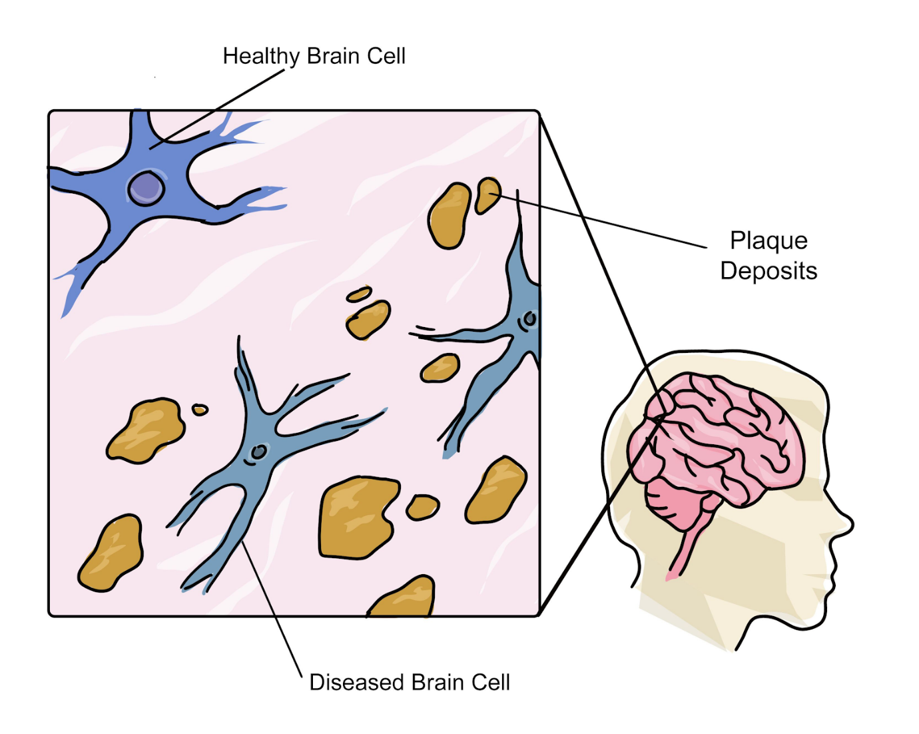Daily medical discoveries (2022).

2.

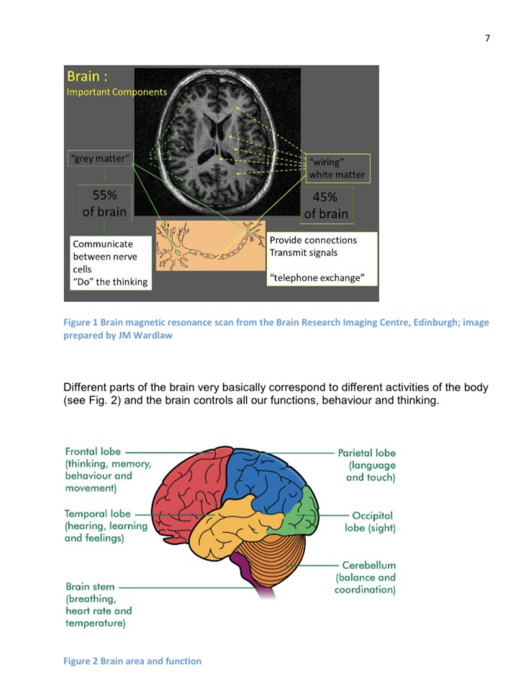Age UK (2014) p.7.

3.
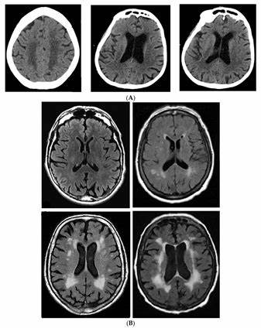Brain Sciences (2020).

4.

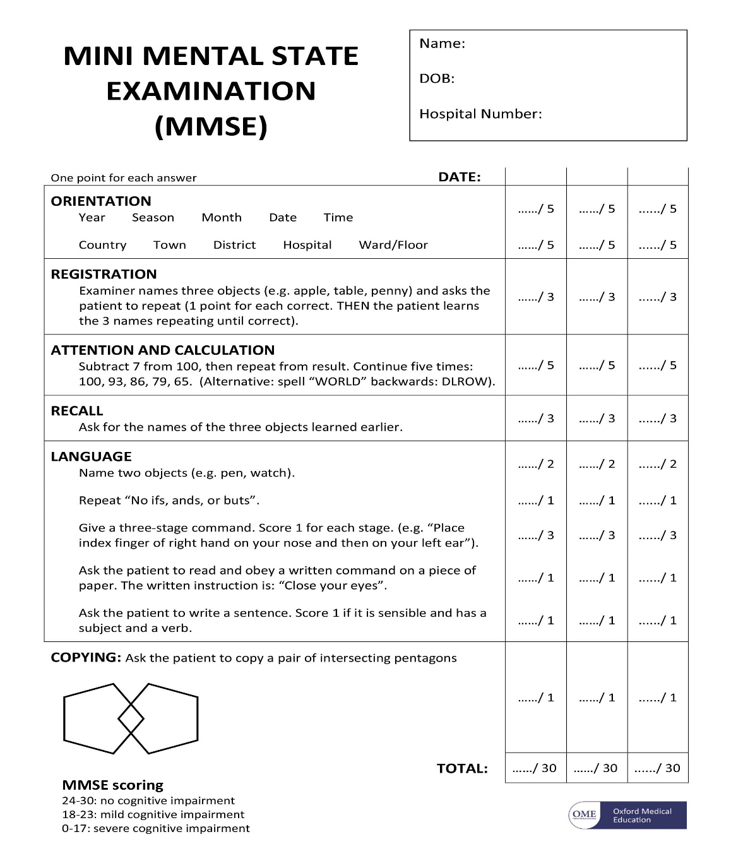
Bing.com (2023).

